

Image [1]

Assignment 2 – Worksheet 3
Name: Zaeem
Student No.: 1902036
Course: Applied Computing (Web Development)
Module: Network Operating Systems and Services
Date: 30/04/2021
Table Of Contents
Content Page Number
1.Introduction 3
2. Task 1: Understanding NTFS and Share Permissions 4
2.1. NTFS – Renaming The Folder – Client 1 4
2.2. NTFS – Setting Permissions – Client 1 6
2.3. NTFS – Share Permissions – Server1 12
2.4. Accessing The File Share / Server On The Network – Client 1 15
3. Task 2 - Utilising Group Policy Management Console 16
3.1. GPO 1: Moderating Access to the Control Panel - Server1 16
3.2. GPO 2: Removing Access to the Command Prompt – Server1 21
3.3. GPO 3: Restricting Access to Removable Media Drives – Server1 24
3.4. GPO 4: Restricting Software Installs – Server1 27
3.5. GPO 5: Password Policy in the ‘nwtraders.msft’ domain – Server1 31
4. Task 3: Observational Tasks 36
4.1. 3a) Local Permission and File Shares – Differences 36
4.1.1. NTFS (New Technology File System) 36
4.1.2. NTFS Permissions 36
4.1.3. Share Permissions 37
4.2. 3b) Group Policy Management 39
4.2.1. Group Policy Advantages 39
4.3. 3c) Good Password Principles 40
5. References 42

1. Introduction
In this documentation, the user will need to create a local drive and a folder with NTFS permissions and managing the usage of Sharing permissions for Network Access Control towards the assets. Basic Local File Access Control would be shown as well to see a difference from a Shared Network Access when transferring the files. Also, the user would be able to control the network area settings and the security policies by using the Group Policy Objects as this will show how the security settings can be produced and used within the network directory service and its assets.

Below will be a diagram from the worksheet brief showing the planning of the configuration for the network on the VMs.
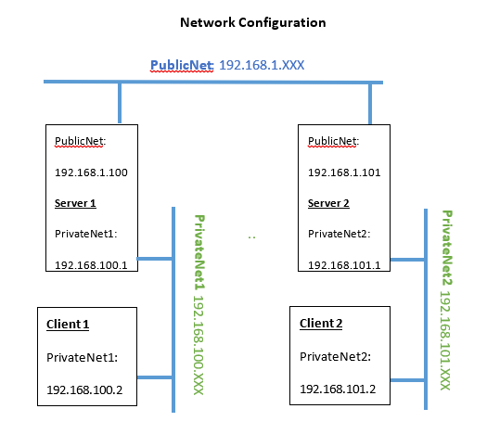

2. Task 1: Understanding NTFS and Share Permissions
2.1. NTFS – Renaming The Folder – Client 1
The user will first need to log on the Client 1 VM with a user account which is connected towards the Administrators group on the domain: nwtraders.msft. For this task, the user will need to enter NWT-ZG as the username and uwtsdZG26.09.00? as the password since this user account is a part of the Administrators group on the domain: nwtraders.msft.
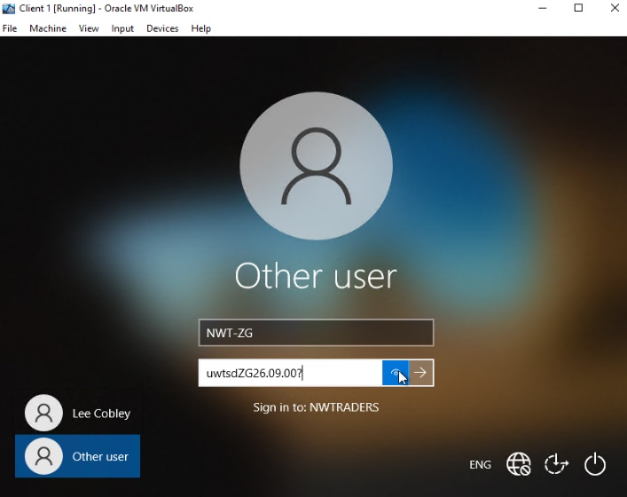
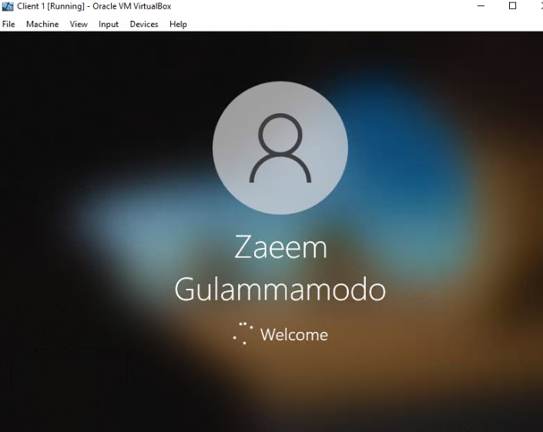

The user will need to click This PC and double click the Windows C: (Local Disk) drive. Then, the user will need to right click on the mouse, select New, click Folder and rename the new folder to Dept_Important_Docs as the user will be creating a new folder to store important information for this task.
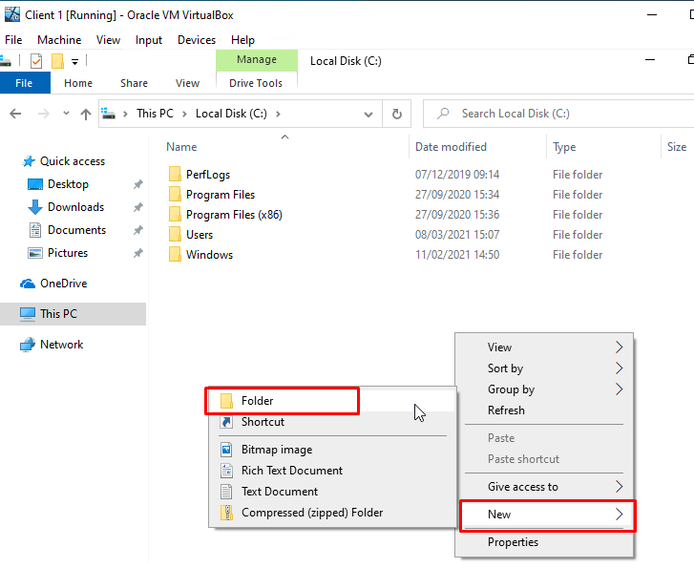
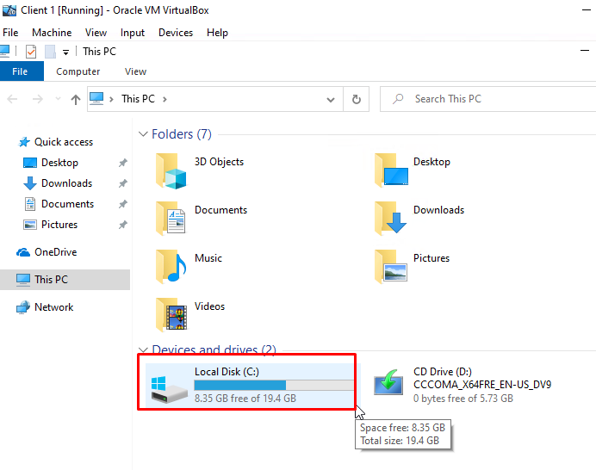
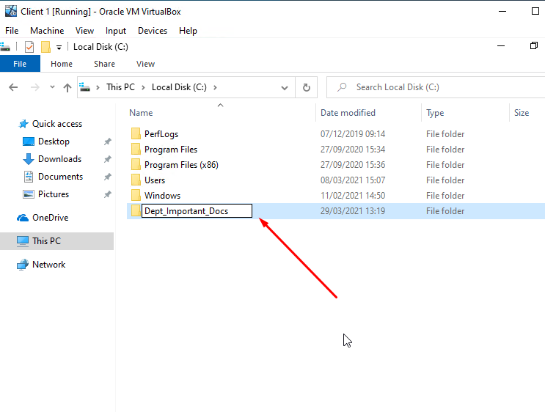

Next, the user will need to enter the Dept_Important_Docs folder, right click on the mouse, select New, click Text Document and rename it to Important File.
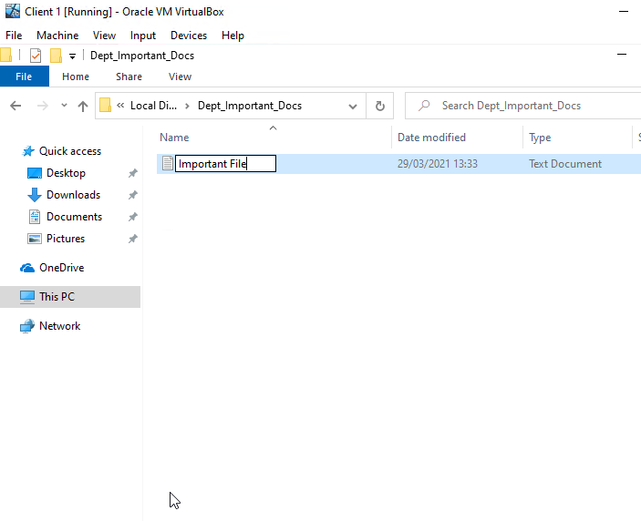
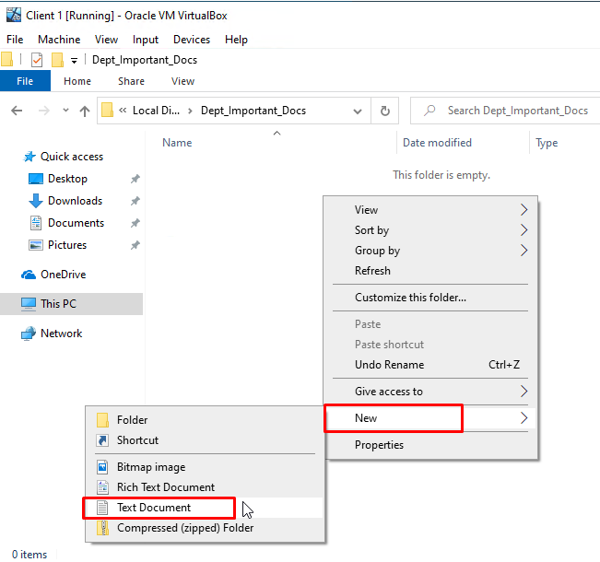

2.2. NTFS – Setting Permissions – Client 1
The user will first need to right click on the Dept_Important_Docs and choose Properties. After that, the user will need to select the Security tab on the navigation bar and click Edit to change the permissions as the user will be setting up access permission for specific users.
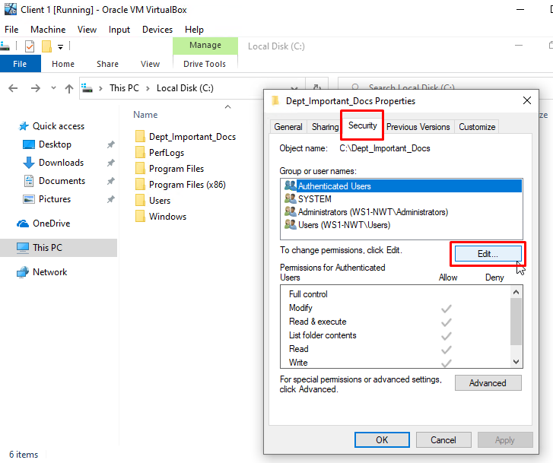
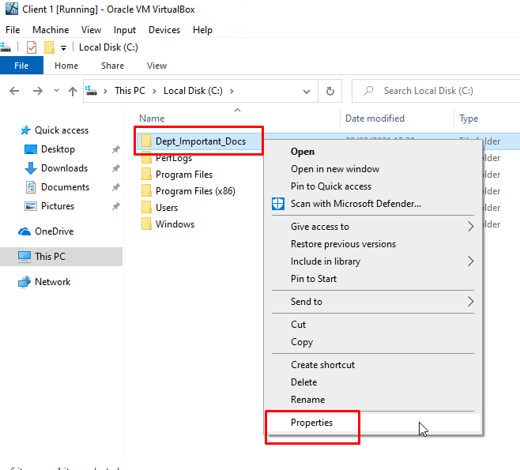

The user will need to select Authenticated Users and click the Remove button as the user will be removing the Inherited permissions from the file system. The user will be prompted showing a Windows Security error screen saying the permissions on this specific folder are being inherited as the user will need to turn this off. The user will need to click OK on this window and click Cancel on the next window.
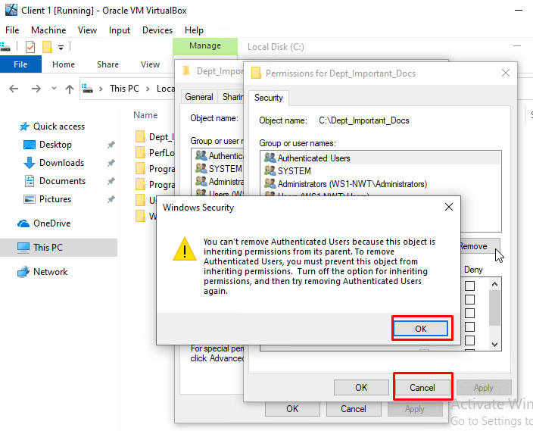
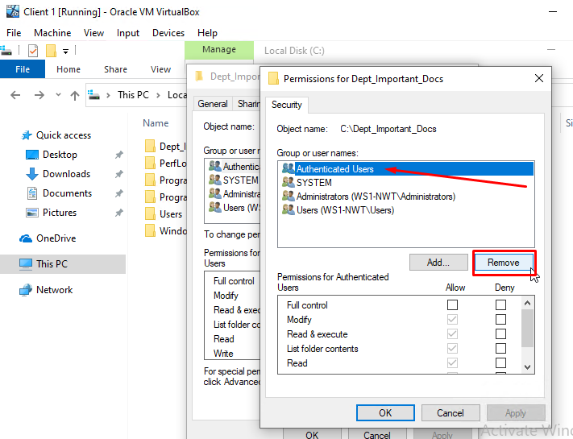

Next, the user will need to click the Advanced button and a window will pop up showing the Advanced Security Settings for this specific folder. The user will need to click the Disable inheritance button, click Remove all inherited permissions from this object and select Apply. The user will be prompted with 2 Windows Security pop-ups, the user will need to select Yes on the first window and OK on the second window.
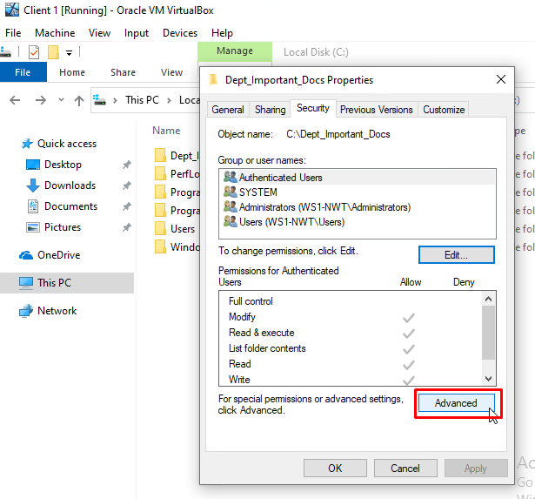
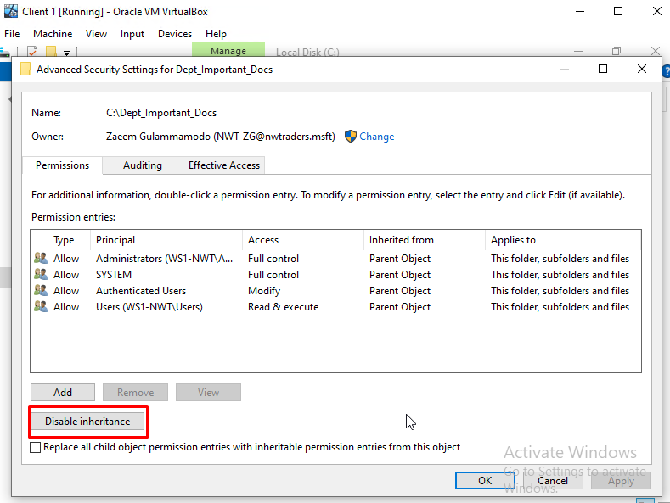

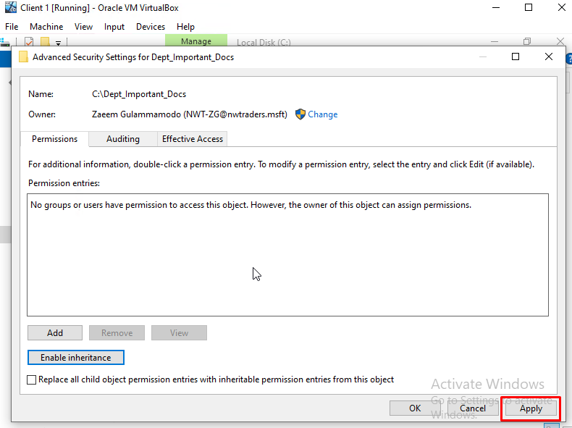
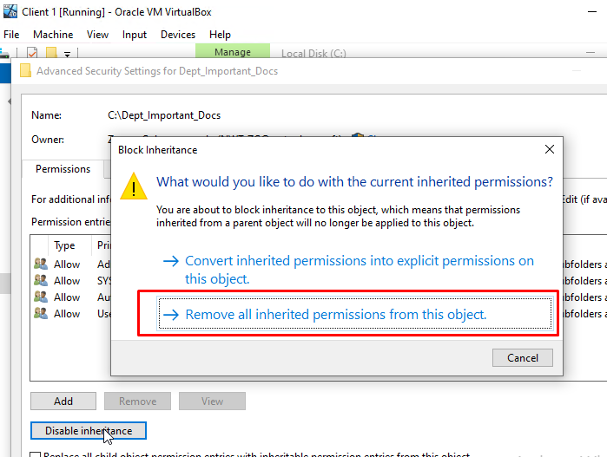

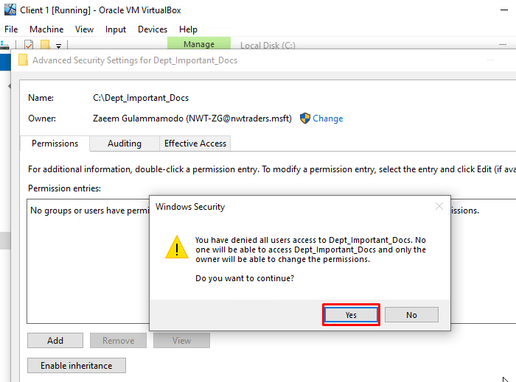
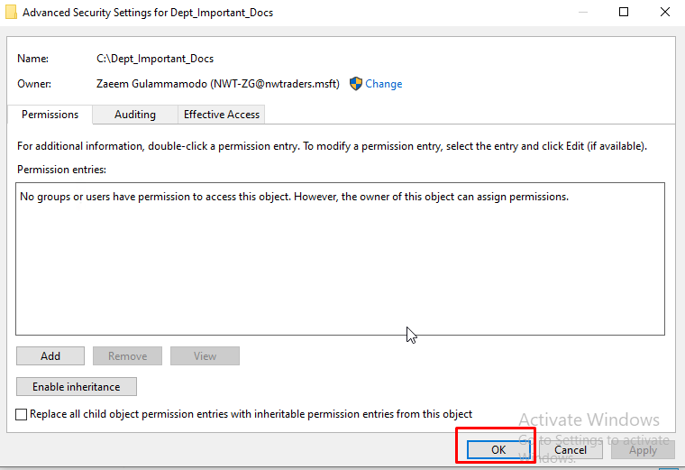

The user will need to click the Edit button again and select the Add button as the user will be adding the permissions they will need on the folder.
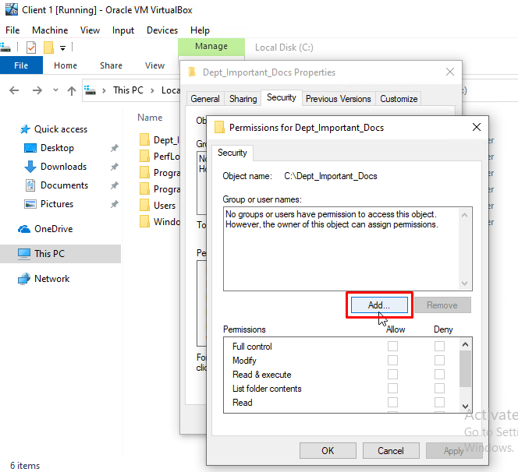
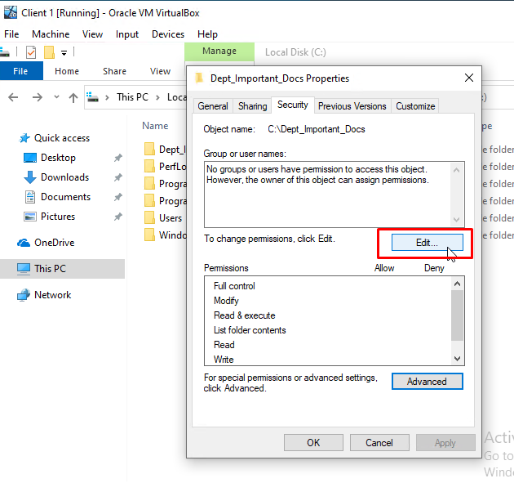

The user will need to enter the username for the current user account (that is logged in), select Check Names and click OK. For this task, the username for the user account will be NWT-ZG. Once that is done, the user will need to check if the current user account has been added on the user names group, on the Allow category, select the Full Control check box and click Apply and OK as this will give the user the full access they require within the specific user account.
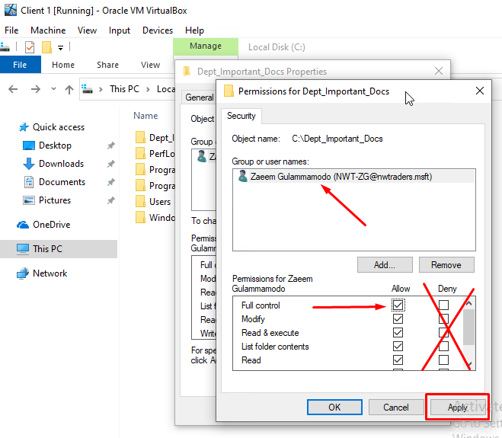
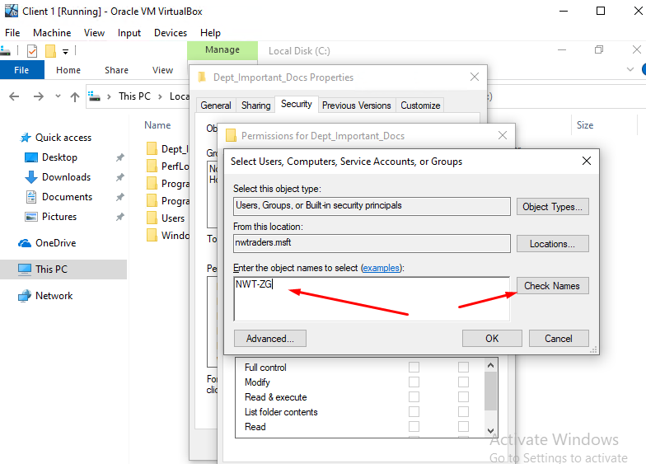

Next, the user will the right click on the Dept_Important_Docs folder and select Properties. The user will be using the same method to add another user account onto this group but this time the user account will be restricted on the set permissions towards the network. The user will need click the Edit button and then the Add button.
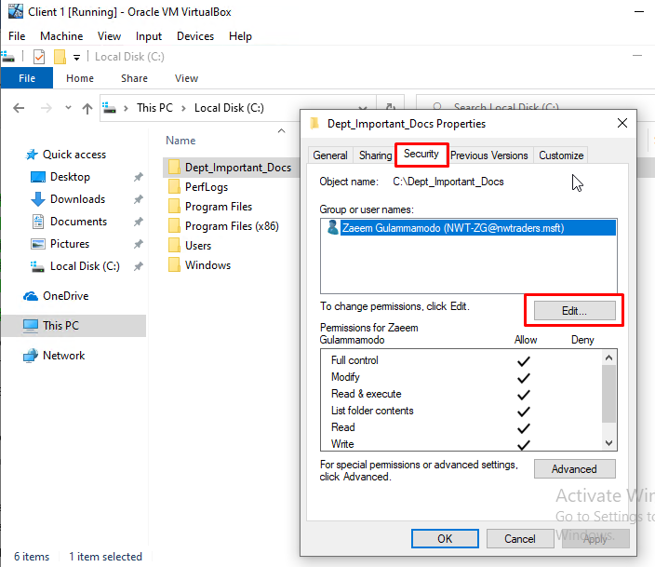
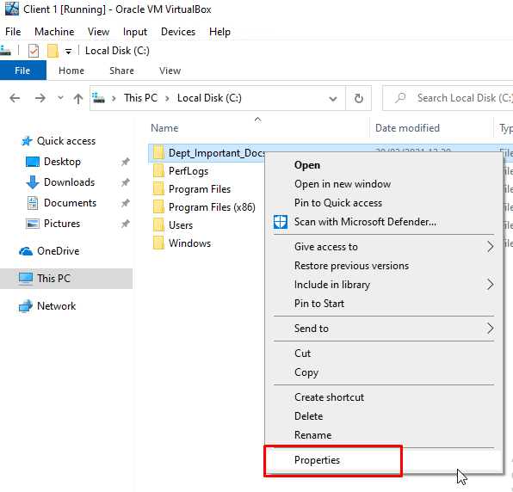

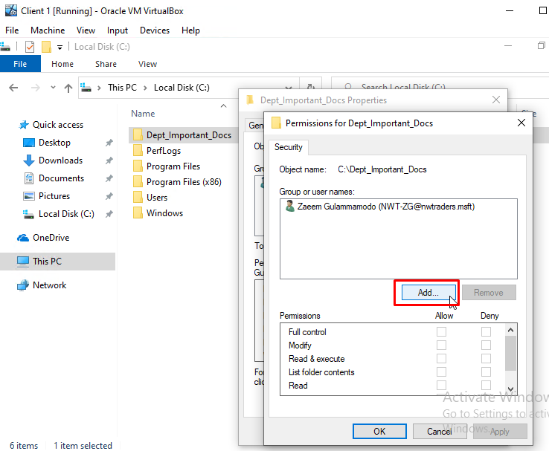

The user will need to enter the username for the other user account, select Check Names and click OK. For this task, the username for the user account will be NWT-LC. Once that is done, the user will need to check if the current user account has been added on the user names group, on the Allow category, select Read & execute check box only and click Apply and OK as this will give the user the full access they require within the specific user account.
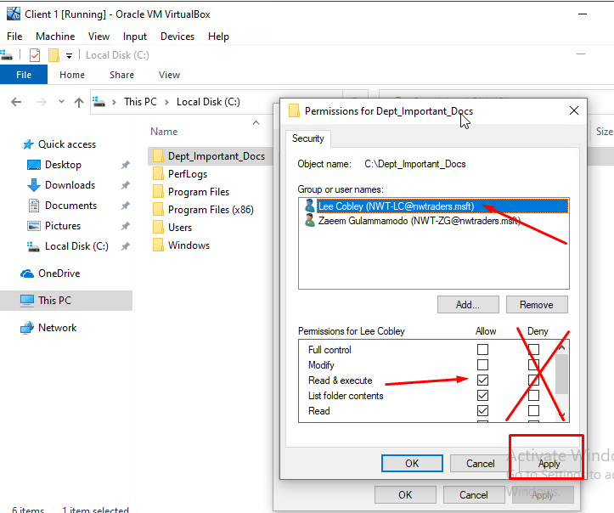
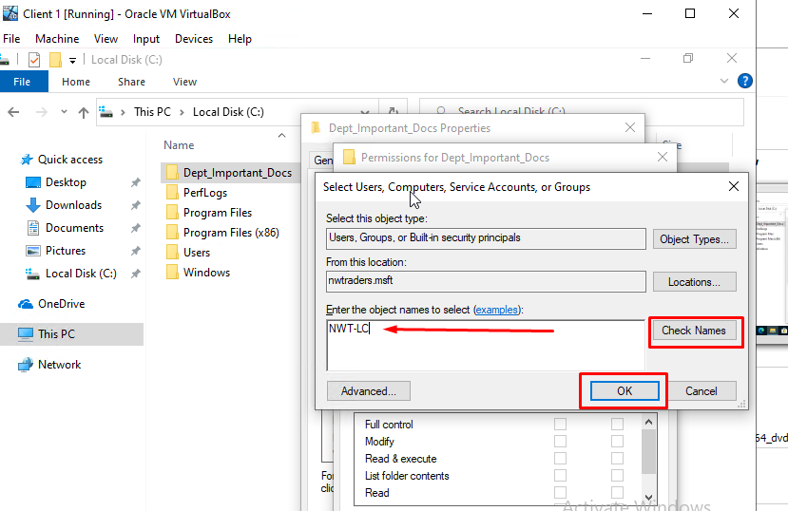

Then, the user will need to open up the text file inside the Dept_Important_Docs folder, enter some random text and save the text file. This will allow the current user to modify and save the text file with no problems.
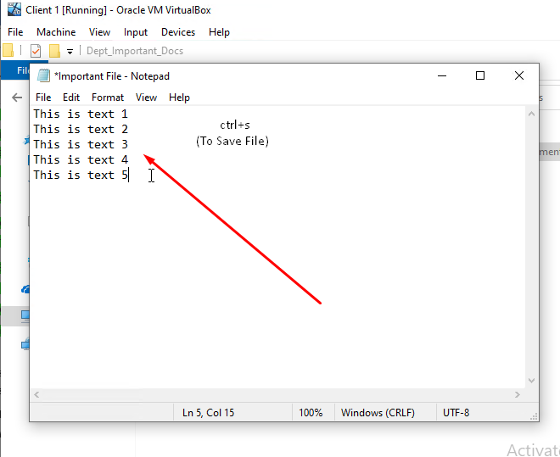

The user will need to log off the current user account and sign in with the other user account. For this task, the user will need to enter NWT-LC as the username and uwtsdLC12.03.21? as the password. The user will need to open up the Dept_Important_Docs folder and check if they can modify the text file. The image below shows that the user cannot modify the text file as a error window shows up saying that this specific user does not have permission to resave the text file in that specific folder.
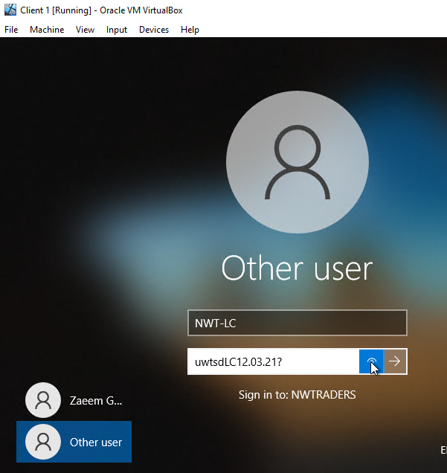
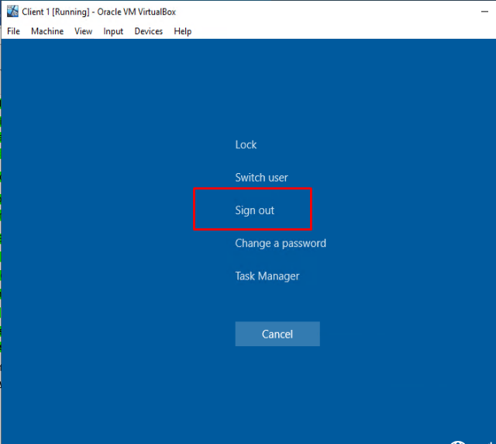

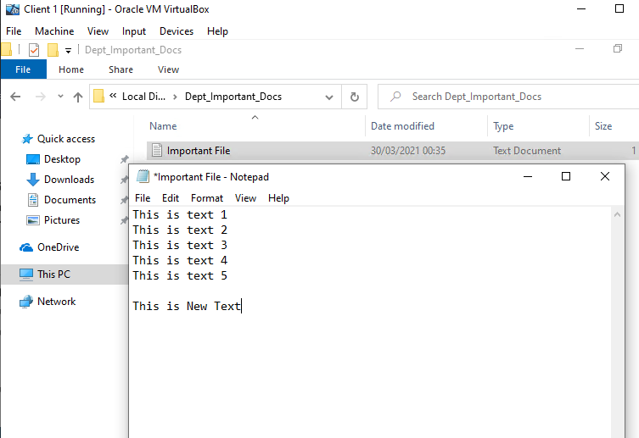
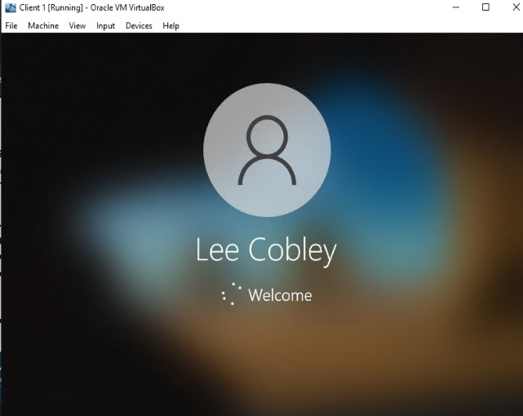

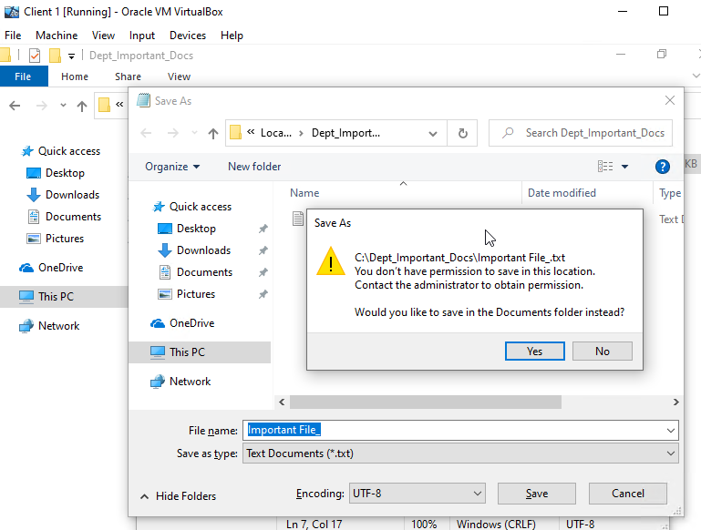

2.3. NTFS – Share Permissions – Server1
The user will first need to log on the Server1 VM. For this task, the username will need to be Administrator and the user will need to enter P@ssw0rd as the password.
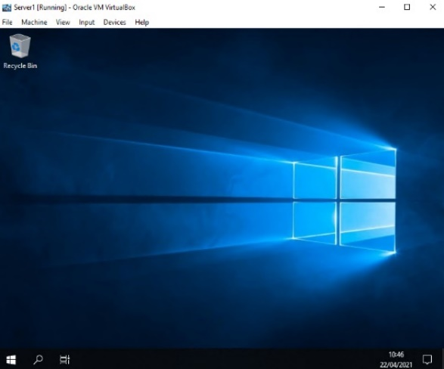
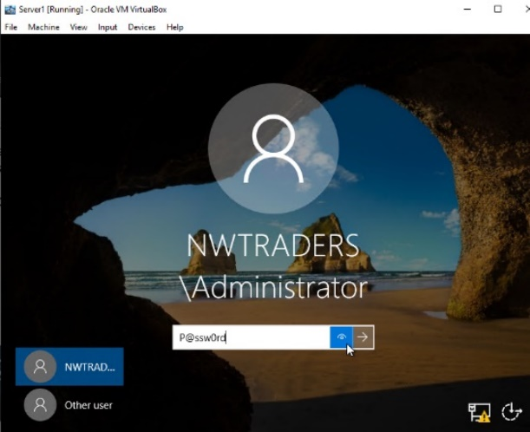

The user will need to load up Server Manager, select File and Storage Services, click Shares, select Tasks and click on New Share as this will allow the user to create a new share folder on the server.
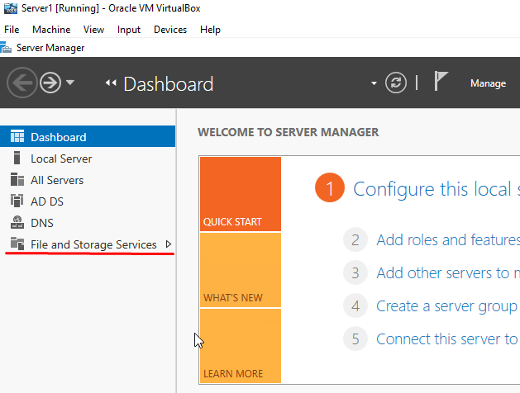
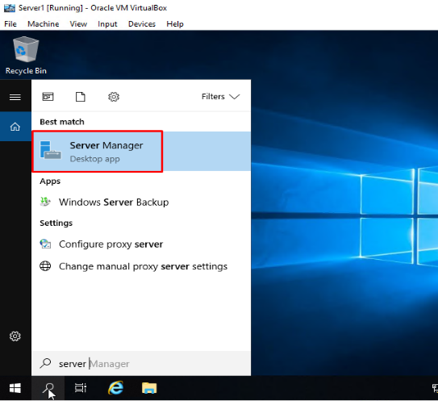

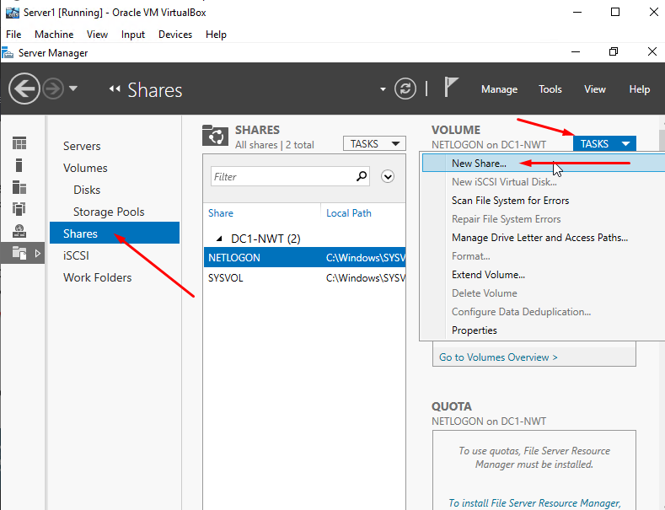

Then, the user will be prompted with a new share wizard window. For this task, the user will need to select SMB Share – Quick and click Next, select the DC1-NWT server and click Next, enter DeptNetShare$ as the share name as the user should see where the share name will be in the local path on the C; Drive and on the server drive and click Next, the user will need to select / tick the Enable access-based enumeration and Allow caching of share options as this will allow the share to show the files and folders which a specific user have the permission to access them and view them offline.
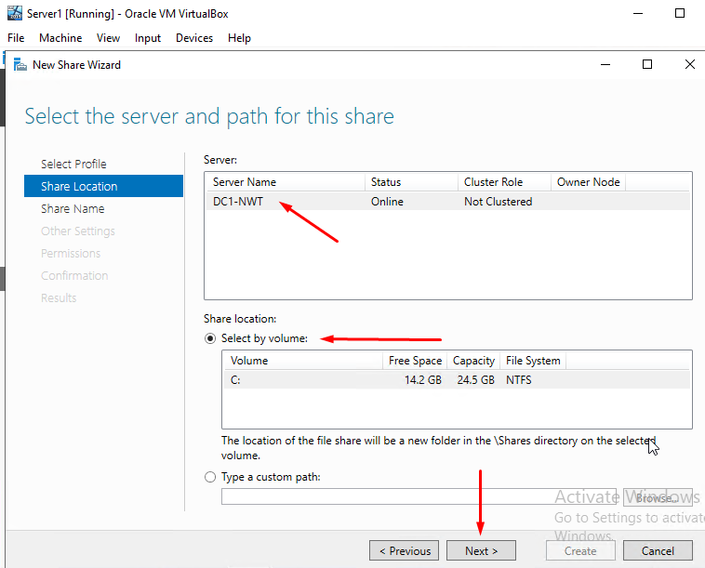
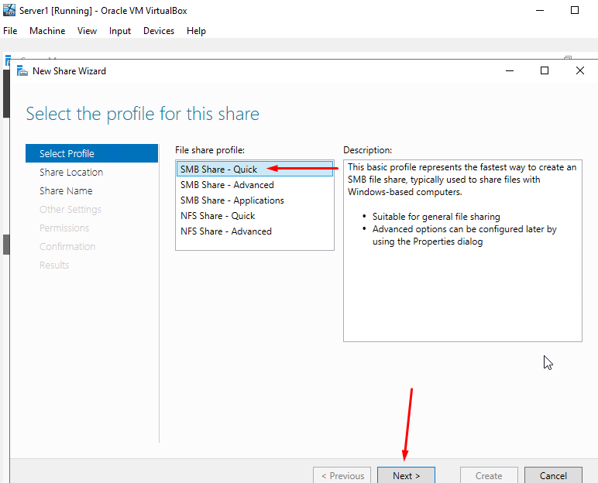

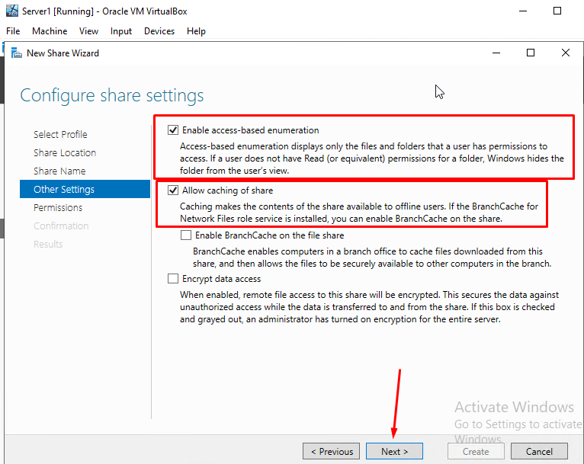
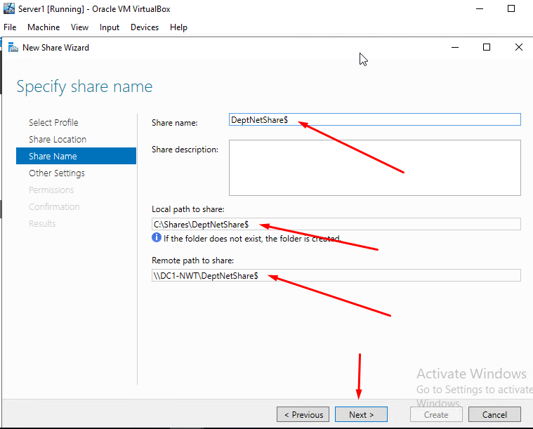

The user will need to check if the Administrator with Full Control has been added and the two users on the domain has been added as well on this permission and click Next. After that, the user will need to all details on the Confirmation page to see if it is all correct and Create. This will show that the network file share was successfully created on the server with no problems
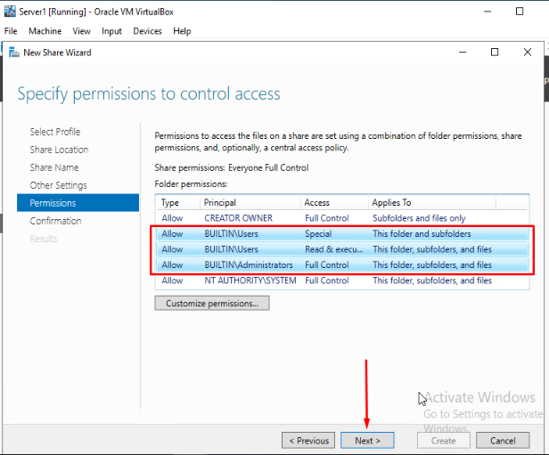
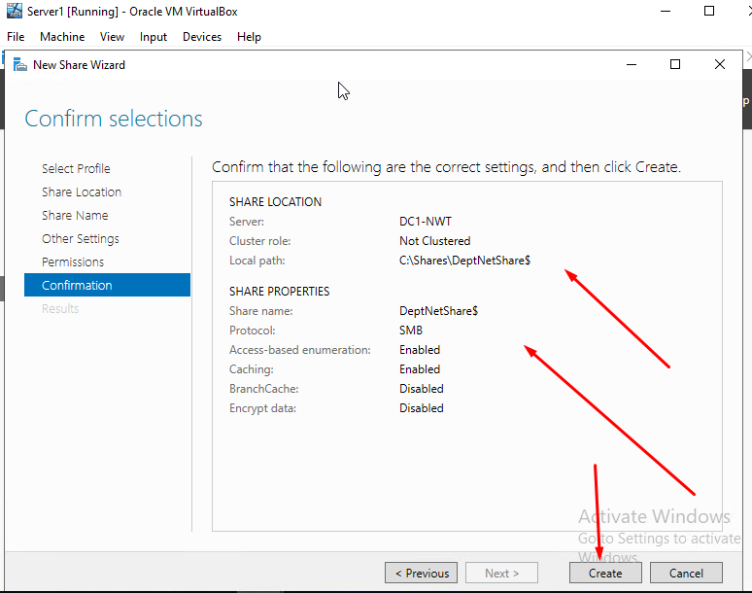

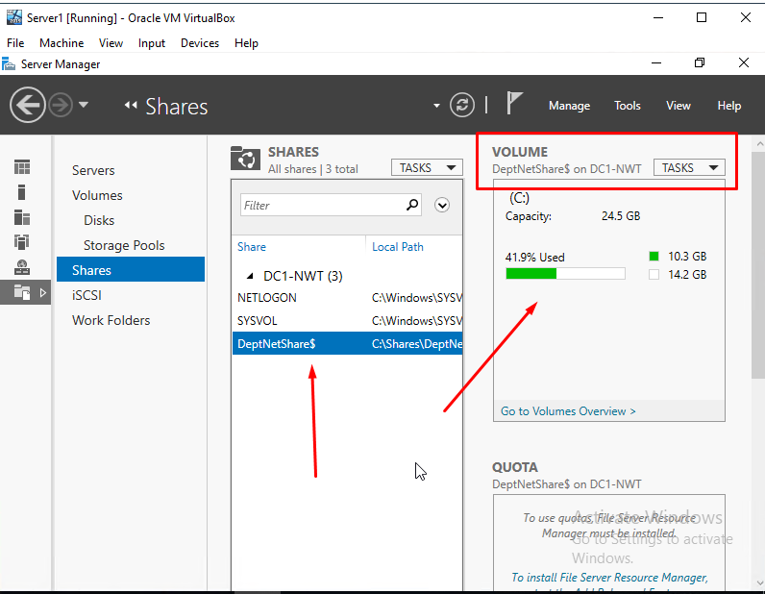
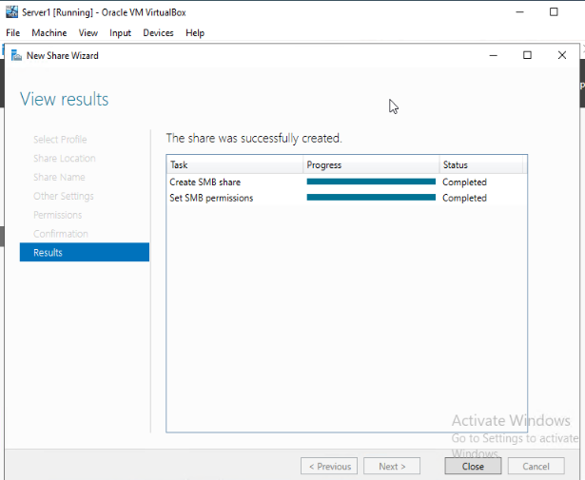

2.4. Accessing The File Share / Server On The Network – Client 1
The user will first need to log on the Client 1 VM. For this task, the username will need to be NWT-ZG and the user will need to enter uwtsdZG26.09.00 as the password.
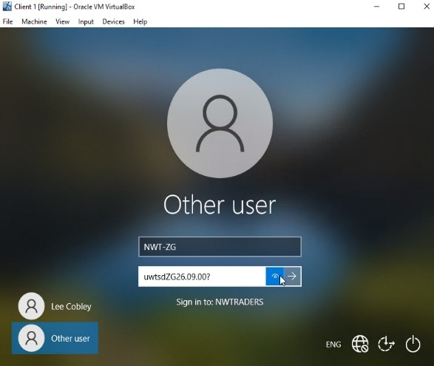

The user will need select the search bar, type “This PC”, right click on This PC and click on Map Network Drive. Next, the user will need to accept the default drive letter the PC gives which will be the Z: drive and type \\DC1-NWT\DeptNetShare$ as the share / network folder that the user will be connecting to and click Finish. This task allows the user to add a local drive on the PC which will reserve the network share that is saved permanently until the user has disconnect from it on the PC.
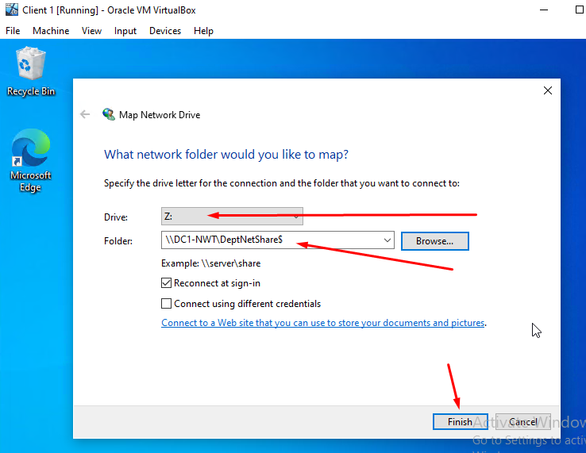
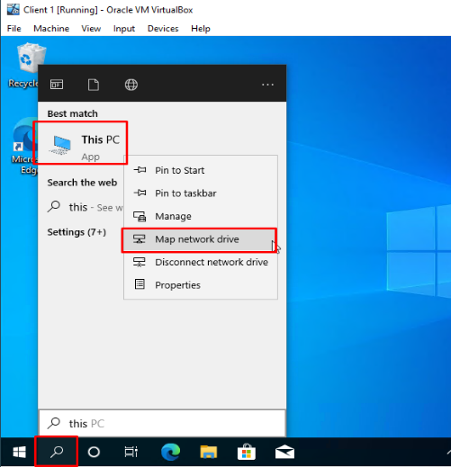

Below will be an image showing that the mapped drive (Z: Drive) has successfully been created with no problems.
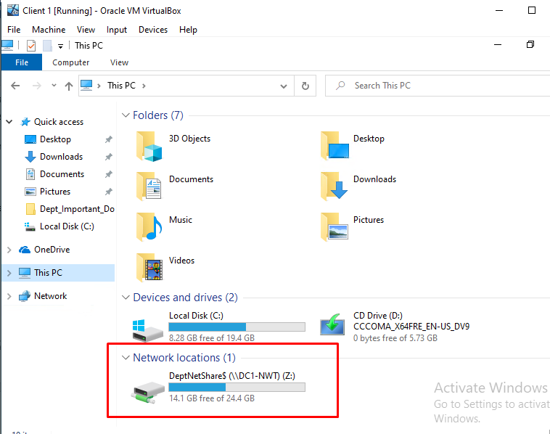

3. Task 2 - Utilising Group Policy Management Console
3.1. GPO 1: Moderating Access to the Control Panel – Server1
The user will first need to click Active Directory Users and Computers, right click on the nwtraders.msft domain on left hand side menu, select New and click Organisational Unit.
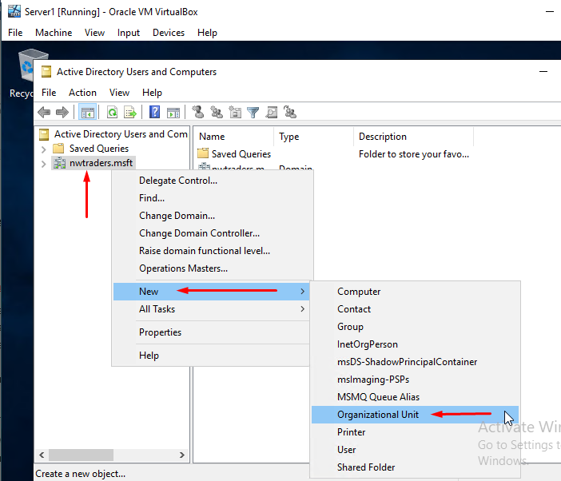
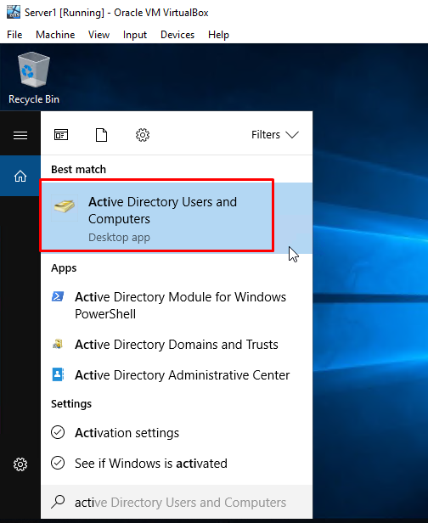

The user will need to enter Non Admin Users as the name of this object and click OK. Next, the user will need to enter the nwtraders.msft domain, right click the Non Admin Users object, select New and click User as the user will be adding a new user to that specific object on the domain.
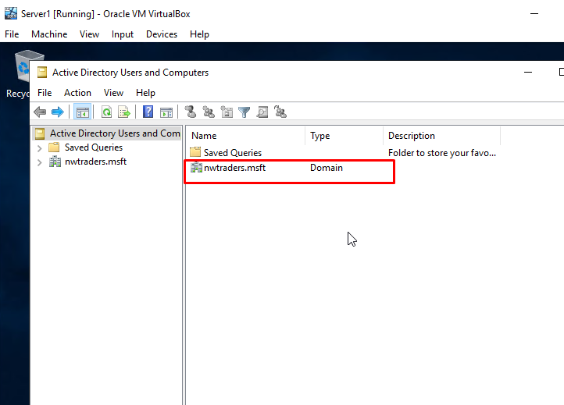
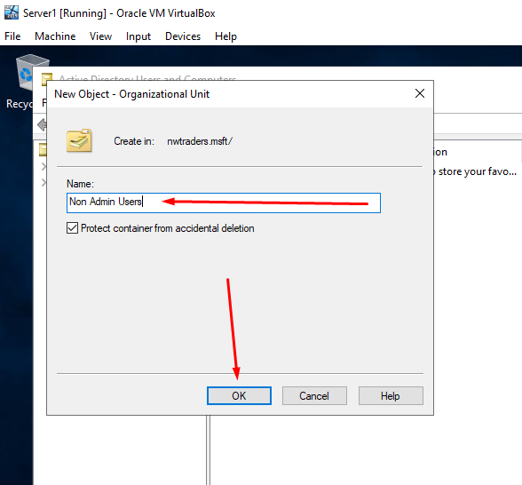

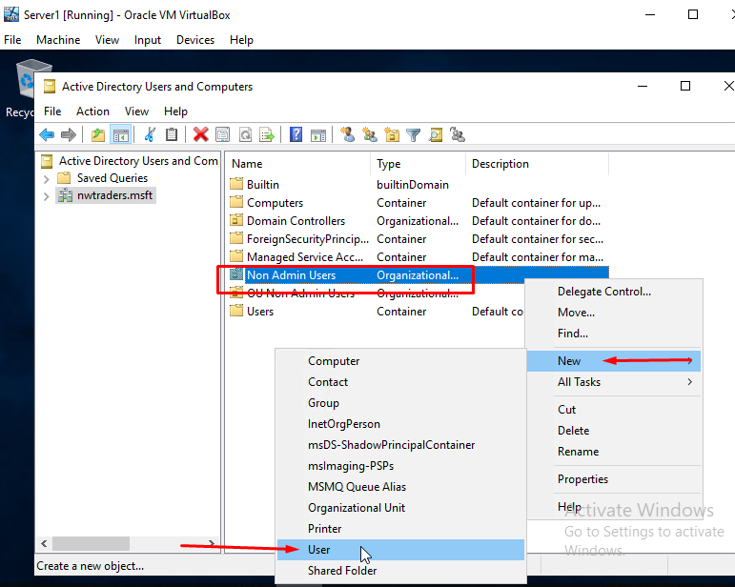

For this task, the user will enter Steve as the first name and Jobs as the last name. The User logon name will be NWT-NA-SJ and click Next as the NA stands for Non Admin. Then, the user will need to create a password for the new user account but the password must meet the Microsoft’s Minimum complexity requirements. The password for this task will be naSJi0s? as this specific password does meet the Microsoft’s Minimum complexity requirements by using lowercase and uppercase letters, special characters and numbers. Also, the user would need to unselect the option User must change password at next logon and select the option Password never expires and click next as the user would be creating a permanent password not a temporary password on the new user account.
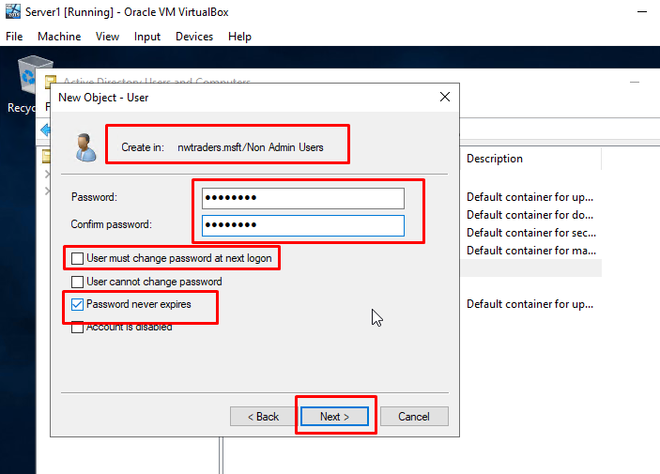
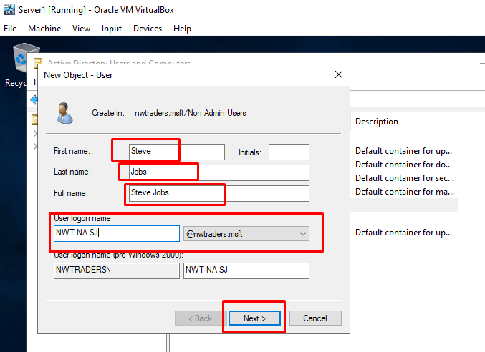

The user will be prompted with a new window showing a summary of the choices that was made during the process of creating a new user account within the Non Admin Users object on the server. Once the user has checked this, click finish and a new user account will be created onto the server.
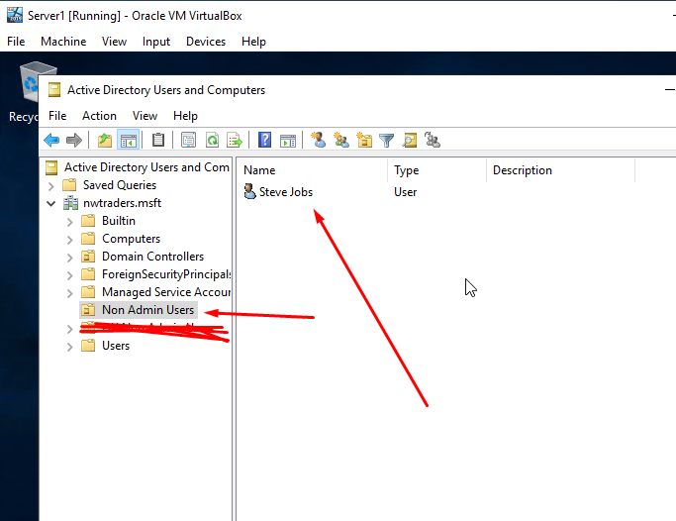
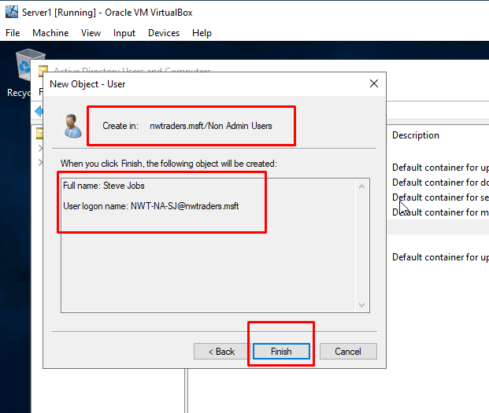

The user will need to go on the search bar, type Group Policy Management Console and run the program as the user will be creating the GPO on the Server1 VM. The user will next need to expand the Domains on the left hand side menu, right click the Non Admin Users object and click Create a GPO in this domain as the user will be creating a GPO.
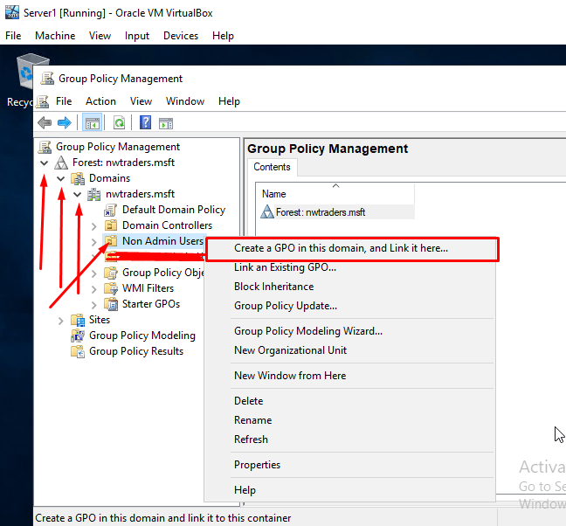
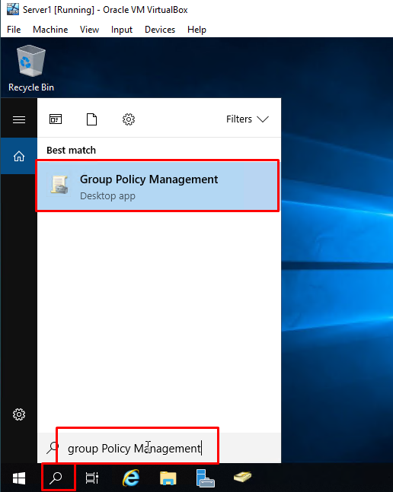

For this task, the user will need to enter NoCtrlPanAccess as the name of the new GPO and click OK. After that, the user will need to expand the Non Admin Users object, right click the new GPO and select Edit.
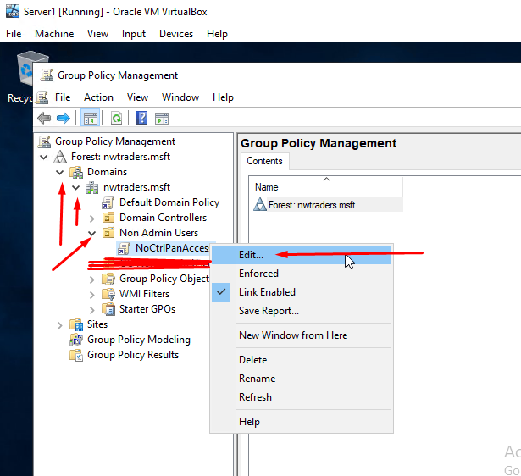
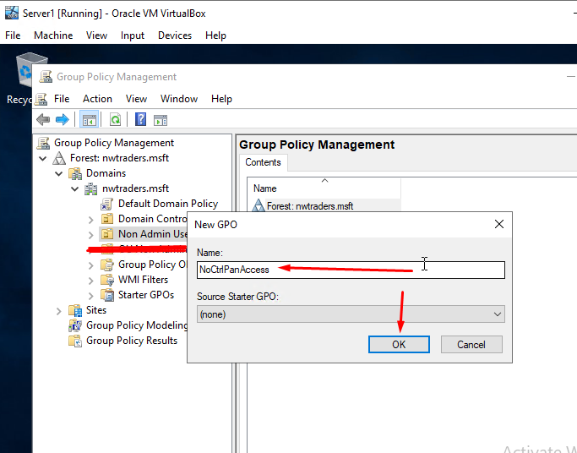

The user will be prompted with a Group Policy Management Editor windows as the user will need to expand the User Configuration object on the left-hand side menu, expand the Policies folder, expand the Administrative Templates and click Control Panel. For this task, the user will need to double click on the Prohibit access to Control Panel and PC settings policy as this will open up the properties. The user will need to select the enabled option and click Next Setting.
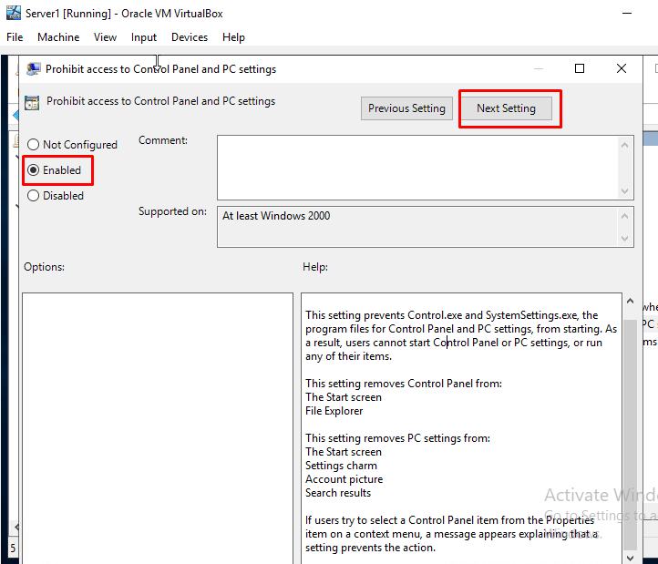
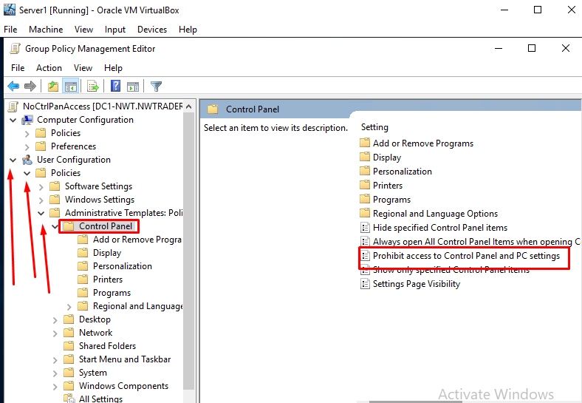

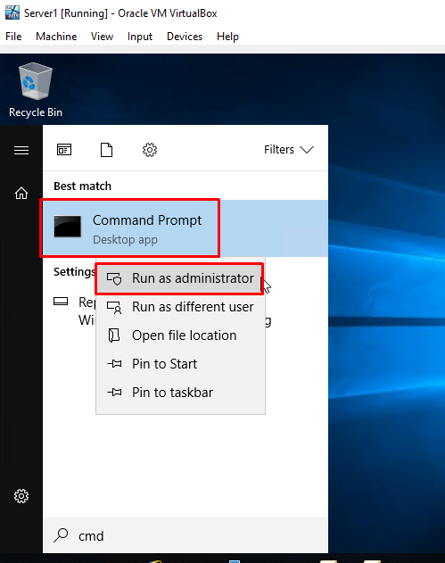
Next, the user will need to run the Command Prompt as an Administrator and enter the command gpupdate /force. This will show that the settings are updating and the user will need to test if the non admin user can or cannot access the Control Panel.
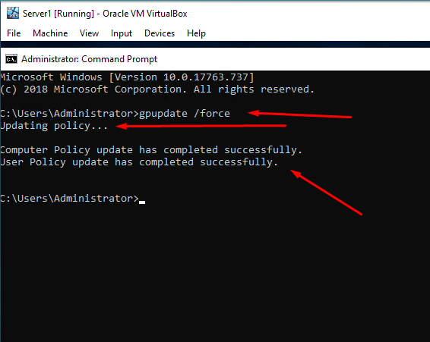

After that, the user will need to log in to the Client 1 VM with the new user account that was created earlier on. For this task, the user will need to enter NWT-NA-SJ as the username and naSJi0s? as the password.
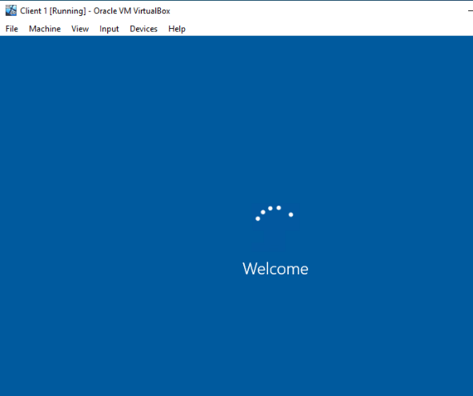
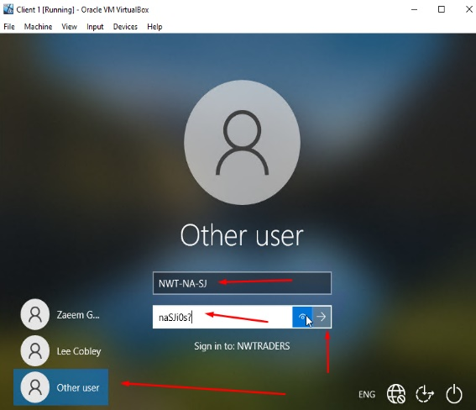

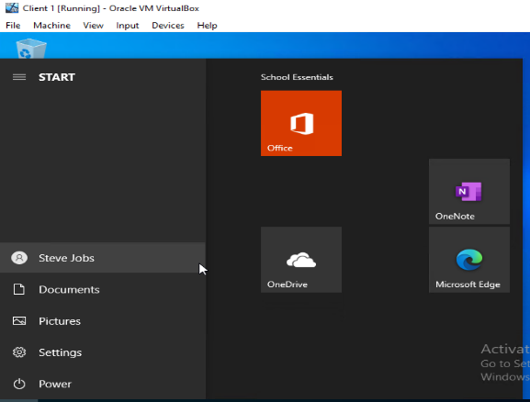
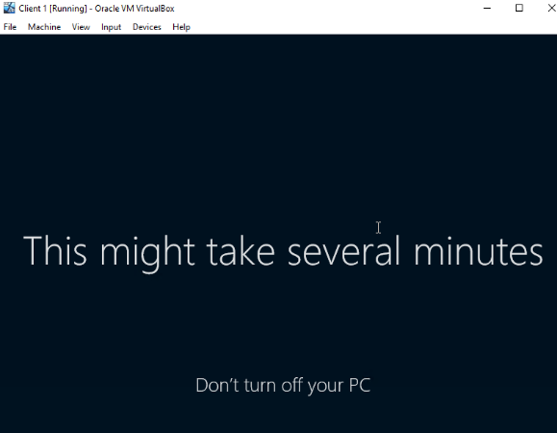

The images below will test if the new user account can access the Control Panel on Client 1 VM and it shows that the user cannot access the Control Panel with an error message being shown due to the policies being updated and restrictions been set on the Server1 VM.
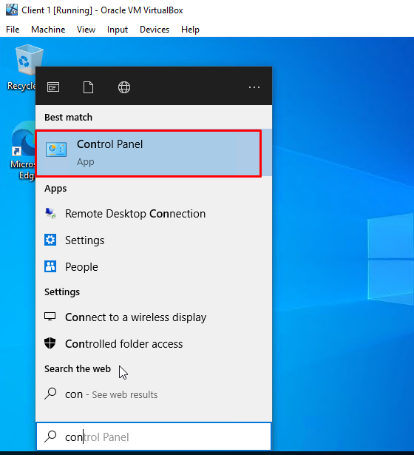
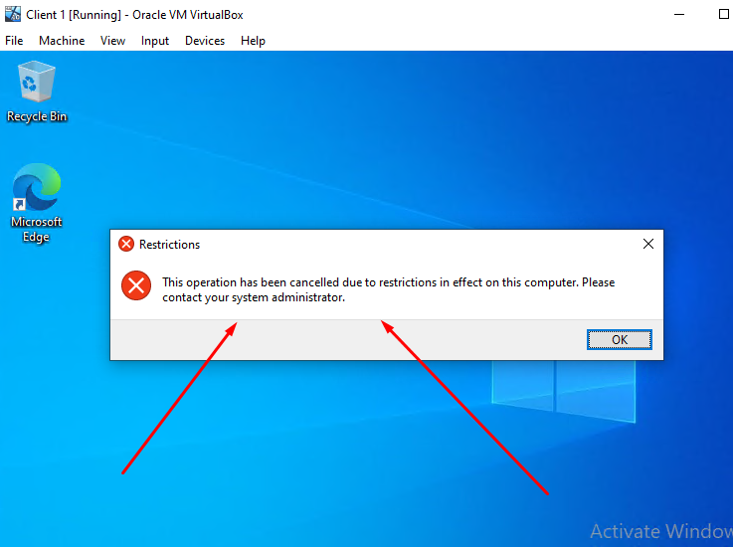

3.2. GPO 2: Removing Access to the Command Prompt – Server1
The user will first need to go on the search bar, type Group Policy Management Console and run the program as the user will be creating another GPO on the Server1 VM. The user will next need to expand the Domains on the left-hand side menu, right click the Non Admin Users object and click Create a GPO in this domain as the user will be creating another GPO.
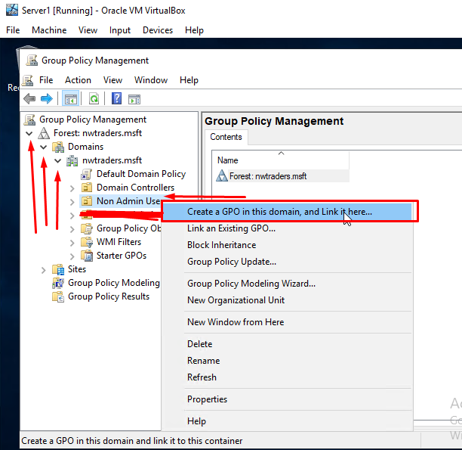
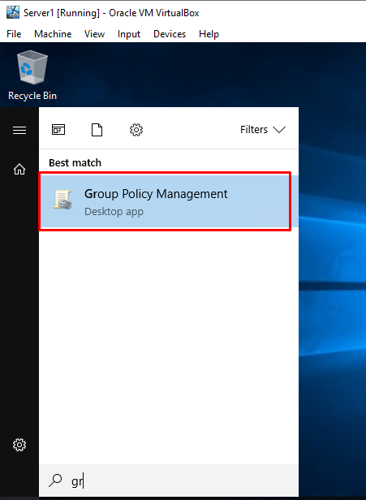

For this task, the user will need to enter NoCmdPrmptAccess as the name of the new GPO and click OK. After that, the user will need to expand the Non Admin Users object, right click the new GPO and select Edit.
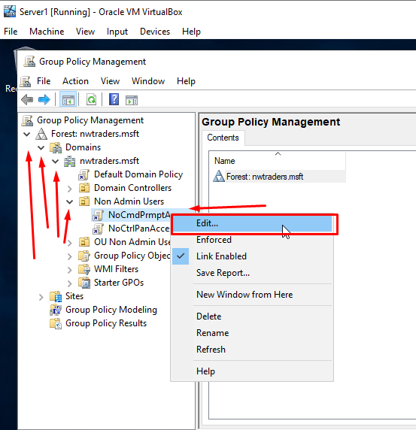
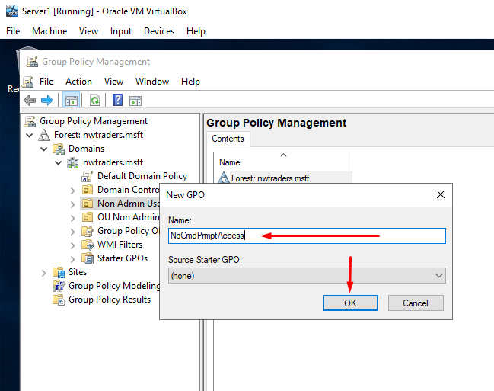

The user will be prompted with a Group Policy Management Editor windows as the user will need to expand the User Configuration object on the left-hand side menu, expand the Policies folder, expand the Administrative Templates and click System. For this task, the user will need to double click on the Prevent Access to the Command Prompt policy as this will open up the properties. The user will need to select the enabled option and click Next Setting.
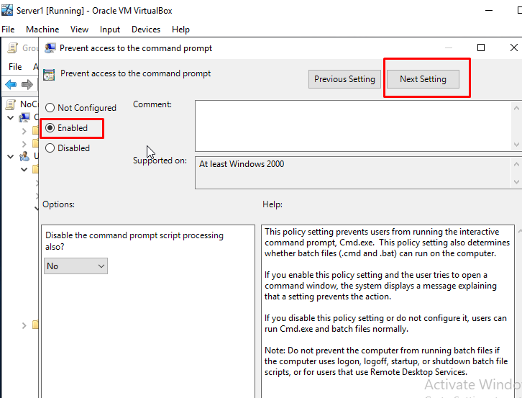
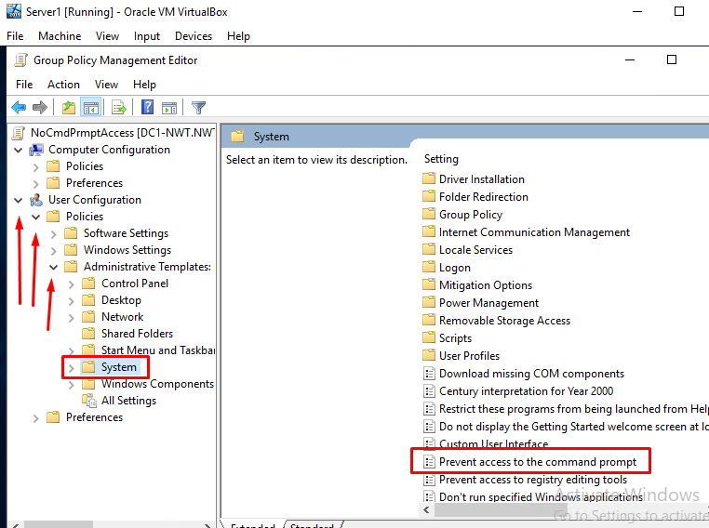

Next, the user will need to run the Command Prompt as an Administrator and enter the command gpupdate /force. This will show that the settings are updating and the user will need test if the non admin user can or cannot access the Command Prompt.
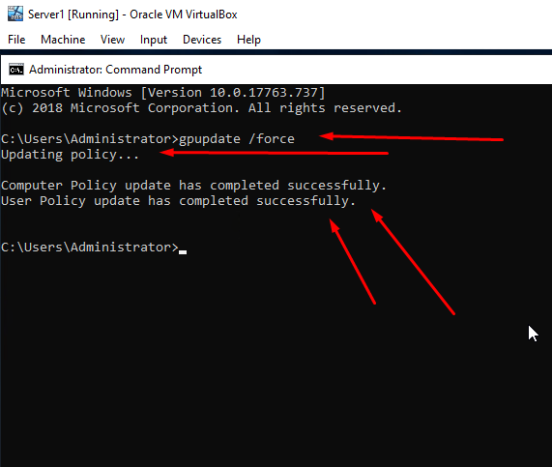

After that, the user will need to log in to the Client 1 VM with the new user account that was created earlier on. For this task, the user will need to enter NWT-NA-SJ as the username and naSJi0s? as the password.
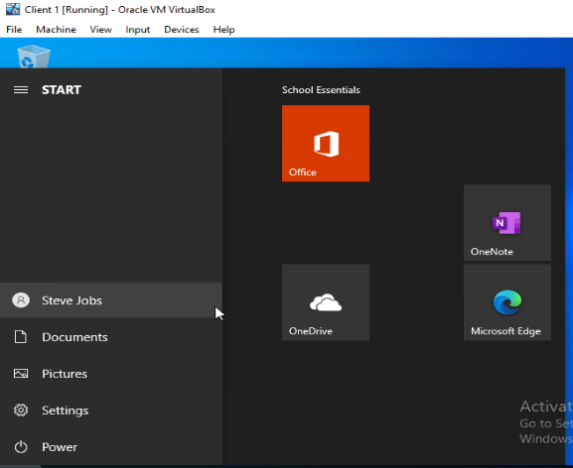
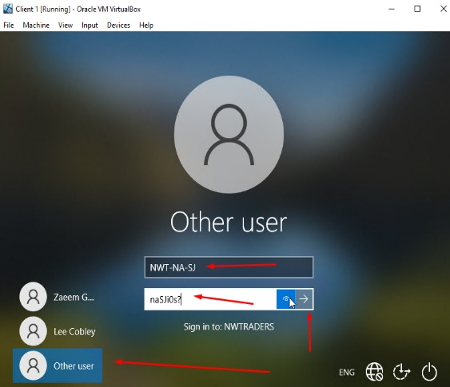

The images below will test if the new user account can access the Command Prompt on Client 1 VM and it shows that the user cannot access the Command Prompt with an error message being shown due to the policies being updated and restrictions been set on the Server1 VM.
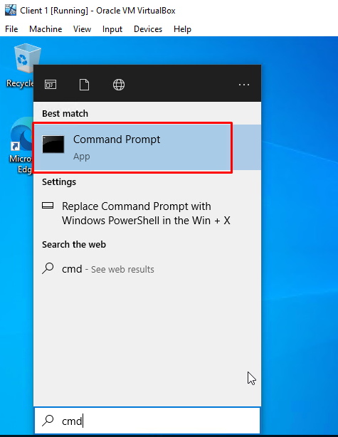
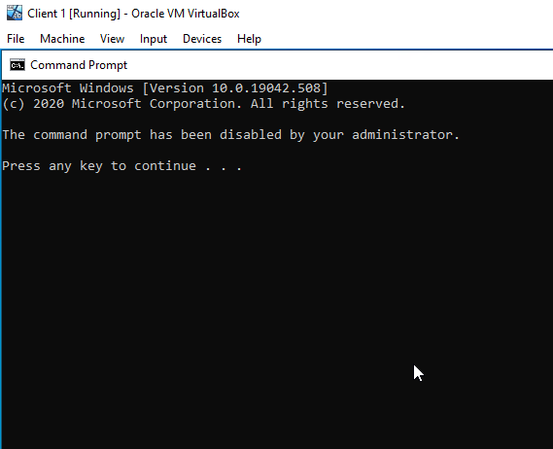

3.3. GPO 3: Restricting Access to Removable Media Drives – Server1
The user will first need to go on the search bar, type Group Policy Management Console and run the program as the user will be creating another GPO on the Server1 VM. The user will next need to expand the Domains on the left-hand side menu, right click the Non Admin Users object and click Create a GPO in this domain as the user will be creating another GPO.
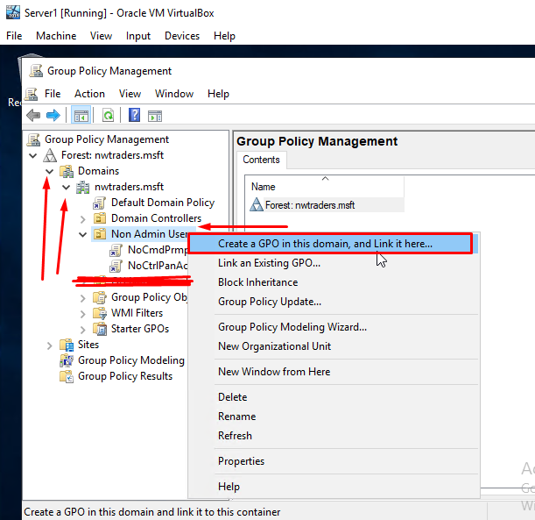

For this task, the user will need to enter NoRemDriveAccess as the name of the new GPO and click OK. After that, the user will need to expand the Non Admin Users object, right click the new GPO and select Edit.
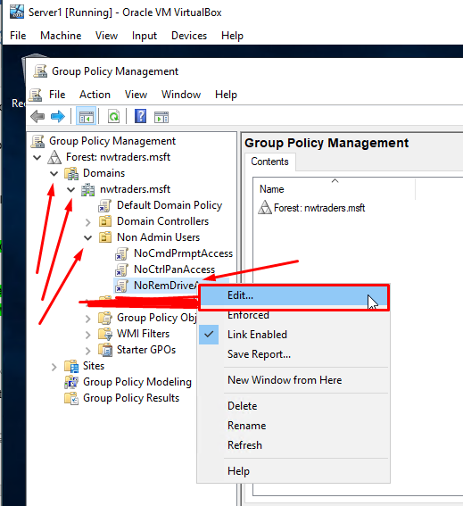
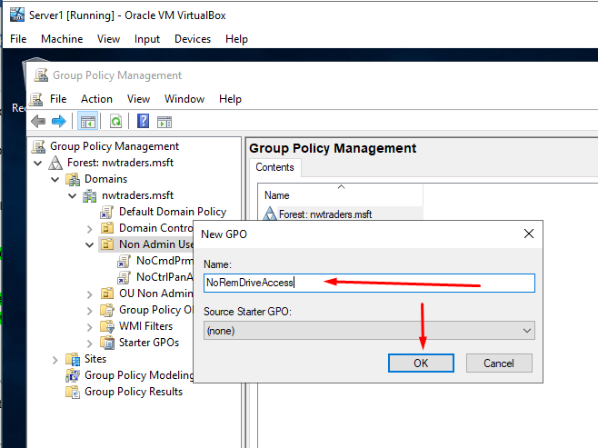

The user will be prompted with a Group Policy Management Editor windows as the user will need to expand the User Configuration object on the left-hand side menu, expand the Policies folder, expand the Administrative Templates, expand the System folder and click Removable Storage Access. For this task, the user will need to double click on the All removable storage classes: Deny all accesses policy as this will open up the properties. The user will need to select the enabled option and click Next Setting.
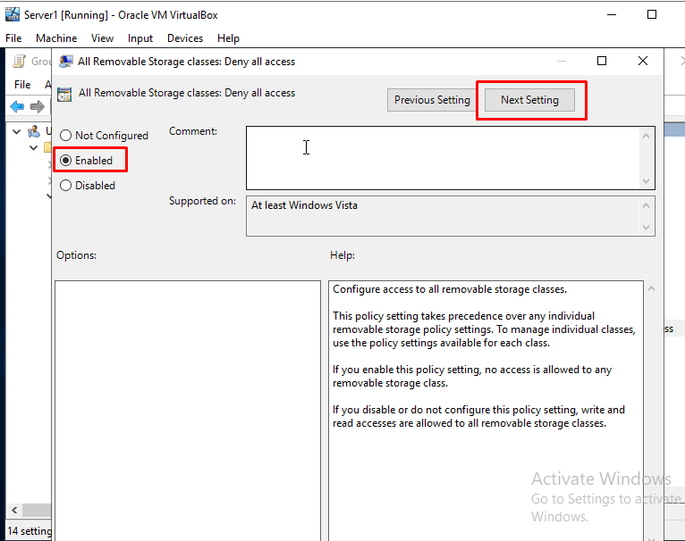
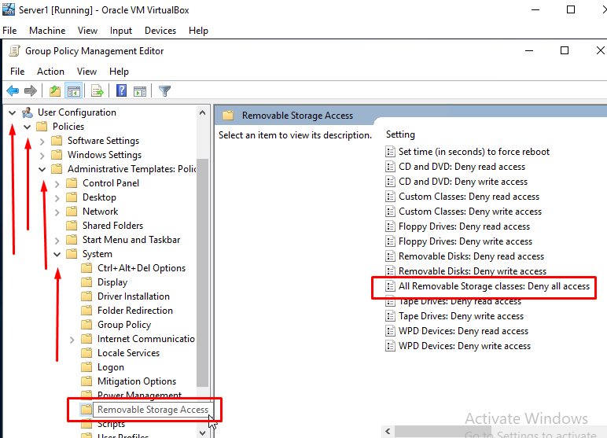

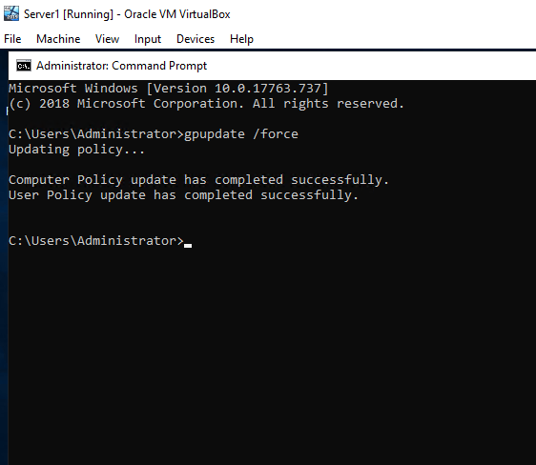
Next, the user will need to run the Command Prompt as an Administrator and enter the command gpupdate /force. This will show that the settings are updating and the user will need test if the non admin user can or cannot access the Removable Storage.

After that, the user will need to log in to the Client 1 VM with the new user account that was created earlier on. For this task, the user will need to enter NWT-NA-SJ as the username and naSJi0s? as the password.

Due to the working remotely on the labstats machines, it was not possible to test policy on new user account as the user does not have Direct Access to Client 1 VM PC. But the user can show what would it do to make this policy work as the user will need to go on Client 1 VM Settings and click the USB tab on the left-hand side menu as this would be the method to add in USB Drives on the Client 1 PC into the VM when using this feature. This would allow the user to enable a VM to access the USB drives on the PC while the policy would restrict USB access on the VM even though the user have exposed it to Client 1 PC through VirtualBox management settings.
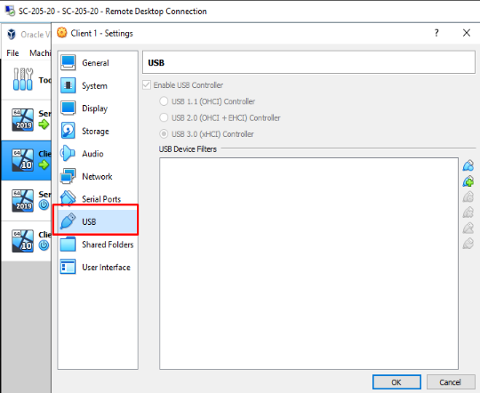
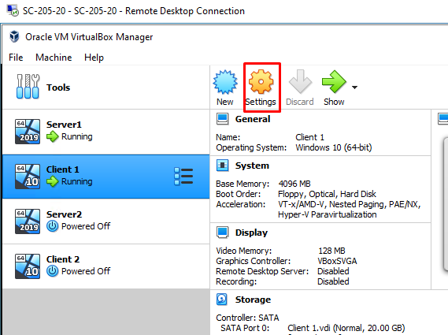

3.4. GPO 4: Restricting Software Installs – Server1
The user will first need to go on the search bar, type Active Directory Users and Computers and run the program as the user will be creating another Organisational Unit object on the Server1 VM. The user will next need to right click on nwtraders.msft, select New and click Organisational Unit.
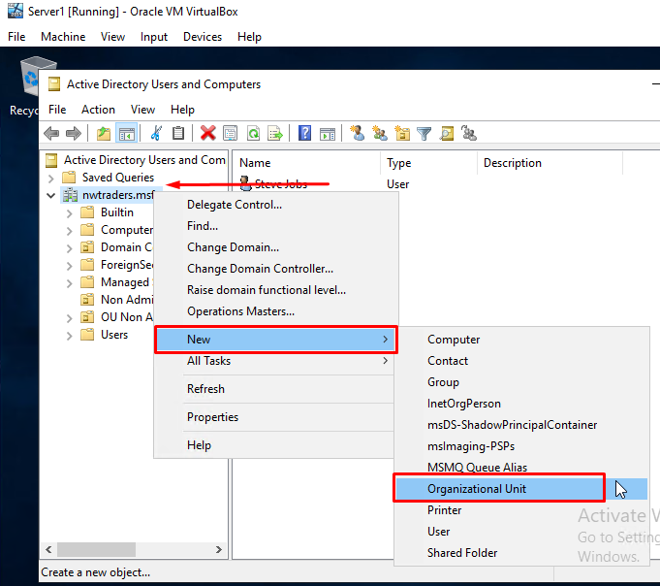
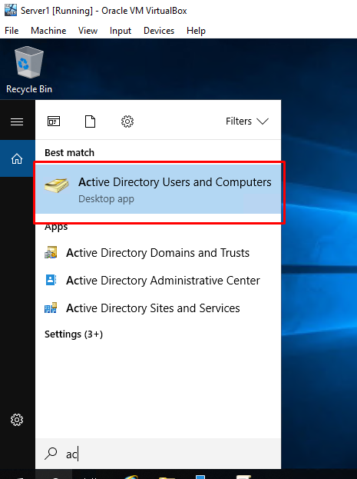

For this task, the user will need to enter NWTClient Computers as the OU name and click OK. The user will next need to find the Computer Object on the Active Directory Users and Computers and move it into the NWTClient Computers OU. To do this, the user will need to click Computers on the left hand side menu, right click on WS1-NWT computer and select Move.
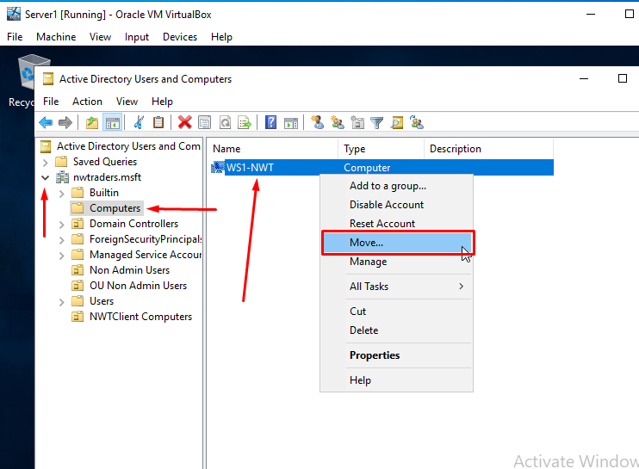
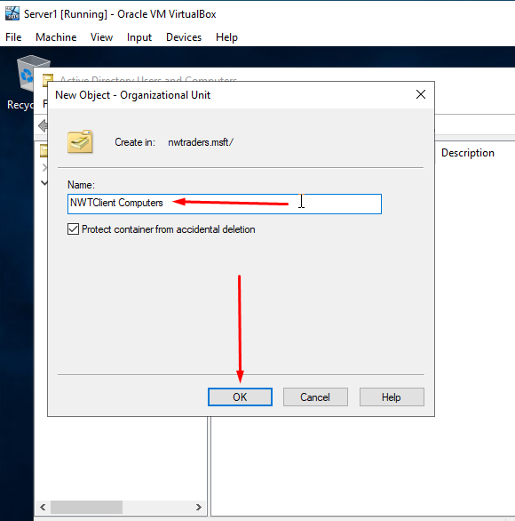

The user will be prompted with a Move windows as the user will need to select NWTClient Computers and click OK. This has shown that the WS1-NWT Computer object has moved in the folder called NWTClient Computers.
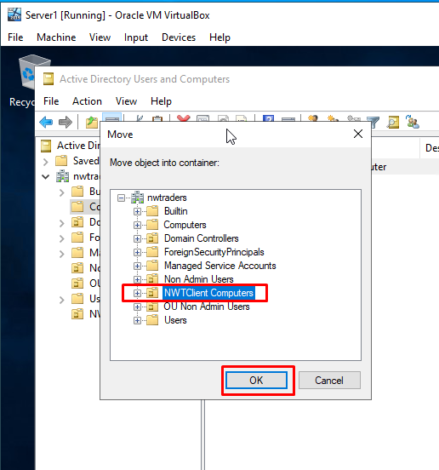
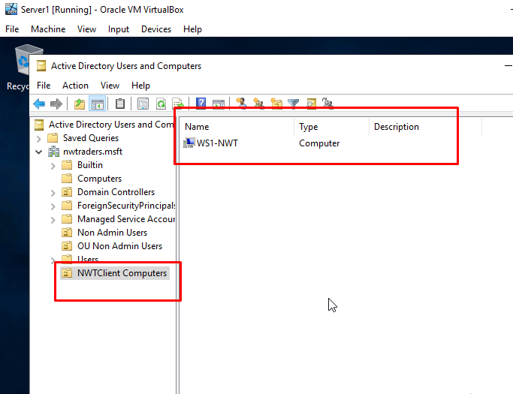
v

Next, the user will need to go on the search bar, type Group Policy Management Console and run the program as the user will be creating another GPO on the Server1 VM. The user will next need to expand the Domains on the left-hand side menu, right click the NWTClient Computers object and click Create a GPO in this domain as the user will be creating another GPO.
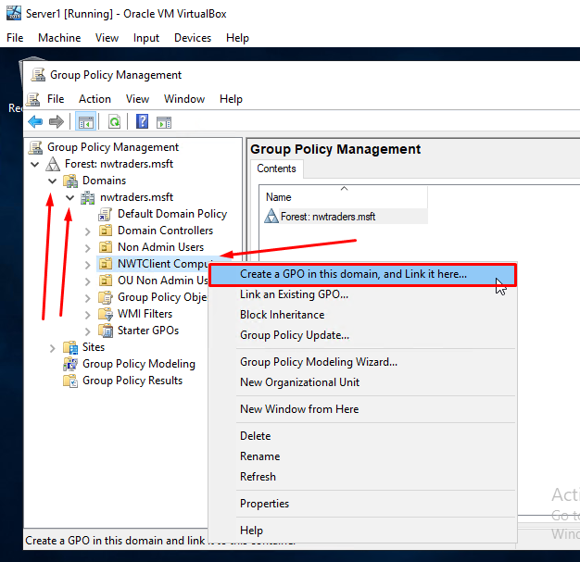

For this task, the user will need to enter NounauthSoftInstallS as the name of the new GPO and click OK. After that, the user will need to expand the NWTClient Computers object, right click the new GPO and select Edit.
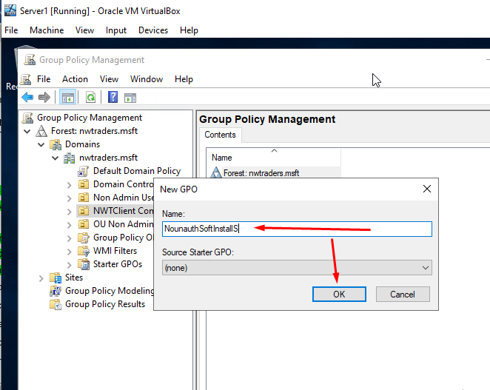
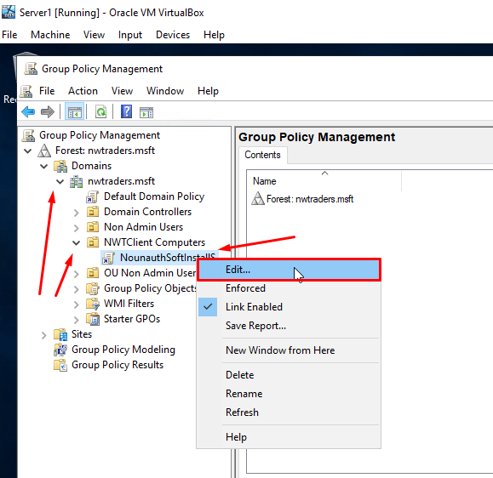

The user will be prompted with a Group Policy Management Editor windows as the user will need to expand the Computer Configuration object on the left-hand side menu, expand the Policies folder, expand the Administrative Templates, expand the Windows Component folder and click Windows Installer. For this task, the user will need to double click on the Prohibit User Install policy as this will open up the properties. The user will need to select the enabled option and click Next Setting.
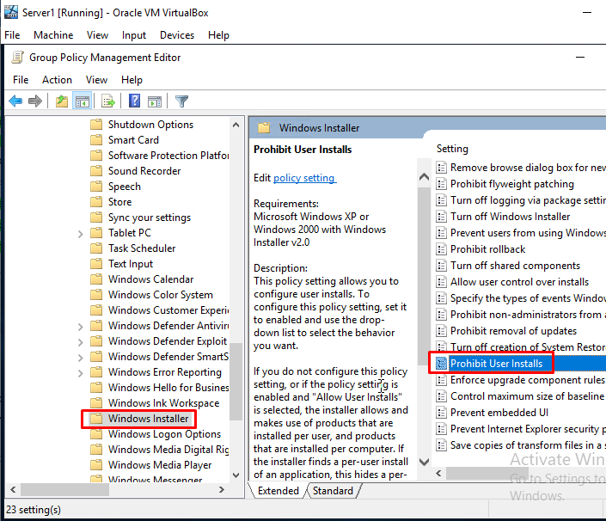
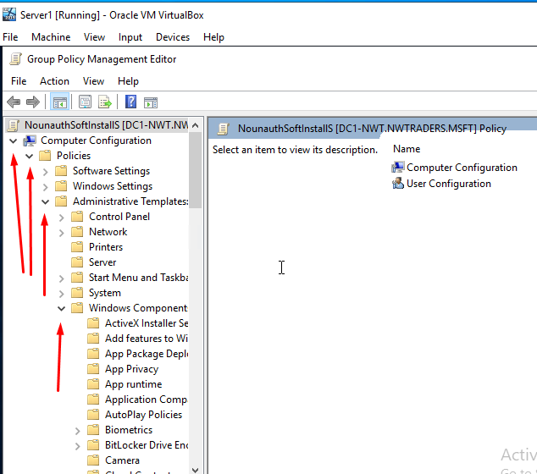

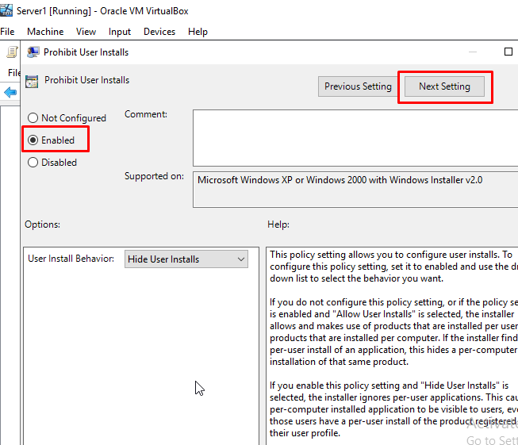

Next, the user will need to run the Command Prompt as an Administrator and enter the command gpupdate /force. This will show that the settings are updating and the user will need test if the non admin user can or cannot install a program.
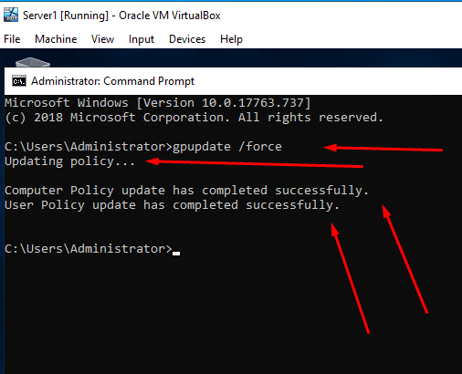

After that, the user will need to log in to the Client 1 VM with the new user account that was created earlier on. For this task, the user will need to enter NWT-NA-SJ as the username and naSJi0s? as the password.

The images below will test if the new user account can install a program on Client 1 VM (which will be the VLC Media Player Installer) and it shows that the user cannot install a program with an error message where the Admin has to login to the PC being shown due to the policies being updated and restrictions been set on the Server1 VM.
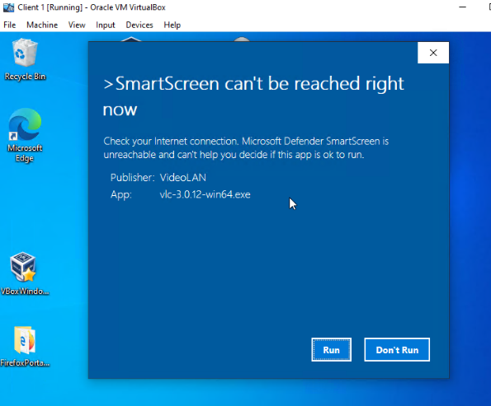
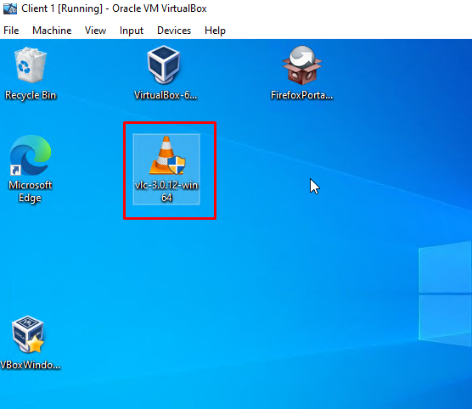

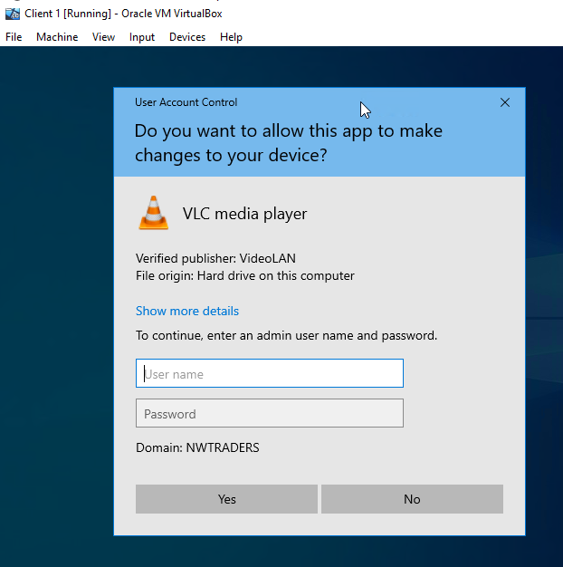

3.5. GPO 5: Password Policy in the ‘nwtraders.msft’ domain – Server1
The user will first need to go on the search bar, type Group Policy Management Console and run the program as the user will be adding a Password Policy on the Server1 VM. The user will next need to expand the Domains object on the left-hand side menu, expand the nwtraders.msft domain, right click Default Domain Policy and click Edit on this object as the user will be creating a Password Policy.
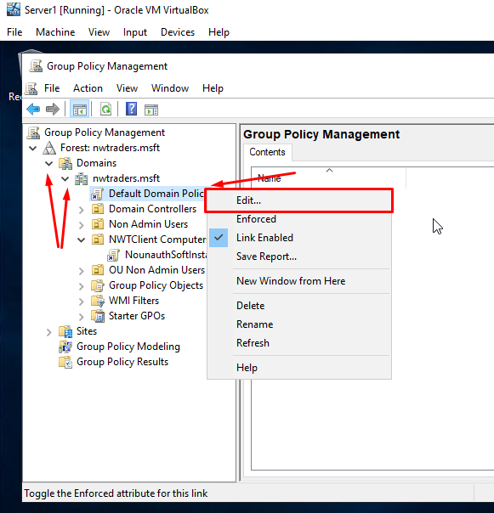

The user will be prompted with a Group Policy Management Editor windows as the user will need to expand the Computer Configuration object on the left-hand side menu, expand the Policies folder, expand the Windows Settings and click Security Settings. For this task, the user will need to double click on the Account Policies policy and double click on Password Policy as this will open up the properties.
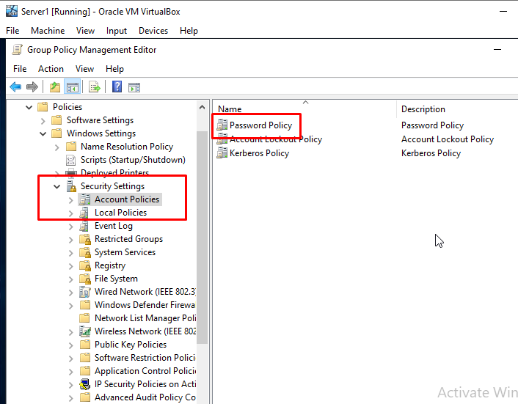
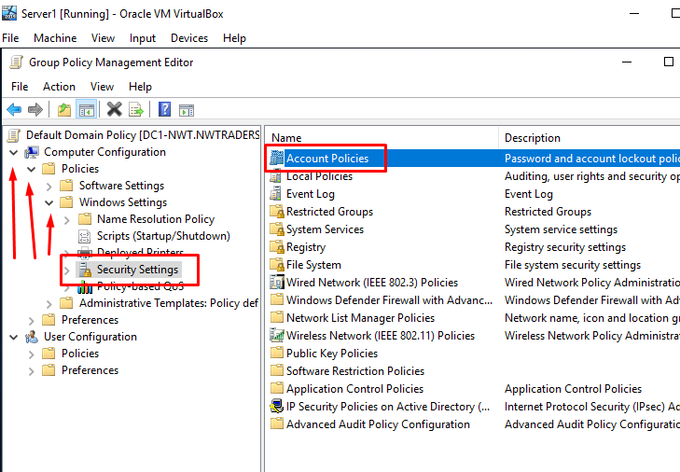

Below will be the policy and its values that the user will need to enter for each policy.
Enforce password history: 8 passwords
Maximum Password Age: 31 days
Minimum Password Age: 1 day
Minimum Password Length: 10 Characters
Passwords must meet complexity Requirements: Enabled
Store Passwords using reversible encryption: Disabled
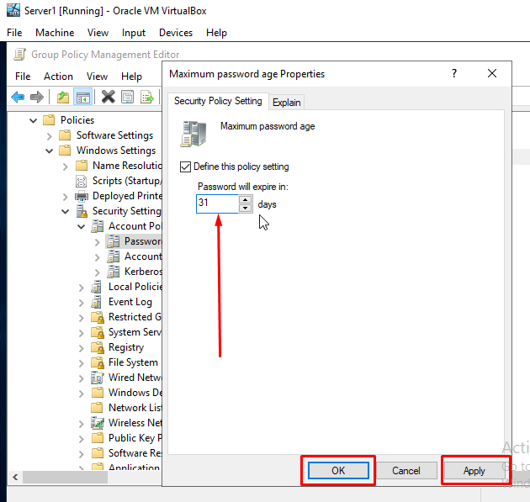
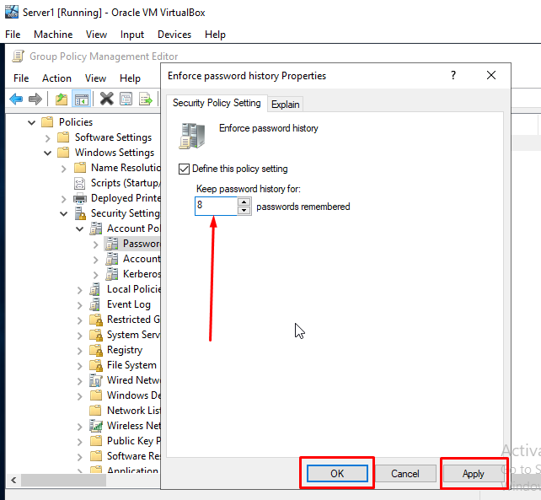

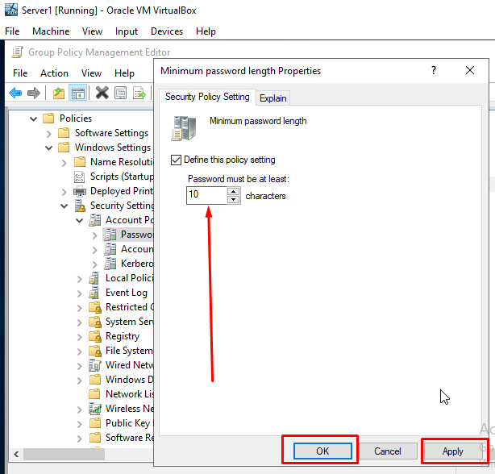
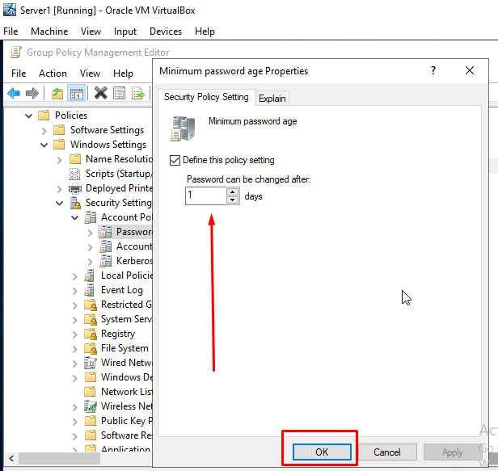

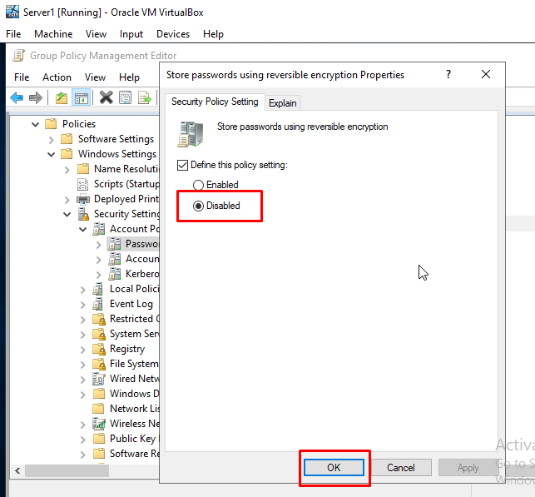
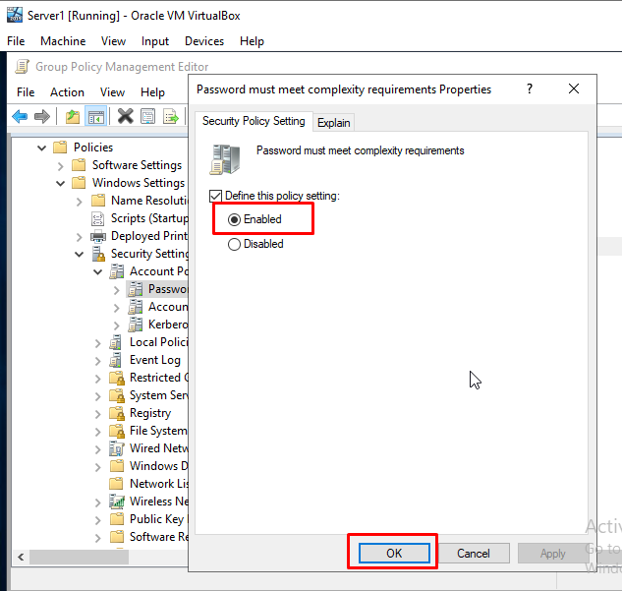

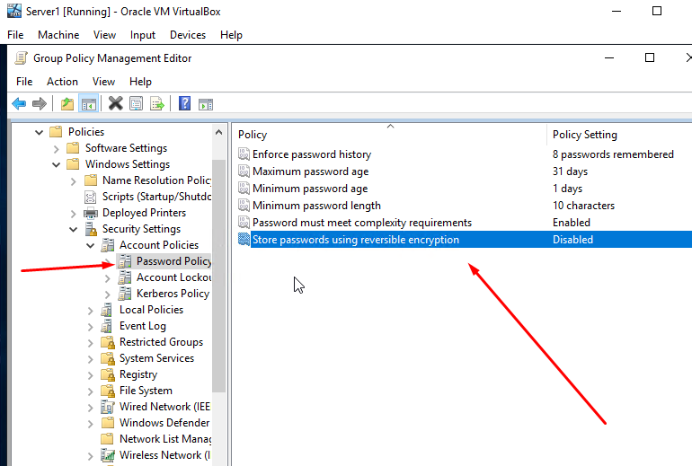

Next, the user will need to run the Command Prompt as an Administrator and enter the command gpupdate /force. This will show that the settings are updating and the user will need test if the new password policies are put into place.
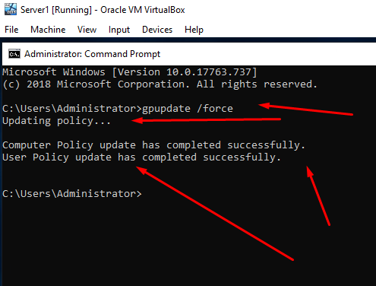

Next, the user will need to create a new user account to test out the new Password Policy. The user will need to open up Active Directory Users and Computers, enter the nwtraders.msft domain, right click the Non Admin Users object, select New and click User as the user will be adding a new user to that specific object on the domain.
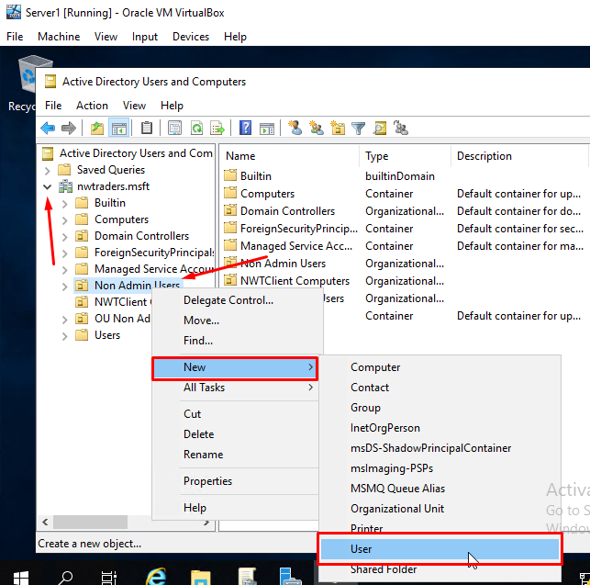
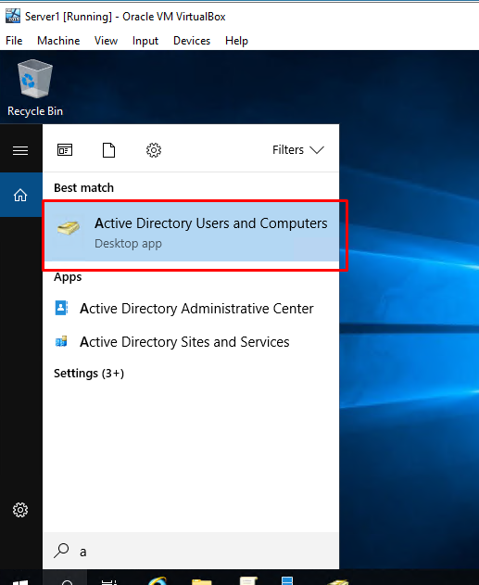

For this task, the user will enter Bill as the first name and Gates as the last name. The User logon name will be NWT-NA-BG and click Next as the NA stands for Non Admin. Then, the user will need to create a password for the new user account but the password must meet the Microsoft’s Minimum complexity requirements. The password for this task will be naBGxb? as this specific password does meet the Microsoft’s Minimum complexity requirements by using lowercase and uppercase letters, special characters and numbers. Also, the user would need to unselect the option User must change password at next logon and select the option Password never expires and click next as the user would be creating a permanent password not a temporary password on the new user account. This would even test what will if the user the password less than 10 characters which was set in the new policy.
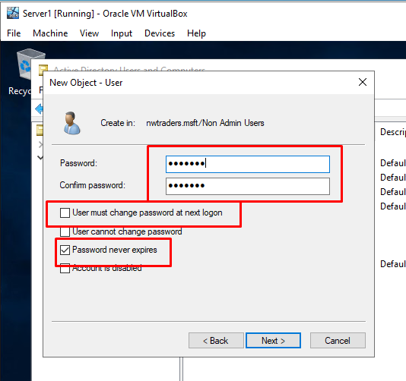
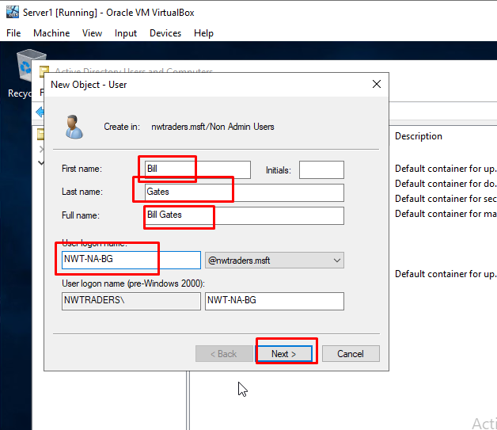

Below will be image showing that the new password policy is working with an error message as the user cannot type a password less than 10 characters. Also, the policy will let the user to change the password less than 31 days and must still use special characters within that password. The new password for this new user account will be naBGmicr0? as this is 10 or more characters for the password.
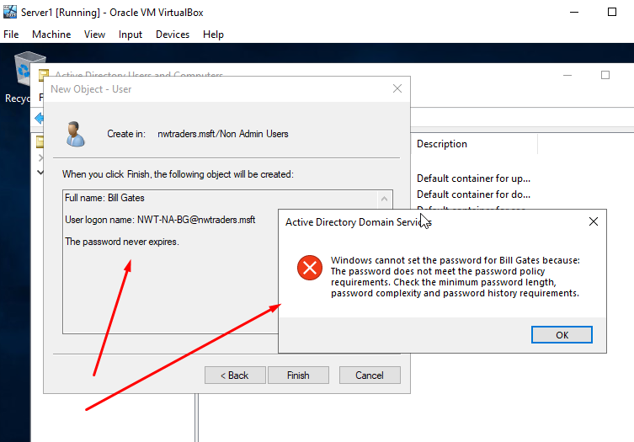

The user will be prompted with a new window showing a summary of the choices that was made during the process of creating a new user account within the Non Admin Users object on the server. Once the user has checked this, click finish and a new user account will be created onto the server.
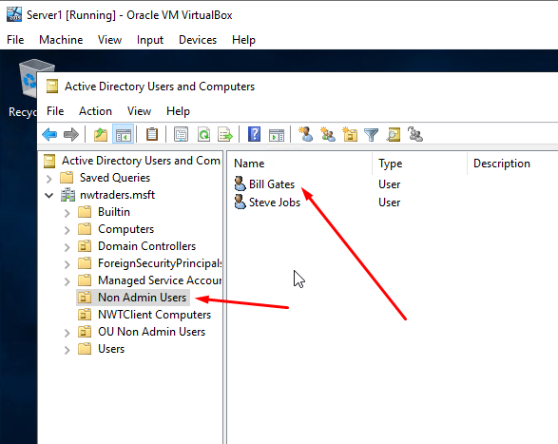
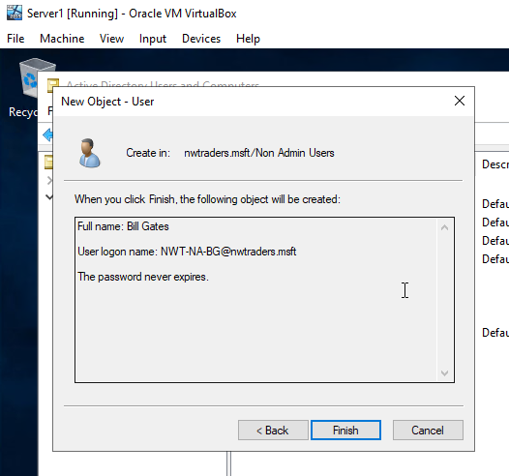

4. Task 3: Observational Tasks
4.1. 3a) Local Permission and File Shares – Differences
Permissions management is one of the most important security principles, since it ensures that appropriate restrictions are set for users, which typically requires understanding the difference between share and NTFS permissions. Share and NTFS permissions work in slightly different ways, but they both have the same objective, to avoid unauthorised entry. [1]
4.1.1. NTFS (New Technology File System)
A file system provides a method of managing a drive that specifies how data is kept on the drive and what kinds of content, like rights and file names, may be connected to files. [1]
The Windows NT operating system uses the NTFS file system for saving and accessing files. Previous to NTFS, Microsoft's older operating systems used the file allocation table (FAT) file system, which was built for small discs and basic folder layouts. The NTFS file system is perhaps safer than FAT and allows bigger file sizes and hard disks. [1]

4.1.2. NTFS Permissions
NTFS permissions are divided into two categories: standard and advanced. The user may build permissions for various elements and set them whether to "deny" or "allow" for each individual user. NTFS permissions could be configured by the user for: [2]
- Full Control - Users can add, modify, transfer, and remove files and folders if this setting is enabled. This also refers to any related file or directory assets. Besides that, users have the ability to modify the privileges for files and folders, allowing them to grant or take away permissions. [2]

- Modify - Users can still access and change files and their resources, but it isn't as effective as full control. They have the ability to add or remove files from a directory, as well as add or remove properties out of a file. [2]

- Read and Execute - Users can view files and run executable files, like programs, as a result of this. They are unable to make changes to files or their properties. [2]

- Read - Just files, their resources, and folders can be accessed or viewed by users. [2]

- Write - Users could only write to files and connect files to directories.
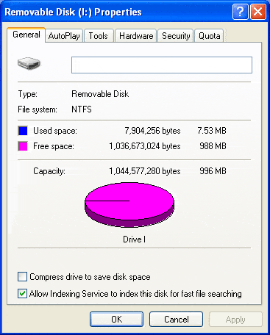
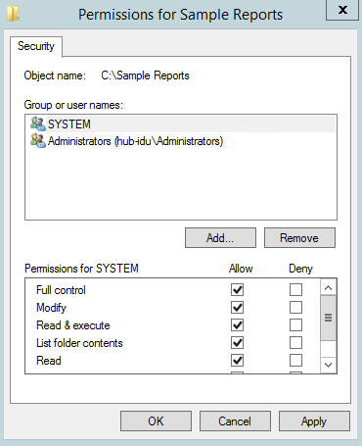
Image [4]
Image [1]
4.1.3. Share Permissions
Share permissions are being used to control who has access to folders that are shared across a network. Share permissions would not work if the user is logged in locally. Share permissions seem to be wider than NTFS permissions, and they can be applied to NTFS, FAT, and FAT32 system files. Share permissions, in general, refer to files and directories, and there are 3 stages of sharing: Full Control, Change, and Read. When a user shares a folder, most of these could be enabled or rejected, and are described as follows: [2]
- Full Control - Users could do anything provided in the read and change categories, as well as change the rights for files and directories, which is the same as the NTFS permissions. By default, all administrators have complete control access. [2]

- Change - Users have all of the read rights, plus the ability to modify data inside files, create new files and folders, and remove files and folders. This authorisation is never granted by default and must be granted on a case-by-case basis. [2]

- Read - This is kind of similar to the NTFS permissions as users could only see the names of files, read the data in them, and run a few applications. [2]
Although share permissions are easier to handle and implement, NTFS permissions enable the user to give other users further good control. Moreover, NTFS permissions only extend to users who have been logged on to the servers locally, while share permissions are available throughout networks. Share permissions seem to be more limited than NTFS permissions since the user can specify the maximum number of connections toward a folder at any particular time. [2]
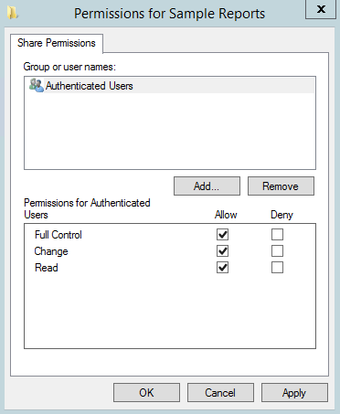

Image [1]

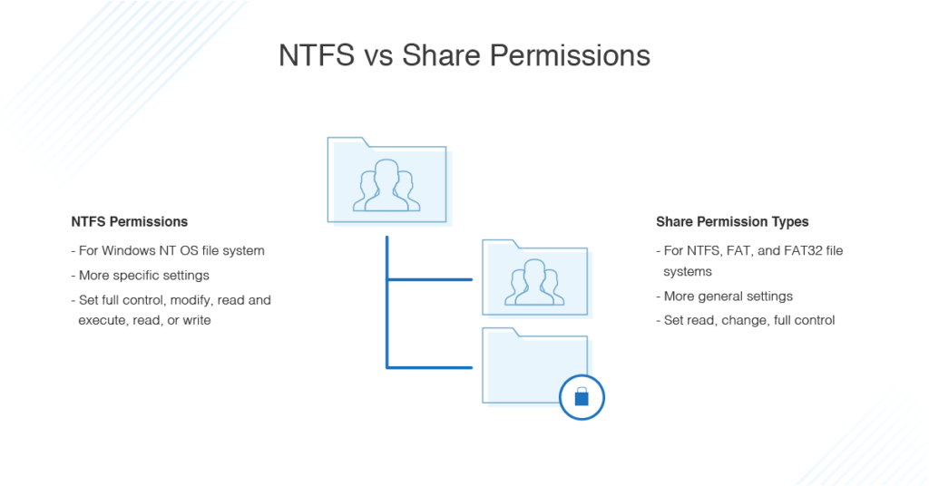
Lastly, making sure the user understands the differences between NTFS and Share Permissions is essential for controlling access to sensitive files, documents, and data. It assists the user in managing user control and access rights in such a way that their IT environment runs smoothly and remains stable.

Image [2]

4.2. 3b) Group Policy Management
Group Policy would be a Windows feature that allows network administrators to monitor the workplace environment of users and device accounts in Active Directory through a range of advanced settings. It effectively gives administrators a standard format to handle and modify operating systems, software, and user preferences. When it is used appropriately, Group Policies will help users improve the protection of their devices and protect against both internal and external threats. [3]
For example, GPOs (Group Policy Objects) will assist users in implementing a specific security policy, in which they only have the permissions they need to do their work. They can do this by removing Local Administrator rights from the network as a whole and granting admin privileges to groups or individuals depending on their positions. Group Policies would be used to improve protection in a range of methods, like removing expired protocols and stopping users from making such changes, among other things. [3]

4.2.1. Group Policy Advantages
- Policy on Passwords - Most companies have weak password policies, and many users' passwords are frequently set to never expire. Passwords which aren't updated on a daily basis, have become too easy, or even use popular names are vulnerable to brute force attacks. GPOs may be used to set specifications for password length, strength, as well as other factors. [3]

- System Administration - GPOs would be used to automate tasks which are at best difficult and at worst highly time-consuming. Through using GPOs to implement a centralised, universal system to new users and devices entering their domain, the user could save hours and hours of time setting up the system for these users and devices. [3]

- Analysing The Health - GPOs would be used to deliver software upgrades and device improvements, ensuring that the user interface is safe and secure against the current security risks. [3]

GPOs aren't sensitive to cyber threats, either. Without the need of a Group Policy monitoring and reporting management solution, it will be very hard to identify an intruder changing local GPOs on a device in order to travel outwards throughout the network. [3]
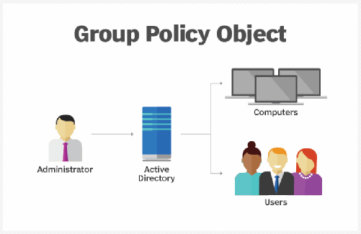

Image [6]
4.3. 3c) Good Password Principles
IT protection for important digital content is just as safe as user account keys. Although the significance of a strong password configuration cannot be underestimated, the basics are simple. These include: [4]
- Passwords being unique - Passwords should never be reused, and only one password should not be used for different accounts. This decreases the chances of a hack at one account exposing access to the other. For many months, Facebook, for instance, saved tens of millions of user passwords in text format. The strongest password in the world was weak in this situation, not because of how it was created, but it was just so quickly available for a variety of users or organisations. [4]

- Passwords should not be easy to guess - Hackers have large tools and assets to unlock almost every password. They also have access to a wide range of stolen account files, which they use to create a list of popular passwords. Attackers will not have to waste any time trying to guess or unlock passwords. They may purchase them for £45. As a result, even the best passwords could be purchased or guessed by attackers. [4]

- Passwords should be difficult to remember - The length, strength, and uniqueness of a password have a direct relationship with the difficulty of unlocking it. As a result, strong passwords should really be greater than 8 characters and include a good combination of upper- and lower-case letters, digits, and special characters like @ % $ # ! ?. Because of the length and complexity of certain passwords, they are difficult to remember, which would be good for protection but difficult for a user to manage. [4]

- Passwords must be kept safe and secure - We suggest using a strong password manager as it's hard for a user to keep track of too many unique and complicated passwords. A good password manager will: [4]

- Produce a unique and important password. It fulfils this by enabling users to follow the site's rules concerning password length, special characters accepted, and letter-number combinations. [4]

- Keeps track of long passwords. The passwords remain saved in an encrypted file which can be shared and accessed across multiple devices by the same person. A unique password can be used to log into an account on a smartphone, tablet, or computer. [4]

- Passwords should be password-protected - Multi-factor Authentication (MFA) adds an extra layer of protection to passwords, making it harder to access accounts wrongfully. Even if a user has the right password, MFA prevents them from accessing the account until they have a second form of identification. It's really the alternative of a password for the password. While most banks have indeed done, almost any organisation can enforce MFA on their users’ accounts. Users are used to getting a text message to confirm account password changes or access. For example, enterprise users begin authenticating to enterprise networks using a well-known digital authentication app like Microsoft Authenticator. [4]
These would be the specifications for keeping good private data protection. Personal and business resources can be protected if these guidelines are followed. In reality, no system is secure without this structure. [4]
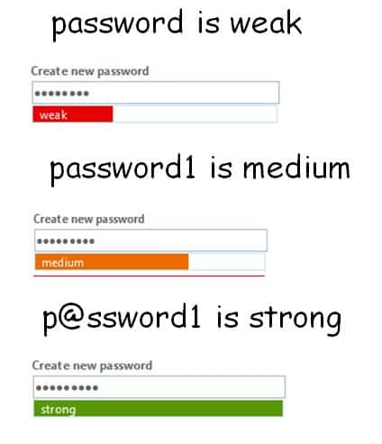

Image [8]

5. References

References

[1] | C. NG, "NTFS Permissions vs Share: Everything You Need to Know," 8 April 2021. [Online]. Available: https://www.varonis.com/blog/ntfs-permissions-vs-share/. [Accessed 30 April 2021].
[2] | dnsstuff, "NTFS vs. Share Permissions," 3 April 2020. [Online]. Available: https://www.dnsstuff.com/ntfs-vs-share-permissions. [Accessed 30 April 2021].
[3] | J. Coggins, "What is Group Policy (GPO) and What Role Does It Play in Data Security," 26 March 2021. [Online]. Available: https://www.lepide.com/blog/what-is-group-policy-gpo-and-what-role-does-it-play-in-data-security/#:~:text=Group%20Policy%20is%20a%20feature,computer%20accounts%20in%20Active%20Directory.. [Accessed 30 April 2021].
[4] | PETERSASSOCIATES, "Five Core Principles of Password Security," 15 August 2019. [Online]. Available: https://www.peters.com/blog/password-security/. [Accessed 30 April 2021].
[5] | L. HILTECH Data Solutions, "System / Network Engineering Services," N/A N/A N/A. [Online]. Available: https://www.hiltech-cs.com/System-and-Network-Engineering-Services/. [Accessed 30 April 2021].
[6] | Editor, "NTFS File System," N/A N/A N/A. [Online]. Available: https://networkencyclopedia.com/ntfs-file-system/. [Accessed 30 April 2021].
[7] | L. Rosencrance, "Group Policy Object (GPO)," N/A September 2019. [Online]. Available: https://searchwindowsserver.techtarget.com/definition/Group-Policy-Object. [Accessed 30 April 2021].
[8] | N/A, "How to create a good strong password," N/A N/A N/A. [Online]. Available: https://www.illit.co.uk/self-help/howto/how-to-create-a-good-strong-password-and-why-it-is-important/. [Accessed 30 April 2021].

