University of Wales Trinity Saint David

School of Engineering

Evaluating Engine Characteristics and Performance using Dynamometer Testing

Filip Stepanovsky
2116622
BA Automotive and Transport Design
10/12/21
ACHA4004 Vehicle Technology

Contents

Introduction

Test Overview

Results

Data Tables

Conclusion

Evaluation

Introduction
The tests outlined in the report were carried out to demonstrate the performance and engine characteristics of a Honda Civic 1.6 D16 2003 engine using a stationary dynamometer. The results are presented, discussed and evaluated below.
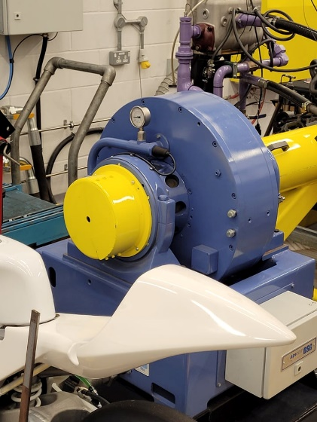
Equipment
- Dynamometer
  - A dynamometer is device that measures torque and rotations per minute (RPM) of an engine simultaneously. The most common type of dyno works by creating resistance against the driveshaft of the engine using electromagnets. This resistance in turn puts stress on the Dynamometer housing making it warp. The attached strain gauge records the housing deformation and records it as force exerted (N) [1] (Wikipedia, 2013)

- Dynamometer software
  - The dyno software allows for specific tests to be set up and carried out based on customisable parameters. It then allows for the results to be recorded and used.
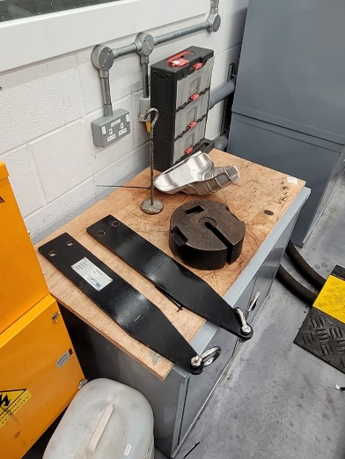

- Torque arm
  - The torque arm is a piece of steel that attaches to the dyno housing. It allows for weight to be hung off it to calibrate the dynamometer.

- Weight
  - A 20kg weight used for dyno calibration.

Test Overview
- Dynamometer calibration
  - Before the dynamometer could carry out the test, it needed to be calibrated correctly. We started by attaching the torque arms to the dyno housing and hanging a 20kg weight from the torque arms. The torque arm and the weight allowed us to calibrate the strain gauge by calculating the expected force exerted on it then comparing it to the recorded strain gauge result. The calculation was simple, we just multiplied the weight by the length from the centre of the dyno to the point where the weight was hanging.
- Sweep Testing
  - We conducted a sweep test on the Honda engine. A sweep test entails taking the engine through a pre-determined RPM range, keeping the dyno resistance constant and recording the force exerted on the dyno housing. Our RPM range was 1000 rpm- 5500 rpm and readings were taken every 50 rpm. This allowed us to have a good amount of data points to ensure our results were accurate, we could effectively evaluate the torque vs engine speed.

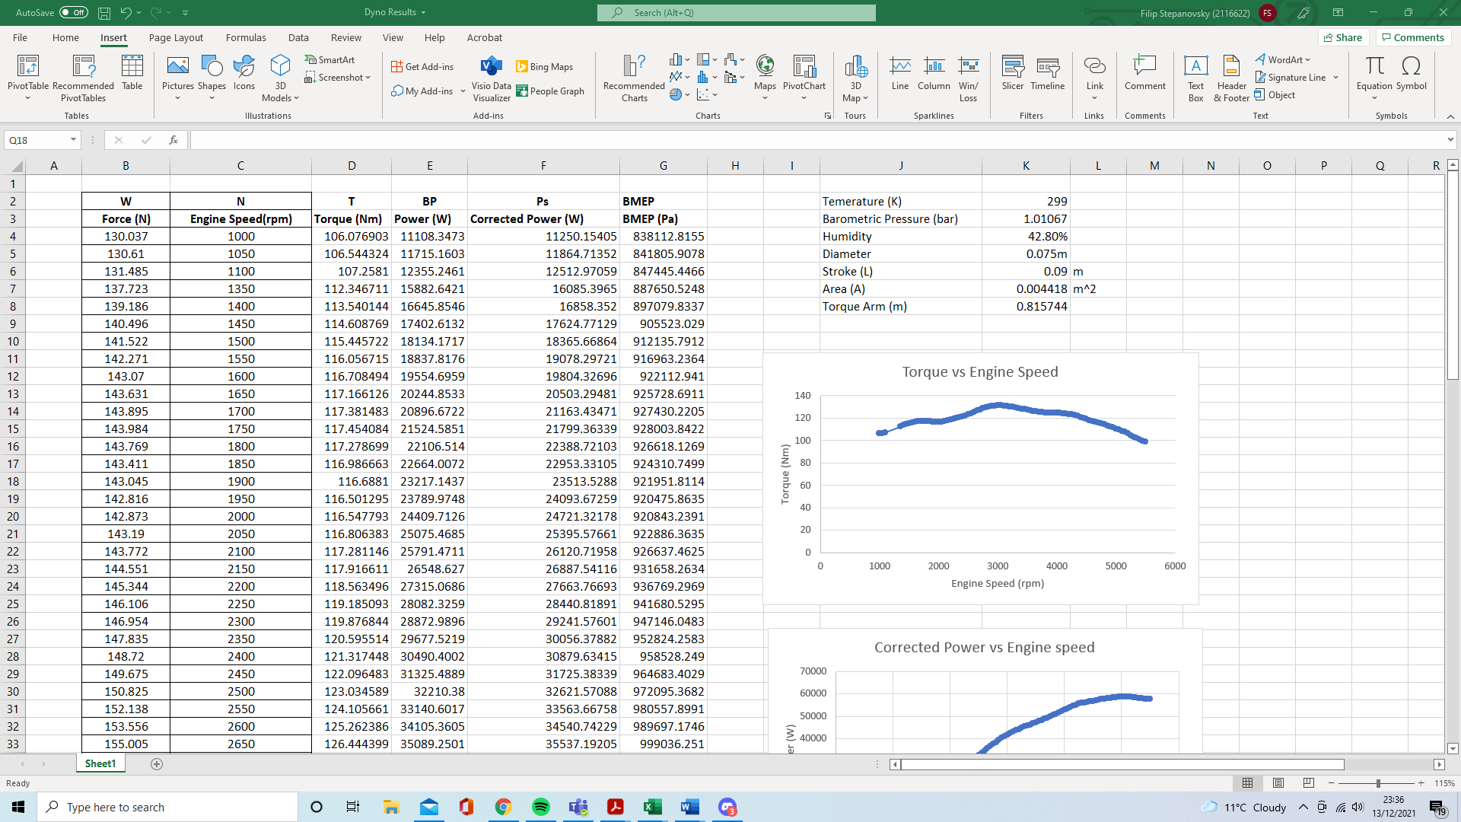
Results
The screenshots show my data table and my constants table

- Torque
  - Our results gave us the force exerted onto housing, measured in newtons (N), and the Engine speed (recorded in RPM). I went on to work out the torque by using the equation below.

    - $T=WR$
- Power
  - Once we had calculated the torque, I could calculate the power of the engine using the equation below
    - $BP=\frac{2πNT}{60}$

- Corrected Power
  - The previous calculation then allowed me to calculate the corrected power based on temperature and pressure of the testing day. I calculated the corrected power using the equation below
    - $\frac{P_{s}}{BP}=\frac{1.01325}{p_{a}}\sqrt{\frac{T_{a}}{293}}$

- Break Mean Effective Pressure (BMEP)
  - My final calculation was the BMEP of the engine. To do this I first had to calculate the piston area by using Equation (i). Then use the results to calculate BMEP using equation (ii).
    - Equation (i):
$$A=\frac{πd^{2}}{4}$$
    - Equation (ii):
$$BP=\frac{B.M.E.P ×L×A×N×n}{60×2}$$

Data Tables
- Torque vs Engine speed
As shown in the graph below, the torque peaks and then starts to decrease even though the RPM keeps increasing. This happens due the decline of both volumetric and mechanical efficiency. At around 3000 RPM the engine is intaking the optimum amount of oxygen and fuel, which therefore results in higher torque values. However, as the RPM increases the engine has less time to intake oxygen and fuel, reducing the amount of oxygen and fuel in the valve and therefore reducing the efficiency of combustion. In addition, at higher RPM the piston produces an increased amount of friction, which decreases the overall mechanical efficiency of the engine, resulting in lowered RPM [2] (Hiran Hasaranga, 2021)

Power vs Engine Speed
  - Power is the rate at which work is carried out. Therefore, the higher the RPM, the higher rate at which work can be carried out. This can clearly be seen on the graph. The line however starts to level out at the highest rpm due to the decrease in torque values as the engine gets less efficient at higher RPM [3] (Ihmusedcars, 2016)

- Conclusion
  - In conclusion, from the results we can clearly see that the Honda Civic 1.6 D16 2003 is a great all-round engine. It produces high torque relative to engine speed meaning that the driving experience and performance should be consistent throughout the RPM ranges. The engine’s torque range, 98 Nm to 130 Nm, shows that the manufacturer did a good job to minimise the energy losses much as possible.

- Evaluation
  - In my opinion I think the test was carried out well and to a high standard. We ensured that the dynamometer was properly calibrated before starting the test to ensure accurate data. To support this, we used many data points to allow us to effectively see both the torque and Power curve trends. This allowed me to effectively evaluate the engine’s characteristic and performance. We considered variables such as the pressure and temperature on the day of testing, to allow us to get even more accurate power readings, which resulted in even more accurate data. The recorded results were all highly precise, which meant we minimised the risk of making an error during calculations. To improve we could run the test multiple times to allow us to take averages of all the results and I think we could’ve spent more time learning about the dynamometer in more depth.

References

- [1] Wikipedia (2013) Dynamometer. Available at: https://en.wikipedia.org/wiki/Dynamometer
- [2] Hiran Hasaranga (2021) Why is torque decreasing as RPM increases? Available at: https://www.quora.com/Why-is-torque-decreasing-as-RPM-increases
- [3] Ihmusedcars (2016) what matters more, Torque or Horsepower? Available at: https://www.lhmusedcars.com/what-matters-more-torque-or-horsepower/

