1/14/2019
M6X02269 | Mark Fall
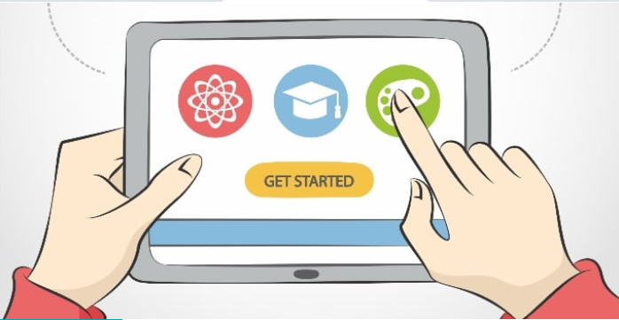
UWTSD | Principles of Teaching, Learning and Emergent Technologies (PTLET).

Contents
- Introduction 3
- Descriptive Procedure for Micro-teach Session 4
- Personal Feelings during the Task 6
- Evaluation of the Session 7
- Analysing the Situation 8
- Conclusions 8
- Action Plan for Future Enhancement 9
- References and Bibliography 10
- Appendix 11
Presentation slide examples 11
Reminder cards 13

Introduction
The deliverables of the assignment “Principles of Teaching, Learning and Emergent Technologies (PTLET)” are comprised of the following, with references to UKPSF ( ) criteria met as required:
- Plan and design a blended learning 30-minute micro-teaching lesson utilising emergent technologies (A1).
- Deliver the micro-teaching lesson to a group of peers (A2).
- Following completion of the micro-teaching session, reflect on and critically evaluate the experience.
This reflective evaluation satisfies the requirements of ‘3.’ listed above. This report follows Gibbs reflective cycle model as described in, Learning by Doing: A guide to teaching and learning methods (Gibbs, 1998) (p50).
Consisting of six specific criteria, which when followed are designed to enhance the user’s ability to evaluate and enhance teaching outcomes.
The six criteria followed on completion of a task begin with
- A description of the task in hand, outlining the procedures and preparation.
- Your personal feelings at the time and how they affected the teaching experience and outcomes
- Evaluation of the task including your experience of the process.
- Analysing which actions enhanced or detracted from the deliverables of the task.
- A conclusion process in order to acknowledge what issues need addressing and which were successful.
- Finally collating an action plan based upon the previous five steps in order to accomplish enhanced the outcomes of future tasks.


Descriptive Procedure for Micro-teach Session
The task of the Micro-teach session was delivered to ten peers from my PCET class on the 14th December 2018 at the library buildings SA1 UWTSD. I decided to use the Otto combustion cycle as the core subject due to its relatively simple process. As a Motorcycle engineer (BEng Hons) (K1). I considered that although the group was diverse in age and knowledge they were predominantly not of an engineering background (K2). I felt that as well as being confident in presenting the information within the timeframe, any increase in complexity would ‘lose’ the attention of the learners. The thinking of over complicating is ‘a common mistake made by teachers’ (Gibbs, 1998) (p116).
The target audience was however a mix of ethnicity and whilst all were fluent in English I was unaware of any reading or learning difficulty issues. I designed he presentation to be diverse in its media and with bold images and fonts tailored to be easily readable. The font for the presentation should be clear and uniform in order that to someone with for example dyslexia, to have no issues with understanding. The BDA (British Dyslexia Association) recommend a variety of font such as ‘Arial’ to provide enhanced readability and understanding (BDA, 2015.) (V1, V2).
In selecting the media I chose Microsoft Power-point media for the main body of the presentation. I was nervous about utilising purely online media for the main body as I regularly witness problems with access to this media due to technology failure or a simple forgetting of passwords. My presentation had embedded GIF (graphics interchange format or short, looped animated pictures) images within the slides in order to animate the processes described.
As well as the above, an online quiz at Kahoot link (crtl+click on link) (K4) was set up with a link embedded within Power Point to have an interactive competition style element using emergent technologies to reinforce and evaluate the micro teach session(K5). Kahoot ‘links in’ users to the online quiz via the internet via the individual’s device to take part. Although the user’s scores are displayed, their anonymity is preserved by the use of pseudonyms. This encourages users whom do not feel knowledgeable or are afraid of ridicule to take part. Reminder card packs of the individual processes and cycle descriptors were also prepared to enhance the Kahoot quiz or as a backup quiz if technology failed. Images of Power Point and card packs are included in Appendices section of this report.

The timings were roughly set to;
- 5 mins introductions
- 15 mins main body
- 10 mins questions including online quiz with image cards
I set up the computer and introduced myself and subject. During the introduction I gave a brief overview of the subject, pointing out that all present relied upon this technology in their vehicles, i.e. the combustion engine. Having secured the students attention I enquired if any students had any technological knowledge of the Otto combustion cycle. This enabled me to tailor any depth of teaching to the knowledge base within the group. As there was very little prior knowledge within the group I was happy to progress with the original depth of complexity.
First stage of the presentation began with a short history of the processes patented by ‘Nicholas Otto’, pointing out that the basic idea and why, behind all our transport, has been virtually unchanged in nearly two centuries.
Next I proceeded onto the cycle processes and to keep the group focused I introduced the cycles in slang terms i.e. Suck Squeeze Bang Blow. I followed this by gradually moved onto basic technical terms with the aid of the animated slides. This was accompanied by explanation of the requirements of each cycle, pointing out aspects of the process. Combining the cycles lead to various explanations for design issues (single cylinder) and remedies (multiple cylinders).
I used the combination of slides and explanation to present this teacher led element whilst keeping the learner engaged.
I opened up the floor for questions prior to the online quiz and was surprised to find that out of the ten peers present, eight raised their hands with questions (nine questions in all). The questions ranged from clarifying aspects of the cycle to alternative engine design and fuel. However although I had sparked a genuine interest in the subject, the time taken for the questions led to the expiry of time given for the presentation.
The final presentation section of the evaluation quiz and card reminders could not take place.

.

Personal Feelings during the Task
On the evening of the micro teaching sessions I was very nervous about standing in front of my peers and presenting, concerns that it would go as planned. I was however confident in the content from a technical aspect but questioned my ability to engage with the audience and deliver to a coherent session which would engage and inspire the learner to think on the subject. I was fourth to present which had both negative and positive influences on my confidence. On a positive note, I felt that I had enough quality and content within my presentation. I also had time to witness technical difficulties encountered by previous presenters including passwords, internet links and software issues. I was confident that I had a ‘backup plan’ for the evaluation stage.
On commencement of my micro-teach, having set up with no issues, I made my introductions and began the narrative by asking the group about any previous knowledge of the subject to which there was very little. This made me more at ease moving forward as I felt that I had judged the technical level correctly.
The first stage of a brief history kept within the timing schedule and recognised that I seemed to have most of the group’s attention. So far so good. Moving onto the body of the presentation I began with the slang terms and my confidence was boosted by the group’s positive reaction. I had to keep in mind that over confidence, or under confidence for that matter, can lead to a ‘wandering off’ of the planned progression of the presentation and in doing so lose the focus of the learner.
“We herald self-confidence as the answer to all our ills but too often self-confidence derives from ignorance rather than knowledge. We mistake confidence for loud bluster” (Quigley, 2016) (p226).
From the opposite end of this scale i.e. lack of confidence or low self-esteem;
“We know that too little confidence can prove damaging. Weakness stresses it is too easy to lose our confidence. When our confidence is low our teaching can unravel. A vicious cycle can ensue” (Quigley, 2016) (p248).
With this in mind I continued through to the final stages of questions and quiz. When faced by the number of questions I was very pleased by the interest I had inspired and used my knowledge base to answer correctly and I feel coherently. I was however surprised to find that my time had expired which led me to question my planning structure.

Evaluation of the Session
After sitting down at the conclusion of my presentation I was deflated and felt concerned about the fact that the task was incomplete. I was happy with the choices that I had made in choosing which emergent technologies to use. An overall a mix of media embedded within Power Point software such as animated images and link to online media software, backed up with thought out and practiced presentation kept the learners focus.
I deliberately kept the mix of embedded and linked media separate in order to keep the learners focus, with the main body of the presentation using embedded media and linked media at the evaluation stage. The switching of media sources regularly during a presentation runs the risk of losing the learners focus because of the pauses that have to be implemented during the switch.
“When you integrate that content, it’s important to think carefully about how to integrate it most effectively to avoid derailing the flow of your students’ learning.” (Pacansky-Brock, 2013) (p30).
This pre-planning of the structure worked well during the presentation phase and I believe that the following evaluation would have been equally successful. Although my Kahoot quiz was not implemented, the reactions to the technology for other presenters use were very positive.
On reflection, despite the timing issue, I was pleased with the overall outcome of my presentation. My confidence issues at the beginning were dispelled as the presentation progressed, with the group seemingly very interested in, which was to them, a new subject. I believe this was proven by the number of questions and interest from the group.

Analysing the Situation
The environment I was to deliver the micro-teach was unusual in that it is normal for me to instruct in a workshop or practical situation. A classroom of peers and having to formalise my teaching practice was new to myself. In planning to do so I endeavoured to learn new strategies and amalgamate my usual teaching practice in order to engage with the learners positively. Basing the lesson plan on UKPSF guidelines enabled me to structure the presentation with the goal of engaging the learner, spark an interest and changing the perspective to the subject, whist accounting for a variety of learner’s prior knowledge as well as catering for any learning issues within the group.
Initially I was unsure that emergent technology would be relevant to my subject, but once the planning process had begun, investigations into the numerous possibilities provided me with an insight as to the opportunities available.
As this was my first attempt at a micro-teach I opted for software that I was familiar with i.e. PowerPoint and by utilizing adding embedded and linked media fulfilled the criteria of the assignment. Alternative presentation software such as Prezi®. Sway® or Nearpod® offer a variety of used friendly interfaces which would be attuned to the presentation of the subject.

Conclusions
The use of emerging technologies in the modern teaching environment will me more and more influential in gaining enhanced learning outcomes. Blended learning, combining the use of technical enhancement as an aid to learning along with traditional practices, is being adopted in the school environment with online media such as search engines and blogs contributing to the gathering of knowledge. This gives the internet a role apart from social media, gaming or other non-learning activities.
“This change in perception of the internet has resulted in virtual learning environments becoming more widely used. These can be used as repositories for learning activities, or as repositories to which pupils can upload their work for teachers to evaluate, or as an interactive discussion site where pupils may upload podcasts, video blogs, images and generally engage with learning objectives.” (Conole, 2007)
As future teachers, we must embrace the emerging technologies if the needs and expectations of future learners are to be met.
Overall I feel that I had achieved the task in hand and tentatively embraced emerging technology. Due to this first assignment process the knowledge of possibilities opened up to me have increased.

Action Plan for Future Enhancement
The issue with the question session and online element would have been more productive and achievable if they were switched in order. Being presented first, the Kahoot quiz and the reminder cards would have left time for answers later with perhaps a number of the questions being already answered. A question and answer session would be less detrimental to the overall outcome if it were curtailed through timing.
An area of the presentation which I felt that I failed in, was the inability to curb the questions in order to fulfil the evaluation element. In this area the goal is to learn strategies that will enhance my ability to control the flow of the lesson in order that the outcomes of the session are achieved. This however is a lesson also learned through experience and the ability to recognise the lessons learnt through such experience.
Moving forward for future sessions, exploration of emerging technologies are to be investigated and utilised in order to enhance traditional teaching methods. This will result in an increase of success for learning outcome objectives.

References and Bibliography
BDA, 2015.. B.D.A. New Technologies Committee.. [Online]
Available at: https://bdanewtechnologies.files.wordpress.com/2011/03/typefaces6.pdf
[Accessed Dec 2018].
Conole, G. F. L. a. H., 2007. Designing for Learning: Contemporary perpectives in e-learning research. London: RoutledgeFalmer.
Crawley, J., 2011. In at the Deep End. Second ed. Oxford: Roultledge.
Denby, N., 2008. Training to Teach. Third ed. London: SAGE.
Gibbs, G., 1998. Learning by Doing: A Guide to Teaching and Learning Methods. Oxford Polytechnic: Oxford: FEU, 1988.
Pacansky-Brock, M., 2013. Best Practice for Teaching with Emerging Technologies. New York: Routledge.
Quigley, A., 2016. The Confident Teacher: Developing the Habits, Characteristics and Pedagogy for Success. s.l.:Routledge.

Cover image; https://edtechnology.co.uk/Blog/edtech-2018-17-emerging-trends/

Appendix

Presentation slide examples
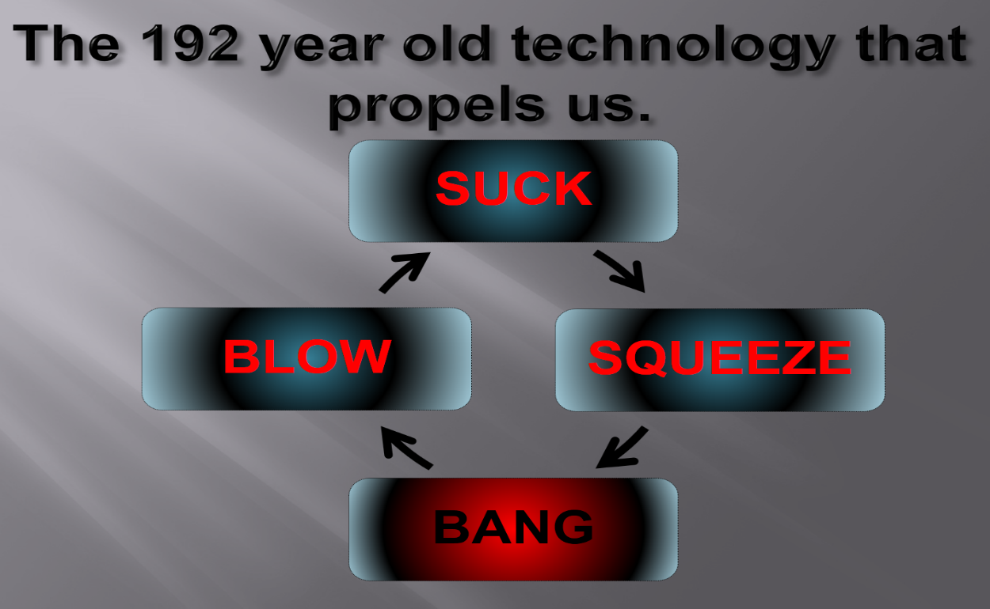
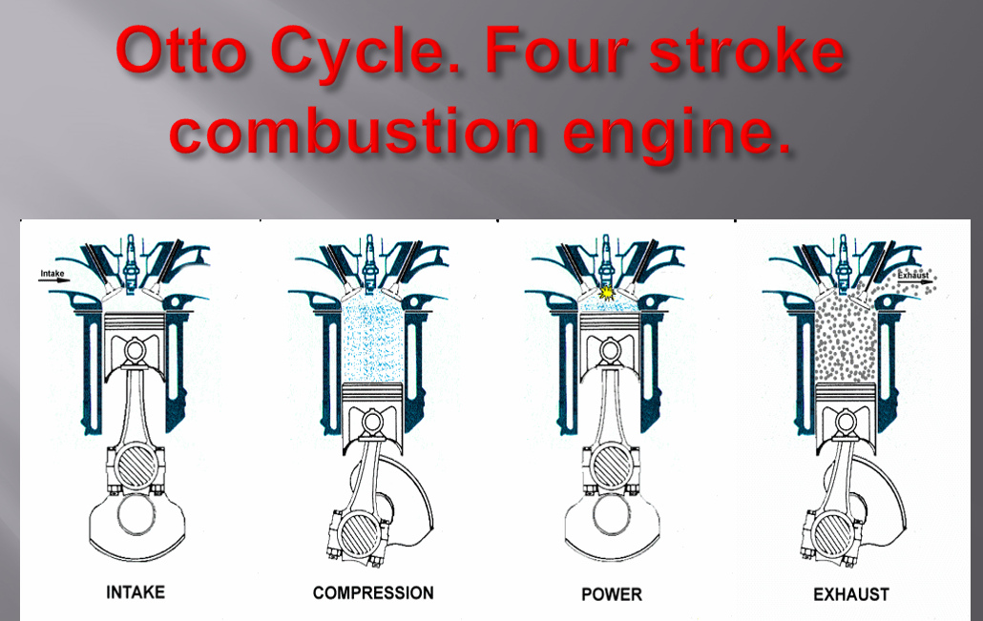
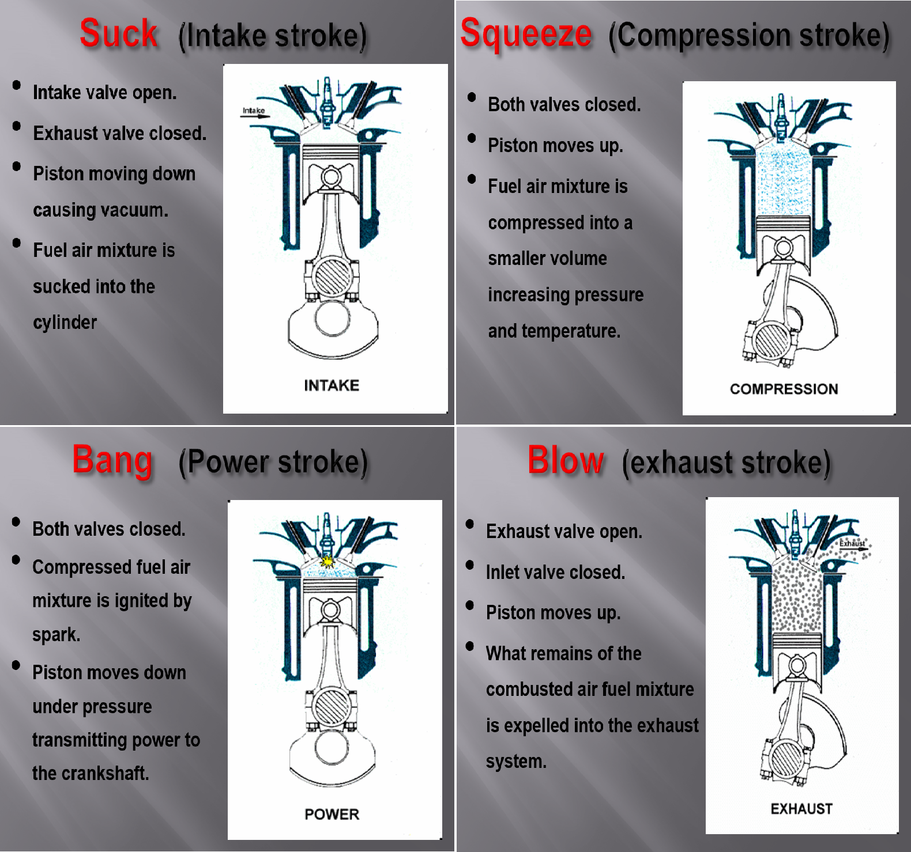

Reminder cards


