Introduction to Physiology
BHMP5003
Rachael Rivers
Individual Academic Poster Presentation
Kemiica Prince
1915210

Anatomy of the Heart

Pulmonary artery
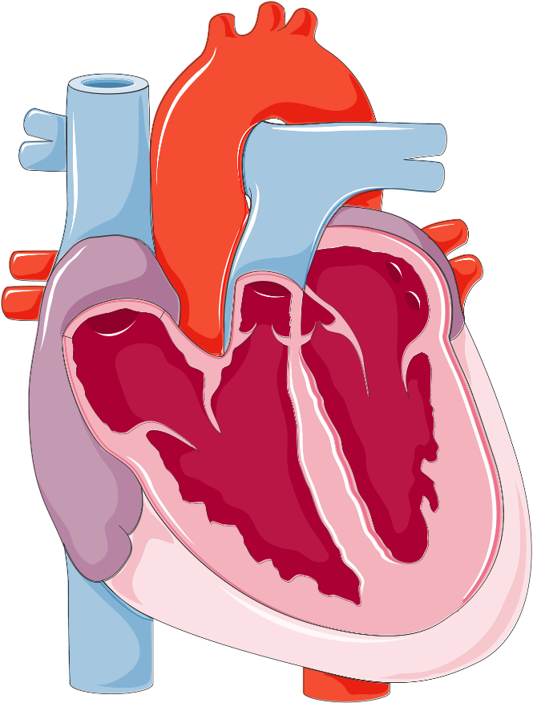
Blood flow
Pulmonary artery
Inferior vena cava
Left ventricle
Aortic valve
Pulmonary veins
Left atrium
Mitral valve
Tricuspid valve
Pulmonary valve
Superior vena cava

Pulmonary veins
Aorta
Right atrium
Right ventricle
Septum
(Anatomy tool, 2023)

The heart is the primary component of the circulatory system helping blood to pump around the body; it is a muscle providing the body with oxygen and nutrients to ensure other organs and muscles work properly and carries away unwanted waste and carbon dioxide. The structure of the heart is made up of three layers of tissue; epicardium, myocardium and the endocardium. A thinner layer called the pericardium is there to protect the heart (NHS Inform, 2022). It is situated in the middle and front of the chest, behind and slightly to the left of the sternum. The heart involves:
- 4 valves (tricuspid, pulmonary, mitral and aortic)
- 3 entrances
- 2 exits
- 2 ventricles
- 2 atriums
- 1 electrical system (Rivers, 2023).
The blood enters the heart through the superior and inferior vena cava, filling up the right side of the heart known as the right atrium and right ventricle as deoxygenated blood. It will pass through the pulmonary artery out into the lungs where the exchange of gases occurs, providing a supply of oxygenated blood to return through the pulmonary veins and into the left side known as the left atrium and left ventricle. It then travels into the aortic artery, sending the fresh supply of blood out to the rest of the body. To prevent the blood from backflowing, it travels in one direction which is controlled by the heart valves (tricuspid, pulmonary, mitral and aortic valve) that opens and closes with every heartbeat. The cycle reiterates the process again (British Heart Foundation, 2021).

The Electrical System

Bundle of HIS divides into two bundle branches contracting both ventricles.
(Left and right bundle branch).
Atrioventricular node (AV) – spreads through the bundle of HIS between the right and left ventricle, passing electrical signals around the muscular walls causing them to contract and pump out blood.

A small mass of tissue known as the sinoatrial node (SA) is found in the upper chamber of the heart, it generates an electrical stimulus continuously. Activating the atria, it then travels down the AV node. Impulses slow down, then continues down the bundle of HIS into the ventricles (Johns Hopkins Medicine, 2023).

Arrhythmia

Arrhythmia is defined as an abnormality of the heart rhythm. The heart may beat too slowly, quickly or irregularly and it could range from the condition causing minor discomfort to it potentially being fatal. There are a few types of arrhymthia such as:
- Atria Fibrillation which is the most common and involves the heart beating irregularly and faster than normal.
- Heart block indicates the heart’s rhythm is delayed which can cause an individual to collapse.
- Supraventricular tachycardia are episodes of an abnormally fast heart rate when resting.
- Ventricular fibrillation can be fatal if not treatment immediately; heart beats at a rarely rapid and disorganised pace that can quickly lead to loss of conciousness and sudden death (NHS, 2021).
Symptoms may range from feeling faint, dizzy, chest pains/discomfort, difficulty breathing or even gasping when asleep. It is important that these symptoms are monitored and to seek urgent care when necessary. To help medical professionals (heart specialist) diagnose the condition, following up on symptoms, the use of an electrocardiogram (ECG) will record the heart’s electrical activity and detect any abnormalities relating the rhymth of the heart. It may be necessary to also follow up on other tests to diagnose arrhythmia (National Heart, Lung and Blood Institute, 2022).
There are a number of causes and triggers that can affect an individual to increase the risk of having arrhythmia. Small studies suggests negative emotion such as stress, anger and depression could have a significant impact to developing arrhythmias; this is due complex and dynamic interaction between the heart and brain (Buckley and Shivkumar, 2015). Other triggers such as:
- Ageing will more likely affect one’s health the older they get such as high blood pressure and diabetes which can lead to arrhythmias.
- Family history
- Lifestyle habits include smoking, excessive alcohol and harmful drug use may increase the risk of arrhythmias significantly.
- Specific medication prescribed for other health conditions could likely cause the risk of developing arrhythmias (National Heart, Lung and Blood Institution, 2022).
Furthermore, discussing treatment would depend on the type of arrhythmia and possible complictions. These include:
- Medication to stop, prevent on control an arrhythmia.
- Electrical cardioversion uses an electricity to shock the heart back into a normal rhythm whilst under strong pain medication (anestethics) or even being sedated.
- Catheter ablation consists of a procedure that destroys the diseased tissue known as a ‘keyhole’ treatment.
- Pacemaker being a small device implanted in the chest, producing electrical signals as the natural pacemaker in your heart would do to beat at a normal rate. Within the UK, arrhythmias affects more than 2 million people, although individuals are still able to lead a normal life as long as it is properly diagnosed (NHS, 2021).

References

Anatomy Tool (2023). Available at: https://anatomytool.org/content/servier-drawing-coronal-section-heart-no-labels. (Accessed: 21 February 2023).
British Heart Foundation (2021). How your heart works. Available at: https://www.bhf.org.uk/informationsupport/how-a-healthy-heart-works#:~:text=The%20right%20ventricle%20pumps%20the,the%20rest%20of%20the%20body. (Accessed: 21 February 2023).
Buckley, U. and Shivkumar, K. (2015) ‘Stress-induced cardiac arrhythmias: The heart-brain interaction’, National Library of Medicine, 26(1), pp. 78-80. doi: 10.1016/j.tcm.2015.05.001.
Johns Hopkins Medicine (2023). Anatomy and Fuction of the Heart’s Electrical System. Available at: https://www.hopkinsmedicine.org/health/conditions-and-diseases/anatomy-and-function-of-the-hearts-electrical-system. (Accessed: 27 February 2023)
National Heart, Lung and Blood Institution (2022). Arrhythmias: Causes and Triggers. Available at: https://www.nhlbi.nih.gov/health/arrhythmias/causes (Accessed: 27 February 2023).
National Heart, Lung and Blood Institute (2022). Arrhythmias: Diagnosis. Available at: https://www.nhlbi.nih.gov/health/arrhythmias/diagnosis. (Accessed: 27 February 2023).
NHS (2021). Arrhythmia. Available at: https://www.nhs.uk/conditions/arrhythmia/. (Accessed: 23 February 2023).
NHS Inform (2022). Understanding how your heart functions. Available at: https://www.nhsinform.scot/illnesses-and-conditions/heart-and-blood-vessels/about-the-heart/understanding-how-your-heart-functions#:~:text=It%27s%20the%20muscle%20at%20the,carbon%20dioxide%20and%20waste%20products. (Accessed: 21 February 2023).
Rivers, R. (2023) Introduction to Physiology (Lecture to BSc Health and Social Care Year 2), Week 4: The Circulatory System: The Nervous System; The Endocrine System. University of Wales Trinity Saint David. 30 January 2023.

