University of Wales Trinity Saint David
Wales Institute of Science and Art


Kinetic Energy Recovery

ACHA5010
Harry Rogers
2205525
06/11/2024
Contents
1 Introduction 1
2 Vehicle specification 2
2.1 Vehicle Overview 2
2.2 Test Mass 2
2.3 Frontal Area 2
2.4 Rolling Resistance 3
2.5 Aerodynamic Resistance 4
2.6 Coefficient of Aerodynamic Drag 4
3 WLTP classification 5
4 Force, Power and Energy plots 6
4.1 Total force against time plot 6
4.2 Total Breaking forces against time 6
4.3 Total braking power against time 7
4.4 Total Tractive energy against time 7
4.5 Total braking energy against time 8
4.6 Cumulative energy graph 9
5 KERS system specification 10
5.1 Motor generator 11
5.2 Inverter 12
5.3 Super capacitor 12
6 Potential energy recoverable 14
7 System operation analysis 15
8 Conclusion 16
9 Reference 17

Introduction
This report explores the use of a Kinetic Energy Recovery System (KERS) in the Ducati 1199 motorcycle, focusing on how it can improve energy efficiency by recovering energy during braking. The study looks at the bike’s key characteristics, such as weight, aerodynamics and rolling resistance. This will then be used in the Worldwide Harmonised Light Vehicle Test Procedure (WLTP) to analyse energy usage. It will also aim to outline the components of a suitable KERS system.
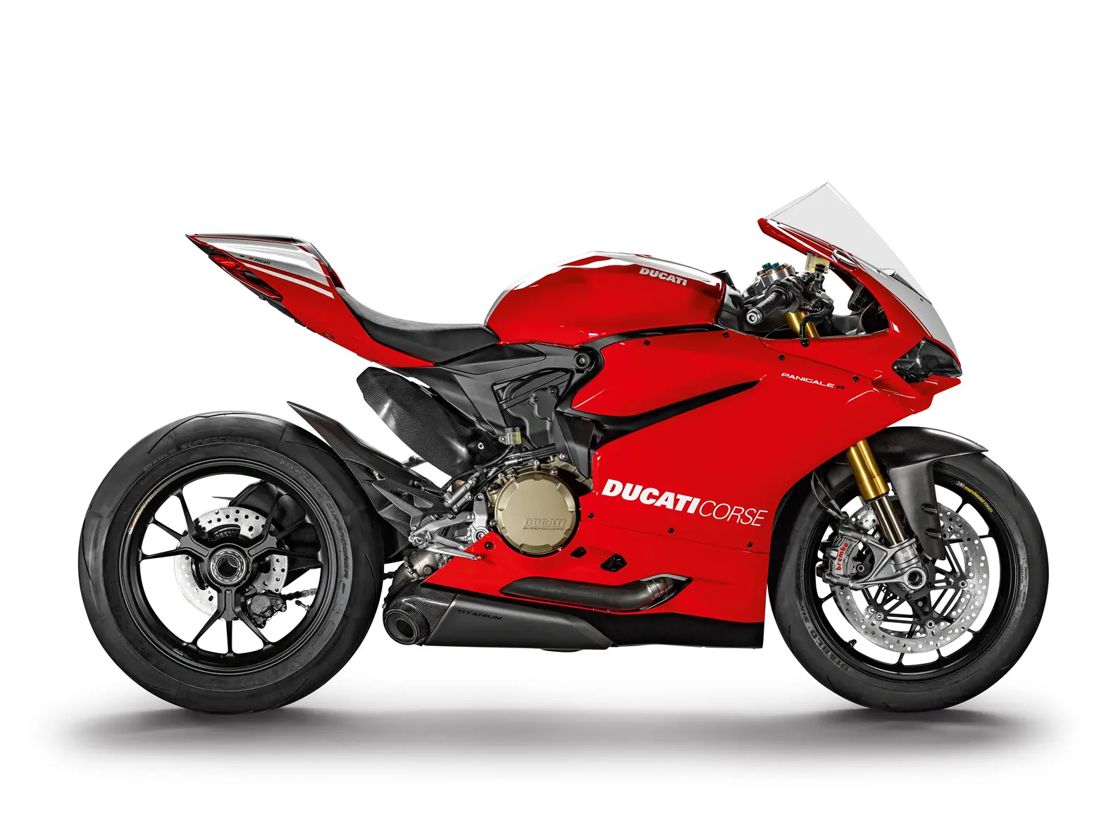
Figure 1 Ducati 1199 (Child, 2015)

Vehicle specification

Vehicle Overview
The selected vehicle for this analysis has been identified as the 2013 Ducati 1199, a high-performance motorcycle renowned for its advanced engineering and aerodynamic design. This vehicle has been chosen due to its high performance and impressing power to weight ratio. This will offer an interesting platform for evaluating energy recovery potential. Some notable specifications for this motorcycle can be found in Table 1 (Correia, 2014).
Table 1 Ducati 1199 specification
Ducati 1199 statistics
 | Kerb mass | 188.0 | kg
M | Test mass | 288.0 | kg
 | Power | 195.0 | Bhp
 | Power | 143.0 | kW
 | Advertised fuel consumption | 41.1 | MPG
 | Power per kg | 760.6 | W/kg
 | Max velocity | 185.0 | mph
Vmax | Max velocity | 82.7 | M/s
A | Frontal area with rider | 0.5 | (m^2)
Rr | Rolling resistance | 56.5 | N
Ar | Aero drag | 225.2 | N
Cd | Coefficient of aerodynamic drag | 0.8 | no units
µ | Tire rolling resistance Coeff | 0.0 | no units
δ | Rotational inertia factor | 1.0 | no units
 | Wheel weight | 10.0 | kg
 | Wheel radius | 0.3 | m

Test Mass
The test mass has been calculated by incorporating the vehicle’s kerb weight, the rider’s mass, and the mass of any additional gear. This calculation has been carried out to ensure that the dynamic properties of the vehicle, such as resistance and energy requirements, have been accurately represented. The test mass has been differentiated from kerb mass or gross vehicle weight (GVW) to align with the assignment requirements.

Frontal Area
The frontal area, inclusive of the rider and associated gear, has been determined to be 0.48m². This value has been derived through the following steps:
- A photograph of the motorcycle with the rider in position has been taken. See Figure 2.
- The image has been imported into SolidWorks, where it has been scaled based on a known measurement—the distance between the rivets of the vehicle’s windscreen.
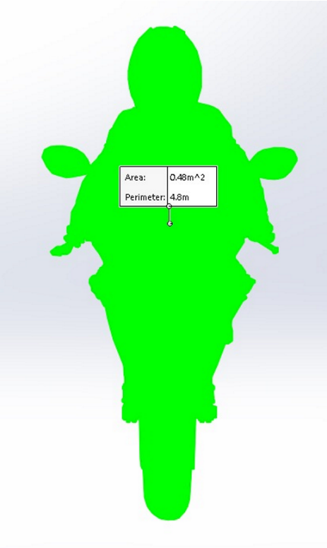
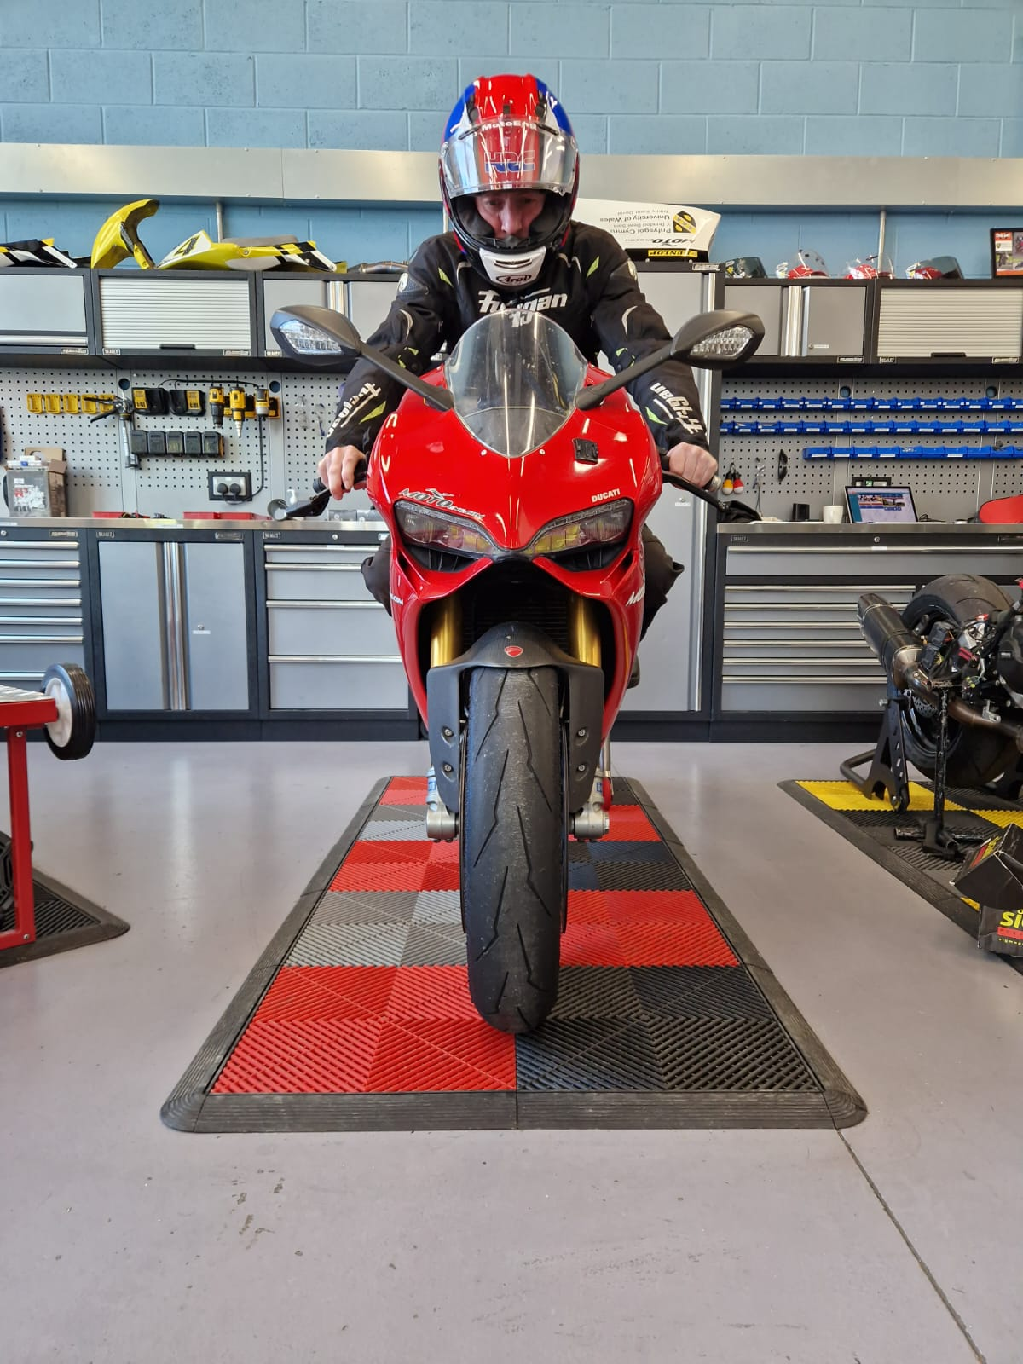
- The outline of the combined vehicle and rider has been traced, and the frontal area has been calculated from the resultant shape.
Figure 2 Ducati 1199 frontal area

This approach has ensured a precise estimation of the aerodynamic profile.

Rolling Resistance
The rolling resistance force has been calculated using the standard formula:
$$Rr=M*g *µ$$
Where:
- µ represents the rolling resistance coefficient, a value that has been sourced from Cossalter’s, (2006) authoritative text, Motorcycle Dynamics.
- M denotes the test mass in kilograms.
- g signifies the gravitational constant 9.81 m/s^2.
This value has been calculated to account for the interaction between the tyres and the road surface under dynamic conditions.

Aerodynamic Resistance
Aerodynamic resistance (Ar) has been calculated using the following equation;
$$Ar=Hr -Lr$$
Where:
- Ar represents the aerodynamic resistance in Newtons.
- Hr​ is the total resistance acting on the vehicle calculated from the High-speed coast down test
- Lr​ denotes the rolling resistance calculated from the low-speed coast down test
This equation illustrates that the aerodynamic resistance has been derived by subtracting the rolling resistance from the total resistance measured during coast-down tests. This method ensures that the aerodynamic contribution to total resistance is accurately isolated, allowing for precise modelling of energy losses at various speeds.

Coefficient of Aerodynamic Drag
The coefficient of aerodynamic drag has been calculated using the following equation:
$$Cd= \frac{2*Ar}{ρ*V^{2}*A}$$
- Cd is the coefficient of aerodynamic drag.
- Ar represents the aerodynamic resistance in Newtons.
- $ρ$ is the density of air.
- A is the frontal area.
- V is the mean velocity gathered in the high-speed coast down test.
The coefficient of aerodynamic drag has been calculated by relating the aerodynamic resistance to the air density, the frontal area, and the square of the mean velocity recorded during the high-speed coast-down test. The aerodynamic resistance has been divided by the product of these parameters, scaled by a factor of two, to derive the drag coefficient. This method has ensured that the drag characteristics of the vehicle have been accurately quantified under dynamic conditions.

WLTP classification
The Ducati 1199 has been classified as a Class 3 vehicle under WLTP regulations. This classification has been determined because its ratio of rated power in watts to kerb mass in kilograms has exceeded the threshold of 34. As per the guidelines, any vehicle surpassing this ratio has been assigned to Class 3. Therefore, the Ducati 1199 has been placed in this category, satisfying the criteria established for Class 3 vehicles (Addendum 153 – UN Regulation No. 154, 2021).

Force, Power and Energy plots

Total force against time plot

Graph 1 Total force against time
Graph 1 illustrates the total forces experienced by the Ducati 1199 throughout the WLTP cycle. Positive forces indicate tractive effort applied during acceleration, while negative forces represent braking events. Frequent transitions between tractive and braking forces can be observed, highlighting the dynamic nature of the cycle. Significant braking phases are evident, providing opportunities for kinetic energy recovery.

Total Breaking forces against time

Graph 2 Total Breaking forces against time
Graph 2 presents the braking forces acting on the Ducati 1199 throughout the WLTP cycle. Peaks in braking force indicate moments of rapid deceleration, which are distributed intermittently over the test duration. Significant variations in the intensity and frequency of braking are observed, suggesting diverse deceleration patterns. These peaks represent critical instances where kinetic energy recovery could be maximised.

Total braking power against time

Graph 3 Total braking power against time
Graph 3 shows peaks in braking power, reaching up to approximately 4.95kW. This highlights moments of high energy dissipation. These instances represent optimal opportunities for kinetic energy recovery.

Total Tractive energy against time

Graph 4 Total Tractive energy against time
Graph 4 depicts total tractive energy across the WLTP cycle, segmented by speed phases (low, medium, high, and extra-high). Energy demands progressively increase with phase, peaking during the extra-high phase, which features the highest tractive energy. This trend demonstrates the correlation between vehicle speed and energy consumption. The data provides insight into energy usage patterns, aiding the evaluation of KERS potential for recovering energy in phases with lower tractive energy and higher deceleration events.

Total braking energy against time

Graph 5 Total braking energy against time
The data in Graph 5 displays total braking energy across the WLTP cycle, categorized by speed phases (low, medium, high, and extra-high). Peaks in braking energy are observed predominantly during the medium and high phases, reflecting significant deceleration events. Braking energy diminishes in the extra-high phase, correlating with sustained high speeds and reduced braking intensity. This information is essential for pinpointing phases where KERS can maximise energy recovery, particularly in medium and high-speed decelerations.

Cumulative energy graph

Graph 6 cumulative traction and braking energy against time
The graph compares cumulative tractive energy and braking energy over the WLTP cycle. Tractive energy (green) increases steadily, representing the energy required for propulsion, while cumulative braking energy (blue) remains significantly lower. The area between the two lines by the end of the test represents energy losses, attributed primarily to inefficiencies and resistive forces. The braking energy represents the potential for recovery using a KERS system. Effective implementation of KERS would aim to minimise these losses by capturing and reutilising this energy during deceleration phases.

KERS system specification
The maximum braking energy generated during the cycle needed to be calculated to size kinetic energy recovery components. This was calculated from Graph 5. The 3 biggest braking event spikes from each of the speed phases was identified. Each event was then found in the data table. Once found, the total energy generated during each event was divided by the duration of the event in seconds to find the total energy generated. This is shown in Table 2. More detail regarding this process can be found in the stored energy tab of the associated Excel document.
Table 2 maximum generated energy per phase
Low
First peak | Second peak | Third peak
12.39 | 10.21 | 8.15
Medium
First peak | Second peak | Third peak
18.22 | 15.32 | 14.14
High
First peak | Second peak | Third peak
22.26 | 19.44 | 12.73
Extra-high
First peak | Second peak | Third peak
37.36 | 5.11 | 3.15

The maximum generated braking energy has been calculated to be 37.35kJ. This calculation has established the foundational energy requirement for the KERS. Following this, the total braking time over the driving cycle has been determined to be 336 seconds. This total duration encompasses all the braking events that occur within the specified cycle.
Subsequently, the number of braking zones throughout the cycle has been identified as 46. By dividing the total braking time by the number of braking zones, the average time per braking zone has been calculated to be approximately 7.64 seconds.
$$Power requirment \left(kW\right)= \frac{37.35}{7.64}$$

Table 3 KERS specification
Total energy losses |  |  |  | Motor/ generator spec requirements
Total tractive energy | 4350.91 | kJ |  | Power requirements | 4.89 | kW
total braking energy | 397.38 | kJ |  | Voltage rating | 72 | V
total losses | 3953.54 | kJ |  | Operating voltage | 60-80 | V
 |  |  |  | Motor type | DC brushless
Maximum power requirements |  |  |  | Peak amperage | 140 | A
Max generated Breaking energy (kJ) | 37.36 | kJ |  | Efficiency | 90 | %
Total breaking time | 336.00 | s
Braking events | 46.00 | s |  | Inverter spec requirements
average breaking event time | 7.64 | s |  | Voltage | 72 | V
power requirements | 4.89 | kW |  | Voltage range | 60-80 | V
 |  |  |  | Peak power output | 12 | kW
Component efficiency |  |  |  | Amperage | 280 | A
Motor/Generator | 0.90 | % |  | Efficiency | 90 | %
Inverter | 0.90 | %
Super-capacitor | 0.95 | %
Total losses into capacitor | 0.77 | % |  | Supercapacitor spec requirements
Total energy returned from capacitor | 0.59 | % |  | Voltage max | 80 | V
 |  |  |  | Voltage min | 40 | V
Maximum possible power output from KERS |  |  |  | Total capacitance | 14.00842 | F
Max generated Breaking energy (kJ) | 37.36 | kJ |  | Max cell voltage | 2.7 | V
Total efficiency losses | 28.75 | kJ |  | Calls required | 30
Total energy returned to tractive energy | 212.36 | kJ |  | Individual capacitance | 420.2526 | F

Using the maximum generated braking energy and the average time per braking zone, the power requirement has been calculated. By dividing the energy of 37.35kJ by the average braking period of 7.64 seconds, an average power requirement of approximately 4.9kW has been determined. This can then be used to size suitable KERS components.

Motor generator
A 72V motor-generator has been specified based on calculated power requirements to ensure effective energy recovery and scalability. The system must recover a peak power of 4.98kW from the wheel, necessitating a motor with a nominal power of at least 5kW. To provide a safety margin and accommodate potential future expansions, the peak power rating has been set at 10kW.
Based on this power requirement, a nominal operating voltage of 72V was selected, with an operating range of 60–84V. This voltage level balances current levels, system efficiency, and compatibility with standard motorbike systems. A Brushless DC (BLDC) motor was chosen for its high efficiency, compact design, and ability to support regenerative braking, which is essential for the KERS functionality.
Current requirements were determined, with the motor needing to handle up to 139A at peak power. Research from (Chapman, 2012) says an efficiency of 90% for a 10kW motor generator is typical for machines of this size and type.

Inverter
The inverter for the 72V KERS has been specified to meet the operational requirements of the motor-generator and the supercapacitor array. A voltage range of 36–72V has been determined, matching the minimum and maximum voltages of the supercapacitor array. The inverter has been rated for a peak power output of 10kW, with a safety margin incorporated by specifying a 12kW unit to ensure durability and scalability.
To support the required power levels, a peak current of 280A at the lowest operating voltage of 36V has been calculated, and the inverter must be capable of handling this safely. Bidirectional power flow has been specified to facilitate the system’s ability to deliver power to the motor during acceleration and recover energy during braking. Regenerative braking capability has been prioritized to enable efficient energy storage in the supercapacitors.
An efficiency of 90%–95% has been specified for the inverter ensuring minimal energy losses during power conversion (Mi and Masrur, 2018). This level of efficiency reflects realistic performance for modern inverters and helps to reduce thermal management requirements.

Super capacitor
The supercapacitor array for the 72V KERS has been specified to meet the energy storage and discharge requirements of the motor-generator and inverter. The array operates within a voltage range of 40V–80V, allowing it to align with the system’s peak and minimum power needs while maintaining operational flexibility. A total capacitance of 14.01F has been calculated, ensuring sufficient energy storage for high-power discharge and rapid charging during regenerative braking.
To achieve the desired voltage range, 30 individual supercapacitor cells have been arranged in series, with each cell rated at a maximum voltage of 2.7V. The individual capacitance of each cell has been specified as 420.25F to achieve the total system capacitance. This configuration provides the necessary energy storage density while maintaining safe operating limits for each cell.
Research from Yu et al. (2013) suggests a realistic efficiency for this type of super capacitor is in the 90%–95% range. This reflects realistic performance under typical charge and discharge cycles. This high efficiency minimises energy losses during energy recovery and release, ensuring optimal performance of the KERS. The supercapacitors have been selected for their rapid charge/discharge capability, long cycle life, and robustness in high-power applications, making them ideal for motorbike energy recovery systems.

Potential energy recoverable

The graph illustrates cumulative braking energy (blue), cumulative braking energy after KERS losses (orange), and the cumulative energy returned to the wheel as tractive energy (grey). The blue line represents the total braking energy available, while the orange line accounts for energy losses within the KERS system during recovery. The grey line indicates the energy that can be re-deployed as tractive energy. This suggests that after losses, it would be possible to return approximately 235kJ back to the wheel when accelerating. This suggests that half the available braking energy is lost to inefficiency in the KERS system, resulting in a relatively low possible gain from the system.

System operation analysis
The KERS system operates by capturing braking energy from the wheels, which is converted into electrical energy by a DC motor-generator. This energy is transferred through a bidirectional inverter to charge a supercapacitor. During acceleration, the stored energy is released back through the inverter to the motor-generator, providing additional torque to the wheel. Assumptions made during the process include:
- Efficient energy transfer with minimal losses.
- Smooth integration with existing braking system.
- Drivetrain systems.
- Ideal riding conditions.
Compared to a conventional bike, the rider may notice less braking being required to slow the motorcycle down. Motorbikes generally have higher levels of engine breaking than cars due to their lower relative mass compared to the resistive forces. This effect would be exacerbated by the KER system. It would produce a more responsive acceleration when stored energy is utilised. These variations would enhance efficiency and performance but could slightly alter the natural braking sensation.

Conclusion
This report shows that adding a KERS to the Ducati 1199 can reduce energy waste and improve fuel efficiency during braking. By following the WLTP and carefully choosing the system components, it’s possible to design a setup that fits the bike’s needs. The most practical solution would involve a motor-generator connected to a supercapacitor, which can efficiently store and release energy. However, the system would only recover a relatively small amount of energy due to the significant losses that occur during energy conversion and storage. Despite these limitations, KERS can still contribute to making the bike more energy-efficient and environmentally friendly, with the potential for further improvement as technology advances.

Reference
Chapman, S.J. (2012) Electric Machinery Fundamentals. 5th edn. New York: McGraw Hill.
Child, A. (2015) DUCATI 1199 PANIGALE R, Motorcyclenews.com.
Correia, A. (2014) 2014 Ducati 1199S Panigale, Motorcyclespecs.co.za.
Cossalter, V. (2006) Motorcycle Dynamics. Lulu.com.
Mi, C. and Masrur, M.A. (2018) Hybrid electric vehicles : principles and applications with practical perspectives. Hoboken, Nj, Usa Wiley.
UNITED NATIONS (2021) Addendum 153 – UN Regulation No. 154, UNITED NATIONS.
Yu, A., Chabot, V. and Zhang, J. (2013) Electrochemical Supercapacitors for Energy Storage and Delivery: Fundamentals and Applications (Electrochemical Energy Storage and Conversion). Taylor & Francis.

