

STUDENT NAME: ABDULSAMAD MALEK
PROGRAMME: MASTER OF BUSINESS ADMINISTRATION
MODULE: MARKETING MANAGEMENT
MODULE CODE: LCMB7024
LECTURER: DR LAILA MAAZOUZ (LONDON)
WORK COUNT: 2569
TERM 1

Executive summary
This report is focusing on the market analysis of Netflix and YouTube as pioneer and Amazon prime video and Disney+ as follower organisation. Adopting the concept of such tools, the intensive growth strategy of Netflix has helped in selling existing products to existing markets. YouTube's market penetration strategy focuses on retaining and expanding its user base through a multi-pronged approach. Amazon and Disney + sustains its competitiveness through focusing on customer-centric innovation as well as operational efficiency.

Table of Contents
1. Introduction 3
2. Task 1: Critical Analysis of the Macro Marketing Environment 3
2.1 Overview of the Macro Marketing Environment 3
2.2 Selection of Two External Macro Marketing Actors 6
2.3 Critical Analysis of Each Actor 7
3. Task 2: Strategic Responses of Pioneering and Follower Organisations 8
3.1 Pioneering Organisations’ Strategic Responses 8
3.3 Follower Organisations’ Strategic Responses 10
4. Conclusion 12
References 14

1. Introduction
Introduction and purpose of the report
The definition of marketing environment analysis is related to a strategic tool that helps in analysing the internal and external environment of an organisation. Market analysis provides an opportunity to identify new market conditions along with impactful engagement of developmental strategies as well. The purpose of this study is to analyse the marketing environment of pioneer organisations Netflix and YouTube considering the follower organisations Amazon prime video and Disney+.
Importance of analysing the macro marketing environment
Macro marketing analysis is crucial for integrating strategic decision making for an organisation. It provides the understanding of recent marketing shifts aligning with diversified decision making approaches based on requirements of the market. As per the analysis of Sałek (2024), macro environment analysis in business helps in structuring the scenario of competitive business growth over the market. It also opens the possible opportunity for strategic business integration in the planning and developmental process. In this study macro environment analysis of the pioneer organisations Netflix and YouTube considering the follower organisations Amazon prime video and Disney+ helps in understanding the broader approaches of decision-making.
Focusing on structure and scope of the report
The structure of this report is related with macro environment analysis of global marketing situations and analysing the impact of two external marketing factors for strategic decision making of Netflix and YouTube as pioneer and Amazon prime video and Disney+ as follower organisation. The scope of marketing environment analysis aligns with strategic marketing implications that ensure in adapting quality driven approaches over the market.

2. Task 1: Critical Analysis of the Macro Marketing Environment

2.1 Overview of the Macro Marketing Environment
Overview of the macro environment and its relevance to marketing strategy
PESTLE ANALYSIS
Factors | Attributes | Impact
Political | - Identification of global issues:  The United Nations has played the foremost role in addressing transcend national boundaries and adjacent issues over the market (un, 2025).  - Score of Political stability index  According to the value of 2023, political stability index score of USA was 0.03 where in the UK the value was 0.51 (theglobaleconomy, 2025) | High
Economic | - GDP Growth rate  As per the analysis of the value of 2025, the global GDP rate has slowed down 3.2% in comparison based on the previous year (tradingeconomics, 2025).  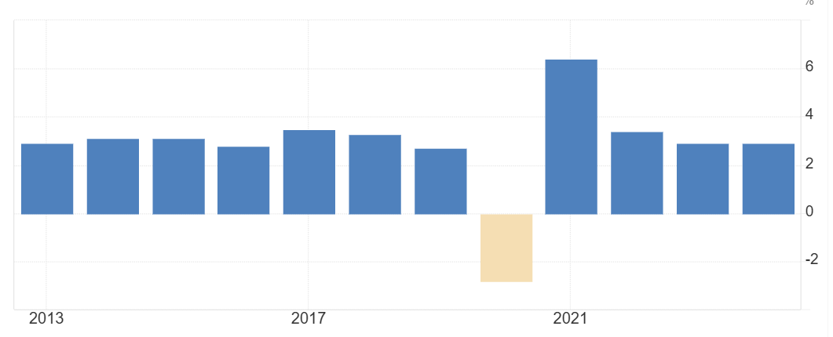  Figure 1: Global analysis of GDP growth rate  (Source: tradingeconomics, 2025)  - Global Inflation Rate  Considering the global economic condition inflation rate has indicated the value of 4.29% fall in the year 2025 (statista, 2025).  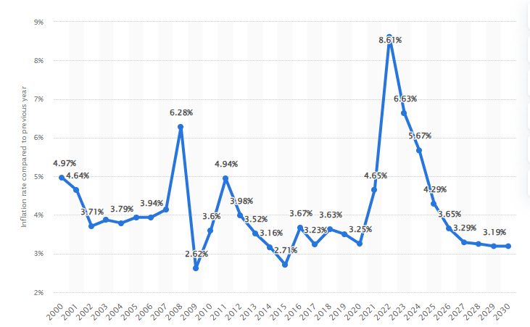  Figure 2: Global inflation rate analysis  (Source: statista, 2025) | High
Social | - Increasing aspects of global population rate  Considering the data of 2025, global population rate has increased 0.85% (worldometers, 2025)  - World employment rate  In the year 2024, the value of world employment rate has indicated number 4.91% (oecd, 2025)  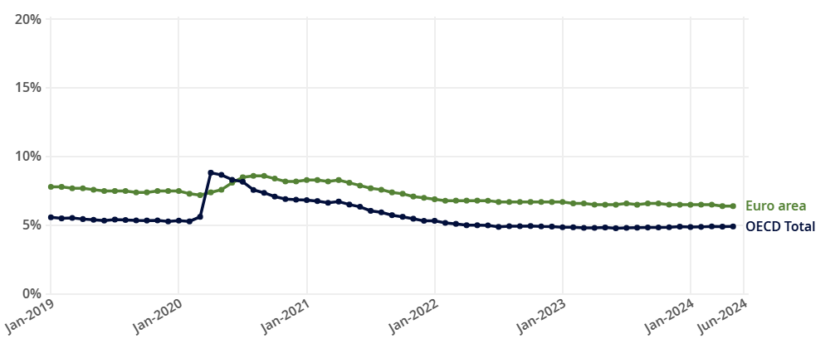  Figure 3: World Employment Rate  (Source: oecd, 2025) | Moderate
Technology | - Digitalisation in Global economy  Digital economy and e-commerce aspects has enhanced the economic reach up to $27 trillion, resulted in increasing market competition (Unctad, 2025) | High
Legal | - Employment Act 2002  It helps in managing equal opportunity and employability aspects for employees of the UK(legislation, 2025)  - Employment Act of 1946  It has provided the rights of equal economic transactions among employees for the people of US (dol, 2025)  - International labour opportunity  International Labour Standards has managed productive work and ensured workplace equality as well as security in the market (ilo, 2025). | High
Environmental | - Global carbon emission rate  As per the analysis of the year 2024, global carbon emission rate has enhanced 0.8% and enhanced concentration 50% higher in pre-industrial level (iea, 2025). | Moderate
Table 1: PESTLE analysis
(Source: Self-created)

2.2 Selection of Two External Macro Marketing Actors
Identifying and justifying the selection
Two external factors that are considered for analysing the strategic business environment of follower and pioneer organisations are political and economic conditions. These two factors have a severe impact over competitive market positioning and developmental aspects.
Explaining the selected actors’ relevance and current influence
The live streaming market has increased its marketing position day by day by using innovative approaches in practices. It has been reported that considering the year 2024, global reach of streaming platforms has enhanced USD 113.21 billion (finance.yahoo, 2025). Rising approaches of internet penetration and application of smartphones is responsible for enhancing the number of viewers in streaming platforms. Political stability and social integration are responsible for managing operational growth of nations. Therefore, a secure economic integration in the market delivering with political stability would be responsible for improving quality aspects of the streaming platforms.
Netflix
Considering the global political condition Netflix is shaping itself according to specific regulations, values, beliefs and cultures in content. As per the analysis of Eke and Ikebude (2025), area specific content creation helps attract local viewers of the market that are dealing with quality driven business growth. It also focuses on managing digital sovereignty for managing geographical tensions in local regions. The packaging systems and discounts rates are also the economic approaches that align with the business developmental aspects of Netflix.
YouTube
The business agenda of YouTube focusing on the geo-political concepts that enhance communication and interaction level with its customers respectively. According to Nursilah and Jayadi (2023), YouTube is a space where local issues are streamed by taking various viewpoints. Therefore, transparency in the operational process helps in delivering economically profitable services. Based on the analysis of the PESTLE table, economic growth in the global economic condition ensures the operational scalability in services.
Amazon prime
Fast growing economic cognition of the global market has created a significant growth in the streaming platform of Amazon Platform. As per the report of global market, 200 million viewers engagement has been observed per week in the year 2024 (hollywoodreporter, 2025). Economically it has settled a transformative milestone in global market conditions.
Disney +
For the aspects of the streaming platform Disney+, economic and political conditions are effective for analysing sustainable growth to ensure competitive market conditions. Considering the table of analysis, Disney+ needs to focus on the aspects of creative content creation that will strategically improve the quality emerging aspects for delivering supportive contents.

2.3 Critical Analysis of Each Actor
Political
Changes impact pioneering and follower organisations differently and creating opportunities and threats within the industry
For both the followers and pioneer organisations, political changes have created a great impact over sustainable business growth. As per the analysis of Rahman (2023), regulations and restrictions due to political changes have created an impact on the streaming platforms for content creation and viewing approaches. Along with that, partnership with location media houses was also impacted for both the followers and pioneer organisations based on the challenges faced due to political conditions.
Key strategic implications
Collaborations with the local government and adoption of respective cultures could be a solution for both the pioneers and followers. It helps in improving market integration and customer engagement rates supportively over the competitive condition. Supportive brand positioning and diversification strategies would require for planning conceptual growth of those business in competitive business conditions.
Economic
Changes impact pioneering and follower organisations differently and creating opportunities and threats within the industry
Economic degradation and fluctuations in inflation rate can be the casualties of the marketing management and planning process. According to Wibowo (2023), operational costs aligning with production costs has been impacted due to economic downturn in strategic business conditions. Economic changes among streaming platforms on a global scale shape in managing the subscription rates, pricing, content production, and strategic management process respectively.
Key strategic implications
Dynamic pricing models along with the key scope of subscriptions are the key specific areas that could improve operational efficiencies of streaming platforms. The future growth of these platforms are ensure strategic aspects of diversified market management and potential scope for streaming and management.

3. Task 2: Strategic Responses of Pioneering and Follower Organisations

3.1 Pioneering Organisations’ Strategic Responses
Evaluating the approach the pioneering firms respond to external challenges and opportunities
- Netflix
The pioneering firms such as Netflix responded to the external challenges such as global political tension due to tariffs imposed by the US president through developing administrative change for global media distribution. Streaming giant Netflix has witnessed a global market setback due to the falling of the shares by 4% in the global market (Economictimes, 2025). Netflix has faced over $20.4 billion loss in the global market capitalization due to the company's heavy dependency on international production. More than 70% of the paid subscribers of Netflix are located outside the US and Canada, therefore Netflix’s popularity is hampered due to production loss. However, Netflix’s macroeconomic subscription strategy has helped the company to respond quickly to the global political tension and achieve global revenue of $10.5 billion in the first quarter of 2025 (Maglio, 2025). Netflix’s own ambitious plan to create a studio can help the company to respond to the global political crisis. On the other hand, other macro factors and global external challenges of world economic output have changed the operational strategy of the company. In 2025, Netflix responded to the global economic opportunity through generating new profitability schemes by revenue generation from the multilayer production system. The lower price segment and ad-supported tier helps the company to gain 55% new sign up in the countries Netflix operated (Communicationstoday, 2025). Below mentioned figure has illustrated that Netflix is evolving in the global market through 300M plus paid subscribers (Medium, 2025). The increasing average revenue per user is the main factor that helps to expand the user base.
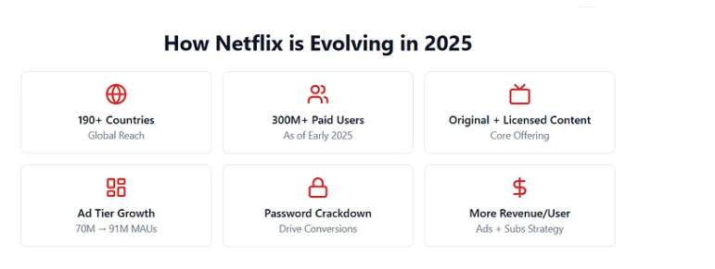
Figure 4: Netflix responds to the global challenges and opportunity
(Source: Equityanalysthub.medium, 2025)
- YouTube
The pioneering firm YouTube responded to the global political challenges through imposing a new monetization policy through changing the payment system from July 2025. YouTube has created a broad range of perspectives that help to develop an ad friendly community and increase subscriber’s collaboration. You tube’s long term incentive scheme has supported the creators to test new ways of generating content in the social media. The hyper scale social video platforms are becoming the dominant force in the streaming media channel (Widener et al. 2025). Thus, YouTube has adopted a strategic and resilient approach that involves anticipating change, fostering a growth mindset as well as utilizing systems thinking in terms of addressing the internal and external challenges.
Application of theoretical models
- Ansoff’s Growth Matrix
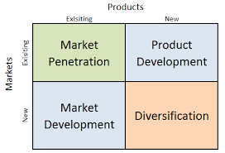
Figure 5: Application of Ansoff’s Matrix
(Source: Self-developed)
The figure mentioned above signifies the Ansoff matrix which is considered to be a strategic planning tool that helps businesses identify growth strategies by analysing four options based on new or existing products and markets (Jintana et al. 2021). Adopting the concept of such tools, the intensive growth strategy of Netflix has helped in selling existing products to existing markets. Similar to the context, YouTube's market penetration strategy focuses on retaining and expanding its user base through a multi-pronged approach. Apart from this, both businesses are required to adopt diversification strategies such as moving within different industries and Conglomerate diversification can be beneficial in addressing the potential changes.
- Porter’s Generic Strategies
Competitive scope | Competitive advantage
Competitive scope | Cost leadership  - Netflix: Leveraging a vast global scale  - YouTube: Absence of cost leadership | Differentiation  - Netflix: Global expansion with local content  - YouTube: Audience engagement
Competitive scope | Cost focus  - Netflix: Strategic Content Investment  - YouTube: Internal operational cost | Differentiation focus  - Netflix: On-demand and ad-free viewing  - YouTube: Empowering individual creators
Table 2: Porter’s Generic analysis
(Source: Self-developed)

3.3 Follower Organisations’ Strategic Responses
Assessing how follower organisations adapt their strategies to sustain competitiveness
- Amazon prime
Amazon sustains its competitiveness through focusing on customer-centric innovation as well as operational efficiency. For instance, the company has launched a campaign such as “one-click ordering” in terms of maintaining its competitive position within the market (Aboutamazon, 2025). As per the opinion of Bataineh et al. (2024), maintaining competitive power within the industry can lead to higher profits, a stronger customer base, and long-term survival by creating a sustainable competitive advantage. Additionally, the company uses behavioural and psychographic data to provide personalized recommendations as well as experiences, making it easier for customers to find and buy products.
- Disney
Disney sustains its competitiveness through a multi-pronged strategy centered on leveraging strong intellectual property, creating synergistic business ecosystems, embracing digital transformation and adapting to global and local market demands (Disneystudiolicensing, 2025). Apart from this, Disney has significantly expanded its content portfolio and audience base by acquiring major franchises such as Pixar, Marvel and Lucasfilm (Osman, 2024). It has been recognised that with the rise of streaming and changing consumer behaviour, Disney made a bold shift from traditional media to a direct-to-consumer model. Thus, the above mentioned factors have helped the company to maintain its competitive advantage to a great extent.
Theoretical application
- Ansoff’s Growth Matrix
Markets | Products
Markets | Market penetration  - Amazon prime: Using competitive pricing strategy  - Disney: Combination of competitive and low pricing | Product development  - Amazon prime: Working backwards" approach  - Disney: Multifaceted strategy using IP.
Markets | Market Development  - Amazon prime: Expanding beyond e-commerce  - Disney: Cross-platform integration | Diversification  - Amazon prime: Customer complementarity  - Disney: Content and intellectual property
Table 3: Application of Ansoff’s Matrix
(Source: Self-developed)
- Porter’s Generic Strategies
Competitive scope | Competitive advantage
Competitive scope | Cost leadership  - Amazon prime: Leveraging economies of scale, operational efficiency, and competitive pricing  - Disney: Operational efficiencies, cost-sharing across business segments, and strategic cost reductions | Differentiation  - Amazon prime: Building loyal customer ecosystem  - Disney: High-quality, immersive, and family-friendly content
Competitive scope | Cost focus  - Amazon prime: Subscription benefits and Competitive pricing  - Disney: Cutting costs and strategically increasing consumer spending | Differentiation focus  - Amazon prime: Fast, reliable delivery and creating a comprehensive ecosystem of services  - Disney: Storytelling, premium quality, and a family-friendly brand experience
Table 4: Application of Porter’s generic framework
(Source: Self-developed)

4. Conclusion
The report above concludes that macro marketing analysis has been a crucial aspect for integrating strategic decision making for an organisation. It has provided the understanding of recent marketing shifts aligning with diversified decision making approaches based on requirements of the market. Apart from this, the two external factors that are considered for analysing the strategic business environment of follower and pioneer organisations are political and economic conditions. For instance, political stability as well as social integration are responsible for managing operational growth of nations. Additionally, the business agenda of YouTube had focused on the geo-political concepts that enhance communication and interaction level with its customers respectively. The pioneering firms such as Netflix responded to the external challenges such as global political tension due to tariffs imposed by the US president through developing administrative change for global media distribution. Thus, Netflix responded to the global economic opportunity through generating new profitability schemes by revenue generation from the multilayer production system.
Strategic significance of environmental scanning and adaptive marketing responses
Analysing the external environment, it has been recognised that the company has faced several issues due to several political affairs as well as increasing global population rate. Apart from this, the company is required to adopt different market penetration strategies in terms of maintaining competitive position within the market. The pioneering firms such as Netflix responded to the external challenges such as global political tension due to tariffs imposed by the US president through developing administrative change for global media distribution. Apart from this, Netflix responded to the global economic opportunity through generating new profitability schemes by revenue generation from the multilayer production system.

References
Aboutamazon, (2025). 1-Click. Available at: https://www.aboutamazon.co.uk/news/innovation/1-click (Accessed: 20 November 2025)
Bataineh, M.J., Sánchez‐Sellero, P. and Ayad, F., (2024). Green is the new black: How research and development and green innovation provide businesses a competitive edge. Business Strategy and the Environment, 33(2), pp.1004-1023. https://doi.org/10.1002/bse.3533
Communicationstoday, (2025). Netflix gains as rosy forecast clams investors nerves aimd tariff fears. Available at: https://www.communicationstoday.co.in/netflix-gains-as-rosy-forecast-calms-investor-nerves-amid-tariff-fears/ (Accessed: 20 November 2025)
Disneystudiolicensing, (2025). Welcome to The Walt Disney Studios Licensing Website. Available at: https://www.disneystudiolicensing.com/ (Accessed: 20 November 2025)
dol (2025) Summary of the Major Laws of the Department of Labor Available at: https://www.dol.gov/general/aboutdol/majorlaws (Accessed: 19 November 2025)
Economictimes, (2025). How streaming giants like Netflix, Disney, and Paramount reacted to Trump’s 100% tariff announcement on foreign films. Available at: https://economictimes.indiatimes.com/news/international/us/how-streaming-giants-like-netflix-disney-and-paramount-reacted-to-trumps-100-tariff-announcement-on-foreign-films/articleshow/120905800.cms?from=mdr (Accessed: 20 November 2025)
Eke, C. and Ikebude, O.D., (2025). Broadcast Media for Entrepreneurial Growth and Business Success. ETHICS, ENTREPRENEURSHIP AND SUSTAINABLE DEVELOPMENT: Converging Perspectives and Insights, p.246. https://www.researchgate.net/profile/Kanu-Ikechukwu/publication/392863222_ETHICS_ENTREPRENEURSHIP_AND_SUSTAINABLE_DEVELOPMENT_Converging_Perspectives_and_Insights/links/6855743099d2ce32c1c9df82/ETHICS-ENTREPRENEURSHIP-AND-SUSTAINABLE-DEVELOPMENT-Converging-Perspectives-and-Insights.pdf#page=260
Finance.yahoo (2025) Live Streaming Market Size to Surpass USD 600.12 Billion by 2032, Driven by Rising Demand for Interactive and Immersive Content | Research by SNS Insider Available at:https://finance.yahoo.com/news/live-streaming-market-size-surpass-073900911.html?guccounter=1&guce_referrer=aHR0cHM6Ly93d3cuZ29vZ2xlLmNvbS8&guce_referrer_sig=AQAAAEI88HEQ9myUzvYRNE0Jd8yOOdb94LG1bCRpp3xJhrWDR1Ka6yuAxh3rdRF8tg211NubLgQD4BpcchM_sfk8mWCtYcArr-wX8YHoyDDmAXr_wnHU2t6oZoyOUOR5FCmOe3R9ANgICLwEztTxAc4bRqGEjR_8-ZTc2B-6YK8g4VXo (Accessed: 20 November 2025)
Hollywoodreporter (2025) Prime Video With Ads Claims New Milestone: 315 Million Monthly Viewers Globally Available at: https://www.hollywoodreporter.com/business/business-news/prime-video-315-million-monthly-viewers-1236423744/ (Accessed: 20 November 2025)
Iea (2025) CO2 Emissions Available at:https://www.iea.org/reports/global-energy-review-2025/co2-emissions (Accessed: 19 November 2025)
Ilo (2025) International Labour Standards Available at:https://www.ilo.org/international-labour-standards (Accessed: 19 November 2025)
Jintana, J., Sopadang, A. and Ramingwong, S., (2021). Idea selection of new service for courier business: The opportunity of data analytics. International Journal of Engineering Business Management, 13, p.18479790211042191. https://doi.org/10.1177/18479790211042191
Legislation (2025) Employment Act 2002 Available at: https://www.legislation.gov.uk/ukpga/2002/22/contents (Accessed: 19 November 2025)
Maglio, T., (2025). Netflix Is “Paying Close Attention” to Tariffs Talk, But Believes It’s “Less Exposed” Than Others. Available at: https://www.hollywoodreporter.com/business/business-news/netflix-ceos-talk-trump-tariffs-1236193774/ (Accessed: 20 November 2025)
Medium, (2025). Netflix, Navigating Mature Growth in the Streaming Landscape. *As of Q1 2025*. Available at: https://equityanalysthub.medium.com/netflix-navigating-mature-growth-in-the-streaming-landscape-as-of-q1-2025-ced7ae4c1be1 (Accessed: 20 November 2025)
Nursilah, N. and Jayadi, U., (2025). Exploring Cultural Representations in Regional Content on YouTube: A Comprehensive Review. Siwayang Journal: Publikasi Ilmiah Bidang Pariwisata, Kebudayaan, dan Antropologi, 4(1), pp.41-52.https://www.publish.ojs-indonesia.com/index.php/SIWAYANG/article/download/2697/1154
oecd (2025) OECD Employment Outlook 2024 Available at:https://www.oecd.org/en/publications/oecd-employment-outlook-2024_ac8b3538-en.html (Accessed: 19 November 2025)
Osman, J., (2024). Disney Stock Faces Major Challenges: Is Iger The Right Choice? Available at: https://www.forbes.com/sites/jimosman/2024/05/30/disney-stock-faces-major-challenges-is-iger-the-right-choice/ (Accessed: 20 November 2025)
Rahman, Z., (2023). Enforcing Copyright on Online Streaming Platforms: Challenges Faced by Rights Holders in the Digital Era. International Journal for Multidisciplinary Research (IJFMR), 5, pp.1-14.https://pdfs.semanticscholar.org/f80c/ce4357eea5c7ac295fa4a5d90a37ac456338.pdf
Sałek, R., (2024). PEST macro-environment impact analysis as a strategic management tool for a weigh-in-motion system implementation. Polish Journal of Management Studies, 30(2), p.244.DOI: 10.17512/pjms.2024.30.2.15.
Statista (2025) Global inflation rate from 2000 to 2024, with forecasts until 2030(percent change from previous year) Available at:https://www.statista.com/statistics/256598/global-inflation-rate-compared-to-previous-year/?srsltid=AfmBOopu7r4vJTgRrN_7_DGeOjdqk8k9FmrFdDEaYsM_upQqZVna__6d (Accessed: 18 November 2025)
Theglobaleconomy (2025) Political stability - Country rankings Available at: https://www.theglobaleconomy.com/rankings/wb_political_stability/ (Accessed: 18 November 2025)
Tradingeconomics (2025) World Full Year GDP Growth Available at:https://tradingeconomics.com/world/full-year-gdp-growth (Accessed: 18 November 2025)
Un (2025) Global Issues Available at: https://www.un.org/en/global-issues (Accessed: 18 November 2025)
Unctad (2025) Digital economy report 2024 Available at: https://unctad.org/publication/digital-economy-report-2024 (Accessed: 19 November 2025)
Wibowo, I., (2023). Business Resilience: Operational Management Strategies for Facing the Global Economic Crisis. Jurnal Sosial Sains dan Komunikasi, 2(1), pp.123-130.https://jurnal.seaninstitute.or.id/index.php/sosak/article/download/527/302
Widener, C., Arbanas, J., and Dyke, D.V., and Arkenberg, C., (2025). 2025 Digital Media Trends: Social platforms are becoming a dominant force in media and entertainment. Available at: https://www.deloitte.com/us/en/insights/industry/technology/digital-media-trends-consumption-habits-survey/2025.html (Accessed: 20 November 2025)
Worldometers (2025) World Population by Year Available at: https://www.worldometers.info/world-population/world-population-by-year/ (Accessed: 19 November 2025)

