University of Wales Trinity St David

School of Engineering

Energy and Environmental Engineering

Materials & Introduction to Manufacturing Technology

(M4X01163)

Kielder Francis - 1907778

Sandcasting assignment

For the design of the badge of a car, I chose a pattern that I have known for a long time, and is one that seems oddly satisfying to sketch (as well as the 3D version). I am talking about the Triforce, a symbol widely recognised from the Legend of Zelda, a series of games from which I found the inspiration for this symbol. However, I tried to remodel this shape into a 3D version of this, or a triangle based pyramid stacked on top of three other pyramids. Unfortunately, due to the Covid-19 outbreak, I was unable to finish this 3D shape as I ran out of time. Fortunately, I was able to fully design the 2D version and I can use that instead. One problem I faced was deciding how big the whole badge should be, as I wanted the look to be as 2D as possible, but big enough to be able to sand cast (otherwise such a thin piece would be incredibly difficult to make. The more I thought and researched about smaller, more 2D shapes, the more I realised how troubling sand casting could be, for 2D shapes, especially for a Triforce, due to the small, unstable pile of sand in the middle.

CAD:

So, I decided to make a Triforce as my badge design, which effectively is just 3 equilateral triangles, each of length 45mm, touching each other at the corners. If you want to sandcast an object, you will need a model to base it off of. One way I thought of making a model was to 3D print a few triangles, and then add a small edge around the outside of them all. Alternatively, you could make them both in one go, rather than risking messing up the whole model if you get a tiny detail wrong. This will add some stability and hold each triangle together, so when the sand is pressing down on them, they won’t fall apart or be separated. After some thought on the whole model, I decided to extrude the triangle and make sure that the cuts do not reach the edges; otherwise there would be no stability. I thought that 15mm should be a good enough thickness to, so it can be thick enough to place on its side. I could 3D print this final model off and use it to create as many Triforces as I want to, assuming I had the time and resources.

Health and safety:
- Wear protective clothes all over
- Wear protective
(Health and Safety Executive)

Sand casting

Equipment and materials used:
- Drag and Cope
- Core
- Silica Sand
- Parting Powder
- Block of wood
- Pencil or a rod
- Funnel
- Zinc
- Furnace
- Large metal spoon
- Heat proof gloves
The two metals that I would have chosen were zinc and aluminium. Zinc has a lower melting point than aluminium, so this means it would take a lot less time to melt all of the metal used. If I were to make many badges, then I would prefer to take the least amount of time possible, and preferably reduce the cost to the minimum too.

Processes:
Now that we have the model of the Triforce, we can start to sand cast as many badges as we want. We would start off by preparing everything, including all the materials used for the product and the equipment used too. Make sure to start the process of melting the metal, as it could take a long time for it to heat up. After the preparation is done, we put the drag (bottom half of the flask) on a flat surface, such as a table, and fill it up with the silica sand. Press down on the sand using your fists or a flat block of wood. Once it is pressed down, add some more sand and press it down again until the drag is full up to the top, and make sure that you have a flat surface. Gently sprinkle some parting powder (such as Calcium Carbonate (CaCO3)) over an area, and then place the Triforce on the flat surface. Make sure that the Triforce is right at the surface of the drag, then place the cope (top of the flask) on top and sprinkle a bit more parting powder on top of the model. Completely fill the cope up with the silica sand and then scrape the rest of the sand off the top. Make sure it is as compressed and as flat as possible. Take the cope off and try and take the Triforce out without deforming the mould too much. Carefully, poke a few holes out of the sand in the cope, to allow for air to escape. Make a much bigger hole for the molten metal to flow into. Place the cope back on top of the drag and start to pour the molten metal in. Stand well back, as the metal is very hot, and could cause serious injuries.

The biggest problem here would probably be the fact that there is a hole in the middle of the shape, and there are large and small edges around it too. This leaves little room for air to escape, which is almost certainly the main reason for deformities in sand casting. One way we could solve this is by making air holes in strategic places to prevent any air pockets forming, which would damage mould.
(Callister, Jr. & Rethwisch)

Injection moulding:
For injection moulding, we would be using thermoplastics instead of metal, so this method is already cheaper. The first thing to do for injection moulding is to make a mould for the pattern you want. Then you would also have to purchase a machine for heat up and inject the molten plastic for you too. You would attach the mould, put some thermoplastic pellets in the hopper, and let the machine do all the work for you. The plus side of this is that it will do a lot of the work for you, and fairly quickly as well, as long as you want many, many plastic shapes that you are making, in this case, a Triforce.

Recommendations:
If I were to tell someone to make and sand cast a model or a patter, I would tell them to start a lot earlier. Another key aspect would also to choose a more simple pattern to make as well, that could be easily done without it giving you a headache if you think about it too much.

Results:
The pictures below show all of the drawings I’ve done on paper and on Solidworks.
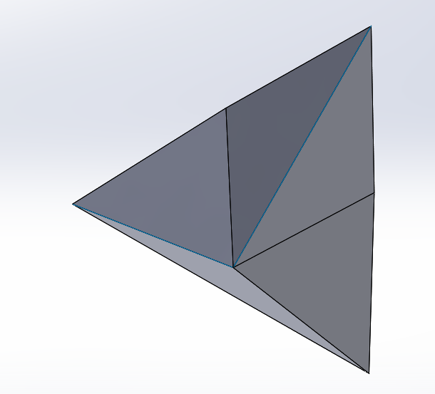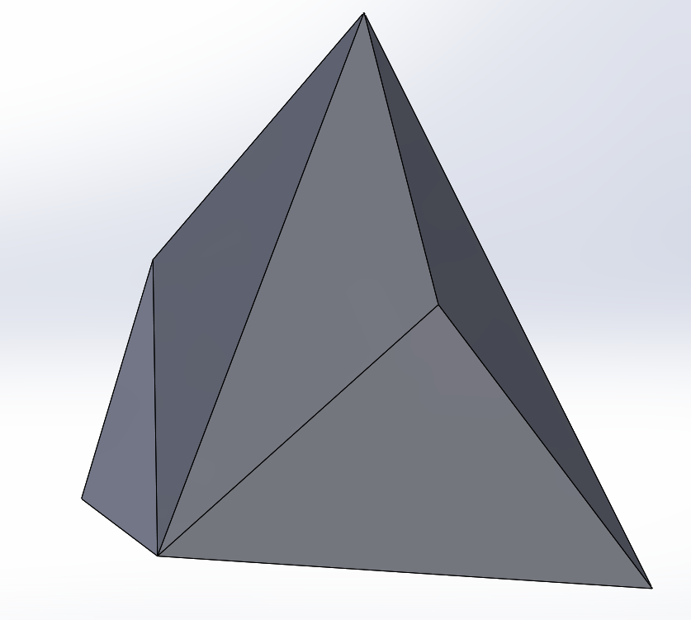
The two shapes above are failed attempts at making a 3D Triforce on Solidworks. Although it would be very difficult to replicate if you were to sand cast or injection mould one, it is possible, but not in one go sadly, due to the hollow shape in the middle. If you were to sand cast it, the three bottom pyramids would be stuck at the bottom. The easiest way to overcome this is to make it in many goes, out of lots of little, smaller parts.
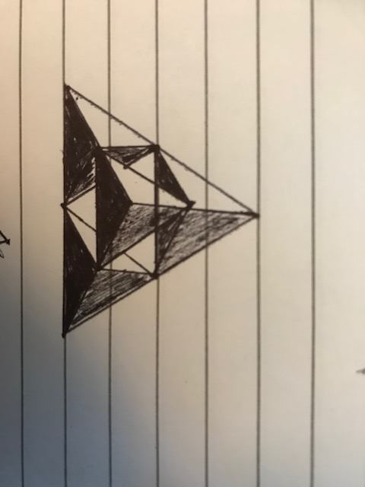
This drawing above is what I was hoping to make in the end. However it did not come down to that. But if I were, I would make 4 smaller pyramids and stack one on the others to make a hollow pyramid.
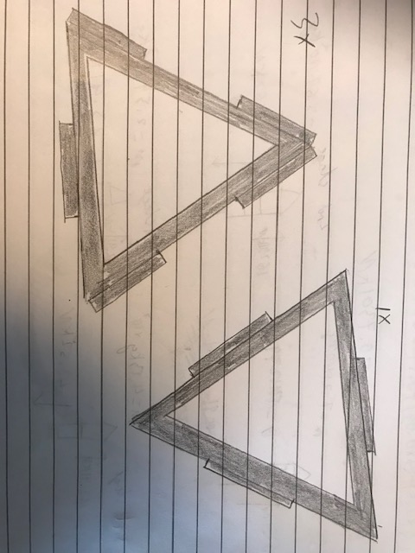
Before I started making the 3D Triforce, I didn’t fully understand how the shape would work when it came to sand casting, but I eventually realised it’s not actually possible to make that object in one go. However, if I were to make 3 separate shapes, and stick them together, then I probably would be able to make the shape. I would make 4 of the pyramids, all in one go, and then a structure around the outside, made up of 4 outlines of triangles that surround the outside. They would be about twice as tall as the pyramid, and would click together like Lego™.
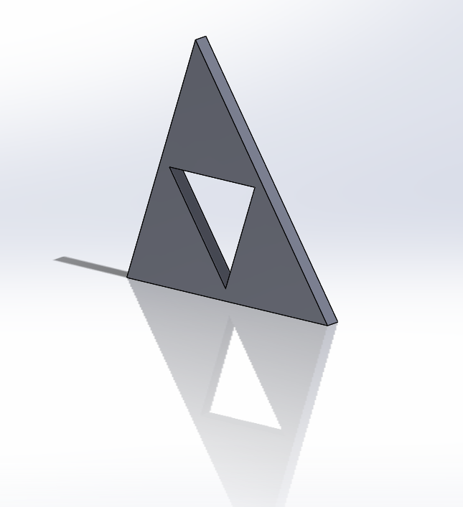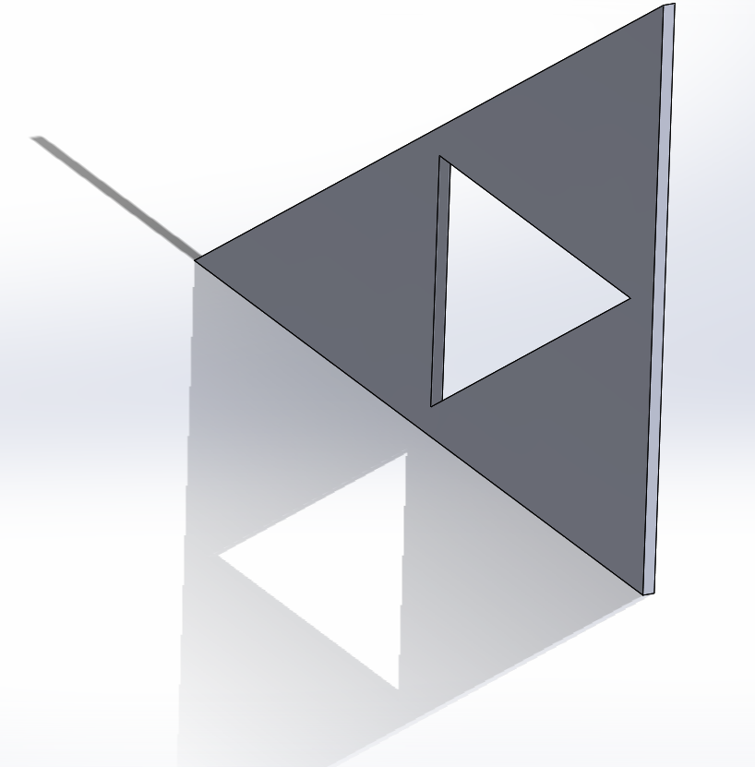
After thinking it would be too much effort and trouble in reality, I went with the slightly more boring and simple 2D design. Above is what the pattern would look like, made on CAD.

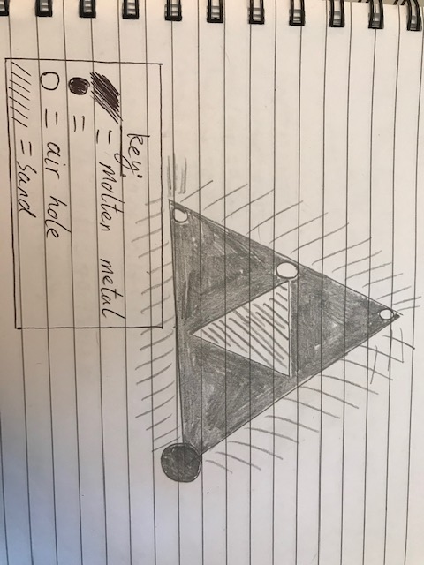
The image above shows how the pattern could be sand casted. The black circle there shows where the molten metal enters.

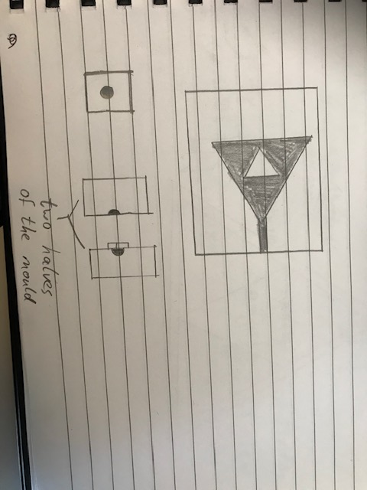

This image shows how the Triforce could be injection moulded. It shows the cross sections of the mould.

Bibliography
(n.d.). Retrieved from Health and Safety Executive: https://www.hse.gov.uk/moltenmetals/protective-clothing/selecting-clothing.htm
Callister, Jr., W. D., & Rethwisch, D. G. (n.d.). Materials scinece and engineering. Wiley.

