

Methods and Search Strategy Academic Poster

Student name: Rizwana Haroon Mahmood
Student ID: 2215431

Module name: Independent Project
Module code: BMHP6020_BIRM

‘’Do Current UK Support Systems and Interventions Offer Sufficient Emotional and Social Support for Parents of Children with Autism?’
  Introduction and Research Aim  This methods chapter describes a qualitative research study examining how well UK support services meet the emotional and social needs of parents raising autistic children. The study seeks to measure how current support programs affect parents' well-being and whether these programs provide adequate help.  The research uses thematic analysis of existing literature, drawing on the Family Quality of Life framework and Ecological Systems Theory as theoretical foundations. Data is systematically gathered from various databases using Braun and Clarke's six-phase analytical framework from 2006. The methodology incorporates quality control procedures and addresses ethical concerns, enabling a comprehensive evaluation of how effectively current support systems work, with the goal of improving these support structures. | Search Strategy  A search strategy for secondary research involves a systematic method of locating information through database selection, keyword development, and the use of Boolean logic to identify literature that addresses specific research questions (Booth et al., 2016). This study conducted a comprehensive search using databases including PubMed, ScienceDirect, and PsycINFO.  The search approach organised keywords into three main groups linked by Boolean operators: target population (parents, caregivers), medical condition (autism, ASD), and assistance types (intervention, service, emotional support). Search parameters were restricted to UK-based studies published in English-language peer-reviewed journals between 2013 and 2024. The strategy was expanded through reference tracking and examination of grey literature from governmental and charitable organisations. Study selection was guided by criteria emphasising parental perspectives on autism support services, with particular attention to emotional and social dimensions, in order to assess whether existing support frameworks are adequate.
Searching for Information  A search strategy systematically retrieves information by selecting databases, developing keywords, and applying logical operators to address research questions (Booth et al., 2016). This study investigated UK support systems for parents of autistic children by selecting PubMed, PsycINFO, and Social Care Online databases, developing categorised search terms (population, condition, support) with Boolean operators, and applying filters for UK studies from 2014-2024. The search was expanded through citation chaining and grey literature, then screened using inclusion/exclusion criteria focused on parental support experiences, with quality assessed using critical appraisal tools. This systematic approach gathered relevant evidence to evaluate whether UK support systems adequately address the emotional and social needs of parents with autistic children. | 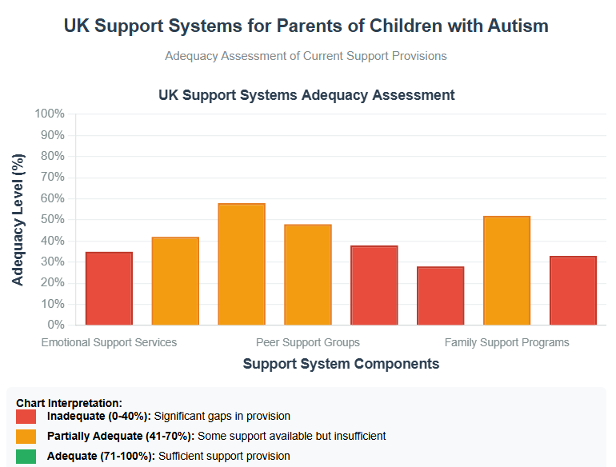
Research Validation and Analysis
Validation in Secondary Research: Validation in secondary research is the process of assessing the credibility and quality of existing information by evaluating its reliability, relevance, and methodological rigour (Noble & Smith, 2015). This dissertation employs critical assessment tools, cross-referencing studies, and documenting search methods to address limitations such as publication bias. Secondary Research Analysis: Secondary research analysis systematically examines existing published research to explore new questions (Johnston, 2014), focusing on reinterpreting findings instead of generating new data. Thematic Analysis Approach: Braun and Clarke's (2006) six-phase approach (familiarisation, coding, theme development, review, definition, and reporting) revealed five interconnected themes: access barriers (waiting times, fragmented services), emotional support needs, social isolation and peer support value, service navigation challenges, and resilience-building factors. These themes form the framework for analysing UK support systems for parents of autistic children in Chapter 4, enabling a comprehensive understanding of parental experiences while revealing patterns across studies. These themes frame Chapter 4's analysis of UK support systems for parents of autistic children, enhancing understanding of their experiences while identifying patterns across studies.
Inclusion Criteria  The research incorporated sources from the past decade (2014-2024) that were UK-focused, fully accessible online, and predominantly peer-reviewed. Selection criteria also included studies examining parental emotional and social support, government policy documents, effective intervention research, caregiving challenge investigations, parent views on service accessibility, and publications from established autism organisations. | Exclusion Criteria  The study excluded literature published before 2014, non-UK research without British applicability, and digitally inaccessible documents. Additional exclusions involved studies focusing exclusively on autism clinical treatments without parental support components, research examining only educational methods, publications centred solely on diagnostic procedures, non-English materials, and sources without peer review or established credibility.
Ethical Considerations
Ethics in secondary research involves the moral principles and regulations governing the responsible reuse of existing datasets for new research purposes, especially when personal data is involved (Laryeafio and Ogbewe, 2023). This study upheld ethical principles by properly acknowledging intellectual property through systematic citation of all sources according to UWTSD standards, giving appropriate credit to original authors for their quotes, concepts, theories, and research outcomes. Citation management tools such as Cite Them Right and MyBib were utilised to ensure precise referencing standards, recognising intellectual ownership, preventing plagiarism, and complying with copyright requirements, even though secondary research does not involve direct participant engagement.

References

- Booth, A., Papaioannou, D. and Sutton, A. (2012) Systematic Approaches to a Successful Literature Review, ResearchGate. Available at: https://www.researchgate.net/publication/235930866_Systematic_Approaches_to_a_Successful_Literature_Review (Accessed: 25 May 2025).
- Braun, V. and Clarke, V. (2006) Using Thematic Analysis in Psychology, Qualitative Research In Psychology. Available at: https://doi.org/10.1191/1478088706qp063oa.
- Googleusercontent (2025) Googleusercontent.com. Available at: https://lh6.googleusercontent.com/BqdnP95ErfwaR4yVGpKSGMF4cxijUS4P7Nwmia38sqOMCCys52i6Vc8jXoUw0IIc2JciLaV7E-ajq8N7aamQccgFgU5wKBTIEcUdub8duFqAsUMxD6ACApUKSUPSl6JZT7yxTDA2 (Accessed: 5 June 2025).
- Johnston, M. (2014) Secondary Data Analysis: A Method of Which the Time has Come, ResearchGate. Available at: https://www.researchgate.net/publication/294718657_Secondary_Data_Analysis_A_Method_of_Which_the_Time_has_Come (Accessed: 3 June 2025).
- Laryeafio, M.N. and Ogbewe, O.C. (2023) ‘Ethical consideration dilemma: Systematic review of ethics in qualitative data collection through interviews’, Journal of Ethics in Entrepreneurship and Technology, 3(2), pp. 94–110.
- Noble, H. and Smith, J. (2015) ‘Issues of Validity and Reliability in Qualitative Research’, Evidence Based Nursing, 18(2), pp. 34–35. Available at: https://doi.org/10.1136/eb-2015-102054.

Submission Notes – Please Delete Before Submission

- The Academic Methodology Poster is worth 15% of your final grade for BMHP6020 Independent Project.
- Your poster should be no more than 2 pages in length and between 300 - 500 words approximately.
- All information should be cited using the UWTSD Harvard Referencing Guidelines from Cite them Right.
- Try not to include too much information as you will be able to explain concepts further within your main dissertation.
- Use visuals and colours to make your poster engaging to the audience.
- Ensure your poster is clear and consistent in style.
- Convey the information in an appealing way which can be understood by any audience.
- Use the headings within this guidance to ensure you include all the information for successful completion of this element.

