

Student name: Annette Dixon
Student ID:2511146
Module name: Health and social care
Module code: LCHS4003
Lecturer name: Oluwadamiloa Tayo

Content page

: Domiciliary care poster page: 3
: Pharmacy service: Page 4-6
: References: Page 6-7


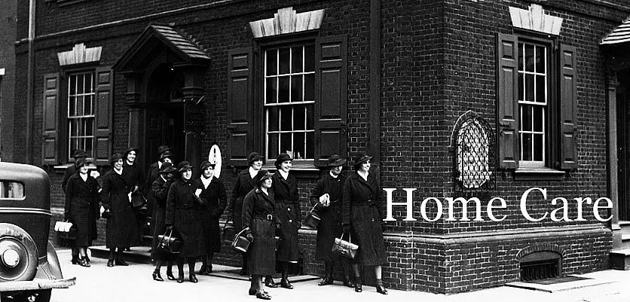
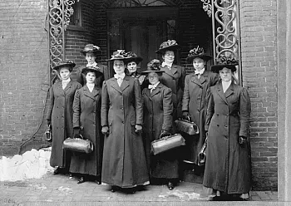
Domiciliary Care- iStock By Getty Images
Conclusion
Domiciliary care services play a vital role in supporting individuals within the community. independence, dignity, and overall quality of life are maintained when care is provided in people own homes. In recent years, domiciliary care has shifted from informal support provided by family members into a crucial service which is now part of the healthcare system (Department Of health and social care, 2018). People can now handle their own day to day tasks by keeping track of their health whilst staying connected to their communities. There is multiple obstacle domiciliary care is facing, but the most critical two are staff shortages and limited funding. Making sure these problems get fixed will allow domiciliary care to support the needs of individuals and communities in the long run.

Home Care- Penn Nursing University of Pennsylvania
Nurse society Philadelphia 1909- Penn Nursing university of Pennsylvania
Brief History
Family members and local communities have been providing care for centuries within homes. Nevertheless, elders and vulnerable individuals were growing rapidly because of this domiciliary care service began to develop in the early 20th century. In the United Kingdom After the second world war social care services were developed significantly because of the welfare state (Department of health and social care, 2018). There were early forms of domiciliary care service which was provided to elderly individuals who were living independently and needed assistance with household task.

Funding and Resource Limitations
Another challenge domiciliary care services face is Limited funding (The King’s Fund, 2022). A significant amount of local authorities have tight budgets, which can affect how much support is available. When funding is restricted, carers visitation may become shorter, fewer services may be available, or people may have to wait longer to access care. As demand for domiciliary care continues to grow, securing enough funding will be important to ensure services remain reliable and effective. Addressing these issues is essential if domiciliary care services are to continue supporting people in the community.

INTRODUCTION
Domiciliary care and home care is often used interchangeably and is a vital part of community health and social care services (NHS, 2023). Individuals who need assistance are supported within their own homes. The Care domiciliary delivers are mainly for elderly’s, people with disabilities, illnesses, individuals recovering from surgery and people with long term conditions. domiciliary care aims and objectives is to promote independence and allow service users to remain in a familiar environment while maintaining links with their community and family.
Workforce Shortages
One of the most challenging problem domiciliary care services is facing is a shortage of care workers (Skills for care, 2023). The demand for home care is increasing exponentially, mainly because the population is ageing and more people are living with long-term health conditions. On the other hand, many care providers struggle to recruit and keep staff. Care work is physically demanding and emotionally challenging. Care Workers travel between different homes during the day, which make the job more difficult at times. Payment in domiciliary care service is often lower than in other industries, which can make recruitment even harder, because employee attrition can be high. This can affect the consistency of care that’s being given because it places extra pressure on the staff who is still available.

Development of Domiciliary Care Services
There was a significant change in the way care was delivered it came with the introduction of the NHS and Community care act 1990 (NHS and community Care Act 1990). This law encouraged care to relocate away from hospitals and from residential institutions and rather be provided within the community. The aim is to help people stay in the comfort of their own home while still getting the support they needed. Overtime, domiciliary care services began to grow, expand and develop. They started to include personal care, specialist support for individual with disabilities, and assistance for individuals living with complex comorbidities. Domiciliary care is an indispensable part of the UK’s health and social care system (The King’s Fund, 2022).

Domiciliary Care Services in the Community
Annette Dixon, Health and social care, 2511146@student.uwtsd.ac.uk

Pharmacy Services

Pharmacy Services: Origins, Development, and Modern Significance
Service users’ overall wellbeing is supported by modern health care systems, accompanied by pharmacy services, which plays a key role in providing access, to medication (NHS, 2023). As years go by, the development in these services has evolved from usual practice into highly regulated and individual care. The distribution of medication not only improves health outcomes, but pharmacy today helps with quality of life. (Anderson et al, 2003)
Pharmaceutical service origin can be tracked all the way back to ancient civilisation. Apothecaries were also known as early pharmacists that made and dispensed herbal remedies (Bennett, 2014). Empirical knowledge and natural substances were used to create medicine in ancient places like China, Egypt, and Greece (Porter, 1997). An important step was the distinction between the role of apothecaries and physicians during the Middle Ages. This was a key part in the professionalism of pharmacy (Bennett, 2014). In the 19th century, the United Kingdom began to formalise pharmacy, and the Royal Pharmaceutical Society was established in 1841. Its aim was to regulate training and practice standards (Royal Pharmaceutical Society).
During the 20th century, science and medicine created an advancement in the development of pharmacy services. The Expansion of pharmaceutical service came about when the National Health Service in 1948 was introduced (NHS, 2018). During this time, changes were made from compounding medicines for dispensing pharmaceutical drugs. Aligned with this was strict regulation to maintain safety and efficiency (Anderson, 2005). Policies and guidelines were introduced by organisation such as the General Pharmaceutical Council. Since their intervention, pharmacy professionals meet high standards of practice and patient care (General Pharmaceutical Council, 2023).
Pharmacy services today function as part of the healthcare system, with its accessibility and essentiality. There are wide range of services that has been provided by community pharmacies for example dispensing prescriptions, offering health advice, administering vaccinations and helping with long term conditions (NHS, 2023). Emergency services receive a big reduction in pressure due to the pharmacist’s role. The reason being pharmacists are the first point of contact for patients seeking medical advice (Public Health England, 2017). This is supported by NHS medication reviews (NHS, 2023). A key role pharmacies present is the promoting of public health through services like smoking cessation programmes and medication reviews.
In the pharmaceutical role, there are multiple challenges they face despite their importance. This could be things such as increasing demand, workforce pressures and the constraints of funding which could impact the quality and consistency of services (Community Pharmacy, 2023). Furthermore, the responsibilities are significantly increasing, which demands the pharmacists to continuously engage in training and adapting to new technologies and healthcare practices (General Pharmaceutical Council, 2023). Also, these developments further improve the service delivery, which in return could place additional strain on the pharmacist. Whilst evaluating, pharmacy services are highly effective in improving accessibility and supporting patients, but there is a need for investment and workforce development to continue their impact.
Pharmacy services have been improving the quality of life and the significance is considerable. Pharmacists keep medication safe and help manage severe chronic conditions like diabetes, asthma, and hypertension (NICE, 2022). They also motivate people when giving personalised advice, which then gives them the confidence to take charge of their own health. Moreover, this further improves not just their physical health but emotional wellbeing. Because of this, you see a decrease in anxiety and an increase in confidence when it comes to managing their own condition (Public Health England, 2017). Pharmacies in community have become very accessible, which in turn allow individuals to receive support without having to visit the hospital. This demonstrates independence and convenience.
In conclusion, pharmacy services have drastically developed from traditional apothecary practices into a professional part of the modern healthcare. Historically, development has changed their roles with regulation and healthcare system. Although pharmacy has multiple challenges, they still play a key role in improving quality of life and improving health outcomes. Their development is essential and plays a key role in today’s society, especially with the growing demand and population.

References
Anderson, S. (2005) Making Medicines: A Brief History of Pharmacy and Pharmaceuticals. London: Pharmaceutical Press.
Anderson, C., Blenkinsopp, A. and Armstrong, M. (2003) ‘The contribution of community pharmacy to improving the public’s health’, Journal of Public Health Medicine, 25(1), pp. 56–60.
Bennett, J. (2014) A Brief History of Pharmacy. London: Pharmaceutical Press.
Community Pharmacy England (2023) Funding and pressures in community pharmacy.
General Pharmaceutical Council (2023) Standards for pharmacy professionals. London: GPhC.
NHS (2018) The history of the NHS. Available at: https://www.nhs.uk
NHS (2023) Pharmacy services. Available at: https://www.nhs.uk
NICE (2022) Medicines optimisation.
Public Health England (2017) The role of community pharmacy in public health.
Porter, R. (1997) The Greatest Benefit to Mankind: A Medical History of Humanity. London: HarperCollins.
Royal Pharmaceutical Society (2022) History of pharmacy. London: RPS.
Department of Health and Social Care (2018) Care and Support Statutory Guidance. London: UK Government.
NHS (2023) Home care services. Available at: https://www.nhs.uk (Accessed: 15 March 2026).
Skills for Care (2023) The state of the adult social care sector and workforce in England. Leeds: Skills for Care.
The King’s Fund (2022) Social care in the UK. Available at: https://www.kingsfund.org.uk (Accessed: 15 March 2026).
UK Government (1990) NHS and Community Care Act 1990. London: HMSO.

