How do depictions of Ancient Greek warfare change from the Archaic period (700-480 BCE) to the Classical period (480-423 BCE) in selected vase paintings and architectural sculptures?

From vase paintings to architectural sculpture, depictions of battles and warfare are common throughout Ancient Greek art. Although typically depicting fictional battles, such as the Trojan war, architectural sculptures and vase paintings depicting such scenes give us a vital look into the cultural values of the time and how they developed. As Echeverría (2015, p.33) notes, vase paintings are art not accurately detailed renditions of reality, and as such “possess their own language and narrative”. Whether or not vase paintings can be used to accurately teach us about Ancient Greek warfare is a subject of scholarly debate. For example, in regards to the existence of the Boeotian shield frequently depicted in Ancient Greek art, scholars like Snodgrass, Greenhalgh and Lorimer (all as cited in Echeverría, 2015, p.37-8) regard the Boeotian shield as mythical or anachronistic, a feature of archaic art with no real basis in history. Webster (as cited in Echeverría, 2015, p.38), on the other hand, posits that oval shields such as the Boeotian and the Dipylon had a place before the introduction of the Argive shield. While more specific details of Ancient Greek art, especially during the Archaic period, may remain up for debate in their historical accuracy, the depictions of warfare are inarguably beneficial in looking at the socio-cultural values placed around battle and warfare, and how some of the associated myths, such as the Trojan war, may reflect these values. As art evolved in Ancient Greece and the style shifted from what we now know as the ‘archaic’ style to the ‘classical’, a change in the way of depicting battles and warfare can be seen, and arguably becomes more effective in depicting such scenes.

The change in effectiveness in depicting warfare and the development of style in architectural art is arguably most evident when looking at the pediments from the temple of Aphaia at Aegina. The west pediment is dated to c.490 BCE and is clearly sculpted in the Archaic style, while the east pediment dated to c.480 BCE and exhibits the clear beginnings of the emerging classical style. One clear way to see this is to compare the archers on the west and east pediments, identified as Paris and Herakles respectively. The figure on the west pediment depicting Paris (Fig. 1) shows clear markers of the archaic style. The archaic smile (seen in Fig. 3), rigid form and somewhat unnatural pose clearly indicate the archaic style. Although the figure is clearly identifiable as a soldier, dressed in form-fitting armour along with Phrygian helmet, and arms positioned so as to indicate the movement of shooting from a bow, the figure of Paris is not designed to replicate a real moment of battle. Instead, in both sculpture and vase paintings, archaic figures were not meant to be seen as exact depictions of real life, but instead were more symbolic, likely a characteristic continued from the early influence of Egyptian monumental sculpture.

However, on the east pediment the figure of Herakles (Fig. 2) depicts a much more realistic image of an archer. While hints of the archaic style still linger in the facial expression of Herakles (Fig. 4), the difference between the two figures is undeniable. The musculature alone in the figure of Herakles is significantly different than that of Paris on the west pediment, and is much more naturalistic. The position of Herakles as well is much more realistic, and the distribution of weight in this figure is more balanced, as Herakles crouches and rests his weight on one knee. This also displays the idea that, unlike the archer on the west pediment, Herakles on the east pediment is ready and able to move swiftly from his position as may be needed, whereas the figure of Paris could not be said to have the same advantage. The attention to detail in each figure's dress is striking as well. While both figures would have been painted regardless, the clothing detail on the figure of Paris is minimal, only showing that he was wearing something and leaving the detail to the paint (Fig. 6), while the figure of Herakles has the detail of the armour sculpted in (Fig. 5), so even without paint the intricacies are clear.

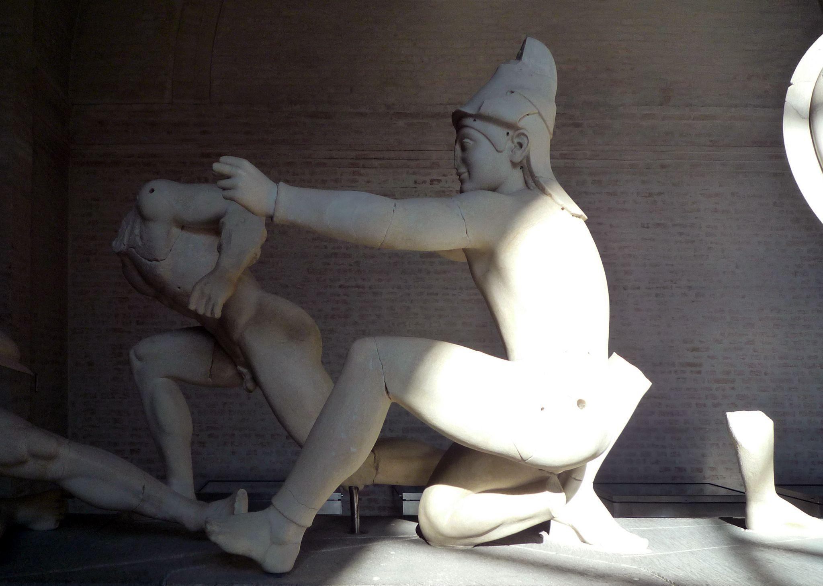
Fig. 1. Paris, West Pediment in Sun
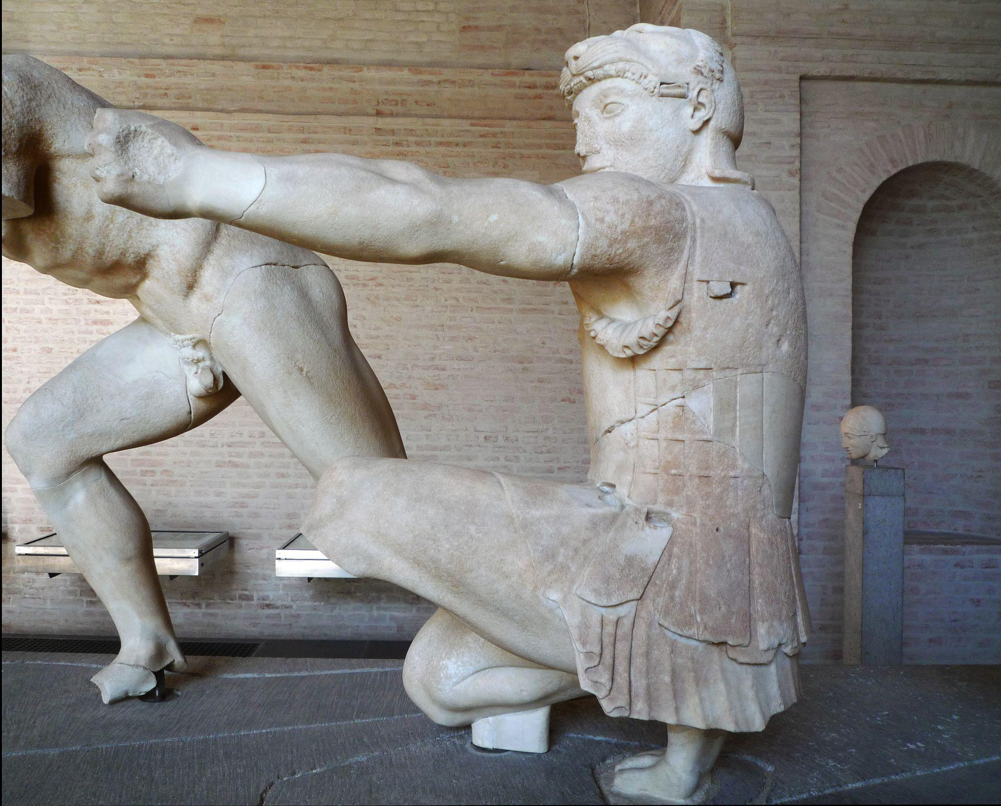
Fig. 2. Herkales, East Pediment
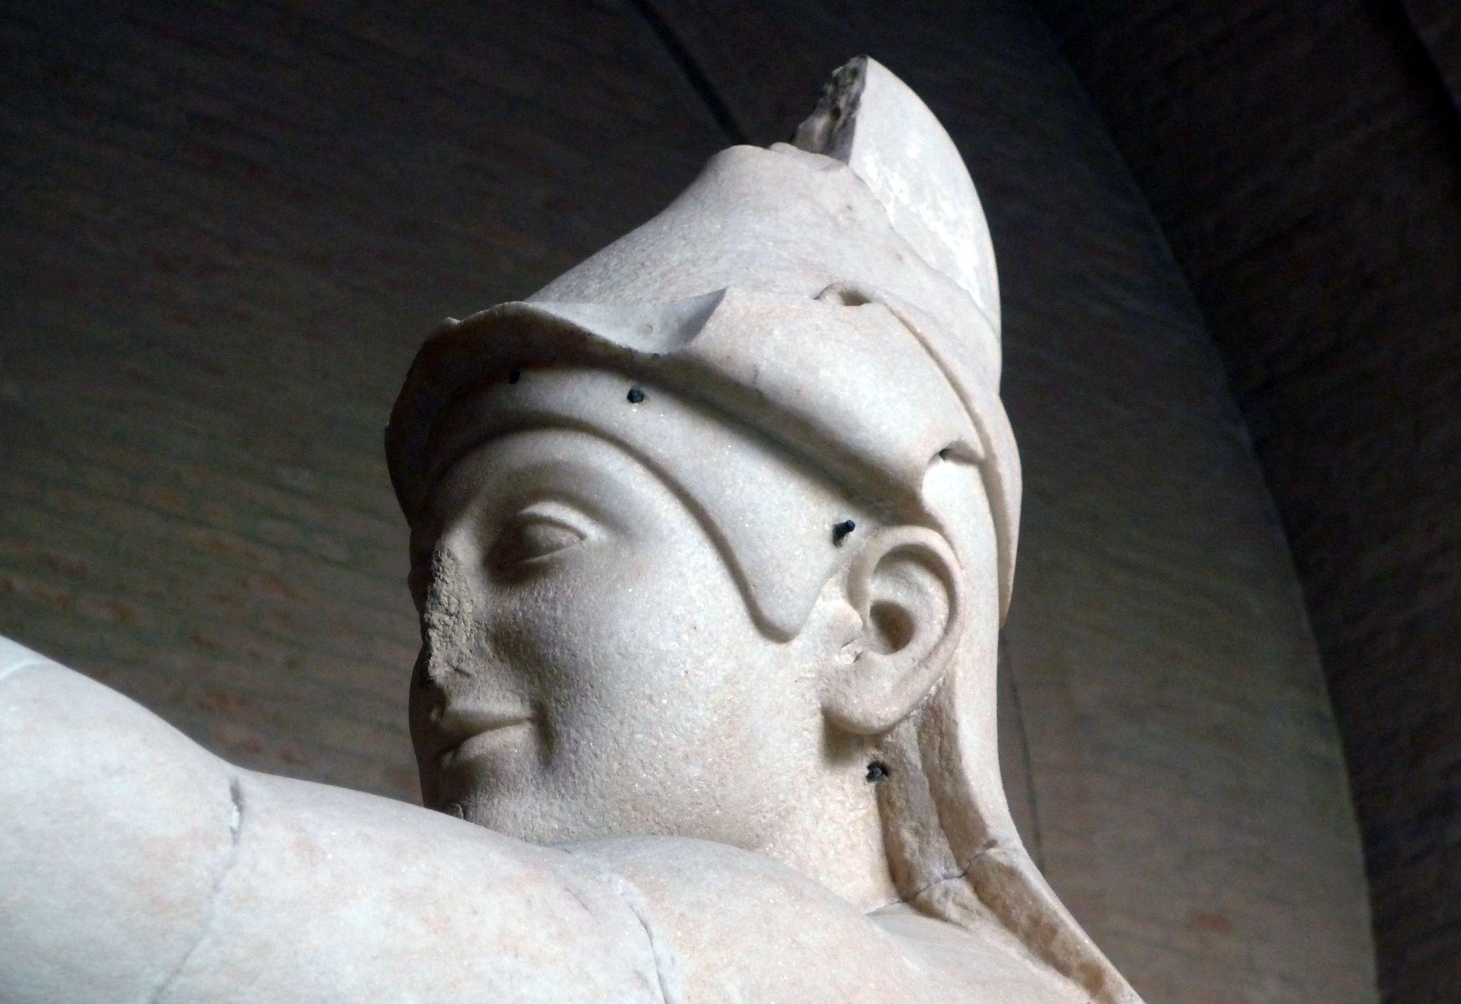
Fig. 3. Paris (Close), West Pediment
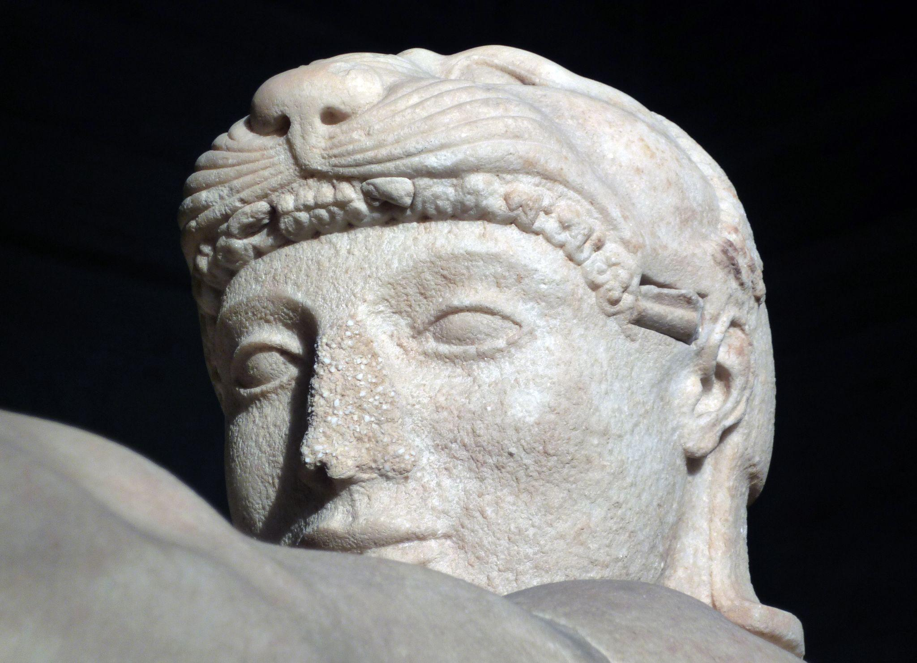
Fig. 4. Herakles (Face), East Pediment
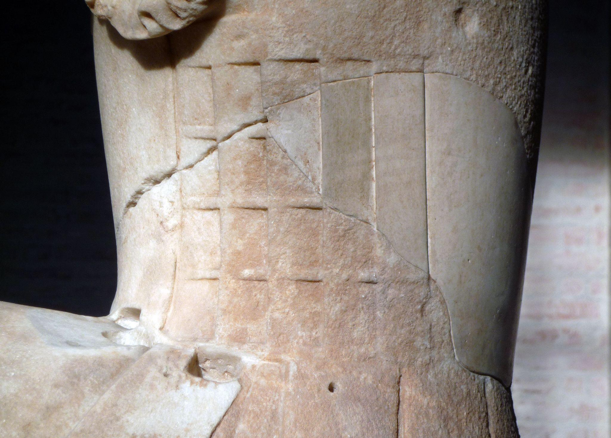
Fig. 5. Herakles (Side plates)
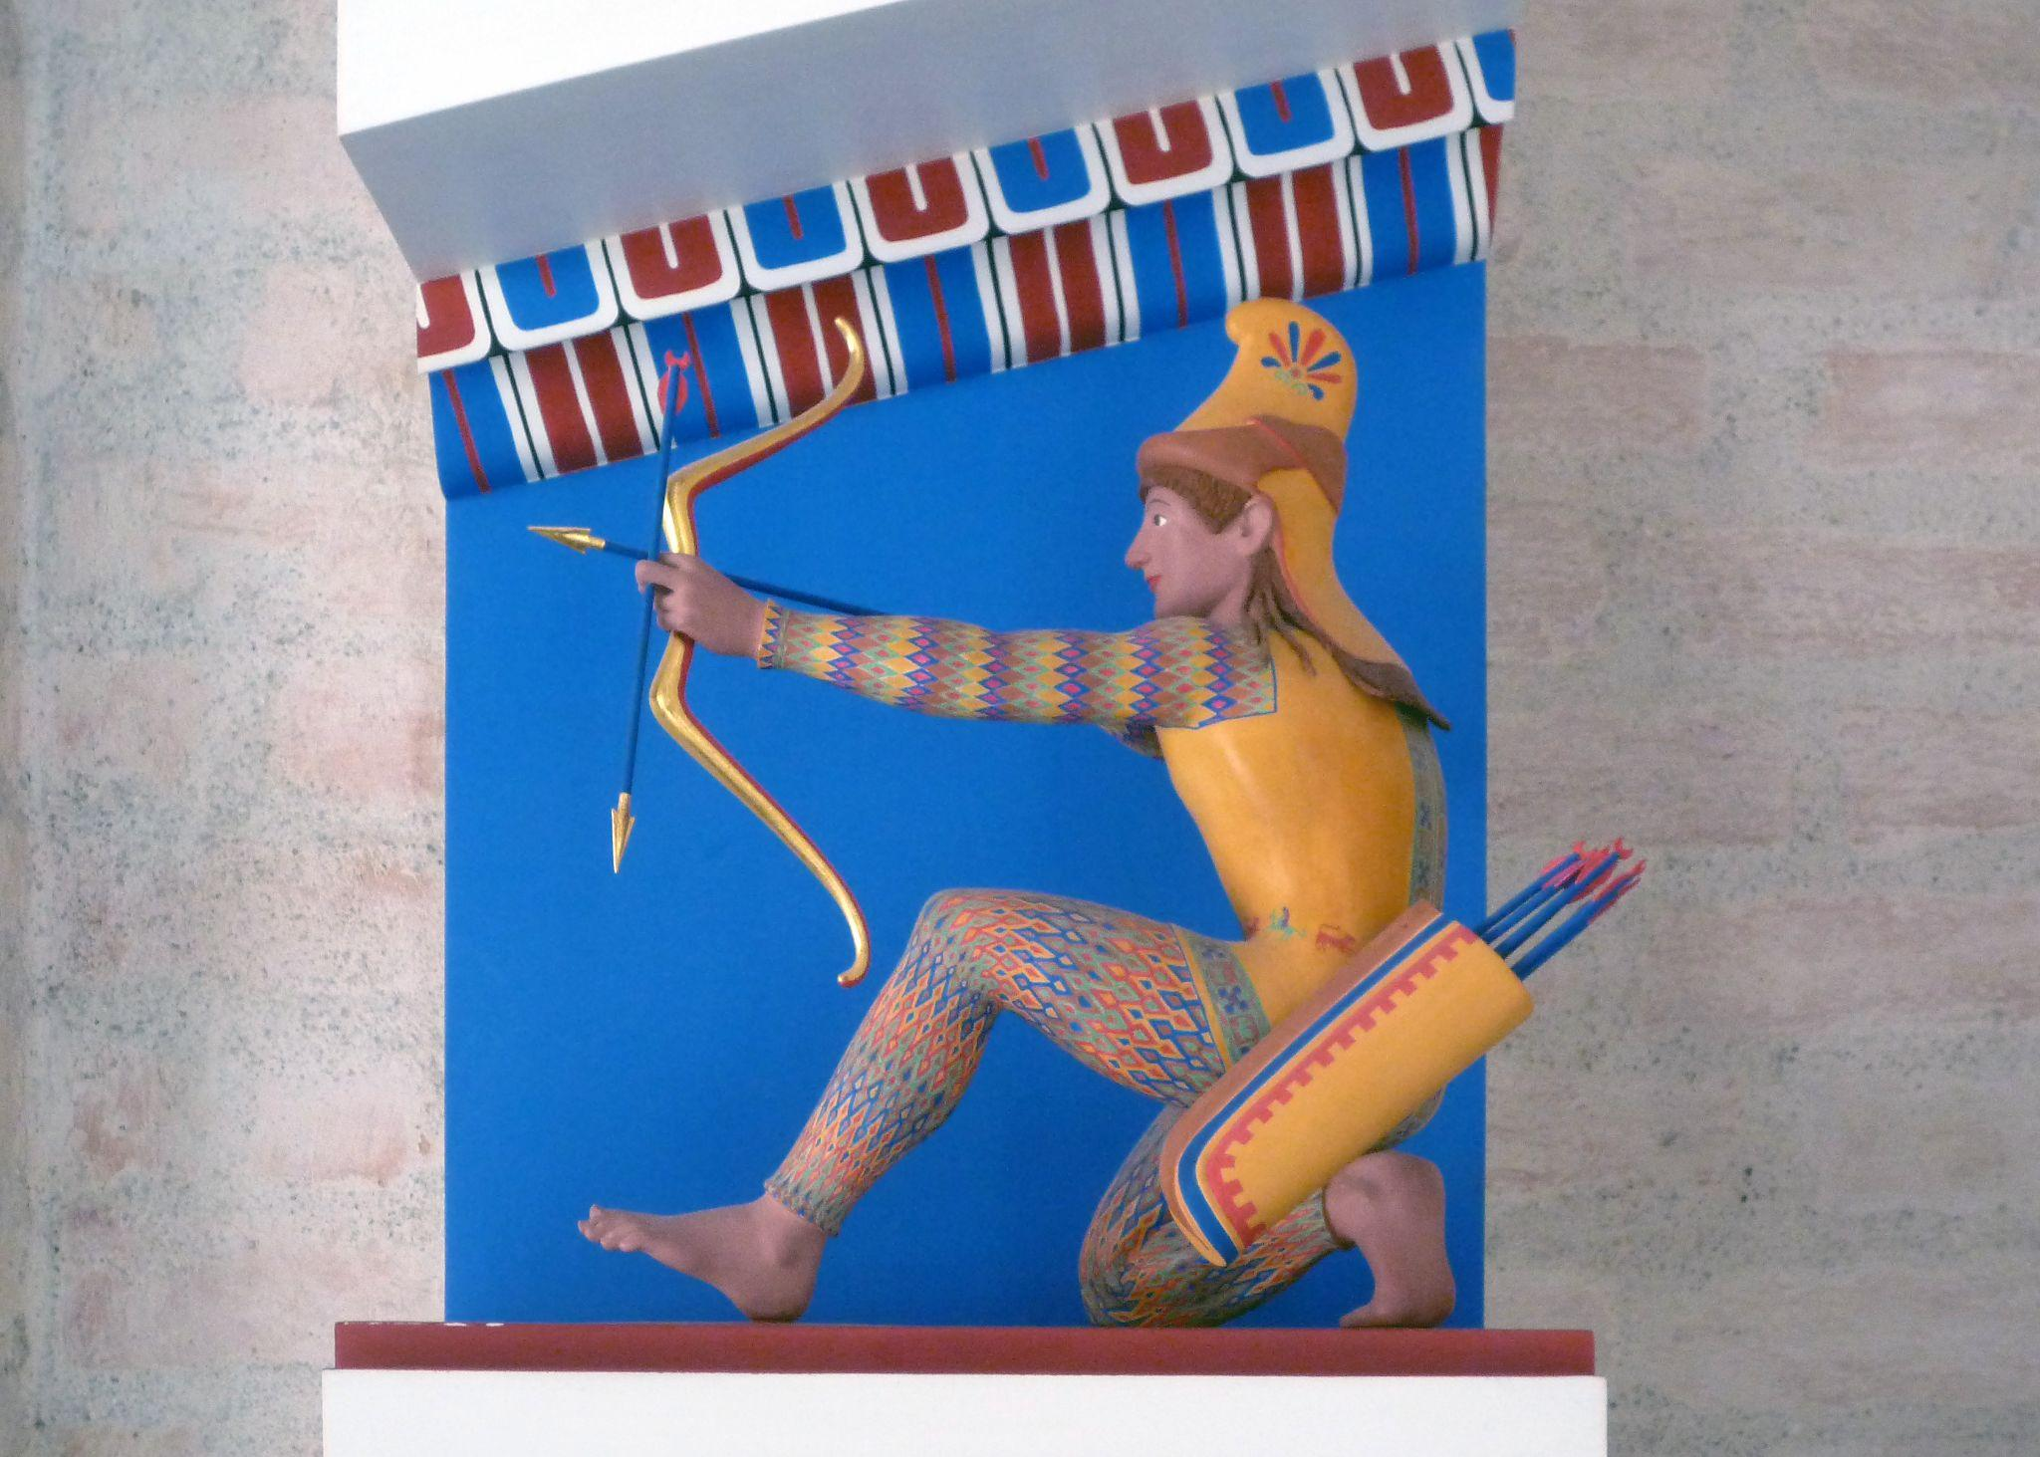
Fig. 6. Painted Mockup (Close)

The same comparison can be made between the two figures of wounded warriors, one on each pediment. The figure on the west pediment is clearly an archaic sculpture, looking almost as if a standing kouros has simply been tipped over (Harris and Zucker, 2015) rather than a man fallen in battle and clearly wounded. The figure lays on its left hip, propped up with the left arm while the right leg crosses over the left in an unnatural fashion and the right arm grasps the embedded spear, elbow held at an awkward angle (Fig. 7). The archaic smile here (Fig. 8) is in stark contrast to the image of the figure; the typical archaic smile gives the figure a serene and transcendent quality, and may even have been a symbol of health (Encyclopedia Britannica, 2018) which directly contradicts with the scene the figure is depicting. It is hard to imagine anyone impaled by a spear in battle would be at such ease as this figure on the west pediment. In a discussion of the temple of Aphaia’s pediments, Harris and Zucker (2015) note that one art historian - whom they do not name - compares archaic sculpture with vase painting and proposes that rather than an attempted at naturalism this figure is instead created for the purpose of displaying an ideal musculature. This would certainly explain the unnatural angle of the body, as well as the awkward angle of the right arm as it grasps the spear without blocking view of the torso (Fig. 9).

Whatever the purpose of the archaic figure’s unnatural seeming positioning, the figure of the wounded Laomedon on the east pediment (Fig. 10) shows a stark development in the depiction of those wounded in battle. Unlike his west pediment counterpart, the figure of Laomedon does not face completely outward, but instead the body is turning, as if having fallen on his back and now attempting to push himself back up. His right hand grasps a now missing sword and his left is still strapped into his shield (Fig. 11), and he uses these in an attempt to brace himself and stand up. While again the archaic smile is still somewhat present (Fig. 11 and 12), this figure depicts a much more realistic image of a wounded warrior. The figure is merely a symbol on the west pediment, somewhat detached from the human experience, whereas on the east pediment it has developed into a true snapshot of the reality of warfare. It is important to note as well the idea of heroic status through nudity in these pediments. While Herakles and Paris are both clothed their status does not need to be specified in this way as they are easily identifiable, especially Herakles. The wounded warriors however are both nude, something that is like an artistic choice rather than a realistic aspect of warfare that is used to accentuate the heroic quality and the idea of the “archetypal state” of Greek males in art (Echeverría, 2015, p.38).

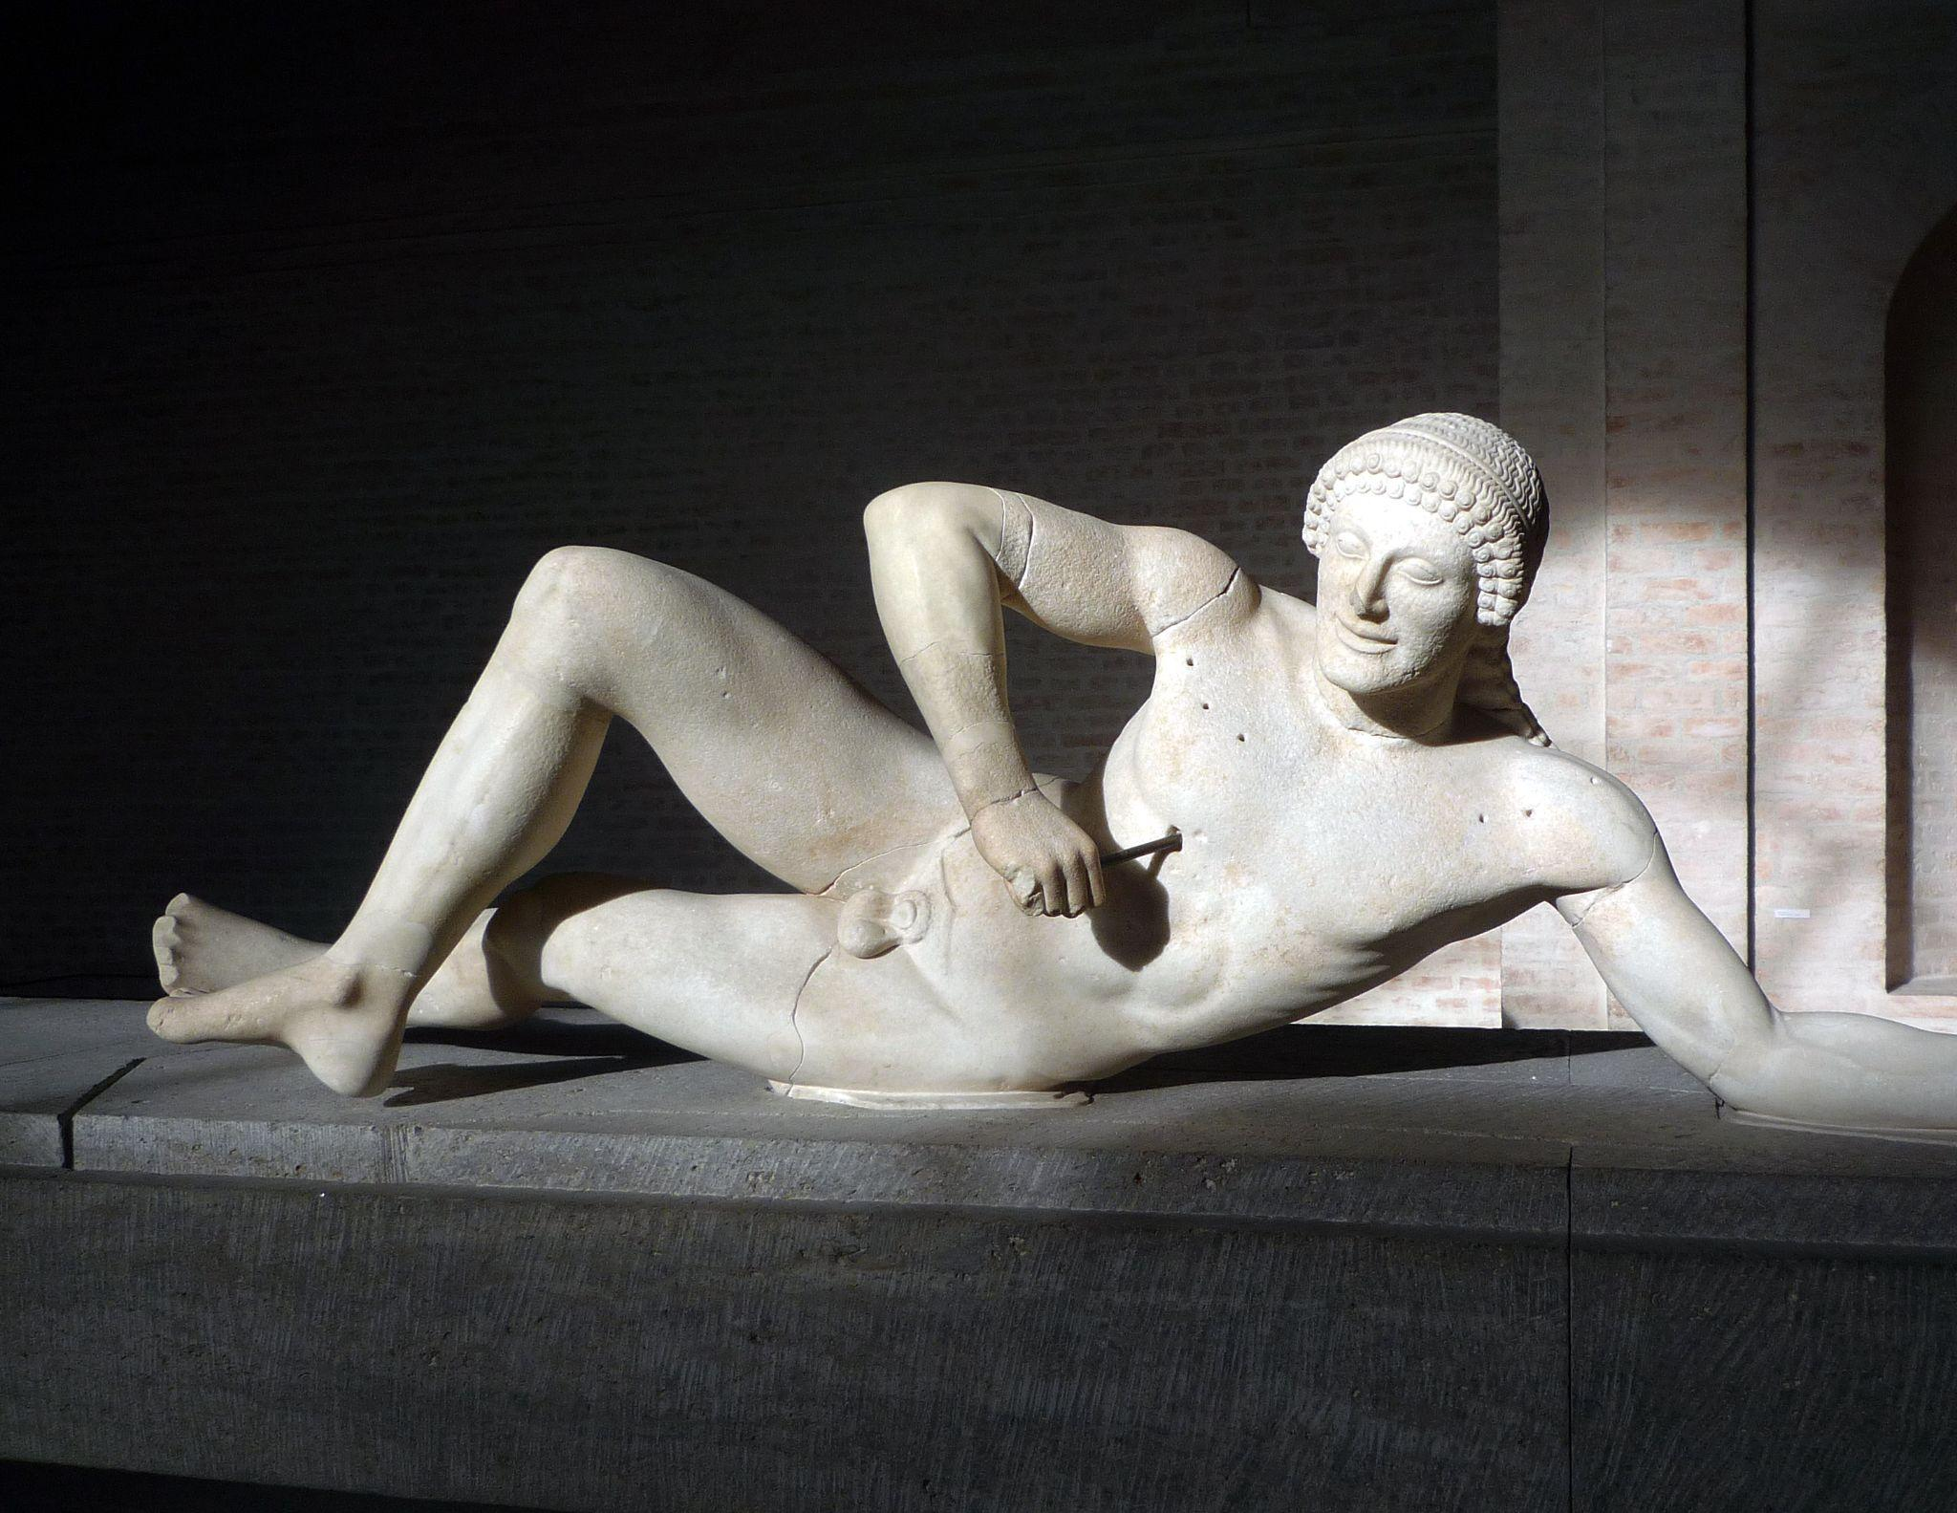
Fig. 7. Impaled Figure, West Pediment
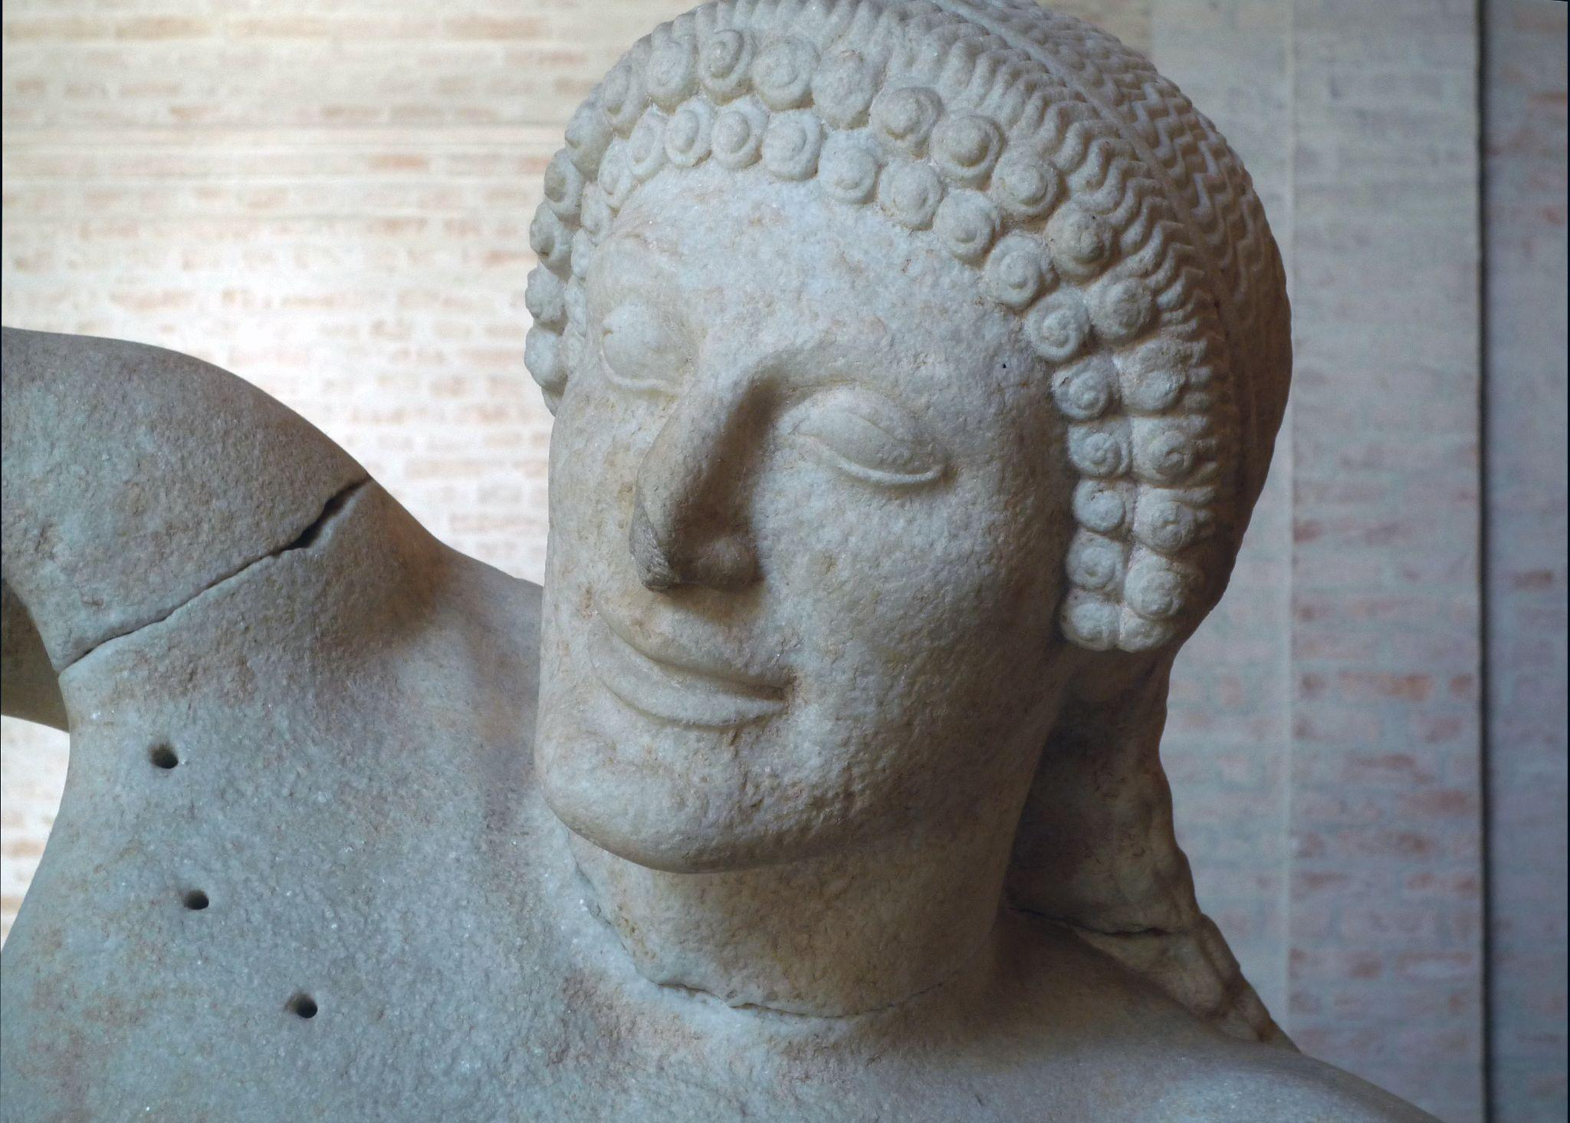
Fig. 8. Head of an Impaled Warrior, West Pediment
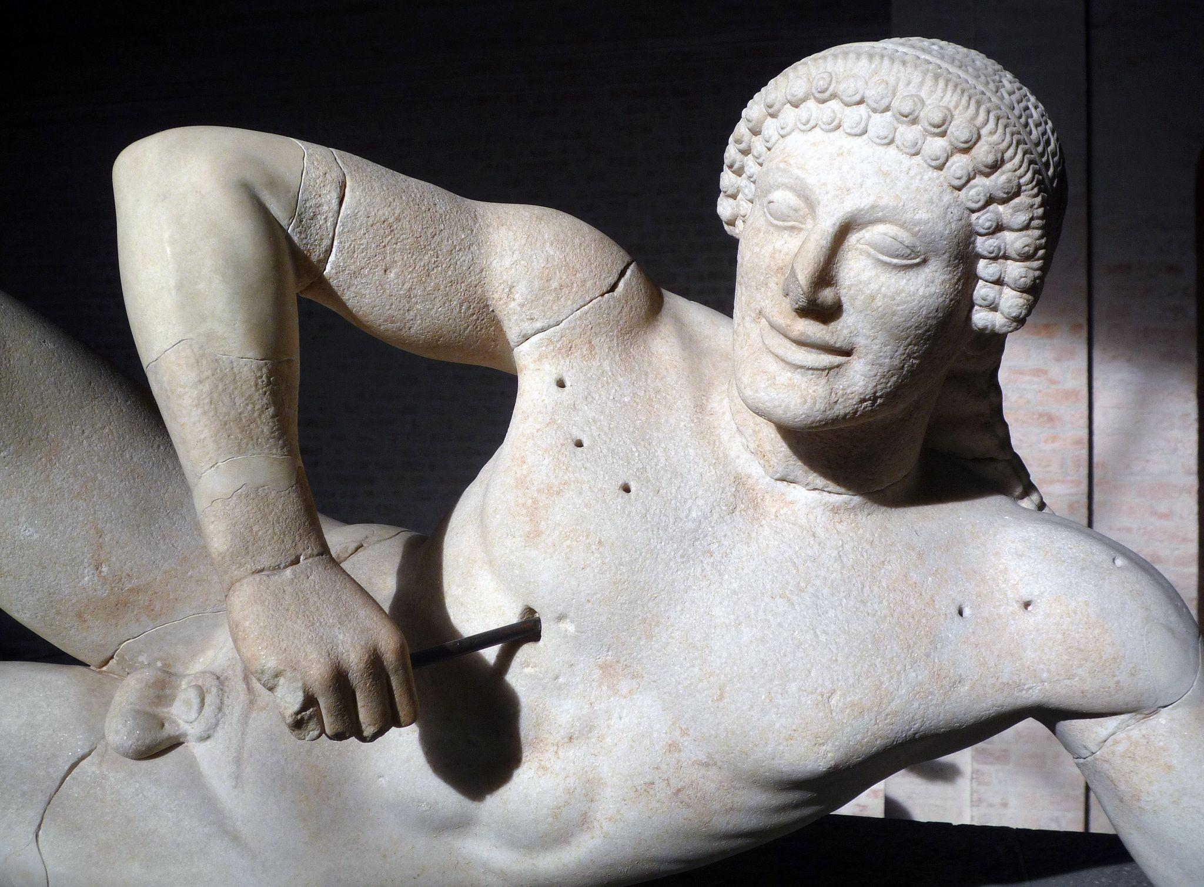
Fig. 9. Impaled Torso, West Pediment
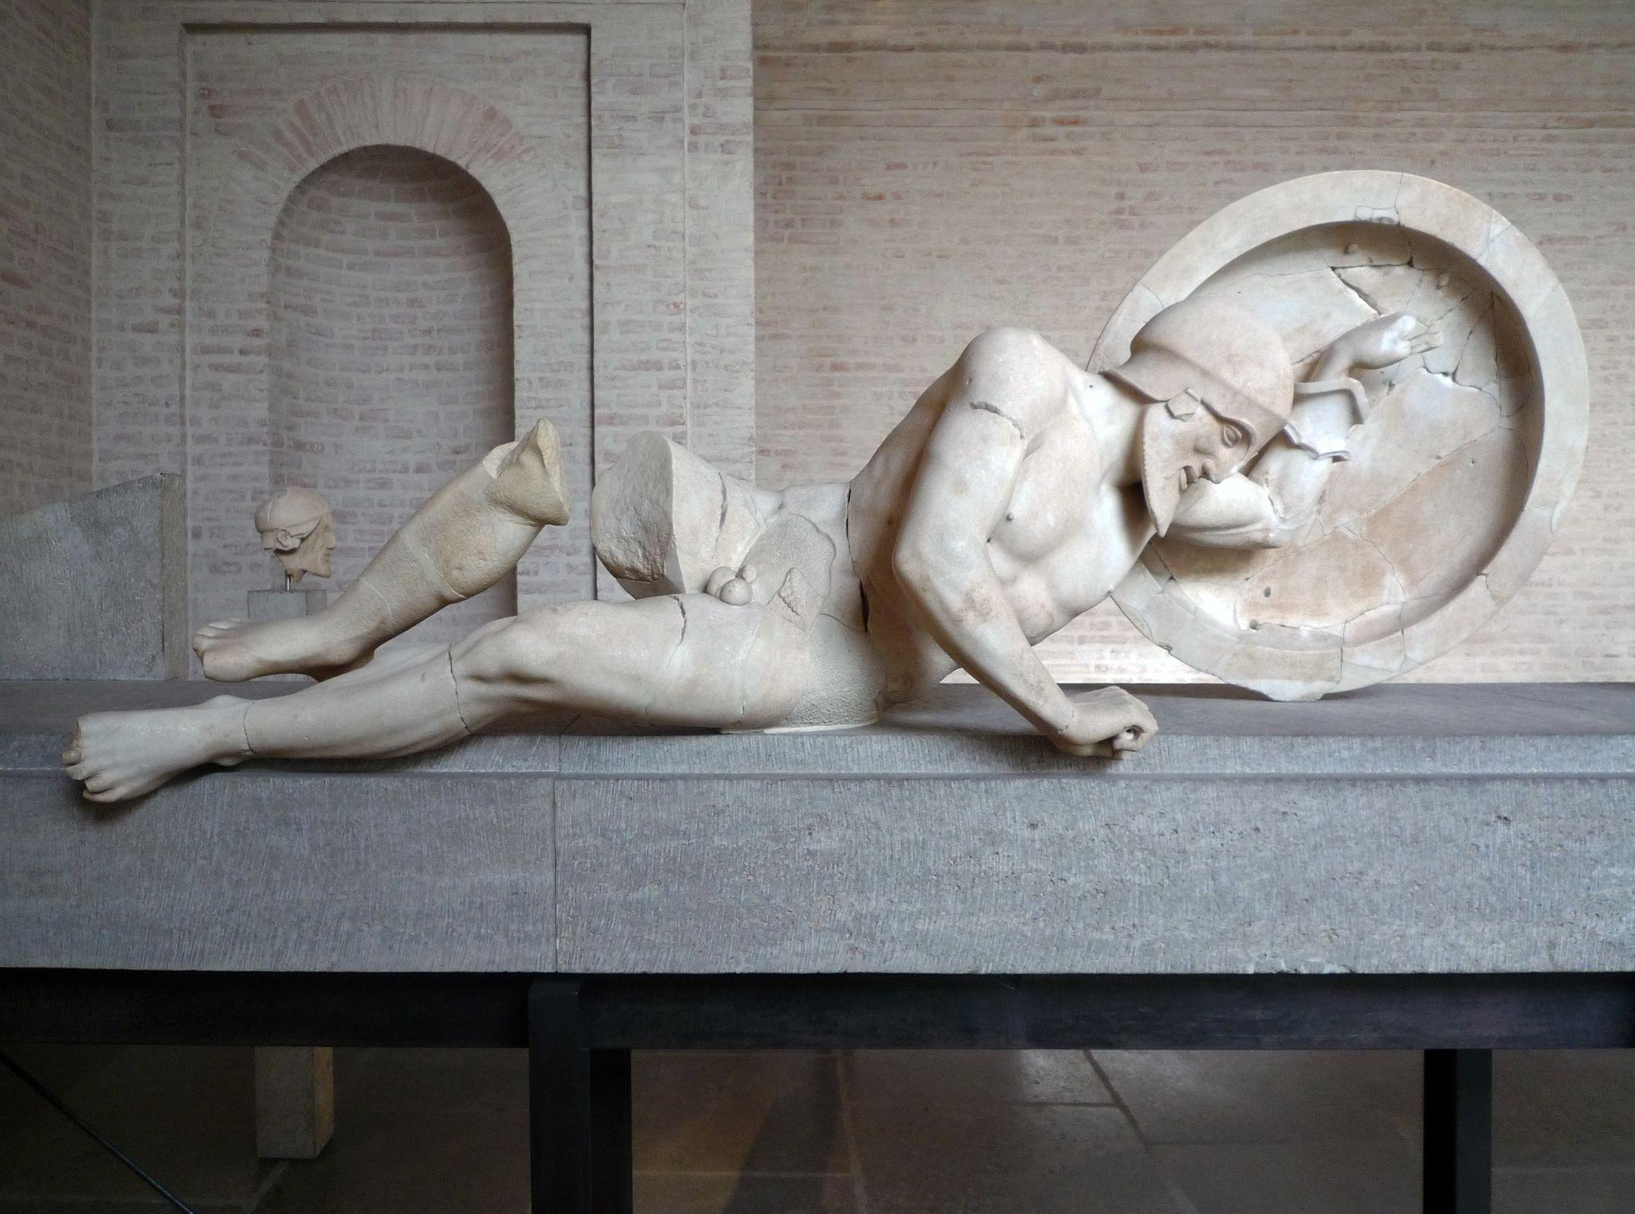
Fig. 10. Laomedon, East Pediment
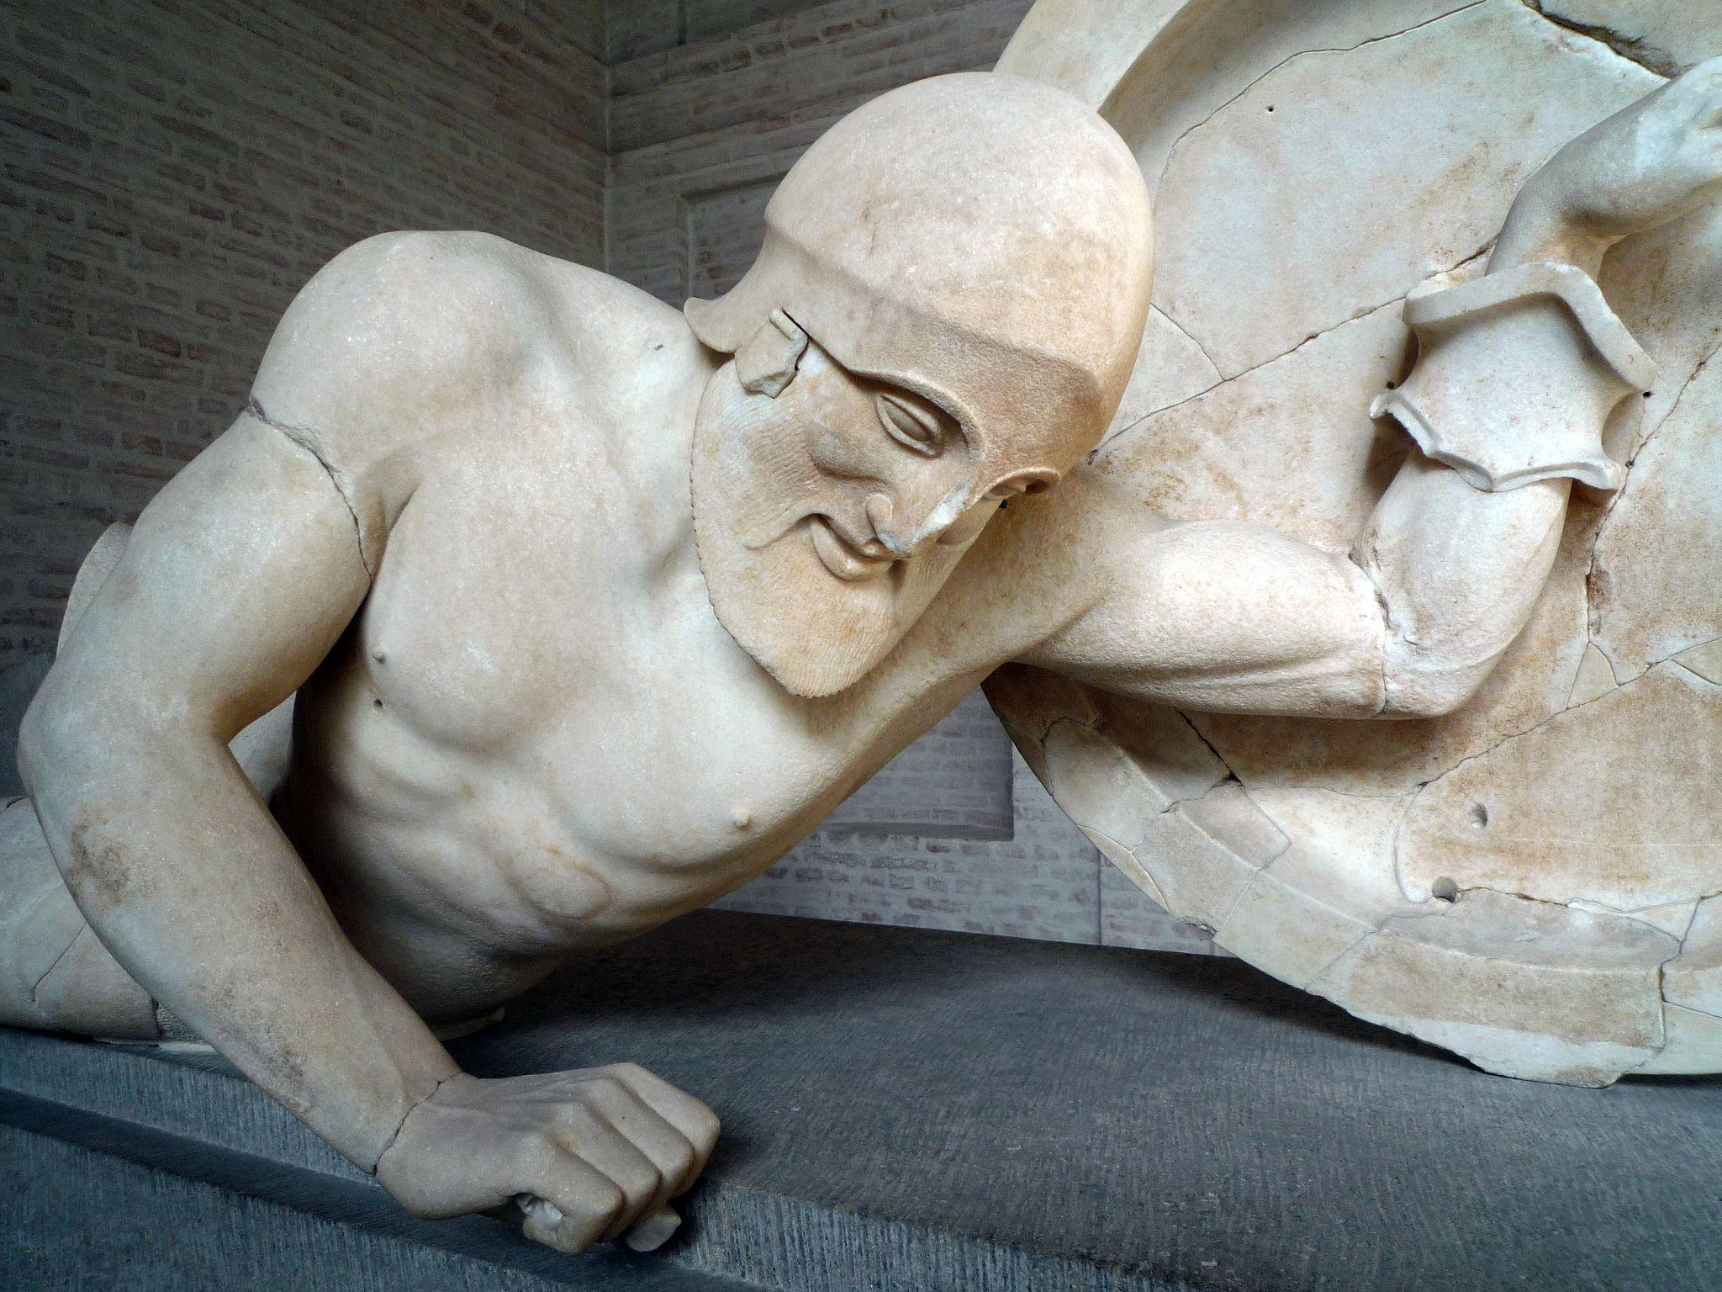
Fig. 11. Laomedon (Oblique), East Pediment
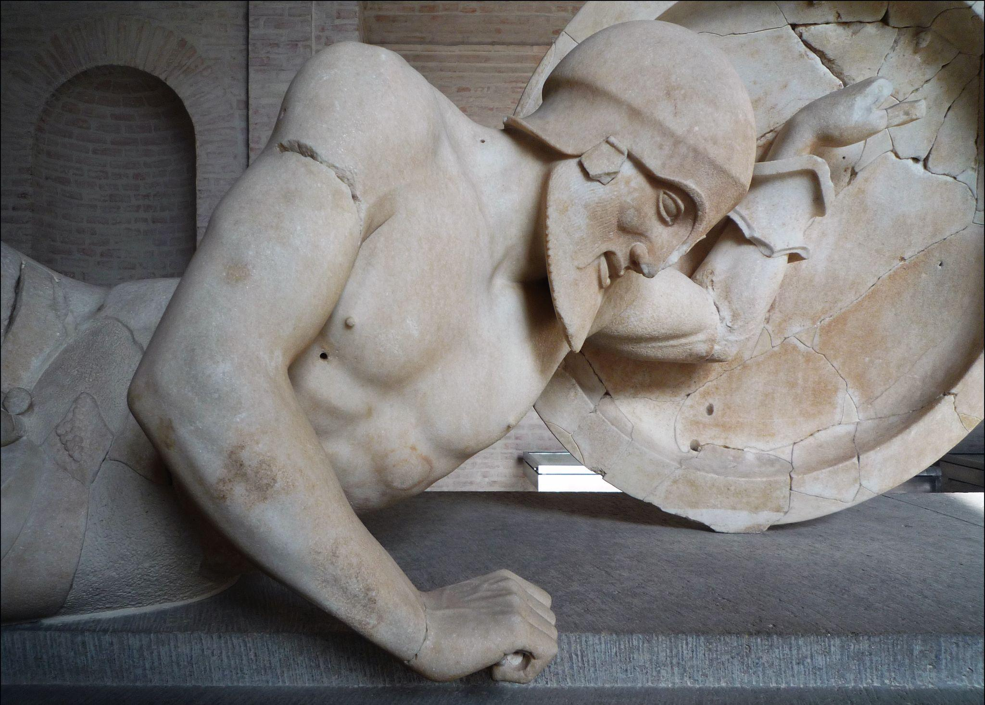
Fig. 12. Laomedon (Upper Body), East Pediment

The temple of Aphaia at Aegina is far from being the only artistic depiction of the Trojan war famously recounted by Homer. Scenes from the legendary war were often depicted in both architectural sculpture - pedimentary and relief - and vase paintings, especially around the time of the Persian wars. One such notable example is the hydria by the Kleophrades painter (early 5th Century) depicting the sack of Troy (Fig. 13 and 14). This hydria in particular was painted shortly after Athens was invaded and the acropolis sacked by the Persians in 480 BCE (placing it in the classical art period), and so we can see a clear link between a devastating contemporary battle and a well known Greek myth. While Webster (1932, p.137) accurately states that the occurrence of the Persian wars had not been the cause in the shift of art style in vase paintings, it is inarguable that the socio-cultural effect can be seen through art. While the sculptures on both pediments of the temple of Aphaia do have minor interactions between each section, the images are generally sectioned into smaller groups with little action extending from one end of the pediment to the other. The Kleophrades hydria, however, is immensely different. The action is almost continuous around the vase; the beginning and end of the scene meet due to the cyclical nature of the vase, making the scene of battle more vivid as it is contained within itself.

Additionally, the scenes depicted in this hydria are more effective at showing the realities of warfare than the previous pediments, despite not being an accurate rendition of reality (Echeverría, 2015, p.33). Not only does the painted figure allow for a higher degree of physical dynamism than seen in the Aphaia pediments, but the vase depicts a level of tragedy and bloodshed missing from these pediments. We see Priam bleeding, his young grandson and the son of Hektor Astynax draped across his lap, slain by Neoptolomus the son of Achilles (Fig. 13), a tragic parallel to the scene in which Achilles kills Hektor. Kassandra can be seen clutching at a statue of Athena and imploring Ajax not to harm her, yet the audience would be well aware her pleas here would be meaningless and her fate would be typical for a woman with the misfortune to be caught in battle. The tragedies committed to men, women and children alike are all represented in this one scene. This particular hydria depicts battle as violent, bloody and without mercy, an idea surrounding warfare that was no doubt fresh in the minds of both the painter and any potential audience in the wake of the Persian invasion of Athens.

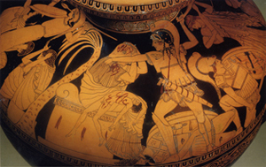
Fig. 13 Kleophrades Painter Hydria ‘Sack of Troy’
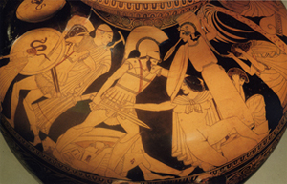
Fig. 14 Kleophrades Painter Hydria ‘Sack of Troy’

While the Kleophrades hydria is not unique in its approach to the depiction of warfare as particularly tragic and violent, even after the Persian war not every approach to battles and warfare is as detailed or focused on the effects to a larger group. This volute krater attributed to the Berlin painter (c.490-460 BCE) focuses on two particular battles: Achilles against Hektor, and then Achilles against Memnon (Fig. 15-18). The two scenes mirror each other, though with small differences. One side depicts the fight between Achilles and Hektor after Hektor kills Patroklus (Fig. 15 and 16), with Athena watching on from Achilles’ side and Apollo watching on from Hektor’s. Achilles is lunging forward towards Hektor, his spear prepared to make the final blow as Hektor, already wounded, falls backwards, his shield held out to the side as he falls and his spear tilting to the ground. Behind Achilles is Athena (Fig. 17), aegis draped across her shoulders and spear held in her right as her left is outstretched, perhaps an encouragement to Achilles, and on Hektor’s right is Apollo, looking back at the scene with a bow in one hand and an arrow in the other as if he were to throw it. Each figure on the vase has their name etched beside them, but even without the engraved names the scene is recognisable as the last moments of the fight between the two opposing warriors.

The opposite side of the vase depicts a similar battle, but this time between Achilles and Memnon, after Memnon has killed Antilochus, the son of Nestor. In this parallel to the fight between Achilles and Hektor, Achilles takes the place on Nestor in avenging the death of the elder man’s son by Memnon’s hand. Achilles in both scenes holds the same pose, striding forward ready to deal a blow with his spear. However, these identical poses are not likely to make him recognisable as the same character in both scenes, as his name is engraved next to each figure. It is possible that instead of the identical pose making him identifiable as Achilles, the pose is meant to identify him as the avenger of both Antilochus and Patroklus. It also elevates Achilles as a soldier and a leader: he is just as willing and ready to fight in response to Nestor’s loss as he is his own. This suggests a value in camaraderie and kinship amongst fellow soldiers that is not necessarily highlighted in other surviving works. As well as the focus on loss between soldiers and father and son, this second image also highlights a mother’s loss of her child, as Thetis and Eos watch their children, Achilles and Memnon respectively, fight to the death. The loss evoked here is particularly poignant, as while Achilles is victorious in this battle he does not survive the war, and so both mothers in this image suffer the same fate of losing their child to war.

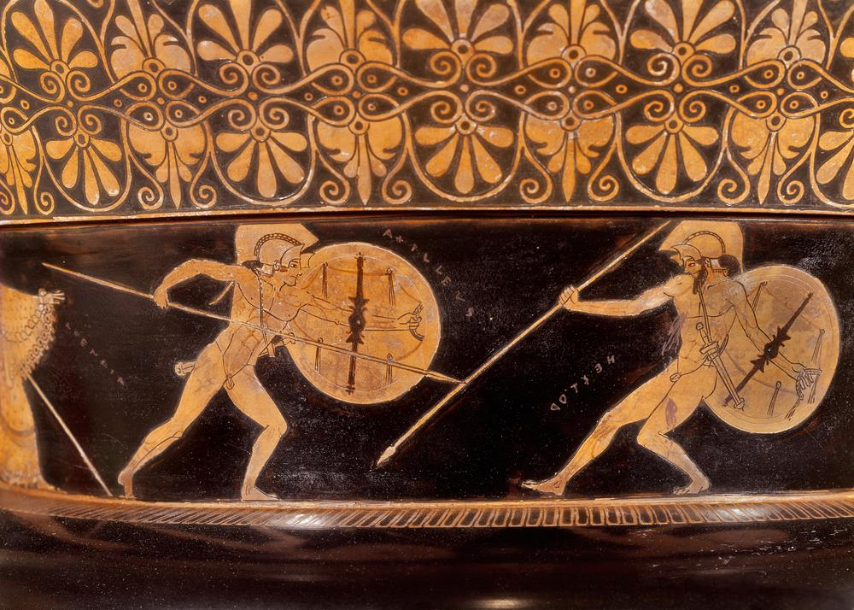
Fig. 15. Volute krater. Achilles and Hektor fight, Athena and Apollo look on (names visible)
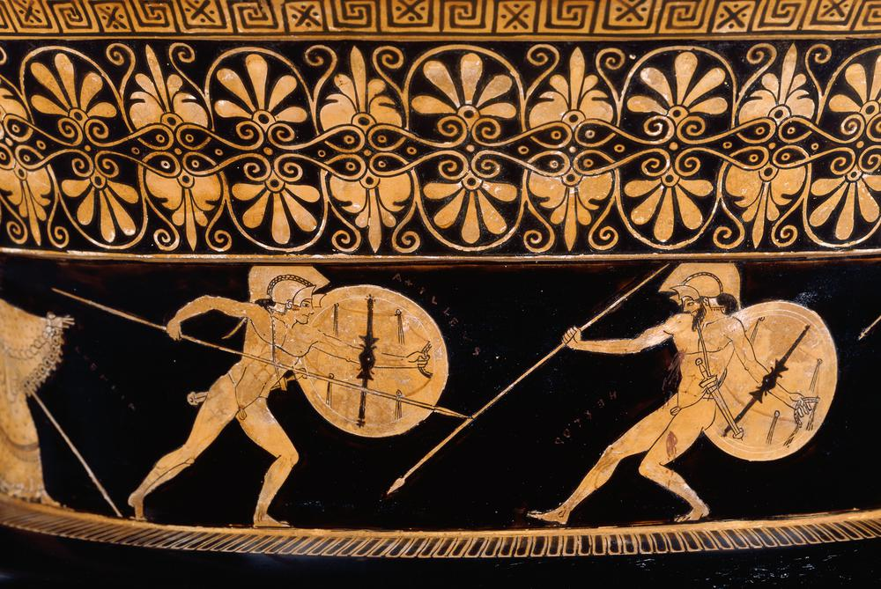
Fig. 16. Volute krater. Achilles and Hektor fight, Athena and Apollo look on
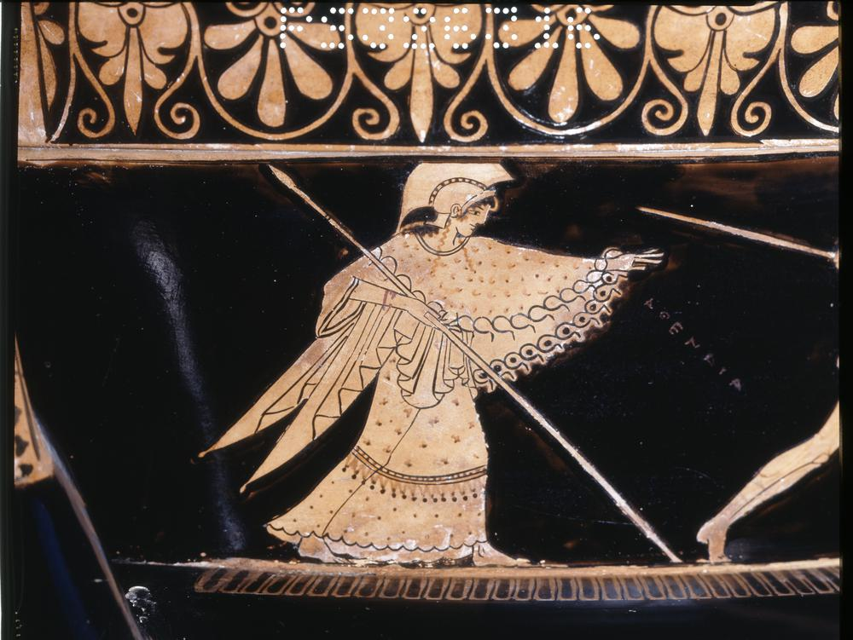
Fig. 17. Volute krater. Athena watching Achilles and Hektor
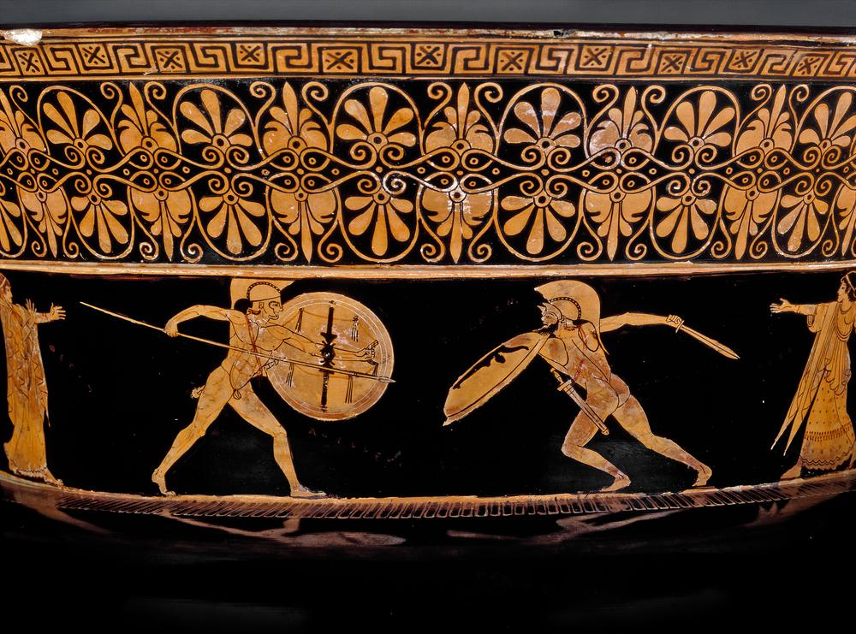
Fig. 18. Volute krater. Achilles and Memnon, Thetis and Eos look on

Achilles’ pose in the Berlin painter volute krater is a pose easily identifiable in many other vase paintings, both for other depictions of Achilles and for soldiers in general. In an archaic period amphora painted by Exekias (c.540-530 BCE), for example, we see Achilles in a very similar position, killing the Amazon Penthesilea (Fig. 19). A noticeable difference in this image, however, is the two figures are closer in proximity than either scene on the Berlin painter volute krater, with Achilles only needing to step forward to drive his spear into Penthesilea’s throat rather than charging from a distance. The art style of this archaic amphora is notably different to the classical Berlin and Kleophrades vases, not only being a black figure vase as opposed to red figure, but the human figure as depicted here is clearly more stylised in the archaic way. Both Achilles and Penthesilea’s torsos are facing directly out towards the viewer, despite their legs clearly being positioned sideways. Additionally, Penthesilea’s head is turned around to face Achilles, despite her legs suggesting her body should be turned away from him. The movement in battle here, while suggested, is much less believable than in the later vases, where the movement in the figures’ bodies seems much more natural and realistic.

Another amphora by Andokides (c.530-520 BCE) depicts two unnamed hoplite soldiers in similar positioning, flanked by Athena and Hermes (Fig. 20 and 21). Both soldiers are stepping forward, spears raised in one hand and bearing shields on the opposite arm. While both hoplite soldiers appear appropriately kitted for battle, the soldier on the left is bearing a Boeotian shield, which as Echeverría (2015, p.37-8) notes is controversial in its status as a real archaic shield. The Boeotian shield, along with items such as chariots, wielding multiple spears and even archers, is typically associated with more open forms of combat, an idea that directly contradicts the phalanx formation attributed to archaic warfare (Echeverría, 2015, p.39). As previously stated, multiple scholars disagree with the idea of the Boeotian shield, or the Dipylon shield, as having been a real aspect of archaic warfare, leaving us to draw the conclusion that if this is the case then these vase paintings cannot be depicting real practices of warfare but instead those of heroic legend (Echeverría, 2015, p.39). The presence of the gods in these artworks only furthers this idea; Homer’s Iliad in particular gives us an idea of how the Greek gods would get involved in warfare in their myths and this is reflected in numerous vase paintings and architectural sculptures.

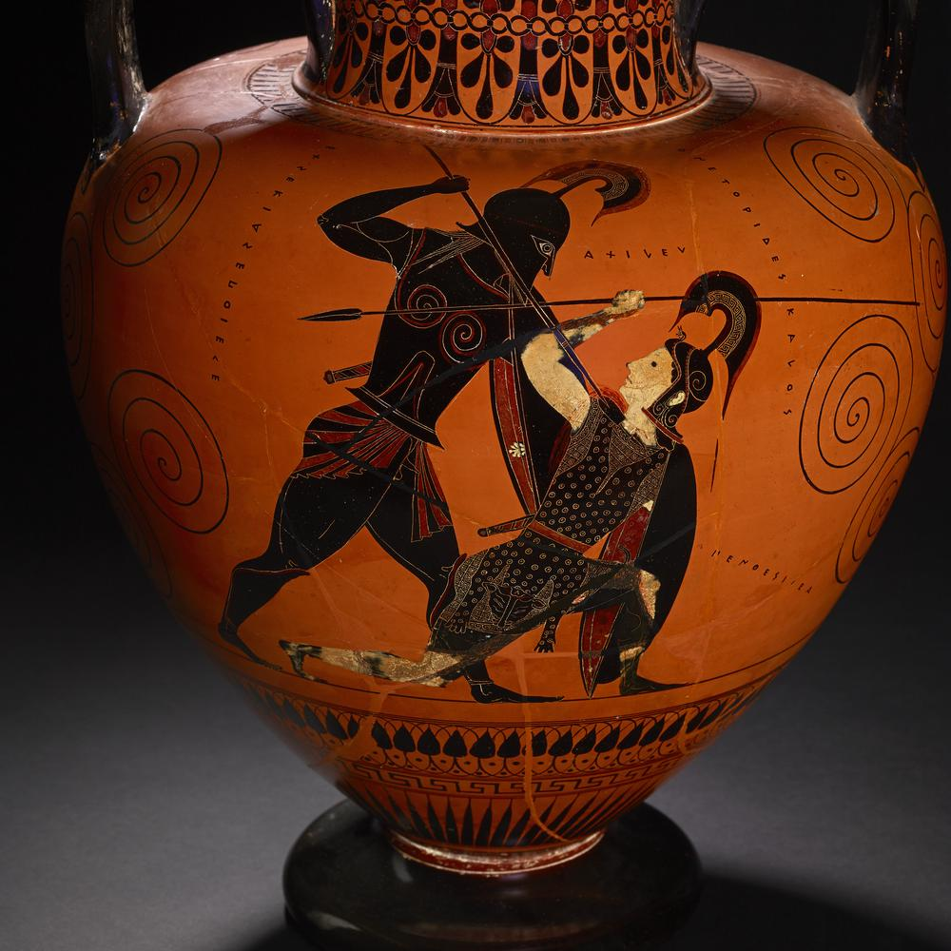
Fig. 19. Exekias Amphora. Achilles kills Penthesilea
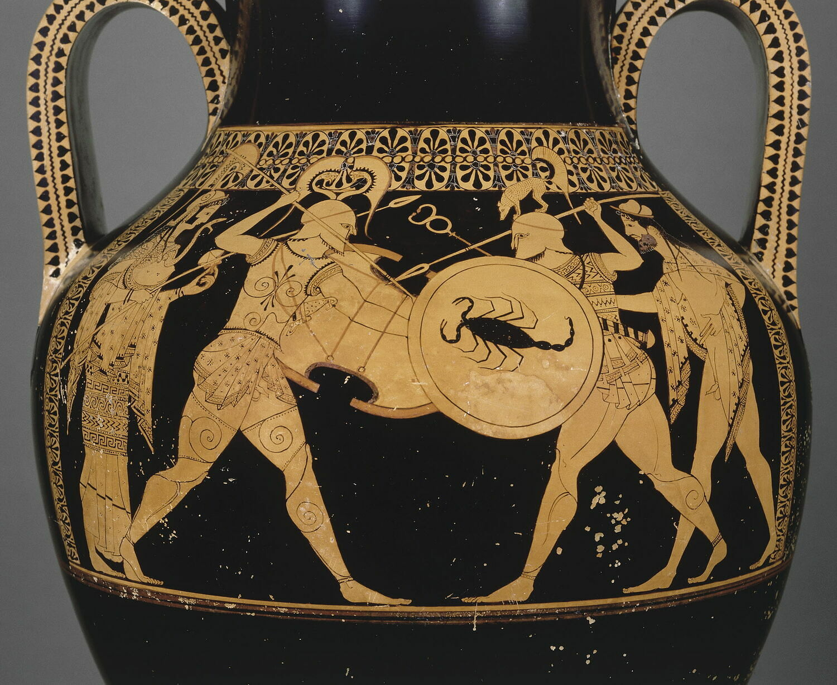
Fig. 20. Andokides Amphora. Hoplites fighting, Athena and Hermes look on
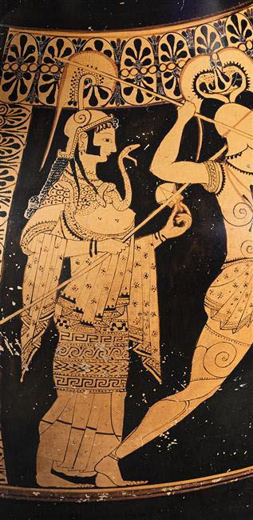
Fig. 21. Andokides Amphora. Athena

The somewhat unusual forward facing positioning of the body can also be seen in archaic relief sculpture, such as on the east and north friezes of the Siphnian Treasury (c.535 BCE). On the east frieze of the Siphnian Treasury is an image of Achilles and Memnon fighting over the body of Antilochus (Fig. 22), and the positions of their bodies are much like the later volute krater by the Berlin painter, though again with some clear differences. While the painted Achilles and Memnon have a very clear sense of movement, this is considerably lacking in this frieze. Of course, relief sculpture has a completely different set of limitations than vase painting, however the attempt at movement here seems stiff and unnatural. While Achilles’ head and legs are facing towards Memnon, his torso is facing out towards the viewer, creating a very awkward position for one who is supposed to be charging forth in battle. While the Siphnian Treasury friezes - especially the north (Fig. 23) - are very successful at creating a sense of depth in the depiction of battle, the archaic style lends itself to some very awkward and unnatural positioning that one would not expect from a battle scene.

In comparison, the southern metopes of the Parthenon (447-438 BCE) depicting the fight between the centaurs and Lapiths are significantly better at managing to show off the muscular torsos of the fighters while also having those depicted in a more realistic seeming way, to a certain extent. For example, metope XXVII (Fig. 24) depicts the Lapith grabbing the back of the centaurs head, ready to deal a blow as the centaur has reared up and reached his right hand around to press at the wound. This action is incredibly graceful for such a violent battle, as the two figures arch in opposite directions and create a somewhat cyclical action in the image, completed by the draping of the Lapith’s chlamys. While this is not the most natural pose for someone fighting, the movement of the body seems more realistic, with the sections of the body following the same line of action instead of doing separate things. Metope XXVIII (Fig. 25) is similar in this aspect; the attacking centaur is reared up on his hind legs over the wounded Lapith on the floor. The Lapith’s body is tilted towards the viewer more than would realistically happen, but it still effectively creates the image of a pained and fallen man. There is also an implication of forward movement from the centaur, as the feline skin draped over his arm swings out behind him. Of these selected sculptures, Metope XXXII (Fig. 26) is the most realistic depiction of a moment in battle, regardless of the fictional content. The two figures are more realistically intertwined in their fight, as the centaur grabs the back of the Lapith’s head and his forelegs cage the Lapith in place. The metopes of the Parthenon are not only more effective at showing movement in battle than the Siphnian Treasury friezes, but the metopes frame each image with a certain grace that suggest a sense of pride in the act of battle itself.

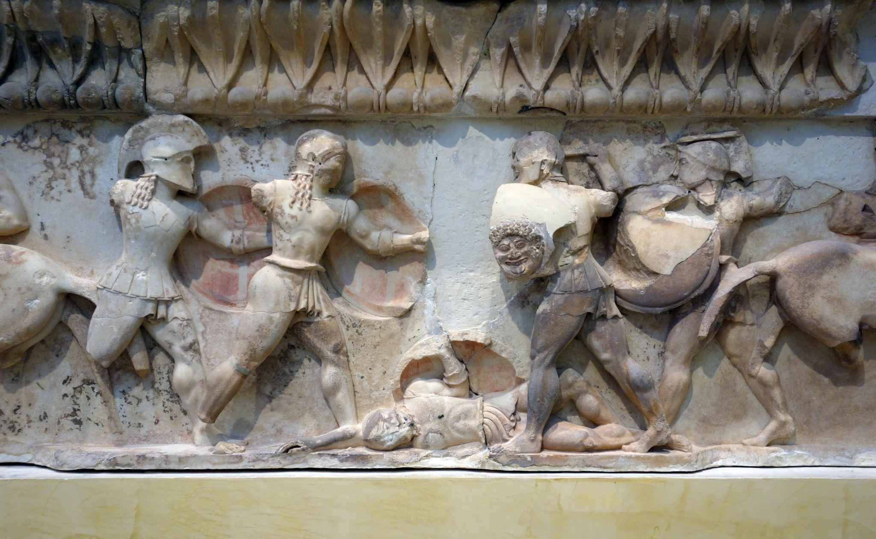
Fig. 22. East Frieze (detail). Siphnian Treasury. Memnon and Achilles.
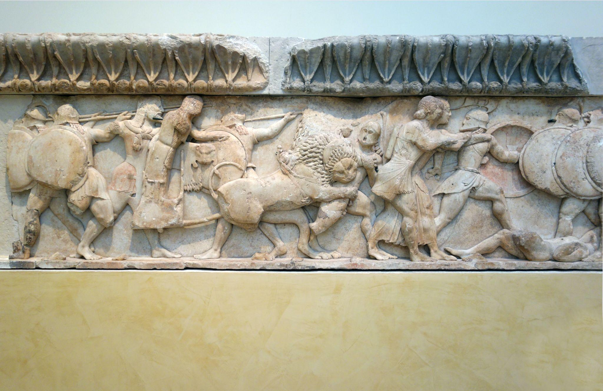
Fig. 23. North Frieze, Siphnian Treasury
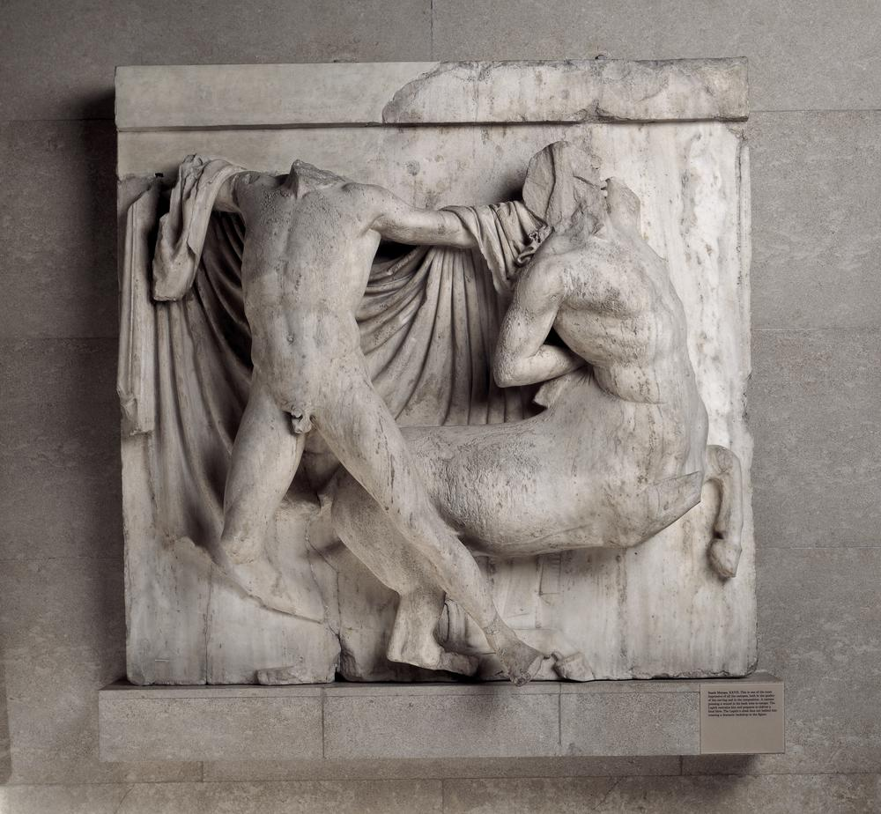
Fig. 24. Parthenon South Metope XXVII
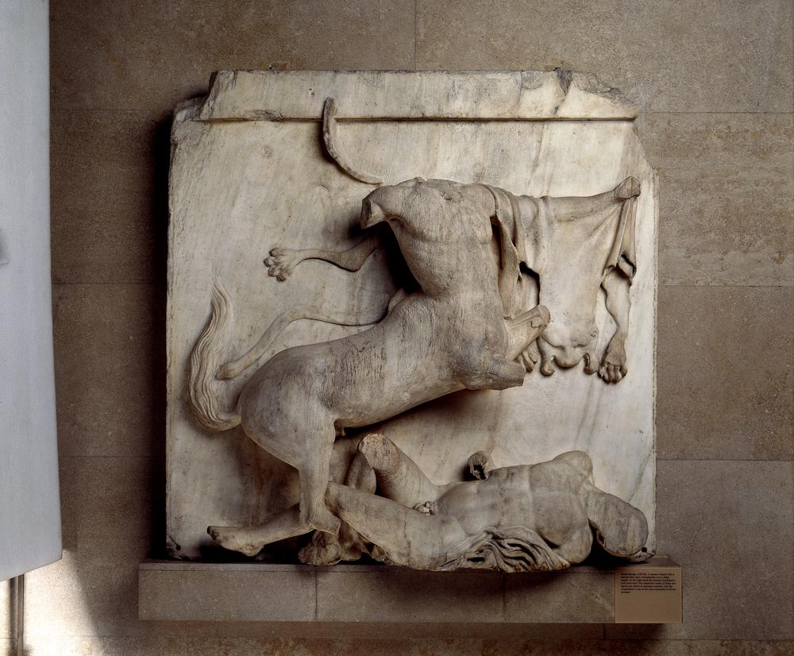
Fig. 25. Parthenon South Metope XXVIII

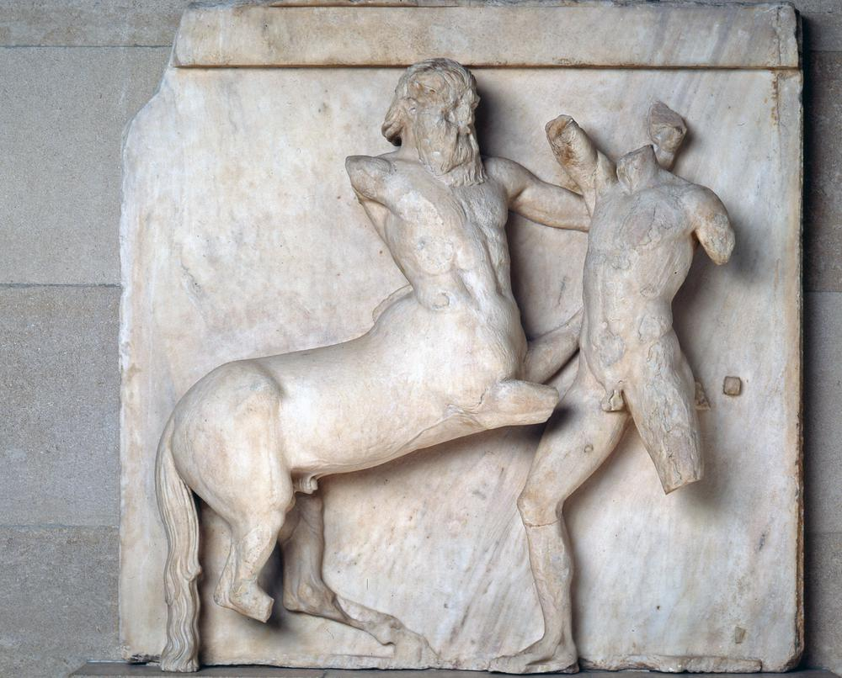
Fig. 26. Parthenon South Metope XXXII

Overall, there is a clear development in how warfare is depicted in Ancient Greek vase paintings and architectural sculpture as the style develops from the archaic period to the classical. While these depictions are largely centred around fictional battles, leading to a discussion on the extent to which the depictions can be considered to be ‘archaising’ or ‘heroising’ the subjects (Echeverría, 2015, p.33-6), the treatment of these scenes can give us an idea about cultural values surrounding battles and warfare. The earlier west pediment of the temple of Aphaia is emotionally detached and symbolic as was fitting for the archaic period, but the change in approach to the west pediment after the Persian war suggests a more realistic approach to the depiction. Similarly, the Andokides and Exekias vases show very solitary scenes of battle between two main soldiers, while the later Kleophrades hydria depicts war as messy and violent, clearly reflecting a reality that was still very much in the social consciousness. As the art style develops and becomes more effective at portraying the human body in a natural way, so do they become more effective at depicting battles and warfare.

Bibliography
- British Museum. Volute Krater. Available at: https://www.britishmuseum.org/collection/object/G_1848-0801-1 (Accessed: 18 March 2023)
- Echeverría, F. (2015). Heroic Fiction, Combat Scenes, and the Scholarly Reconstruction of Archaic Greek Warfare. Bulletin of the Institute of Classical Studies, 58(1), http://www.jstor.org/stable/26343165 (Accessed 15 March 2023)
- Encyclopedia Britannica. (2018). Archaic smile. https://www.britannica.com/art/Archaic-smile (Accessed: 20 March 2023)
- Harris, B. and Zucker, S. (2015). East and West Pediments from the Temple of Aphaia, Aegina. Available at: https://smarthistory.org/east-and-west-pediments-from-the-temple-of-aphaia-aegina/ (Accessed: 19 March 2023)
- Webster, T. B. L. (1932). Attic Vase Painting during the Persian Wars. Greece & Rome, 1(3), 137–142. Available at: http://www.jstor.org/stable/641844 (Accessed: 21 March 2023)

Images
- British Museum. Amphora. Available at: https://www.britishmuseum.org/collection/image/1299129001 (Accessed: 18 March 2023)
- British Museum. Metope XXVIII. Available at: https://www.britishmuseum.org/collection/image/423251001 (Accessed: 23 March 2023)
- British Museum. Metope XXVII. Available at: https://www.britishmuseum.org/collection/image/479940001 (Accessed: 23 March 2023)
- British Museum. Metope XXXII. Available at: https://www.britishmuseum.org/collection/image/1563451001 (Accessed: 23 March 2023)
- British Museum. Volute Krater. Available at: https://www.britishmuseum.org/collection/object/G_1848-0801-1 (Accessed: 18 March 2023)
- Louvre. (2012) Amphora. Available at: https://collections.louvre.fr/en/ark:/53355/cl010250715# (Accessed: 19 March 2023)
- Tiverios, M. Kleophrades Painter ‘Sack of Troy’ Hydria Available at: https://www.carc.ox.ac.uk/carc/resources/Introduction-to-Greek-Pottery/Keypieces/redfigure/kleophrades (Accessed: 18 March 2023)
- Zucker, S. (2012) East Frieze (detail). Siphnian Treasury. Memnon and Achilles. Available at: https://www.flickr.com/photos/profzucker/25285148236/in/album-72157715730243857/ (Accessed: 22 March 2023)
- Zucker, S. (2012) Head of an Impaled Warrior, West Pediment Available at: https://www.flickr.com/photos/profzucker/8212221035/in/album-72157715730243857/ (Accessed: 21 March 2023)
- Zucker, S. (2012) Herakles, East Pediment Available at: https://www.flickr.com/photos/profzucker/8212213289/in/album-72157715730243857/ (Accessed: 17 March 2023)
- Zucker, S. (2012) Herakles (Face), East Pediment Available at: https://www.flickr.com/photos/profzucker/8212229533/in/album-72157715730243857/ (Accessed: 17 March 2023)
- Zucker, S. (2012) Herakles (Side plates) Available at: https://www.flickr.com/photos/profzucker/8212230099/in/album-72157715730243857/ (Accessed: 17 March 2023)
- Zucker, S. (2012) Impaled Figure, West Pediment Available at: https://www.flickr.com/photos/profzucker/8213316424/in/album-72157715730243857/ (Accessed: 17 March 2023)
- Zucker, S. (2021) Impaled Torso, West Pediment Available at: https://www.flickr.com/photos/profzucker/8213315976/in/album-72157715730243857/ (Accessed: 17 March 2023)
- Zucker, S. (2012) Laomedon, East Pediment Available at: https://www.flickr.com/photos/profzucker/8212229025/in/album-72157715730243857/ (Accessed: 17 March 2023)
- Zucker, S. (2012) Laomedon (Oblique), East Pediment Available at: https://www.flickr.com/photos/profzucker/8212216353/in/album-72157715730243857/ (Accessed: 17 March 2023)
- Zucker, S. (2012) Laomedon (Upper Body), East Pediment Available at: https://www.flickr.com/photos/profzucker/8213303910/in/album-72157715730243857/ (Accessed: 21 March 2023)
- Zucker, S. (2012) North Frieze, Siphnian Treasury. Available at: https://www.flickr.com/photos/profzucker/24943768829/in/album-72157715730243857/ (Accessed: 22 March 2023)
- Zucker, S. (2012) Painted Mockup (Close) Available at: https://www.flickr.com/photos/profzucker/8213310566/in/album-72157715730243857/ (Accessed: 21 March 2023)
- Zucker, S. (2012) Paris (Close), West Pediment Available at: https://www.flickr.com/photos/profzucker/8212225803/in/album-72157715730243857/ (Accessed: 17 March 2023)
- Zucker, S. (2012) Paris, West Pediment in Sun Available at: https://www.flickr.com/photos/profzucker/8212218171/in/album-72157715730243857/ (Accessed: 17 March 2023)

