Marketing plan for
Ritz Carlton Hotel

Student Name: Florin Andrei Ghinea
Student ID Number: 2214960
Module Title: Marketing Essentials BMIH4005
Lecture’s Name: Luciana Suardi
Date: 06 March 2

A marketing plan is intended for a company to better its products and services (Akbar et al. 2019). In light of this, this marketing plan aims to analyse the present significance of Ritz Carlton and offer practical proposals to enhance its services, goods, and facilities while considering current developments and client views. As a result, frameworks like the SWOT analysis, STP, Porter's five forces, and PESTLE analysis would be included in the marketing strategy for Ritz Carlton. Even though the research would be based in the UK, The Hotel is primarily an American company.
The SWOT analysis for the Ritz Carlton is as follows:
Strengths  - It has a high brand value  - Get positive customer feedback  - Employee quality  - Strong customer loyalty  - Global presence | Weaknesses  - Changing demands of customers  - The state of the economy will certainly affect consumers' earning power  - Declining bottom line
Opportunities  - Development of the tourism market  - Rising demands for luxurious products  - Travelling move towards novel destinations | Threats  - High competition  - Changing demands of the industry  - Financial instability in the country

Geographic | Business travellers, corporates, and international customers
Behavioural | - Explorer  - Business Travelers  - Meeting event planners
Psychographic | - Middle and upper-class people  - Business and tourist individuals
Demographic | - The hotel targets people of age 16-70  - Both female and male

Bowman's Strategic Clock analyses possible tactical standing. It shows the wide range of choices a business, company, or company has when positioning a product on the basis of price and apparent value. This results in 8 strategic options divided into 4 quadrants and displayed in a clock (Villagrasa et al. 2021). Below is the positioning map for Ritz Carlton:
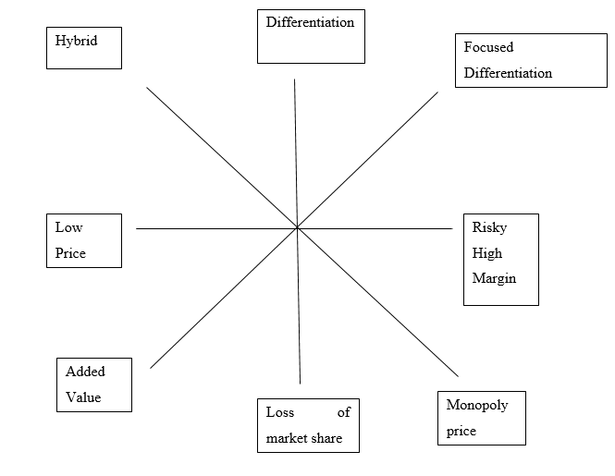
Figure 1: Bowman Strategy Clock
The Marriott family and Ritz Carlton worked together to deliver the highest customer service. As a result, the Marriott Bonvoy rewards system connects with the Ritz-Carlton Reserve brand, which allows customers to earn points at any of the five Ritz-Carlton Reserve hotels worldwide (Ritz, 2023 a). Under the partnership with Marriott, the hotel offers a daily average of 75 residential-style suites and villas.
Political | - Hotel brands will gain from the latest text restrictions to sustain business performance.  - The country's political stability is the obligation of the government.
Economical | - The country's inflation rate is constantly dropping.  - The UK's trade value impacts how much income hotels can make.  - The hotel sector is recovering rapidly following the epidemic's end, enabling the UK to produce a gross GDP of 4.2%, equivalent to 3.198 pounds (Statista, 2022).
Social | - The way of life of the British raises the chance for the hotel industry.  - Businessmen are generally expected to keep in calm, luxurious hotels for meetings purposes and other strategies.
Technological | - The hotel industry is focusing on digitalisation to become competitive.  - They are investing highly in the technologies, especially after covid-19
Environmental | - With the threat of global warming due to the hotels' air pollution and carbon emissions, hotels must alter their practices to be more ecological (Franzoni et al. 2021)
Legal | - Safety laws highly effect the business performance  - Health and safety laws are imposed by the hospitality sector of the UK (Lu and Tabari, 2019)

Objectives
Specific: The goal is to improve business and sales profits in the next five months.
Measurable: The management of Ritz Carlton will emphasise customer feedback.
Attainable: The goals will be attainable as the demands of guests will shift towards travelling.
Realistic: The goal is realistic because Ritz Carlton remains in people's heart by delivering exceptional services.
Time-bound: The goal will take 5 months to attain
The Ritz Carlton's unique selling point is based on giving its customers genuine care and comfort. To do that, the hotel's facilities comprise the most opulent luxury experience. The hotel further declared its objectives as offering its customers highly regarded services targeted to their satisfaction and relaxation, ultimately giving them a memorable stay. In light of this, Ritz Carlton trains its staff to be "customer focused," which means that only the needs of their customers should be given priority (Ritz Carlton, 2023). Moreover, it promotes social media to draw attention to these services. In addition to increasing the accessibility of healthy consumable food, the hotel plans to involve sanitary and health goods in its room services for hour.
Marketing mix
- Product
The company's current service is to serve customers, but it will put a higher priority on treating customers with better facilities, all provided by the superior standards of sanitation and provided to fulfil the desires of the guests. Hence, the hotel will give its clients more access to its spa by offering a special price to its regular customers.
- Price
Customers of The Ritz Carlton obtain first-rate services at a premium price point. Ritz Carlton clarifies to customers that providing maximum services and managing service quality is essential for supporting the premium pricing plan (Kerin and Hartley, 2019). As it has been determined that a Ritz Carlton room costs $26,300 per night on average,
- Place
Availability online and in popular tourist destinations are Ritz Carlton's primary services to its consumers. It is simple for customers to contact travel and tourism websites and make hotel accommodations at the places of their choice. The users utilise regular Google Mapss to track places. Visitors can also access their website's online channel and guide (Balu, 2018). By including correct info on its websites and internal maps, Ritz carton UK makes sure to assist its customers and visitors.
- Promotion
Ritz Carlton spends in its marketing efforts because they are seen as a necessary element in promoting the brand and a channel for getting the consumer's focus. Promotional activities are believed to assist in raising brand recognition. Ritz Carlton invests in high-end advertising spaces and various media platforms (Hudson, 2017).
The below action plan demonstrates the activities required for the marketing plan of Ritz Carlton:
Tasks | Weeks
Tasks | March 2023 |  |  |  |  |  | April 2023 |  |  |  | May 2023
Tasks | Week 1 | Week 2 | Week 3 | Week 1 | Week 2 |  |  | Week 3 | Week 1 |  |  |  |  | Week 2 | Week 3
Market Research  - Questionnaire  - Trail Products  - Beta Test | ✓ | ✓ | ✓
Preparation  - Preparation of videos  - Time scheduling |  |  |  | ✓ | ✓ |  |  | ✓ | ✓
Marketing Channels Schedule  - Social media channels  - Online booking |  |  |  |  |  |  |  |  | ✓ |  |  |  | ✓ |  | ✓
Gathering Feedback
- Reviews from social media pages.
- Customers who stay in the hotel

It is a provable fact that hotels need to make income in order to stay afloat. Ritz Carlton must strongly emphasise consumer involvement in the execution of novel marketing strategies. To this end, the hotel finances social media campaigns and provides frequent guests with a range of discounts (Baran and Galka, 2016). In order to draw guests and encourage them to stay at the hotel following the Pandemic, the Ritz hotel also makes investments in an Instagram influencer programme. In spite of this, the hotel also employs digital marketing to raise client value while improving hotel facilities.
Therefore, it can be concluded from analyses that a continuous marketing strategy can assist units in the hospitality sector in accomplishing what they want. Following the effects of the Pandemic, it is possible to move forward rapidly by employing the key components of the 4 PS of marketing, where the company's business in the market will be determined largely by its pricing and promotion methods. This is similar to the Ritz Carlton's corporate philosophy. Lack of skills among employees may be the company's biggest problem; thus, to address this, the firm may decide to engage in staff training.

Akbar, M.B., French, J. and Lawson, A., 2019. Critical review on social marketing planning approaches. Social Business, 9(4), pp.361-393.
Balu, L., 2018. Work-Timings and its Effect on Work-Life Balance in the Ritz-Carlton, Bengaluru. Work.
Baran, R.J. and Galka, R.J., 2016. Customer Relationship Management: the foundation of contemporary marketing strategy. Routledge.
Franzoni, S., Sarwar, H. and Ishaq, M.I., 2021. The Mediating Role of HRM in the Relationship between CSR and Performance in the Hospitality Industry. Sustainability, 13(24), p.13699.
Hudson, B.T., 2017. Approaches to corporate heritage brand management: The cases of Cunard and Ritz-Carlton. In Foundations of corporate heritage (pp. 288-301). Routledge.
Kerin, R. and Hartley, S., 2019. Marketing, 14e.
Lu, L. and Tabari, S., 2019. Impact of Airbnb on customers' behavior in the UK hotel industry. Tourism Analysis, 24(1), pp.13-26.
Ritz Carlton, 2023. About Us. Available at: https://www.ritzcarlton.com/en/about. [Accessed on 2nd March 2023]
Ritz, 2023 a. A Renowned Cellist Brings Music To The Ritz-Carlton Experience. [Online] Available at < https://www.journey.ritzcarlton.com/exclusive-partnerships/on-tour-with-tina-guo> [Accessed on 2nd March 2023].
Statista (2022). GDP forecast UK 2022. Available at: https://www.statista.com/statistics/375195/gdp-growth-forecast-uk/#:~:text=During%202022%20the%20gross%20domestic,9.4%20percent%20contraction%20in%202020. [Accessed on 2nd March 2023].
Villagrasa, J., Sánchez, F. and Donaldson, C., 2021. DECIPHERING THE STRATEGIC CLOCK HANDS: FROM THEORY TO REALITY. In INTED2021 Proceedings (pp. 9571-9584). IATED.

Component B: Presentation
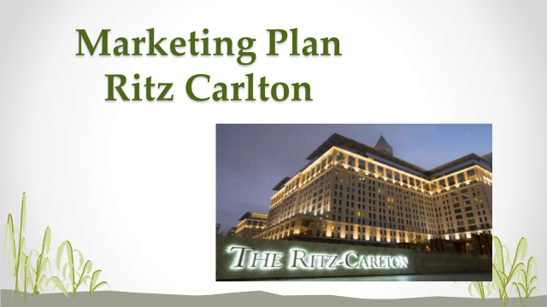
Introduction
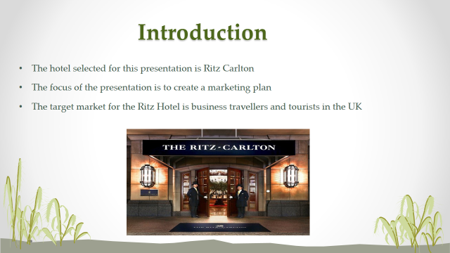
- The hotel selected for this presentation is Ritz Carlton
- The focus of the presentation is to create a marketing plan
- The target market for the Ritz Hotel is business travellers and tourists in the UK
SWOT Analysis
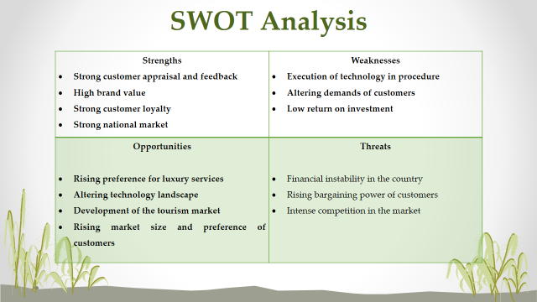
Strengths  - Strong customer appraisal and feedback  - High brand value  - Strong customer loyalty  - Strong national market | Weaknesses  - Execution of technology in procedure  - Altering demands of customers  - Low return on investment
Opportunities  - Rising preference for luxury services  - Altering technology landscape  - Development of the tourism market  - Rising market size and preference of customers | Threats  - Financial instability in the country  - Rising bargaining power of customers  - Intense competition in the market

PESTLE
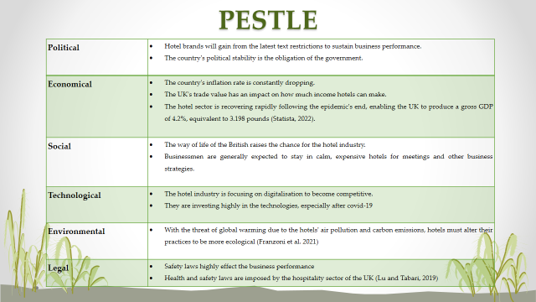
Political | - Hotel brands will gain from the latest text restrictions to sustain business performance.  - The country's political stability is the obligation of the government.
Economical | - The country's inflation rate is constantly dropping.  - The UK's trade value has an impact on how much income hotels can make.  - The hotel sector is recovering rapidly following the epidemic's end, enabling the UK to produce a gross GDP of 4.2%, equivalent to 3.198 pounds (Statista, 2022).
Social | - The way of life of the British raises the chance for the hotel industry.  - • Businessmen are generally expected to stay in calm, expensive hotels for meetings and other business strategies.
Technological | - The hotel industry is focusing on digitalisation to become competitive.  - They are investing highly in the technologies, especially after covid-19
Environmental | - With the threat of global warming due to the hotels' air pollution and carbon emissions, hotels must alter their practices to be more ecological (Franzoni et al. 2021)
Legal | - Safety laws highly effect the business performance  - Health and safety laws are imposed by the hospitality sector of the UK (Lu and Tabari, 2019)

Marketing mix
Product
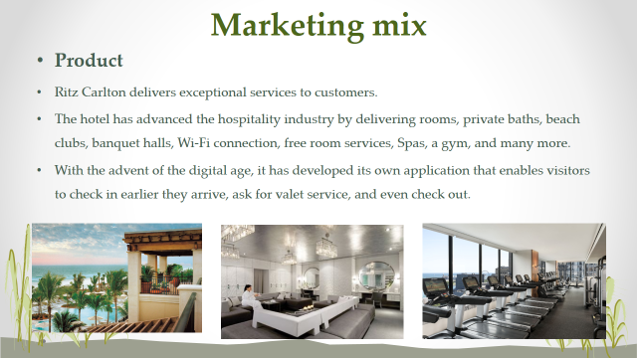
Ritz Carlton delivers exceptional services to customers. The hotel has advanced the hospitality industry by delivering rooms, private baths, beach clubs, banquet halls, Wi-Fi connection, free room services, Spas, a gym, and many more. With the advent of the digital age, it has developed its own application that enables visitors to check in earlier they arrive, ask for valet service, and even check out.
Price
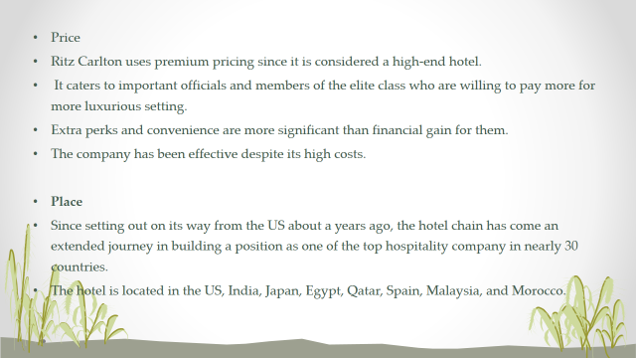
Ritz Carlton uses premium pricing since it is considered a high-end hotel. It caters to important officials and members of the elite class who are willing to pay more for more luxurious setting. Extra perks and convenience are more significant than financial gain for them. Therefore, the company has been effective despite its high costs.
Place
Since setting out on its way from the US about a years ago, the hotel chain has come an extended journey in building a position as one of the top hospitality company in nearly 30 countries. The hotel is located in the US, India, Japan, Egypt, Qatar, Spain, Malaysia, and Morocco.

Promotion
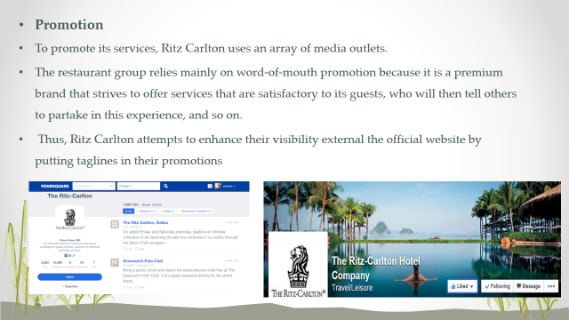
To promote its services, Ritz Carlton uses an array of media outlets. The restaurant group relies mainly on word-of-mouth promotion because it is a premium brand that strives to offer services that are satisfactory to its guests, who will then tell others to partake in this experience, and so on. Thus, Ritz Carlton attempts to enhance their visibility external the official website by putting taglines in their promotions.

Marketing Strategies
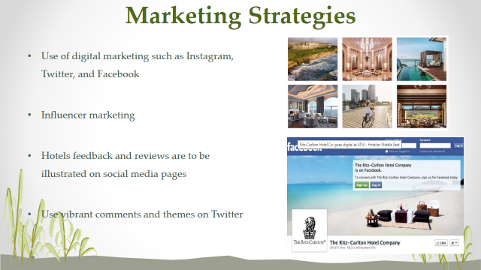
- Use of digital marketing such as Instagram, Twitter, and Facebook
- Influencer marketing
- Hotels feedback and reviews are to be illustrated on social media pages
- Use vibrant comments and themes on Twitter

Conclusion
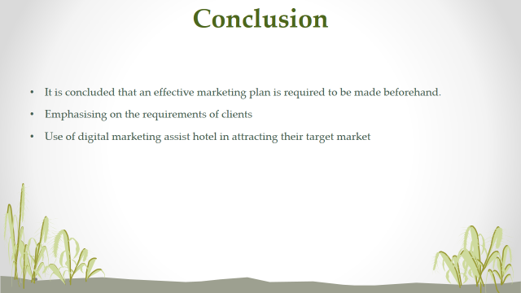
- It is concluded that an effective marketing plan is required to be made beforehand.
- Emphasising on the requirements of clients
- Use of digital marketing assist hotel in attracting their target market



