Name:_Emyr Jones

Student Number: _1701036
__________________________________________________________

WORKSHEET 3 – TESTING (Lap Times)

- Original code:
LapTime = []

print("Welcome to the Racing stats program:")
Flag = 0
while Flag == 0:
try:
Target = float(input("please enter your target lap time: "))
except ValueError:
print("not a valid number try again: ")
if Target < 1:
print("not a valid time try again: ")
else:
Flag = 1

for i in range(5):
Flag = 0
while Flag == 0:
try:
print("please enter your lap time for lap", i+1)
LapTime.append(float(input()))
except ValueError:
print("not a valid number try again: ")
if LapTime[i] < 1:
print("not a valid time try again: ")
else: Flag = 1

total = sum(LapTime)

print(f"Overall time for {len(LapTime)} was: {total} seconds")

Average = sum(LapTime) / (len(LapTime))

print(f"Average lap time was: {Average} seconds")

FastestLapTime = 100
FastestLap = 100
for j in range(len(LapTime)):
if LapTime[j] < FastestLapTime:
FastestLapTime = LapTime[j]
FastestLap = j+1
print(f"The fastest lap was lap {FastestLap} in {FastestLapTime}")

SlowestLap = 0
SlowestLapTime = 0

for k in range(len(LapTime)):
if LapTime[k] > SlowestLapTime:
SlowestLapTime = LapTime[k]
SlowestLap = k+1
print(f"The slowest lap was lap {SlowestLap} in {SlowestLapTime}")

Counter = 0

for l in range(len(LapTime)):
if LapTime[l] <= Target:
Counter = +1
print(f"{Counter} of your laps were better or equal to your target")

PreviousLap = LapTime[0]

print(f"Lap 1 was {LapTime[0]}")
for h in range(1,len(LapTime),1):
if PreviousLap > LapTime[h]:
PreviousLap = LapTime[h]
print(f"Lap {h+1} was faster than the previous lap")
elif LapTime[h] == PreviousLap:
PreviousLap = LapTime[h]
print(f"Lap {h+1} was equal the previous lap")
else:
PreviousLap = LapTime[h]
print(f"Lap {h+1} was slower than the previous lap")

- Code Testing
For each test below, run your code and show the results of the scenarios below. Present a screenshot of what happened when the programme ran. Did the programme behave correctly or did it do something unexpected, and if so, why?

- Test a lap time for your programme:
- 42 seconds
- 2 seconds
- -4 seconds
- 53444 seconds
- Test the target lap time – show that the values entered are reasonable

- Using the same five lap times as the sample output ie

Lap 1: 42.3
Lap 2: 42.1
Lap 3: 44
Lap 4: 44
Lap 5: 39.4

Examine each statistic (1-6) and comment on whether the correct answer(s) are displayed or not. (If any statistics were incomplete after Phase 1 (code completed in class) simply write “Unfinished”)

- Test two further sets of lap times of your own choice.

Template for tests:
Test:
i) 42 seconds

Screenshot(s) of output:
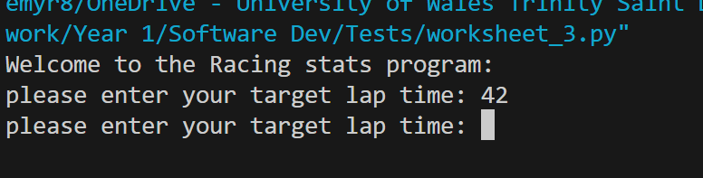
Result: Did the programme behave as expected ie syntactically and logically correct?
NO
If NO, what went wrong and why? Suggest how things could be improved

This is because the else statement is outside of the try loop so does not go past the first input from the user being the target lap, it will keep looping and asking the user to enter the same thing.

Will need to amend the validation and re-run the test to make sure it is compliant.

Test:
ii) 2 seconds

Screenshot(s) of output:
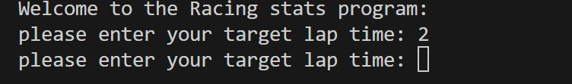
Result: Did the programme behave as expected ie syntactically and logically correct?
NO
If NO, what went wrong and why? Suggest how things could be improved

This is because the else statement is outside of the try loop so does not go past the first input from the user being the target lap, it will keep looping and asking the user to enter the same thing.

The program should catch the input and tell the user to input another number as 2 seconds would be too fast for the user to make that a lap time

Will need to amend the validation and re-run the test to make sure it is compliant.

Test:

iii) -4 seconds

Screenshot(s) of output:
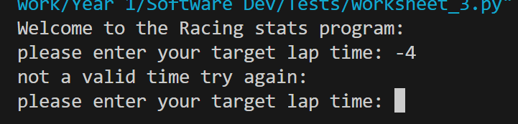
Result: Did the programme behave as expected ie syntactically and logically correct?
YES
If YES, comment on what happened.
The program catches the users input of being a negative number and asks the user to input another number

Test:
iiii) 53444 seconds

Screenshot(s) of output:
Result: Did the programme behave as expected ie syntactically and logically correct?
NO
If NO, what went wrong and why? Suggest how things could be improved

This is because the else statement is outside of the try loop so does not go past the first input from the user being the target lap, it will keep looping and asking the user to enter the same thing.

The program should catch the input and tell the user to input another number as the number entered seems too slow to go round the lap and would be unrealistic.

Will need to amend the validation and re-run the test to make sure it is compliant.

Test:
- Test the target lap time – show that the values entered are reasonable

Screenshot(s) of output:
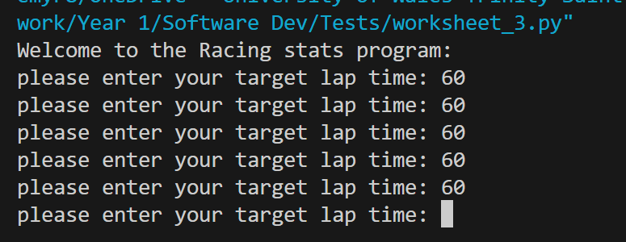
Result: Did the programme behave as expected ie syntactically and logically correct?
NO

If NO, what went wrong and why? Suggest how things could be improved

Unable to perform this test as the program is stuck in a loop asking the user to enter the target lap, will need to amend the validation code.

Test:
- Using the same five lap times as the sample output ie

Lap 1: 42.3
Lap 2: 42.1
Lap 3: 44
Lap 4: 44
Lap 5: 39.4

Screenshot(s) of output:
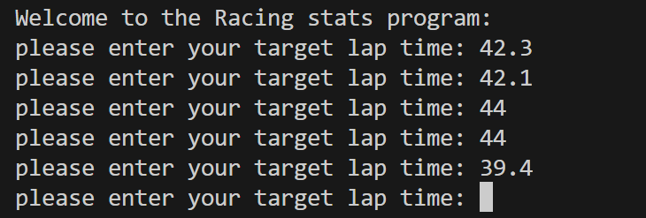
Result: Did the programme behave as expected ie syntactically and logically correct?
NO

If NO, what went wrong and why? Suggest how things could be improved

Unable to perform this test as the program is stuck in a loop asking the user to enter the target lap, will need to amend the validation code.

Test:
Enter all lap times the same to see what is the output

Screenshot(s) of output:
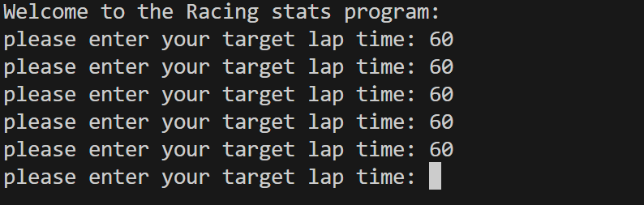
Result: Did the programme behave as expected ie syntactically and logically correct?
NO

If NO, what went wrong and why? Suggest how things could be improved

Unable to perform this test as the program is stuck in a loop asking the user to enter the target lap, will need to amend the validation code.
If NO, what went wrong and why? Suggest how things could be improved

Test:
Enter 2 laps above target lap 2 laps below target lap and 1 lap equal to target lap

Screenshot(s) of output:
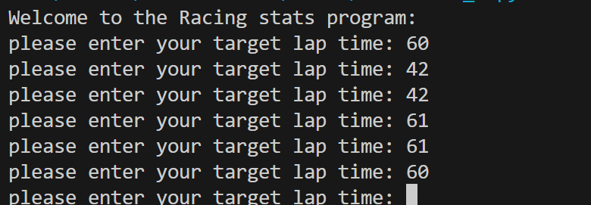
Result: Did the programme behave as expected ie syntactically and logically correct?
NO

If NO, what went wrong and why? Suggest how things could be improved

Unable to perform this test as the program is stuck in a loop asking the user to enter the target lap, will need to amend the validation code.

- Consider the results of the above tests and revisit your original code in order to address any tests that failed and/or improve code efficiency.

(Note: you may not be able to solve all of the problems that were encountered, but solve as many as you can.)

Paste your full revised code here :

LapTime = []

print("Welcome to the Racing stats program:")
Flag = 0
while Flag == 0:
try:
Target = float(input("please enter your target lap time: "))
if 10 <= Target <= 1000:
Flag = 1
else:
print("not a valid time try again: ")
except ValueError:
print("not a valid number try again: ")

for i in range(5):
Flag = 0
while Flag == 0:
try:
print("please enter your lap time for lap", i+1)
temp = float(input())
if 10 <= temp <= 1000:
LapTime.append(temp)
Flag = 1
else:
print("not a valid time try again: ")
except ValueError:
print("not a valid number try again: ")

total = sum(LapTime)

print(f"Overall time for {len(LapTime)} was: {total} seconds")

Average = sum(LapTime) / (len(LapTime))

print(f"Average lap time was: {Average} seconds")

FastestLapTime = 1000
FastestLap = 100
for j in range(len(LapTime)):
if LapTime[j] < FastestLapTime:
FastestLapTime = LapTime[j]
FastestLap = j+1
print(f"The fastest lap was lap {FastestLap} in {FastestLapTime}")

SlowestLap = 0
SlowestLapTime = 0

for k in range(len(LapTime)):
if LapTime[k] > SlowestLapTime:
SlowestLapTime = LapTime[k]
SlowestLap = k+1
print(f"The slowest lap was lap {SlowestLap} in {SlowestLapTime}")

Counter = 0

for l in range(len(LapTime)):
if LapTime[l] <= Target:
Counter += 1
print(f"{Counter} of your laps were better or equal to your target")

PreviousLap = LapTime[0]

print(f"Lap 1 was {LapTime[0]}")
for h in range(1,len(LapTime),1):
if PreviousLap > LapTime[h]:
PreviousLap = LapTime[h]
print(f"Lap {h+1} was faster than the previous lap")
elif LapTime[h] == PreviousLap:
PreviousLap = LapTime[h]
print(f"Lap {h+1} was equal the previous lap")
else:
PreviousLap = LapTime[h]
print(f"Lap {h+1} was slower than the previous lap")

