

ADVANCED STATISTICAL ANALYSIS OF PORT TALBOT AIR QUALITY DATA USING R

Student name: Mahmmad Alfaj Munirmiya Malek
Student ID : 2520650
Submitted to Dr Aliyu Sambo

TABLE OF CONTENTS
1. Introduction 3
2. Dataset Description 3
3. Data Import and Summary 5
4. Exploratory Data Analysis 7
5. Correlation Analysis 11
6. Hypothesis Testing 13
7. Seasonal Comparison 14
8. Conclusion 16
Reflective Summary 18
Reference List 20

LIST OF FIGURES
Figure 1: Missing Values 5
Figure 2: Cleaned Data Structure 6
Figure 3: Descriptive Statistics 7
Figure 4: Time Trend of PM2.5 9
Figure 5: Time trend of Nitrogen Dioxide 10
Figure 6: Relationship Between Temperature and Ozone 11
Figure 6: Relationship Between Wind Speed and PM2.5 11
Figure 7: Relationship Between Temp. and NO₂ 12
Figure 8: Correlation Heatmap 13
Figure 9: Pairwise Relationship 14
Figure 10: PM2.5 levels under Low and High Wind Speed 15
Figure 11: Seasonal Comparison 16
Figure 12: Monthly Distribution of PM2.5 17

TASK 1 - CODE
Pollutant air is among the most important environmental and public health problems globally. An increase in atmospheric pollutants has been linked to cardiovascular disorders, respiratory disease, a decrease in life expectancy, and environmental impacts. By continuously monitoring air quality, governments, environmental agencies and researchers can gain insights into pollution trends and sources, and create effective strategies to integrate into air quality monitoring, thereby reducing harmful emissions. Analysis of environmental datasets is made essential by the use of statistical programming, which enables researchers to clean up large sets of data, detect patterns, analyse statistical data and present their findings in informative visualizations.
This project uses the air quality data set provided hourly from Port Talbot, Wales, and analyzes them in the R programming language. This dataset includes air pollutant data measured hourly for multiple pollutants for several years as well as meteorological data. R took the spot up to us due to the highly useful packages for data manipulation, statistical testing, and graphical visualisation in R: dplyr, ggplot2, lubridate, and corrplot. These packages enable the processing of large environmental datasets in an efficient way, while guaranteeing reproducibility and transparency of the analysis.
The primary aim of this analysis is to explore the nature/norms of air pollution in the study area by using descriptive, exploratory data analysis, visualization techniques, correlation and statistical hypothesis testing. The purpose of this study is to provide information on temporal trends in concentrations of pollutants, relationships between pollutants and weather factors and statistical significance between various weather factors and concentrations. The results obtained from this analysis will give an insight into the local air quality behaviour and illustrate the practical application of statistical programming with R.

2. Dataset Description
The data set employed in this project derives from the Port Talbot Hourly Air Quality Data set which comprises of hourly environmental observations taken at the Margam monitoring station in Port Talbot. This is a rather large environmental dataset of around 87,672 observations and 24 variables that are appropriate for advanced statistical programming and exploratory data analysis.
The data include measurements for various air pollutants such as O₃, NO, NO₂, NOx, SO₂, CO, PM10 and PM2.5 (Carslaw and Ropkins, 2019). The list of pollutants monitored is a representative sample and includes those pollutants that are particularly important in relation to impacts on human health and environmental quality.
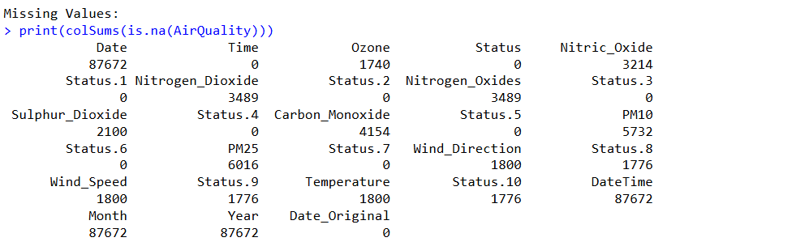

Figure 1: Missing Values
The dataset includes the concentration of pollutants, as well as meteorological parameters that could affect pollutant dispersion and atmospheric conditions. These variables are modelled wind direction, wind speed and ambient temperature (Wickham, Çetinkaya-Rundel and Grolemund, 2023). For each pollutant there is a status column describing the validity of the measurement and the units. Additional data elements provide date and time information to enable analysis by hour across various time-scales.
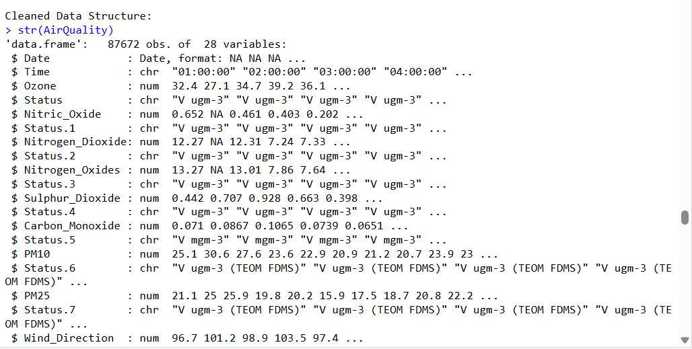

Figure 2: Cleaned Data Structure
To perform statistical analysis, some steps were necessary to preprocess the data. The missing values, denoted in the data as "No data" were automatically replaced with NA during data import. A few variables were changed for ease of reading and for further use in programming. Date and time variables were converted to the proper date-time object types for proper representation and analysis of temporal aspects e.g., visualization and trend analysis. All numerical variables also were examined to make sure they were represented with appropriate numeric data types so that statistical analysis could be performed on them.
Overall, the dataset is a good representation of the hourly air quality conditions and has sufficient data to examine the behaviour of pollutants, seasonal variation in pollutant levels and how meteorological conditions effect pollutant levels.

3. Data Import and Summary
The first step of the analysis was to import the csv data set into R. The read.csv() function was used to read the dataset, with the argument not to use the missing values as missing values. After importing several functions such as head(), str(), dim(), summary(), and names() were employed to check the overall structure of the data.
The first check showed that the data had 87,672 observations and 24 variables, suggesting the data was a set of hourly data from a long monitoring period (James et al., 2021). The inspection also confirmed that there were numeric and character variables for the pollutants and polluter information, respectively.
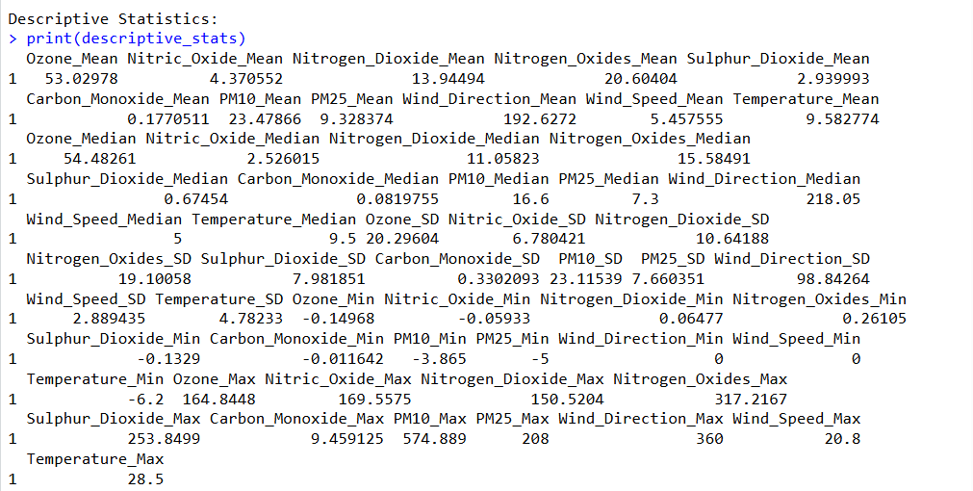

Figure 3: Descriptive Statistics
A few preprocessing procedures were then performed. All date variables were converted to standard dates and additional variables were created for month and year for seasonal analysis later in the project. Descriptive names for the columns were shortened to a short descriptive variable name for example PM25, PM10, Nitrogen_Dioxide, Carbon_Monoxide and Wind_Speed. This is to make the code easier to understand and decrease the chance of programming mistakes in the future stages of the analysis.

After preprocessing descriptive statistical analysis for all the numerical variables was done. Various calculations were performed; the mean, median, standard deviation, minimum and maximum values (Wickham, 2016). The descriptive statistics listed below give a first impression of the distributions of the pollutants and may be used to detect anomalies/outliers.
The results revealed average concentration of ozone as 53.03 and N2O2 is around 13.94 average concentration. The average level of PM10 particulate matter was about 23.48, while the average level of PM2.5 particulate matter was significantly lower at approximately 9.33. The mean wind speed was about 5.46 m/s while the mean ambient temperature was about 9.58°C for the entire monitoring period.
The mean and median values indicate that there are several pollutant variables with positive skewness. This is especially true for maximum levels of sulphur dioxide, carbon monoxide and particulate matter, which significantly surpass the average levels. Occasional pollution events usually result in high values of the data points, which can cause the arithmetic mean to be larger than would normally be found, and this is reflected by the behaviour seen in data from environmental monitoring.
Other negative pollutant data were also revealed by the descriptive statistics (Grolemund and Wickham, 2019). These small negative concentrations, and the associated uncertainties, are typical and not indicative of physically meaningful pollutant concentrations and associated uncertainties, and are typically related to instrument calibration and measurement uncertainty within environmental monitoring systems. Such observations are typically stored during exploratory analysis, as they are indicative of features of the monitoring process.
Overall, the descriptive statistics can give a good idea of the central tendency, variability and distribution of the pollutant concentration before undertaking more sophisticated statistical analysis.

4. Exploratory Data Analysis
Exploratory Data Analysis (EDA) is one of the most crucial phases in a statistical investigation. EDA is intended to get to know the features of the data set before statistically testing the data. Visualisation tools help to recognize trends, outliers, relations among data elements, and data quality.
Pollutant concentration over time time-series plots were the first visualisations created in the context of this project. Time series plots are especially suitable for environmental monitoring efforts, as pollutant levels tend to vary naturally throughout hours, days, months and years (Pebesma and Bivand, 2023). When the dates of observation are plotted on the x-axis, PM2.5 and NO2 concentration values can be determined to see the concentrations of each pollutant and trends over longer time periods in the monitoring period.
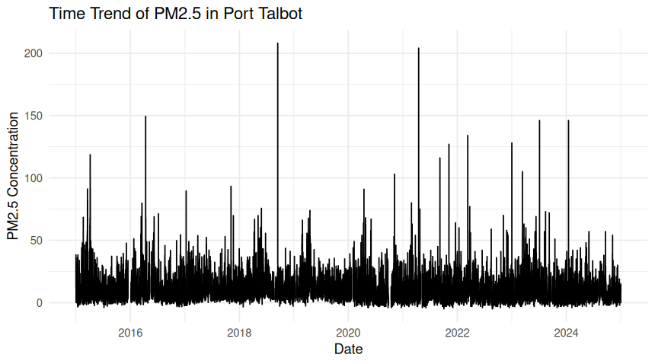

Figure 4: Time Trend of PM2.5
The PM2.5 time-series plot shows a large degree of variability during the period of observation. Pollutant concentration generally stay in moderate levels but there is included some occasional peaks in the pollutants. These peaks can be related to local emission events, industrial impacts, bad meteorological conditions or seasonal effects which lead to a temporary rise in the concentration of particles.
Likewise, fluctuations in the amount of nitrogen dioxide are quite large over time. In addition, NO₂ is closely linked to road transport emissions and process emissions from combustion facilities, which can lead to changes being linked to changing traffic flows, industrial activity or the dispersion conditions of the air (World Health Organization, 2021). The time-series visualisations offer useful context to inform understanding of pollutant behaviour which is not readily available in summary statistics.
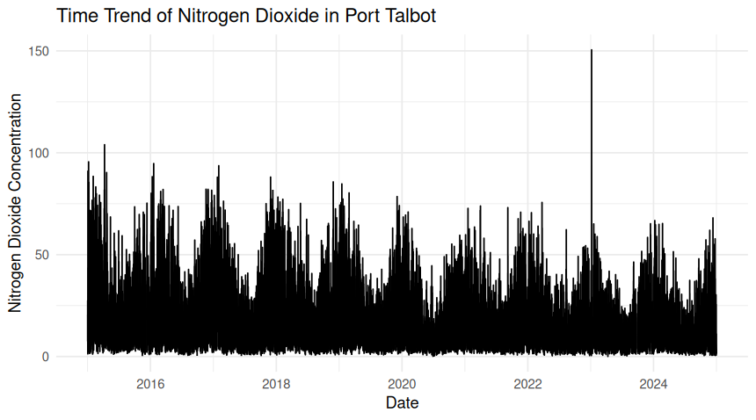

Figure 5: Time trend of Nitrogen Dioxide
Relationships between pollutants and meteorological variables were then explored with the creation of scatterplots. Relationships between two continuous variables can be effectively visualized in a scatterplot, which can also detect linear or non-linear relationships.
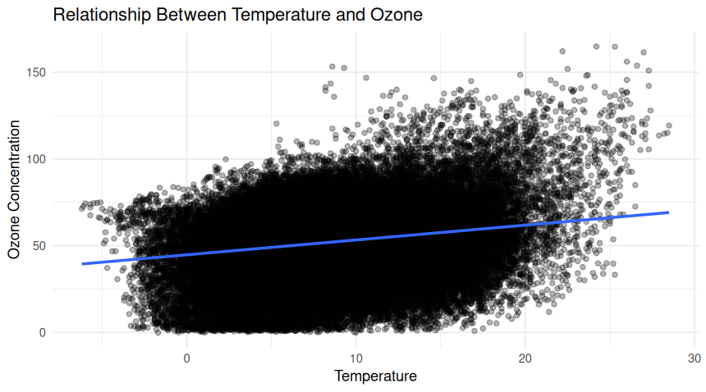

Figure 6: Relationship Between Temperature and Ozone
From the correlation of PM2.5 with wind speed, it is seen that the above correlation is in general form, that is, wind speed is higher, the PM2.5 concentration is lower. With high wind speeds, more mixing and dispersion take place in the atmosphere, lessening the amount of pollutants that can be collected near the monitoring station (United States Environmental Protection Agency, 2024). On the other hand, at lower wind speeds the atmosphere is more stable, which allows pollutants to build up.
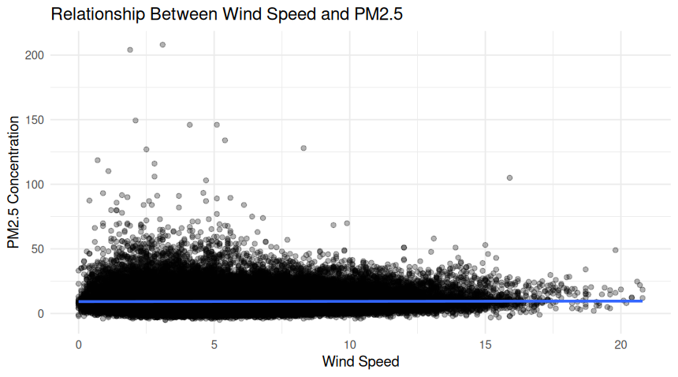

Figure 6: Relationship Between Wind Speed and PM2.5
The impact of meteorological conditions on the concentrations of pollutants is further shown in additional scatterplots between nitrogen dioxide and temperature, and ozone and temperature. Among the air quality models, the temperature is a significant explanatory variable for both atmospheric chemical reactions and formation of pollutants and dispersion processes.
A linear regression line was plotted on each of the scatterplots to help with visualization (European Environment Agency, 2024). The relationships are not straightforward, however, these trend lines do give an indication of the direction and strength of the association between variables.
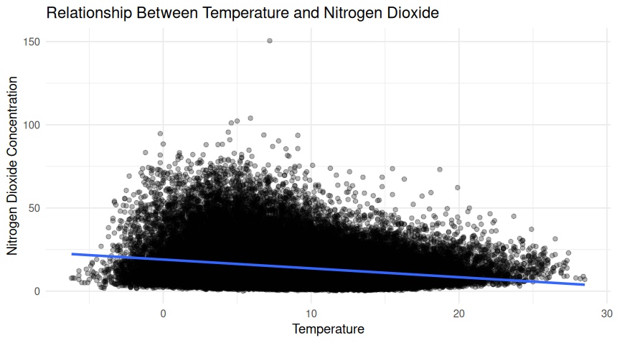

Figure 7: Relationship Between Temp. and NO₂
The use of ggplot2 was guided throughout the exploratory analysis in order to create highly flexible and publication-quality graphics. Each figure was given an appropriate chart title, axis labels, limited visual themes in order to ensure that each figure portrays the information in a clear and professional manner.
The general exploratory data analysis suggests that the concentrations of pollutants are highly variable with time and also reflect the variations in meteorological parameter, especially temperature (Department for Environment, Food & Rural Affairs, 2024). These preliminary results will form the basis for further correlation analysis, hypothesis testing and seasonal comparison, which will enable more detailed statistical conclusions to be drawn about the factors contributing to air quality in Port Talbot.

5. Correlation Analysis
After the exploratory visualisation, the strength and direction of relationship between the major air pollutants measured at the Port Talbot monitoring station was analysed using correlation analysis. The correlation analysis is an important statistical tool and it is used to measure the degree of association between two continuous variables (Posit Software, 2025). In environmental studies, finding such relationships gives important clues to the similarity or dissimilarity of the sources of emissions responsible for pollutants and to whether they are affected by common meteorological conditions.
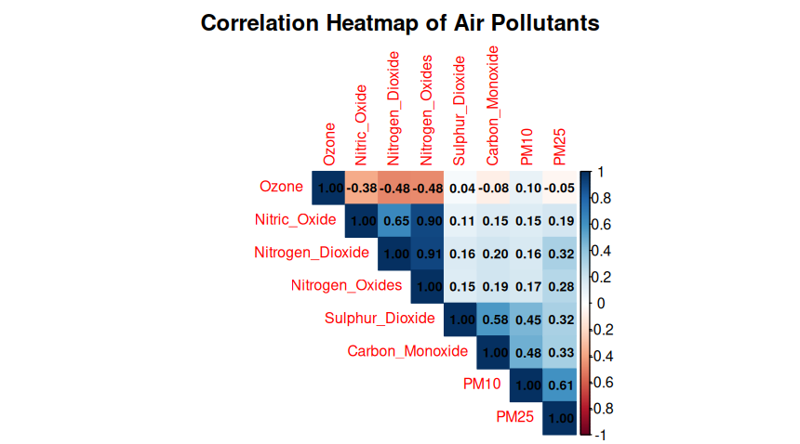

Figure 8: Correlation Heatmap
Due to the nature of the variables being analysed, the Pearson correlation coefficient was chosen. The correlation range is from -1 to +1, with values near +1 that the two variables have a strong positive correlation, values near -1 that the two variables are strongly negatively correlated, and values near 0 that there is little linear correlation between the two variables. Pollutants selected for the correlation analysis were: O3, NO, NO2, NOx, SO2, CO, PM10 and PM2.5. Complete-case analysis was used to exclude missing observations, so that only valid paired observations would be used in calculations.
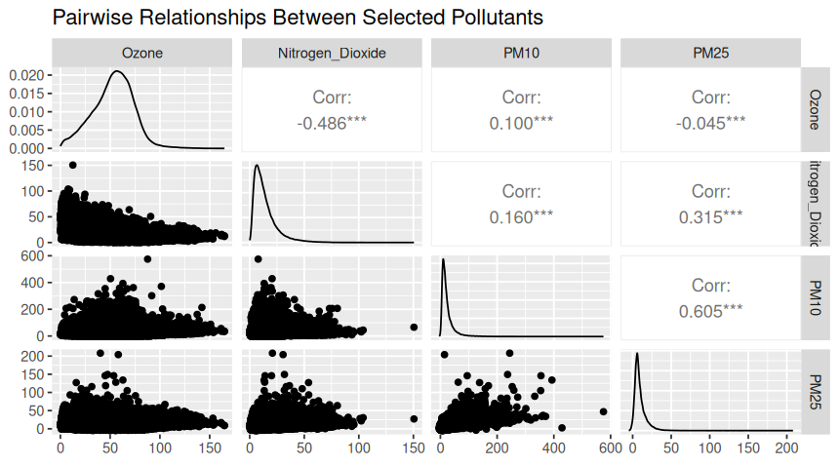

Figure 9: Pairwise Relationship
The correlation matrix was plotted using the package corrplot to create a heatmap. This visualization gives a graphical overview of the overall (co)occurrence of all pairs of pollutants. Colours indicate the size and the direction of the correlation, so that it is easy to quickly see which variables are highly correlated (Kassambara, 2023). In order to increase interpretability and to be able to make more detailed comparisons of individual relationships, numerical correlation coefficients were also shown on the heatmap.

6. Hypothesis Testing
The correlation analysis, formal statistical hypothesis test was performed to test the hypothesis that wind speed has a significant effect on PM2.5 concentration. Hypothesis testing differs from descriptive statistics and exploratory visualisations, which are more subjective, in that it offers a statistical analysis method to decide if observed differences between groups are likely to be due to chance.
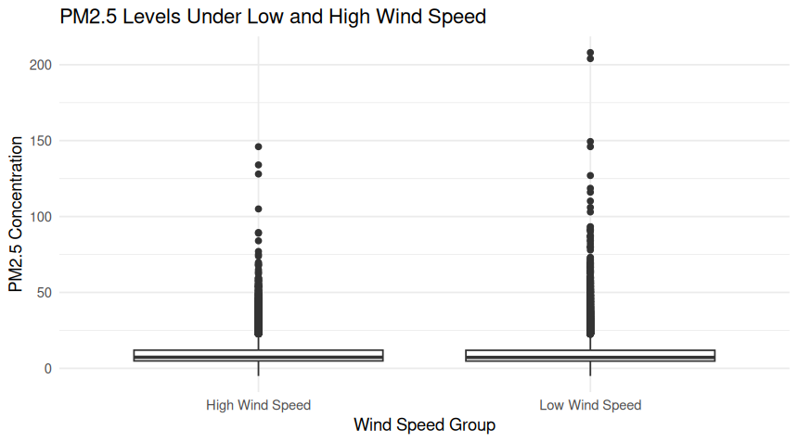

Figure 10: PM2.5 levels under Low and High Wind Speed
The wind speed observation data was split into two classes based on the median wind speed. Values of measurements below the median were assigned to Low Wind Speed and values of measurements equal to or greater than the median were assigned to High Wind Speed. This method resulted in two comparable classes and allowed PM concentration to be compared between the two classes under varying atmospheres.
The hypotheses were formulated as follows:
Null Hypothesis (H₀): There is no statistically significant difference in PM2.5 concentrations between periods of low wind speed and high wind speed.
Alternative Hypothesis (H₁): There is a statistically significant difference in PM2.5 concentrations between periods of low wind speed and high wind speed.

7. Seasonal Comparison
The last analytical step included the comparison of the concentration of PM2.5 among the four meteorological seasons. The advantage of this method of analysis is that in environmental studies the conditions of weather, domestic heating, industrial activity, atmospheric stability, and photochemical reactions vary greatly during the year.
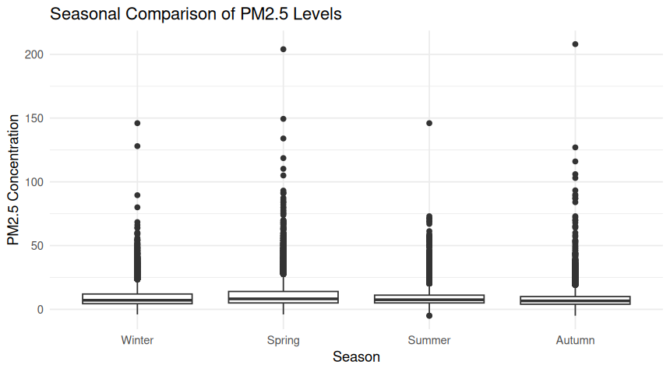

Figure 11: Seasonal Comparison
Boxplots were then created to visualise the distribution of PM2.5 concentrations within each season after classification. Boxplots are useful in comparing more than one group since they summarize the median, interquartile range, overall spread, and possible outliers of the data.
It appeared visually that there was a distinct seasonal variation in the particulate concentrations. Generally, PM2.5 concentrations were higher during the winter months and lower during the summer months (Kassambara, 2023a). This type of pattern is anticipated in an environment since during colder months, whether they be winter or early spring, there are likely to be greater atmospheric emission levels from domestic heating and less atmospheric dispersion because of the reduced temperature and or meteorological factors. Better dispersion and less particulates during summer, due to higher solar radiation and atmospheric mixing.
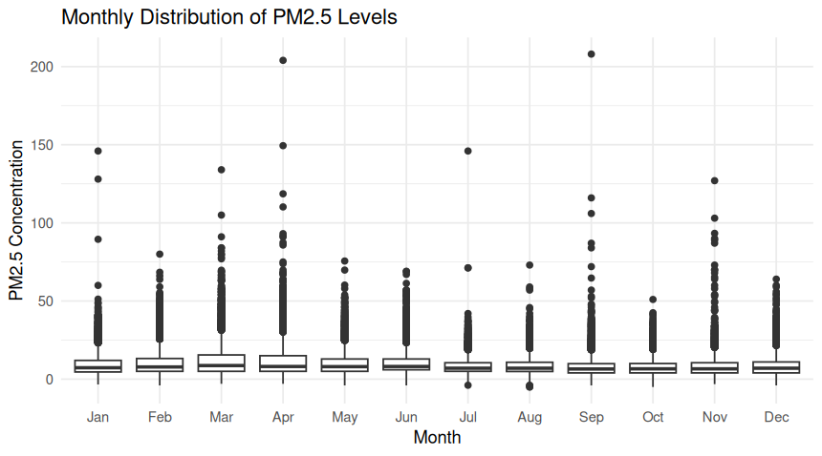

Figure 12: Monthly Distribution of PM2.5
Formal group comparison tests were carried out to establish if these visual differences were statistically significant. One-way Analysis of Variance (ANOVA) was used where the normality and equal variance assumptions were found appropriate (Torgo, 2023). The Kruskal–Wallis test was also performed as a non-parametric alternative to the analysis due to the fact that data from the environment are often not normally distributed.
The null hypothesis from the season comparisons indicated that the means of all the four seasons were the same. The alternative hypothesis was that at least one season was different to at least one of the others.

Generative AI use statement
No generative AI tools have been utilized in the process of creating this assignment. All data preparation, R programming, statistical analysis, interpretation of results and report writing have been completed in an independent manner. By making use of my own knowledge, practical work, and on the basis of understanding of assignment requirements.

Reflective Summary
Upon first recognition of the data set at the outset of the assignment, I knew that it was quite large, with more than 87,000 hours of data, and a multitude of variables constructed around the pollutants and weather. Due to the large size and complexity of this data, I knew that it would require some work to ensure the data were appropriately normalized prior to any meaningful analysis. I learned the end-use of the whole data analysis process from starting with data, cleaning it, applying statistical tests, and visualising it in various informative ways, throughout the project.
The first thing I did, is I tried to structure myself into different sections that are meaningful in the R script, starting with data import, data cleaning, exploratory analysis, statistical testing and finally results interpretation. This approach to structuring the code really helped me to be able to trace out the bugs and the logic. I have also used comments in the code to give reasons for each part of the code, this will make the code easier to read, and helped keep the code sequence clear as it was analyzed.
Visualisations were an extra real added to my experience with this dataset, as this was extremely helpful in understanding the data set. Time-series plots were chosen due to the data being hourly observations over a long time. These plots enabled me to see long term fluctuations in the pollution levels, and be able to detect periods of time when the pollution levels would rise noticeably. Scatterplots were analysed for the relationships between pollutants and weather variables as they are a good means of examining potential linear relationships in continuous variables. The regression lines were added to further clarify interpretations of the data and to create general trends. I also used boxplots to compare pollutant levels among groups of data, for example pollutant levels for different wind speed ranges and seasons. These visualisations clearly showed any difference in medians, variability and extreme observations, making it easier to interpret the statistical results.
There were a number of difficulties faced during the project. The biggest challenge was the correct preparation of data. At first, spaces and special characters were in some of the column names, leading to errors when trying to change the names of the variables. Additionally, a number of issues arose when I tried to use the date and time variables to a suitable date-time format, and this caused problems with producing time-series graphs. These problems were solved by meticulous examination of the data structure brought in and a few changes to the code prior to the complete processing of the dataset. This was a good reminder of the need to carefully review data brought in from other sources before conducting statistical analyses.

Reference List
Carslaw, D.C. and Ropkins, K., 2019. openair: An R package for air quality data analysis. Environmental Modelling & Software, 27(1), pp.52–61.
Wickham, H., Çetinkaya-Rundel, M. and Grolemund, G., 2023. R for Data Science. 2nd ed. Sebastopol: O'Reilly Media.
Wickham, H., 2016. ggplot2: Elegant Graphics for Data Analysis. 2nd ed. Cham: Springer.
James, G., Witten, D., Hastie, T. and Tibshirani, R., 2021. An Introduction to Statistical Learning with Applications in R. 2nd ed. New York: Springer.
Grolemund, G. and Wickham, H., 2019. Dates and Times Made Easy with lubridate. Journal of Statistical Software, 40(3), pp.1–25
Pebesma, E. and Bivand, R., 2023. Spatial Data Science with Applications in R. Boca Raton: CRC Press.
World Health Organization (WHO), 2021. WHO Global Air Quality Guidelines: Particulate Matter (PM2.5 and PM10), Ozone, Nitrogen Dioxide, Sulfur Dioxide and Carbon Monoxide. Geneva: World Health Organization.
United States Environmental Protection Agency (EPA), 2024. Criteria Air Pollutants.
European Environment Agency (EEA), 2024. Air Quality in Europe 2024 Report. Luxembourg: Publications Office of the European Union.
Department for Environment, Food & Rural Affairs (DEFRA), 2024. UK Air Information Resource.
R Core Team, 2025. R: A Language and Environment for Statistical Computing. Vienna: R Foundation for Statistical Computing.
Posit Software, PBC, 2025. RStudio IDE User Guide.
Kassambara, A., 2023. Practical Guide to Correlation Analysis in R.
Kassambara, A., 2023. Practical Guide to ANOVA in R.
Torgo, L., 2023. Data Mining with R: Learning with Case Studies. 2nd ed. Boca Raton: CRC Press.

