Research Proposal:

Impact of Water/Methanol Injection on Gasoline Engine Emissions
  - Postgraduate research methods
Morgan Kirkham-Jones | MSc Motorsport Engineering | 18/03/2020
Contents
Introduction 1
Aims and Objectives 3
Timing Plan 3
Literature Review 4
Pre 1945 4
Post 1945 4
Methodology 6
Equipment 6
Equipment Setup & Testing 6
Initial Testing 8
Combustion Model 8
Water Methanol Testing 8
Emissions Testing 9
Results 9
Data Analysis 9
Validation 9
Evaluation 10
Bibliography 10

Introduction
The general public perception of internal-combustion cars is changing. The global CO2 crisis, awareness of environmental impacts, and the move by governments to begin to ban combustion vehicles, is causing a negative view of both petrol and diesel vehicles. Due to emissions, the UK Government has suggested a ban on new Internal combustion vehicles could come in place in 2035, or 2032 subject to consultation (Jolly, 2020). In addition, the Diesel-Gate scandal of 2015 has highlighted the importance of vehicle emission levels. This scandal was caused by the discovery of cheat devices in vehicles, mainly Volkswagen. Cars affected were able to detect when emission testing was taking place by monitoring sensors such as wheel speed and steering inputs. When it was believed to be under test, the vehicle altered its calibration in order to provide lower emissions and subsequently a lower test result. This not only impacted tax levels, but vehicles which were would not pass emission testing under real driving, were appearing to be cleaner than they were. This scandal was mainstream news, affected multiple manufactures, and led to changes in emission testing. The EU changed from the NEDC test to the WLTP as a result of this, in order to make vehicle testing more representative of real-world driving.
Due to this change in public opinion, and subsequent buying choices, manufactures are aiming to reduce emissions.
Emission regulations, such as the incoming Euro 7 levels, are also incentivizing manufacturers to reduce emissions, particularly CO2 and NOx levels. Multiple methods of reducing vehicle emissions are being used currently. These include exhaust gas recirculation valves, additives such as Ad-blue, and engine changes such as downsizing.
NOx emissions are a big target for manufacturers to reduce. NOx emissions can lead to environmental impacts such as acid rain and smog, in addition to respiratory conditions. NOx is caused by high temperatures, around 2000K during combustion leading to a process called dissociation. If temperatures during combustion can be reduced, NOx emissions may also reduce.
Water/Methanol injection is a method used to reduce combustion temperatures, commonly used in performance applications to reduce knock. Knock is when the air fuel mixture in a combustion engine detonates prematurely, as a result of high boost or high intake air temperatures. The effects of knock can vary from a loss in power to severe damage to engine components. This is a limiting factor in engines, with many forced induction engines being limited by knock.
The first mention of water/methanol injection was in The High-Speed Internal Combustion Engine, published in 1935 by Sir Harry Ricardo. This invention was subsequently used considerably during the Second World War for use in planes. The power increase was used to aid take off in larger bomber planes, and used in fighter aircraft when power was needed in combat situations.
Post 1945 usage of water/methanol injection has been limited. The first production vehicle to feature it was the 1962 Oldsmobile Jetfire. This vehicle had issues with the system and was not considered a success. Other notable vehicles to feature this was a Subaru Impreza, and a Saab 99 Turbo. It was an optional extra supplied by Saab called a Sport Kit, increasing power output from 145 to at least 160bhp (Kingston, 2018). In modern day, only one vehicle has used water/methanol injection, the 2016 BMW M4 GTS, a high-performance vehicle sold in limited numbers.
The modern usage of this system in a 2016 production vehicle shows this is a viable topic to study and relevant in the modern world. This system is also popular in the aftermarket industry, for vehicle tuning, and largely used in high performance applications such as drag racing. Limitations in publicly available research on the topic suggest this research could be beneficial to the industry and to academia.
The research will examine the effect of using water/methanol injection on an internal combustion engine. A Honda Naturally Aspirated internal combustion engine will be setup and fitted with sensors, including a pressure transducer and intake and exhaust thermo-couples. A combustion model will be developed using Microsoft Excel, from pressure data gathered from the engine. The engine will also be tested using water methanol injection and data recorded. The combustion model will be used to examine the impact of the water methanol injection on combustion temperatures, flame speed, mass fraction burned, and NOx emission levels. The data calculated will be validated using a Bosch Gas Analyser.
The hypothesis theory is that water methanol injection lowers NOx emissions by the lowering of combustion temperatures.
This research is a continuation of a Bachelor’s Degree Dissertation, which examined the calibration of a water methanol injection on a turbo-charged engine and the possible performance increases. A vehicle was tested and measured using a chassis dynamometer. Performance increased considerably as a result of the water methanol injection, at the expense of an increase in un-burned hydrocarbon emissions. Repeatability was a limiting factor due to the testing being completed using a chassis dynamometer. This in part influenced the decision to complete this research using an engine dynamometer. Whereas the Bachelor’s dissertation took a wide view on studying the effect of water methanol injection, this research is concentrating on combustion and emissions.
This research will be limited to the effect of the water methanol injection on combustion and emissions, and is not considering increasing power or usage in performance applications. While it is appreciated that water/methanol injection can be beneficial to vehicle performance, this research is retaining clear focus on vehicle emissions.

Aims and Objectives
This project has 3 clear aims;
- Develop a combustion model using an internal combustion engine
- Validate the results of the combustion model using an engine dynamometer and gas analyser
- Examine the implications of using water methanol injection.

Timing Plan
Initial testing and setup has begun throughout the academic year where possible, but the majority of testing must be completed after the taught MSc modules have finished, approximately May 2020. All equipment has been sourced as of March 2020, and the engine has been found to be running with data acquisition working. This will minimize the possibility of future delays. In addition, this means testing can begin immediately when project time starts and aid in ensuring the research is completed on time. Whereas a standard MSc project would need to be finished by mid September, due to employment this research must be completed by August 2020.

Literature Review

Pre 1945
Water Methanol injection has been studied for nearly 100 years, since 1927.
Sir Harry Ricardo first put forward the idea of port injected water/methanol mixture in his book The High-Speed Internal Combustion Engine
Water methanol injection was used extensively during the second world war.

Post 1945
In 1999 Rosario Lanzafame, from the University of Catania, published a paper on Water Injection which has been important in this area of research. Lanzafame studies the impact of the Water injection, considering both a theoretical and experimental approach. The paper looks at the impact of the injection on NOx emissions and knock suppression. With regards to knock suppression, in terms of Research Octane Number water injection changed fuel with a RON on 70 to 93. Lanzafame also found that when examining Nitric Oxide levels, water injection caused a drop of 50%. In addition to this a reduction of carbon monoxide was noticed when using rich mixtures. One negative implication of water injection is an increase of 20% of hydrocarbon emissions, likely as a result of poor combustion (Lanzafame, 1999).
Lanzafame has published considerable research into this topic, with most papers from other academics referencing Lanzafames work considerably. In 2003 another paper from Lanzafame suggested that using a pulse injection rather than continuous spray could provide more benefits, which is something that this research will consider should equipment allow this. Lanzafame summarises the paper claiming that water injection “represents a new way to avoid detonation and to control NOx formation in SI engines… [and] seems to be very attractive in automotive [applications]” (Lanzafame, 2003).
Lanzafame’s studies however are concise and concentrate on practical testing, setup and evaluating the basic results found i.e. exhaust emissions. There is a lack of explanation in Lanzafame’s work, explaining why NOx levels reduce and CO increases. Lanzafame does not discuss the impact water has on combustion in his papers, purely the results. This is something that this research proposal aims to achieve. Lanzafame has been contacted via email on 10/03/20 but no reply has been received as on 25/03/20.

In more recent studies, a thesis by J Parley Wilson in 2011 at the University of Idaho had similar findings to Lanzafames work. Wilson modified a single cylinder four stroke SI engine to test water injection, in conjunction with an increased compression ratio. Wilson tested three air fuel ratios and six water to fuel ratios. The findings of this report were that an increase in torque is possible with the compression ratio increased, up to 65%, BSFC reduces by up to 39% and also reduces NO and CO emissions by 78%. Similar to the work of Lanzafame, Wilson also found an increase in hydro-carbon emissions of up to 45% (Wilson, 2011).
Wilson discusses the reasons for this increase in HC emissions. It was found that academics disagree to an extent. Two academics, Tsao and Wang, found “moderate” increases in HC emissions, specifically a “30% increase in HC emissions for 15% by volume water/fuel ratio” (Tsao & Wang, 1984), whereas Peters and Stebar report HC emissions increased rapidly, with a 40% water addition increase HC emissions fourfold (Peters & Stebar, 1976).
Wilson finds multiple sources, Tsao & Wang, Peters & Stebar, along with two other academics, agree that the reason behind this is due to a “change in the quenching layer of combustion and/or by a change in gas temperatures”. Wilson explains that flame quenching occurs when a flame is extinguished a short distance from a cool surface. Due to the cylinder walls being cooler, the flame extinguishes as it approaches the walls and causes incomplete combustion. The water may increase the distance at which this happens due to the quenching layer increasing, subsequently increasing the amount of unburned hydrocarbons emitted from the exhaust.
With regards to CO emissions increasing, this is discussed by Wu and Chen, in the International Journal of Vehicle Design. It is found that CO levels decrease as the water percentage increases, possibly due to the higher oxygen concentration in the exhaust due to the water. The findings of Wu and Chen support the other research discussed in that HC emissions increase with water content. A further point discussed is that once water content increases to above 15%, an increase in exhaust gas temperature is found, in addition to a decrease in engine torque and fuel consumption. This was found to be as a result of a slower and/or incomplete burn. It may be considered in this research to discover the point at which exhaust temperatures stop decreasing.
A further study comes from the University of Modena, by Fabio Berni. This institution is highly respected and renowned for its pioneering work and the close relationship between the University and its local industrial partners, Ferrari, Lamborghini, Pagani etc. This study uses CFD to examine how water/methanol injection can improve knock safety margins without negatively impacting brake mean effective pressure (Berni, 2015). The main aim of this study is examining the impact of using different water methanol ratios and the implications on vehicle performance. The useful information from this study is the 3d modelling used, and how this could be adapted to accurately model for this research with an aim on emissions.
The combustion model used by Berni is the ECFM3Z – The Extended Coherent Flame Model of Colin et al (2003). The model is described by Colin as allowing accurate modelling of the three main combustion modes ( flame diffusion, auto-ignition and premixed flame), in addition to pollutant formation (Colin & Benkenida, 2004). If practical testing is postponed or not possible, due to equipment failure or unforeseen worldwide pandemic, this combustion model will be used in place of practical testing.
In more recent studies, an article in Mobility Engineering, a quarterly publication of SAE International discusses the BMW M4 GTS. The article explains how BMW injects water at 145psi in the intake plenum, and this reduces IAT’s by 27 degrees celcius. The article elaborates more on the system of the M4, with its 1.3 gallon tank in the rear of the vehicle, filled by the driver. Under normal driving circumstances, it is expected to fill this tank every fifth refuel. The system was developed in conjunction with Bosch and has a self-diagnosis system. If the tank empties or a malfunction occurs, engine calibration is changed to operate safely without the water. The system also drains when the vehicle is switched off in order to prevent freezing (Brooke, et al., 2016).
This recent article shows that a water injection system can be produced by a mass manufacturer, albeit in a small run vehicle. This vehicle was also approved by various type approval bodies for sale as a motor vehicle therefore water injection systems can meet new vehicle legislation and are feasible for production.

Methodology

Equipment
There is a considerable amount of equipment required for this testing. All equipment required is available as of March 2020, therefore the project will not be hindered as a result of equipment not being available. This equipment includes;
- IC Engine on test rig
- Engine Dynamometer
- Pressure Transducer
- Data Acquisition software
- Water Methanol Injection Kit
- Exhaust gas analyser

Equipment Setup & Testing
The initial stages of this research are the equipment setup. The Engine will be fitted to the dynamometer. The Honda engine to be used has previously been fitted to a test rig which is compatible with the University Engine dynamometer. After the engine is fitted to the dynamometer it will be tested to ensure it starts and is able to run reliably for this testing.
The pressure transducer and data acquisition software will also need to be tested. A base run will be made logging cylinder pressure and crank angle. This will act as a test to find any issues with the data logging software or equipment. Any issues with this could cause considerable setbacks later on in the project. At this stage the water/methanol injection equipment will also be fitted to the engine and tested running to ensure it is working.
Crank angle will be recorded using a hall sensor. This data is from a sensor and a toothed wheel. This works via a hall sensor, shown in figure 1 A toothed wheel is mounted to the crankshaft and a hall sensor in place. A hall sensor creates a voltage when a magnetic material comes close to it, i.e. with each tooth of the wheel. The hall sensor is used for the engine control unit to read engine speed, and to know when to ignite spark plugs and inject fuel etc. The angle is known by having one tooth missing which is a known value from top dead centre.
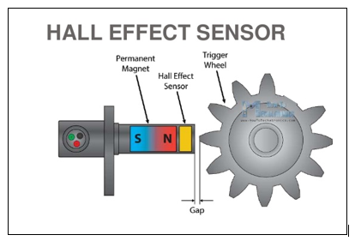
Figure 1 Hall Sensor Diagram

In order to calculate the difference between the missing tooth position and top dead centre, a test must be completed. The engine must be run with the pressure transducer connected, but with the spark plug disconnected. This will allow the cylinder pressure to be recorded without combustion, therefore peak pressure will occur at top dead centre. The point of peak pressure and the position of the missing tooth can be used to find exact crank angle. As this data has already been collected, an excerpt is shown in figure 2.

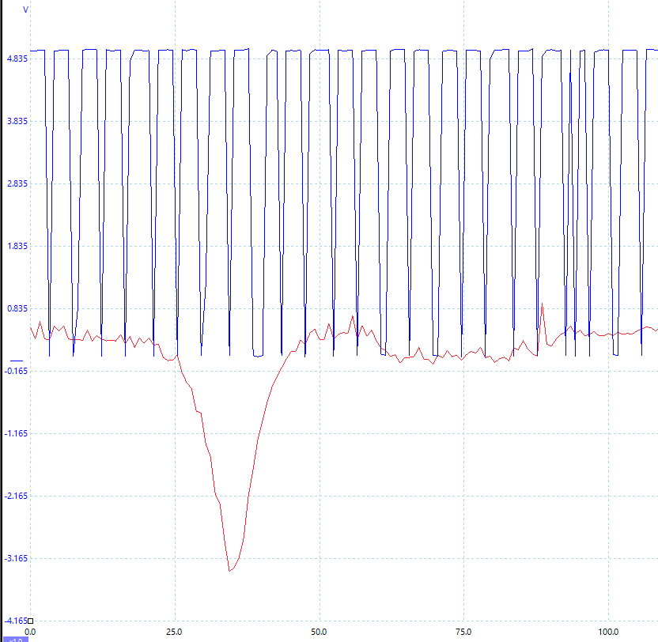
Figure 2 Graph Showing Motored Pressure Data

Initial Testing
A test cycle will be developed on the dynamometer. This will hold ensure the same test is completed every time. The cycle will ensure the same test is completed every time, as it will be computer controlled it will remove the possibility for user error. This will ensure higher levels of repeatability and less variables.

Combustion Model
The testing will have provided cylinder pressure and the crank angle will allow volume to be calculated. Air flow will be taken from the air mass sensor on the engine and logged. Also measured will be lambda, which is O2 content in the exhaust. These 2 values will allow the calculation of air and fuel mass. This data will allow a 2-zone combustion model to be completed. The combustion model will be completed in Excel. This will be using a similar model that has been developed for another module.

Water Methanol Testing
The same test cycle will be repeated using the water methanol injection system. This will log the same data and allow combustion modelling to be completed with the water methanol injection. This will allow comparison of the 2 models for analysis. Multiple water methanol tests will be completed, using 3 levels of flow and different ratios of water and methanol. The flow levels to be tested will vary depending on the results of the first test. If the engine struggles with the first test, a lower will be used, or if the engine is okay, a higher will be tested in addition. The first test will use 180cc/min. For the subsequent testing, the available injectors are 32cc, 47cc, 60cc, 180cc and 270cc per minute. The ratios to be tested will be 100% methanol, 75% methanol, 50%, 25% and 0%, with the rest water. This wide variation in tests will ensure thorough testing is completed.

Emissions Testing
During both the standard test cycle and the water methanol test, exhaust gases will be tested and logged. This will allow analysis of the water methanol injection as it will provide detailed levels of the exhaust gases, including NOx and CO2 levels. This data will also be used to provide validation to the combustion models. The exhaust will be sampled by the gas analyser test tube being inserted into the extraction system of the dynamometer, into a test hatch designed for this purpose.

Results

Data Analysis
The raw data collected will be a voltage from the pressure transducer. Using the information provided on the equipment, this will be converted to a pressure reading (bar) using Excel or MATLAB. The crank angle will also be provided as a voltage, from the hall sensor, and will subsequently be converted to an angle.
There is a considerable amount of data needed for this research, hence a suitable storage device will be required, and ideally an automated method of sorting this data. Each test will consist of an average taken over 300 cycles of the engine, at each rpm site. This is to increase reliability in results and negate any cyclic variation. 300 cycles are standard use in industry, including Ford.

Validation
Upon completion of the testing and modelling, the gas analyser results will be compared to the predicted emissions from the combustion model. This will show what margin of error there is between the predicted combustion model and the measured values.

Evaluation
This research will show the impact of water methanol injection on the combustion process and the impact of it on harmful vehicle emissions. This research will also see the development of a combustion model aimed at predicting the impact of water methanol injection, which may be useful to vehicle manufactures and calibration engineers.
The scale of the success of this research will depend considerably on the margin of error from the gas analyser and combustion model. A lower margin of error will show an accurate combustion model, whereas a high error margin could question the validity and reliability of the research.
If the reduction in NOx emissions is found to occur this research could have industry wide benefits, such as the introduction of a water methanol injection system in new vehicles, either by regulation in that a system must be fitted to new vehicles, or by manufactures choice in order to hit emissions levels. Another possibility is the retrofitting of a water methanol injection kit to current vehicle, in order to reduce vehicle emissions using current vehicles rather than having to wait for new vehicles only.
A further limitation to this research is the limited time available for research. If any issue arises with the engine, pressure transducer or dynamometer, a delay could cause time issues. Testing is aimed to be completed as soon as possible to allow any issues to be rectified.
[Added 18/3/20] Due to the current situation regarding Coronavirus and the closure of the University, this may result in limiting the amount of practical testing possible. If the University remains closed throughout the academic year this research will be purely model based, using cylinder pressure data provided for another module, which will be changed to consider water methanol injection.

Bibliography
Berni, F., 2015. Numerical Investigation on the Effects of Water/Methanol, Modena: Univ of Modena & Reggio Emilia.
Brooke, L., Birch, S., Buchholz, K. & Weissier, P., 2016. BMW’s first production use of water injection in automobiles. Mobility Engineering, March, pp. 45-46.
Colin, O. & Benkenida, A., 2004. The 3-Zones Extended Coherent Flame Model (Ecfm3z). s.l.:Institut Français du Pétrole.
Jolly, J., 2020. UK could ban sale of petrol and diesel cars in 12 years, says Shapps. London: The Guardian.
Kingston, L., 2018. PH Origins: Water Injection. [Online]
Available at: https://www.pistonheads.com/news/features/ph-origins-water-injection/37471
[Accessed 01 03 2020].
Lanzafame, R., 1999. Water Injection Effects In A Single-Cylinder CFR Engine. Catania: University of Catania.
Lanzafame, R., 2003. Water Injection in IC - SI Engines to Control. Catania: University of Catania.
NACA, 1944. Effect of Water Injection on Knock Limited Performance of a V Type 12 cylinder liquid-cooled engine. Cleveland: National Advisory Committee for Aeronautics.
Peters, B. & Stebar, R., 1976. Water-Gasoline Fuels - Their Effect on Spark Igntion Engine Emissions and Performance.. s.l.: SAE 760547.
Ricardo, H., 1955. The High Speed Internal Combustion Engine. s.l.:Blackie & Son Limited.
Tsao, K. & Wang, C., 1984. Performance of Gasoline-Water Fuel in a Modified SI Engine. s.l.: SAE Paper 841399.
Wilson, J. P., 2011. Effects of Water Injection and Increased Compression Ratio in a Gasoline Spark. Universtiry of Idaho: College of Graduate Studies.

