Student name: Juliette Zelleke
Student number: 1706524
Module course and number: Research in context ADAD5003
BA Course: Design crafts
Tutor name: Julia Lockheart
Question 1: What is the role of the designer/maker in the 21st Century and how might this role change in the next 10 years? Discus your ideas with reference to two of the practitioners or thinkers in your lecture stand.
Word count: 2,294

In this essay I will be exploring what the role is of a designer/maker and how that might change in the future. I will be looking at texts from J. A. Walker’s ‘History of design and a design history’ and ‘crafts culture’ by Peter Dormer, to help me have an understanding on the history that surrounds designer/makers and craft. I will also be collecting data and information about the environmental crises from online articles, to create a comparison between what was and what is. I will be exploring the relationship between a designer/maker and modern day technology, looking at both the negative and positive impacts they may have in the environment, society and the design community, and how the future is evolving and what can be done to make it evolve in the most positive and beneficial way.
In the past designers looked to the future and mostly to technology and how that could not only revolutionise the world but also the world of design itself. As explained in ‘Design as future making’ ‘the term digital Crafting suggests the intersection between digital design tools and the capacity of precision, variation and control within the crafts tradition’ (Veiavich and Adams, 2014) shows that there is still craftsmanship behind more modern pieces but that technology has simply made it easier to design. However it is also my belief that now in the new wave, there is a strong disconnect between an object and the craftsmanship behind that objects that we interact with. We are so used to having everything at the tips of our fingers; that objects and information are given to us quickly, minimal time and effort are needed. It is as if the faster something is made the faster that something becomes disregarded, thrown away and eventually forgotten. ‘Men now live in conditions that are less than human’ (Ellul, Wilkinson and Merton, 1967) Because of this disconnect there is a market where simpler and more natural designs that require skill is more important in the modern market of design. Having said that it does not mean that technology and the designer cannot work hand in hand.
Crafts is seen as something from the past, yet in third world countries it still plays an important role in everyday life. Not having gone through an ‘industrial revolution’; the objects that are made come from the materials that they have been collected from waste materials or harvested from natural resources. The natural materials are shaped into objects that are fundamental to everyday life, using skills that have been passed on or learned anew are essential for day to day tasks. ‘Crafts tends to be part of the luxury and gift markets. First and third worlds come together in the craft products made by the poor for the affluent foreign tourists that are the so called ‘ethnic’, ‘tourist’ and ‘airport arts.” (Walker, 1989) Having to make objects from the materials that we have is essential to a craftsman, yet when machines are able to do all the same jobs, the ‘craft’ pieces lose value because they become generic forms, and traditionally made objects rise in value, much like when a painter/artist dies their work become more valuable to the public. But craft and design is not a dying art form and it never will be. Designers are always looking into the future and solve problems that may not even exist yet or problems that we didn’t know we had. Many artists are looking forwards by learning from the past. The market has been flooded by cheep manufactured objects that lack, skills, feeling and the individuality, thus creating a gap in the market, a gap that designers are trying to fill, and because of this gap there is a rise in design sustainability. Many designers are going back to old practices and skill making and using materials that will last longer, though a lot of these objects are higher in price. I think that people are willing to spend more money on an object that will last longer, rather than to continually pay for something that is of less quality.
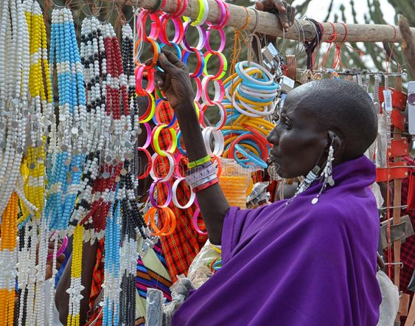
(Image 1: Masaii woman in the masaii market, Tanzania)
Ceramics, metals and glass are materials that need long amounts of patience, practise and skill to master and have been used for centuries. However plastic is a revolutionary material that changed everything and is very difficult to avoid in day to day life, it has created a world that revolves around it. ‘more than 448 million tons of plastic produced every year is disposable, much of it used as packaging intended to be discarded within minutes after purchase.’ (National Geographic, 2019)
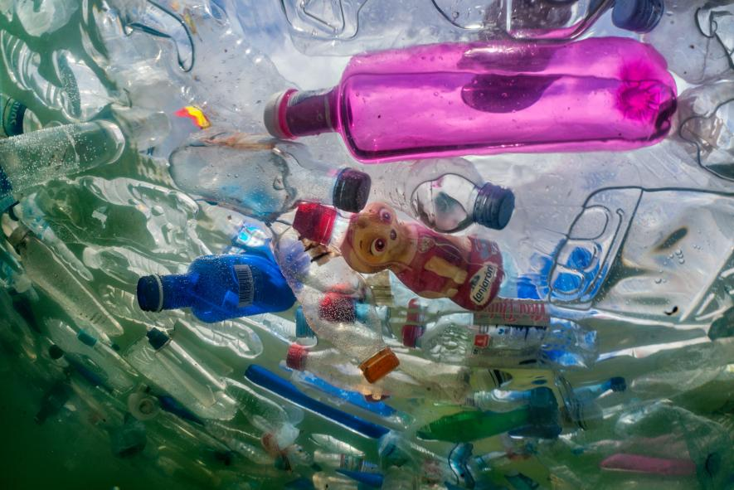
(Image 2: Plastic bottles in the Cibeles fountain, Madrid, Spain)
It is killing the planet, and it is slowly killing us. I believe that we as designers need to change the narrative of how we interact with objects. We need to have a more positive approach to this new problem as modern problems need modern solutions. We have become comfortable in a vicious cycle of using cheep products, made from cheep materials that are then disregard. Single use plastics are changing the way that people look and interact with objects and have created a strong throwaway consumerist society. ‘industrial manufacture; mass production methods; a capitalist, free market economy and a reasonably affluent population’(Walker, 1989) makes it easy for larger companies who can afford to uses plastic and dispose of it, disregarding its negative effects on the planet, and create cheep manufactured goods that appeal to the fast pace lifestyle of the new age. We are drowning in an economy that realise on fast, cut-price and affordable items, creating a negative reaction towards humanity and the planet. Because of this reaction there is a higher demand for thing that can be made to a much higher quality using raw materials such as glass, ceramics, wood and metals. On the other hand, some may argue that if we continue to use these raw materials it might make the situation worse; for example for a carpenter to make a wooded table a tree must be cut down, and for a ceramist to fire clay (which has to be dug up) they have to burn in a high fire contributing to the disappearance of the ozone layer. However raw materials tend to last much long and have more value.
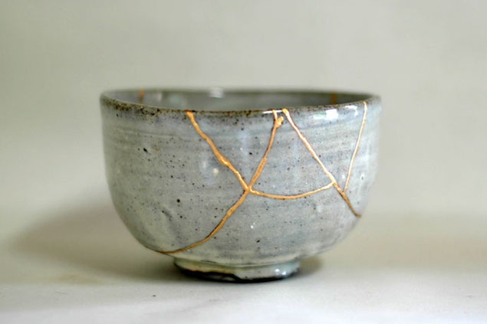
(image 3: Kintsugi bowl)
Kintsugi or Kinstukuroi (translated as golden joinery or golden repair) is a Japanese art of repairing broken pottery with lacquer mixed with gold or silver powder to mend the cracks. The philosophy behind this traditional art form, it to embrace the imperfections in the pottery and life, and to show that just because something is broken whatever it may be it can always be repaired and in some cases be more beautiful than before. They say that Kintugi originated when an emperor had broken his favourite tea cup and when it broke he was devastated and demanded it to be repaired. However when it came back they had put ugly staples into the cup and he was not pleased, so he asked the best craftsmen if they could find a solution to this problem, thus Kintugi was born. The idea that when something is broken or does not work like it used it has to be disregarded and replaced is the modern mentality of today’s society. This was before technologies had a bigger impact and objects more importance as people tended to live a minimalistic life and only owned what they needed making objects hold stronger emotional value.
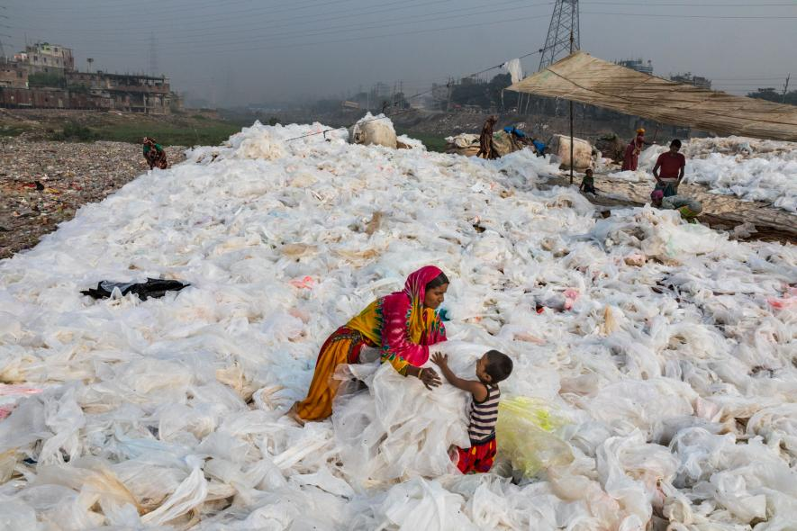
(Image 4: sheets of plastic in Dhaka, Bangladesh)
Some may say the solution to these problems is for science, technology and designers to work together and create a new material, I do not agree with this because the last material man made was plastic and that has not worked out so great. The argument that the use of raw and natural materials is problematic is a non-conclusive argument that barely has any basis in truth, in fact there are many counter argument and solutions to this, such as controlling the mount of materials we use and replacing what we can replace I.e. replanting trees. However bigger corporations are making it hard for people to detach themselves from this ‘self fulfilling prophecy’ that we have created and are finding it difficult to break out of the cycle that we have become so accustomed too, making us dependant on the use of plastic. Nonetheless because of this, crafts and other art forms are becoming forgotten languages of the past. As the new wave of technology arises there are fears that art of design and crafts will be completely forgotten or so excluded that most people will not be able to access it.
“Crafts’ This name is given to any profession that requires the use of hands’(Dormer, 1997) With all these technological advances such as the use of 3D printers, ‘Craft’ in the sense of the word is created however can a machine really do what a person can do? To some extent machines are extensions of the human hand however with its lack of nerve endings one may argue that it is in fact not a craft as it has not been made by hand, and creates a perfect object that adds an inhuman a atmosphere to the objects. On the other hand, ‘Architects, engineers, and designers are creating a new generation of prototypes that challenge the way we think about materials in a built environment’ (Veiavich and Adams, 2014) The new generation is thinking about the future not only in terms of designing but also environmentally. As mentioned before the environment plays a much bigger role in design today than it has in the past. The rise in awareness about the environment has caused a rise in consumers who want environmentally friendly and sustainable objects, making the designer/makers think about how they can change techniques and incorporate modern techniques with more traditional style, as in the past architects, engineers, and designers, made buildings, motors and other day to day objects to last the test of time, with this we can try and stop or at least slow down the demand for fast and convenient life style.
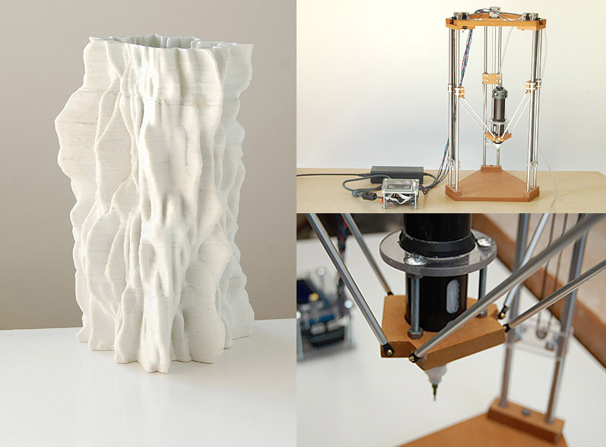
(Image 5: 3D Ceramic printer)
In addition, Some also argue that machines help designers ‘understand structural performance and create better less materially intense and therefore, more sustainable structures’(Veiavich and Adams, 2014) insuring that the work created does not cause more waste than necessary. Most products manufactured by machines, have to be polished or finished off by hand, thus allowing the object to still be classified as ‘handmade’. Though this is a controversial topic among the crafts community it is a discussion that needs to be had. Can there be a line drawn when it comes to working with machines? Machines are simply more efficient and modern tools that the designer’s disposal. As people have adapted to change in the past it is our turn to start adapting and to create art that can work more efficiently with technology and machines. By doing this designers can be more efficient with their work, but also keep the handmade aesthetic of that object, allowing it to still be handmade and filling in the gap of the market where more affordable but craft objects that are wanted.
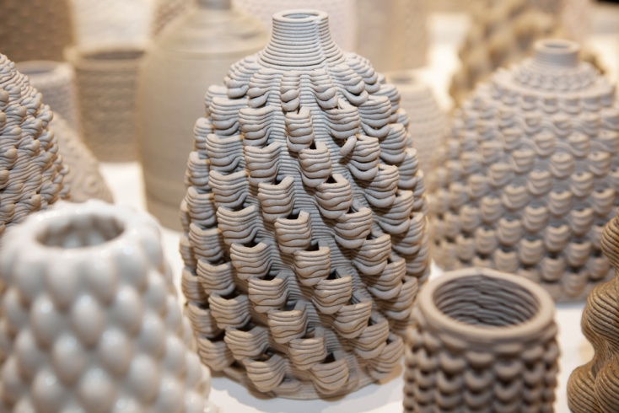
(Image 6: 3D printed ceramics)
‘Wherever ornament is wholly affected by machinery, it is certainly the most degraded in style and execution; and the best workmanship and the best taste is invariable to be found in those manufactures and fabrics wherein handicraft is entirely or partially the mean of producing the ornament.’ (Redgrave and Redgrave, 1876) Although Redgrave’s views can be found to be extreme and somewhat old fashioned to a few people; I believe that there is, and always will be a high status for all things handmade. Handmade objects are unique pieces in their own right and are widely recognised for their exclusivity, higher price range and distinctive aesthetic, thus making them more desirable for people who prefer them to manufactured pieces. There also needs to be a new understanding as to how much work and time goes into pieces. Something as small as a bowl made from ceramics takes years to master, it is not only the time it take to make a piece but the amount of time it took the maker to develop the skills, understanding of the material and the development as a designer that must not go forgotten. Machines are capable of creating piece quickly but they do not have the skill that a designer/maker has.
In conclusion, the role and future of the designer is always changing and adapting with the development in areas like technologically, socially and environmentally. ‘Technology as we know it is rooted in craft but it different from craft’ (Dormer, 1997) As designer/makers we need to learn how to create with the technology that has been developed over the years, but without forgetting the fundamentals of craft. We designers are also capable of changing society and creating change from the background by revolutionising day to day objects and making peoples live easier. We cannot forget the old methods in designing and making and we cannot ignore the impact that we have had on the earth. I strongly believe that with the knowledge and awareness that designer/makers have today we can change the way people interact with each other, nature, art and technology. Creating a balance between them all is important, and I believe that we are capable of creating that balance by using what we know from the past, and what we are learning in the and designing in the present and by thinking of new ways of adapt to the future.

Bibliography
Dormer, P. (1997). The culture of craft. Manchester: Manchester University Press.
Ellul, J., Wilkinson, J. and Merton, R. (1967). The technological society. New York: Vintage Books.
Redgrave, R. and Redgrave, G. (1876). Manual of design. [London]: Published for the Committee of Council on Education, by Chapman and Hall, 193, Piccadilly.
Veiavich, S. and Adams, B. (2014). Design as Future-Making. London: Bloomsbery.
Walker, J. (1989). Design History and the History of Design. London: Pluto.
National Geographic. (2019). We Made Plastic. We Depend on It. Now We’re Drowning in It.. [online] Available at: https://www.nationalgeographic.co.uk/2018/05/we-made-plastic-we-depend-it-now-were-drowning-it [Accessed 3 Dec. 2019].

