

Chloe Burgess

SBUS6120 - Strategic Management and Sustainability

Strategic

Management

of

Adidas

Table of Contents

Executive Summary…………….………………………………………………………………………… 2

Introduction 3

Company background 3

Objectives of the report 4

What is a strategy/strategic management? 4

What is a competitive strategy/business level strategy? 4

Main findings

General overview of Adidas strategy 4

Analysis of Adidas strategy 5

Bowman’s Strategic Clock (detailed analysis) 6

PEST analysis (detailed analysis) 7

SWOT analysis (detailed analysis) 8

Advantages 9

Disadvantages 9

Conclusion 9

Recommendations 9/10

Appendices 10/11

Reference List 12/13

Executive Summary –
The purpose of this report is to identify and analyse the internal and external factors that influence the competitive strategy and position of adidas with the use of 3 strategic management tools. It will start with a company background of adidas along with definitions of a competitive strategy and strategic management.
The main findings will consist of an analysis of adidas’s competitive strategy ‘Creating the New’ as well as an analysis of the internal and external factors that are having an influence on their position and strategy. These have been identified using the following 3 strategic management tools; a PESTLE and SWOT analysis and the Bowman’s strategic clock.
To conclude, once I have gathered my findings and analysed the factors that have influenced adidas’s competitive strategy to give them their current position I will provide 3 personal recommendations for their competitive strategy/position.

Introduction
During this research on adidas I hope to identify their competitive strategy and the key actions they are taking to accomplish this strategy.

I am also going to analyse the micro (internal) and macro (external) environment the business operates within by using a variety of strategic management tools to help understand their current competitive position; A SWOT and PEST analysis and Bowman’s strategic clock. Strategic management tools are known to be useful to many companies as they allow them to identify and avoid potential problems that may occur and take advantage of foreseeable opportunities (SWOT) within the internal and external environment.

In conclusion, based on the findings I gather I will make a few personal recommendations for adidas based on their current position and justify why I have given them.

Company background
Adidas is a German manufacturer that now markets a range of athleticwear from casual shoes to gym clothing and accessories. Adidas was originally founded by two brothers Adolph (Adi) Dassler, and Rudolph (Rudi) who invented spiked shoes in 1920 for any running-based activity. Four years later in 1924, they found the German sports shoe company Gebruder Dassler, later to be known as adidas (Flippo, 2018).
August 18th, 1949, Adi Dassler (49) separated from his brother and registered the “Adi Dassler adidas Sportschuhfabrik” alongside employing 47 individuals in a small town of Germany. Later that day, Dassler registered a shoe as well as the now globally known 3-stripes design. It wasn’t until 1992, 5 years after the deaths of the founder (Adi) and his family the business suffered a devastating record loss that brought the company to near bankruptcy.
Over the next decade a few CEO’s stepped in and helped turn adidas into a marketing-driven company, guiding it back on the growth path. In early 2006, adidas acquired Reebok; bringing together two of the world’s most globally-known companies in the sporting industry. Between 2006 and 2012, Adidas searched for new teammates and released the “all in” campaign featuring celebrities that brought together sport, street and style resulting in a push of growth in sales (see appendix 1). October 2016, new leader and CEO Kasper Rorsted transitioned to adidas from the consumer goods company Henkel; Rorsted is a leader with a digital vision and is now steering the company to successes in a digital era by building on the company’s previous established strategy “Creating the New” (Adidas, 2018).

Objectives of the report
The objectives of this report are as follows:
- To gain an understanding of a strategy, a competitive strategy and strategic management
- An overview and analysis of adidas competitive strategy
- An analysis of the micro and macro environment adidas operates within through a SWOT and PEST analysis and to understand their competitive position through Bowman’s strategic clock
- 3 personal recommendations for adidas based on the findings

What is a strategy and strategic management?
According to Johnson, et al. (2014), a strategy is “the long-term direction of an organisation”. While, Finlay (2000), states that strategic management is “the process of managing the mix of goals and the strategic pathway that serve to define what the organisation is (or wishes to be), where it is going, when it wants to get there and how in general it is to get there. It also includes the processes of monitoring and controlling the strategy of an organisation”.

Competitive strategy / business level strategy
Johnson, et al., (2014) further states that a business level strategy is about how an individual business should compete in their market and usually consists of issues such as innovation and response to competitors’ moves. Therefore, because of this a business level strategy is often also referred to as a competitive strategy which is further concerned with how a strategic business unit (SBU) strategically achieves a competitive advantage in its daily operations.

Main findings

General overview of Adidas strategy
Adidas’ mission is to be the ‘best’ sports company in the world, ‘best’ to them means that they design, build and sell the best sports products in the world, with the best service and experience, and that they do so in a sustainable way. Everything adidas believe in is influenced by sport and the fact that it is becoming an increasingly important role in more people’s lives, allows adidas to operate strategically to drive brand desire and capitalise on growth opportunities whether it be sport or sports-inspired casual and activewear (Adidas, 2018).
“Sports is central to every culture and society and is core to an individual’s health and happiness” (Adidas, 2018). This is a good example of adidas primarily taking a highly demanded need and turning it into a competitive advantage.

Adidas have implemented a strategic business plan ‘Creating the New’ (see appendix 2) until 2020 which is not only the attitude that leads them into the future but accomplishes their mission too. The fundamental desire of this plan is to additionally drive top-and-bottom line growth by significantly increasing brand desirability. To do so, adidas are focusing on their core brands to connect and engage with consumers through 3 key choices of the plan:
- Speed – how they deliver: by putting consumers at the heart of everything they do means that adidas can ensure they always find new and desirable products when and where they are wanted.
- Cities – where they deliver: Urbanisation is a global megatrend as most of the global population live in or near cities; this also shapes trends, consumer perception, perspectives and buying decisions. Therefore, adidas have identified 6 main cities; London, Los Angeles, New York, Paris, Shanghai and Tokyo, where they want to grow share of mind, share of market and share of trend.
- Open source – How they create: This choice is all about collaboration and innovation; learning and sharing. adidas are opening the arms of their brands to athletes, consumers and partners to co-create the future of sport and sports culture together.
In addition to the business plan and corporate culture, adidas have 4 initiatives they will continue to focus on; portfolio, adidas North America, Digital and ONE adidas.
(Adidas, 2018)

Analysis of Adidas strategy
Despite a few difficult years for adidas, especially with near bankruptcy it is evident they are back on track as in 2016 there was an outstanding result from their growth strategies of the new adidas Group as revenues increased by 18% up to $19.3bn, resulting in the brand image growing by 22%. Furthermore, as of November 2017, adidas received a strong quarter of earnings and revenue growth from the US and China as a result of expansion, proving their ‘cities’ choice of the ‘creating the new’ business plan, effective (Aguilar, 2017).
It is evident that the first key choice of adidas’ business plan, speed is too effective as they focus on how they deliver to their consumers by putting them at the heart of everything they do, and ensuring they provide desirable products that are widely available. For Adidas, the best way to build direct relationships with consumers is digitally, to do so; customer experiences must feel premium, connected and personalised. Therefore, adidas have designed their mobile app to customise content, products and interaction based on a customer’s personal preference and behaviour through various engagement points (Cameron, 2017). Adidas also feel that consumers play an important role in shaping their brand and provide the necessary tools; focus groups, online reviews and customer feedback to become a “creator consumer” who is someone that doesn’t want to just receive products but want their experiences heard and the chance to connect with others (Gilliland, 2017).

The focus of the 3rd choice of adidas’ strategic business plan/strategy ‘open source’ is comprised of crowd sourcing ideas from four pillars within and outside of adidas, those being; creators, communities, customers and partners (Haas, cited by (Blaustein, 2015)) thus enabling access to tonnes of information that can be used strategically. Blaustein (2015) also states that a key practical effect of the collaboration from this choice was the integration of materials made from ocean plastic waste into Adidas products in 2016 and beyond, which will result in many benefits as plastic pollution is a growing concern today. Therefore, companies like adidas promoting a change like this can result in a positive spiralling effect on companies and the planet in general.

Bowman’s strategic clock (detailed analysis) / Porter’s generic strategies
Bowman’s strategic clock (see appendix 3) was developed by Cliff Bowman based on Michael Porter’s generic strategies and is a model used by companies like adidas, whilst designing their marketing strategy to analyse their competitive position in comparison to their competitors (Ahmed, 2014). The clock consists of 8 positions listed below and will be used to help analyse adidas’ current competitive position:
Position 1: Low Price / Low Added Value – a lot of companies tend to avoid this position and are only left here when their products lack differentiated value. Therefore, it is clear adidas do not sit in this position.
Position 2: Low Price – companies like Aldi sit in this category as they convince their suppliers of providing low prices in return of high sales volumes. However, this can end up affecting the quality of a product.
Position 3: Hybrid – most discount retailers fall into this position where they offer good quality products to customers at a lower price than other companies, giving off a higher perceived value compared to low cost competitors.
Position 4: Differentiation – this position is when a company can offer unique characteristics to a product and/or service that are highly valued by consumers which differentiate to their competitors, giving them a competitive edge. Nike is an example of a company who are in this position, with adidas/reebok differentiating by providing high quality with a lower cost (focused differentiation).
Position 5: Focused differentiation – Adidas falls into this position which is when companies like themselves offer high value products against the high price’s competitors offer, like Nike; who is their main competitor. Anonymous (2017) backs this up by stating that “one of the biggest reasons adidas’ product differentiation is so profound is that even though their products are high quality, they actually price lower than Nike in a lot of different areas strategically”.
Position 6: Risky, high margins – This is a short-term strategy companies use when they take a gamble by increasing their prices on a product that is still of the same value, but it is only effective when consumers accept the price inflation.
Position 7: Monopoly pricing – this strategy is implemented by a company that is the only one competing in a certain market. Monopolist companies don’t need to worry about the value of their product because if customers need it, they will pay whatever price for it.
Position 8: Loss of market share – any company that offers a low value product and/or service will have to sell at a set price as that is the only way they will receive sales.
After analysing their strategic position using Bowman’s clock it is clear adidas are more in position 5; focused differentiation as they gain a competitive advantage by offering higher perceived value products and/or services at lower prices than other well-known brands like Nike and Callaway. Not only this, but by using effective promotional strategies, like associating with celebrities and idols of the sports world they are able to gain steady sales and revenue whilst creating a desirable brand image (Adamkasi, 2017).

PEST analysis (detailed analysis)
Silva (2016) states a PEST analysis is a widely used strategic planning tool to help identify the political, economical, social and technological issues that may have an effect on a project and its planning process.
Political – As adidas supplies and distribute their products worldwide they are required to follow several rules and regulations such as trade and labour laws and extend international supply chains when selling their products online (Frue, 2017). Brexit will also have a significant impact on adidas as rules and regulations will be altered to suit the country’s needs and will need to be adhered to. (2)
Economical – The economic factors that have an uncontrollable effect on adidas include: taxation, inflation, unemployment, currency fluctuations and counterfeit issues. The main factor that impacts adidas the most is counterfeit issues as they are completely uncontrollable and a problem the government tackles. However, they’re not all negative factors if they are investigated deeply enough, hence why adidas has taken advantage of China’s economy to manufacture their products as they’re labour intensive with low cost for creation. (4)
Social – Social factors that influence the innovation of adidas entail language, race, religion, gender, lifestyle and culture. For example, if adidas were to do an advertisement in an Islamic country then they would need to consider the dressing styles they offer due to culture and religion. Personally, this is the most important factor of the PEST analysis for adidas as there are so many lifestyles they need to adhere to, to be a globally desired brand. (1)
Technological – as adidas is an online based retailer there are not many factors that affect their daily operations. However, by using technology adidas can understand who their consumers are and the more about them they know, they better they can serve thus making it fundamental to their ability to design great products (Cameron, 2017). (3)

Swot Analysis
A SWOT analysis (see appendix 4) is an abbreviation for strengths, weaknesses, opportunities and threats and is a process that is used by the management team of an organisation like adidas to help identify internal and external factors that may influence the performance in the future. The strengths and weaknesses are internal factors with threats and opportunities being external.
Weaknesses:
- Outsourced manufacturing
Strengths:
- Using innovation to keep up with consumer trends
- Passionate to be the ‘best’ sports company in the world
- Diversified portfolio for athletic and casualwear
- Branding by creating engagement points (celebrity endorsements)
Threats:
- A lot of competitors
- Government regulations (Brexit)
- Counterfeit issues
Opportunities:
- Trend rise in health & fitness
- Technological advancements
- Expansion in products (technological)

(Bhasin, 2018)

Strengths:
The continuous change in consumer taste in health and fitness allows adidas to use this to their advantage by constantly coming up with new ideas every year or season to attract maximum attention. By being so passionate to be the ‘best’ sports company, adidas brand value has grown by 41% to $14.3 billion in 2018 (Rooney, 2018).
Weaknesses:
There are very little weaknesses for adidas as they are growing so well over the last few years, proving their strategic methods a success. However, outsource 93% of their production to 3rd party manufacturers - mainly Asia, to avoid costs, therefore they are running the risk of over dependency on outsourcing (Bhasin, 2018)
Opportunities:
To attain a wider target market adidas need to ensure they keep up with all health trends; Pilates and yoga is becoming an increasing trend amongst millennials and a perfect opportunity for adidas to widen their products. Technological advancements like a fit bit could be a good opportunity for adidas to take advantage of as an accessory to their clothing.
Threats:
With a lot of competitors in the same industry such as Puma, Under Armour and Fila; adidas need to think of continuous ways to gain a competitive edge. This is where they can use opportunities to turn threats and weaknesses into strengths, which they are clearly aiming to do.

Advantages to their strategy
Adidas have a few competitive advantages that I have noticed from their strategy, the main one being from the Bowman’s clock where they identify themselves as using the ‘focused differentiation’ strategy by offering high value products at a lower price than rivalry competitor Nike. The second one being the sustainability they are trying to embed into their products as Haas went on to say that “consumers make decisions based on the brands they prefer, sustainability and innovation are two of the key criteria’s of selection” (Blaustein, 2015). Internal factors that influence their strategy include their diversified portfolio for athletic and casualwear as well as their passion to be the ‘best’ sports company in the world.

Disadvantages to their strategy
It is clear throughout my research that there are not many disadvantages to their strategy, only the external environment they operate within which was noticed in the SWOT and PEST analysis as uncontrollable factors.

Conclusion
This report has analysed the internal and external environment adidas operates within and identified the factors that have an influence on their competitive strategy to give them their current competitive position. To conclude, there are many benefits to adidas strategy as a result of the environment they operate within; with very few disadvantages noticed from the analyses. The main factors I noticed to be working so well for adidas is their desire to drive brand value and the importance of their consumers.

Recommendations
1. Continue to collaborate on the open source choice of the strategy because there are many environmental benefits as well as opportunities to gaining a competitive advantage.
2. By exploring diversification further - in terms of offering personalised fit bits or health devices will enable adidas to keep up with consumer trends and technological advancements.
3. Maintain celebrity endorsements as they are strongly influential on today’s millennials.

Appendices
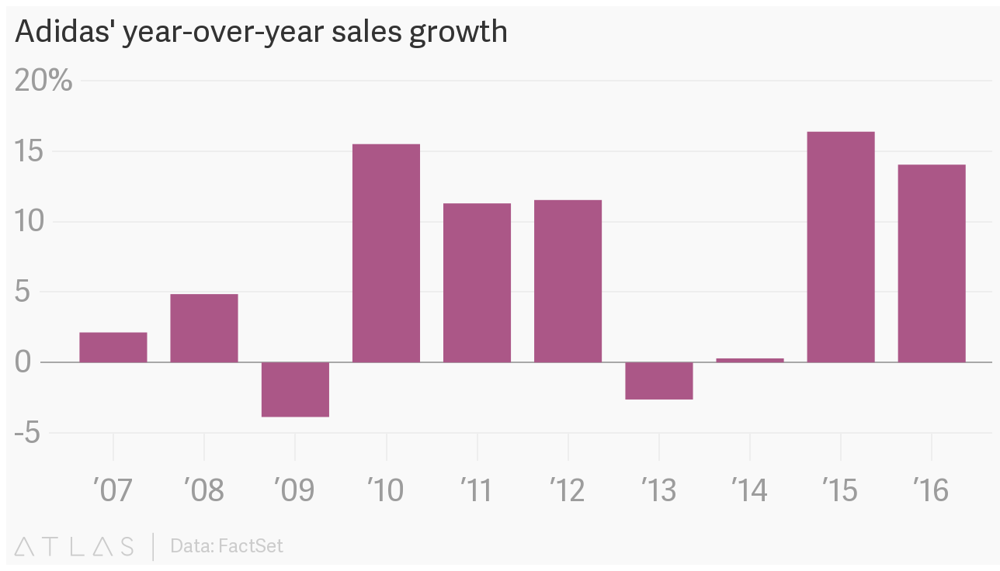
Appendix 1:

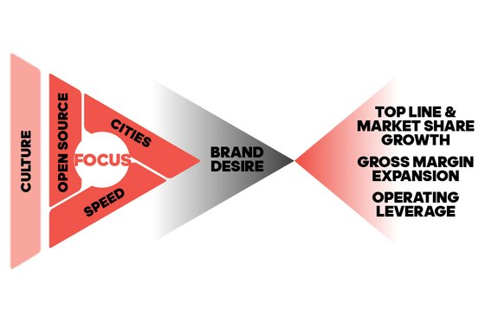
Appendix 2:

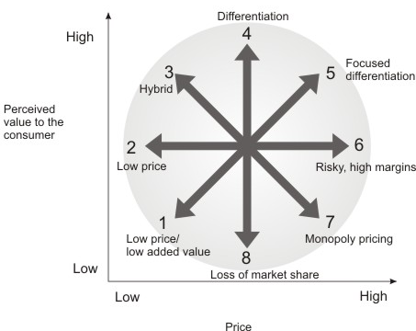
Appendix 3:

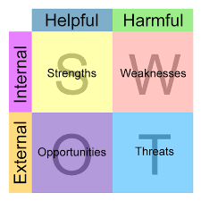
Appendix 4:

References
Adamkasi, 2017. Competitive Advantage of Adidas. [Online]
Available at: www.competitiveadvantageanalysis.com/competitive-advantage-of-adidas/
[Accessed 19 November 2018].
Adidas, 2018. History. [Online]
Available at: https://www.adidas-group.com/en/group/history/
[Accessed 12 November 2018].
Adidas, 2018. Strategy. [Online]
Available at: https://www.adidas-group.com/en/group/strategy-overview/
[Accessed 15 November 2018].
Aguilar, P., 2017. Adidas poised to thrive in highly competitive landscape. [Online]
Available at: https://www.just-style.com/comment/adidas-poised-to-thrive-in-highly-competitive-landscape_id132114.aspx
[Accessed 17 November 2018].
Ahmed, G., 2014. Bowman's Strategy Clock Model & its Eight Competitive Directions for Edge. [Online]
Available at: http://www.studylecturenotes.com/management/bowmans-strategy-clock-model-its-eight-competitive-directions-for-edge
[Accessed 16 November 2018].
Anonymous, 2017. Adidas & Product differentiation. [Online]
Available at: http://allaboutadidas101.blogspot.com/2017/10/adidas-product-differentiation.html
[Accessed 17 November 2018].
Bhasin, H., 2018. Adidas SWOT analysis - SWOT analysis of Adidas. [Online]
Available at: https://www.marketing91.com/adidas-swot-analysis/
[Accessed 19 November 2018].
Blaustein, L., 2015. How Adidas is pioneering open-source sustainability for sports. [Online]
Available at: https://www.greenbiz.com/article/how-adidas-pioneering-open-source-sustainability-sports
[Accessed 17 November 2018].
Cameron, N., 2017. Adidas taps data and technology smarts to build personalised digital engagement with consumers. [Online]
Available at: https://www.cmo.com.au/article/629662/adidas-taps-data-technology-smarts-build-personalised-digital-engagement-consumers/
[Accessed 17 November 2018].
Finlay, P., 2000. Strategic Management; An Introduction to Business and Corporate Strategy. 1st ed. Essex: Pearson.
Flippo, H., 2018. A Brief History of Adidas. [Online]
Available at: https://www.thoughtco.com/quick-history-of-adidas-1444319
[Accessed 12 November 2018].
Frue, K., 2017. PESTLE Analysis of Adidas. [Online]
Available at: https://pestleanalysis.com/pestle-analysis-adidas/
[Accessed 18 November 2018].
Gilliland, N., 2017. How Adidas uses digital to enable powerful experiences. [Online]
Available at: https://econsultancy.com/how-adidas-uses-digital-to-enable-powerful-experiences/
[Accessed 16 November 2018].
Johnson, G. et al., 2014. Exploring Strategy. 10th ed. Edinburgh: Pearson.
Rooney, S., 2018. Battle of the Sportswear Brands: How Nike & Adidas are Competing for Young Consumers in the US. [Online]
Available at: https://entsight.com/blog/battle-of-the-sportswear-brands-how-nike-adidas-are-competing-for-young-consumers-in-the-us
[Accessed 19 November 2018].
Silva, N., 2016. How a PEST Analysis Can Help with Strategic Planning. [Online]
Available at: https://www.business2community.com/strategy/pest-analysis-can-help-strategic-planning-01420731
[Accessed 16 November 2018].

distinguishing a product/service
Increased prices on a standard product
High price/low value
Low value/standard price

