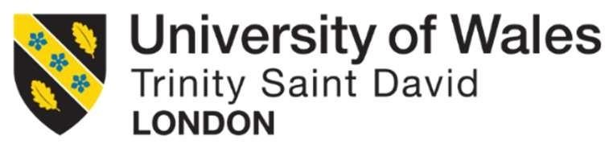

Student Name/ID | Faiyaz Faruk Malek/ 2544436
Module Name | Human Capital Management
Module Code | LCMB7023
Assessment Title | Assessment component 1:  Individual report
Topic | Designing a Human Capital Architecture for Strategic Renewal

Table of Contents
Task A: Socialisation, Identity & Business Activism 3
1.1 Traditional Onboarding versus Strategic Organisational Socialisation 3
1.2 Strategic Organisational Socialisation Framework for Helios 4
1.3 Developing Organisational Identification, Ethical Professionalism and Business Activism 6
Task B: Job Design 7
2.1 Innovative Job Design Strategy for Helios 7
2.2 How the Proposed Job Design Supports Intrinsic Motivation and Innovation 9
Task C: Reflective Report 10
3.1 Responsible Use of AI in HR Decision-Making 10
3.2 Personal Capability Development Plan 11
Reference 12

Task A: Socialisation, Identity & Business Activism

1.1 Traditional Onboarding versus Strategic Organisational Socialisation
Traditional onboarding tends to focus on the administrative and operational integration of a new employee, including activities such as organisational orientation, policy briefings, compliance training, etc., and role familiarisation (Frögéli, Jenner and Gustavsson, 2023). Although the practices will allow staff to gain an understanding of simple job tasks and organisational procedures, they are often short duration, routine and business like. As a result, the traditional approach to induction does not necessarily lead to psychological attachment, organisational commitment or shared organisational values, which means that it is less effective in boosting long-term engagement and retention. Helios Urban Mobility (HUM) is a company with an average entry time for new employees of eight months, and a high number of new employees who leave the organization. However, such a strategy is too simple to overcome the underlying problems of HUM, which take an average of eight months to get new employees to be fully productive, and which has a high number of employees that leave once they are hired.
Strategic organisational socialisation, on the other hand, is an ongoing one in which the employees internalize the organizational value system, build professional relationships and create an organizational identity. Organisational Socialisation Theory by Van Maanen and Schein suggests that organisational socialisation tactics will influence (over time) how employees adjust to the organisation, their expectations of behaviour and commitment to the organisation (Houle et al., 2024). This longer term perspective is especially useful for organisations like Helios, which are knowledge-intensive, where collaboration, innovation and sharing of knowledge are key factors to competitive advantage.
The superiority of strategic socialisation is also supported by the Psychological Contract Theory which posits that workers' expectations of the organisation in terms of support, advancement and mutual obligations are implicit (Vos, 2005). Trust grows, as do organisational commitment and the expectations are met when these are supported by a structured mentoring process, regular feedback and developmental opportunities. On the other hand, inadequate induction can lead to psychological contract violations, which can drive talented graduates away by inducing them to leave.
Likewise, according to Identity Construction Theory, employees will be fully integrated if they feel they are a valued member of the organisation rather than an outsider recruited into the organisation (Nadeem Ahmed Awan and Abbas, 2024). This identity formation is supported by strategic socialisations that involve significant interaction, shared organisational stories and collaborating in organisational tasks, which enhances organisational identification and discretionary behaviours.
Strategic organisational socialisation offers a more holistic and long-term approach for Helios than the traditional approach to onboarding (Hietanen, 2025). It can help to speed up cultural integration and address technical skills, reduce the ramp-up time, improve employee satisfaction and boost employee retention, and match the long-term innovation and strategic development goal of the organisation with human capital development.

1.2 Strategic Organisational Socialisation Framework for Helios
Helios must have a structured organisational socialisation frame to quickly increase new recruits' commitment to become organisational contributors while cutting down the current eight-month ramp-up period. This is a developmental approach to onboarding that is continuous, enhancing organisational commitment, role clarity and professional identity, rather than the traditional onboarding process.

Stage | Objectives | HR Interventions & Activities | Expected Outcomes & Justification
Pre-boarding | Set realistic expectations, minimise uncertainty and early organisational attachment before joining work. | Include a welcome pack of digital resources, assign a peer mentor, share organisational values and strategic plans in virtual sessions and communicate with clarity role expectations. | Psychological Contract Theory implies that if it's fulfilled in the early stages, then there will be more trust and commitment to the organisation(Ismail Juma, 2022). Early engagement decreases stress, hastens the adjustment process and minimizes employee turnover.
First 90 Days | Improve technical skills, cultural integration and relationship development. | Provide structured induction, role specific training, regular manager feedback and mentoring meetings, cross functional training and scheduled performance discussions. Promote innovation projects and team work. | Van Maanen and Schein's theories of organisational socialisation techniques focus on structured learning and interpersonal communication to help with adjustment(Galema et al., 2022). Frequent feedback and social support helps with role clarity, lessens learning curve and employee engagement, which results in reduced ramp-up time.
Year One | Create a common corporate image, encourage career growth, and promote longevity. | Establish continuous learning programmes, leadership coaching, career planning, internal mobility, innovation challenges and recognition schemes that are in line with organisational values. | According to Identity Construction Theory, organisational identification increases with the persistent involvement and appreciation of employees(Afshari et al., 2019). Career development opportunities help satisfy the psychological contract and help retain high-potential graduates and motivate their discretionary giving as well.

This progressive program is designed to support Helios strategic goals and not as a one-time administrative process to welcome employees. The process of continuous socialisation allows staff to become technically competent as well as gaining cultural awareness, professional relationships and an organisation's identity. This means that new employees will show increased productivity faster, show greater engagement and organisational commitment. These outcomes directly tackle the challenges Helios faces today, such as minimizing the time it takes to get apps running, enhancing employee engagement and creating a strong pool of talented graduates to support long term growth and innovation.
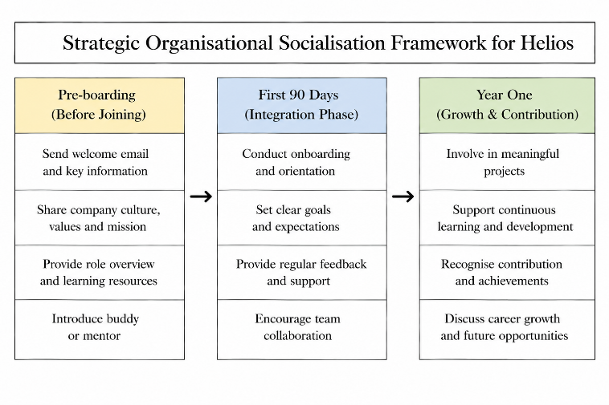

1.3 Developing Organisational Identification, Ethical Professionalism and Business Activism
Helios should promote organisational identification by promoting a culture in which organisational success seems to be closely associated with employees' professional success. This can be done by joint goal setting, multi-functional innovation projects, leadership programme of visibility and recognition, which reinforces the organisational values. According to Identity Construction Theory, in the case of meaningful organizational activities, employees will build a stronger sense of belonging, which in turn will increase commitment and voluntary turnover reduction (Manzi et al., 2023).
Embed ethical professionalism with values-based leadership, values-based decision making workshops, communication and performance management systems that involve transparent, responsible and business-related systems. These mechanisms promote the importance of employees' professional integrity, adding to organisational trust and sustainable organisational performance.
To foster a business activist mindset employees need to go beyond day-to-day tasks and take on an active role to improve the organisation. Through his development of the HR Business Partner, Ulrich has focused on co-opting employees into the process of creating strategic value, getting them to see opportunities, question ineffective practices and offer innovative solutions(Kieran, 2019). This is in line with the concept of stakeholder capitalism, which aims to generate value for all stakeholders (employees, customers, communities and shareholders) over time instead of just providing financial returns.
Together, these activities create an organisation that is dedicated, good and strategic. Staff who are strong believers of the values of the organisation are more likely to share information, work across departments and champion ongoing innovation. Helios' behavioural outcomes are expected to increase employee engagement, better graduate retention and organisation adaptability, and deliver a sustainable human capital advantage that will help to drive long-term strategic growth in the highly competitive and dynamic smart mobility market.

Task B: Job Design

2.1 Innovative Job Design Strategy for Helios
Helios needs to implement an integrated job design approach based on the Job Characteristics Model (JCM), Job Crafting Theory and a Skills-Based Architecture (SBA) to enhance the engagement of their employees, speed up innovation and increase their graduate retention. It is important to note that these approaches are not being considered as separate initiatives, but rather a combination of them, to create a flexible and employee-centred working environment, which at the same time increases motivation, learning and organisation agility. It is especially relevant for Helios, due to the fast growth of the organisation, the extended ramp up periods and the high attrition of high potential graduates, which makes the previous job structures an inadequate approach.
The Job Characteristics Model is the basis for work redesign to improve five dimensions of the job; skill variety, task identity, task significance, autonomy and feedback.(Yang and Jiang, 2025) Technical employees at Helios may be part of special project teams, but it may be hard to get a wider picture of the organisation and hence, innovation. Having workers responsible for the entire work package, give workers more autonomy in decision making, and have cross functional project assignments to increase skill variety would create more meaningful work experiences. Developmental feedback from managers and peers should be used regularly to supplement these to further enhance role clarity and to facilitate ongoing performance development. The model suggests that these attributes increase employee intrinsic motivation by the increased sense of meaningfulness, responsibility and knowledge about work results.
The Job Characteristics Model will transform jobs, but the Job Crafting Theory will enable individuals to proactively influence their job role in a way that assists them to be stronger, more interested and more oriented towards their career(Holman et al., 2023). Employees should be therefore encouraged to shift some responsibilities of their choice within tasks, build inter-departmental relationships and look for innovation possibilities in relation to the organisation's goals. For instance, an AI engineer may offer his support on smart infrastructure analytics projects, in addition to his core responsibilities, and transport analysts can also cooperate with software engineers to enhance the functions of the product. These changes by the employees help them feel responsible and increase their creativity and learning within the organization's goals. Most importantly, job crafting shifts employee roles from a passive to an active role, which is consistent with Helios' vision to develop business oriented and innovative employees.
Additionally, a Skills Based Architecture enhances this integrated approach by moving the workforce management function from a job description based approach to a capability based approach(Flores, Xu and Lu, 2020). Helios should not have a static skills database that only shows people what they currently have the skills to do, but should have a dynamic one and be able to track all the skills employees acquire, their technical skills, certifications, project experience and new skills they have developed. Thereafter, projects would be allocated based on skills demonstration not only on hierarchical levels.The allocation of projects would then be based on skills demonstration, not only on hierarchical levels, in terms of internal mobility, career development. This flexible structure allows workers to have several tasks, learn new skills and follow a different career path if they wish, and to see the organisation quickly redeploy talent to fill potential career gaps.
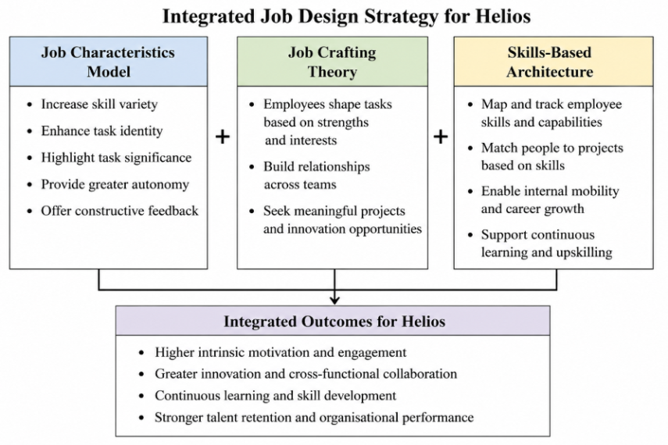
When combined, these three approaches combine to create more strategic value than any one approach taken alone. The Job Characteristics Model sets the foundations of motivating job structures, Job Crafting helps employees make their job their own and continually refine it, and the Skills Based Architecture helps the organisation be flexible, with employees' skills-based deployment. This comprehensive design approach helps overcome the challenges of the Helios operation, making it more flexible both in terms of roles and the speed of employee growth and continuous innovation. Helios challenges the job-as-it-was concept and introduces a human capital system that is dynamic, with organizational needs evolving in line with the capabilities of its employees, to increase the adaptability of the workforce and give companies a competitive edge in the fast-changing smart mobility market.

2.2 How the Proposed Job Design Supports Intrinsic Motivation and Innovation
The proposed integrated job design strategy establishes mutually reinforcing mechanisms that increase the motivation of employees, their innovation and effectiveness of the organisation. Through an engaging job design, career development that is based on employee capabilities, and employee autonomy, Helios can create a work environment that allows individual employees to fulfil themselves and that performs well in the long term.
The Job Characteristics Model boosts employees' sense of meaningfulness, responsibility and achievement and is used to increase intrinsic motivation. With greater autonomy, workers have the opportunity to use their judgment in their work and to get a wider variety of tasks and a sense of ownership of their work, which decreases repetitive tasks and boosts the satisfaction of employees. Continuous feedback is also used to reinforce competence by helping the employees to track their progress and find opportunities for development(Idrus, 2025). These factors motivate employees to work since the work itself is rewarding and not just for external motivations.
Fostering a sense of belonging to decision making, having a clear career path, and more support from the organisation should lead to increased employee engagement(Adriyanto, 2023). The ability to design a specific part of their jobs helps workers match their work roles and duties to their talents, interests and goals which helps to cultivate psychological ownership and employee engagement. This is also a participative approach that helps to build organisational identification, minimising disengagement and boosting discretionary effort.
Cross functional working and flexible use of skills is used to support innovation(Gutiérrez-Broncano et al., 2024). The sharing of ideas and information is promoted, allowing employees to learn from one another and creatively solve problems as they work on various projects. The Skills Based Architecture can help Helios rapidly put together multidisciplinary teams to address new technology challenges that allows a quick acceleration of innovation and organisational agility.
In addition, the integrated design supports continuous learning by offering and facilitating the employees to acquire new skills and competencies through diverse assignments, mentoring and internal mobility. Ongoing skill development enhances the flexibility of organisations and equips them with the skills needed for their future roles.
This fosters talent retention as employees feel there is a good pathway for them to continue their careers, and their skills are always developing and recognized. Investing in employee development and offering further progression can reduce the risk of employees leaving voluntarily, especially those with high potential who are looking to further develop their skills.
The outcomes when taken together lead to improved organisational performance, in terms of productivity, collaboration, knowledge integration and adaptability of the workforce. Helios' integrated job design not only solves today's engagement and retention problems but also forms an innovative, sustainable human capital system that will help the smart mobility sector maintain its innovation and competitiveness.

Task C: Reflective Report

3.1 Responsible Use of AI in HR Decision-Making
Artificial intelligence can help HR teams make better decisions by sifting through vast amounts of data, uncovering trends in the workforce and providing more evidence-based insights that can be used to make informed decisions. As an aspiring human resources professional, I plan to leverage AI as an aid to decision-making but not a replacement for my personal and professional judgment. AI can support the workforce planning and talent acquisition process, analyze employee sentiment and provide learning recommendations to inform faster and more informed decisions. I do appreciate, however, that there are ethical, contextual and human factors to consider in making strategic decisions about HR that algorithms can't necessarily capture.
I know that overuse of AI can be dangerous, such as algorithmic bias, privacy issues, transparency and dependency on algorithms. If the underlying data is biased or incomplete, this can lead to decisions that are made that may unintentionally disadvantage individuals during the recruitment, promotion or performance management process. So I think that any output of AI should always be critically assessed based on the organisational context, professional experience and human empathy prior to any decisions being made.
It is important to have the human element and challenge AI-generated recommendations, ensure that the available data is of quality and broader organisational issues are considered. I will not blindly take on the outputs produced automatically by AI, but will use AI to produce alternate ideas and take responsibility for decisions. Another aspect of ethical AI is ensuring that it complies with legal regulations, and taking proper care of data governance, transparency in data collection, and its usage by employees. I think AI can complement human strategic HR practice while maintaining fairness, trust and employee wellbeing, thanks to its analytical capabilities and ethical approach coupled with its professional judgement.

3.2 Personal Capability Development Plan
I understand the need to continually develop myself to be effective in the increasingly digital HR world. I want to sharpen my data skills, and become better at interpreting workforce metrics, assessing HR analytics, and turning organisational data into strategic recommendations. These skills will help me to take informed decisions and be able to articulate business value better.
I also want to gain skills in HR AI to deepen my knowledge about the use of emerging technologies to enhance the recruitment process, workforce planning, employee development and organizational performance. I embrace the concept of bringing technology to support strategic HR practice, but not at the expense of the knowledge, judgment and ethical choices of HR practitioners.
Another key goal is to get to know how to strategically influence. I will develop my communication skills in presenting evidence-based recommendations to stakeholders and influence organisational decision making in relation to human capital initiatives and how these fit in with the business objectives. These skills will help me to bring in a better value of my contribution as a strategic HR partner.
Finally, I will build my global mobility awareness by gaining a better understanding of cross-cultural management, international employment practices and a range of expectations on the employees. This knowledge will enhance my capacity to facilitate countries-wide and consistent HR strategies, as organisations become more multinational. I will continuously seek to update my knowledge and skills throughout my career, embracing lifelong learning and professional development to be prepared to meet future challenges in my organisation.

Reference
Adriyanto, A. (2023). Evaluation of Employee Engagement Level in Improving Productivity and Retention in the Company. Atestasi : Jurnal Ilmiah Akuntansi, [online] 6(1), pp.583–598. doi:10.57178/atestasi.v6i1.1105.
Afshari, L., Young, S., Gibson, P. and Karimi, L. (2019). Organizational commitment: Exploring the role of identity. Personnel Review, 49, pp.774–790. doi:10.1108/PR-04-2019-0148.
Flores, E., Xu, X. and Lu, Y. (2020). A Reference Human-centric Architecture Model: A skill-based approach for education of future workforce. Procedia Manufacturing, [online] 48, pp.1094–1101. doi:10.1016/j.promfg.2020.05.150.
Frögéli, E., Jenner, B. and Gustavsson, P. (2023). Effectiveness of formal onboarding for facilitating organizational socialization: A systematic review. PLOS ONE, [online] 18(2). doi:10.1371/journal.pone.0281823.
Galema, G., Duvivier, R., Pols, J., Jaarsma, D. and Wietasch, G. (2022). Learning the ropes: Strategies program directors use to facilitate organizational socialization of newcomer residents, a qualitative study. BMC Medical Education, 22(1). doi:10.1186/s12909-022-03315-9.
Gutiérrez-Broncano, S., Rubio-Andrés, M., Jiménez-Estévez, P. and Opute, J. (2024). Cross-Functional Teams. Springer, pp.515–538. doi:10.1007/978-3-031-70984-5_22.
Hietanen, A.-M. (2025). How do newly recruited employees perceive and evaluate onboarding strategies? [online] Uwasa.fi. Available at: https://osuva.uwasa.fi/items/746c9bf5-31bd-4803-ae38-959e3b5fc0e8 [Accessed 15 July 2026].
Holman, D., Maximiliano Escaffi‐Schwarz, Vasquez, C.A., Julien Patrick Irmer and Zapf, D. (2023). Does job crafting affect employee outcomes via job characteristics? A meta‐analytic test of a key job crafting mechanism. Journal of Occupational and Organizational Psychology, 97(1). doi:10.1111/joop.12450.
Houle, S.A., Morin, A.J.S., Vandenberghe, C., Tóth‐Király, I. and Fernet, C. (2024). From employee socialization to co‐evolution: A lifespan multidisciplinary conceptualization. Applied Psychology, 74(1). doi:10.1111/apps.12572.
Idrus, S. (2025). Performance Management Reimagined: Moving Beyond Annual Reviews to Continuous Feedback. The Journal of Academic Science, [online] 2(1), pp.222–231. doi:10.59613/q0e78r85.
Ismail Juma, I. (2022). I trust friends before I trust companies: The mediation of WOM and brand love on psychological contract fulfilment and repurchase intention. Management Matters, [online] 19(2), pp.167–186. doi:10.1108/MANM-02-2022-0033.
Kieran, S. (2019). Book Review on HR from the Outside In: Six Competencies for the Future of Human Resources. The Irish Journal of Management, [online] 37(1), pp.31–34. doi:10.2478/ijm-2018-0003.
Manzi, C., Gorli, M., Reverberi, E., Crapolicchio, E., Regalia, C. and Valenzisi, P. (2023). What drives young workers? <Scp>Person‐organization</scp> fit‐in identity motives—A mixed‐method study. Journal of Community and Applied Social Psychology, 33(6), pp.1549–1563. doi:10.1002/casp.2730.
Nadeem Ahmed Awan and Abbas, M. (2024). Organizational socialization strategies and newcomers” identity development: A social identity perspective. Human resource development quarterly. doi:10.1002/hrdq.21527.
Vos, A. (2005). The psychological contract of organisational newcomers: An investigation of antecedents and changes over time. International Journal of Human Resources Development and Management, 5. doi:10.1504/IJHRDM.2005.008508.
Yang, T. and Jiang, J. (2025). Designing job characteristics for effective hybrid intelligence: Insights from job design and human–AI collaboration. Personnel Review, [online] 54(6), pp.1441–1456. doi:10.1108/PR-03-2024-0229.

