

Innovation in Crisis – Why is it More Critical than Ever?

Sarah Rees | Leadership and Management Skills for the Workplace | 23rd April 2021

Executive Summary
The contents of this report compiled by Sarah Rees showed us that innovation is applying something new to your business to give a business advantage. The report showed that innovation is the creation, development, and implementation of a new product, process, or service. The meaning of creativity was defined as a central source of meaning in our lives, most things that are interesting, important, or human are the results of creativity. Although innovation and creativity are not the same, they rely on each other, as to be creative you must be able to come up with new ideas, and to be innovative they need to act on those ideas. For the main findings of this report the reporter applied the innovation of Primark going online to the innovation models. The Open and Closed model showed that Primark needed to incorporate external knowledge to help set up the new technology. The innovation process revealed that during the 4 stages, Primark need to research the market, monitor trends, and generate ideas to give them an advantage. The 4P’s model showed that the changes for Primark were all radical and new changes to their business strategy. Analyzing Lewin’s Force Field analysis revealed that this innovation could be successful as there were more forces in favor of the change than forces against, this shows it can be effective. It was also identified that the forces against could also be the barriers for Primark. The Reporter concluded the report on these results and their main recommendation was that Primark should use the innovation process as their innovation model as it’s simple, effective and allows you to plan ahead and create value.

Contents Page

Executive summary Page 1
1.0 Introduction Page 3
1.1 Innovation Page 3
1.2 Creativity Page4
1.3 Differences between both Page 4
2.0 Main Findings Page 5
2.1 Innovation Matrix Page 5
2.3 Models of Innovation Page 5
2.3.1 Open and Closed Innovation Page 6
2.3.2 The Innovation Process Page 6
2.3.3 4P’s to Innovation Page 7
2.4 Assessment of the Effectiveness Page 7-8
2.4.1 Barriers and Risks Page 8
3.0 Conclusion Page 8-9
4.0 Recommendations Page 9
References Page 10-11
Appendices Page 12-15

Introduction
This Report has been compiled by the researcher Sarah Rees, the report was requested by Davina Evans and its publish date is the 23rd April 2021. The aim of this report was to establish a significant new opportunity for growth within an organisation. The organisation that this report focuses on is Primark. Primark opened its first store in Dublin in 1969 under the name Penny’s. today it operates in over 380 stores in 13 countries across Europe and America. This international retailer offers the latest fashion, beauty and homeware at the best value on the high street; put simply, amazing fashion at amazing prices. Primark, (2021). This report looks at innovation and creativity and then compares the differences between them. The reporter will also demonstrate use of models of innovation such as: the innovation process, open and closed innovation and the 4p’s to innovation. Also, the innovation matrix will pinpoint the type of innovation that is being evaluated for the proposed innovation that is being suggested for Primark. The researcher will continue to access the effectiveness of the proposed innovation using Lewin’s Force Field Analysis, this will highlight the barriers and risks that Primark would need to be aware of when implementing the innovation that the researcher has identified. Conclusions of all the findings will be made and the researcher will suggest recommendations accordingly.
1.1 Innovation
Many people question what innovation is and all business leaders insist it is important, but truly people differ on their opinions of what it actually is. Even some of the top innovators opinions differ, David Burkus, (2016) defines innovation as “The application of ideas, creativity, and the ability to generate novel and useful ideas, is the seed of innovation, but unless its applied and scaled it’s just an idea. Whereas Stephen Shapiro, (2016) simple solutions to that question is that “innovation is about staying relevant, we are in a time of unprecedented change. As a result, what may have helped an organisation be successful in the past could potentially be the cause of their failure in the future. Companies need to adapt and evolve to meet the ever-changing needs of their constituents Skillicorn, (2016).
According to Kylliainen, (2019) Innovation is important for organisations as innovation increases your organisations chances to react to changes and discover new opportunities. It also helps foster competitive advantage as it allows you to build better products and services for your customer.
Innovation really is the core reason for modern existence. Although innovation can have some undesirable consequences, change is inevitable and, in most cases, innovation creates positive change.

1.2 Creativity
Lobell, (2018) describes creativity as simply transforming ideas, imagination, and your dreams into reality. By being creative it can help you make connections between things that are not normally related and come up with new ideas. Creative ability depends on creative thinking and creative problem solving. Csikszentmihalyi, (2018) Quotes the definition as “creativity is a central source of meaning in our lives, most of the things that are interesting, important, and human are the results of creativity.
Morr, (2018) maintains that creativity is a trait most people seem to have but if they are asked to define the meaning, they are unable to specifically depict the meaning. Creativity is the ability to transcend traditional ways of thinking or acting, and to develop new and original ideas, methods, or objects. It allows you to draw an understanding of the world around you, connect those observations to your existing knowledge reservoirs, and imagine new applications of your knowledge on the world.
1.3 Differences between both
You may ask yourself is innovation the same as creativity but the main difference between the two is the focus. Creativity is about unleashing the potential of the mind to conceive new ideas and innovation is about introducing change into relatively stable systems. It is also concerned with the work required to make an idea viable. Business Insider, (2013).
In Rowlands, (2018) view Innovation and Creativity rely on each other, but they are not the same. To be creative, a person, group or business must be able to come up with new ideas. To be innovative, they need to act on those ideas.

- Main Findings
The main findings of this report provide an overview of the innovation identified for Primark. During lockdown many businesses have managed to survive due to the fact that they offer online services for either delivery or click and collect, so many people have taken to their social media stating how they can’t wait for stores to reopen as they all miss Primark dearly. This presented the idea for a great innovation to become apparent that Primark should set up an online website where customers can still get their favorite products without the long term wait for stores to open. Simpson, (2021) reported that Primark stated in the past that they had no plans to go online as the cost and manning the operation and processing high volumes of returns would mean it could no longer offer low prices. However, threats of long periods of lockdowns meaning total loss of profit could hit the business hard, over £1bn of losses has already been reported. Evidence of other retailers such as H + M offer online services and are still able to offer products at low prices successfully.

2.1 The Innovation Matrix
The innovation matrix created by Davila et al, (2006) classified the types of innovation accordingly to the change the innovation causes to the organisations current use of technology and their business model. There are 4 sections of the matrix, ranging from semi radical to incremental Research Gate, (2021). The innovation for Primark brings about some innovations that are close to existing for example that would be incremental innovation by expanding on their currant ranges for online purposes to radically new innovations such as building a website for online ordering services, opening a new market for new customers as well as existing, and improving Primark’s market position against other low-cost competitors like H + M. The most appropriate innovation that best fits this innovative idea would be technology based as this brings about significant technological changes by creating an online source, this source will allow Primark’s customers to do more than browse their range of products but to order online also. Primark will need to gain deep knowledge into online facilities in order to be capable of applying this innovation to their company as this is radically new to them as this has not been done before. Please refer to appendices for the full model under Appendix 1.
2.3 Models of Innovation
There are many Models of Innovation some of which are covered by in this report. As Alcor, (2020) specifies that innovation is part of a successful business strategy and often innovators fail when they pursue the wrong model for the implementation of innovation. An innovation model provides a detailed framework in order to identify, advance, and implementing ideas Alcor, (2020). Exploring different models is necessary to find the best model that fits your organisation and the innovation you intend to pursue.

2.3.1 Open and Closed Innovation
There is a distinction between open and closed innovation, Zapfl, (2018) explains that this is determined by how the innovation is created. Closed innovation is developed within the company environment whereas open innovation incorporates external knowledge into the innovation management. There are advantages and disadvantages with both open and closed innovations the main advantage of closed innovation would be that the organisation has full overall control of the innovative process but the downside to this would be higher risk because developed ideas may not end up being supported by the organisation. While open innovation has the advantage of allowing knowledge, ideas, and technology to flow in and out between organisations, but this leads to the disadvantage of increased costs for process co-ordination and implementation costs. Research gate, (2021). This is a new innovation for Primark that is radically new and although this will be mainly developed within the company environment, Primark would need to incorporate external knowledge to help set up this new technology and online service as this is knowledge that isn’t held within the company environment.

2.3.2The Innovation Process
The innovation process is a pathway to figure out new or existing knowledge into marketable solutions. Businesses that pursue a successful innovation process have something decisive that will put them ahead of others. The path of an idea or innovation runs through from the generation, through development and on to market entry. The process is the heart of innovation management. Lead Innovation, (2021). The 4 stages of the process are search, select, implement, and capture. During these stages Primark must research the market, monitor trends, and generate ideas which can give them an advantage. During the select process Primark will be improving their technology and identifying the most valuable information they have gathered to build their website and develop online ordering services. Primark will use a specialist company to implement the plans and put everything in place to launch their website and manage the innovation plan. Once everything is up and running Primark can start capturing and gathering data and monitor profits to see if the innovation is successful and capture business value. Please refer to appendices to view the full model as appendix 2.

2.3.3 4P’s to Innovation
When organizing and managing innovation we need to consider where and how innovation can be used to gain strategic advantages. Tidd, Bessant, and Pavitt, (2006) 4P’s model shows there are two key points to consider are what is the overall business strategy and how will innovation help us achieve this. There are advantages to the 4P’s model the 4 categories makes you aware of the way innovation and change influence each other. Also, they range from incremental to radical and is an easy-to-use model that shows your current position and allows you to kick off the thought process of the achievable changes to your current business strategy and the ramifications these changes bring with them. Bearing in mind this model’s biggest strengths is one of its weaknesses, the simplicity of this model lacks guidance for further steps to be taken. The 4 innovations in this model are Product, Process, Position, and Paradigm. The changes for the product for Primark would be setting up a website, offering low-cost products in comparison to competitors and having the option of having larger stock online compared to what they can stock in store. Please refer to appendices for full model as appendix 3. The application of this model showed that the changes on how each innovation type of product, process, position, and paradigm all fall under radical changes which stem from the Technological changes going online brings to Primark’s existing strategy, there are some incremental changes to the strategy as well, but they are mainly strengthening their existing strategy.
2.4 Assessment of the Effectiveness
To assess the effectiveness of any new innovation then Lewin’s Force Field analysis is the model to use as recommended by Connelly, (2020). The Force Field Analysis is a framework that organisations use to help in decision making. Lucidity, (2021) indicates that its mainly used in strategic planning, implementation, or change management. This model indicates the forces in favor of the decision and forces against the decision. For the change to happen, the forces against must be weaker than the forces in favor of the decision. The force field analysis for Primark scored a score of 23 for and 20 against which indicates that Primark setting up online shopping would be more beneficial for them to pursue this innovation rather than not implement this idea.
The results of this model show that this innovation would benefit Primark as the forces for show how this opportunity will be a success as this is more positive than the negative forces against. The forces against are minor issues and it also shows the main force for this innovation would be that customers want Primark to go online and have also taken to social media to show the demand for this innovation, with working on Primark’s current business plan they can strengthen the forces for and eliminate the forces against proving that this model is simple yet effective when weighing up the evidence of an innovative idea.
There are advantages to the Force Field Analysis, it provides a clear analysis for a decision to be made and it identifies the negative forces that will need to be removed to ensure successful implementation of the change being introduced Get Lucidity, (2021).
However, Brent, (2018) indicates although it is an effective model there are disadvantages. To provide an accurate and effective analysis it requires the full participation of everyone involved, it can be a disadvantage when it is not possible for full participation. This results in the analysis providing an unrealistic picture of the supporting and opposing forces and can sometimes cause division in groups between those who support and oppose the decisions.
2.4.1 Barriers and Risks
According to Fallon, (2015) Every company dealing with Tech wants to innovate. Breaking away from tradition and bringing new and improved versions of products and services to the market but it’s not always easy to accomplish. Business leaders believe the biggest innovation obstacles faced are fears of change and the fact that businesses tend not to look outside of the company’s walls for innovation. Primark’s results of the force field analysis on forces against would act as their barriers in the innovation plan for instance Primark are set in their ways of have store only business so overcoming the disruption of becoming an organisation selling online would be a big shake up for Primark so to would the costs be a big barrier for them, the costs of set-up and customer returns worry them as they believe would affect the low-price product they offer and would drive up product costs. Primark need to take some risks to keep up with today’s evolving market. Also, the lack of technology and knowledge on technology will also be one of Primark’s barriers that they need to overcome as they need to be prepared for high demand on their website.

- Conclusion
To conclude this report the reporter has looked into the innovation for Primark as they recognized that Primark was one of the very few companies that didn’t trade online and for such a large company that is in high customer demand the pandemic has shown how customers were frustrated, they were unable to purchase their favorite items online when stores were closed. The researcher looked into Innovation, creativity and the difference between them to establish a true understand. This was then used to apply the innovation to the innovation models as they would apply for the information for adapting this idea for Primark and the advantages and disadvantages for the models and indicators show that the Innovation Process would be the better of the innovation models for Primark to use. Lewin’s force field analysis established that this was an effective innovative idea as the forces for came out higher than the forces against. The forces against also helped establish the barriers and risks that Primark needed to be aware of when implementing the innovation opportunity.

- Recommendation
The reporter has studied the outcomes of the innovation models and information of the report and believes that the following recommendations would be the best and most beneficial recommendations for Primark going forward. Firstly, the Main recommendation would be for Primark to proceed with the innovation following the Innovation Process model because Primark is quite hesitant to follow this innovation then the innovation process will allow Primark to set out a clear strategy and this model is simple yet effective, allowing them to recognize the opportunity, find the necessary resources to plan ahead, while developing the venture and seeing the benefits when creating the value.
Secondly, I would urge Primark to look into more external sources for innovation rather than within the walls of Primark or they will not be able to stay up to date with customers supply and demand needs and will remain stuck in their ways.
The final recommendation for Primark would be embark on staff training for the new technology that is being introduced as staff need to be able to tackle technical issues and be competent at it, Primark need a strong team to make this innovation a success.

References
Alcor, (2020). Innovation Models. Available at: https://alcorfund.com/insight/innovation-models-innovation-process-models-examples/#:~:text=Most%20often%2C%20innovators%20fail%20when,for%20the% (Accessed 12th April 2021).
Brent, M. (2018). Advantages & Disadvantages of the Force Field Analysis. Available at: https://www.careertrend.com/info-8613855-advantages-disadvantages-force-field-analysis.html (Accessed 16th April 2021).
Burkus, D. (2016). What is Innovation? 15 Experts share their innovation definition. Available at: https://www.ideatovalue.com/inno/nickskillicorn/2016/03/innovation-15-experts-share-innovation-definition/ (Accessed 5th April 2021).
Business Insider, (2013). There’s a critical difference between creativity and innovation. Available at: https://www.businessinsider-com.cdn.ampproject.org (Accessed 1st April 2021).
Connelly, M. (2020). Force Field Analysis – Kurt Lewin. Available at: https://www.change-management-coach.com/force-field-analysis.html (Accessed 22nd April 2021).
Fallon, N. (2015). Overcoming the 5 Biggest Obstacles to Innovation. Available at: https://www.businessnewsdaily.com/8267-obstacles-to-innovation.html (Accessed 20th April 2021).
Get Lucidity, (2021). Introduction to force field Analysis. Available at: https://getlucidity.com/strategy-resources/introduction-to-force-field-analysis/ (Accessed 8th April 2021).
Kylliainen, J. (2019). The Importance of Innovation – What does it mean for Businesses and our society? Available at: https://www.viima.com/blog/importance-of-innovation (Accessed 6th April 2021).
Lead Innovation, (2021). Defining the Innovation Process. Available at: https://www.lead-innovation.com/en/innovation-process#:~:text=The%20innovation%20process%20describes%20the,through%20development%2C%20to%20market%20entry (Accessed 11th April 2021).
Lobell, K. (2018). What is Creativity? Defining the skills of the future. Available at: https://www.creativelive.com/blog/what-is-creativity/ (Accessed 28th March 2021).
Lucidity, (2021). Introduction to Force Field Analysis. https://getlucidity.com/strategy-resources/introduction-to-force-field-analysis/ (Accessed 8th April 2021).
Morr, k. (2018). What is Creativity? Available at: https://99designs.com/blog/creative-thinking/what-is-creativity/ (Accessed 7th April 2021).
PLA Group, (2021). Advantages and limitations of the 4P Model Available at: https://pla55106group4.wordpress.com/im-innovation-space-4ps/advantages-and-limitations-of-the-4p-model/ (accessed 5th April 2021).
Primark, (2021). About Us. Available at: https://www.primark.com/en/aboutus (Accessed 2nd April 2021).
Research Gate, (2021). Innovation Matrix. Available at: https://www.researchgate.net/figure/Innovation-Matrix-Davila-et-al-2006_fig1_330422963 (Accessed 8th April 2021).
Research gate, (2021). Benefits and limitations of open innovation and closed innovation.
Rowlands, D. What is the Difference between Creativity and Innovation? Available at: https://weareive.org/what-is-the-difference-between-creativity-and-innovation/ (Accessed 7th April 2021).
Shapiro, S. (2016) What is Innovation? 15 Experts share their innovation definition. Available at: https://www.ideatovalue.com/inno/nickskillicorn/2016/03/innovation-15-experts-share-innovation-definition/ (Accessed 5th April 2021).
Simpson, E. Primark refuses to go online despite £1bn lockdown loss. Available at: https://www.bbc.co.uk/news/amp/business-55661741 (Accessed 12th April 2021).
Skillicorn, N. (2016). What is Innovation? 15 Experts share their innovation definition. Available at: https://www.ideatovalue.com/inno/nickskillicorn/2016/03/innovation-15-experts-share-innovation-definition/ (Accessed 5th April 2021).
Tidd, J. Bessant, J and Pavitt, k. Innovation 4 key points. Available at: https://www.wileyeurope.com/college/tidd (Accessed 5th April 2021).
Zapfl, D. (2018). Lead innovation blog. Available at: https://www.lead-innovation.com/english-blog/open-innovation-vs-closed-innovation (Accessed 16th April 2021).

Appenices
Appendix 1
Innovation Matrix
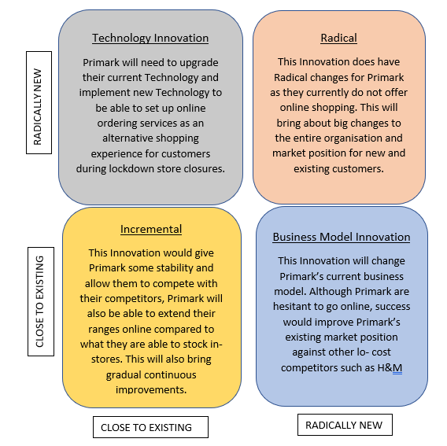

Appendix 2
Innovation Process
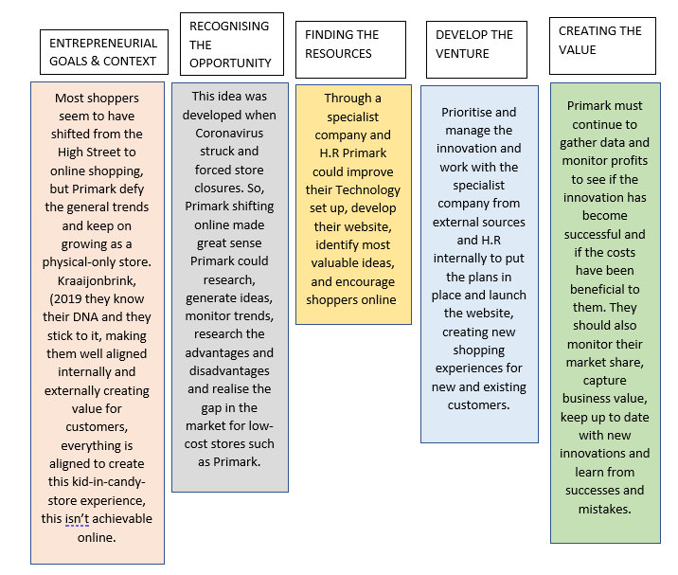

Appendix 3
4P’s Model
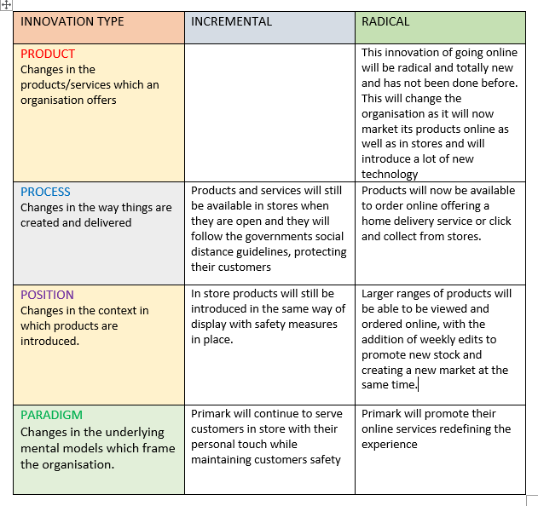

Appendix 4
Force Field analysis


