Module Code: BMBM 6021
Module Title: International Business Communication
Assignment Title: The Challenges and Sensitivities of Doing Business in the Czech Republic from a British Perspective

Word Count: 2549
Student name: Qingyan Zhang
Introduction
Communication is widely perceived as a social interaction process that involves the creation and exchange of ideas, facts, opinions, experiences, feelings, and information between a receiver and a sender (Adu-Oppong & Agyin-Birikorang, 2014). The topic of international business communication has received increasing attention due to the globalization process resulting in an extensively integrated work economy, and businesses no longer confined primarily to local economies for growth and profits (Forey & Lockwood, 2010). Consequently, people in different locations of the globe are more mobile than ever, giving the share rise of the intercultural workplace (Debrah & Smith, 2001). At the same time, the effective implementation of all fundamental business activities in an intercultural setting, such as the alignment of tasks, the negotiation of businesses, and the collaboration in a diversified team, is based on the ability to communicate with people with different cultural backgrounds (Martin & Nakayama, 2015).

Before the Covid-19 pandemic, the Czech Republic had continued to grow at a healthy sequential pace since 2000, although the year-on-year pace of expansion moderated a wanning base effect （See Figure 1） (OECD, 2021). Underlying momentum for economic growth has likely to continue due to a series of supportive foreign investment policies published by the state and the ambition of the state to aggressively develop the infrastructure (New Europe, 2021). The geographical proximity between the Czech Republic and the United Kingdom further makes the Czech Republic an attractive destination for British businesses. However, besides the evaluation of market attractiveness and potentialities, it is also crucial for the British business to consider all possible challenges they may encounter in the Czech market, of which the most prominent one is the challenges of communicating with Czechish people in the relocated business. The present essay, leveraging different theories from the international business communication field of study, analyses and evaluates the possible challenges and sensitivities of operating businesses in the Czech market from a perspective of British businesses.
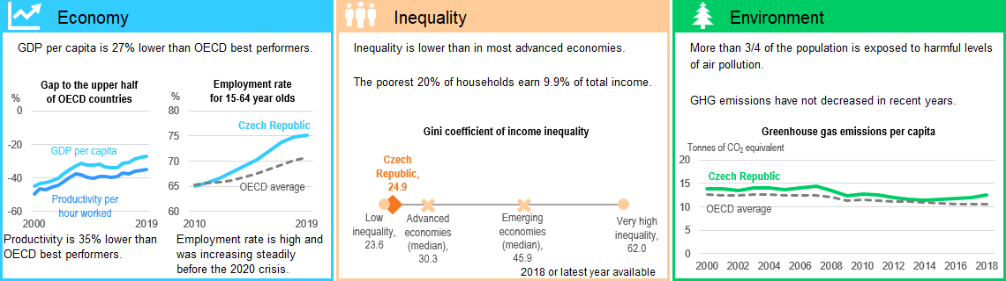
Figure 1. The economic highlight of the Czech Republic
Source: OECD (2021)
A large amount of literature attests to the fact that most failures in international business communication arise because of significant cultural differences in the workplace (Neuliep, 2020). Hofstede’s cultural dimensions have given the primary interest in uncovering work-related differences across cultures (Hofstede et al., 2005), making it an ideal model to investigate the challenges and sensitivities when communicating with Czechs. The differences in each dimension are presented in Figure 2.

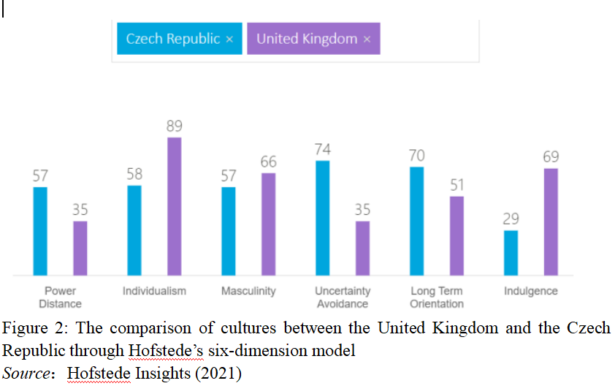

Power distance involves the way how two countries deal with inequality in the workplace. The Czech Republic exhibits a much higher score in this dimension compared to the United Kingdom, indicating its higher tolerance of inequalities in power and wealth in the workplace. Typically, the organization structure in the Czech tends to be more centralised, featuring relatively autocratic leadership (Musteen et al., 2010). Obedience and compliance due to respect for power are more common than in the British workplace (Abrams, 2004). However, the British workplace is more decentralised with the promotion of equality (Liao et al., 2011). It might be sensitive for British people to learn to respect the senior leadership and follows their instructions more stringently when they operate in the Czech Republic.

The differences in individualism/collectivism indicate Czechish people are typical people belonging to in-groups that look after them in exchange for trust and loyalty (Abrams, 2004), while British employees places more emphasis in “I” consciousness and self-actualisation (Childs & Storry, 2013). Typically, British employees tend to work alone and desire more autonomy in tasks; Czechish employees prefer team collaboration and emphasise team achievement. The integration into the collectivistic team-oriented culture in the Czech can be challenging for British employees.
In terms of masculinity/femininity dimension, British workplaces are typically dominant by performance, achievement and success, resulting in fiercer competition in the workplace, the admiration of individual brilliance, as well as the idolization of the overachiever (Childs & Storry, 2013). The Czech workplace, in turn, exhibits more values associated with femininity, such as nurturance, caring and sympathy, and emphasizes role-sharing, life quality and interdependence in job design (Danis et al., 2011). Thereby, it can also be challenging for British people to be more centred on the work and be less ambitious and aggressive in the competition when working with Czechs.

In terms of uncertainty avoidance, Czechish has a much lower tolerance to ambiguous workplace situations, indicating that the more rigid codes of conduct, procedures, regulations and guidelines are required to avoid any possible unorthodox scenarios in the work progress. At the same time, precision and punctuality in communication are highly important in all kinds of communication (Abrams, 2004). The higher tolerance of uncertainty of British employees indicates they can take risks rather easily, and tolerate behaviours and situations deviated from the predetermined ones. Therefore, the relatively less respect for norms of British employees in the workplace can be sensitive when working with Czechish, resulting in possible misunderstanding and even conflicts.

In terms of long-term/short-term orientation, Czechish workplace exhibits a bit higher pragmatic future-oriented perspective, indicating typical attributes of stability, perseverance, commitments and thriftiness in achieving results (Abrams, 2004). The relatively short-term oriented British employees prefer quick results, personal steadfastness and leisure time. How to fit into the long-term orientation culture in to the Czechish workplace or realize a balanced system works for both parties can be a challenge here too.

In terms of indulgence dimension, British employees attach more importance to the fulfilment of natural desires, and they behave in ways which lead them to gratification (Dalby & Dalby, 2000); while Czechish employees place more attention to duty over freedom and pleasure, and tend to control over basic human desires (Jirkovska & Janeckova, 2019). Their attitudes towards work, therefore may differ from those of British, as they have different priorities against goals, norms and responsibilities. It might be challenging for British employees to adapt into a more restraint culture.

In addition to the above differences on the six primary cultural dimensions in the workplace, which highlight the challenges and sensitives that British people may encounter when operating in the Czech Republic. Language has also been perceived as the most important and commonly used medium for communication (Hua, 2018). Hall’s high context and low context culture perspectives afford a more specific lens to see the differences in verbal and non-verbal language communications across cultures. Context refers to all information surrounding what is being verbally communicated, typically including the setting to the people involved in the communication, and the context of any interpersonal interaction in the workplace can impact much of what is communicated and perceived (Armstrong & Ferguson, 2010). Britain is a typical low context culture, and the Czech Republic is a typically high low context culture. Having a firm understanding of differences here, particularly in the business context, will truly help British businesses operating in the Czech Republic to better communicate with locals. British people tend to communicate in a straightforward manner, basically they ‘mean what they say’, and people should take at their words (Christopher, 2015). Moreover, to the opposite, Czechish people tailor their words and messages according to the specific contexts (Abrams, 2004). Information is made implicitly, and the context surrounding factors significantly influences the interpretation of the sent information. When communicating with Czechish employees in the workplace, British employees may expect them to use the same communication style they are accustomed to, leading to possible guesswork, judgment, confusion, and misunderstanding. Being aware of what the exact communication style used by Czechish people in the workplace, British employees can adjust their communication styles and preferences accordingly and avoid some potentially awkward situations.

As a socio-cultural phenomenon, trust is influenced by culture throughout the process of its creation, establishment, development and disappearance (Spector & Jones, 2004). The tendency to trust is an important psychological perception within organisations and is important for members to achieve their work goals. Trust is described as "the tendency to take risks for other groups or individuals in the face of uncertainty" and is particularly important for achieving organisational goals when many people work together to get the job done (Hughes et al., 2018). The tendency to trust between members of the organisation in an intercultural setting helps create a positive organisational climate that may influence employees' attitudes to work, such as employee satisfaction and organisational commitment (Downey et al., 2011). As an arbitration mechanism for reducing complex social interactions, trust is largely influenced by socio-cultural contexts (Doney et al., 1998). In terms of the loose-tight dimension of culture, there are differences in the way individuals interpret the behaviour of others in different cultural logic. Tight cultural contexts are characterised by very clear boundaries of social institutions and behavioural norms that are more dependable (Gelfand, Nishii, & Raver, 2006). In contrast, social rules in loose-culture contexts are more flexible, changeable, and have blurred boundaries, and individuals are relatively less dependent on the system (Triandis, 2004). This difference in dependency is also one of the important reasons for the differences in trust-building. In the tight culture of the UK, individuals' behaviour is controlled to a greater extent by the social system in which they live, leaving little room for subjective interpretation of the behaviour of others (Christopher, 2015). As a result, when individuals are exposed to uncertain risks, they often rely on the safeguards provided to them by the social system to build trusting behaviour. It is because individuals do not rely on their own judgement of risk to control their own behaviour that they generally have a higher level of general trust in institutionalised contexts such as tight cultures (Christopher, 2015). In contrast, in the loose Czech culture, due to the flexibility of social rules, individuals rely primarily on their own preferences and emotions in evaluating the behaviour of others, and interpret unknown risks according to their own needs in order to maintain social equality (Abrams, 2004). Due to the importance of interpersonal relationships in this culture, individuals are more dependent on each other and are one of the most critical factors influencing the establishment of interpersonal trust.

Corruption has different manifestations in different socio-cultural contexts; there are also different criteria for judging what is corrupt in different cultural contexts (Graycar & Jancsics, 2017). What is acceptable and legal according to traditional norms becomes unacceptable and corrupt in the eyes of these modern people; what one person offers as a bribe may be seen as a gift in another society; what is seen as corrupt by outsiders may be seen by another society as merely following its own traditional norms of formal behaviour (Graycar & Jancsics, 2017; Lambsdorff & Frank, 2010). The same is true of what is seen as corrupt in another society, which is merely acting in accordance with its own traditional norms of behaviour. In Czech society, where relationships, favours and face-saving are the core norms of everyday behaviour, gift-giving is common in the daily practice of every individual in society (Naxera, 2015). It is also inevitable for state officials, who are both holders of public power and members of society, to be involved. In reality, the corrupt practice of "bribery" in the name of "gift-giving" is common, and in the process the bribe-giver transforms legally and morally unacceptable bribes into "bribes" through the strategy of "self-moralisation" (Naxera, 2015). In the face of the expanding areas and evolving forms of bribery in the modern business world, the UK, as a key member of the Organisation for International Economic Cooperation and the European Union, has an obligation to comply in a timely manner with international or regional treaties against corruption, which has led to a comprehensive reform of UK bribery offence legislation (Fisher, 2007). The compliance to the UK Anti Bribery Act and their emphasis on integrity and independence in the workplace results in less prevalence of gift-giving culture in the British workplace. Besides the general regulation written in the Act, each firm has its own stringent guidelines on gift-giving (Rose, 2012). The more blurring boundary of gift-giving and bribery and the higher prevalence of gift-giving in exchange for business insights or opportunities indicate some sensitivity there worth much attention of British businesses when they operate in the Czech Republic.

The trend of international economic trade requires companies to improve their intercultural communication skills in order to ensure good communication in international economic activities. The employees from both parties should fully understand and grasp the different cultural differences, recognise the different cultural advantages of each country, bring out the cultural differences of each country, interact with them, find the cultural balance between other countries and the country, realise the complementary advantages of each other and create a corporate culture suitable for the development of the company. At the same time, British culture should not prevail in the process of cultural integration. Alternatively, ways to dissolve cultural differences and promote inclusion should be sought. Cultural differences can be eliminated by training the staff and leadership on the new cultural concept through specific measures such as a detailed introduction to the traditional Czech culture and the development of the corporate culture of the original company, simulating the Czech cultural environment from different sides through various means, helping the staff to gain an in-depth understanding of the characteristics of different cultural regions and to become familiar with the policies and regulations, market dynamics, customs and traditions of the cross-cultural region. Also, the emphasis should not be solely given to language barriers. On one hand, fluent communication with no barriers in linguistic exchange should be ensured; on the other hand, non-verbal communication such as basic business etiquette in Czech should be taught too. Additionally, it is important to have a good understanding of history, culture and other social knowledge through training and to grasp the rich cultural connotations before implementing intercultural communication and gift-giving initiatives in the specific Czech cultural setting. At the same time, employees from both parties need to be trained in conflict management skills, as conflicts often arise in everyday work due to differences in habits and so on, so they need to master basic conflict management skills to ease conflicts between employees. At the same time, the development of an inclusive working environment and corporate culture that favours diversity, transparency, mutual respect and appreciation should be prioritised by British businesses when they operate in the Czech market. The sense of belongingness under the cohesive and inclusive culture can encourage intercultural learning and mutual trust.

The present essay sheds light on the possible challenges and sensitivities in terms of communication that British businesses might experience if they expand their businesses in the Czech market. The essay uses classic models, including Hofstede’s six cultural dimensions and Hall’s culture context are used to evaluate the differences and challenges resulting from differences in the cultural level in the workplace. The issues of trust and gift-giving, which are closely related to the specific culture, are also discussed and compared. Regarding huge differences in the workplace and all kinds of possible challenges, it is suggested that necessary training and development programmes should be implemented for employees from both parties to facilitate effective communication. Also, the construction of a cohesive company culture that balances and integrates both Czech culture and British culture can help to remote ineffectiveness in communication.

References
Abrams, B. F. (2004). The struggle for the soul of the nation: Czech culture and the rise of communism. Rowman & Littlefield.

Adu-Oppong, A. A., & Agyin-Birikorang, E. (2014). Communication in the workplace: Guidelines for improving effectiveness. Global Journal of Commerce & Management Perspective, 3(5), 208–213.

Armstrong, E., & Ferguson, A. (2010). Language, meaning, context, and functional communication. Aphasiology, 24(4), 480–496.

Childs, P., & Storry, M. (2013). Encyclopedia of contemporary British culture. Routledge.

Christopher, D. P. (2015). British culture: An Introduction. Routledge.

Dalby, A., & Dalby, A. K. (2000). Empire of pleasures: luxury and indulgence in the Roman world. Psychology Press.

Danis, W. M., Liu, L. A., & Vacek, J. (2011). Values and upward influence strategies in transition: Evidence from the Czech Republic. Journal of Cross-Cultural Psychology, 42(2), 288–306.

Debrah, Y. A., & Smith, I. G. (2001). Globalization, Employment, and the Workplace. Routledge.

Doney, P. M., Cannon, J. P., & Mullen, M. R. (1998). Understanding the influence of national culture on the development of trust. Academy of Management Review, 23(3), 601–620.

Downey, L. A., Roberts, J., & Stough, C. (2011). Workplace culture emotional intelligence and trust in the prediction of workplace outcomes. International Journal of Business Science & Applied Management (IJBSAM), 6(1), 30–40.

Fisher, J. (2007). Business marketing and the ethics of gift giving. Industrial Marketing Management, 36(1), 99–108.

Forey, G., & Lockwood, J. (2010). Globalization, communication and the workplace: Talking across the world. A&C Black.

Graycar, A., & Jancsics, D. (2017). Gift giving and corruption. International Journal of Public Administration, 40(12), 1013–1023.

Hofstede, G., Hofstede, G. J., & Minkov, M. (2005). Cultures and organizations: Software of the mind (Vol. 2). Mcgraw-hill New York.

Hofstede Insights. (2021). Czech Republic - United Kingdow[online]. Available at https://www.hofstede-insights.com/country-comparison/czech-republic,the-uk/[accessed on 3rd January 2022]

Hua, Z. (2018). Exploring intercultural communication: Language in action. Routledge.

Hughes, M., Rigtering, J. P. C., Covin, J. G., Bouncken, R. B., & Kraus, S. (2018). Innovative behaviour, trust and perceived workplace performance. British Journal of Management, 29(4), 750–768.

Jirkovska, B., & Janeckova, H. (2019). Workplace stress and employees’ well-being: Evidence from long-term care in the Czech Republic. Central European Journal of Public Health, 27(2), 87–92.

Lambsdorff, J. G., & Frank, B. rn. (2010). Bribing versus gift-giving: An experiment. Journal of Economic Psychology, 31(3), 347–357.

Liao, C., Chuang, S.-H., & To, P.-L. (2011). How knowledge management mediates the relationship between environment and organizational structure. Journal of Business Research, 64(7), 728–736.

Martin, J. N., & Nakayama, T. K. (2015). Reconsidering intercultural (communication) competence in the workplace: A dialectical approach. Language and Intercultural Communication, 15(1), 13–28.

Musteen, M., Francis, J., & Datta, D. K. (2010). The influence of international networks on internationalization speed and performance: A study of Czech SMEs. Journal of World Business, 45(3), 197–205.

Naxera, V. (2015). Corruption perception in the Czech Republic. Politics in Central Europe, 11(1), 51–73.

Neuliep, J. W. (2020). Intercultural communication: A contextual approach. Sage Publications.

New Europe. (2021). The Czech Republic’s economy in 2021[online]. Available at https://www.neweurope.eu/article/the-czech-republics-economy-in-2021/ [accessed on 1st January 2022]

OECD. (2021). OECD Economic Surveys: Czech Republic 2020[online]. Available at https://doi.org/10.1787/1B180A5A-EN[accessed on 2nd January 2022]

Rose, C. (2012). The UK Bribery Act 2010 and Accompanying Guidance: Belated Implementation of the OECD Anti-Bribery Convention. International & Comparative Law Quarterly, 61(2), 485–499.

Spector, M. D., & Jones, G. E. (2004). Trust in the workplace: Factors affecting trust formation between team members. The Journal of Social Psychology, 144(3), 311–321.

Triandis, H. C. (2004). The many dimensions of culture. Academy of Management Perspectives, 18(1), 88–93.

