Understanding Poverty in Swansea

Definition of Relative Poverty
“Individuals, families and groups in the population can be said to be in poverty when they lack the resources to obtain the types of diet, participate in the activities, and have the living conditions and amenities which are customary, or at least widely encouraged or approved, in the societies to which they belong. Their resources are so seriously below those commanded by the average individual or family that they are, in effect, excluded from ordinary patterns, customs and activities.” p. 31 Townsend, P. (1979) Poverty in the United Kingdom: A Survey of Household Resources and Standards of Living. London. Allen Lane and Penguin Books. Available at: http://www.poverty.ac.uk/system/files/townsend-book-pdfs/PIUK/piuk-chapter01.pdf (Accessed: 7 March 2018)

Poverty Line Definition: Official Definition
60% of national median income for equivalent household, AFTER housing costs
Problematic: when median income drops, numbers of people “in poverty” drops, although overall standard of living has fallen. Latest update for 2017/2018 financial year (published 28 March 2019) available here: https://www.gov.uk/government/statistics/households-below-average-income-199495-to-201718 (Accessed 01/11/2019)

Minimum Income Standard: alternative “poverty line”.
Income required for basic minimum standard of living, by public consensus (which changes over time as society evolves), according to household type – see Minimum Income Standard Calculator online available at: https://www.minimumincome.org.uk/ (Accessed 01/11/2019)
– Calculator figures updated to April 2019 prices. ‘In order to reach a minimum acceptable living standard in 2019, a single person needs to earn £18,800 a year and a couple with two children need to earn £20,600 per parent.’ Summary: A Minimum Income Standard for the United Kingdom in 2019, pg. 1, Hirsch, D (JRF, 2019) available at: https://www.jrf.org.uk/report/minimum-income-standard-uk-2019 (Accessed 01/11/2019)

Benefits vs ‘National Living Wage/Minimum Wage vs Living Wage
According to the MIS: Living Wage as of November 2019 £9.30 per hour outside of London. So-called “National Living Wage” (minimum wage for over-25s): £8.21 as of April 2019. Minimum wage for other age groups far less. Benefit income is far below the 60% poverty line, which is far below the MIS.

Poverty and Work
In-work poverty is more of a problem than worklessness. There are more people in poverty with a wage coming in than not. It is very difficult for a family to stay above the poverty line if only one adult is working. Having one wage-earner and one caregiver is a luxury.

Child Poverty in Swansea, by Parliamentary Constituency
Children living in Poverty 2017-2018 (the most recent year for which figures are available, Data generated May 2019) http://www.endchildpoverty.org.uk/poverty-in-your-area-2019/ [Accessed 03/06/2019]. Makes the best estimate of child poverty in a local area using a wide range of indicators. Based on the “less than 60% of the median measure” after housing cost, in 2017- 2018: in Swansea East 34.2% (7836) of children in poverty; in Swansea West 30.4% (4194) of children in poverty and in Gower 21.1% (3865) of children in poverty.
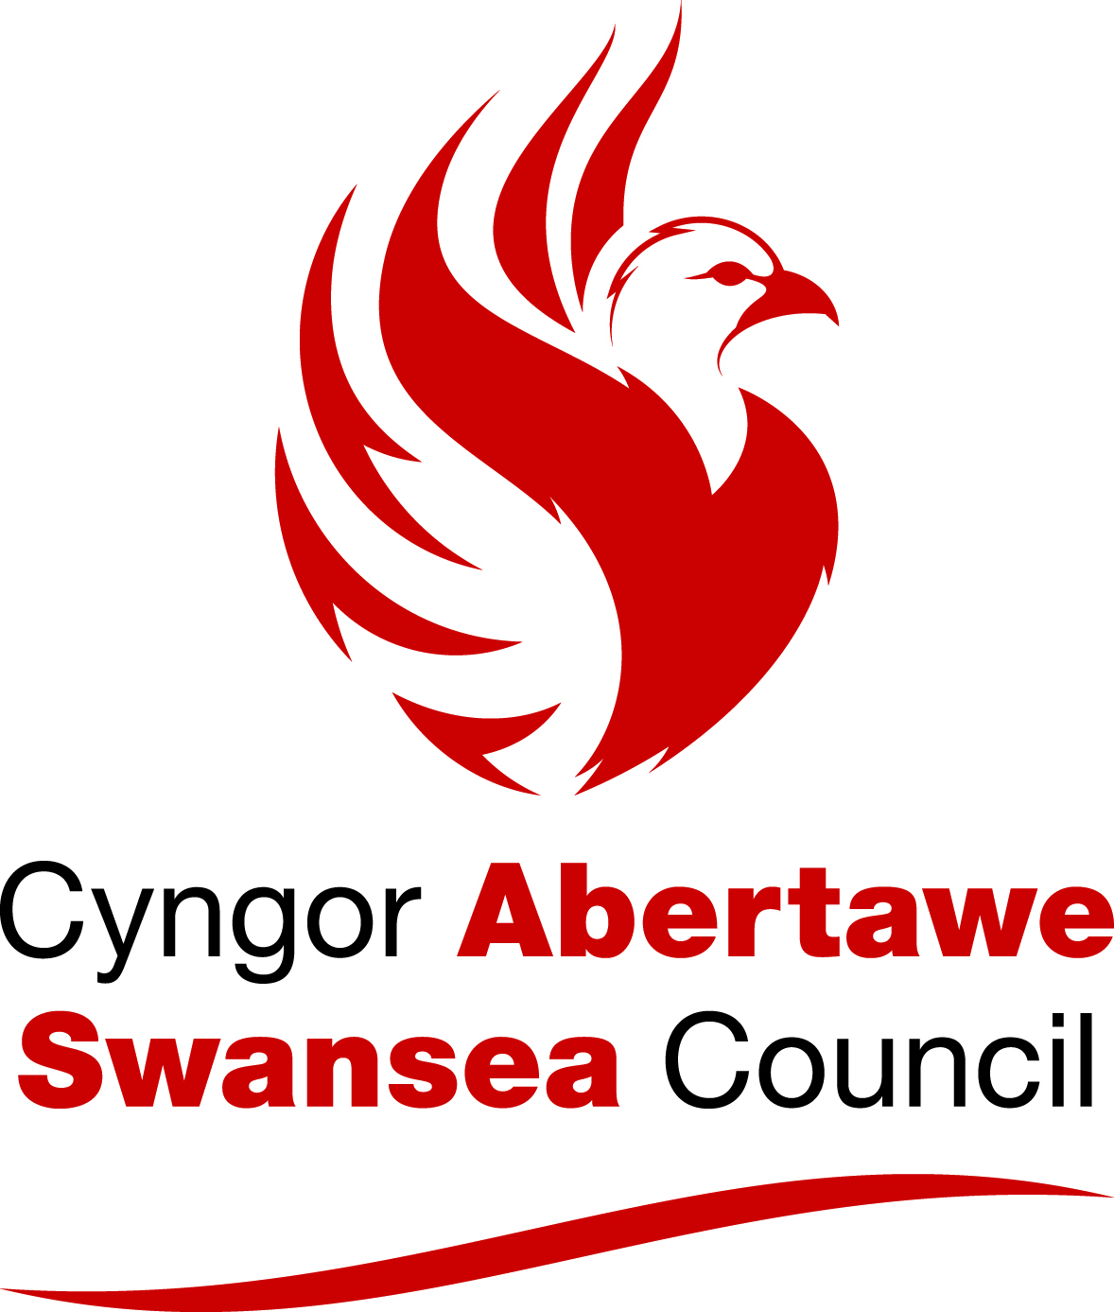

Wealth Re-distribution: From the Poorest to the Wealthy
- The Poverty Premium: those on low incomes pay more for fuel (prepayment meter surcharges & inefficient homes and appliances), credit (higher interest rates), insurance (high-risk addresses), transport and food (smaller, local shops charge more). Large purchases like TV, appliances, furniture typically come from shops with affordable weekly instalments but at v high interest rates; paying outright for something from a cheaper shop, or second-hand, isn’t possible. (£100 up-front vs £10 per week for 40 weeks. The first option is “cheaper” but not manageable).
- Unequal Taxation: Income tax is progressive (increasing according to ability to pay). VAT, fuel duty etc. are applied at the same rate to all. The poorest pay the greatest proportion of their income in tax.
Cumulative impact of Welfare Reforms in Swansea
Swansea Council commissioned Policy in Practice to investigate the impact of multiple welfare reforms at the household level in Swansea.

The Single Household Benefit Extract (SHBE) data September 2018, which contains information on Housing Benefit support and Council Tax Reduction, was analysed to examine the impact of the main welfare reforms that have already taken place. In addition to those yet to be implemented, the mitigation measures put in place by the government and the cumulative impact of all these on individuals and low-income households in Swansea. The prediction made by Policy in Practice in Sept 2018 using this data for Swansea was as shown in the chart below:
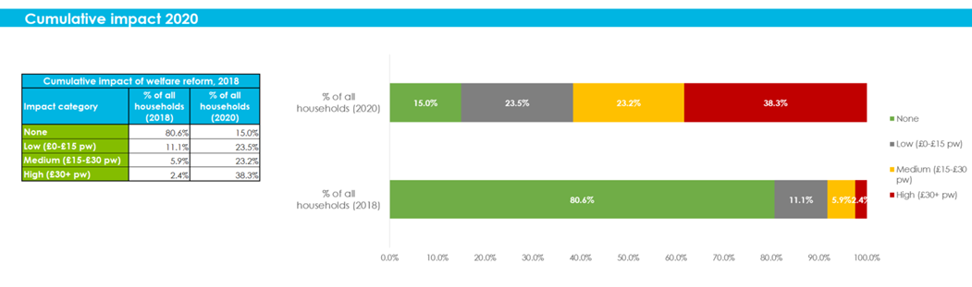

Coping on Low Incomes
Families prioritise the essentials, missing out participation in social, cultural and leisure activities. These develop skills, aspirations and networks, so skipping them impacts on life chances, reducing “resources” (see below).

Effects of Poverty
Insufficient income, lack of access to services, and reduced participation in society (including decision-making in matters that affect you) are cyclical and related impacts, resulting in reduced resources (personal; family; community); reduced resilience (ability to “bounce back” from bad experiences); increased exposure to adversity.

Privilege and Power are Invisible if you have them.
See “Pencilsword: On A Plate” by Toby Morris, Auckland.

Culture of Poverty / Dependency / Worklessness
There is no evidence base for these myths. Research by Joseph Rowntree Foundation and others finds that successive generations born into poverty in the UK hope and intend to escape it, through employment. Less than 1% of workless families have had 2 generations with no job. The idea that poverty persists because of “deficits” in poor people, rather than because of the insurmountable barriers placed in their way by the powerful, diverts attention away from where responsibility really lies. Are ‘Cultures of Worklesness’ Passed Down the Generations? JRF 2012 – Available at https://www.jrf.org.uk/report/are-cultures-worklessness-passed-down-generations {Accessed 07/03/2018}

What can be done?
Support people on low incomes to have experiences that build resources, develop opportunities and increase resilience to adversity. Themes could include: developing aspirations and experiences; reducing isolation and facilitating access; directly addressing economic insufficiency (community growing/bulk-buying/group discounts; credit unions); seeking the VOICES of the experts people directly experiencing disadvantage, to influence policymaking and action.

Further info:
- Donald Hirsch A Minimum Income Standard for the United Kingdom in 2019 (JRF, July 2019) available at :https://www.jrf.org.uk/report/minimum-income-standard-uk-2019
- The Myth of the Culture of Poverty – Paul Gorski In Educational Leadership Journal (April 2008 | Volume 65 | Number 7, Poverty and Learning Pages 32-36) (“As the Children file out of Janet’s Classroom, I sit in the back corner…”)
- Joseph Rowntree Foundation: “Are ‘Cultures of Worklessness’ Passed Down the Generations?” Shildrick, MacDonald, Furlong, Roden, Crow, December 2012.
- Understanding and defining poverty: A guide for Swansea, January 2017 available at:
https://www.swansea.gov.uk/povertystrategy

Tackling Poverty Service, Swansea Council: Email: Sian.Denty@swansea.gov.uk
or Anthony.Richards@swansea.gov.uk

Updated: 11 November 2019

The cumulative impact of welfare reform in Swansea. Policy in Practice, Sept 2018

