School of Sport, Health & Outdoor Education

Assessment Feedback Sheet

Student No. 1902244 Name: Declan Davies
Module: Facilitating Adventurous Activities
Module Code: SHSS4079

Personal Evaluation – to support your academic progress please complete the section below BEFORE submitting your work.
What do you consider to be the best aspects of this work? |  |  | I consider the best aspect of this piece of work to be the way in which I set the essay out.
Which aspects do you consider could have been improved in this piece of work? |  |  | I think that my reference list could have been improved as I feel that I wasn’t confident when completing it.
What have you found most satisfying whilst undertaking this submission? |  |  | What I found most satisfying about this piece of work was looking up the information I used as I found it enjoyable taking the information in.
ASSESSMENT CRITERIA | Learning  Outcomes |  | GRADE
ASSESSMENT CRITERIA |  |  | Poor  < 20% | Weak  20-29% | Unsatisfactory  30-39% |  | Satisfactory  40 – 49% | Good  50 – 59% | Very Good  60 – 69% | Excellent  70 – 84% |  | Exceptional  85– 100% | %
Understanding of the concept of physical literacy | 3 |  |  |  |  |  |  |  |  |  |  |  | 40%
Awareness of the benefits of adventurous activities and outdoor learning | 3 |  |  |  |  |  |  |  |  |  |  |  | 40%
Links to literature and research to support opinions | 3 |  |  |  |  |  |  |  |  |  |  |  | 20%
It is expected that students will present work that is proof read, correctly referenced and adheres to the Assessment Checklist. Therefore a range of 0 – 10 marks will be deducted for non-completion of any of the points on the checklist below.
TUTOR COMMENTS:

Submission date: 03/04/20  via Turnitin |  | Return date:  (at least within 4 weeks) |  |  |  | Tutor: J HAYLOCK |  |  |  |  | Mark:

Evaluate how adventurous activities contribute to the development of children’s physical literacy
Throughout this essay I will define what physical literacy is and ways in which it can be developed for a child’s benefit. I also will look to define what adventurous outdoor activities are what makes an adventurous activity adventurous. I will look at some of the benefits of doing adventure outdoor activities and how by doing the contributes to developing a child’s physical literacy. I will also look into if affordance has an affect on children’s development.
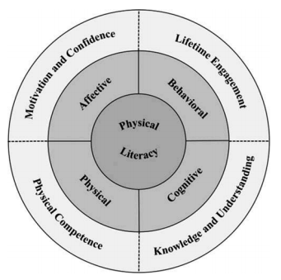
Physical literacy is to connect with physical activities throughout your life while you develop your curiosity, physical attributes, learning, belief in yourself and taking accountability for your commitment to physical activities throughout your life. Wainwright (2018) supports this when stating “Physical literacy can be described as the motivation, confidence, physical competence, knowledge and understanding to value and take responsibility for engagement in physical activities for life.”. This shows that physical literacy is developed through experiences and opportunities and cannot not be taught. This is why hours a week of high-quality physical education is so important to developing physical literacy as it is a good opportunity to have a different experience. All of the elements such as cognitive, behavioural, physical and cognitive come together to make up what physical literacy is through out your life.

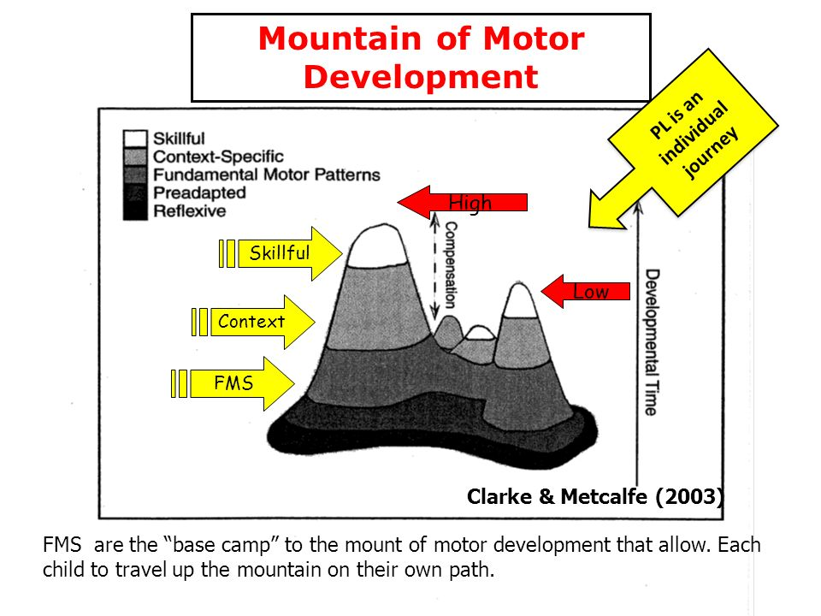
Robinson & Randall’s (2016) diagram shows that physical literacy is with you throughout your life as you develop by becoming more motivated to do activities with a higher level of confidence as you start to understand more about the activity which will then in turn help with physically performing the interest. Physical literacy is crucial throughout your life and it happens without us even noticing as it is a part of growing up. Ayres and Robbins (2005) support this when stating “Higher intellectual functions will develop after the age of 7, and they will develop better if the sensorimotor functions are well developed. The 3rd – 7th years are a critical period for sensory integration” this shows that one of the first stages of physical literacy development starts from just being a baby as you start to adapt to sounds and the fundamental movements skills start developing. There are also other journeys that are taken when developing such as the fundamental movement of skills but isn’t as diverse as physical literacy as it doesn’t cover the other developmental elements.
Clarke and Metcalfe’s (2003) diagram supports this as it shows that Physical Literacy is better than FMS as it covers a broader aspect of development as FML only looks in to progressing physical skills but physical literacy also considers the cognitive and affective aspects of developing throughout your lifetime. There are ways in which some children can develop more progressively than others which include the environment in which they are brought up in which can affect the opportunities given. Affordances are parts of the environment that are best fitted for children to challenge their motor activity such as a park. Fjortoft, I (2001) supports this when stating “Natural environments represent dynamic and rough playscapes that challenge motor activity in children.”. This shows affordances are where children are able to challenge themselves in dynamic environments and develop their motor skills when given the opportunity. Whitehead (2016) supports this when they stated, “It is through physical ‘embodiment’ that humans ‘create themselves as they interact with their surroundings”. This shows that from the view of physical literacy that the experiences we have are vital for the growth of who we are and the way in which we understand and adapt which then proves that the environment that we grow up with are very valuable. We have to safeguard opportunities for children to experience a broad range of affordances from early on in their life to make sure that they have good motor development. Gibson (1986) reinforces this when they state “Affordance theory states that the world is perceived not only in terms of object shapes and spatial relationships but also in terms of object possibilities for action (affordances) perception drives action.” This shows that where you live and grow up has a great effect on the opportunities a child is given to improve motor development and learning readiness. When doing adventurous activities, you are given great opportunities in affordance spaces which shows that adventurous activities contribute to the development of children’s physical literacy when given the opportunity to experience them.
An outdoor activity has to have a sense of risk as that is what draws people in as they feel they can’t find it anywhere else.
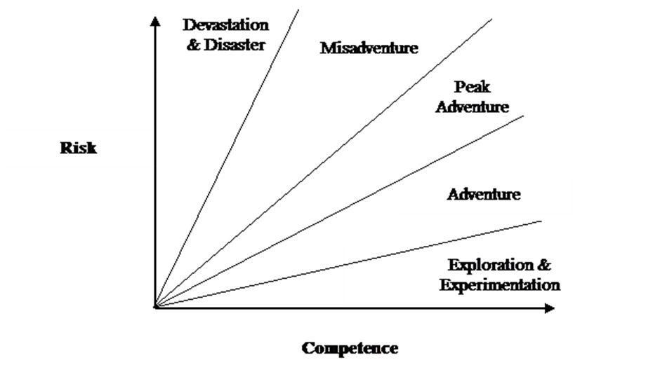
Martin, P and Priest, S’s (1986) diagram on The Adventure Experience shows that without the element of risk can’t be an outdoor adventure. But for people to be drawn into these activities then they have to feel like they are at risk, but the guide always knows they are safe. Barton, B (2007) supports this point up when stating “In a holistic view of adventure, the attractive and threating elements are in balance and harmony as yin is to yang.”. This shows that it is a balancing act for the activity leader as they have to make the child feel as though they are at risk and safe at the same time. There are many different benefits to doing adventurous activities such by doing an adventurous activity you are able to learn and take knowledge for the next time you have the opportunity to do the activity. Gill, T (2010) backs this up when stating “For the most part, as previous generations have learnt by experience, it is rare indeed that a well-planned exercise leads to accident. It will instead be most likely to bring a sense of enterprise, fun and accomplishment, so vital for maturity, judgement and well-being, which must nearly always offset the residual and inevitable risk” this shows that by the child experiencing the activity they are able to develop a better judgment for next time they do the activity or a similar activity as they are able to learn from there mistakes and triumphs. This shows that adventurous activities contribute to the development of children’s physical literacy as the child is able to take in knowledge. Also, by experiencing these activities a child is able to develop their physical competence. Gill, T (2010) reinforces this up when stating “The demands that adventurous activities make may be physical, or skill-based” this shows that as the adventurous activities demands can be physical and skill-based as for example when rock climbing or white water rafting that an adventurous activity can benefit a child’s physical competence development. This shows that adventurous activities contribute to the development of children’s physical literacy as the child is able to develop their physical attributes when doing adventurous activities. Adventurous activities are also able to help with motivational progression and well-being in a person’s mind. Gill, T (2010) supports this up when stating “given information and opportunities to experience risk in a positive environment, girls can develop the confidence and skills to make the best decisions for themselves.”. This shows that adventurous activities are beneficial to children’s physical literature development as it helps raising a child’s morale and confidence in the decisions they make and encourages them to keep developing their skills and stay engaged with physical activities. Another benefit to doing adventurous activities is learning responsibility for yourself when participating in activities. Gill, T (2010) backs this up when siting Judith Hackitt CBE, Chair, Health and Safety Executive’s speech which states “Helping young people to experience and handle risk is part of preparing them for adult life and the world of work. Young people can gain this experience from participating in challenging and exciting outdoor events made possible by organizations prepared to adopt a common sense and proportionate approach that balances benefits and risk.”. This shows that by kids having to take responsibility for themselves they are able to learn in a safe environment how to adapt into later life while still being able to engage with physical activities.
So, in conclusion adventurous activities contribute to the development of children’s physical literacy. Some of the benefits of children doing adventurous activities include being responsible for their own participant in activities throughout their lives. Another benefit is also the mental benefits it can have on children as it helps with building their confidents and reassure themselves in their own ability. In my opinion adventurous activities can contribute to the development of children’s physical literacy as adventurous activities give us the opportunity to affordances which can help drastically with mechanical movement development.
Word count: 1420

References
- Ayres, A.J. and Robbins, J., (2005). Sensory integration and the child: Understanding hidden sensory challenges. Western Psychological Services.
- Barton, B., (2007) Safety, Risk & Adventure In Outdoor Activities. London: Sage Publications Ltd
- Dr. Nalda Wainwright., (2016) Physical Literacy Dr. Nalda Wainwright July 2016. (online : https://slideplayer.com/slide/11760107/)
- Fjortoft, I. (2001). The Natural Environment as a Playground for Children: The Impact of Outdoor Play Activities in Pre-Primary School Children. Early Childhood Education Journal, 29(2), 111-117.
- Gibson, J. (1986). The ecological approach to visual perception. USA: Erlbaum.
- Gill, T., (2010) Nothing Ventured: Balancing Risks and Benefits in the Outdoors, English Outdoor Council, (online: http://www.englishoutdoorcouncil.org/wp-content/uploads/Nothing-Ventured.pdf)
- Martin, P. Priest, S. (1986) The Adventure Experience Paradigm, England
- Robinson, D. B., & Randall, L. (2016). Marking physical literacy or missing the mark on physical literacy? A conceptual critique of Canada’s physical literacy assessment instruments. Measurement in Physical Education and Exercise Science.
- Wainwright, N. (2018) "Laying the Foundations for Physical Literacy in Wales: The Contribution of the Foundation Phase to the Development of Physical Literacy." Physical Education & Sport Pedagogy 23.4: 431-45. Web.
- Whitehead, M. (2016) Definition of Physical Literacy. Available at: https://www.physical-literacy.org.uk/

