

Methodology Assignment: The impact of obesity in old adults in the UK.
Student name: Kati Nehme
Student ID: 2224741
Module name: Methodologhy
Module code: BMHP6020
Supervisor’s name: Bianca Sanfilippo

SUBMISSSION: 3 july 2026

  (ICHOM,2026) |  | The impact of obesity in old adults in the UK.  Aim: Understand the impact of obesity on old adults in the UK.  Objectives  - Discuss obesity among old adults in the UK  - Assess factors leading to obesity.  - Analyse the impact of obesity on old adults in the UK  - Provide recommendations/suggestions for the improvement of the quality of life of old adults with obesity.  in the UK |  | 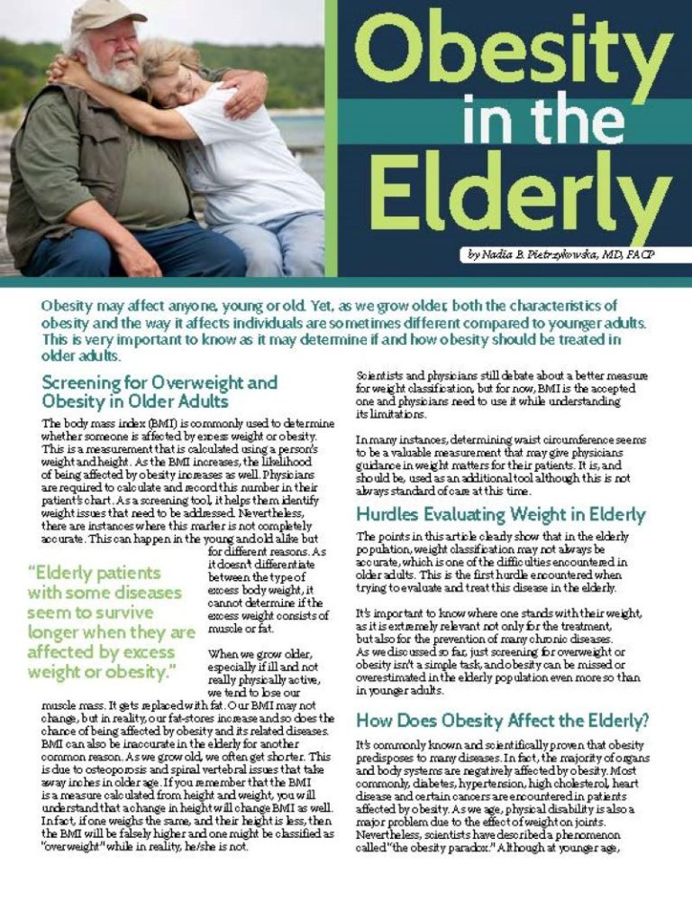  (Lalpathlabs,2019)
Methodology  This study utilises secondary research method gand uses analyses of academic studies to examine how obesity affects old adults in the UK though a systematic review (NHS.HRA,2019). At least ten peer reviewed journal articles will be selected for the systematic review. The search will be carried out using academic databases such as PubMed, Google Scholar, ProQuest, UWTSD Library.  The following keywords will be used to enhance the search:  ‘Impact of obesity in old adults in the UK’, ‘obesity in older adults in United Kingdom’  Inclusion criteria will include primary research studies, articles published within the last ten years, based on obesity and older adults living in the UK.  Exclusion criteria: Articles published prior to 2016, research carried out outside the UK, secondary research not related to obesity in adults.  ‘Challenges’, ‘barriers older people’, ‘elderly’, ‘digital technology’, ‘UK’, ‘United Kingdom’  PRISMA flowchart is used to record the selection process of the articles. |  |  |  | Data analysis  Thematic analysis is used to find similarities among the articles (Braun and Clark,2021).  Ethical considerations  Ethical considerations for secondary research include:  - Accurate reporting of data  - Reference all the sources used  - Using reliable sources
Resources
- Internet,
- Laptop,
- Lessons,
- UWTSD Library,
- Databases.

References

Ichom, (2026) Adult Obesity
Available at: https://www.ichom.org/patient-centered-outcome-measure/adult-obesity/
Accessed: 16th March 2026

Lalpathlabs,(2019) Obesity and Management Tips For Adults
Available at: https://www.lalpathlabs.com/blog/obesity-and-management-tips-for-adults/
Accessed: 16th Maerch 2026

GOV.UK (2025) Obesity profile: short statistical commentary.
Available at: https://www.gov.uk/government/statistics/obesity-profile-may-2025-update/obesity-profile-short-statistical-commentary-may-2025
Accessed: 20 February 2026

NHS England (2023) Obesity.
Available at: https://www.england.nhs.uk/ourwork/prevention/obesity/
Accessed: 2 March 2026.

NHS Digital (2022) Health Survey for England 2021: Adult Health Related behaviours.
Available at: https://digital.nhs.uk/data-and-information/publications/statistical/health-survey-for-england
Accessed: 25 February 2026.

NHS Health Research Authority (2019) Impact of obesity on health and social care needs among older adults
Available at: https://www.hra.nhs.uk/planning-and-improving-research/application-summaries/research-summaries/impact-of-obesity-on-health-and-social-care-needs-among-older-adults/
Accessed: 2 March 2026

Public Health England (2020) Obesity: Applying All Our Health.
Available at: https://www.gov.uk/government/publications/obesity-applying-all-our-health
Accessed: 23 February 2026.

