

Module: Leadership and Management Theory and Practice
Module code: LCBB6003

Component 2: Practical: Individual Reflection Report

Module Leader: Dr Faizu Edu
Lecturer: Dr Piyumika K. Gamage
Student Name: Oleksandra Chebotareva
Student ID: 2247384

Introduction
This reflection documents my transformative journey in understanding Emotional Intelligence EI and Cultural Intelligence CQ, using Gibbs Reflective Cycle to structure my learning progression and future development plans. (Sekarwinahyu et al., 2019)
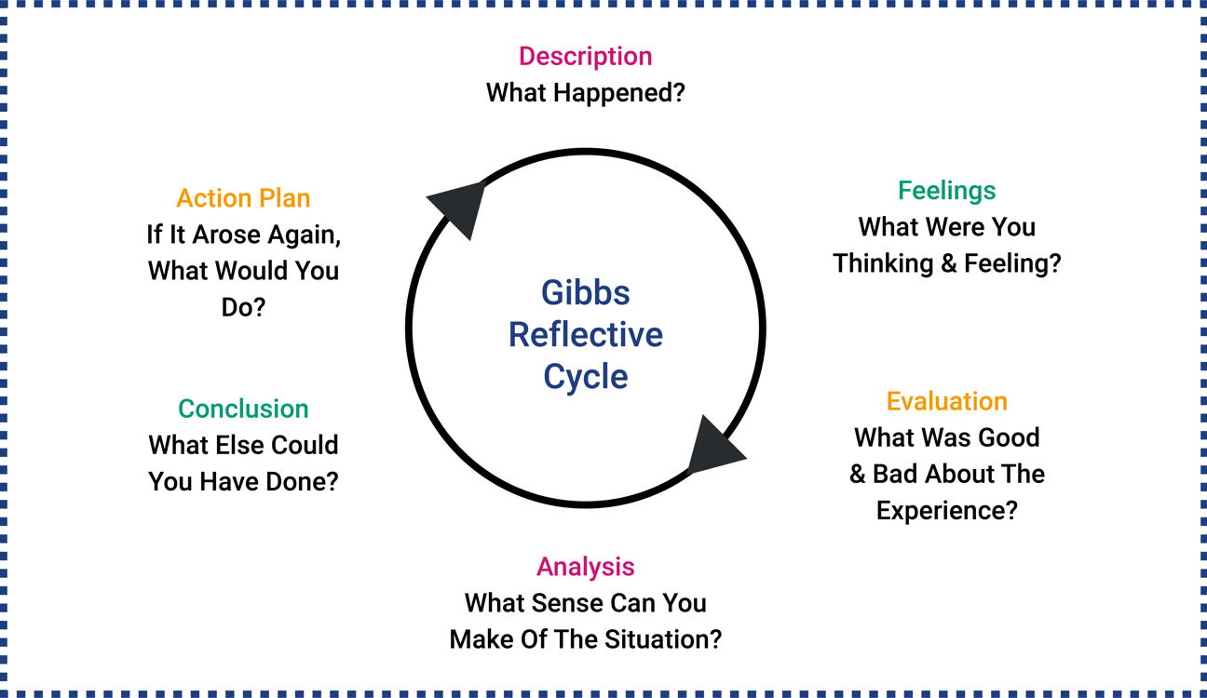
Figure 1: Gibbs’ Reflective Cycle (Dynamic Training, n.d.)
Description
Emotional Intelligence (EI) in leadership is defined as "the capacity to be aware of, control, and express one of emotions, and to handle interpersonal relationships judiciously and empathetically". (Mayer, Caruso & Salovey, 2016). It is considered a critical competency for effective leadership, influencing team dynamics, resilience, and organizational results.
Cultural Intelligence (CQ), on the other hand, is described as "an individual’s capability to adapt effectively to new cultural contexts and to function appropriately in situations characterized by cultural diversity". (Thomas & Inkson, 2009). This capability includes intellectual, motivational, and behavioural dimensions essential for global collaboration.

In exploring these theories, two foundational models are crucial. For EI, Daniel Goleman competency model which summaries five key components like self-awareness, self-regulation, motivation, empathy, and social skills provided a comprehensive framework for understanding emotional capabilities in leadership. For CQ, Hofstede cultural dimensions theory including dimensions such as power distance, individualism versus collectivism, and uncertainty avoidance offered a valuable approach for analysing and navigating cultural differences in global business contexts. (Alon et al., 2016)
After studying practical examples from companies such as IKEA and Microsoft, I discovered that EI extends beyond simple empathy to include nuanced skills like emotional regulation in high-pressure situations. Similarly, CQ emerged as more than cultural awareness, it represents a strategic capability to bridge differences in global business environments. (Livermore, 2022)
Feelings
Learning about Emotional Intelligence (El) made me feel more self-aware and motivated to improve my interpersonal skills, especially in managing my reactions during team conflicts. Regarding Cultural Intelligence (CQ), I initially felt a sense of humility and curiosity, recognizing how much there is to learn about navigating cultural details in professional settings.
I initially approached these concepts with academic curiosity but quickly felt challenged when recognizing my own limitations. During a self-assessment exercise, I was surprised to discover blind spots in my cross-cultural communication style. This created a sense of time sensitivity to develop these skills more intentionally, transforming my perspective from passive learning to active skill building.
Evaluation
The most valuable aspect was understanding how EI and CQ interact in practice. I excelled at recognizing cultural differences but struggled with adapting my leadership approach accordingly. Positive discoveries included realizing these are learnable skills rather than innate traits. However, I underestimated the emotional discipline required to consistently apply EI principles in stressful, multicultural situations. This gap between knowledge and consistent application emerged as the central challenge in my development, highlighting a need for more practical, repeated exposure to diverse scenarios to build my adaptive capabilities effectively. (Goleman, 2020).
Analysis
Contemporary research reveals why these competencies matter increasingly in our interconnected world. Livermore (2020) work demonstrates that CQ directly impacts innovation in diverse teams, explaining why some organizations outperform others globally. Goleman's updated research 2020 shows that EI accounts for nearly 70% of leadership effectiveness in cross cultural settings. The meta-analysis by Miao et al. 2018, further confirms that these skills can be systematically developed through targeted practice. This theoretical understanding helped me recognize that my challenges were not personal failures but rather development opportunities requiring structured approaches. Specifically, it became clear that moving from cultural recognition knowing the differences to cultural adaptation adjusting my behaviour is the critical boundary that requires deliberate practice and a mindset open to continuous feedback and learning.
Conclusion
This learning journey transformed my understanding from seeing EI and CQ as abstract concepts to recognizing them as essential, interconnected capabilities for global leadership. The most significant insight was understanding that cultural intelligence without emotional awareness is incomplete, and vice versa. I now appreciate these as dynamic skills that require continuous refinement rather than one-time learning. Moving forward, I recognize that true skill involves not just understanding these concepts intellectually but expressing them in daily interactions and decision-making processes. This reflective process has been crucial in identifying both my strengths and areas for growth, providing a clear roadmap for my ongoing professional development in an increasingly complex global landscape.
Action Plan
To develop my EI, I will implement a "pause-and-reflect" practice before responding in emotionally charged situations, using specific techniques like cognitive reframing. For CQ enhancement, I will create a "cultural learning portfolio" where I document and analyse cross-cultural interactions monthly. I will specifically focus on understanding how power distance and communication styles vary across cultures I frequently encounter professionally. Additionally, I will seek mentorship from leaders with international experience and participate in at least two global virtual team projects this year to practice these skills in real-world contexts. To ensure obligation, i will set per quarter review target to assess my progress against these goals. I will also utilize tools such as diary and feedback solicitation from diverse colleagues to gain slight insights into my intercultural effectiveness and emotional self-regulation, ensuring these plans translate into tangible competence. (Deardorff, 2020)

References:

Alon, I., Boulanger, M., Meyers, J. & Taras, V. (2016) ‘The development and validation of the Business Cultural Intelligence Quotient’, Cross Cultural & Strategic Management, 23(1), pp. 78–100. Available at: https://doi.org/10.1108/CCSM-10-2015-0138 (Accessed: 7 December 2025).
Deardorff, D.K. (2020) Manual for Developing Intercultural Competencies: Story Circles. 1st edn. London: Routledge. Available at: https://doi.org/10.4324/9780429244612. (Accessed: 29 November 2025).
Dynamic Training. (n.d.) Understanding Gibbs' Reflective Cycle [Online image]. Available at: https://www.dynamiccollege.co.uk/learner-pulse/study-skill-gibbs-reflective-cycle/ (Accessed: 30 November 2025).
Goleman, D. (2020). Emotional Intelligence: The Essential Skills. Harvard Business Review Press. Available at: https://librarysearch.uwtsd.ac.uk/permalink/44WHELF_UWTSD/upgrip/alma99100343059702421 (Accessed: 25 November 2025).
Livermore, D. (2022) Digital, Diverse & Divided: How to Talk to Racists, Compete with Robots, and Overcome Polarization [online]. Available at: https://davidlivermore.com/wp-content/uploads/2022/06/Digital-Diverse-Divided-_Ch-1.pdf (Accessed: 27 November 2025).
Mayer, J. D., Caruso, D. R. & Salovey, P. (2016) ‘The ability model of emotional intelligence: Principles and updates’, Emotion Review, 8(4), pp. 290–300. doi: 10.1177/1754073916639667. Available at: https://doi.org/10.1177/1754073916639667 (Accessed: 7 December 2025).
Miao, C., Humphrey, R.H. and Qian, S. (2018) ‘Emotional intelligence and authentic leadership: a meta-analysis’, Leadership & organization development journal, 39(5), pp. 679–690. Available at: https://doi.org/10.1108/LODJ-02-2018-0066. (Accessed: 23 November 2025).
Sekarwinahyu, M., Rustaman, N.Y., Widodo, A. and Riandi, R, (2019) ‘Development of problem-based learning for online tutorial program in plant development using Gibbs’ reflective cycle and e-portfolio to enhance reflective thinking skills’, Journal of Physics: Conference Series, 1157(2), p. 022099. Available at: https://doi.org/10.1088/1742-6596/1157/2/022099. (Accessed: 25 November 2025).
Thomas, D. C. & Inkson, K. (2009) Cultural Intelligence: Living and Working Globally., p. 12. 2nd edn. San Francisco: Berrett-Koehler Publishers. Available at: https://books.google.com/books/about/Cultural_Intelligence.html?hl=ro&id=v-V3q9Impv0C (Accessed: 7 December 2025).

