Certificate in Higher Education in Business Skills for the workplace
Student Name: Constantin Safta
Student Number:2325737
Course Name: Digital Skills LCLM4002
Lecturer Name: Nishi Ramsurrun
Session: October 2024 Term

Group: 1

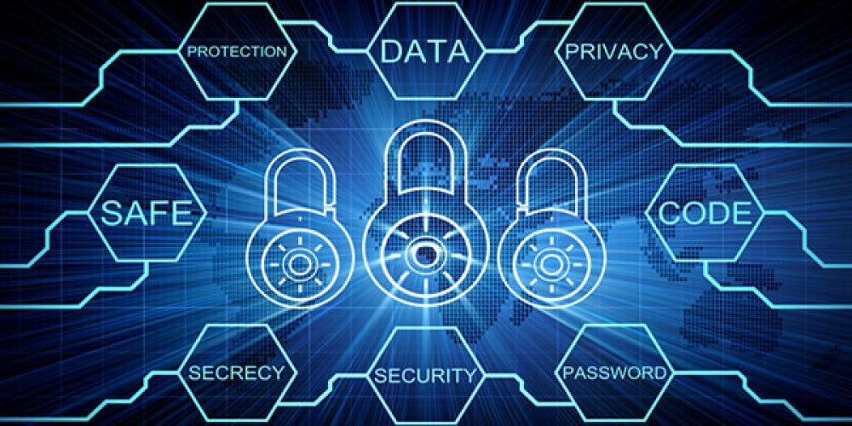
Basic Digital Safety
PASSWORD: Always choose a strong password, instead of one that is easy to remember
PRIVACY: Always check your privacy settings, web browsers and mobile operating system have settings available to protect your privacy online
SECRECY: Make sure your internet connection is secure. Use a secure VPN connection. When using a public Wi-Fi, remember that you cant control its security or privacy. Ensure your device is secure, and if you’re unsure, wait for a more secure network before sharing sensitive info like your bank account
SAFE: - Practice safe browsing. If a website looks off, it probably is. Just like you wouldn’t go to sketchy area, avoid suspicious sites online
-Be careful what u download. Hackers often trick u into downloading malware, witch damages your computer or steals info. Malware can hide in apps, disguised as games or traffic checkers.
- Be careful who you meet online.
- Make online purchase from secure sites. When buying online, only share your credit card or bank info with secure sites. Look for addresses that start with https and a padlock icon in the address bar.
PROTECTION: Keep your antivirus program up to date, internet security software cant catch every threat, but it removes most malware if its up to date
SOURCE: internet

