Name: Lindsay Davies
Student ID: 2414210
Degree: BSc Health, Nutrition, and Lifestyle
University: University of Wales Trinity Saint David
Moodle code and title: BMSS5002/Nutrition in sport and exercise
Tutor: Geraint Forster
Title of report: Train, Compete, Recover-Nutrition for Football
Word count: 2093 (excluding appendices and tables)
Submission date: 11 December 2025
Throughout the planning and writing process, I used Copilot to deepen my understanding of sports nutrition evidence, refine the athlete's nutrition guide, and clarify technical elements, including referencing, justification, and formatting. The table below documents each interaction and its purpose.
AI tool | Date used | Why did you use this tool? | Example prompt(s)
Copilot | 02/12/25 | To get a better understanding of the task. | Based on this task description, please provide all the essential details I must include about the athlete.
Copilot | 03/12/25 | To identify an effective way to present the data gathered on the athlete clearly.  Learning | Please show me how to present all the data I have gathered on the athlete in a table.  What does all this data gathered on the athlete tell me?
Copilot | 04/12/25 | Research | Show me journal articles that look at nutrition for athletes.
Copilot | 04/12/25 | Research | Please find me a study or academic journal article that discusses the importance of periodised nutrition for athletes.
Copilot | 05/12/25 | Research | Provide an academic journal article that examines periodisation in athletes' nutrition.
Copilot | 06/12/25 | Research | Find me studies that examine how to explain energy systems to athletes.  Review academic papers that investigate whether explaining energy systems to athletes is effective for adherence.  Find a study that examines which energy systems football players primarily use.  Show me an academic study examining the contribution of fat to athletes' energy systems.  Provide an academic journal article that examines higher protein intake among football players.
Copilot | 07/12/25 | Research | Show me studies that have examined the effects of whey protein on athletic performance.  Please find a journal article that examines the effects of branched-chain amino acids on athletic recovery.  Find me academic studies that look at creatine supplementation for athletes' performance.  Please find me a study on athletes that examines the effects of caffeine.  Look at electrolytes and sports drinks for exercise performance.
Copilot | 08/12/25 | Research | Provide an academic paper that supports my method for measuring hydration using urine colour.  Find me the original reference for the Cunningham equation.
Copilot | 09/12/25 | Structuring | Would my nutrition guide for the athlete and my justification section benefit from subheadings?
Copilot | 10/12/25 | Checking consistency | Verify that my references conform to Harvard style.

I also used Grammarly to check punctuation, grammar, and sentence structure throughout my assignment to ensure clarity and professionalism.

Train, Compete, Recover — Nutrition for Football
This report examines a 16-year-old amateur male athlete who plays football weekly, lifts in the gym three times per week, runs regularly, and takes one rest day. These combined demands place significant strain on energy balance, recovery, and overall well-being, so a structured nutrition plan is essential (Jeukendrup & Gleeson, 2024; Thomas, Erdman & Burke, 2016). The athlete's goal is to maintain current body mass while increasing lean mass and reducing fatigue during congested training weeks. Football demands endurance and repeated high-intensity efforts (Larrosa et al., 2024). Gym sessions and runs further raise the need for carbohydrates to fuel activity, protein for repair, and micronutrients for health (Amawi et al., 2024). Balancing these overlapping demands is especially important during adolescence, when growth and training coincide (AfN, 2025; Everett, 2025; NHS, 2025). This analysis aims to assess his nutritional status and performance needs and to produce a sport-specific, evidence-based nutrition plan that supports endurance, recovery, and long-term development while remaining practical and sustainable for his lifestyle.

Athlete Profile and Baseline Tests
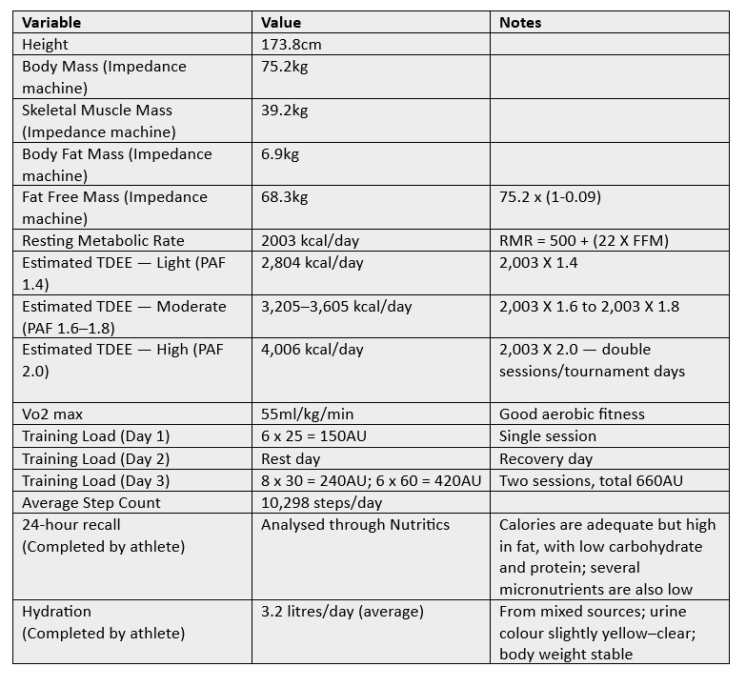
Parental consent was obtained prior to testing because the athlete is under 18 years old. The athlete's resting metabolic rate was calculated using the Cunningham equation, resulting in 2006 kcal/day (Cunningham, 1980). VO₂ max was measured at 55 ml/kg/min, indicating a high level of aerobic fitness (ACSM, 2021). Body weight recordings showed small fluctuations between 78.3 and 78.8 kg, remaining within the normal <2% variation range (ACSM, 2021). Hydration records documented fluid intake, urine colour checks indicated slightly yellow readings before and after training on Monday and Wednesday, with occasional clear samples, suggesting hydration status was generally adequate (ACSM, 2021). Training load was moderate, supporting endurance and recovery (ACSM, 2021). Overall, the athlete's physiological and hydration data provide a baseline profile of energy requirements, aerobic capacity, and fluid balance (ACSM, 2021).

Periodised Nutrition Strategies for Football Performance: 75.2 kg Athlete
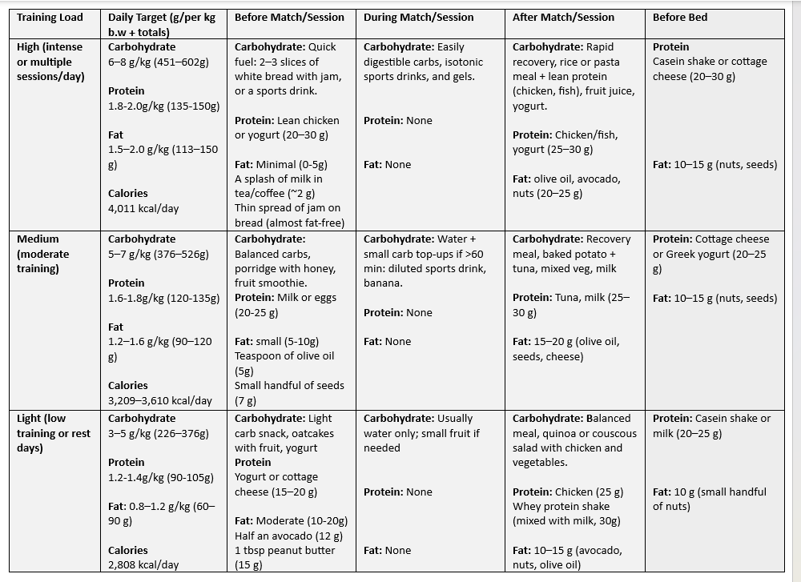
To perform at your best, match your nutrition plan to how your body produces energy. Muscles use three energy systems: ATP–PC for very short bursts, anaerobic glycolysis for repeated sprints, and the aerobic system for longer efforts. Type I (slow-twitch) fibers favour endurance; Type II (fast-twitch) fibers rely on glycogen for explosive actions. Supporting both fiber types through periodised nutrition enables endurance and decisive high-intensity efforts. Different training loads require adjustments to carbohydrate, protein, and fat intake. Your 24-hour recall indicates that you meet your calorie needs, but too much comes from fat. Reduce high-fat choices and increase carbohydrates and lean protein. You're also low in micronutrients; aim for five portions of fruit and vegetables a day to boost your intake of vitamins and minerals. On high-intensity days, 6–8 g/kg of carbohydrate is sufficient to maintain glycogen stores for explosive actions.

Pre-Competition
Before a match (1–2 hours before), consume easily digestible carbohydrates like white bread with jam or a sports drink for quick energy, plus 20–30 g of lean protein for muscle preparation. Keep fat low (0–5 g) to avoid slow digestion.

During Competition
During play, energy is maintained with isotonic drinks or gels, deliberately excluding protein and fat to prioritise rapid fuel. For sessions longer than 60 minutes, aim for approximately 30–60 g of carbohydrate per hour using sports drinks or gels to maintain intensity and delay fatigue.

Post Competition
Once the match ends, recovery becomes the priority. Have a rice or pasta meal with lean protein (chicken, fish, or whey) plus 20–25 g healthy fats (olive oil, avocado, nuts). Whey protein is adequate post-exercise due to rapid digestion, delivering amino acids quickly to muscle tissue — ideal for fast-twitch fibers. Distribute protein intake throughout the day: aim for 20–30 g every 3–4 hours, including within 30–60 minutes after training.

Overnight Recovery
As the day ends, focus shifts to overnight recovery. Casein protein (from cottage cheese, milk, or a shake) digests slowly, releasing amino acids for hours. Taken before bed, it reduces muscle breakdown and supports growth. Pairing casein with 10–15 g of fat from nuts or seeds further slows digestion, enhances satiety, and supports hormone regulation, thereby ensuring adequate overnight muscle fuel.

Training Load Adjustments
On moderate- and light-intensity days, macronutrient intake is adjusted, with larger reductions in carbohydrate and fat intake and minor changes in protein intake. Tailoring intake to training load prevents excess calories on rest days while still supporting recovery and adaptation.

Exclusions
It is also important to note what has been deliberately excluded. Protein supplements, such as isolated amino acids (BCAAs), do not provide the full spectrum of essential amino acids required for muscle protein synthesis. Despite heavy promotion, they are not equivalent to whole protein sources and often cause confusion. Whole foods remain the preferred option, as they supply complete proteins alongside essential micronutrients, supporting both performance and overall dietary quality.

Hydration
Hydration is another key element. Aim for pale yellow urine as a hydration guide. On hot or strenuous days, increase fluids. Electrolyte drinks during long or intense sessions help maintain balance. Consume 500–600 ml before exercise and 150–250 ml every 15–20 minutes during exercise, using electrolyte solutions for sessions longer than 60–90 minutes or in hot conditions.

Ergogenic aids
Creatine: 3–5 g/day, taken consistently (ideally with carbohydrate) to support repeated sprints and finishing bursts; does not require loading and typically does not cause unwanted weight gain when used sensibly.
Caffeine: 3–6 mg/kg (225–450 mg for 75.2 kg), taken 60 minutes before training or matches to enhance endurance, sprint performance, and focus; avoid high doses and late-day use to protect sleep. (Practical equivalents: 2–5 cups of coffee or 1–2 caffeine capsules)
Safety and implementation: obtain parental consent and medical clearance before starting; introduce one supplement at a time and log effects on sleep, mood, and performance.

Portable snacks
Practical on-the-go food options make the plan easier to follow. Keep healthy snacks available, such as sandwiches, bananas, cereal bars, canned tuna, and single-serve nut butter. These items help hit targets when time or cooking facilities are limited.

Monitoring and review
Monitoring and review are essential for a growing athlete. Track body mass weekly and record perceived recovery, sleep, appetite, and training quality; perform a monthly review to adjust calories and carbohydrate targets if weight or performance trends down. If persistent fatigue, unexplained weight loss, poor sleep, or frequent illness occur, seek clinical advice. By combining targeted timing, sensible portioning, hydration, monitored supplement use, and simple, practical tools, this periodised nutrition plan supports performance and healthy growth while remaining easy to implement.

Evidence and Rationale
The dietary recommendations in the athlete's nutrition guide are consistent with recent consensus and systematic reviews (Jeukendrup & Gleeson, 2024; Thomas, Erdman, and Burke, 2016; Larrosa et al., 2024; Amawi et al., 2024; Zhao et al., 2024). The guide applies evidence supporting periodised carbohydrate intake to sustain glycogen availability and performance in team-sport athletes (Amawi et al., 2024; Jeukendrup & Gleeson, 2024; Larrosa et al., 2024). The 24-hour recall is a practical method for capturing intake and guiding interventions (AfN, 2025). Accurate macronutrient distribution, adequate carbohydrate, and protein are essential for recovery (Thomas, Erdman, and Burke, 2016). Addressing micronutrient shortfalls, particularly iron, vitamin D, and calcium, by increasing intake of fruits, vegetables, fortified products, and appropriate protein sources supports metabolism, immune function, and bone health during growth and heavy training (Everett, 2025; Shao et al., 2021). It also reflects systematic reviews and expert guidance that endorse higher protein recommendations for endurance and team sport athletes compared with sedentary populations (Zhao et al., 2024; Thomas, Erdman, and Burke, 2016; Jeukendrup & Gleeson, 2024). The document's guidance on fat aligns with narrative reviews emphasising fat's role in energy balance and recovery (Amawi et al., 2024; Lyudinina, Bushmanova, and Bojko, 2024). Ongoing monitoring of growth, recovery, and training quality ensures that nutrition targets remain responsive and support both performance and healthy development in adolescent athletes (Everett, 2025).

Protein Timing and Recovery Strategies
To translate these targets into practice, the guide specifies protein-timing strategies to optimise recovery and adaptation (Jeukendrup & Gleeson, 2024). It recommends whey protein post-exercise for its rapid digestibility and demonstrated efficacy in muscle repair and recovery (Morton et al., 2018). For overnight recovery, the guide recommends casein before sleep to maintain amino acid availability and support overnight muscle protein synthesis (Trommelen & van Loon, 2016). Tracer studies show that amino acids derived from pre-sleep protein are incorporated into myofibrillar proteins overnight (Trommelen et al., 2018). These timing recommendations are embedded within a periodised-nutrition framework that aligns daily and sessional feeding with training objectives (Jeukendrup & Gleeson, 2024).

Periodisation Framework and Energy Systems
Periodised nutrition in the guide is defined as the systematic alignment of dietary intake with the physiological demands of training and competition (Stellingwerff, Morton & Burke, 2019). Following Jeukendrup and Gleeson, the guide frames periodisation as the planned, strategic application of nutrition interventions to optimise acute exercise responses and promote long-term adaptations (Jeukendrup & Gleeson, 2024). Practically, this means matching macronutrient availability to the predominant energy systems used in each session—supporting metabolic efficiency, recovery, and performance—and integrating nutrition into the training cycle. Hence, dietary strategies act as both fuel and modulators of adaptation and readiness for competition (Jeukendrup & Gleeson, 2024). To apply periodisation effectively, the guide outlines the body's primary energy systems and their ATP resynthesis pathways, since different sessions place distinct demands on phosphagen, glycolytic, and oxidative metabolism (Archacki et al., 2024; Ogun et al., 2023). Explaining these systems clarifies how nutrition aligns with physiological demands—for example, carbohydrate availability supports glycolysis during high-intensity efforts, whereas lipid oxidation predominates during prolonged, lower-intensity aerobic work—ensuring dietary guidance is logically connected to training demands (Lyudinina, Bushmanova & Bojko, 2024; Ramonas et al., 2023; Ogun et al., 2023). Providing easy-to-understand guides and clear explanations of energy systems promotes athletes' compliance with nutrition strategies (ACSM, 2021; Jeukendrup & Gleeson, 2024; Ogun et al., 2023). To reinforce athletes' understanding, the guide also explains fiber-type characteristics, thereby linking nutrition strategies to the physiological demands of training (Archacki et al., 2024).

Food Choices and Supplement Guidance
Understanding these physiological demands also explains why whole-food protein sources are prioritised and why certain isolated supplements are of limited value (Jeukendrup & Gleeson, 2024). The guide notes that isolated amino acid products, such as BCAAs, do not provide the full spectrum of essential amino acids required to sustain muscle protein synthesis (Kaspy et al., 2023; Plotkin et al., 2021). Because such products are widely promoted and often mistaken for intact protein sources, the guide cautions athletes against using isolated protein supplements, given evidence showing no clear advantage over whole foods (Kaspy et al., 2023; Plotkin et al., 2021; Zhao et al., 2024). Whole foods are recommended as the preferred option, supplying protein alongside essential micronutrients and supporting overall dietary quality (NHS, 2025; Office for Health Improvement and Disparities, 2024; Zhao et al., 2024). This improves the guide's coherence by prioritising evidence-based strategies that align dietary recommendations with athletes' physiological demands (Thomas, Erdman, and Burke, 2016; Zhao et al., 2024).

Hydration and Electrolyte Strategies
The guide translates hydration evidence into clear recommendations, linking fluid adjustments to training load and environmental conditions, which supports intensity, thermoregulation, and recovery (Jeukendrup & Gleeson, 2024; Deshayes, Pancrate & Goulet, 2022; Wardenaar et al., 2023). It highlights that dehydration increases perceived exertion and can impair endurance, recommending electrolyte solutions to replace sodium and other minerals lost in sweat, thereby supporting fluid balance and reducing cardiovascular strain (Tambalis, 2022; Deshayes, Pancrate & Goulet, 2022; Racinais et al., 2024). For sessions lasting 60–90 minutes or conducted in hot conditions, the strategic use of electrolyte solutions is advised to sustain performance and aid recovery (Tambalis, 2022; Deshayes, Pancrate & Goulet, 2022; Racinais et al., 2024).

Education and Ergogenic Aids
To ensure these strategies are adopted effectively, the guide prioritises clear, actionable education and simple decision rules so athletes can translate evidence into everyday practice and meet nutrition targets that support performance and recovery (Janiczak et al., 2023; Jayawardena et al., 2023; Hulland et al., 2023; Hopper, 2025; Zhao et al., 2024). With that foundation, the guide also provides evidence-based protocols for the use of targeted ergogenic aids. It recommends creatine supplementation protocols to elevate phosphocreatine stores and support repeated-sprint capacity (Forbes et al., 2023; Kreider et al., 2017), and it offers caffeine dosing and timing guidance, while cautioning against excessive or late-day use to protect sleep and recovery (Guest et al., 2021; De Souza et al., 2022; Grgic, 2020). These recommendations are presented as practical tools and checklists to help athletes implement them reliably in practice (Jeukendrup & Gleeson, 2024; Forbes et al., 2023; Guest et al., 2021). These measures improve adherence and safety, translating evidence into daily practice among adolescent athletes.

References
American College of Sports Medicine (ACSM) (2021). ACSM's guidelines for exercise testing and prescription. 12th ed. Philadelphia: Wolters Kluwer.
Amawi, A., AlKasasbeh, W., Jaradat, M., Almasri, A., Alobaidi, S., Abu Hammad, A., Bishtawi, T., Fataftah, B., Turk, N., Al Saoud, H., Jarrar, A. and Ghazzawi, H. (2024) 'Athletes' nutritional demands: a narrative review of nutritional requirements', Frontiers in Nutrition, 10, 1331854. Available at: https://doi.org/10.3389/fnut.2023.1331854 (Accessed: 07 December 2025).
Association for Nutrition (AfN) (2025) Home — Association for Nutrition. Available at: https://www.associationfornutrition.org/ (Accessed: 09 December 2025).
Archacki, D., Zieliński, J., Pospieszna, B., Włodarczyk, M., and Kusy, K. (2024) 'The contribution of energy systems during 15-second sprint exercise in athletes of different sports specializations', PeerJ, 12, e17863. Available at: https://peerj.com/articles/17863/ (Accessed: 04 December 2025).
Cunningham, J.J. (1980) 'A reanalysis of the factors influencing basal metabolic rate in normal adults', American Journal of Clinical Nutrition, 33(5), pp.1190–1192.
De Souza, J.G., Del Coso, J., de Souza-Fonseca, F., Silva, B.V.C., de Souza, D.B., da Silva Gianoni, R.L., Filip-Stachnik, A., Serrão, J.C. and Claudino, J.G. (2022) 'Risk or benefit? Side effects of caffeine supplementation in sport: a systematic review, European Journal of Nutrition, 61(8), pp.3823–3834. Available at: https://www.researchgate.net/publication/359745251_risk_or_benefit_side_effects_of_caffeine_supplementation_in_sport_a_systematic_review (Accessed: 05 December 2025).
Deshayes, T.A., Pancrate, T. and Goulet, E.D.B. (2022) 'Impact of dehydration on perceived exertion during endurance exercise: a systematic review with meta-analysis', Journal of Exercise Science & Fitness, 20(3), pp.224–235. Available at: https://doi.org/10.1016/j.jesf.2022.03.006 (Accessed: 05 December 2025).
Everett, S. (2025) 'Optimizing performance nutrition for adolescent athletes: a review of dietary needs, risks, and practical strategies'. Nutrients, 17(17), 2792. https://doi.org/10.3390/nu17172792 (Accessed: 08 December 2025).
Forbes, S.C., Candow, D.G., Falk Neto, J.H., Kennedy, M.D., Forbes, J.L., Machado, M., Bustillo, E., Gomez Lopez, J., Zapata, A. and Antonio, J. (2023) 'Creatine supplementation and endurance performance: surges and sprints to win the race', Journal of the International Society of Sports Nutrition, 20(1), 2204071. Available at: https://doi.org/10.1080/15502783.2023.2236060 (Accessed: 05 December 2025).
Guest, N.S., VanDusseldorp, T.A., Nelson, M.T., Grgic, J., Schoenfeld, B.J., Jenkins, D.M., Arent, S.M., Antonio, J., Stout, J.R., Trexler, E.T., Smith-Ryan, A.E., Goldstein, R., Kalman, D.S. and Campbell, B.I. (2021) 'International Society of Sports Nutrition position stand: caffeine and exercise performance', Journal of the International Society of Sports Nutrition, 18(1), pp.1–28. Available at: https://jissn.biomedcentral.com/articles/10.1186/s12970-020-00383-4 (Accessed: 05 December 2025).
Janiczak, A., Alcock, R., Forsyth, A. and Trakman, G.L. (2023) 'A systematic review of interventions targeting modifiable factors that impact dietary intake in athletes', British Journal of Nutrition, 131(2), pp.229–247. Available at: https://www.cambridge.org/core/journals/british-journal-of-nutrition/article/systematic-review-of-interventions-targeting-modifiable-factors-that-impact-dietary-intake-in-athletes/9AE2DD0686611A18BBF3364C0B05AD22 (Accessed: 05 December 2025).
Jeukendrup, A. and Gleeson, M. (2024) 'Sport nutrition'. 4th ed. Champaign, IL: Human Kinetics. Available at: https://librarysearch.uwtsd.ac.uk/permalink/44WHELF_UWTSD/1pbrh66/alma99100627102702421 (Accessed: 05 December 2025).
Kaspy, M.S., Hannaian, S.J., Bell, Z.W. and Churchward Venne, T.A. (2023) 'The effects of branched chain amino acids on muscle protein synthesis, muscle protein breakdown and associated molecular signalling responses in humans: an update', Nutrition Research Reviews, 37(2), pp.273–286. Available at: https://www.cambridge.org/core/journals/nutrition-research-reviews/article/effects-of-branchedchain-amino-acids-on-muscle-protein-synthesis-muscle-protein-breakdown-and-associated-molecular-signalling-responses-in-humans-an-update/9912227dd5144b0f7eb06260029520d7 (Accessed: 06 December 2025).
Kreider, R.B., Kalman, D.S., Antonio, J., Ziegenfuss, T.N., Wildman, R., Collins, R., Candow, D.G., Kleiner, S.M., Almada, A.L. and Lopez, H.L. (2017) 'International Society of Sports Nutrition position stand: safety and efficacy of creatine supplementation in exercise, sport, and medicine', Journal of the International Society of Sports Nutrition, 14(1), p.18. Available at: https://doi.org/10.1186/s12970-017-0173-z (Accessed: 07 December 2025).
Larrosa, M., Gil Izquierdo, A., González Rodríguez, L.G., Muñoz Alférez, M.J., San Juan, A.F., Sánchez Gómez, Á., Calvo Ayuso, N., Ramos Álvarez, J.J., Fernández Lázaro, D., Lopez Grueso, R., López León, I., Moreno Lara, J., Domínguez Balmaseda, D., Illescas Quiroga, R., Cuenca, E., López, T., Montoya, J.J., Rodrigues de Souza, D.P., Carrillo Alvarez, E., Casado, A., Rodriguez Doñate, B., Porta Oliva, M., Santiago, C., Iturriaga, T., De Lucas, B., García Solaesa, Á., Montero López, M.P., Benítez De Gracia, E., Veiga Herreros, P., Muñoz López, A., Orantes Gonzalez, E., Barbero Alvarez, J.C., Cabeza Ruiz, R., Carnero Diaz, Á., Sospedra, I., Fernández Galván, L.M., Martínez Sanz, J.M., Martín Almena, F.J., Pérez, M., Guerra Hernández, E.J., López Samanes, Á., Sánchez Oliver, A.J. and Domínguez, R. (2024) 'Nutritional strategies for optimizing health, sports performance, and recovery in athletes', Nutrition Reviews, 83(3), e1068–e1089. Available at: https://academic.oup.com/nutritionreviews/article/83/3/e1068/7712679 (Accessed: 07 December 2025).
Lyudinina, A.Y., Bushmanova, E.A. and Bojko, E.R. (2024) 'The significance of fatty acids in improving an athlete's aerobic performance: review and prospects', Human Physiology, 50(3), pp.285–292. Available at: https://link.springer.com/10.1134/s0362119723600492 (Accessed: 04 December 2025).
Morton, R.W., Murphy, K.T., McKellar, S.R., Schoenfeld, B.J., Henselmans, M., Helms, E., Aragon, A.A., Devries, M.C., Banfield, L., Krieger, J.W. and Phillips, S.M. (2018) 'A systematic review, meta-analysis and meta-regression of the effect of protein supplementation on resistance training-induced gains in muscle mass and strength in healthy adults', British Journal of Sports Medicine, 52(6), pp.376–384. Available at: https://doi.org/10.1136/bjsports-2017-097608 (Accessed: 08 December 2025).
NHS (2025) 'The Eatwell Guide', NHS. Available at: https://www.nhs.uk/live-well/eat-well/food-guidelines-and-food-labels/the-eatwell-guide (Accessed: 04 December 2025).
Office for Health Improvement and Disparities (2024) 'The Eatwell Guide: Government dietary recommendations', GOV.UK. Available at: https://www.gov.uk/government/publications/the-eatwell-guide (Accessed: 03 December 2025).
Ogun, B., Tamirci, M., Pournaki, M. and Tetik, Ş. (2023) 'Energy balance and management in sports and exercise', Mathews Journal of Sports Medicine, 3(1), pp.1–15. Available at: https://www.mathewsopenaccess.com/full-text/energy-balance-and-management-in-sports-and-exercise (Accessed: 06 December 2025).
Plotkin, D.L., Delcastillo, K., VanEvery, D.W., Tipton, K.D., Aragon, A.A. and Schoenfeld, B.J. (2021) 'Isolated leucine and branched chain amino acid supplementation for enhancing muscle anabolism: a narrative review', International Journal of Sport Nutrition and Exercise Metabolism, 31(3), pp.292–301. Available at: https://journals.humankinetics.com/view/journals/ijsnem/31/3/article-p292.xml (Accessed: 07 December 2025).
Ramonas, A., Laursen, P.B., Williden, M., Chang, W.L. and Kilding, A.E. (2023) 'Carbohydrate intake before and during high-intensity exercise with reduced muscle glycogen availability affects the speed of muscle reoxygenation and performance', European Journal of Applied Physiology, 123(6), pp.1479–1494. Available at: https://doi.org/10.1007/s00421-023-05162-y (Accessed: 04 December 2025).
Shao, T., Verma, H. K., Pande, B., Costanzo, V., Ye, W., Cai, Y. and Bhaskar, L. V. K. S. (2021) 'Physical Activity and Nutritional Influence on Immune Function: An Important Strategy to Improve Immunity and Health Status', Frontiers in Physiology, 12:751374. Available at: https://www.frontiersin.org/articles/10.3389/fphys.2021.751374/full (Accessed: 09 December 2025).
Stellingwerff, T., Morton, J.P. and Burke, L.M. (2019) 'A framework for periodized nutrition for athletics', International Journal of Sport Nutrition and Exercise Metabolism, 29(2), pp.141–151. Available at: https://doi.org/10.1123/ijsnem.2018-0305 (Accessed: 08 December 2025).
Tambalis, K.D. (2022) 'The effect of electrolytes and energy drinks consumption on athletic performance – a narrative review', European Journal of Fitness, Nutrition and Sport Medicine Studies, 3(1). Available at: https://oapub.org/hlt/index.php/EJFNSM/article/view/127 (Accessed: 05 December 2025).
Thomas, D.T., Erdman, K.A. and Burke, L.M. (2016) 'Position of the Academy of Nutrition and Dietetics, Dietitians of Canada, and the American College of Sports Medicine: Nutrition and athletic performance', Journal of the Academy of Nutrition and Dietetics, 116(3), pp.501–528. Available at: https://doi.org/10.1016/j.jand.2015.12.006 (Accessed: 04 December 2025).
Trommelen, J. and van Loon, L.J.C. (2016) 'Pre-sleep protein ingestion to improve the skeletal muscle adaptive response to exercise training', Nutrients, 8(12), 763. Available at: https://doi.org/10.3390/nu8120763 (Accessed: 08 December 2025).
Trommelen, J., Kouw, I.W.K., Holwerda, A.M., Snijders, T., Halson, S.L., Rollo, I., Verdijk, L.B. and van Loon, L.J.C. (2018) 'Pre-sleep dietary protein-derived amino acids are incorporated in myofibrillar protein during post-exercise overnight recovery', Gatorade Sports Science Institute Sports Science Exchange (article). Available at: https://www.gssiweb.org/sports-science-exchange/article/pre-sleep-dietary-protein-derived-amino-acids-are-incorporated-in-myofibrillar-protein-during-post-exercise-overnight-recovery (Accessed: 08 December 2025).
Wardenaar, F.C., Whitenack, L., Vento, K.A., Seltzer, R.G.N., Sieglar, J. and Kavouras, S.A. (2023) 'Validity of combined hydration self-assessment measurements to estimate urine concentration in tactical athletes', European Journal of Nutrition, 63(1), pp.185–193. Available at: https://link.springer.com/article/10.1007/s00394-023-03254-1 (Accessed: 05 December 2025).
Zhao, S., Zhang, H., Xu, Y., Li, J., Du, S. and Ning, Z. (2024) 'The effect of protein intake on athletic performance: a systematic review and meta-analysis', Frontiers in Nutrition, 11, 1455728. Available at: https://doi.org/10.3389/fnut.2024.1455728 (Accessed: 06 December 2025).

Appendix A: 24 Hour Recall
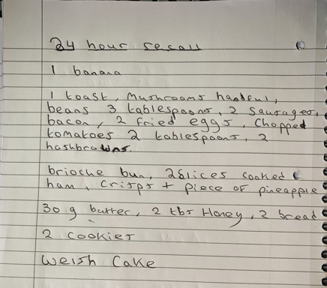

Appendix B: Analysis on Nutritics
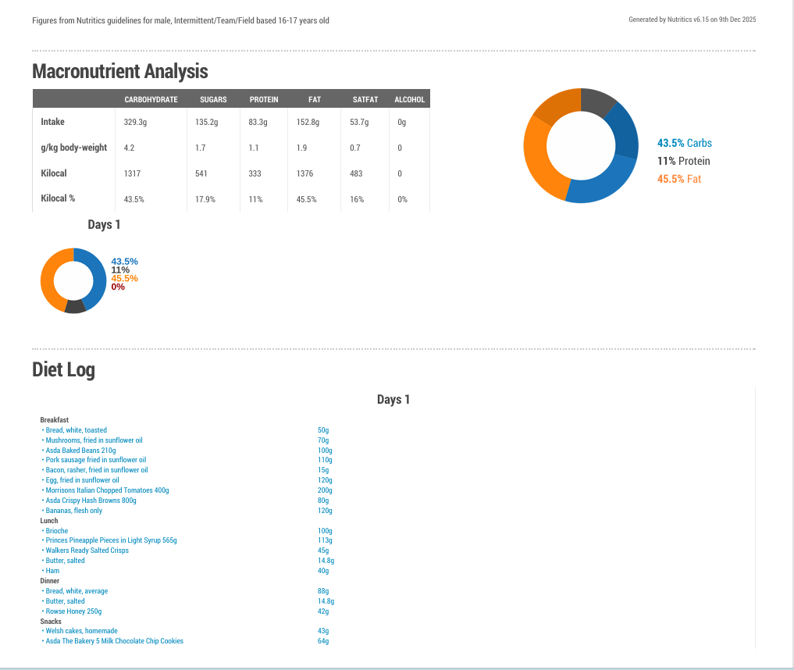

Appendix C: Weigh Before Work Out and After/ Workout Intensity
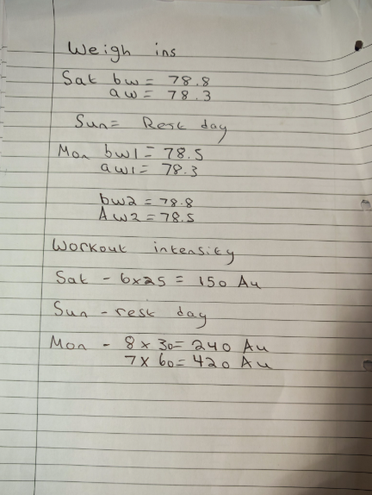

Appendix D: Urine Logs and Drink Consumed
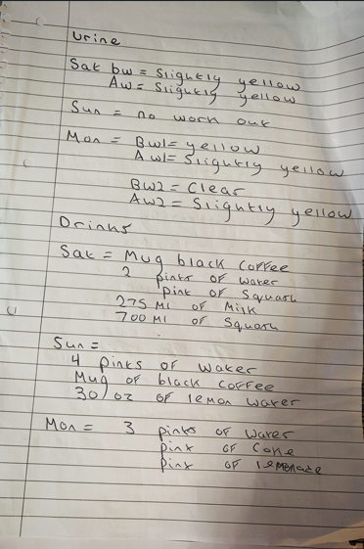

Appendix E: Impedance Results


