Module name: Development Across the Lifespan
Module code: ECES4009

Student number: 2200299
Contents

Is there a correlation between attachment and cognitve functioning? …………………..……..….. 3
Does a balanced diet encourage children’s physical development? …………………………………… 7
Is children’s language development affected by poverty? ……………….………………………………. 11

Reference list …………………………………………………………………………………………………………………... 14

Is there a correlation between attachment and cognitive functioning?

I believe everyone should experience an attachment bond with another person. When children feel safe and loved by family members or caregivers, their brains can develop, and the child can reach expected developmental milestones.
Attachment theorists, such as Ainsworth and Bowlby, have explored the connections between individuals and provided insightful information on how parents and/or caregivers can ensure they are establishing bonds with their children.
Furthermore, there is a cognitive aspect to the attachment bond. Without using cognitive functioning to recall memories or the feeling of comfort and security with someone, attachment would not be possible.

The biological aspects of attachment
Relationships and social interactions are how the brain develops and matures (Hand in Hand, 2019a). Attachment is assumed to be located in the middle prefrontal cortex region because the pre-frontal cortex is responsible for empathy (Hand in Hand, 2019a).
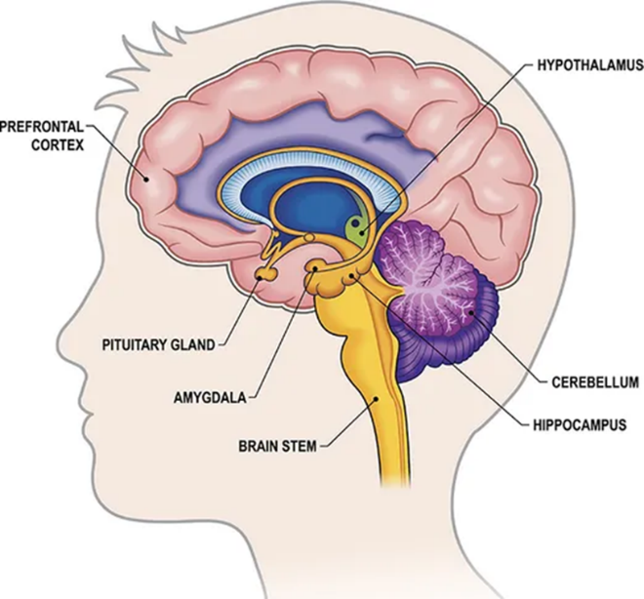
When you have experiences or social interactions, neurons are fired in your brain (Hand in Hand, 2019a). This means the more you accept opportunities and explore, the more neurons in your brain will form stronger neural pathways (Hand in Hand, 2019a). This is how attachment is formed and how it can alter depending on individual differences and experiences (Hand in Hand, 2019a).
The temporal lobe, in the cerebral cortex, is where memories of attachment are stored (Hand in Hand, 2019a). Therefore, if you have had comforting and enjoyable memories with family members, friends, or caregivers, you are likely to recall these emotions when you see them, leading to an attachment bond.
Source: Guy-Evans, 2021
Two regions within the temporal lobe, which are related to attachment, are the amygdala and the hippocampus. The amygdala is where your emotional learning and social processing are processed and it accesses every experience you have (Hand in Hand, 2019a). The hippocampus can recall relational experiences from when we were 2 ½ to 3 years old (Hand in Hand, 2019a).
So, if during early childhood, children did not form attachments to their parents or caregivers, it might impact their future relationships because the child could remember the absence of an attachment bond.
Studies on monogamous prairie voles have discovered that there are two primary hormones released in correlation to attachment behaviours (Fisher, 2000). These are oxytocin and vasopressin.
While I know humans are more complicated compared to voles, the genetic structure in all mammals is relatively similar, so it would be probable to assume that males and females do release these hormones when displaying attachment behaviours (Fisher, 2000).
Additionally, research on the hypothalamus reveals how through touch and warmth, the bonding hormone, oxytocin is released (Hand in Hand, 2019a). This supports the study on voles and, I think, highlights the importance of oxytocin in forming attachments.

Harlow’s rhesus monkeys experiment
Harry Harlow experimented on rhesus monkeys in the 1950s and 1960s exploring maternal deprivation and the impact it could have on behaviour (Hand in Hand, 2019b).
At birth, newborn rhesus monkeys were separated from their mothers and placed in cages with two wire-monkey mothers; one held a bottle for nourishment and the other was covered in soft terry cloth (Hand in Hand, 2019b).
The findings showed the monkeys favoured the soft cloth monkey as they would go to it for comfort and security (Hand in Hand, 2019b). Therefore, Harlow concluded that early attachments were not formed simply by being fed but by receiving comfort and care from a caregiver (Hand in Hand, 2019b).
While we cannot fully generalise the results of this experiment to humans, it does provide insight into maternal deprivation.

Mary Ainsworth
Mary Ainsworth, in the 1970s, performed her research, ‘Strange Situation’, on children aged between 12 and 18 months old (Hand in Hand, 2019b). The purpose of the experiment was to observe how the children responded to a situation where they were briefly left alone with a stranger before the mother returned (Hand in Hand, 2019b).
From the findings, Ainsworth found 3 major attachment styles: secure attachment, ambivalent-insecure attachment, and avoidant-insecure attachment (Hand in Hand, 2019b).
- Secure attachment is when the infant will display distress when they are separated from caregivers and express happiness when the caregiver returns (Hand in Hand, 2019b).
- Ambivalent attachment is when the infant is very distressed when the caregiver leaves, which might be because of poor parental availability (Hand in Hand, 2019b).
- Avoidant attachment is when the infant shows no preference between a caregiver and a stranger (Hand in Hand, 2019b).
From these three attachment styles, secure attachment highlights a positive attachment bond, which suggests the child’s cognitive processes have recalled the warmth and comfort their caregiver provided them.
Children who display ambivalent or avoidant attachment styles do not have the same cognitive process as children with secure attachments. This is similar to Harlow’s rhesus monkeys experiment, as it reveals the consequences of maternal deprivation on the child’s emotional state.
Additionally, if you consider Schaffer and Emerson's four stages of attachment, from 1964, by stage four, children should have established a secure bond with their caregivers by about nine months.

John Bowlby
John Bowlby was interested in understanding children’s separation anxiety and distress when their primary caregiver was separated from them (Hand in Hand, 2019b).
Bowlby believed the earliest bonds between children and their caregivers were because staying close to their mother would increase the child’s chances of survival as they are expected to provide nutrition and comfort (Hand in Hand, 2019b). This connection with the mother was thought to be innate, suggesting humans are biologically pre-dispositioned to have an attachment to their mothers (Hand in Hand, 2019b).
However, this is a nature argument and does not consider environmental influences or individual differences which could affect the attachment bond.

Problems because of attachment
If children do not receive secure attachment during childhood, then it could negatively influence their behaviour throughout their life (Hand in Hand, 2019b).
Children who have been diagnosed with conduct disorder (CD), post-traumatic stress disorder (PTSD), or oppositional defiant disorder (ODD) frequently show attachment issues, possibly because of early trauma, neglect, or abuse (Hand in Hand, 2019b).
Considering the attachment theories from Ainsworth and Harlow they both state the emotional harm the absence of attachment can cause.

Factors which influence attachment
Children raised in orphanages might not have a primary or constant caregiver, so they do not have the opportunities to form attachments. Also, the quality of caregiving towards a child can influence attachment (Hand in Hand, 2019b).
For example, a caregiver responding consistently and immediately to the child’s needs teaches the child how the people responsible for their wellbeing can be depended upon. In later life, the child might find trusting and forming attachments easier because they have established a dependable relationship with their caregivers.
Another factor which I think is important to consider is the cultural differences in how parents were raised and, consequently, how they raise their children. Different cultures have different parenting styles.
While we in the UK may not understand how families in Asia or Africa raise their children, it should not be considered harsh or wrong, because we would not raise our children the same way.
This video, YouTube (Focus Features, 2009), shows the unique parenting methods across different cultures. The video displays attachments between caregivers and children, highlighting how the comforting emotions some of the children feel towards their caregivers can establish strong cognitive bonds.

Conclusion
To conclude, cognitive functioning is important in attachment bonds as without memories of the warmth from the caregiver, then an attachment cannot be formed. Furthermore, I think it is important to remember how individual differences can impact every child’s cognitive functioning and attachment bonds.

Does a balanced diet encourage children’s physical development?

It is vitally important that children are eating a balanced diet to ensure they are receiving nourishing foods with help their development. If children’s diet consists of mostly high sugar and processed foods, then, I believe, this could influence their physical development. Additionally, if children do not eat enough food it could harm their physical development.

Gross and fine motor skills
Motor development describes the various movement skills children learn when in the early developmental phase and as they continue to be young adults (Boyd and Bee, 2014, p. 117). Within motor development, there are two categories; movement skills, often referred to as gross motor skills, and manipulative skills, often called fine motor skills (Boyd and Bee, 2014, p. 117).
Usually, fine motor skills take longer to develop and refine compared to gross motor skills which develop earlier (Boyd and Bee, 2014, p. 117). But as development continues, children learn precision and how to improve their fine motor skills in activities such as playing a musical instrument or participating in sports (Boyd and Bee, 2014, p. 117).
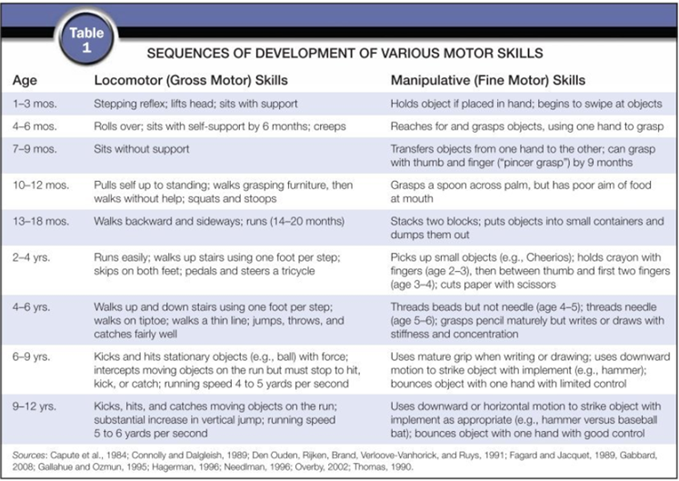

The table (Boyd and Bee, 2014, p. 117) shows the expected developmental milestones for both gross and fine motor skills at expected ages. While this table provides parents and caregivers with the average child’s developmental rate, it does not consider individual differences, environmental factors, or biological influences.
Arnold Gesell
Arnold Gesell’s maturation theory in 1925 stated how a child’s physical development was based on internal and external factors (Gesell Program in Early Childhood, 2022). Internal influences, such as genetics, learning styles, and temperament, and external factors, including the environment, cultural influences, parenting styles, and early experiences with adults, could influence the expected rate of development in children (Gesell Program in Early Childhood, 2022; Health Research Funding, no date).
Nevertheless, Gesell’s research was only based on middle-class socioeconomic families and has been criticised for generalising to lower-income households (Health Research Funding, no date). Therefore, individual differences in environmental factors have not been considered (Health Research Funding, no date).

What should children’s diet consist of?
If the child’s diet does not consist of fruits and vegetables, milk and dairy products, or starchy foods, such as rice and potatoes, then this could impact their physical development (NHS, 2022). These are some examples of the food groups children need because they provide nutrients, calcium, vitamins, minerals, and fibre (NHS, 2022).
If a child does not have a balanced diet, I think their gross and fine motor skills could be impacted. This is because if the child does not receive enough calcium, their fine motor skills could take longer to refine as their bones are not strong enough.

Teenagers' diet during secondary school
At school, children are given more freedom over their diet and can try new foods without their parent’s or caregivers’ permission (Boyd and Bee, 2014, p. 130). Due to this, nutritional issues can arise as the children are not balancing their diet (Boyd and Bee, 2014, p. 130).
I remember at secondary school, the vending machines and the counters serving food were full of unhealthy snacks. Although there were options for healthy foods, these were incredibly limited. So why would you choose to be healthy when you could have a warm chocolate muffin with chocolate chips?
Without guidance on their nutrition, children could gain excessive weight, which is considered one of the most serious health issues of childhood (Boyd and Bee, 2014, p. 130). This could have lasting implications on the child’s life because they are more susceptible to health conditions in adulthood (Boyd and Bee, 2014, p. 130).
However, it is important to consider how during secondary school, children’s bodies go through a transitional period and the weight gain might be normal (Boyd and Bee, 2014, pp. 130-131). Therefore, it would be wrong to suggest the child was gaining excessive weight when their BMIs are temporarily distorted (Boyd and Bee, 2014, pp. 130-131).
How poor nutrition affects children’s physical development
Poor nourishment can take three different effects on children: stunting, wasting, and/or obesity.
If a child does not receive the correct nutrition in utero and early childhood, then they could suffer from stunting (United Nations Children’s Fund et al. 2020).
This means the child’s brain might never achieve its full cognitive potential and they may not reach their full possible height (United Nations Children’s Fund et al. 2020).
Additionally, wasting is a life-threatening result of disease and/or the child receiving poor nutrients (United Nations Children’s Fund et al. 2020). These children are vulnerable to long-term developmental delays from having weak immunity (United Nations Children’s Fund et al. 2020).
These effects of poor nourishment can impact the life of the child and could be irreversible.

Reasons for poor nutrition
The industry's marketing of processed foods is considered one of the reasons why there has been a rise in obesity and overweight individuals (United Nations Children’s Fund et al. 2020). In correlation to the increased obesity levels, there have been lower levels of physical activity (United Nations Children’s Fund et al. 2020).
The UK government has enforced a ban, from 9 pm to 5:30 pm, on online TV advertisements for foods which are high in fat, salt, and sugar (Department of Health and Social Care, 2021). While I think this regulation might help decrease obesity, advertisements for processed foods are everywhere. Even if you do not see one on TV, you are likely to see it on social media.

How to combat malnutrition
There are various other ways to ensure children are receiving a balanced diet which can support their physical development.
Here are three ways which could help combat malnutrition:
- The mother, before and during pregnancy and lactation, should establish a nutritional and balanced diet and breastfeed the child for the first two years (United Nations Children’s Fund et al. 2020).
- To minimise the risk of children developing issues with poor nutrition parents and caregivers should create a healthy environment, one where there is easy access to basic water, hygiene, and opportunities for safe physical activities (United Nations Children’s Fund et al. 2020).
- Adults should explore diverse and nutritional foods in early childhood to encourage healthy eating and trying new foods (United Nations Children’s Fund et al. 2020).
Conclusion
To conclude, children who do not receive a balanced diet from birth could be at risk of their physical development being slower. I believe it is important for children to be taught about nutrition and food groups so they can make responsible decisions about what they are eating.
If parents or caregivers are unsure about how to provide their child with a balanced diet to help their physical development, research and help are available to support them.

Is children’s language development affected by poverty?

Why are language and speaking easy for some individuals but not for others? Could there be factors which influence a person’s ability to understand and respond to language?
Language development is improved and refined by children’s imitation of individuals' speech and language with constant reinforcement. Poverty is when individuals do not have enough income to provide for basic human needs, for example, clothing, food, and shelter (Green, 2021).
Imagine being a parent who is working full-time and living in poverty with a young child. Children might not see their parents as much compared to children of high-economic families, which means their language and ability to speak correctly could develop slower.

The nativist perspective
Nativism states that knowledge cannot only come from experiences as this approach believes people are born with innate traits (Fucci, 2024). This theory focuses on nature and does not believe the environment is important to the development of language.
Noam Chomsky’s Universal Grammar revoluiosinsed langauage aquistion. In an interview, Chomsky, (CUNY TV, 2014), stated how he believed most people learn a language without training once they are immersed in the language. Chomsky thought language could not be taught as it was a biological framework and humans are pre-dispositioned to it.
Considering this perspective, language development is deemed to be within children and external circumstances will have no confounding influence on this progression, including poverty or the absence of support.
However, in contrast to Chomsky, Vygotsky believed social interactions with the environment would develop children’s thinking and language skills (Kaufman, 2004).
The active pursuit of knowledge and support from internal and external scaffolding is important to the learning process (Kaufman, 2004). Vygotsky’s theory of the More Knowledgeable Other highlights how children need caregivers to expose them to language and teach them how to communicate.

The behaviourist perspective
The behaviourist approach to language believes it is developed through reinforcement and imitations of others.
Skinner, in 1957, stated how language in children was developed through environmental influences (Lemetyinen, 2012). His theory of operant conditioning suggested children learnt the language from behaviourist reinforcement principles (Lemetyinen, 2012).
For example, if a child correctly said a word then they would be positively rewarded by the parent or caregiver.
In my opinion, Vygotsky’s theory of the More Knowledgeable Other and exposure to language with Skinner’s operant conditioning highlights how language is acquired. Language could be biologically pre-determined, but I think, children must have interactions and opportunities to refine and consistently use language rather than wait for it to develop.

Differences between socioeconomic households
Brain scans have displayed differences in the brains of children from poorer backgrounds compared to children from higher economic backgrounds (Gering, 2015). The researchers scanned the cerebral cortices, the area responsible for language and reading, and found there was a correlation between cortical surface area and socioeconomic background (Gering, 2015).
This meant children from lower economic backgrounds were achieving lower test scores compared to children from a higher economic status (Gering, 2015).
The Borgen Project discovered two factors which could have influenced the smaller cortical surface areas.
Firstly, children from low socioeconomic households were more likely to go to school hungry or undernourished, meaning they might have an absence in cognitive functioning because they were tired (Gering, 2015).
Secondly, the education the parents received would influence the brain structure of the child, for example, educated parents were seen to have a larger hippocampus, which is important in learning and memory (Gering, 2015).
The Borgen Project is suggesting both nature and nurture influence the development of language. This is because the genetics of the parents are presumed to influence the structure of the brain, while environmental factors, for example, living conditions and the absence of experiences, could influence the rate of their progression.
Nevertheless, despite research stating children from poor economic backgrounds are more susceptible to smaller cortical surface areas, individual differences are important to consider, as not every child from a low economic family will fail to reach language developmental milestones.

Supporting children’s language development
I CAN (I CAN, no date) published how parents and/or caregivers can support their child’s language development. This included (I CAN, no date):
- Reducing background distractions
- Gaining your child’s attention before speaking and talking to them face to face
- Using simple repetitive language
- Using expressions to convey meaning
- Following the child’s interest as they are likely to be more attentive
This is similar to Baby Talk Register which stresses the importance of adults talking to children to increase their language skills.
Furthermore, if parents or caregivers do not think they are spending time with their child, communication activities, for example, talking during bath time or while in the supermarket, can support the growth of their vocabulary (I CAN, no date). This is because it is helpful for them to learn new words in context.
These activities could be helpful for parents who might not be able to afford the resources children are expected to have to increase their language skills.

Conclusion
To conclude, I believe language is developed through exposure to it, despite Chomsky’s theory. Therefore, caregivers should consistently talk to their child while encouraging their speech, without forcing it.
Also, families in poverty are at a disadvantage, but if they provide their children with opportunities to expand their language, such as reading or interacting with other people, it will have a significant impact on the rate of their language development.

Reference list

Boyd, D.G., and Bee, H.L. (2014) The Developing Child. 13th edn. United States of America: Pearson Education.
CUNY TV (2014) Day at Night: Noam Chomsky, author, lecturer, philosopher, and linguist. [video] Avaliable at: https://www.youtube.com/watch?v=rH8SicnqSC4 (Accessed: 20 January 2023).
Department of Health and Social Care (2021) New advertising rules to help tackle childhood obesity. Avaliable at: https://www.gov.uk/government/news/new-advertising-rules-to-help-tackle-childhood-obesity (Accessed: 20 January 2023).
Fisher, H.E. (2000) Brains Do It: Lust, Attraction, and Attachment. Avaliable at: https://dana.org/article/brains-do-it-lust-attraction-and-attachment/ (Accessed: 20 January 2023).
Focus Features (2009) BABIES – Offical Trailer. [video]. Avaliable at: https://www.youtube.com/watch?v=vB36k0hGxDM (Accessed: 20 January 2023).
Fucci, R. (2014) Nativism vs Empiricism. Avaliable at: https://sites.psu.edu/intropsychs14n1/2014/02/05/nativism-vs-empiricism/ (Accessed: 20 January 2023).
Gering, D. (2015) Poverty Impacts Brain Development in Children. Avaliable at: https://borgenproject.org/poverty-impacts-brain-development-in-children/ (Accessed: 19 January 2023).
Gesell Program in Early Childhood (2022) Gesell Theory. Avaliable at: https://www.gesell-yale.org/pages/gesell-theory (Accessed: 21 January 2023).
Green, F. (2021) What is poverty? Avaliable at: https://povertychild.org/what-is-poverty/ (Accessed: 20 January 2023).
Guy-Evans, O. (2021) Anatomy of the Brain. [Image]. Available at: https://www.simplypsychology.org/Anatomy-of-the-Brain.html (Accessed: 22 January 2023).
Hand in Hand (2019a) Understanding How Attachment Affects the Brain. Avaliable at: https://handinhandmentoring.org/understanding-how-attachment-affects-the-brain/ (Accessed: 16 January 2023).
Hand in Hand (2019b) What Is The Attachment Theory? Avaliable at: https://handinhandmentoring.org/why-attachment-matters/ (Accessed: 16 January 2023).
Health Research Funding (no date) Arnold Gesell Maturation Theory Explained. Avaliable at: https://healthresearchfunding.org/arnold-gesell-maturation-theory-explained/ (Accessed: 20 January 2023).
I CAN (no date) A communicative supportive enviornment: helping your child communicate. Avaliable at: https://speechandlanguage.org.uk/media/3282/communication-supportive-environment-for-parents.pdf (Accessed: 18 January 2023).
Kaufman, D. (2004) ‘14. CONSTRUCTIVIST ISSUES IN LANGUAGE LEARNING AND TEACHING’, Annual Review of Applied Linguistics, 24, pp. 303-319. DOI: 10.1017/S0267190504000121
Lemetyinen, H. (2012) Language Acquisition. Avaliable at: https://www.simplypsychology.org/language.html (Accessed: 18 January 2023).
NHS (2022) What to feed young children. Avaliable at: https://www.nhs.uk/conditions/baby/weaning-and-feeding/what-to-feed-young-children/ (Accessed: 20 January 2023).
United Nations Children’s Fund (UNICEF), World Health Organization, International Bank for Resconstuction and Development/The World Bank (2020) Levels and trends in child malnutrition. Avaliable at: https://apps.who.int/iris/bitstream/handle/10665/331621/9789240003576-eng.pdf (Accessed: 18 January 2023).

