 | LEVEL 5  ASSESSMENT  ACCA5034

DATA SECURITY & COMPLIANCE
Research and Case Scenario
in Data Security and Compliance
BSc Applied Computing | Computing Portfolio
STUDENT NAME | Muhammad Waqas Akram
STUDENT ID | 2429948
UNIVERSITY | University of Wales Trinity Saint David
PROGRAMME | BSc Applied Computing
MODULE | Data Security and Compliance
MODULE CODE | ACCA5034
ASSESSMENT SUBMISSION
Research paper and case scenario • 5000 words or equivalent • 100% module assessment

CONTENTS
Contents
TASK – 1- Research in Data Security and Compliance 1
I. Introduction 1
A. Organisational Adoption of AI and Emerging Governance Exposure 1
B. Problem Statement 1
C. Aim and Scope 1
II. AI Governance Foundations and Literature Synthesis Selecting a Template 1
A. Evolution from AI Ethics Principles to Organisational Governance 1
B. Major Governance Frameworks 1
C. Governance Roles and Organisational Accountability 1
D. Critical Literature Gap 1
III. AI Risk and Security Lifecycle: Anticipate, Protect, Detect and Respond 2
A. Anticipate: AI Inventory and Risk Assessment 2
B. Protect: Data, Model and Infrastructure Controls 2
1) Data Risks 2
2) Model Risks 2
3) Protective Controls 2
C. Detect: Continuous AI Assurance 2
D. Automatically Respond 2
E. Critical Evaluation 2
IV. Ethical Governance and Human Accountability 2
A. Fairness and Bias Mitigation 2
B. Transparency and Explainability 2
C. Accountability and Human Oversight 2
D. Innovation versus Ethical Precaution 2
E. Ethics-Washing and Checkbox Governance 2
V. Compliance and Cross-Jurisdictional Alignment 3
A. EU AI Act Risk-Based Regulation 3
B. GDPR and Automated Decision-Making 3
C. Sector-Specific Regulatory Overlap 3
D. Comparative Regulatory Analysis 3
E. Critical Evaluation of Regulatory Fragmentation 3
VI. Critical Synthesis and Proposed AI Governance Control Loop 3
A. Intersection of Risk, Ethics, Security and Compliance 3
B. Limitations of Existing Approaches 3
C. Proposed Six-Stage AI Governance Control Loop 3
D. Governance Performance Indicators 4
E. Overall Critical Judgement 4
VII. Conclusion 4
references 5
Task 2 - Case Scenario 6
I.Introduction 6
II. Organisational Structure and Accountability 6
A. Governance Failure Identified 6
B. Proposed Cybersecurity Governance Structure 6
C. Reporting and Accountability 6
D. Critical Justification 6
III. Formalised Policies and Procedures 7
A. Vulnerability Management Policy 7
B. Patch Management Policy 7
C. Secure Software Development Lifecycle 7
D. Asset Visibility Policy 7
E. Monitoring and Data Protection Policies 8
F. Policy Enforcement and Auditability 8
IV. Governance and Strategic Alignment 8
A. NIST Cybersecurity Framework 2.0 8
B. Equifax Programme Mapping 8
C. Business Objectives 9
D. Critical Evaluation 9
V. Risk Management and Assessment 10
A. Risk-Assessment Method 10
B. Key Risks 10
C. Risk Prioritisation 10
D. Mitigation Rationale 11
E. Residual Risk 11
VI. Compliance, Incident Response and Protection Controls 12
A. Regulatory Alignment 12
B. Breach Notification Protocol 13
C. Incident Response Plan 13
D. Disaster Recovery and Business Continuity 13
E. Technical Protection Controls 13
F. Reducing Dwell Time and Organisational Impact 13
VII. Implementation Roadmap and Performance Measurement 14
G. Phase 1: First 30 Days 14
H. Phase 2: Days 31–90 15
I. Phase 3: Months 3–12 15
VIII. Conclusion 15

TASK – 1- Research in Data Security and Compliance
Data Security and Compliance

Muhammad Waqas Akram
Student ID: 2429948
BSc Applied Computing
University of Wales Trinity Saint David

Abstract— Artificial intelligence and machine learning are being used by organizations for vital decision assistance, but there are no governance structures in place to handle the dangers associated with their use. The study critically examines the literature and contrasts the governance models, such as the EU AI Act, NIST AI RMF, and ISO/IEC 42001, to explore how organizations can control the data, models, and automated decisions associated with AI. The analysis reveals that inconsistent risk, ethics, security and compliance controls are insufficient due to the lack of accountability, monitoring and response. The study suggests a proactive strategy for the AI Governance Control Loop that links governance, inventory, impact assessment, proportionate controls, ongoing monitoring, and incident response. The study proposes not only effective governance principle but also the principle of adaptive, evidence-based and accountable life cycle management.
Keywords— Artificial Intelligence Governance, AI Risk Management, Data Security, Ethical AI, Regulatory Compliance, EU AI Act, NIST AI RMF, ISO/IEC 42001.

Introduction

Organisational Adoption of AI and Emerging Governance Exposure
AI and machine-learning systems impact recruiting, lending, healthcare, cybersecurity and customer services. These systems analyze data sets and scale decisions to be efficient, but also end up increasing opacity, discrimination, and privacy threats. The principles that bring the ethical guidelines together are transparency, fairness, responsibility and privacy, but the implementation remains inconsistent [1].

Problem Statement
Organizational adoption is currently outpacing governance capacity. Confidentiality, integrity and availability are protected by conventional information-security controls, but not by the control of changing model behavior, biased outcomes, explainability or diffused accountability. Thus, ownership and operational controls can justify harmful AI practices if they are not enforceable, whereas principles cannot [2].

Aim and Scope
This paper aims at critical assessment of the integration of risk management, ethics, security, and regulatory compliance to effectively govern AI data and models within organizations.

AI Governance Foundations and Literature Synthesis Selecting a Template

Evolution from AI Ethics Principles to Organisational Governance
Initial AI governance was based on ethics, fairness, transparency, accountability and non-maleficence. Normative direction was created through their convergence, but no effective means of addressing competing values or policing behavior existed. Values became practices in the world of responsible AI, and trustworthy AI expanded the scope of assessment to include legally compliant, ethically sound, and technically sound systems. However, the principles are worthy and meaningful only if applied along with risk management and a life cycle process for designing, procuring, deploying, monitoring and retiring [3].

Major Governance Frameworks
The EU AI Act lays out risk-based mandatory requirements, and the NIST AI RMF outlines optional risk stages – Govern, Map, Measure and Manage – to address risks [4],[5].ISO/IEC 42001 standardizes and establishes continuous improvement through an AI management system that can be audited [6]. OECD Principles establish expectations on human rights, transparency and accountability [7]. Legislation establishes the minimum duties, management process’s structure, and the principles for normative alignment, but none is effective if it is too easy to evade, or if it leaves too much room for interpretation.

Governance Roles and Organisational Accountability
A multidisciplinary AI governance committee and board oversight of risk appetite and strategic implications are essential for effective governance. Model owners stay responsible for performance and limits, data stewards are responsible for quality, provenance and access. T Independent challenge, testing of controls and verification of evidence within risk, compliance, legal, cybersecurity and internal audit teams are required. This allocation prevents developers and technology from taking responsibility.

Critical Literature Gap
Although frameworks generally agree on the importance of fairness, accountability, transparency and safety, they still vary on their enforceability, the detail of operation, and measurable thresholds [8]. Principles usually define desirable outcomes, but do not consider who intervenes, what measures signal action, or how dangerous models are managed. Thus, for a mature governance, decision rights must be named, control gates must be based on evidence, there must be assurance, and there must be escalation and suspension rules that are already established.

AI Risk and Security Lifecycle: Anticipate, Protect, Detect and Respond

Anticipate: AI Inventory and Risk Assessment
The first step to AI governance is visibility. Organizations should keep an inventory of internal AI systems, systems they have bought and systems they have embedded in, to record who is using them, what data they rely upon and how decisions are being made, and how impactful those decisions are. AI decision assessment and licensing should be considered based on reversibility, harm and affected populations. Provenance, lineage and licensing should be traceable as otherwise it creates accountability and reproducibility risks in data [9].

Protect: Data, Model and Infrastructure Controls

Data Risks
Historical and representation bias perpetuates structural inequality, and the inadequacy or ungoverned quality of data triggers cascading failures throughout the system lifecycle [10]. Legitimate reuse and audit are difficult without clear provenance, and training-serving skew is a problem when operational data is different from deployment data.

Model Risks
Models produce hallucinated or unreliable responses, opaque to affected users and fail on adversarial examples. Extraction and inversion attacks may expose model functionality and training information, and concept drift will cause accuracy and fairness to gradually decrease. These risks show that model validation at launch is insufficient and the assurance process should be continued throughout operation [11].

Protective Controls
Protection requires validated data pipelines, least-privilege access and documented datasets and models through datasheets and model cards [12]. Secure MLOps should enforce code review, environment separation, signed artefacts, version control and reproducible deployment. Red team testing should assess technical, ethical and misuse hypotheses. Minimization, differential privacy and controlled access should be selected in proportion rather than universal safeguards.

Detect: Continuous AI Assurance
Continuous assurance should track for accuracy, subgroup fairness, drift, anomalous inputs, and security events. Immutable model and data-lineage logs allow investigation and accountability. Additionally, deployments built with Generative-AI also need prompt and output monitoring, and complaints and appeal patterns serve as evidence that quantitative metrics may be missed. When changes are made to the vendor model, the changes must be reassessed because external changes can affect the behavior without the organization’s authorization [13].

Automatically Respond
Response mechanisms must include automated alerting, traffic throttling, model rollback, dataset or model quarantine, safer-model fallback and temporary suspension of automated decisions. High impact incidents should be elevated to accountable human reviewers who have authority to stop deployment, inform stakeholders and initialize recovery.

Critical Evaluation
While automation decreases detection and response time, unnecessary shutdown can cause disruption to critical functions or exacerbate impact. Therefore, the response actions should be based on the policy defined thresholds, tested playbooks, proportional human escalation. Maximum automation is not maximum governance, but rather evidence, accountability and safe reversibility of the automation, which is controlled governance.

Ethical Governance and Human Accountability

Fairness and Bias Mitigation
Fairness is not one-dimensional. Group fairness is based on outcomes by protected groups, while individual fairness is based on the expectation of similar treatment for similarly situated individuals. Such aims are conflicting in scenarios where historical data indicate structural inequality [14]. Pre-processing can rebalance or relabel data; in-processing can limit learning goals; and post-processing can fine-tune decisions following the prediction. But a mere statistical parity cannot determine what is morally just or legally permissible as fairness is based on the rights involved, and on the distributional effect of any action [15].

Transparency and Explainability
Transparency encompasses an ability to comprehend the development, usage and governance of an AI system. Global explanations provide general information about the model behavior, and Local explanations provide local information about model outputs. However, technical explainability alone is not necessarily meaningful: developers must know how to make the technical explanations a means of diagnosis; managers must know how to make technical explanations a means of risk assessment; regulators must know how to make technical explanations a means of compliance; and individuals affected must know how to make technical explanations a means of challenge [16].

Accountability and Human Oversight
Governance is required for human-in-the-loop; human-on-the-loop provides supervision; and human-in-command maintains authority to set boundaries, intervene and withdraw systems. Oversight becomes symbolic when the reviewers are lacking in time, competence, information or power. To achieve meaningful control, there must be documented responsibilities shared amongst the developer, deployer and senior management with escalation and appeal processes [17].

Innovation versus Ethical Precaution
Excessive caution can stifle innovation, and too little governance can spread discrimination and risky choices. The severity of the situation, reversibility, and exposure should be reflected in controls, with greater evidence and supervision for more meaningful, and high impact uses.

Ethics-Washing and Checkbox Governance
Ethics-washing happens when organizations declare principles with no ownership, evidence or consequences. Measurable thresholds, impact assessments, audit trails, independent challenge and sanctions for unaddressed violations [18] are required for ethical governance.
The Information Commissioner's Office (ICO) has discovered that AI recruitment software does not have enough transparency, data minimization, accuracy testing, bias monitoring, or a clearly defined controller. These findings show that model metrics alone are not enough to achieve fairness; the contracts must be fair, and ownership must be documented as well. [19] The same applies to the privacy interference of the fraud detection system SyRI. The study shows that to achieve legitimacy transparent risk profiling is required [20].

Compliance and Cross-Jurisdictional Alignment

EU AI Act Risk-Based Regulation
The EU AI Act introduces differentiated obligations based on the purpose, context and potential harm of an AI system. Specified manipulative, exploitative, social-scoring and biometric uses are prohibited as endangering fundamental rights. For some applications such as recruitment, creditworthiness and biometric identification, risk management, data governance, technical documentation and logging, human oversight, accuracy and post-market monitoring are all necessary for high-risk systems. Systems that interact with individuals or create synthetic content are subject to transparency obligations, whereas lower risk systems are required only to have limited mandatory controls.

GDPR and Automated Decision-Making
In cases where AI generates personal data, the concept of ‘lawful purpose’, necessity, fairness' and ‘data minimization' continue to be essential. Where processing is likely to result in high risks, data-protection impact assessment is essential. Article 22 covers the case of a decision being made entirely by means of an automated process having a legal or comparable effect on the individual, with exceptions and safeguards, such as human involvement and contestability [21]. The scope of a legally enforceable “right to explanation” is, however, debated, with narrow interpretations arguing that a universal right to explanation does not exist [22],[23], and functional approaches claiming that information is necessary to enable data-subject rights. The AI Act does not replace GDPR; organizations are required to demonstrate GDPR-compliance in addition to AI-system-level conformity and personal-data-processing compliance.

Sector-Specific Regulatory Overlap
For financial entities, DORA includes ICT risk governance, ICT-resilience testing, ICT-incident management, business continuity and ICT-critical third-party oversight. Although the regulations apply only to certain sectors, NIS2 places obligations on certain essential or important entities (EOIE) in the critical sectors when it comes to cybersecurity risk-management and reporting [24],[25]. Therefore, integrated reporting criteria and tested recovery arrangements are more efficient than compliance processes in isolation.

Comparative Regulatory Analysis
The EU adopts horizontal, rights-oriented and risk-based legislation, while the U.S. has taken more concerted action to promote sectoral law, state initiatives and voluntary standards like the NIST AI RMF, and China has a mix of the PIPL with state-led algorithm, content and security regulation [5],[26]. As a result, EU organizations are subject to a broad range of conformity evidence, US organizations to regulatory inconsistencies, and Chinese operations to registration, localization and supervisory obligations.
Table I compares how the EU AI Act and ISO/IEC 42001, while offering differing degrees of flexibility.
- Comparative AI Governance Frameworks
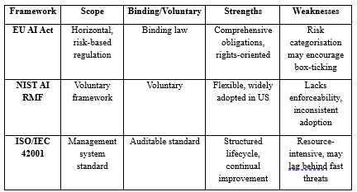

Critical Evaluation of Regulatory Fragmentation
The legal status of a global AI service can vary from country to country, and being legal does not mean its ethical. Organizations should therefore establish a minimum baseline for the inventory, impact assessment, security, fairness, transparency, human review, monitoring and incident response across the globe, and then overlay jurisdiction specific controls. This will minimize duplication but cannot prevent overlapping legal obligations, culture, and enforcement practices.

Critical Synthesis and Proposed AI Governance Control Loop

Intersection of Risk, Ethics, Security and Compliance
Risk management evaluates the potential for uncertainty such as likelihood, impact and reversibility, ethics evaluates the societal acceptance of the outcomes and process of the decision. Compliance establishes low level legal and regulatory requirements while security ensures that data, models, infrastructure and interfaces are protected from unauthorized access, manipulation and disruption. Governance integrates all of these by allocating decision-making authority, establishing decision making risk appetite and requiring evidence that controls are effective.

Limitations of Existing Approaches
Ethical issues often have little guidance and are not legally required when fairness, privacy or commercial interest is at high risk [27]. Audits may be rewarded for the success that they provide, even if the findings are bad, and metrics can turn social harm into thresholds. When a third-party foundation model is used, training data and silent updates are less visible.

Proposed Six-Stage AI Governance Control Loop
The proposed 6-step AI Governance Control Loop fulfils all the proposed requirements. First, Govern determine the direction of policy, the appetite for risk, uses and accountability of the board. Second, Inventory and Classify catalogs all internal, embedded and vendor AI systems and rank them on a Risk Tier. The third, Assess Data, Model and Human Impact, focuses on issues of provenance, security, performance, fairness, privacy and impacted stakeholders. Fourth, Apply Controls utilize proportional measures to provide ethical, technical and legal protection before being approved. Fifth, Monitor, Audit and Detect is continually assessing behavior, drift, incidents and control effectiveness. Sixth, Respond, Recover and Improve includes Containment, Rollback, Notification, Remediation and Lessons Learned, and then Evidence to feed into governance. End-to-end auditing is required as bugs may be discovered in the development and deployment process and not just during the approval phase [28]. Because of this feedback loop, all organizational levels' policies, thresholds, training material, deployment requirements, and future approvals are continually updated. An accountable designated owner, necessary documentation, approval criteria, monitoring indicators, and an escalation threshold should all be included at each step. Periodic Independent Review should be used to challenge management assumptions, verify operation of controls, and assess outcomes. For instance, high-risk deployment should be accompanied by validated data provenance, subgroup testing, security assessment, and acceptance of residual risk with human oversight. Control patterns are reusable but must be customized to fit the context of the system [29]. The governance cycle is shown in Figure 1.
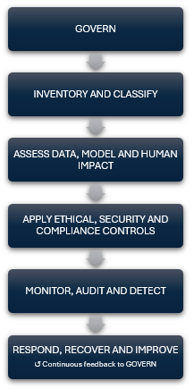

- Proposed AI Governance Control Loop
Practical implementation involves turning governance concepts into effective checks and balances. Table II shows the ownership, evidence required, performance indicator and response action for each lifecycle stage. This structure helps to overcome the accountability gap by identifying risks through the post-deployment stage and referring them to the decision makers, and thereby, referring to the predefined intervention [28].

Table II. AI Governance Control Implementation Matrix [29]
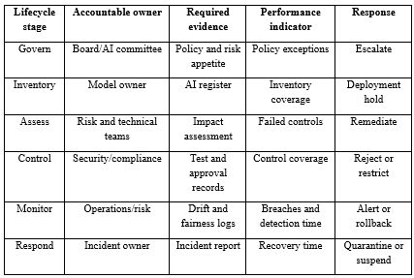

Governance Performance Indicators
Governance performance should be reported using inventory coverage, risk-classification coverage, completion of model-card and data-card, unresolved high-risk audit findings, violations of fairness-thresholds, mean time to detect drift, mean time to roll back unsafe models, human-override rates, third-party assurance coverage and significant AI incidents. Indicators are not always straightforward to interpret: a high override rate could be a good sign of oversight or a failure of the model, and few incidents could reflect safety or underreporting.

Overall Critical Judgement
Overall, the Control loop is more robust than checklist governance as it links principles and legal responsibilities to owners, controls, evidence and continuous response. However, effectiveness relies on organization culture, adequate resources, reliable data, and truly independent assurance.

Conclusion
In modern organizations, risk management, ethics, security, and regulatory considerations should be embedded throughout the system lifetime process to ensure the effective management of AI data, models, and automated decisions. Because they don't always establish clear ownership, quantifiable controls, continuous assurance, and timely intervention, that’s why stand-alone ethics statements and compliance programs are inadequate. By connecting governance, inventory, impact assessment, safeguards, monitoring, auditing, incident response, and organizational learning, the suggested AI Governance Control Loop tackles this issue. In the real world, this allows teams, boards, risk departments and regulators to share information, take responsibility and react to new risks. Governance shouldn't be viewed as a standardized certification procedure, as technology, risks, and social expectations change over time, and organizations need to periodically review controls, thresholds, and roles to assure trusted innovation.

references
- Jobin, A., Ienca, M. and Vayena, E. (2019) ‘The global landscape of AI ethics guidelines’, Nature Machine Intelligence, 1(9), pp. 389–399. doi: 10.1038/s42256-019-0088-2.
- Mittelstadt, B.D. (2019) ‘Principles alone cannot guarantee ethical AI’, Nature Machine Intelligence, 1(11), pp. 501–507. doi: 10.1038/s42256-019-0114-4.
- Mäntymäki, M., Minkkinen, M., Birkstedt, T. and Viljanen, M. (2022) ‘Defining organisational AI governance’, AI and Ethics, 2, pp. 603–609. doi: 10.1007/s43681-022-00143-x.
- European Union (2024) ‘Regulation (EU) 2024/1689 of the European Parliament and of the Council laying down harmonised rules on artificial intelligence’, Official Journal of the European Union, L 2024/1689, 12 July.
- National Institute of Standards and Technology (NIST) (2023) Artificial Intelligence Risk Management Framework (AI RMF 1.0). NIST AI 100-1. Gaithersburg, MD: U.S. Department of Commerce. doi: 10.6028/NIST.AI.100-1.
- International Organisation for Standardization and International Electrotechnical Commission (ISO/IEC) (2023) ISO/IEC 42001:2023 Information technology—Artificial intelligence—Management system. Geneva: ISO.
- OECD (2024) Recommendation of the Council on Artificial Intelligence. OECD/LEGAL/0449. Paris: Organisation for Economic Co-operation and Development.
- Wirtz, B.W., Weyerer, J.C. and Kehl, I. (2022) ‘Governance of artificial intelligence: A risk and guideline-based integrative framework’, Government Information Quarterly, 39(4), article 101685. doi: 10.1016/j.giq.2022.101685.
- Gebru, T., Morgenstern, J., Vecchione, B., Vaughan, J.W., Wallach, H., Daumé III, H. and Crawford, K. (2021) ‘Datasheets for datasets’, Communications of the ACM, 64(12), pp. 86–92. doi: 10.1145/3458723.
- Sambasivan, N., Kapania, S., Highfill, H., Akrong, D., Paritosh, P. and Aroyo, L.M. (2021) ‘“Everyone wants to do the model work, not the data work”: Data cascades in high-stakes AI’, in Proceedings of the 2021 CHI Conference on Human Factors in Computing Systems. New York: ACM, pp. 1–15. doi: 10.1145/3411764.3445518.
- Biggio, B. and Roli, F. (2018) ‘Wild patterns: Ten years after the rise of adversarial machine learning’, Pattern Recognition, 84, pp. 317–331. doi: 10.1016/j.patcog.2018.07.023.
- Mitchell, M., Wu, S., Zaldivar, A., Barnes, P., Vasserman, L., Hutchinson, B., Spitzer, E., Raji, I.D. and Gebru, T. (2019) ‘Model cards for model reporting’, in Proceedings of the Conference on Fairness, Accountability, and Transparency. New York: ACM, pp. 220–229. doi: 10.1145/3287560.3287596.
- Laato, S., Birkstedt, T., Mäntymäki, M., Minkkinen, M. and Mikkonen, T. (2022) ‘AI governance in the system development life cycle: Insights on responsible machine learning engineering’, in Proceedings of the 1st International Conference on AI Engineering: Software Engineering for AI. New York: ACM, pp. 113–123. doi: 10.1145/3522664.3528598.
- Mehrabi, N., Morstatter, F., Saxena, N., Lerman, K. and Galstyan, A. (2021) ‘A survey on bias and fairness in machine learning’, ACM Computing Surveys, 54(6), article 115, pp. 1–35. doi: 10.1145/3457607.
- Hoffmann, A.L. (2019) ‘Where fairness fails: Data, algorithms, and the limits of antidiscrimination discourse’, Information, Communication & Society, 22(7), pp. 900–915. doi: 10.1080/1369118X.2019.1573912.
- Barredo Arrieta, A., Díaz-Rodríguez, N., Del Ser, J., Bennetot, A., Tabik, S., Barbado, A., García, S., Gil-López, S., Molina, D., Benjamins, R., Chatila, R. and Herrera, F. (2020) ‘Explainable Artificial Intelligence (XAI): Concepts, taxonomies, opportunities and challenges toward responsible AI’, Information Fusion, 58, pp. 82–115. doi: 10.1016/j.inffus.2019.12.012.
- Santoni de Sio, F. and van den Hoven, J. (2018) ‘Meaningful human control over autonomous systems: A philosophical account’, Frontiers in Robotics and AI, 5, article 15. doi: 10.3389/frobt.2018.00015.
- Ayling, J. and Chapman, A. (2022) ‘Putting AI ethics to work: Are the tools fit for purpose?’, AI and Ethics, 2, pp. 405–429. doi: 10.1007/s43681-021-00084-x.
- Information Commissioner’s Office (ICO) (2024) ‘AI tools used in recruitment’, 6 November. Available at: https://ico.org.uk/action-weve-taken/audits-and-overview-reports/2024/11/ai-tools-used-in-recruitment/ (Accessed: 22 July 2026).
- Stefanelli, J.N. (2020) ‘Netherlands District Court rules benefits fraud detection tool violates human rights’, American Society of International Law, 6 February. Available at: ASIL website (Accessed: 22 July 2026).
- European Union (2016) ‘Regulation (EU) 2016/679 of the European Parliament and of the Council on the protection of natural persons concerning the processing of personal data’, Official Journal of the European Union, L119, pp. 1–88.
- Wachter, S., Mittelstadt, B. and Floridi, L. (2017) ‘Why a right to explanation of automated decision-making does not exist in the General Data Protection Regulation’, International Data Privacy Law, 7(2), pp. 76–99. doi: 10.1093/idpl/ipx005.
- Selbst, A.D. and Powles, J. (2017) ‘Meaningful information and the right to explanation’, International Data Privacy Law, 7(4), pp. 233–242. doi: 10.1093/idpl/ipx022.
- European Union (2022a) ‘Regulation (EU) 2022/2554 on digital operational resilience for the financial sector’, Official Journal of the European Union, L333, pp. 1–79.
- European Union (2022b) ‘Directive (EU) 2022/2555 on measures for a high common level of cybersecurity across the Union’, Official Journal of the European Union, L333, pp. 80–152.
- Wang, S., Zhang, Y., Xiao, Y. and Liang, Z. (2025) ‘Artificial intelligence policy frameworks in China, the European Union and the United States: An analysis based on structure topic model’, Technological Forecasting and Social Change, 212, article 123971. doi: 10.1016/j.techfore.2025.123971.
- Morley, J., Floridi, L., Kinsey, L. and Elhalal, A. (2020) ‘From what to how: An initial review of publicly available AI ethics tools, methods and research to translate principles into practices’, Science and Engineering Ethics, 26, pp. 2141–2168. doi: 10.1007/s11948-019-00165-5.
- Raji, I.D., Smart, A., White, R.N., Mitchell, M., Gebru, T., Hutchinson, B., Smith-Loud, J., Theron, D. and Barnes, P. (2020) ‘Closing the AI accountability gap: Defining an end-to-end framework for internal algorithmic auditing’, in Proceedings of the 2020 Conference on Fairness, Accountability, and Transparency. New York: ACM, pp. 33–44. doi: 10.1145/3351095.3372873.
- Lu, Q., Zhu, L., Xu, X., Whittle, J., Zowghi, D. and Jacquet, A. (2024) ‘Responsible AI pattern catalogue: A collection of best practices for AI governance and engineering’, ACM Computing Surveys, 56(7), pp. 1–35. doi: 10.1145/3626234.

Task 2 - Case Scenario

I.Introduction
In the 2017 Equifax breach, hackers took advantage of a known Apache Struts vulnerability in an internet-facing application by exploiting CVE-2017-5638 to access the personal information of roughly 147 million people. While critical vulnerabilities were anticipated to be patched quickly, the vulnerable system remained accessible for 76 days allowing attackers to continue to obtain highly sensitive information [1]. This study (task 2) suggests a forward-looking cybersecurity programmed [2], to build governance, protection, detection, response, recovery and organizational resilience and maintain consumer trust.

II. Organisational Structure and Accountability

Governance Failure Identified
Equifax's failure was not a patch failure, it shows lack of accountability, escalation and assurance in the governance system. The investigations by Congress and GAO have exposed issues including inadequate asset identification, vulnerability remediation and monitoring, and lacking enterprise risk oversight over the vulnerable application [1]. It was thus that the board did not have timely sight of any material cyber exposure; there was no central authority to raise issues; and patching was treated as an operational matter rather than as a risk to consumer trust, regulatory position and business continuity.

Proposed Cybersecurity Governance Structure
Equifax should create a Board Risk and Cybersecurity Committee to approve risk appetite, challenge management, and monitor remediation of critical findings. The Chief Executive Officer (CEO) should take final responsibility and an independent CISO should manage security strategy and report directly to the committee. The Chief Risk Officer is expected to incorporate cyber risk into enterprise risk management, and the Data Protection Officer should manage obligations for privacy impact, obligations for lawful processing, and obligations for breach. Roles should include a Security Architecture Lead, Application Security and Secure Development Lead, Vulnerability and Patch Management Owner, SOC Manager, Incident Response Lead, and Business Continuity and Disaster Recovery Lead. The objective of Internal Audit is to independently verify that policies, controls and management reporting are functioning as specified.

Reporting and Accountability
The reporting model should incorporate the separation of duty and shared responsibility. Vulnerability owner identifies, prioritizes and verifies remediation; system owner provides resources, schedules change, accept operational consequences. A critical finding should not be closed by either party alone. Exposed critical vulnerabilities, dates of patches, exceptions to controls, and signal flags for incidents should be displayed in an executive dashboard with owners, dates and residual-risk. Business leaders should formally accept residual risk only within the tolerance approved by the board and risks that are higher than the tolerance should be escalated to CISO, CRO and board committee. NIST CSF 2.0 facilitates this integration of cybersecurity governance and enterprise decision-making [2].

Critical Justification
Independent audit eliminates conflicts between delivery pressure and control assurance, while direct CISO access avoids filtering of material risks through the operational hierarchy. Adding roles would, however, result in bureaucracy without authority, decision thresholds, evidence requirements and consequences. The proposed structure, therefore, shifts accountability from responsibility to ownership and audit, meaning that strategic oversight is now joined by technical execution, privacy assurance and operational resilience as one control system for the enterprise
Figure 2 separates operational control ownership from independent assurance while ensuring that material cybersecurity risks remain visible to executive leadership and the board.

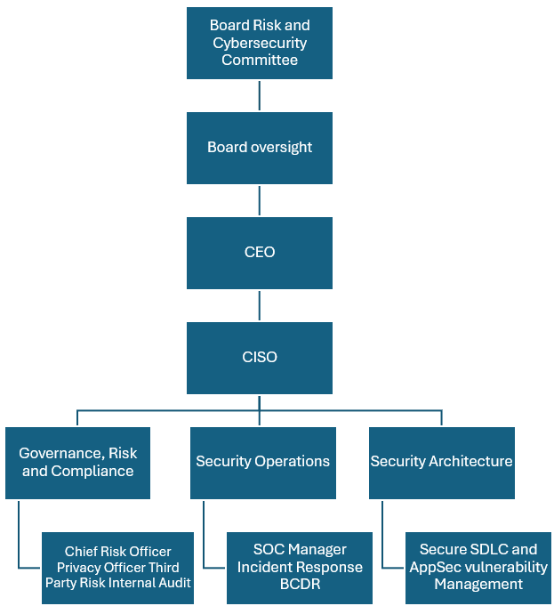
Figure 1. Proposed Cybersecurity Governance and Reporting Structure for Equifax

III. Formalised Policies and Procedures

Vulnerability Management Policy
Equifax needs to replace any “informal” remediation techniques with an enterprise vulnerability-management policy for every application, server, endpoint, cloud service and third-party dependency. Internet-facing assets should be scanned continuously, and inside, at regular intervals, with authentication. The findings should be prioritized based on the factors of exploitability, exposure, sensitivity of the data, business criticality, and evidence of current exploit and not only CVSS. Escalation of vulnerabilities should be done immediately if they appear in the CISA's Known Exploited Vulnerabilities catalogue [3]. Each exception should specify an accountable owner, compensating controls, expiry date and executive approver. Closure should be based on rescanning or similar technical verification.

Patch Management Policy
Patch management should be handled under enforceable service level agreements: critical internal weaknesses to be patched within seven days, high-severity vulnerabilities discovered on the Internet should be patched within 24–72 hours, and medium should be patched within 30 days. Emergency changes need testing, rollback plans and coordination between business owners, but availability concerns should never be an indefinite deferral. NIST views patching as a preventive maintenance task that is essential for enterprise plan [4].

Secure Software Development Lifecycle
Security needs should be incorporated into the design, threat modelling, peer review, static and dynamic testing, software-composition analysis and penetration testing of a secure software development lifecycle. Production release should be based on evidence-based security gates, and un-resolved critical findings should not allow deployment. Dependency inventories and software bills of materials should enable quick impact analysis in the event of new vulnerabilities. Such controls consider introduced defect and inherited component risk, as highlighted by the NIST Secure Software Development Framework [5].

Asset Visibility Policy
Each asset, application, API, software version, data classification, Internet exposure and named business and technical owner must be documented in an authoritative configuration-management database. Automated discovery needs to match unmanaged assets with the register and identify software that is not supported.

Monitoring and Data Protection Policies
Monitoring policy must include central, time-synced logs for critical applications, identity systems, databases and security devices. The retention time and thresholds for alerts; the ownership of alerts; and SIEM correlation must all be documented and tested. The data-protection rules should include classification, least privilege, encryption, minimization, privileged access monitoring and secure disposal.

Policy Enforcement and Auditability
All policies need to define owner, mandatory action, completion date, evidence and exception path. Dashboards should display compliance of patch-SLA, asset coverage, failed release gates, log-source coverage and encryption status. There should be independent audit of evidence by Internal Audit and as repeated breaches are noted, management escalation and corrective action will be taken. This transforms policies from intent to measurable, auditable controls that are aligned with enterprise risk (NIST, 2024). More importantly, compliance should be defined by proven risk reduction.
Table 3 converts policy requirements into accountable ownership, measurable performance indicators and auditable evidence, thereby preventing policy compliance from becoming a documentation-only exercise.
Table 1. Proposed Security Policy and Assurance Matrix
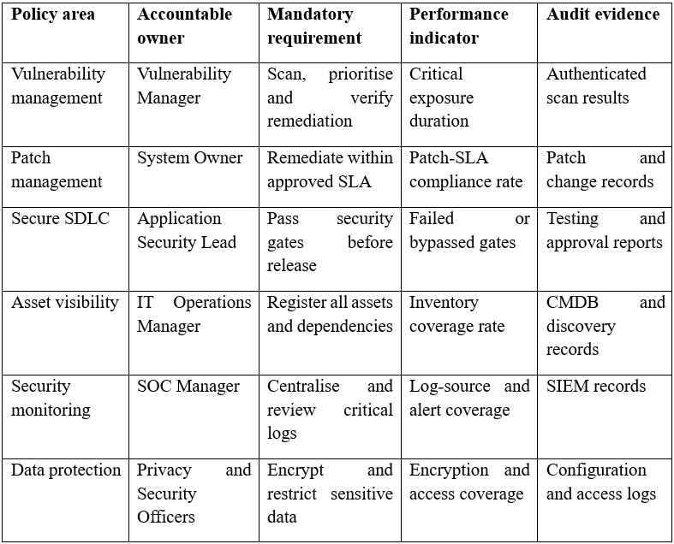

IV. Governance and Strategic Alignment

NIST Cybersecurity Framework 2.0
NIST Cybersecurity Framework 2.0 is a framework that links cybersecurity activity to enterprise governance based on the principle of risk. NIST (2024) outlines the following steps in the process: establish risk appetite, policy, accountability and oversight; Identify, critical assets, data, dependencies and exposures; Protect, safeguards like patching, access control and encryption; Detect, anomalies and control failures; Respond, coordinate containment, communication and legal escalation; Recover, restore services, incorporate lessons learned. For Equifax, this cycle should be undertaken as a seamless process, because the weak preparation in Govern and Identify will lessen the effectiveness of detection, response and recovery.

Equifax Programme Mapping
The proposed programmed outlines Govern to board oversight, direct reporting CISO, enforceable policies and documented risk acceptance. Identify involves asset inventory, data-flow mapping, vulnerability assessment and third-party dependency register. Protect is converting risks to patch service-level agreements, secure configurations, least privilege, multi-factor authentication, segmentation and encryption. Detect integrates the SIEM, endpoint detection and response, behavioral analytics and alert escalation. Respond is built on the use of incident playbooks, evidence preservation, regulatory notification and crisis coordination. Recover involves restoration testing, recovery objectives, remediation of consumers, and improvement after the incident.
Table 4 demonstrates how each NIST CSF function is converted into specific organizational actions and measurable security outcomes rather than remaining a conceptual framework.
Table 2. Alignment of the Proposed Equifax Programme with NIST CSF 2.0. Ref: Developed based on [2].
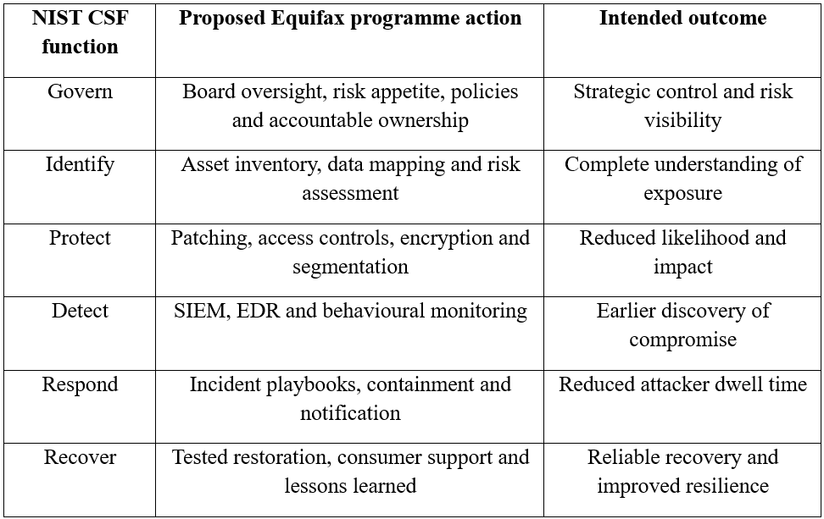

Business Objectives
Strategic alignment is crucial as the confidentiality, integrity and availability of credit data are the backbone of Equifax's service. It also helps to protect reputation, facilitate dependable credit reporting, enhances trust by lenders and third parties, and enhances long term resilience. Business impact and risk tolerance, not technical severity, should therefore be used to priorities cybersecurity investment.

Critical Evaluation
NIST CSF 2.0 is a framework, not a guarantee. A framework map can generate false security if the controls are unfunded, unowned, untested or without a deadline. Everyone involved in designing the Equifax target outcomes should be assigned to a named owner, a budget, a measurable indicator, and an audit threshold for escalation. Figure 3 illustrates the nature of the cybersecurity governance cycle as evidence of incidents and lessons from recovery inform new priorities, risk assessments, and new controls.

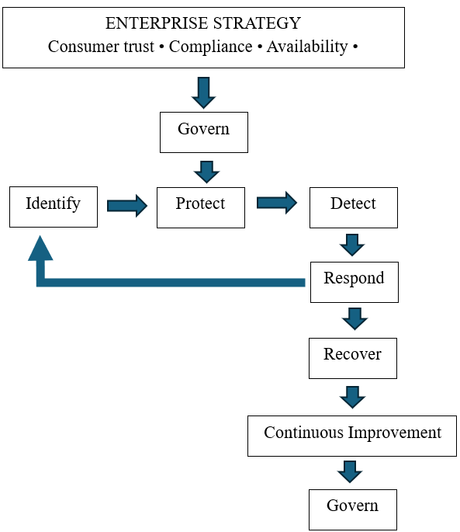
Figure 2. Alignment of the Proposed Equifax Cybersecurity Programme with NIST CSF 2.0 Ref: Developed based on [2].

V. Risk Management and Assessment

Risk-Assessment Method
Risk assessment is not a once-off compliance exercise, but rather a repeatable decision process. For each service, Equifax should identify the asset, threat, exploitable vulnerability, existing control, likelihood, impact, inherent risk, selected treatment and residual risk. This approach is designed to align technical findings with executive risk decisions and to facilitate reassessment of assets, threats, and controls when changes occur [6].

Key Risks
Internet facing applications are direct exposure as they can be scanned and exploited remotely at scale. The Equifax breach highlighted the risk of an unpatched, public-facing Apache Struts component being a point of entry into sensitive data environments [1]. Known vulnerabilities, unclear remediation ownership, weak verification and unsupported systems are thus considered vulnerabilities and are included in the patch gaps. Risk from supply-chain exposure is created by third-party libraries, vendor remote access, cloud service and vulnerable dependencies that change outside of Equifax's control. A segmentation gap can turn one application breach into a pervasive attack, allowing lateral movement and widespread access to sensitive databases. Failure to correlate logs, misconfiguring certificates/sensors, and having no defined escalation of alerts further increases impact, as attackers can go undetected and can gain further access to the system.

Risk Prioritisation
A likelihood-impact matrix plus business context is used to prioritize risks. The vulnerability is internet-facing and the segmentation is critical, and both have a high likelihood of exploitation and serious data impact. Third-party compromise, privileged-account misuse and incomplete asset inventories are still High priorities as they can circumvent perimeter defenses or hide unmanaged exposure. An urgent situation should be recognized by CISA's Known Exploited Vulnerabilities catalogue, but catalogue inclusion and CVSS score should not be a substitute for contextual assessment [3]. The result of these priorities, treatments and residual exposure is summarized in Table 5.

Mitigation Rationale
Internet facing vulnerabilities are the most critical and can be exploited remotely, rapidly and without authentication, thus providing a starting point for exploitation of high-value systems. Emergency patching, compensating controls, exposure reduction and verified rescanning should all be included in treatment. If prevention fails, then movement should be restricted through segmentation, least privilege and EDR. This layered sequence is better than patching alone, since dependency conflicts or incomplete inventories might result in exposure being left unresolved.

Residual Risk
Residual risks are assumed, documented, and assessed. Segmentation slows lateral movement but does not stop initial compromise, EDR improves detection but may not detect new techniques, vendor assurance removes hidden dependency risk. Therefore, acceptance of risk must be based on evidence and limited to a specific time and a specific level of authority as related to potential impact. Lower exposure and quicker detection are the criteria for the successful implementation of controls, not the completion of remediation tickets.
Table 3. High-Level Equifax Cybersecurity Risk Register Ref: Developed based on [1], [3] and [6].
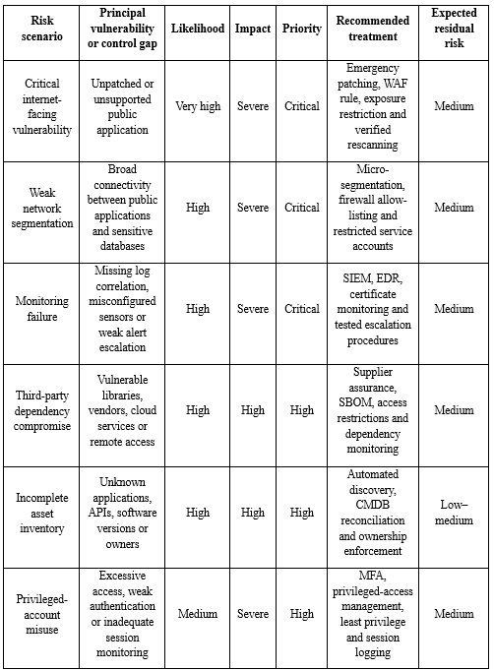

VI. Compliance, Incident Response and Protection Controls

Regulatory Alignment
Compliance with a breach is a coordinated effort between the law, privacy and operations. The FTC Safeguards Rule mandates covered financial institutions to have a written information security programmed, and to notify the FTC within 30 days of discovery, at the latest, of any notification event that involves 500 or more consumers [7]. Generally, GDPR Article 33 mandates notification to the supervisory authority within 72 hours if the breach is likely to affect the rights and freedoms of individuals where EU residents are concerned [8]. Legal and privacy groups need to decide whether it's applicable, maintain privilege, facilitate regulatory connections and ensure forensic evidence, decision logs and chain of custody are defendable.

Breach Notification Protocol
Notification process should start with detection, technical triage, scope and data validation, persistence and data exfiltration. Before executive escalation, legal and privacy experts should review notification thresholds and deadlines. The CISO, privacy officer, legal counsel, communications lead and affected business owner should all approve regulator, customer and contractual notifications; the SOC should approve and provide evidence but not be considered as final decision maker. The updates should be accurate, consistent and backed up by documented evidence.

Incident Response Plan
The phases of incident response should include preparation, detection and analysis, containment, eradication, recovery and post-incident improvement, in conjunction with enterprise risk management [9]. Equifax should maintain policies ready to be tested for exploited web apps, data theft/exfiltration, credential theft, third-party theft, ransomware, insider misuse etc. Decision authority, forensic actions, isolation criteria, communication routes and recovery conditions should be outlined in each playbook.

Disaster Recovery and Business Continuity
Recovery-time and recovery-point objectives should be determined based on service criticality for business continuity and disaster recovery. Offline, encrypted and immutable backups, alternative service arrangements and dependency maps and crisis-communication procedures must be tested through restoration. Recovery should not only restore availability but also ensure that the system is sound and that controls are effective.

Technical Protection Controls
Preventative and detective controls should include continuous monitoring of the attack surface, web-application firewalls, network segmentation, secure configuration baselines, encryption in transit and at rest, MFA, privileged-access management, data-loss prevention and database-activity monitoring, and authenticated vulnerability scanning. The layers of controls should include scanning for exposure, WAF for temporary protection, segmentation for lateral movement and access controls for privilege control.

Reducing Dwell Time and Organisational Impact
SIEM provides cross system visibility, EDR detects suspicious endpoint activity, automated scanning detects exposure early and SOAR speeds up authorized containment. These are the benefits of segmentation, encryption, MFA and rehearsed playbooks that constraint blast radius, make compromised data less valuable, limit credential-based access and reduce decision delay. However, technology can reduce the dwell time only when it is fully implemented, the alerts are well tuned, the analysts are trained, and the actions taken by the responders are authorized. Otherwise, automation generates unnecessary noise without reducing any actual risk. This governance is operationalized in figure 4 with a linkage between technical detection and multi-disciplinary assessment, containment, recovery and learning.
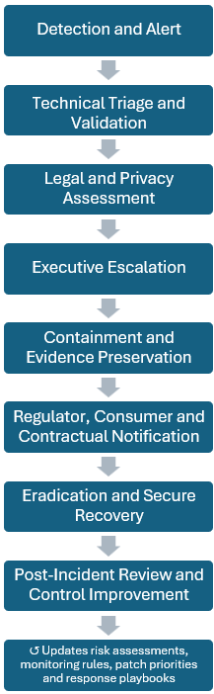
Figure 3. Integrated Incident Detection, Escalation, Containment and Recovery Process Ref: Developed based on [7], [8], [9]

VII. Implementation Roadmap and Performance Measurement

Phase 1: First 30 Days
Implementation should be incremental, considering exposure and capability building. In the first 30 days, Equifax needs to put in place executive ownership, identify critical internet-facing systems, address critical vulnerabilities, ensure monitoring is adequate and establish a multidisciplinary breach-response team. These actions are specific to issues of visibility and patching and detection that were noted following the breach [1].

Phase 2: Days 31–90
For the 31 to 90 days, the organization should complete the asset inventory, establish patch SLAs, strengthen network segmentation, deploy EDR and any centralized logging and conduct playbook drills incidents. Equifax needs to further develop its secure SDLC, supplier assurance, automate control reporting, perform red team exercises, and conduct an independent audit from months 3 to 12.

Phase 3: Months 3–12
Critical-path SLA compliance, asset-inventory coverage, mean time to detect, mean time to contain, EDR coverage, log-source coverage, tested-recovery-system coverage and overdue high-risk findings are all elements that should be covered by monitoring measures. Table 6 takes the programmed and translates it to actions, accountable ownership, and evidence and performance outcomes that are time-bound, which allows the board to sort out what is actually being reported as activity from what is happening to reduce risk.
Table 4. Phased Cybersecurity Programme Implementation Roadmap. Ref: Developed based on [1] and [2].
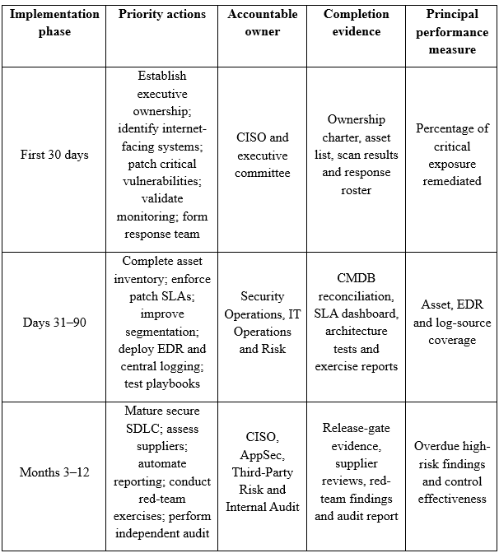

VIII. Conclusion
The Equifax hack explicit that one failure in corporate governance, asset visibility, monitoring and accountability leads to an enterprise disaster. The main take-away is that risk mitigation is a multifaceted process that relies on executive oversight, measurable policies, continuous risk assessment, and standardized action response. The proposed solution provides a clear governance framework, patching and secure-development controls, integration with NIST CSF 2.0, prioritized risk registry, layered technical controls, and phased implementation, to mitigate these issues. These strategies are designed to increase consumer trust and regulatory compliance while reducing exposure, the attacker dwell time and lateral movement. However, over time, resilience is not a unique and complete one-time solution. Equifax should periodically re-evaluate risk, adopt new technology, follow changing requirements, and changing risk tolerance.

References

[1] U.S. Government Accountability Office (GAO) (2018) Data Protection: Actions Taken by Equifax and Federal Agencies in Response to the 2017 Breach. GAO-18-559. Washington, DC: U.S. Government Accountability Office.
[2] National Institute of Standards and Technology (NIST) (2024) The NIST Cybersecurity Framework (CSF) 2.0. NIST CSWP 29. Gaithersburg, MD: National Institute of Standards and Technology. doi: 10.6028/NIST.CSWP.29.
[3] Cybersecurity and Infrastructure Security Agency (CISA) (n.d.) Known Exploited Vulnerabilities Catalog. Washington, DC: Cybersecurity and Infrastructure Security Agency.
[4] Souppaya, M. and Scarfone, K. (2022) Guide to Enterprise Patch Management Planning: Preventive Maintenance for Technology. NIST Special Publication 800-40, Revision 4. Gaithersburg, MD: National Institute of Standards and Technology. doi: 10.6028/NIST.SP.800-40r4.
[5] National Institute of Standards and Technology (NIST) (2022) Secure Software Development Framework (SSDF) Version 1.1: Recommendations for Mitigating the Risk of Software Vulnerabilities. NIST Special Publication 800-218. Gaithersburg, MD: National Institute of Standards and Technology. doi: 10.6028/NIST.SP.800-218.
[6] National Institute of Standards and Technology (NIST) (2012) Guide for Conducting Risk Assessments. NIST Special Publication 800-30, Revision 1. Gaithersburg, MD: National Institute of Standards and Technology. doi: 10.6028/NIST.SP.800-30r1.
[7] Federal Trade Commission (FTC) (2024) FTC Safeguards Rule: What Your Business Needs to Know. Washington, DC: Federal Trade Commission.
[8] European Union (2016) ‘Regulation (EU) 2016/679 of the European Parliament and of the Council on the protection of natural persons concerning the processing of personal data’, Official Journal of the European Union, L119, pp. 1–88.
[9] Nelson, A., Rekhi, S., Souppaya, M. and Scarfone, K. (2025) Incident Response Recommendations and Considerations for Cybersecurity Risk Management: A CSF 2.0 Community Profile. NIST Special Publication 800-61, Revision 3. Gaithersburg, MD: National Institute of Standards and Technology. doi: 10.6028/NIST.SP.800-61r3.

