Contemporary Challenges : Making a Difference (BMSP4008/C)

Rebecca Bartley 2218485

What issues the people of the surrounding areas of Canolfan Carwyn are facing.

Following on from the group visit to Canolfan Carwyn community facility and after researching the area I think there is lack of facilities available to people living in the area especially around the elderly age group. There is a bus service that runs roughly every 2 hours from most local villages to the 2 nearest town centres which are Carmarthen and Llanelli. (Bustimes, 2023).
24% of the population of Carmarthenshire are aged 65 years and over (Office for National Statistics, 2022).
At present everyone is having to deal with the ever rising cost of living crisis, Carmarthenshire county council have been making use and distributing funds to people though the government’s cost of living support scheme. 35.6% of households in Carmarthenshire are really suffering though the cost of living and classed as actually living in poverty. Pensioners are particularly hit by this and as many as 1 in 5 are suffering through poverty. (Carmarthenshire County Council, 2022).
Crime does seem to be of an issue in the surrounding areas of the Canolfan Carwyn centre. Within a 1 mile radius a total of 23 crimes were reported during one month this year. The highest number os types of crimes were Violence or sexual offences. (Crime Statistics, 2023).
CarmDas which is the Carmarthenshire Domestic Abuse service now offer training which is free and available to help stop all sorts of violence against women and girls. The campaign is called the Safe Streets Campaign. (CarmDas, 2023).
Canolfan Carwyn run a range of activities at the centre, these include many different children’s sports clubs which run through the school holidays and all year through the week nights. There is a boxing gym which cater to all ages and a martial arts class which also is for all ages. There are many more activities advertised on their website but I feel most are catered to children. (Canolfan Carwyn, 2023).
As there are lots of elderly people in the area I believe more activities could be catered towards them.
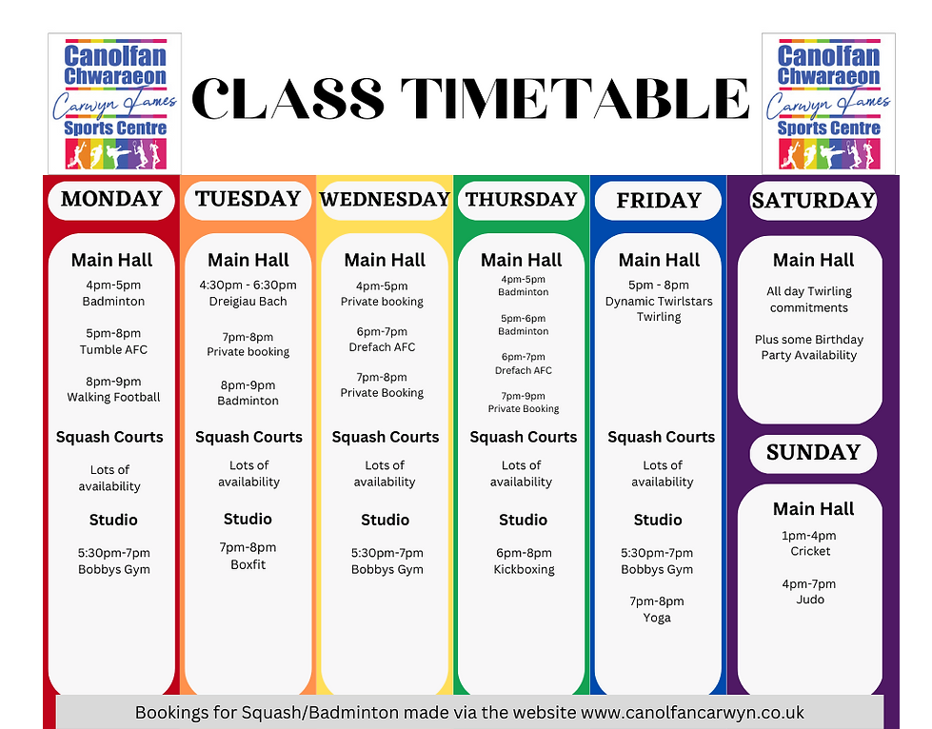
Pictured above is a current timetable for this week taken from the website. (Canolfan Carwyn, 2023).

The role of community facilities.

Community facilities provide numerous services that are becoming a vital part of many peoples lives. They are usually run by local people to benefit the local community. After a visit to the Canolfan Carwyn Sports Centre I learned that the facility was previously run by the local council but local sports groups often had great difficulty accessing and booking the centre to use the hall.
Kelly Lewis-Bennett who is a committee member of the Baton Twirling Association Cymru (BTAC) was accessing and using the centre for her members to train in the sports hall. The hall wasn’t very well managed but Kelly and her team seemed to be improving the centre and making it a better place for her members and also other local groups who use the space. She got into talks with the council and is now responsible for the running of the centre. She is hoping to develop the centre to help not just sport in the community but also help to promote health and well being too. (UWTSD, 2022).
Whilst researching the many roles that community facilities offer, I learned about dedicated warm spaces that have been set up in local libraries in Carmarthenshire. They offer warm reading spaces, some including access to tv’s, ipads and free tea and coffee. The Council are now encouraging local communities to apply for funding which is made available from the councils poverty fund to set up their own warm spaces throughout their own communities. (Carmarthenshire County Council, 2022).
It seems to be that many, if not all community run facilities access grants and funding. Through research I believe the community centres are better run when they don’t solely rely on this and have many enterprises running to help facilitate the running and maintenance of the facilities.
Upon researching it would appear that if community facilities have a good set of plans in place they manage to generate more money to put back into facilities. Volunteers are an excellent and vital part of community facilities but paid staff are also needed to run a striving facility. Inviting as many members of the local community who are willing to help will help with success and survival.
Community centres are an extremely important part of our communities. They help people to get together and socialise, provide opportunities for volunteers to gain experience. Help with many different projects that communities have ongoing. Many help promote health and wellbeing.
I prepared a mind map showing various services that many of the community facilities offer. 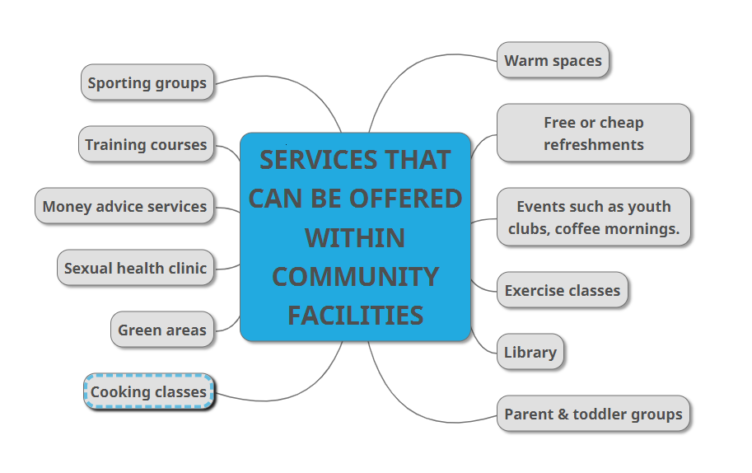

Activity Planning

As a group, myself and classmates, Donna and Katy decided to put on an activity at the Canolfan Carwyn Centre. It was called ‘Blast from the Past’. After research of the local area and also what was already available at the centre, we realised there were much more activities and events being held at the centre which seemed to cater more for children and younger people. We then went on to decide to aim our activity more towards the older generation from the community. We felt that not just through the centre but locally they lacked facilities in general. We decided to charge a small fee of £2 entry to cover costs. We then had free tea and coffee, biscuits and cakes. Although we aimed the activity towards the older generation we also stated that all ages were also welcome. We played old music and people who attended enjoyed a dance. We decided to run the event for 2 hours which we felt would be enough for some elderly people who may of got tired. We felt that the event was a success and the people who attended enquired to the centre about holding similar events more regular. To advertise the event I made leaflets for the local community and also emailed them to the centre and they then advertised this on their website and social media. Below is a copy of this.



References Bustimes. (2023). 128 - Ammanford Bus Station - Graig Campus. [Online]. Bustimes. Available at: https://bustimes.org/services/128-ammanford-llanelli [Accessed 30 March 2023]. Canolfan Carwyn. (2023). Multi-sports facility. At the heart of the Gwendraeth Valley.. [Online]. Canolfan Carwyn. Available at: https://www.canolfancarwyn.co.uk/ [Accessed 30 March 2023]. Canolfan Carwyn.. (2023). Class Timetable. [Online]. Canolfan Carwyn. Available at https://www.canolfancarwyn.co.uk/blank-1. [Accessed 30 March 2023]. Carmarthenshire County Council. (2022). Helping our communities through the cost of living crisis. [Online]. Newsroom. Last Updated: 27th October 2022. Available at: https://newsroom.carmarthenshire.gov.wales/2022/10/helping-our-communities-through-the-cost-of-livin [Accessed 31 March 2023]. Carmarthenshire County Council. (2022). Warm places will be available for Carmarthenshire residents this winter. [Online]. Newsroom. Last Updated: October 17th 2022. Available at: https://newsroom.carmarthenshire.gov.wales/2022/10/warm-places-will-be-available-for-carmarthenshire [Accessed 30 March 2023]. CarmDas. (2023). Safer Streets Campaign. [Online]. CarmDas. Available at: https://www.carmdas.org/News/safer-streets-campaign [Accessed 31 March 2023]. Crime Statistics. (2023). 23 Crimes reported in February 2023. [Online]. CrimeStatistics. Last Updated: February 2023. Available at: https://www.crime-statistics.co.uk/postcode/SA147AB [Accessed 31 March 2023]. Office for National Statistics. (2022). Population and household estimates, England and Wales: Census 2021. [Online]. Census 2021. Last Updated: 28th June 2022. Available at: https://www.ons.gov.uk/peoplepopulationandcommunity/populationandmigration/populationestimates/bulle [Accessed 30 March 2023]. UWTSD. (2022). UWTSD Student takes over local Sports Centre with a vision to create a community hub. [Online]. University of Wales Trinity Saint David. Last Updated: 12th April 2022. Available at: https://www.uwtsd.ac.uk/news/press-releases/press-2022/uwtsd-student-takes-over-local-sports-centre- [Accessed 30 March 2023].

