
Strategic Management for Business
Individual Report

November 1, 2025
name: nazra parveen
Student ID: 2316083
Module lecturer: Yohaan Mendis

Table of Contents
- Introduction
  - Overview of The Clean Kilo
  - Purpose and Structure of the Report
- The Clean Kilo: Business Overview
  - Products, Services, and Business Model
  - Uniqueness and Value Proposition
- Appraisal of Strategic Direction
  - Vision, Mission, and Objectives
  - Critical Appraisal of Strategic Direction
- Environmental Scan and Competitive Positioning
  - SWOT Analysis
  - PESTEL Analysis
  - Porter’s Five Forces Analysis
- Growth Strategy and Portfolio Analysis
  - Ansoff Matrix: Strategic Growth Directions
  - BCG Matrix: Product Portfolio Analysis
  - Analysis and Strategic Implications
- Strategic Growth Choices for SMEs
  - Porter’s Generic Strategies
  - Proposed Sustainable Growth Strategy
  - Justification for Long-Term Sustainability
- Suitability, Feasibility, and Acceptability (SFA) Evaluation
- Application of Mendelow’s Matrix
    - Critical Evaluation of Stakeholder Expectations and Influence
- Strategic Recommendations for The Clean Kilo
- Conclusion
- Reference List

Introduction
The Clean Kilo is a pioneering zero-waste supermarket chain based in Birmingham, UK. Founded in 2019, it operates on a simple but powerful premise: to make sustainable shopping accessible, affordable, and convenient by eliminating packaging at its source. This report provides a brief introduction to The Clean Kilo, followed by a critical appraisal of its strategic direction. It then conducts a comprehensive environmental scan, analysing both the internal and external factors shaping its competitive position.
The Clean Kilo: Business Overview
Products, Services, and Business Model
The Clean Kilo operates primarily on a retail-based business model, generating revenue through the direct sale of goods to consumers. Its product range is extensive, encompassing over 450 loose, package-free items. This includes:
Food Staples: Pulses, rice, pasta, flour, cereals, and spices.
Dairy & Alternatives: Milk, yoghurt, and plant-based milks dispensed from refillable containers.
Household & Personal Care: Washing-up liquid, laundry detergents, shampoos, and conditioners available via refill stations.
Fresh Produce: A wide selection of loose fruit and vegetables, often sourced locally to reduce food miles.
Speciality Items: Vegan cheeses, local beers, wines, and other artisanal products with minimal or reusable packaging.
A key service is its refill-and-save system. Customers are encouraged to bring their own containers, which are weighed (tared) before filling. They can also purchase containers in-store. This model directly tackles the root cause of single-use plastic pollution. The business has expanded from a single store to multiple locations in Birmingham, including its flagship store which also houses a zero-waste restaurant and bakery, diversifying its revenue streams (The Clean Kilo, 2024).
Uniqueness and Value Proposition
The Clean Kilo’s uniqueness stems from its holistic commitment to a circular economy. Unlike conventional supermarkets that offer limited refill options, The Clean Kilo’s entire operation is built around the zero-waste principle. Its value proposition is threefold:
- Environmental Impact: It offers a tangible solution for consumers to drastically reduce their household waste.
- Economic Sense: By removing packaging costs, it often offers products at prices 10-15% cheaper than equivalent packaged goods in traditional supermarkets (The Clean Kilo, 2024).
- Consumer Empowerment: It gives customers control over the quantity they purchase, helping to reduce food waste and allowing them to buy exact amounts.
- Local / seasonal sourcing: They stock seasonal fruits & vegetables and have variation across store locations. This suggests they try to source locally or at least seasonally. thecleankilo.co.uk
- Multiple revenue streams / services: Besides retail sales, they appear to have additional offerings:
  - They run a café/bar & refill taproom (“KiloZiro Wine Bar”) in one of their sites. thecleankilo.co.uk
  - A “Christmas Veg Box” pre-order service. thecleankilo.co.uk
  - Click & Collect and local delivery in certain postcodes for online orders. thecleankilo.co.uk+1
  - Consultancy (mentioned in their About Us menu). thecleankilo.co.uk
The following sections critically appraise The Clean Kilo’s strategic direction and analyse its internal and external environment to identify opportunities for sustainable growth.
Appraisal of Strategic Direction
A clear strategic direction is crucial for guiding an organisation's long-term goals and decision-making.
- Vision: "To be the UK's leading zero-waste supermarket, making package-free shopping the norm, not the niche" (The Clean Kilo, 2024). This vision is ambitious and forward-thinking, clearly positioning the company as a market leader and change-agent within the retail sector.
- Mission: "To make sustainable living accessible and affordable for everyone by providing package-free, high-quality products that are good for people and the planet." The mission is effective as it clearly defines who they are (a zero-waste retailer), what they do (provide package-free goods), and why they do it (to make sustainable living accessible). It strongly aligns with the growing consumer demand for ethical and environmentally responsible businesses.
- Objectives: While not always publicly detailed in formal corporate documents, The Clean Kilo’s objectives can be inferred from its actions: physical store expansion, diversification into hospitality (the restaurant), and maintaining competitive pricing. To strengthen its strategic framework, these objectives could be formalised using the SMART (Specific, Measurable, Achievable, Relevant, Time-bound) criteria—for example, "to open three new stores in major UK cities within the next 24 months."
Critical Appraisal: The strategic direction is fundamentally strong and highly relevant to the current market. The vision provides a clear "north star," while the mission effectively communicates its core purpose and values to customers and stakeholders. The focus on accessibility and affordability is a key differentiator from many eco-brands, which are often perceived as expensive. The main strategic challenge lies in scaling this model while maintaining its core values, particularly regarding local sourcing and supply chain integrity.
To understand how effectively this strategic direction positions The Clean Kilo within the broader market, the next section examines internal strengths and external environmental factors.
Environmental Scan and Competitive Positioning
SWOT Analysis
Strengths
- Strong Brand Identity:
The company has developed a well-recognised identity associated with zero-waste and sustainability in the Midlands, reflecting a wider cultural shift towards ethical and environmentally responsible consumption (Saintenoy, 2019; Birmingham City University, 2024).
- Proven, Scalable Model:
Success across multiple Birmingham locations demonstrates that the zero-waste model can be effectively replicated and adapted to new markets (Montano and Toral, 2021).
- Customer Loyalty:
Research shows that ethically conscious consumers display high loyalty towards brands aligned with their sustainability values (Gordon-Wilson, 2022; Kemper, 2024).
- Integrated Supply Chain:
Strong community partnerships and collaboration with local suppliers improve credibility, reduce costs, and strengthen local PR and media coverage (Saintenoy, 2019; Birmingham City University, 2024).
Weaknesses
- Limited Geographic Reach:
The business currently operates mainly in Birmingham, restricting its overall market share and exposure to new audiences (Montano and Toral, 2021).
- Supply Chain Vulnerability:
Heavy dependence on a small number of bulk and package-free suppliers increases exposure to shortages and price fluctuations (Kemper, 2024).
- Higher Operational Complexity:
Managing refill systems and container hygiene requires additional staff training and operational oversight compared to conventional retail models (Gordon-Wilson, 2022).
- Limited Marketing Budget:
Independent zero-waste retailers often struggle to compete with the vast marketing resources of large supermarket chains (CIM Content Hub, 2021).
Opportunities
- Market Expansion:
Expanding into other environmentally aware UK cities such as Bristol, Manchester, and Brighton offers significant growth potential (Saintenoy, 2019; Birmingham City University, 2024).
- E-commerce and Delivery:
Online zero-waste delivery services using returnable or deposit-based containers align with growing consumer demand for convenience and sustainability (Kemper, 2024).
- B2B Supply:
Supplying package-free ingredients to cafés, restaurants, and offices could diversify income streams and strengthen local partnerships (Montano and Toral, 2021).
- Growing Consumer Awareness:
Rising public concern over plastic pollution and climate change continues to drive demand for sustainable shopping alternatives (Gordon-Wilson, 2022; Consultancy.uk, 2024).
Threats
- Mainstream Competition:
Large supermarkets such as Tesco and Waitrose are launching their own refill stations, leveraging economies of scale and established customer bases (Saintenoy, 2019; CIM Content Hub, 2021).
- Economic Downturn:
During economic recessions, price often outweighs ethical considerations, causing consumers to shift toward discount retailers (University of Manchester, 2023; Reuters, 2025).
- “Greenwashing” Backlash:
As sustainability claims become widespread, consumer scepticism towards environmental branding is increasing (Consultancy.uk, 2024).
- Logistical Challenges:
Scaling a zero-waste supply chain nationally involves complex logistics, including distribution, storage, and hygiene control (Kemper, 2024; Montano and Toral, 2021).
External Environment Analysis
PESTEL Analysis
- Political: The UK Government’s Plastic Packaging Tax (GOV.UK, 2022) and Extended Producer Responsibility (EPR) schemes create a favourable regulatory environment, incentivising businesses to reduce packaging.
- Economic: High inflation pressures household budgets, making The Clean Kilo’s price-saving proposition attractive. However, rising energy and transport costs could squeeze margins. Wanderlog
- Social: A significant cultural shift towards sustainability, particularly among younger generations (Gen Z and Millennials), is driving demand for ethical consumption (Mintel, 2023).
- Technological: Advancements in bulk dispensing technology, smart scales, and inventory management software can improve operational efficiency and customer experience.
- Environmental: Public awareness of the plastic pollution crisis and climate change is at an all-time high, creating a strong tailwind for the business model.
- Legal: The business must comply with strict food safety and hygiene regulations (Food Standards Agency, 2024), which can be more complex for open, refillable goods.

The PESTEL shows strong tailwinds (social/environmental/policy) but clear risks from economic volatility and regulatory/compliance demands. Strategic moves should prioritise flexibility (cost control, supplier diversification) and leverage policy narratives to access grants/partnerships.

Porter's Five Forces Analysis
- Threat of New Entrants (Moderate): Opening a refill shop has moderate barriers (store capital, supplier relationships), but franchise/pop-up models show new entrants can appear locally. Brand and community loyalty provide some protection. Indiegogo+1
- Bargaining Power of Buyers (Moderate): Individual consumers have many alternatives (supermarkets, other zero-waste stores). But committed environmentally minded customers are less price-sensitive; group purchasing or B2B clients could have higher bargaining leverage. Wanderlog
- Bargaining Power of Suppliers (Low to Moderate): For standard bulk goods (pulses, grains), there are many suppliers, giving The Clean Kilo choice. For unique, local, or artisanal products, supplier power may be higher.
- Threat of Substitute Products/Services (High): This is the most significant force. Substitutes include conventional supermarkets (now offering sustainable ranges), online grocery delivery, farmers’ markets, and refill services. Large retailers adopting refill counters increases substitute threat. The Guardian
- Rivalry Among Existing Competitors (Moderate to High): The Clean Kilo faces intense competition. This includes direct competition from other independent zero-waste stores and, more formidably, indirect competition from the refill initiatives of large supermarkets like Tesco and Waitrose, which have immense market power.
This analysis highlights that while The Clean Kilo benefits from favourable social and environmental trends, its limited scale and resource base necessitate a focused growth strategy. The next section explores feasible strategic directions.
Growth Strategy and Portfolio Analysis of The Clean Kilo
The Clean Kilo must manage its growth and product line carefully to achieve its goals. The BCG Matrix helps analyse its product portfolio and allocate resources, while the Ansoff Matrix offers a way to evaluate strategic growth directions.
  - Ansoff Matrix: Strategic Growth Directions
Market Penetration: This is the foundational strategy. The Clean Kilo continues to deepen its presence in Birmingham, its home market. This is a low-risk strategy that leverages existing brand strength and operational infrastructure.
Market Development: This represents the primary growth vector for achieving its vision of being the "UK's leading zero-waste supermarket." Expanding its proven, scalable model to new cities is the most logical and critical next step. The recent multi-store expansion within Birmingham serves as a test case for this.
2. BCG Matrix: Product Portfolio Analysis
The BCG Matrix classifies a company's product portfolio into four categories based on market growth and market share (Johnson et al., 2023). For The Clean Kilo, we can analyse its Strategic Business Units (SBUs) or product categories.
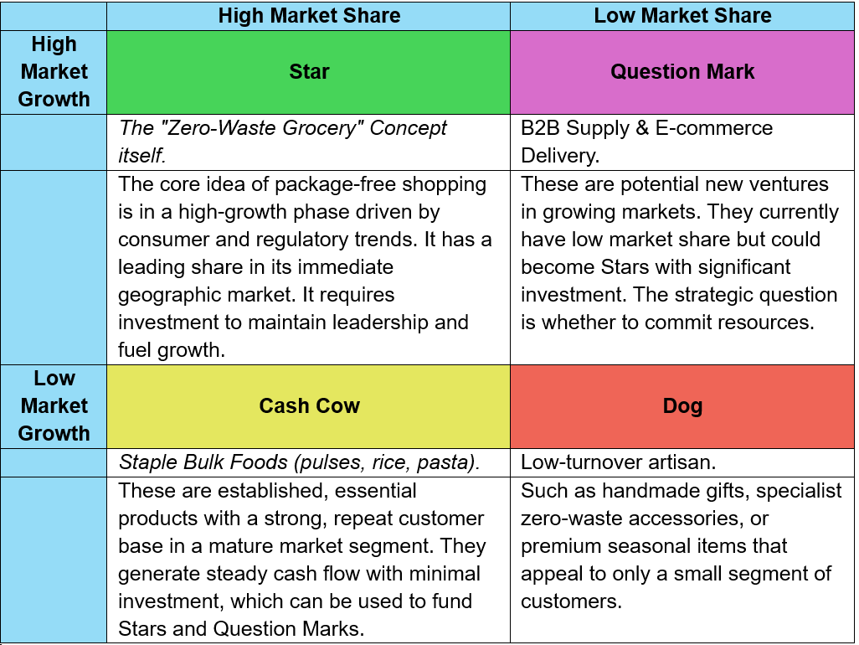
Analysis and Strategic Implications:
- Star (The Core Concept): The entire business is built around this Star. The profits from Cash Cows and potentially new investment must be pumped back into the business to expand geographically (Market Development) and defend against competition from major supermarkets.
- Cash Cow (Staple Bulk Foods): Products like rice and lentils are the engine room of the business. They are reliable, high-volume sellers that bring customers into the store regularly. The cash generated here should be used to fund the growth of the Star and selectively invest in promising Question Marks.
- Question Mark (B2B & E-commerce): These are the future growth drivers. A zero-waste delivery service (using returnable containers) is a logical but capital-intensive Question Mark. Similarly, supplying local cafes with package-free coffee or oats is a high-potential venture. The Clean Kilo must decide which of these to invest in to transform them into future Stars.
- Dogs

Rationale: Some niche or one-off SKUs (e.g., single-origin specialist gifts, irregular seasonal lines) may consume shelf space and working capital without contributing proportionally to growth. Consider delisting, moving to consignment, or running limited-time features to reduce inventory drag (Liverpool, 2025).
While the Ansoff Matrix identifies potential growth paths, Porter’s framework helps evaluate how The Clean Kilo can sustain competitive advantage within each option.
Strategic Growth Choices for SMEs
Porter’s Generic Strategies
Porter (1980) identified three core strategic options for achieving competitive advantage: cost leadership, differentiation, and focus.
- Cost Leadership involves minimising operational costs to offer lower prices, often achieved through economies of scale or efficiency improvements. For SMEs, this can be challenging due to smaller production volumes (Johnson et al., 2017).
- Differentiation focuses on offering unique products or services that create value for customers beyond price (Grant, 2019). This strategy suits SMEs that can leverage innovation and niche markets.
- Focus Strategy involves targeting a narrow segment, either through cost focus or differentiation focus. For SMEs, this often aligns with their resource limitations and niche expertise (Porter, 1985).
Given The Clean Kilo’s unique zero-waste concept, the differentiation focus strategy is currently the most relevant, as it competes based on environmental value and ethical consumption rather than price.
Proposed Sustainable Growth Strategy
Applying the Ansoff Matrix, a hybrid product and market development strategy is proposed, focusing on:
- Digital Platform Expansion: Develop an online zero-waste ordering and subscription model using eco-friendly reusable delivery packaging. This allows scaling beyond physical store locations.
- Partnerships with Local Producers and Cafés: Expand the product range to include locally sourced ready-to-eat meals, encouraging circular economy practices.
- Community Education Initiatives: Strengthen customer engagement through workshops on sustainable living, reinforcing brand loyalty and social value.
This approach integrates elements of differentiation focus (Porter, 1985), sustaining competitive advantage through innovation, ethical branding, and digital accessibility.
Justification for Long-Term Sustainability
- Environmental Sustainability: By extending its zero-waste mission digitally, The Clean Kilo reduces emissions and packaging waste, aligning with UN Sustainable Development Goals (SDG 12 – Responsible Consumption and Production).
- Economic Sustainability: Digital platforms enable scalability without high fixed costs, improving profitability and resilience against market shocks (Barbero et al., 2021).
- Social Sustainability: Partnerships with local suppliers support community-based economies and strengthen customer relationships through shared environmental values (Doherty et al., 2014).
- Strategic Fit: The strategy leverages existing brand equity and customer loyalty while expanding market reach—reducing the risks associated with diversification.

This analysis confirms that the digital expansion and local partnership strategy is both feasible and acceptable to core stakeholders such as investors, customers, and suppliers.

Suitability, Feasibility, and Acceptability (SFA) Evaluation
Using stakeholder insights, the proposed digital expansion and local partnership strategy can be evaluated through the SFA framework (Johnson et al., 2017):
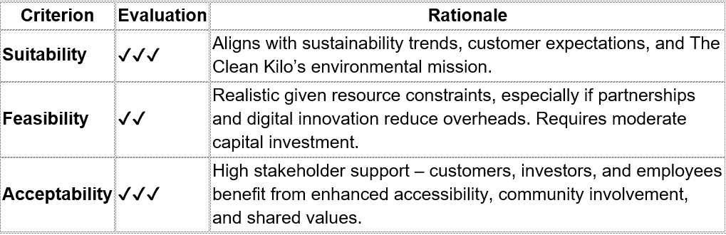
Overall, this strategy achieves a balance between stakeholder expectations and organisational capabilities, making it the most suitable, feasible, and acceptable option for long-term sustainable growth.

Application of Mendelow’s Matrix
Mendelow’s Matrix categorises stakeholders into four quadrants:
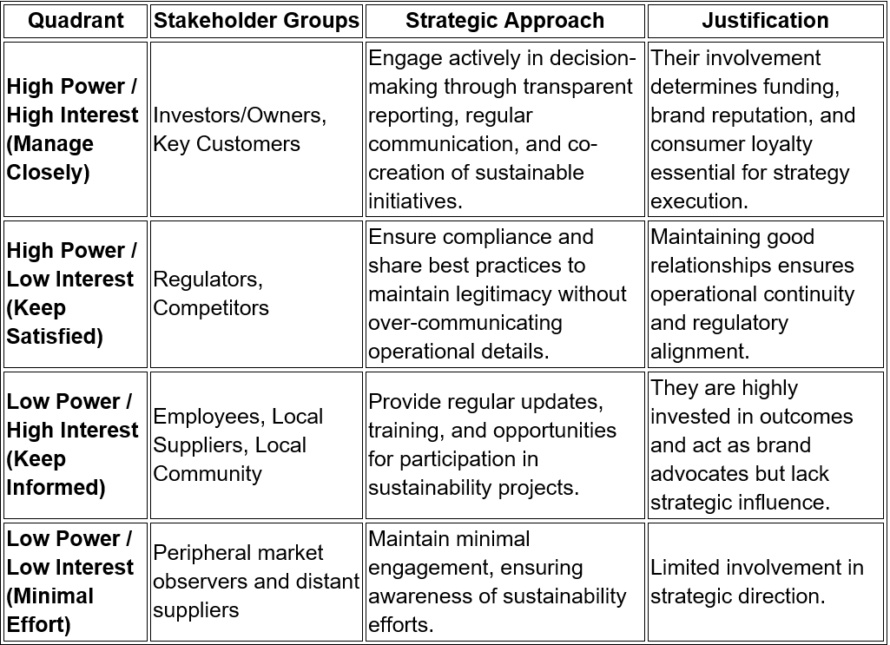

Critical Evaluation of Stakeholder Expectations and Influence
Investors and Owners possess the greatest power, as they control capital allocation and strategic priorities. Their expectations of growth and sustainability strongly influence the feasibility of expansion into digital and partnership models. A sustainable strategy must demonstrate financial viability and social impact to gain their full support (Freeman, 2010).
Customers have increasing influence due to shifting consumer values towards ethical consumption (Mintel, 2023). Their high interest makes them central to strategic acceptability — strategies must maintain affordability while advancing zero-waste principles. Expanding into digital platforms directly addresses customer convenience and inclusivity.
Employees and local suppliers are pivotal for operational feasibility. Employee buy-in ensures effective implementation, while supplier collaboration supports product and market development. Mutual training and transparent communication foster alignment with The Clean Kilo’s mission (Mitchell, Agle & Wood, 1997).
Regulators hold significant power but moderate interest; compliance and alignment with UK environmental policies (DEFRA, 2024) are essential to avoid reputational or operational risks. Local communities enhance long-term legitimacy, particularly if community education and engagement remain central components of The Clean Kilo’s strategy.
Strategic Recommendations for The Clean Kilo
1. Strengthen Environmental Sustainability
- Develop measurable ESG metrics for energy, carbon, and waste reduction.
- Prioritize local and ethical suppliers through simple sustainability audits.
- Partner in low-emission logistics (e-bikes, EVs) to reduce delivery impact.
Start small with one sustainability target per quarter using affordable ESG tools.
2. Enhance Social Impact
- Expand community education on zero-waste living with schools and councils.
- Foster inclusive employment and sustainability training for staff.
- Encourage customer participation through refill reward schemes and feedback loops.
Use volunteer programs or partnerships to deliver social projects at low cost.
3. Improve Governance and Accountability
- Appoint a sustainability lead or small ESG committee to oversee progress.
- Publish a short annual “Impact Report” for transparency.
- Establish simple ethical sourcing and diversity policies.
Keep governance lean but consistent to build credibility.
4. Advance Circular Economy Innovation
- Introduce refill container return or deposit schemes.
- Collaborate with local producers to repurpose waste into new products.
- Explore digital tools to track reuse and engage customers.
Seek small grants or partnerships to test new circular initiatives.
5. Build Strategic Partnerships and Advocacy
- Join local sustainability and SME ESG networks.
- Co-create campaigns with ethical suppliers to expand reach.
- Engage in local waste-reduction policy discussions to influence change.
Collaborations help share costs and scale impact.
Conclusion
By maintaining its zero-waste ethos while innovating digitally, The Clean Kilo is well-placed to shape the future of sustainable retail in the UK. This report has shown that while the company benefits from growing consumer demand for sustainability, its long-term success depends on strategic innovation and operational resilience.
Using frameworks such as Porter’s Generic Strategies and the Ansoff Matrix, a differentiation focus supported by market and product development emerges as the most sustainable growth path. The proposed strategy—centred on digital expansion, local partnerships, and operational efficiency—offers both economic feasibility and environmental integrity.
Stakeholder analysis highlighted the importance of managing key relationships with investors, customers, and suppliers to ensure strategic alignment and acceptability. By pursuing innovation while remaining true to its zero-waste values, The Clean Kilo can achieve sustainable growth, strengthen its market presence, and continue to lead the transition towards responsible and circular retail in the UK.
Reference List
Ansoff, H.I. (1957) ‘Strategies for Diversification’, Harvard Business Review, 35(5), pp. 113–124.
Barbero, J.L., Casillas, J.C. and Wright, M. (2021) ‘Do small firms benefit from digitalization? Evidence from European SMEs’, Journal of Small Business Management, 59(6), pp. 1125–1144.
Liverpool, I. (2025). The Clean Kilo – Independent Birmingham. [online] Independent-birmingham.co.uk. Available at: https://www.independent-birmingham.co.uk/profile/the-clean-kilo [Accessed 10 Nov. 2025].
DEFRA (2024) Environmental Improvement Plan 2024. Department for Environment, Food and Rural Affairs. Available at: https://www.gov.uk/defra (Accessed: 3 November 2025).
Birmingham City University (2024) Sustainability strategy for businesses in the West Midlands. Birmingham City University Business Blog, 3 October. Available at: https://www.bcu.ac.uk/business/blog/sustainability-strategy-for-businesses-in-the-west-midlands (Accessed: 10 November 2025).
Chartered Institute of Marketing (2021) No-waste shopping: the next biggest retail disruption. CIM Content Hub, 10 December. Available at: https://www.cim.co.uk/content-hub/editorial/no-waste-shopping-the-next-biggest-retail-disruption/ (Accessed: 10 November 2025).
Consultancy.uk (2024) Consumers struggle to prioritise sustainable packaging. 20 February. Available at: https://www.consultancy.uk/news/36609/consumers-struggle-to-prioritise-sustainable-packaging (Accessed: 10 November 2025).
Gordon-Wilson, S. (2022) Values, personality traits, and packaging-free shopping. University of Portsmouth. Available at: https://researchportal.port.ac.uk/files/50346044/Values_personality_traits_and_packaging_free_shopping.pdf (Accessed: 10 November 2025).
Kemper, J.A. (2024) ‘The emergence of plastic-free grocery shopping’, Journal of Environmental Psychology, 85, pp. 1–12. Available at: https://www.sciencedirect.com/science/article/pii/S0301479723020789 (Accessed: 10 November 2025).
Montano, S. and Toral, I. (2021) Zero-waste: the future of the weekly shop? Birmingham Business School Blog, 27 September. Available at: https://blog.bham.ac.uk/business-school/2021/09/27/zero-waste-the-future-of-the-weekly-shop/ (Accessed: 10 November 2025).
Reuters (2025) UK retail downturn stretches into 10th month, CBI says. 28 July. Available at: https://www.reuters.com/business/retail-consumer/uk-retail-downturn-stretches-into-10th-month-cbi-says-2025-07-28/ (Accessed: 10 November 2025).
Saintenoy, S. (2019) The zero-waste revolution: how a new wave of shops could end excess packaging. The Guardian, 21 April. Available at: https://www.theguardian.com/environment/2019/apr/21/the-zero-waste-revolution-how-a-new-wave-of-shops-could-end-excess-packaging (Accessed: 10 November 2025).
University of Manchester (2023) Study shows how ethical brands fare in a recession. University of Manchester News, 8 December. Available at: https://www.manchester.ac.uk/about/news/study-show-how-ethical-brands-fare-in-a-recession/ (Accessed: 10 November 2025).
Doherty, B., Haugh, H. and Lyon, F. (2014) ‘Social enterprises as hybrid organizations: A review and research agenda’, International Journal of Management Reviews, 16(4), pp. 417–436.
Food Standards Agency (2024) Food Hygiene for Businesses. Available at: https://www.food.gov.uk/business-guidance/food-hygiene-for-businesses (Accessed: 15 October 2024).
Freeman, R.E. (2010) Strategic Management: A Stakeholder Approach. Cambridge: Cambridge University Press.
GOV.UK (2022) Plastic Packaging Tax. Available at: https://www.gov.uk/guidance/check-if-you-need-to-register-for-plastic-packaging-tax (Accessed: 15 October 2024).
Grant, R.M. (2019) Contemporary Strategy Analysis. 10th edn. Hoboken: Wiley.
Indiegogo (2023) ‘The Clean Kilo Crowdfunding Campaign.’ Available at: https://www.indiegogo.com (Accessed: 10 October 2024).
Johnson, G., Scholes, K. and Whittington, R. (2017) Exploring Corporate Strategy. 12th edn. Harlow: Pearson Education.
Mendelow, A.L. (1991) ‘Environmental scanning: The impact of the stakeholder concept’, Proceedings of the International Conference on Information Systems, pp. 407–418.
Mintel (2023) Ethical Consumer Market Report 2023. London: Mintel Group Ltd.
Mintel (2023) Sustainability and the Consumer. London: Mintel Group Ltd. Available at: https://www.mintel.com/press-centre/retail-press-centre/sustainability-remains-a-key-purchase-driver-for-brits (Accessed: 15 October 2024).
Mitchell, R.K., Agle, B.R. and Wood, D.J. (1997) ‘Toward a theory of stakeholder identification and salience: Defining the principle of who and what really counts’, Academy of Management Review, 22(4), pp. 853–886.
Porter, M.E. (1980) Competitive Strategy: Techniques for Analyzing Industries and Competitors. New York: Free Press.
Porter, M.E. (1985) Competitive Advantage: Creating and Sustaining Superior Performance. New York: Free Press.
Storey, D.J. (2016) Understanding the Small Business Sector. London: Routledge.
The Clean Kilo (2024) About Us. Available at: https://thecleankilo.com/pages/about-us (Accessed: 15 October 2024).
Wanderlog (2023) ‘The Clean Kilo – Birmingham Travel Guide.’ Available at: https://wanderlog.com (Accessed: 10 October 2024).

