Marketing Essentials
BMIH4005
Essay: A Comparison of the Marketing Methods of Two Multinational Hotel Brands
[Word Count: 1500]

Table of Contents
1 Introduction 3
2 Marketing Choices and Marketing Direction 3
3 Current Market Positions 4
4 Current Marketing Strategies 6
5 Sustainable Marketing and Green Messaging 7
6 Positions after COVID-9 7
7 Conclusion 8
8 References 9

Introduction
Marketing plays a significant role in the maximisation of profit and revenue in the hotel industry. With the help of effective marketing, the hotel industry target customers and offer unique selling proposition as well as brand value. In regards the essay will present a comparison of marketing methods between two hotels that are selected, Ritz Carlton and Holiday Inn. For comparison, the report will highlight the marketing choices and direction of two selected hotels and will discuss marketing positions and marketing strategies. Also, there will be a discussion of sustainable marketing and green messaging from the hotels and their position after the dramatic impact of COVID-19.

Marketing Choices and Marketing Direction
Ritz Carlton was first established by Albert Keller in the year 1900. Ritz Carlton is categorised as an elegant, luxurious, and formal hotel chain. The main motive of Ritz is to offer customers commendable services. The motive of the Ritz is to serve ladies and gentlemen in a great manner (The Ritz Carlton, 2022). The employees are well trained and behave in a well-trained way with customers in Ritz. The hotel is one that offers high-class services to customers and makes their memories supreme and great.
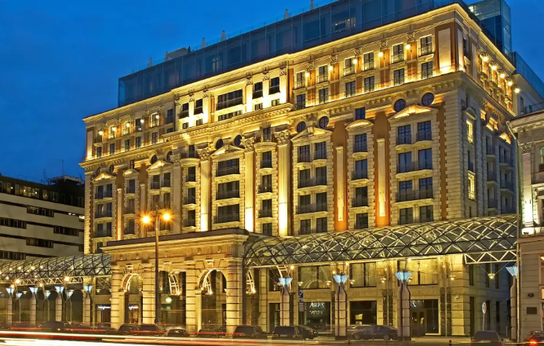
(Source: The Ritz Carlton, 2022)
The vision of Ritz is to differentiate the brand from other hotels by offering warmth and refined services, like; they offer spacious private rooms, comfortable accessories, comfortable and natural environment, private baths etc. The core focus of Ritz hotel is on social media, which is used as an engagement channel for the brand. Ritz focuses on marketing and always tries to maximise customer engagement, especially for luxury travellers. Contradict to this; Holiday Inn is categorised as an American hotel chain that contains about 1173 hotels all around the world (IHG, 2022). Holiday Inn is famous because of its emotional bonding with customers, which makes it an iconic brand. The key mission of Holiday Inn is to provide high-level cleanliness to the customers and maintain cultural ethics all across the hotels. The hotel invests in different marketing tactics in order to make a difference in the lives of customers who choose Holiday Inn.
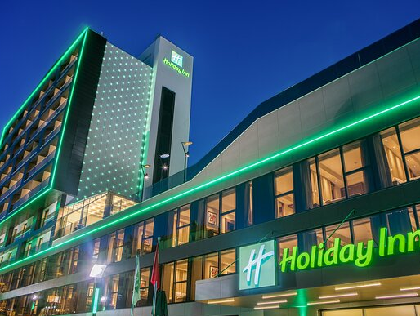
(Source: IHG, 2022)
The hotel focuses on marketing efforts that help in increasing customer loyalty. The marketing tactics of Holiday Inn are effective because of its investment in different marketing campaigns that target cultural norms (IHG, 2022). Holiday Inn initiated many successful marketing campaigns, as they invested in broadcast advertising (Fallon Minneapolis), engagement marketing (Look Again campaign), and so on. It is a true fact that Holiday Inn uses digital marketing strategies as well as traditional marketing tactics to maintain its position in the hospitality industry.

Current Market Positions
To analyse the concept of market position, STP is an effective tool that abbreviates as segmentation targeting and positioning (Schlegelmilch, 2022). For both hotels, the STP framework is discussed below;
Segmentation
Segmentation is used to categorise the marketplace into subsections and helps in targeting the potential market (An and Liu, 2021).
Segmentation | Ritz Carlton | Holiday Inn
Demographic | - The main target of the hotel is high-class and rich customers.  - The hotel targets families and those who are willing to spend on travelling. | - The key target of the hotel is those who have high-income earners.  - The hotel focuses on businessmen and corporate persons specifically.
Psychographic | - The main focus of the Ritz is to satisfy the ambitions and desires of those who want a luxury lifestyle and love to travel expensively (The Ritz Carlton, 2022).  - The brand is the perfect choice for one who seeks luxury and is high-status conscious. | - Holiday Inn focuses on those who like to take an interest in tourism-related activities.  - A mostly business-oriented person is attracted.  - The main target is the customers who intend to get excellent customer service and a luxurious experience at the same time.
Behavioural | - Ritz offers customers specific booking preference options, like for leisure, for business, or for family time.  - Target those who show loyalty towards the brand. | - The target market is those who prefer customised booking at an expensive rate.  - The hotel focuses on those who are interested in travelling for the purpose of tourism (IHG, 2022).  - The key emphasis is on business travellers.
Geographic | - The hotel is present all across the world.  - It has a well-known position in the UK. | - The hotel operates worldwide, including in the UK.

Targeting and Positioning
From the above table, it has been demonstrated that the main target of Ritz Carlton hotel is high-class and upper-class customers. Similarly, Holiday Inn targets those who intend to take luxurious services for travelling and business purposes both.
According to Garachkovska et al. (2021), positioning is used by brands to clarify the target audience and set the best possible pricing strategies in the market. Concerning the selected hotels, the positioning mapping is defined below;
High Price
Low Price
High Quality
Low Quality
Hilton Hotel
Holiday Inn
Ritz Carlton
Ibis
Raffles

Current Marketing Strategies
Being a leading chain in the hotel industry, Ritz Carlton always focuses on providing unique services to the customers, as they offer special spa services, a dream destination, excellent arrival and departure services, halls and restaurants, valet services, tracking apps, etc. Ritz serves customers with quality service, for which the business strategy follows by the hotel is a premium pricing strategy (The Ritz Carlton, 2022). Offering with premium pricing strategy, Ritz is hired from elite areas of the country, as the staff reflects the business objective of the hotel. Because of its luxury hospitality chain, the hotel targets the upper section of society and offers them premium services. For marketing purposes, Ritz follows social media strategies and heavily relies on word-of-mouth publicity. Moreover, Ritz operates with its original website, and the hotel increases its visibility with the use of advertisements like Ritz promotes its brand with catchy lines on magazines and social media pages (Cunha et al., 2021). On the other hand, Holiday Inn is known as a well-known brand that serves a range of services to customers, including; a swimming pool, restaurants, hotels, gyms, yoga centres and many more. The focus of Holiday Inn is to perform marketing with the help of a demand-based pricing strategy. It helps in attracting customers who are usually price-conscious and intends to get the best services within an affordable range. The hotel invests heavily in its app and online website to ensure that customers gain all the information about booking and account details for a hotel within one page (Purnamayanti et al., 2021). In addition, Holiday Inn initiated advertising and broadcasting and similar other services. The hotel extensively uses social media platforms along with digital investment, where travellers are encouraged to share their experiences and journey with others. With the analysis of the marketing strategies of both hotels, it is evaluated that pricing strategies are different, which is the main comparison factor between Ritz and Holiday Inn.

Sustainable Marketing and Green Messaging
In the field of hospitality, sustainability is considered an important factor as it provides value to clients as well as serves nature and the environment (Johnston et al., 2022). It is important for hotel management to promote practices that are socially and environmentally both ethical and sustainable. Ritz hotel focuses on sustainability and emphasises promoting environmentally responsible practices like work with the goal to reduce water and energy consumption by the end of 2030. Ritz also focuses on the increasing use of organic and local dining options, for which they create a partnership with local farmers, organic raw materials growers, and seafood tattlers (Horng et al., 2022). Ritz also makes moves towards green hotels and reduction in energy usage in the entire operations of the hotel. In comparison, Holiday Inn is also investing heavily in sustainability; they focus on reusing, recycling, and preventing water waste as well. The hotel initiated different operations that engage customers in the green management agenda of Hilton (Wee et al., 2021). In particular, the hotel worked on an online environmental sustainability system which has a positive impact on society and the environment. In addition, cost saving is also an important objective of Holiday Inn's sustainability mission.

Positions after COVID-9
With the outbreak of COVID-19, operations of the hotel industry have been significantly impacted. In terms of Ritz, Carlton dealt with the dramatic situation of the pandemic and acted quickly to maintain customer loyalty. In the hotel, customers are provided with proper precautionary messages and practices via the digital channels of Ritz. After the pandemic, the management of the hotel initiated a global marketing campaign in which customers are encouraged to be back on their travelling track (Wei and Jingyi, 2021). The campaign helps the management of the hotel to clarify the mind of customers and attract them as well. With the help of a digital platform, Ritz invites customers and gives them a warm welcome with little gifts and sweet gestures. The hotel tries to be in touch with customers as much as possible to help them to get back into their normal routine after the pandemic (Khan, 2021). Despite this, Holiday Inn also quickly responded after the pandemic and offered positive messages to customers via different social media platforms and digital media channels. Also, the hotel provides guests and travellers with flexibility and safety in terms of cleaning and sustainable practices. Holiday Inn highly invests in digital checks to deal with arrival and departure records.

Conclusion
In a nutshell, Ritz and Holiday Inn are both well-known hotel chains in the UK. The key difference between both hotels is pricing strategy, as one performs with premium pricing and the second use demand-based pricing. There are different marketing choices and strategies used by hotels that are discussed in the essay. Conclusively, hotels have made noteworthy efforts in order to regulate practices after the pandemic and attract customers.

References
An, F.P. and Liu, J.E., 2021. Medical image segmentation algorithm based on multilayer boundary perception-self attention deep learning model. Multimedia Tools and Applications, 80(10), pp.15017-15039.
Cunha, M., Correia, R. and Costa, A., 2021. Digital marketing in the hospitality-case study of social networks as a communication tool in Oporto hotels. Journal of Internet Social Networking & Virtual Communities, pp.1-17.
Garachkovska, O., Sytnyk, O., Fayvishenko, D., Taranskiy, I., Afanasieva, O.M. and Prosianyk, O.P., 2021. Strategic management of brand positioning in the market.
Horng, J.S., Liu, C.H., Chou, S.F., Yu, T.Y. and Hu, D.C., 2022. Role of big data capabilities in enhancing competitive advantage and performance in the hospitality sector: Knowledge-based dynamic capabilities view. Journal of Hospitality and Tourism Management, 51, pp.22-38.
IHG, 2022. Hotels and Resots. [Online] Available at https://www.ihgplc.com/en/our-brands [Accessed on 31st October 2022].
Johnston, N.E., Jai, T.M.C., Phelan, K.V. and Velikova, N., 2022. Supporting sustainable marketing programs: exploring relationships between cultural values, green attitudes and intent. Social Responsibility Journal, pp. 12-90.
Khan, B., 2021. Sunset Inn: three-phase case study before, during and after the wrath of COVID-19. Journal of Business & Industrial Marketing, pp. 15-60,
Purnamayanti, D.P.O.S., Sudiana, I.G.N. and Januariawan, I.G., 2021. Strategi Komunikasi Interpersonal Sales Dan Marketing Dalam Meningkatkan Minat Pelanggan Di Holiday Inn Resort Bali Benoa. Anubhava: Jurnal Ilmu Komunikasi Hindu, 1(1), pp.38-45.
Schlegelmilch, B.B., 2022. Segmenting targeting and positioning in global markets. In Global marketing strategy (pp. 129-159).
The Ritz Carlton, 2022. About us. [Online] Available at < https://www.ritzcarlton.com/en/about/history> [Accessed on 31st October 2022].
Wee, H., Mustapha, N.A. and Anas, M.S., 2021. Characteristic of green event practices in mice tourism: a systematic literature review. International Journal of Academic Research in Business and Social Sciences, 11(16), pp.271-291.
Wei, T. and Jingyi, C., 2021. Research on Hotel Service Innovation under COVID-19 Pandemic. Journal of Landscape Research, 13(6), pp.48-56.

