

By Callum George Poole
BSC: Applied Computing
An investigation into applications to aid the effectiveness of interior design

Abstract

This Document’s aim is to highlight the need for further advancements within the interior design industry and how it can benefit the lives of millions of people along with an application that achieves these goals. An overview has been documented of the interior design industry and the many principles that could be implemented into the applications to further people’s lives for the better. Many scholarly articles and case studies have been primarily used to lead the research within the current technologies in use within the industry. Within this document each stage of a suggested improved interior design application has been specified and documented to a clear level of understanding.

Contents Page

Contents
Abstract 2

Contents Page 3

1. Introduction 5

2. Research & Review of Literature 6
2.1 Introduction of the problem 6
2.2 Physiological effects of interior design 6
2.3 The Doctrine of colours 7
2.4 Costs of interior design 8
2.5 Fire safety and interior design 8
2.6 The History of interior design 9

3. Current tools Available 10
3.1 Planner 5d 11
3.2 Ikea home planner 12
3.3 Sweet Home 3D 13

4. Potential development technologies 14
4.1 Mobile application 14
4.2 Desktop application 14
4.3 VR 15
4.4 Chosen development technology 15

5. Web based applications vs non-web applications 16

6. Security Concerns in application development 17

7. Cost estimation 18

8. Conclusion 20
9. Research and Development Methodologies 21
9.1 Introduction 21
9.2 The research onion 22

10. Development method 24
10.1 RAD Development. 25
10.2 System flow 26

11. Design & Implementation 27

12. Evaluation 34

13. Conclusions and Recommendations 35

14. Reflection 36

References 37

1. Introduction

This document describes the details and research into the development for the software as proposed previously. The research done has been implemented and adjusted in a way to the application at hand that will benefit the people who use it for the better.
The document includes the development and end prototype of the system being designed along with each stage of the development along with the system for an application for an interior design application. Given the applications within the interior design industry at the current age many features are still missing and many features that could save lives have yet to be implemented. The following report covers the much-needed updates to these system along with a proposed system for an interior design application.

2. Research & Review of Literature

2.1 Introduction of the problem

Within the interior design industry over the last few decades there have been major advancements in the technology used to benefit the companies that reside within the ever-growing trade. This technology although useful has many weaknesses that have been shown to cause countless lives to be put at risk. Within this document I will be identifying and advancing on this these weaknesses and allocating suitable corrections that can advance this software into more secure and forward-looking applications with minimal flaws.
Due to the change of interior design over the years it has been hard for many people to keep up with modern trends without spending lucrative amounts of money and ensuring their house is safe to live in. Due to the drastic changes within the interior design industry that happens weekly people have found it is near impossible to ensure their house follows modern trends. Although many people believe they can stay up to date they do not take into consideration the health and safety aspects of designing interiors of homes.

2.2 Physiological effects of interior design

Within day to day living many people do not think of the effects of the environment around them and how it can alter the way they act or think. When people are left in a dull and lifeless environment for hours on end it can lead to any series of issues such as depression and a sense of being trapped within a cage. Given studies in 2014, 19.7% of people in the UK aged 16 and over showed symptoms of anxiety or depression - a 1.5% increase from 2013. This percentage was higher among females (22.5%) than males (16.8%) (1) Of the UK have depression making it a major epidemic that needs to be altered within the UK. It is essential to anyone who may work from home that their interior is full of life and has vibrancy as it not only will improve their mental wellbeing but also invigorate them with new founded energy decrease the chance of them feeling depressed. It is shown that when the body is subjected to brighter colours rather than dull the brain is stimulated invigorating the person (2). This not only allows for the person to not be placed into a state of depression but also allows them in some cases to do more work (3) as they may feel more stimulated by the brighter colours.
One method that many people use within interior design is Feng Shui (4). Feng Shui is simply the art of allowing energy to flow through the room allowing people to feel refreshed and positive within the room they are in. This although may not work for some may reduce the amount of people who work from home who have depression as the interior design will make the worker feel more relaxed and positive about their environment which in some cases can give them alternative out looks on problems they may be dealing with.

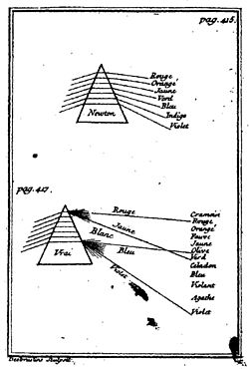
2.3 The Doctrine of colours

The theory behind colours have been researched and developed on for thousands of years and have helped develop an understanding of design that has been implemented in many mental health studies. Within the early stages of colour research and how it relates to light (5).
The main starting point of colour theory was from a poet called Johann Wolfgang von Goethe who highlighted what colour is and the effect that it presents to the people who overserve the colours around them (6). He briefly describes how given how light gives colour and how humans cannot live without light that in some cases humans may need colour to live as much as they need light. This brings to mind how if someone is exposed to a lack of colour or a lack of light how it may affect the person’s mentality and how it may alter the way they feel internally.
Given this knowledge when designing an interior of a home it may be paramount to allow each room to have a direct source of light and colour in order to not damage the occupants of the home itself. By not having light within a room it can give the room a feeling of lifelessness and will make people feel less happy as highlighted above. It is known that the lighter in a room gives the room more life making it seem more of an inviting environment for the occupants of the residence. As found by scientists’ different colours can have different effects on people within those around them. This idea can be applied to rooms by using different types of lighting such as UV lighting and different coloured bulbs within the area being designed. It’s known by Goethe that the darker the colour the less lively the environment and the lighter and the brighter the light the more active the perceivers are (6)

2.4 Costs of interior design

A major issue regarding interior design is a lot of people have limited amounts of money to spend on their interior design making it somewhat limiting to what they can do regarding making their homes a comfortable place to live in. This can severely affect people as if they do not feel comfortable within their own homes, they may not feel happy anywhere which again can lead to depression. Although some professional interior designers and interior design applications can cost a fair amount it is shown that these services help exponentially within the lives of those who use them (7).
Although to hire a professional interior design consultant can cost up to £1100 for the drawings alone (7), many of the applications offered can cost only a fraction of this price making them to major option for those people who may not have access to excessive amounts of money. If people are going to be using the applications more than the designers, it is paramount that aspects that may seem like common sense should be included within the applications such as there being a place to walk within the room and there being accessible furniture otherwise the applications may simply be not worth the money and time put into them.

2.5 Fire safety and interior design

Another growing issue within the UK is fire safety (8) which effects the lives of thousands (8) every year. It is shown that 11% (9) of fires are caused by people leaving furniture in places blocking fire escapes stopping people from being able to escape from fire. This is a major issue as countless lives could be saved by people simply knowing where to put a bookshelf or where a bed should go within a room. This simple decision can save lives. Many existing interior design applications do not warn people that they may not be able to escape within an emergency which is a massive flaw that needs to be fixed.
Shown by recent studies over 11% (9) of deaths regarding fires have been caused by blocked exits and people being unable to escape from the fire within their own homes. This problem could be simply solved if within these applications for interior design it could allocate and determine fire escapes and ensure that bookshelves and other furniture do not stop people from living through such an event. It is also shown that the UK government has spent a total of 2806 million pounds (10) on Fire safety precautions within 2017/2018 which is money that could be spent elsewhere for decreasing aspects such as the homelessness epidemic within the UK (11).

2.6 The History of interior design

Since the early stages of civilisation people have enjoyed luxury and bragging rights over others to show others how much more superior, they are. This has not changed over the years and people still today wish to live in luxury to make themselves feel more empowered.
An example of people of decorating their homes to show wealth was back in the Victorian era the Pineapple was deemed as a fruit of luxury and was used within the interior design or external design of many buildings to show others of the house owners’ wealth (12). Many Victorians would use these fruits as a sign that they were within the upper-class giving others the feeling of in superiority for not having a rare and luxury decoration for their homes. This although not so prolific is still done today with fruit baskets and fake fruits in homes planned on being sold. This gives the buyer a sense of life within the home they are looking at and gives more of an incentive to purchase the house.
Another interior design quirk which was found within the history of interior design was the colour purple. The colour purple when used in certain areas of the world such as Egypt is deemed as a rich and royal colour due to its origination. This is because the creation of the colour was deemed very difficult to manufacture in days gone by and many trades across Egypt would pay large sums of money to obtain fabrics with the colour in them (13). Due to this many people will see the colour purple within homes as a rich colour and will feel more empowered due to it.
Although many people are unsure of what a good interior design is or how to give the right impression of a well-designed house it is difficult to do so. Due to many of past trends when it comes to designing homes the term well designed or good can be difficult to narrow down on. A good interior design can mean different things to different people and generations so to ensure the interior you are designing is deemed as well designed you must first know what style and generation of design you want and what feel the room you are designing wants to give to the guests to it.

3. Current tools Available

Due to the interior design industry being around for so long a series of companies and individuals have spent time and have already created simple interior design applications. Although these applications are useful, they are limited in many aspects which can be improved on tenfold.
Below are three examples of current technologies that are currently in deployment within the interior design industry. These applications although limited still have a basic concept of the application being proposed. The current tools within this industry are somewhat limited in many regards but have simplistic functionality that allow for the applications to be somewhat functional for the purposes at hand. The applications currently allow the user to design their own rooms and allow for the customization to a somewhat high level. Although this is useful, they are still limited in functionality as will be highlighted below.

3.1 Planner 5d
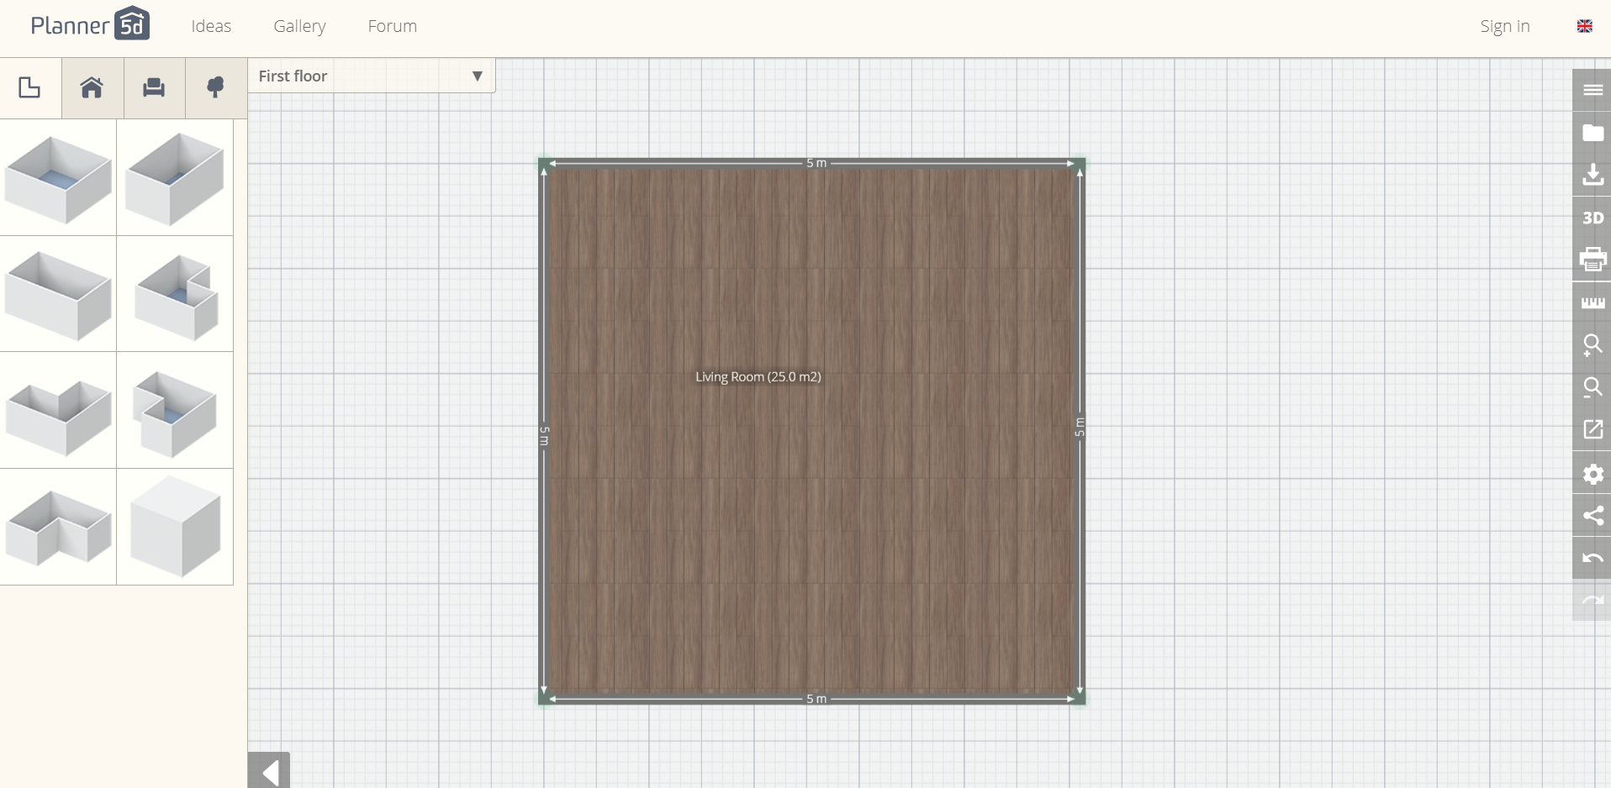
Figure? Planned 5e (14)
Planner 5d is an application that allows users to design a room in either a 3d or 2d view. This application is much like the application chosen to be developed except for a few aspects such as the allowance of no fire escapes and doors. Unlike other applications within the same topic area as this this application is all on one page allowing for the application to feel less confusing. Although in many ways this can aid a design it can also make the user feel overwhelmed by the design making it harder for them to understand each aspect of the UI (User interface).
A design choice which will not be included within the end design due to time limitation is a floor selector. This Choice is good as it allows for the application to have more design choices for the user. This although would be a good addition to the final application would mean the development of an extra few screens for each of the extra floors the user wishes to design which may be too much for the limited time for the project at hand.

3.2 Ikea home planner
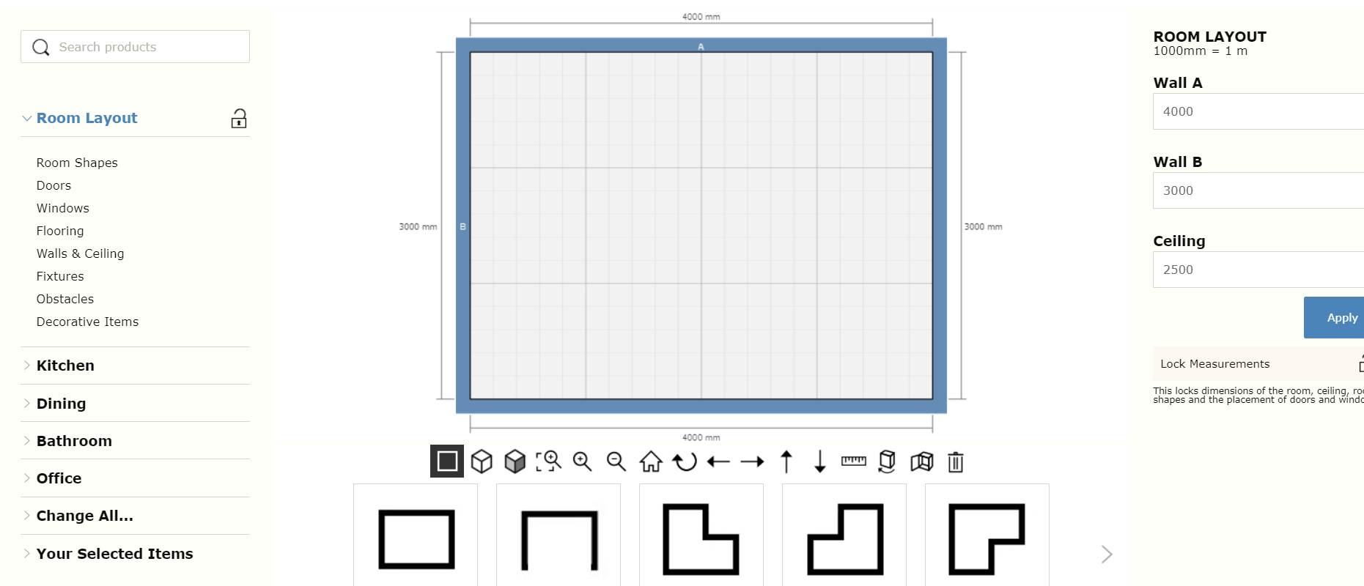

Figure? Ikea home planner (15)

Much like Planner 5E Ikea home planner is all on one page making the application feel cluttered. Unlike planner 5e however Ikea home planner allows for the sizes of the room to be inputted changing the size of the room. This is a good addition as it allows for more usability for the user. Unlike Planner 5e Ikeas home planner has clearly labelled icons allowing for any user to understand where each component of the application is and how to use it with ease. One of the main features that the Ikea home planner offers that is useful for the user is a search box that allows the user to find furniture with ease. This is a good addition as it allows the quality of life for the user of the application to be improved giving them more incentive to use the application more.

Although Ikea home planner is developed and funded by Ikea it seems the main aim of the planner is for them to sell their furniture which may give them a bias towards using set furniture’s using higher quality images for the more expensive pieces of furniture. This although is useful for when selling items of furniture and lighting is not good for a program that is not aiming to sell furniture as it will make the interiors of many of the designer look the same.

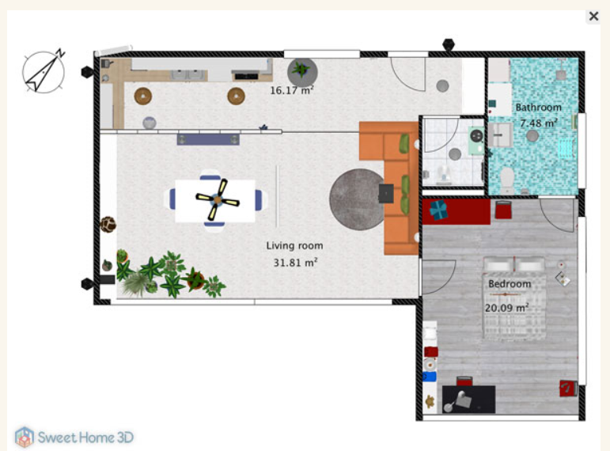
3.3 Sweet Home 3D

Sweet Home 3D (16)
Much like the application being developed each component has a Birdseye view of a room giving the illusion of a 3d view. This design feature allows for more usability and allows for the user to gain a more in-depth knowledge of what the room being designed will look like. Unlike the other applications sweet home 3d has the addition to doors and windows but do not make them essential when designing a room. Much like the other applications reviewed this application allows for the user to block windows and doors with furniture which as discussed previously is a major contributor to the fire related deaths in the UK (9).

Much like the other applications listed this application is free to use allowing anyone who wishes to design an interior to design it without a set cost. This application unlike the other allows for the room sizes to be shown along with the angles the corners of the room are at so the user has a more in-depth knowledge of what the end room will look like. This although is useful is not needed in the end application as the main goal of the application at hand is to allow for fire escapes and design techniques which can promote stress relief to be applied to the end design.

4. Potential development technologies

4.1 Mobile application

With the ever-growing mobile phone industry, the technologies being developed for the mobile phone are becoming more of a staple within the lives of thousands across the globe. It is estimated that just under 9 billion phones are connected globally (17) making it one of the largest platforms to sell applications from. Although this is beneficial it will also mean that you will have to compete with the ever-growing markets that are offered to mobile phone users such as the apple store and the google play store.
Another disadvantage of many mobile phones is the screen size. Given how modern mobile phones have less than 6.5 Inches of screen (18) to access the applications from. This can be limiting for an application such as this as it will mean they will either have to have the components small enough to fit or they will be only limited to seeing a small amount of the house at one time. This can make the application a fair amount harder to work with which may create users to not want to use the application.
One of the main advantages to mobile phone applications is the portability that the mobile phone offers. This allows users to walk around their homes and design at the simultaneously. This can be beneficial as you will be able to make changes on the go or whilst away from home allowing for more customisation whilst away from home.

4.2 Desktop application

Unlike mobile phones many desktops do not struggle with the limiting size of the mobile phone screen allowing for an even greater view of the room they are designing. This is shown to help many users as over 2 million people in the U.K (19) have some form of vision impairment limiting them to what they see. By simply making the screen that the user is working on larger not only will they be able to see more of the room they are working on but will have a greater overall feel for the room they are designing as some components may look good in a part of the room but may look out of place within the whole room.
Another advantage of using a desktop application for this system is the system will become more efficient than if it was to be placed onto a mobile phone. This is simply due to the macros and shortcuts that the desktop computer offers over a mobile phone. This will not only make the job easier for the client when it comes to designing their home but also, they will be able to design it in a way they may prefer due to the flexibility that desktop computers offer.

4.3 VR

One of the newest emerging technologies is virtual reality. This type of technology has been tested in the past for designs applications (20) but given the cost of the technology (21) many people have been turned away leaving this technology difficult to develop for. Another issue with VR is that due to the technology changing so rapidly it will be difficult to design the application for it because by the time the application would have finished the final stages of development the platform or hardware may have changed leaving the software out of date and in some cases unusable.
VR although is a new and unique technology which has attracted a fair amount of attention over the years has led to many people feeling ill and getting hurt due to it. Although this is the same for many new technologies the issues tend to subside given time. If the application was to use VR it may be recommended to wait some time for the technology to develop allowing for a greater use of the technology to be used.

4.4 Chosen development technology

The chosen development technology for the final application was a desktop application. Unlike the other potential technologies, the desktop platform allows for a series of benefits. The main benefit of using a desktop platform for the chosen application is due to the size of the room being designed. Given how when designing a room for personal use many people will want it detailed the designer will need a larger screen to see these details. Another advantage of using a desktop platform for the development for this application is the fact that PCs (personal computers) allow for more processing power than any mobile phone could offer due to their hardware components. This power although may not be needed could be a utilised for future use if the application implements any rising technologies such as VR or a 3d view.
Another advantage of using the desktop technology over other current technologies is the maintenance of the application will become a fair amount easier.

5. Web based applications vs non-web applications

Although a desktop application has been chosen there are two different types of desktop application platforms that could be used these are web based and non-web-based applications. Although both have their advantages and disadvantages the development will be done using a non-web based for a series of reasons. The first main reason is that if the user is disconnected from the internet the user will be cut off the application removing all unsaved work that they may have done prior to this point. This will not only make the user feel like they may not want to use the application but will also mean they will not want to use it in the future.
The main benefit to using a web-based system would simply be that there would be easy to apply updates to the application as it will be online allowing for all updates to be done at once. Although this may be a benefit the web application will need to come offline for a short amount of time whilst the updated application is to be uploaded. This can cause connection issues and displeased customers for the application as they may not know what is going on unlike if the application was to be downloaded onto the user’s machine. If the application is running on each user’s machine it would be up to them to choose if they wish to update the application giving them more control over what happens to their designs.
Unlike web-based applications the security of the application will be down to the user whereas if the application was web based a large sum of the production time will be ensuring that the security of the application on the web server is safe for public use. This will mean applying a series of web certificates (22) and security protocols to protect the user’s information from those who wish to access it.
The final benefit to be discussed is the fact that unlike web application a non-web-based application will allow for the user to keep backups of their designs and will allow for the user to keep their information safe. If the application was web based the rooms designed will need to be saved onto a web server meaning more money needed for the development for user storage. This will also mean if the web server is damaged a large amount of the user’s designs may be lost causing a large issue within the audience of the application.

6. Security Concerns in application development

Much like any application within the modern age there are security concerns. Within the modern day of technology there are a series of ways a person(s) can damage a system and exploit it for their own uses. This needs to be avoided in the case of breaking the DPA (23) and other data protection laws.
The main threats to a system much like this are the loss of personal information as there will be no payments being put into place removing the risk factor of people being exploited for money. Due to the application taking no personal details and allows anyone to use the system there is minimal security concerns in regards to the person details however users can still exploit the program and edit the system potentially damaging the system intentionally.
Due to many virus types and code manipulators existing such as Trojan horses and worms the program being designed will need to be protected against a large amount of the threats to it. The main method of protection is to simply have nothing to protect to start with. This can be done by only having the application installed on the client’s machine and have all data stored locally and not connected to any external server connected to the company. This not only limits the damage that the user can do the application but also means that the only one they will end up damaging is the locally installed application on their machine.
Many threats can be avoided within the application by including error catching and error prevention screens within the application to ensure that the application is not abused in the way that any potential threat wants it to. These error catches can simply be placed around large chunks of code to ensure that if there is an error in place the program does not simply break but will continue running and show the user an error message or simply close the application before the application is damaged.

7. Cost estimation
Within the early stages of the application development it can be hard to identify the cost of the overall application which can be an issue for many companies. The cost for the application at hand can be estimated via the technologies and development methods used within the development of the application at hand along with the time scale. By working out the cost at hand will allow the company to know how much they are able to spend on each section of the development giving them more control over each stage of the development.
One of the main contributing factors to many failed projects is the cost constraints. When a company aims to develop an application without knowing the cost of the overall application at hand it can lead to them overspending and costing them too much. Many companies may not know how much an application would cost to develop or simply do not understand any of the hidden costs within the overall application at hand.

Many researchers have attempted to create a formula to work out cost estimation for projects. One cost estimation formula goes as follows
Y = mx + b
Where

Y = total cost

m = the slope of the line, i.e., unit variable cost (cost per day of development)

X = the number of units of activity (days of development)

b = the y-intercept, i.e., total fixed costs (fixed application prices) (24)

This formula can be used and is used to work out the costing of the development of products and projects. Using this for the application at hand using estimation techniques for the fixed prices allows the company to understand the pricing of the overall application giving them ample understand on what will be needed for the end application.

7.1 Viability vs cost

Once the company is able to work out the pricing of the application at hand, they will then be able to work out if the application is viable for creation. If the application is not viable and is not going to be useful for the company at hand, they may decide the end application is not worth developing. A proposal for the viability of an application has been created.
S(uccess) = P(urpose)T(alent)^{C(ulture)}
Or: S = (PT)^{C (25)}

This formula allows for a project to be completed that is useable for the end client and allows them to work out if the overall system will be a success. If the system is not going to be a success, there will be no need for the development of it.
Each of the sections within the formula are understandable besides the talent and culture sections. The talent simply underlines how or who is developing the application and how much skill they have within the development stages. The culture is simply the backbone to the application. This includes the team developing the application and their teamwork and the care they have for the application at hand. Using the formula above the company should be able to work out if the system will be a success making it viable.

8. Conclusion

In conclusion the application should allow the user to design the interior of a room within a home or work space which is take into consideration the fire escapes along with the person the application is being designed for. The application will suggest to user’s colour schemes and interior layouts that will benefit the user such as the suggestion of brighter colours to stop the user feeling caged in.
The application will be a desktop application allowing not only the benefits of a larger screen for the work but also more processing power for the application at hand. The application should be a cheaper alternative for the user to them hiring an interior designer but should still keep the quality of the designer within it. This although can be harder for an automated service to give to the user it still should be able to be achieved by the application.
Unlike the other applications reviewed the application at hand will have multiple pages and will only allow for the designs of the rooms to be done with no bias towards any furniture types or style and only focusing on the end rooms in detail. This allows for the best end design to be made without any form of bias towards more expensive furniture types in order to sell more products to make more profit.
The cost effectiveness and success criteria have been discussed and have been identified to be suitable for the application at hand. Given the time scale and the cost of the application the application should be a success and should be a success. Although it is uncertain at this stage if the formulas are correct there is a higher chance of it being a success.
If the final application functions as intended, it should not only decrease depression rates within the U.K but also limit the amount of deaths caused by fires in the U.K. It should also allow people to design interiors of their homes or buildings of their choosing and rooms of their choosing. Although there may not be much of a change between rooms it will allow the user to create the perfect room for if they wish to decorate a home.

9. Research and Development Methodologies

9.1 Introduction
Due to work done by Wedawatta et al (26) the main method of research methodology chosen for this project will be the research onion. The research onion covers the main principles of the research that will need to be done into the application using the layers it provides. These layers include aspects such as the positivism vs phenomenology layer. This gives the user of the onion the choice of the research philosophy they wish to use.

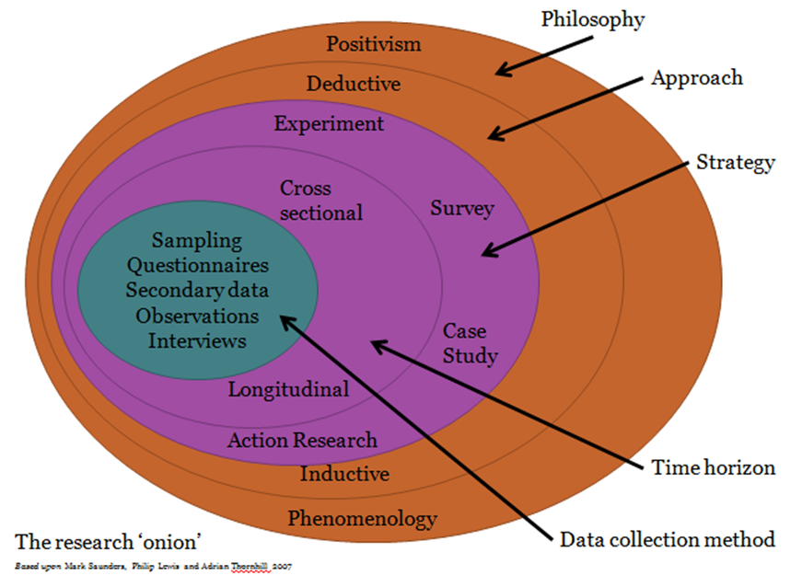
9.2 The research onion

I will be using a Phenomenology approach to research and develop the project, and this will be done using the prototyping method of development. The prototyping method is simply to keep producing the chosen product for the client until it meets all client’s needs. This method although can take a fair amount of time to produce a final working product will lead to the overall best application to be developed as it will contain first-hand experience with the application allowing the client and developer to test the program throughout each stage of development.

Phenomenology is a qualitative approach to gathering data on a project meaning that it primary focuses on non-numerical facts. This simply means the data collected will be what the client and developer think about the final product and not exactly what it is. This type can be useful for developing an application such as this as it simply allows the end client to have exactly what they want out of the final product. Although Positivism could be used within the development of this project its known that positivism only collections factual knowledge and not first-hand feelings about a topic. ““As a philosophy positivism adheres to the view that only “factual” knowledge gained through observation (the senses), including measurement, is trustworthy. In positivism studies the role of the researcher is limited to data collection and interpretation through objective approach and the research findings are usually observable and quantifiable” (27). This simply means the only way that some would deem information worthwhile is to collect information that is only factual and that can be put into a quantifiable outcome. This although is useful is not beneficial when designing an application such as this as although the application may work it may not be suitable for the end user which is why Phenomenology is needed.

The development will also be using an inductive research method for the application. This simply means the programmer will be using broad generalizations using an observation data collection method. This method is beneficial to the application at hand as it simply allows for a clear outcome to be estimated for the final application. Inductive gives this outcome by simply giving a suspected outcome based on evidence collected. The other advantage of using this layer of the onion allows for the prototypes being designed to be designed with a broader selection of data due to the generalization of the data collected. This allows for more unique designed to be made during the prototyping phases of the development. By having a wider range of unique prototypes allows for a higher chance for the client to like a prototype making it easier to know what they may want from the application at hand.
In order to create this project, the case study method in order to collect enough data about the chosen topic area and sort it into understandable information about the topic. The case study approach has been chosen to use a case study for this as not only do case studies provide qualitative information but also, they allow for information to be collected that will allow the project to advance my project to a better standard. The benefit of using a case study for this chosen topic area is that there is a limited amount of information in regards to the elements being designed together allowing to collect information in a way that would benefit the project unlike other research methodologies.

Although case studies do have their disadvantages such as time and it being costly if done by a third-party company these will be avoided as the project will be using the Timeboxing method for the development, this will neutralize the threat of going overtime for the case study. The costs will be avoided as the case study will not be done via a third-party company and will be done within the company this although maybe it may not be to as a professional standard as a third-party company may offer it will still allow the case study to be viable for the project at hand.

Another layer being used within the development and research will be using longitudinal research. This is simply due to the time and budget constraints of the application at hand. Longitudinal allows for observations to be made of the same variables (in this case the application) in a repeated pattern. This allows for a vast amount of data to be collected about a small area of study which is ideal for the proposal at hand.

As mentioned earlier the development will be using observations to collect the data for the inductive method. This type of data collection simply allows for the designer to overview the users testing or sampling the applications allowing for the developer to understand the users more and the application to a higher-level understanding of what is needed from the application. This also allows for the developer to understand any flaws within the system being tested first hand as users may be unable to use a system and feel that they should not put this on their final review of the system. By having a first-hand view of the application being used will allowing for the developer to pick up on these issues first hand. Another benefit of using this type of data collection method is that the developer is able to work out the skill level and education level of the end user of the application allowing them to design the application in a way that will suit the end client. This although may not seem needed may save the company money in the long run as they will not need to train their staff if the end application is suited to the staff at hand.

10. Development method

The main method of development for this project is Time Boxing as this is not only the most suitable method to use for this project but also the best method to ensure the development is on track with the time provided for the project and research. I have chosen to use Timeboxing as it allows the developer to use applications such as Microsoft project and Team week to allocate Time to the work being done to ensure that no one piece of the research or development is over or under worked.
This is useful for this research project as there will be multiple areas to research within this project and if they are all allocated the correct amount of time, they may not be done to a quality that would be deemed acceptable to the designer.
In order to develop the application at hand visual basic has been chosen. The application visual basic allows for simplistic coding to be done with enough flexibility for the application at hand to be designed in a way that will be useable for the end client. Visual basic much like many programming platforms is a free to use platform for developers allowing for anyone to use. Although the programming language at hand is not the most comprehensive and may not be the most advanced language with the most flexibility it still allows for simplistic applications such as this to be made. This also means that during the devolvement stages a fair amount of code snippets can be found to further the development of the application.
Visual basic is an object-oriented language or OOS which simply put is a language which replies on objects to run code. This means all code is encapsulated within objects allowing for code to be found quicker along with this it allows for code to be kept separated.
One of the main limitations of applications made in Visual basic is the scalability. Although this can be an issue if data is being stored is not an issue for this application as it will not be storing information. This simply means there will be no need for expansion within the application. Although if the client wishes to expand within the future and develop the application further in the future this may become an issue and would require the application to be rebuilt using a different platform and language.

10.1 RAD Development.
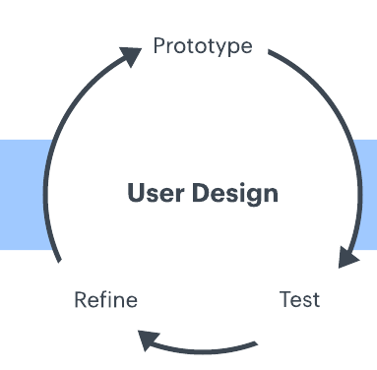
The application at hand will be using RAD for the development. RAD or rapid application development is a development lifecycle that allows for quick builds to be made for applications. Due to time limits and the end application needing to be built within a 6-month time period RAD development is suited for the application.
This type of development type is suited for the prototyping style chosen as this allows for many projects to be built with simple testing and evaluation. These testing stages and evaluations are then used to develop another prototype which should be more refined than the last iteration of the application. Once this cycle has happened a few times the prototype should have gone through a series of changes and refinements until the prototype at hand is more suited for the client’s needs. This cycle should continue until the end prototype is suited for the end client perfectly but due to time constraints the application at hand may only be refined a set number of times.
Unlike many other development lifecycles, the RAD development cycle allows for cheap and quick prototypes to be made. This allows for smaller companies to develop applications without the worry of overspending. Although each refinement within the development could cost it would not be as much as other life cycles such as Waterfalls and spiral methods. The system also allows for the client to see the application prototypes and allows for the system to change over time to a system that the end client is happy with. This is benefited to a system such as this as it means the end system will work as the user intends and allows for their chosen outcome to be developed. Although in many cases this may mean restarting the project this would end up costing the company more money but given the end prototype is good during one of the early prototypes it means the system would be a lot cheaper than many other development cycles currently existing.

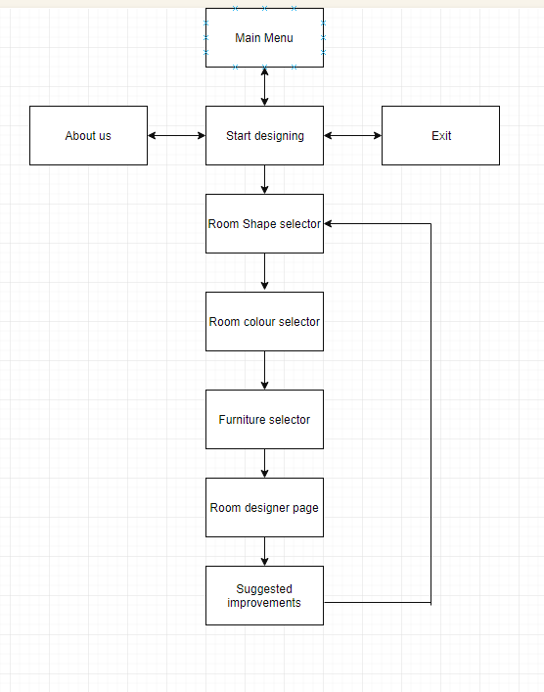
10.2 System flow

The system follows a simple flow and moves from page to page with ease. The system allows for the user to restart once the application has been followed through and allows for an escape from the system within all pages.
All information is passed from page to page allowing for all choices within the system to be stored and moved.

11. Design & Implementation
The user will first of all have to select the room they wish to design. This allows for a better design outcome to be given in the end along with a reminder to the user which room they are designing.
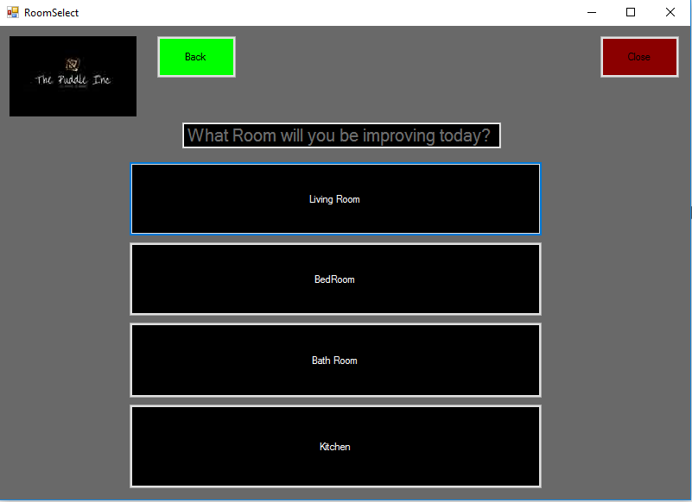
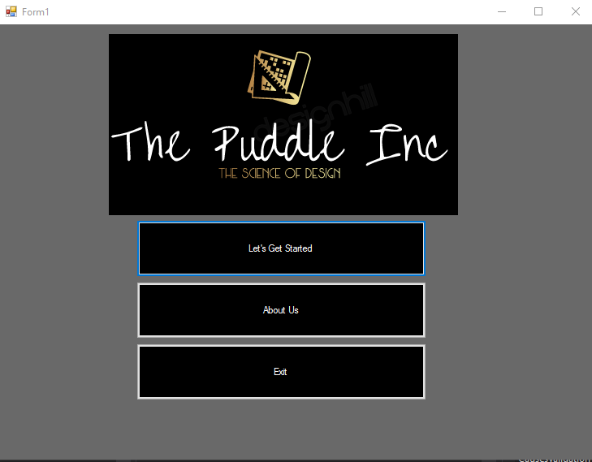
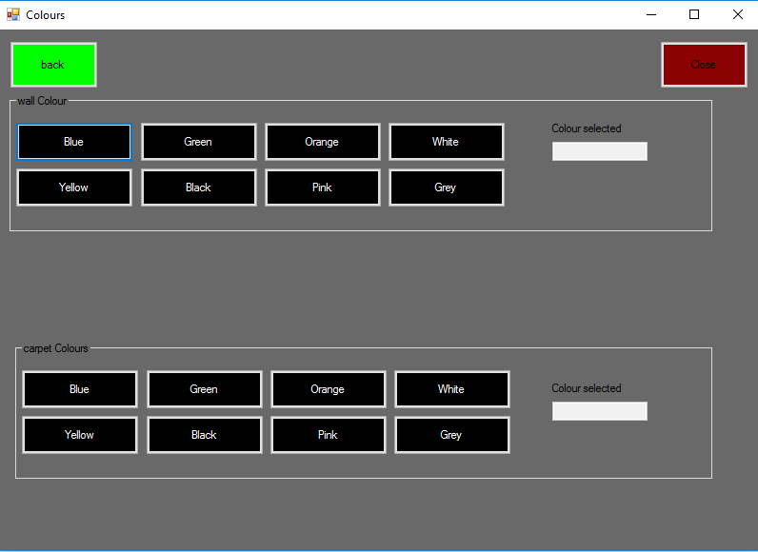
The user will then have to select the colour of floors and walls they wish for the chosen room. Along with this they will have to chose from two shapes of room which are currently in the system. Although this is limited it will be expanded upon in future developments.
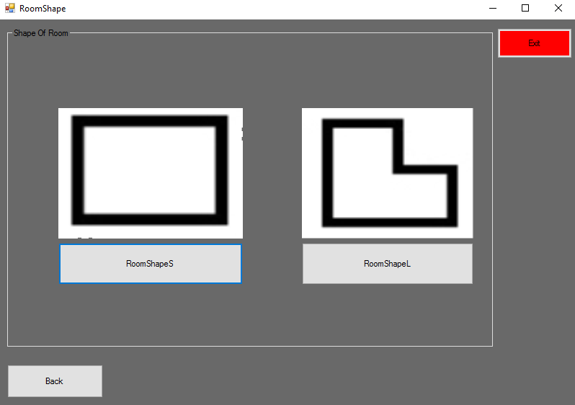
The user will then have to select the furniture they wish to put into the room. There have been no limitations in regards to the future as if someone wishes to have furniture in a different room than normal, they are welcome to. The system will then load this room and show the user the furniture they have selected along with the colours they have chosen prior. This room can then be saved for later use.
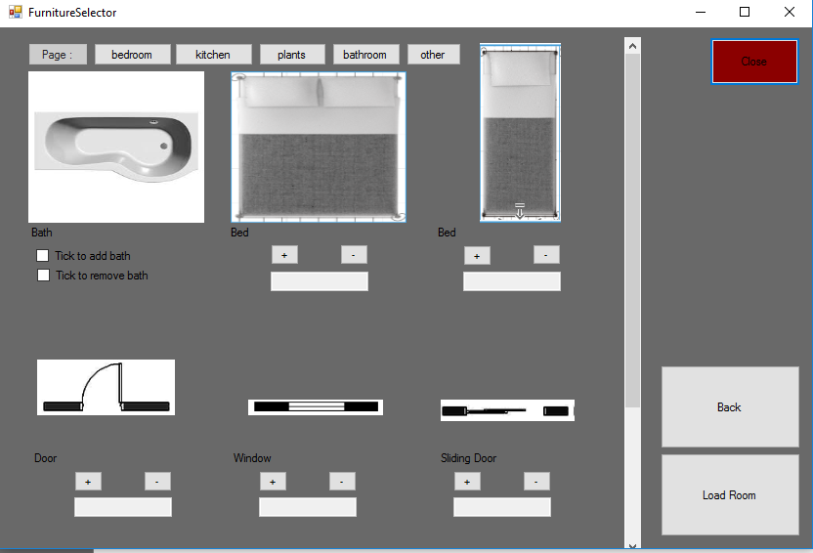
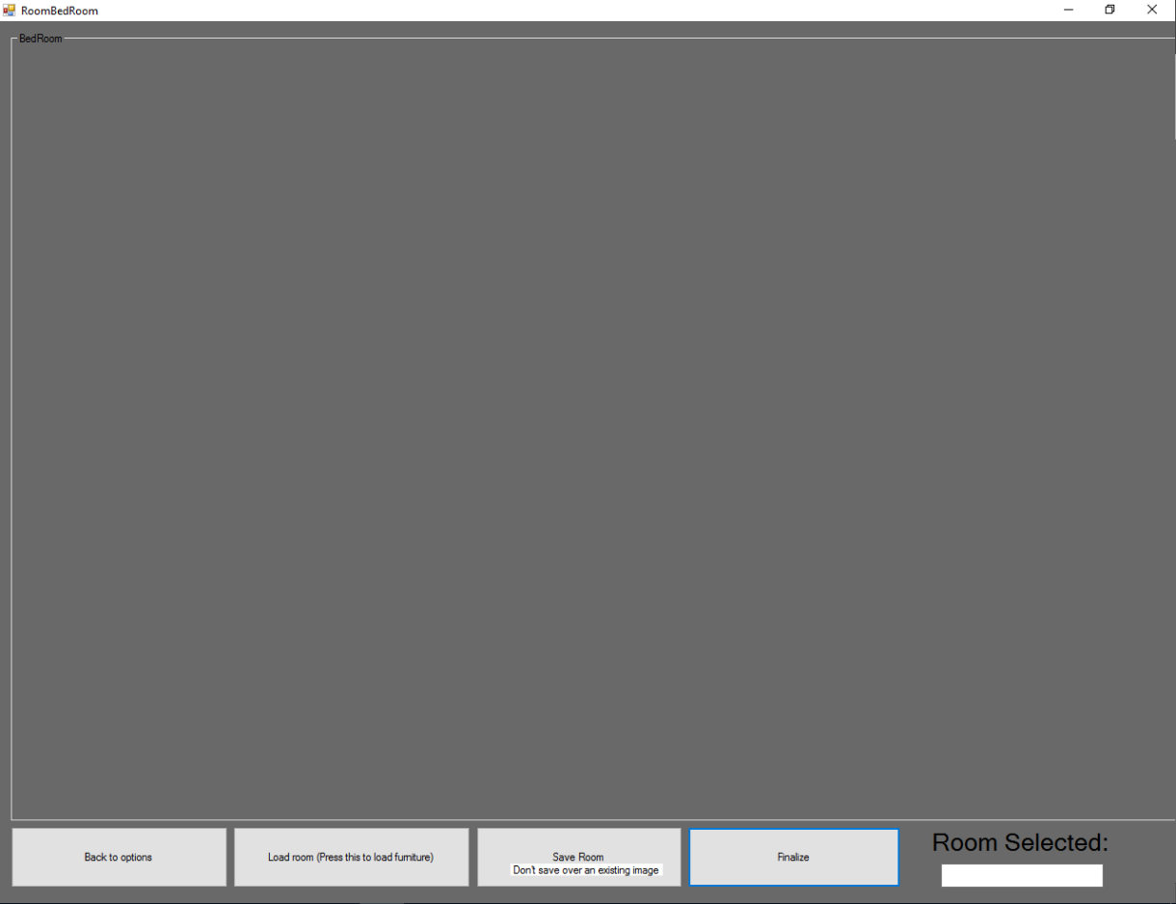
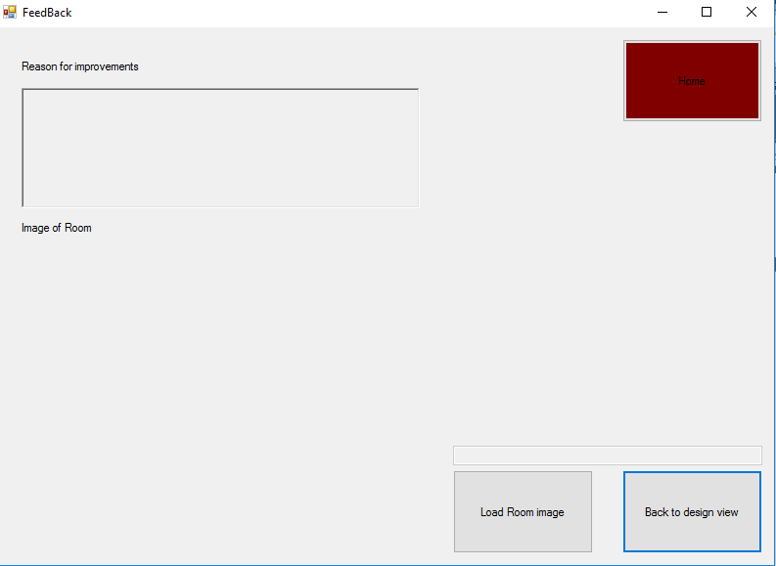
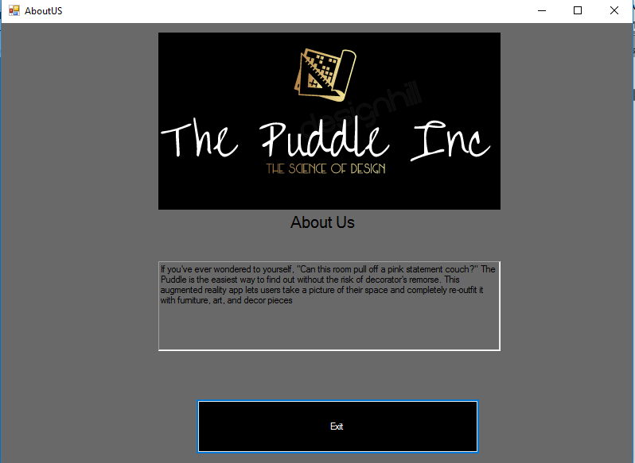
Once the room design is loaded into the system it will display an image of the room designed and will give the user some improvements for the room they have designed. This allows for the room to be designed in a way that will improve the life of those using the system and will allow people to have a professional outlook on the room they have designed.

12. Evaluation

The main system was achieved overall but some functions were not included due to some limitations on the system at hand. An example of this would be the rotation of furniture and a purchasing system for the backend of the system. This could have been implemented from the early stages of the system as attempting to add it onto the backend at a later stage caused some technical issues. Due to the client not needing a purchasing system this was overlooked as it was not needed for the client’s current needs. The rotation of the images could have been added but due to all the images needing to be duplicated it was shown the system would lower loading speeds which was not welcome in the application.
The system allows for the user to design a room of their choosing with the furniture of their choice. It covers fire escapes and forces the user to add a window or a door to the end system and allows for the addition of many pieces of furniture. If the user does not add a door to the end system or a window the application will refuse to proceed past the furniture screen and will display a message asking the user to add one. This is good as it covers one of the main aims of the system which is to prevent as many fire deaths as possible.
The system includes some Feng Shui in regards to a message on the end of the system for recommended improvements. Due to my limited knowledge in Feng Shui some simple messages have been show but given more knowledge in the area more accurate messages will be displayed.
The choice of using a desktop application instead of using a mobile application was a good choice as the room design screen and the buttons on the application may have been too small if added onto a mobile device. This would also limit the users using the system as they may struggle to use smaller buttons.
The system had a single flaw in the final prototype as seen within the application maintenance which was if the user wishes to save their current room over an old room the system would break. Due to this being down to the user where they wish to save the room it has been advised to users not to do this.
Given the alternate choices in the room design applications the system at hand is recommended. Although the current system does not contain the styling and choice of other systems currently accessible it does limit fire deaths and does give feedback to the user on the room, they have designed which no other application offers.

13. Conclusions and Recommendations
Given the prior research into the art of Feng Shui prior to the application development along with a lack of design knowledge it may be worth developing or further developing the system with more knowledge in these areas. It may allow for a more in-depth recommendation page to be developed for the user and may allow for a better choice of system design to be implemented.
It may be recommended within the future development to add a purchasing system a login with a login system connected to a database. This will allow for more security and will allow for the application to make a profit as currently the application does not sell any items and only allows people to design a home. It may also be recommended to hire professional designers for the application as the current design of the application does not meet many standards in design. The only issue in regards to this is more validation which was unneeded for the client’s current needs.
Due to the majority of the data being hard coded for the system at hand it may be suggested for future development to add a database to store this information. This although is currently unneeded for the primary function of the system at hand it would be needed if more information was to be added to the system. Due to the system only being built for a small amount of people to use and for it to be downloaded locally onto machines it was not needed as all the information was stored into the file itself.
The choice of making the system offline was a good choice as this did limit the security needs for the system overall. Although if it was to be moved online it would need to have more security if the user was to edit any of the files on the current system all that would happen is their version downloaded would break. This would only affect them and not others using the system.
The research methodologies chosen allowed for a good system to be designed and allowed for a more in-depth look into the area of development prior to the creation of the system. Given the system was for a small-scale application with a very minimal budget the system allowed for these to be done.
Although another more complex language could’ve been utilized for the development of this application the choice of Visual basic was chosen due to the simplistic culture and the online materials which could be utilized to help develop the application. This allowed for the code to work with minimal issues along with the implementation of unique code due to the language being simplistic and easy to learn. Given if the system was to be developed upon it may be recommended to change language to Java or C# due to this being more commonly accepted within many companies but due to this being a small-scale application the language suited it perfectly.

Test number | Test Name | Test description | Test Outcome | Fix if applicable
1 | Launch application | The launching of the application | The application launched
2 | Page navigation | Test the page navigation | Page navigation worked
3 | Button presses | Test each button to see if they work as intended | Each button worked as intended
4 | Select each room | Select each room to see if the end room being designed changes | End room changed
5 | Select room shapes | Selecting each room shape to see if the room shape changes | Room shape changed
6 | Change colour of the walls | Change colour of the walls | Colour of walls changed
7 | Change colour of the floor | Change colour of the floor | Colour of floor changed
8 | Save room to a new drive | To save the chosen room to a new drive | Saved to new location
9 | Save over old room file | To save the current room over an old file | Crash | No fix. Users have been advised of issue

Application Maintenance
When the program is to be tested in the future it may be recommended to follow this maintenance table as it allows for the tester to see any issues that arise. The system has been tested and this is an example of a test which was done during the development of the system.

These tests were completed throughout each stage of the development of the system and allowed for many of the main issues to the located and nullified without issue. This maintenance plan should be run through each prototype of the system as without it there could be many issues which could arise and damage the system.

14. Reflection

The system showed me that although visual basic is an easy to learn application it did mean that the system was basic. This although was enough to make the system at hand work for the clients need could have changed in the future. During the development of the system showed many unique and alternative methods of programming and allowed for my skills within coding the expand a fair amount.
The system also showed that my design skills may not be the greatest and could do with a review and update if I was to design the system for a larger company. Although my current design skills are sufficient it would not suffice for an actual application.
The final aspect I would have done is more research into SQL and other database technologies as adding this as one of the first stages of the development would have made the task of adding a database a lot easier.
It was also clear when showing other developers my code that more comments and more structure is needed. This although did not affect me would have helped other developers add onto and maintain the system with more ease than they currently can. This is normally a common feature within the development of the system but due to the developer being the only one to see the code the convention was not needed as much as it may be needed in larger projects.

References
References
1. Evans, J., Macrory, I., & Randall, C. (2016).
Access date 27/11/2018
Measuring national wellbeing: Life in the UK, 2016. ONS.
Cited from: https://www.ons.gov.uk/peoplepopulationandcommunity/wellbeing/articles/measuringnationalwellbeing/2016#how-good-is-our-health.

2. KIMBLE, G. A. AND SCHLESINGER, K.
Access date 27/11/2018
Topics in the History of Psychology
Kimble G, Schlesinger K. Topics in the History of Psychology. 3rd ed. Hoboken: Taylor and Francis; 2014. P 116
Cited from:
https://bit.ly/2ApwFHz

3. SGROI, D.
Access date 27/11/2018
Happiness and productivity: Understanding the happy-productive worker
SGROI D. Happiness and productivity: Understanding the happy-productive worker [Internet]. 4th ed. 2015 [cited 27 November 2018].
P8
Cited from:
http://www.smf.co.uk/wp-content/uploads/2015/10/Social-Market-Foundation-Publication-Briefing-CAGE-4-Are-happy-workers-more-productive-281015.pdf#page=9

4. BEATTIE, A.
Access date 27/11/2018
Feng shui dictionary
Beattie A. Feng shui dictionary. San Diego, Calif.: Thunder Bay Press; 2003.
P 1-11
Cited from: https://books.google.co.uk/books?id=RV4K8NHEitoC&printsec=frontcover&dq=feng+shui&hl=en&sa=X&ved=0ahUKEwjC0J2IufTeAhVqJsAKHY9ZBxYQ6AEIQDAE#v=onepage&q=feng%20shui&f=false

(5) Issac Newton: A Biography
https://books.google.co.uk/books?id=11w1DgAAQBAJ&pg=PT13&dq=issac+newton+light+prism&hl=en&sa=X&ved=0ahUKEwjVn9aX64vgAhUwUhUIHefECTMQ6AEIKzAA#v=onepage&q=issac%20newton%20light%20prism&f=false P12
Accessed on 27/03/2019
(6) Goethe’s theory of colours ; https://books.google.co.uk/books?id=8Yg5AAAAcAAJ&printsec=frontcover&dq=goethe+colour+theory&hl=en&sa=X&ved=0ahUKEwjlstPi4ovgAhUnShUIHX05BigQ6AEIKTAA#v=onepage&q&f=false
27/03/2019

7. Dak Kopec
Access date 27/11/2018
Health and Well-being for Interior Architecture
Routledge. Taylor & francis Group New York And London.
P1
Cited from: https://books.google.co.uk/books?id=2gYqDwAAQBAJ&printsec=frontcover&dq=interior+design+health&hl=en&sa=X&ved=0ahUKEwi_qJPcvPTeAhWOOsAKHRZfA2UQ6AEIMTAC#v=onepage&q=interior%20design%20health&f=false

8. https://www.stylewithin.co.uk/interior-design-services/property-renovation-cost-estimating/major-home-renovation-costs/
Accessed on 05/12/2018

9. Statistical Bulletin 16/18
Access date 27/11/2018
Fire and rescue incident statistics: England, year ending March 2018
P7-12
Accessed on 05/12/2018
Cited from
https://assets.publishing.service.gov.uk/government/uploads/system/uploads/attachment_data/file/732555/fire-and-rescue-incident-march-2018-hosb1618.pdf

10. John Krasny, William Haber, William Parker, Vytenis Babrauskas
Access date 27/11/2018
Fire Behavior of Upholstered Furniture and Mattresses
P 8
Accessed on 05/12/2018
Cited from
https://books.google.co.uk/books?id=tKbigP9ZBscC&pg=PA9&dq=fire+caused+by+furniture&hl=en&sa=X&ved=0ahUKEwjknaT6wvTeAhVSQ8AKHaCFDOYQ6AEIKTAA#v=onepage&q=fire%20caused%20by%20furniture&f=false

11. https://www.statista.com/statistics/298661/united-kingdom-uk-public-sector-expenditure-fire-protection-services/
Accessed on 05/12/2018

12. https://www.crisis.org.uk/ending-homelessness/about-homelessness/
Accessed on 05/12/2018

13. https://books.google.co.uk/books?id=-vtsBQAAQBAJ&pg=PA135&dq=victorian+pineapple&hl=en&sa=X&ved=0ahUKEwj6op-3oOngAhVlUBUIHb31C5YQ6AEIKTAA#v=onepage&q=victorian%20pineapple&f=false p135
Accessed on 05/12/2018

14.https://books.google.co.uk/books?id=gam10TAOZusC&pg=PA160&dq=purple+egypt+luxury&hl=en&sa=X&ved=0ahUKEwin58P2oengAhX9VBUIHSoUCVMQ6AEILDAA#v=onepage&q=purple%20egypt%20luxury&f=false p160
Accessed on 05/12/2018

15. https://planner5d.com/e/
Accessed on 05/12/2018

16. https://www.ikea.com/ms/en_JP/rooms_ideas/splashplanners.html
Accessed on 05/12/2018

17. http://www.sweethome3d.com/
Accessed on 05/12/2018

18. https://www.gsmaintelligence.com/
Accessed on 05/12/2018

19. https://www.apple.com/uk/iphone-xs/
Accessed on 06/12/2018

20. https://www.nhs.uk/conditions/vision-loss/
Accessed on 06/12/2018

(21) https://www.diverseinteractive.com/?gclid=EAIaIQobChMIx-XrkbD03gIVqLXtCh2zrQbcEAAYAiAAEgLymvD_BwE
Accessed on 06/12/2018

(22)https://www.ssls.com/?gclid=EAIaIQobChMI0p-b7ced4AIV573tCh0vbAg9EAAYAiAAEgKVz_D_BwE#certs
Accessed on 06/12/2018

(22)Sheriff, P. Designing for Web or Desktop? Microsoft Developer Network. [Online] Microsoft, 2002. http://msdn.microsoft.com/en-us/library/ms973831.aspx.

(22).https://www.vive.com/uk/product/?gclid=EAIaIQobChMIsMuz87D03gIVrrvtCh2TogfsEAQYASABEgK7APD_BwE
Accessed on 06/12/2018

(23). https://visualstudio.microsoft.com/
Accessed on 02/12/2018

(24)https://www.unf.edu/~dtanner/dtch/dt_ch5.htm
Accessed on 06/12/2018

(25) https://hbr.org/2011/06/the-success-equation
Accessed on 06/12/2018

(26) Wedawatta, B et al. Case study as a research strategy. Salford University. [Online] Unknown. http://usir.salford.ac.uk/18250/1/6_Wedawatta_Case_study_as_a_research_strategy_ Investigating_extreme_weather_resilience_of_construction_SMEs_in_the_UK.pdf.
Accessed on 06/12/2018

(27) research-methodology.net. Positivism. research-methodology.net. [Online] research-methodology.net, 2014. http://research-methodology.net/researchphilosophy/positivism/.
Accessed on 06/12/2018

Ethics Approval Form

Before you complete this form, please take time to carefully consider the following questions:

Have you considered yet whether there are any problematic ethical issues in your proposed research project? If you have not you should talk to your Course Tutor or Supervisor.

Have you already completed an Ethics Approval Form? Yes – then you do not need to complete this form

No – please complete this form in as much detail as you can

Name: | Callum Poole
Project/Research Title: | An investigation into applications to aid the effectiveness of interior design
Name of Supervisor: | Jeanette Adams
School/Dept. | NPTC GROUP
Faculty: | Computing
Proposed Start Date: | 28/10/2018 | End Date: | 07/05/2018

1. Summary of planned research (please indicate below the purpose of your planned project/research, together with your aims, main research questions and research design – you should continue onto a separate sheet if necessary)
An investigation into applications to aid the effectiveness of interior design

Do interior design application benefit from the addition of design elements such as colour theory and Feng Shui?

Does Feng Shui decrease depression within its user?

Is interior design the main cause of fire within the U.K?

2. Methodology (You need to be clear about the methodology you intend to use in your study; this could include any number of methods, so either tick those shown below (where appropriate) or put the details in the box marked *)

 | Interviews | X | Participant Observation |  | Use of personal data
 | Focus groups |  | Questionnaire | X | Literature Review
 | Performance | X | Presentation |  | Other (state below)*

3. Participants - Does your proposed project/research involve human participants?

X | 1. Yes, as a primary source* |  | 2. Yes, as a secondary source* |  | No- go to section 4

*If you have ticked yes, it is likely you will need an Advanced CRB check before undertaking your study

If yes, indicate who your participants are:

 | Early years/Pre-School children | X | Adults - give details below
 | School age children |  | Vulnerable people - give details below
X | Young People aged 17-18
 | Unknown at this stage

4. Ethical issues - you should tick all that apply

 | Administration of drugs incl. alcohol |  | Deprivation
 | Unpleasant stimuli in any manner or form |  | Active deception or withholding information
 | Collection of highly personal information |  | Payment

5. Are there any ethical concerns other than those listed above? (Continue onto a separate sheet if necessary)

6. If there are any ethical concerns, please state how you intend to minimise any risk of harm or distress that could be caused (continue onto a separate sheet if necessary)

You should enclose any materials (e.g. questionnaire, interview schedule), plus the Consent Form, and the Debriefing Sheet when submitting the Ethics Approval Form to your supervisor.

Student Signature __Callum G Poole__________________________________________Date: _____18/12/2018_________

**********************************************************************************
 | Advanced CRB check required |  | CRB confirmation received - Date:_______________
 | Recommendation of approval given at Faculty Level
 | Approval not given at Faculty level – forwarded for discussion at the next meeting of the University Ethics Committee
Comments:

Signature: (Assistant Dean/Head of School) _______________ ____________ Date: ________________

Faculty recommendation endorsed by the Ethics Committee | Chair’s Initials |  | Date

