When considering traditional printed books and digital eBooks; which is the healthiest choice for the reader and the most sustainable choice for the environment?

Amber Morris
1602592

Submitted in partial fulfilment of the requirements for the degree of
BA (Hons) Graphic Design.
University of Wales Trinity Saint David, Swansea.

Tutor Dr Scott L. Smith
M6X01791

Wednesday 12th December 2018
Word Count 5,939

Certificate of authenticity 1

Table of contents 2

Summary of topic 2

List of illustrations 3

Introduction 4

Chapter 1

“The eBook versus the traditional book” 6

The practicalities and enjoyment of reading 6

1.2 Children’s imaginations and the effects of digital reading 9

Chapter 2

“The future of the traditional book” 10

2.1 Loss or regeneration of an art form? 11

Chapter 3

“The future of the traditional book within education” 13

The effects eBooks have on education 13

Making libraries desirable places for the younger generation 17

Chapter 4

“Sustainability of the eBook” 19

Cost, life span and wastage values of eBooks and traditional books 20

Conclusion 23

Bibliography 27

Total word count 5,939

Summary of topic

This essay studies eBooks and traditional printed books in regard to which is healthier for the reader and which is most sustainable for the environment. It looks at various factors which contribute to the argument, including; reading enjoyment and practicality, use within education, books as an art form and the carbon footprint of reading. The conclusion discusses whether there is a solid answer to this question or whether the question is purely ambiguous and entirely open to personal judgement.

List of illustrations
Figure 1: Matas, M. (2011) Al Gore - The Next Generation Digital Book [photograph] [online] Available at: https://www.ted.com/talks/mike_matas (Accessed: 21 October 2018)

Figure 2: Kidd, C. (2011) Haruki Murakami 1Q84 [book cover design] [online] Available at: https://www.goodreads.com/book/show/10357575-1q84 (Accessed: 23 September 2018)

Figure 3: Voltolina, L. (14th Century) Liber Ethicorum des Henricus de Alemannia [oil painting] [online] Available at: https://www.npr.org/sections/ed/2016/04/05/472139919/wax-tablets-chicken-rustling-and-the-medieval-roots-of-the-modern-university?t=1541362153402 (Accessed: 21 October 2018)

Figure 4: Bierut, M. (2000) Christoph Niemann - New York Public School Library, [photograph] New York Public School Library Scheme [online] Available at: https://www.pentagram.com/work/the-lbrary-initiative/story (Accessed: 21 October 2018)

Figure 5: Bierut, M. (2000) L!BRARY [logo] New York Public School Library Scheme [online] Available at: https://urbanomnibus.net/2010/05/the-robin-hood-library-at-bronx-ps69/ (Accessed: 20 November 2018)

Introduction
This essay explores various factors that contribute to determining the best choice between a digital eBook and a traditional printed book. The argument considers the term healthy regarding the reader and sustainable regarding the environment and each chapter will discuss various aspects that have an impact on the overall decision. The chapters see various periods throughout history being discussed, compared and contrasted for the benefit of each theme rather than portraying an accurate chronological timeline. Therefore, the intention of the research is to define whether or not a decision can be reached regarding the better choice for reading.

Chapter one looks at thoughts from renowned authors in relation to the enjoyment of reading and how children interact with digital reading. Various viewpoints are considered, spanning from those of 1967’s intellectual Marshall McLuhan, to present day children’s author Mac Barnett. Theories from digital pioneer Mike Matas are contrasted with more traditional views regarding the use of printed books and their place in today’s society.

Chapter two considers books as an art form and connections between The Arts and Crafts movement and the millennial book trade. Each of these periods in history is then discussed in relation to its impact on today’s book trade. Chip Kidd’s book cover designs are explored in relation to the beauty of traditional printed books and how this secures their place in today’s market. The views of Christi Cowan, journalist Paula Cocozza and Random House’s Madeline Mcintosh are then discussed in relation to the future of traditional books.

Chapter three explores the impact that technology has had on education throughout history and whether it has benefitted or hindered our learning processes. Writing from Purdue University is then discussed regarding technology’s impact on the education system, leading this section into the current use of eBooks within education. The thoughts of author Alison Flood and ecologist/author Michael Carpenter are then considered. Lastly, libraries are discussed in regard to whether or not the younger generation view them as desirable places. Michael Bierut’s L!BRARY scheme is examined and therefore the impact on the future of traditional, printed books.

Chapter four discusses the sustainability of reading. Thoughts and findings from ecologist Michael Carpenter are revisited along with the carbon footprint of printed books and eBooks. Comparisons between the two forms of reading are made and this leads the section toward how an individual’s reading behaviour can impact the environment. The chapter finishes with views from Indie publisher Melville House’s Dennis Johnson and how he believes that the consumers choice of reading is sometimes a subconscious decision made by marketplace advertising and large retailers.

The conclusion explains whether a definitive answer can be reached regarding the better choice for the reader and the most sustainable choice for the environment between eBooks and traditional books. It will discuss the main opposing arguments and findings to determine whether the argument is answerable or whether it is ambiguous and purely down to an individual’s taste and behaviour.

Chapter 1

When considering traditional printed books and digital eBooks, if one was to try and decide which is the most enjoyable item to read, they may want to take into consideration the books physical qualities. The weight of the item, it’s aesthetic and portability are all contributory factors in determining this decision. One could also consider the ritualistic aspect and interactive values of reading, for example children’s books are often used as transportation to other worlds through the imagination that they inspire. This chapter also looks into the enjoyment of reading each form of book and how the choice can alter the way in which one reads.

1.1
There will always be people who fight against new technologies and fear the unknown, as people feel safe with what they know and understand. Looking back to 1967, McLuhan and Fiore (1967, p. 96) referred to The Dance of Death in medieval art and how it resembled peoples fear of print and the hugely innovative yet practically unknown technology that came along with it. One might suggest that these fears are re-living themselves in the current day, as traditional books are threatened by digital reading alternatives “electric technology shapes, works over, alters-massages-every instant of our lives.” (McLuhan and Fiore, 1967, p. 148).

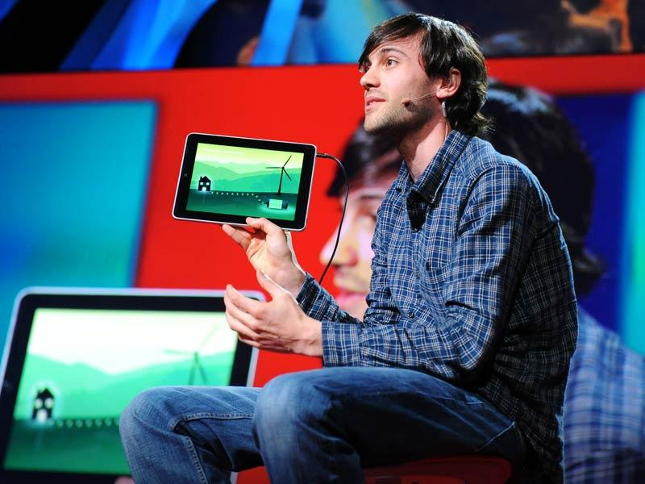
Fig. 1: A next-generation book

Although there will always be people who contest change, it is fair to suggest that there will also be just as many people who pioneer these changes. People who develop solutions and look to the future for more economic and effective alternatives to everything we use. When looking back to 2011, digital reading was considered a much fresher concept than it is today. Mike Matas (2011), a previous user interface designer for Apple presented his next-generation book by Al Gore [fig 1], for Push Pop Press. Matas claimed this highly interactive iBook was to be the future of reading (Matas, 2011). The book which included infographics and animations, aimed to enable learning in an interactive and interesting manner for the reader. In an age where life is evolving digitally; where we can answer text messages on our watches and have cameras inside our fridges for easier shopping. It is fair to suggest that Matas’ iBook perfectly portrayed the positives of technological advancements in 2011. However, upon reflection today, it is clear that this was not the future of reading as traditional books are still here and arguably stronger than ever.

Traditional books have been described as making a comeback recently. Many argue that printed books make the enjoyable little habits and quirks of reading a reality which isn’t achievable through a screen. Paula Cocozza, award winning author and feature writer for The Guardian supports this by saying “You can’t turn down a corner”, “or flick the pages to see how far you have come and how far you have to go.” (Cocozza, 2017). In today’s digital world, where everything is connected and constantly evolving, Cocozza argues that eBooks are looking out-of-date, tired in comparison to their traditional, printed alternatives. She writes “you just can’t do a shelfie with an e-reader” (Cocozza, 2017). Referring to social media selfie trends but in relation to her bookshelf, she hints to daily evolving trends and the huge realm of social media where particular importance is played upon superficial aesthetics. Many authors and book fans believe we should stick with what works in relation to the traditional books which both look good and are fit for purpose. If something isn’t broken, why fix it?

In 2014, Maddie Crum writes about authors tendency to favour traditional books over modern digital alternatives. Her article Authors weigh in on print versus E-Books for The Huffington Post, includes interviews with authors Sue Monk Kidd and Anthony Doerr. She claims they both enjoy the ritualistic aspect of reading a printed book. Kidd enjoys the stability of a book, the weight and substance making the story more authentic for her. Doerr, likens reading a book to taking a hike (Crum, 2014). Like Doerr, many people enjoy the sense of progress when reading a physical book; feeling and seeing how far they have come with every turn of the page, consuming the story with each chapter passing. Thus enabling the reader to feel more involved in the writing, a quality which could be suggested as unachievable with digital, screen based reading. Can the same feeling be achieved by watching the percentage bar crawl along at the bottom of the screen? The points raised by Crum (2014) are interestingly challenged by a reader of the article, Josiah Jackson. The reader’s comment could be likened to the views of people who pioneer technological change and believe Crum’s point of view is stuck in time. Jackson suggests that technology is a natural development and words are no more meaningful printed on a page than they are when read through a screen, when he writes “This article should read "Authors struggling with the digital age".” (Crum, 2014).

Many cannot deny the ease of an eBook in certain situations, Cocozza claims the two are able to sit side-by-side in today’s market due to their individual strengths (Cocozza, 2017, p. 58). Christi Cowan supports Cocozza with his Niche Gratification theory. Cowan’s thesis Printed books versus e-Book formats: a study using Niche Gratification Theory presents that books and eBooks have strong individual niche’s which enable them each to have a healthy market within the reading population (Cowan, 2013, p. 60). Many people are optimistic for the future of both forms of reading due to their individual strengths being so diverse.

Cowan’s research found traditional books to be most effective for mental processing within education and eBooks to be most efficient for their ease and portability. The eBook was found to be most successful when following the format of a traditional book (Cowan, 2013, p. 55-58) this could be due to familiarity and legibility for the reader.

1.2
In opposition to Matas’ (2011) beliefs about technology aided learning and the interactive values of an iBook. Mac Barnett, New York Times award winning children’s author, believes in the magic of a physical printed book. It is said that he utilises his books to enable children’s imaginations and through the use of his storylines and illustrations, children can travel between different worlds when turning the pages (Barnett, 2014). One might argue that this concept is not achievable digitally and that illustrations often lose their magic when viewed through a screen. People - children and adults alike, often use the term getting lost in a book, it could be said that getting lost in a kindle doesn’t have quite the same ring to it. Paula Cocozza (2017) also believes that children’s books don’t have the same effect on a device as it is much more difficult to get into the storyline. There is the temptation of games, internet and social media distracting attention which may stop the reader from becoming fully immersed.

Chapter 2
When considering books as an art form, eBooks are often classed as secondary to their traditional printed ancestors. Book covers are often so well designed and exquisitely produced that they sell the book aesthetically, regardless of their content. “Without having books embedded in our physical environment, it would be so much harder to help readers connect with new books and authors.” (Library Journal, 2011). Many book lovers enjoy the ritual of purchasing a physical, printed book. First perusing the bookshelves then flicking through the pages and admiring the ornately designed covers. Once the book is purchased, inhaling the new smell and cracking its spine open, then after it has been read from cover to cover, displaying it on their bookshelf at home. Some would argue that buying a book on a kindle doesn’t evoke any of these feelings or experiences, yet we still buy them. Is it purely for the ease, convenience and ability to carry multiple stories around in your handbag or are there other reasons why digital books have been so popular in the last ten years? This chapter aims to determine if this question can be answered.

2.1
Earlier this millennium, books were being mass produced using thin paper stock and pages which turned yellow, this meant books were cheaper than ever to produce and purchase. It could be suggested that these factors deprived part of the experience of buying a traditional book. At this time, it was rarer to see high quality, printed hardback books than when printing first evolved and bespoke bookmaking was argued as on the way to extinction. Paula Cocozza (2017) suggests that these elements all contributed to the birth of the eBook. Stating that people were hasty to swap to digital due to the traditional alternative losing its quality which many people appreciated and therefore thoroughly missed.

This thought could be likened to the Arts and Crafts movement from the 19th Century. When William Morris, a pioneer of the high quality and handcrafted ran his emporium on the belief that people bought excellence “Have nothing in your houses that you do not know to be useful or believe to be beautiful” (Victoria and Albert Museum, 2018). His items were produced to last, with more man power and longer production times than other items but people were willing to pay for these qualities. The industrial revolution affected his business as new items were becoming readily available in mass, quickly and cheaply through the birth of the machine. It became fashionable to buy more disposable items along with evolving trends instead of items which would last a lifetime. This revolution could be likened to the millennial book trade, where books were being cheaply mass produced. It could be suggested that William Morris was an early example of the fight against the development of technology with The Arts and Crafts movement having many similarities to today’s book trade and the fight against digital reading.

Today sees a resurgence of the traditional printed book, with artists, designers and publishers producing beautiful, high quality books and covers once again. These factors are all encouraging the buyer into wanting to own the physical item again, in harsh contrast to the temporary, digital alternatives. Random House’s Madeline Mcintosh is completely confident about the future of traditional books.

as long as we stay true to our core contribution to the market--selecting great books and helping their authors to connect to as many readers as possible--then I truly believe publishers will be OK. We do, of course, have to adapt to readers' changing preferences and habits, and at Random House we're actively embracing the very positive opportunities that are opened up by digital publishing and distribution (Library Journal, 2011).

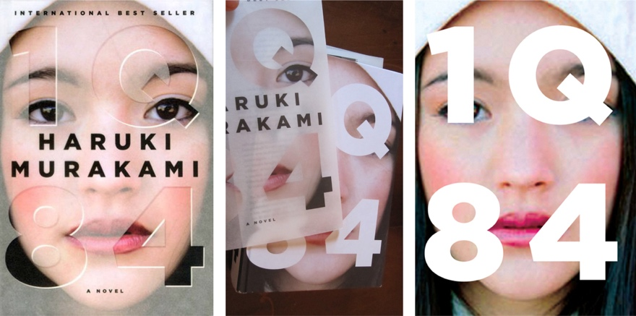
Fig. 2: 1Q84

The quality of the book cover could be argued to be just as important as the book’s content. The job of the designer is to attract attention and entice the reader into purchasing the book. Award winning book cover designer Chip Kidd (2012), believes that his covers reflect the book’s storyline and embody the stories message. Kidd is known for creating out of the ordinary covers, which really make you think and draw in your attention; whoever said never judge a book by its cover, had probably never met Kidd as this seems to be his work and design ethic. One of his most famous covers for 1Q84 by Haruki Murakami [fig 4], has many similarities in its style and concept to the work of designer Stefan Sagmeister with the use of clever hidden messages. The cover and dust jacket each have their own design but when combined they create another look; a metaphor for the hidden meanings within the story. This cover was also published to eBook but Kidd (2012) states that it doesn’t have anywhere near the same effect on a kindle. The experience of removing the dust jacket and revealing the cover underneath is entirely lost to the digital reader.

Chapter 3
When comparing eBooks and printed books, the enjoyment and aesthetics of the reading experience could be described as just the very tip of the iceberg. There are many other factors to consider, such as the way we learn through each medium. Do eBooks help or hinder education? This chapter looks into possible factors that contribute to answering this question.

3.1
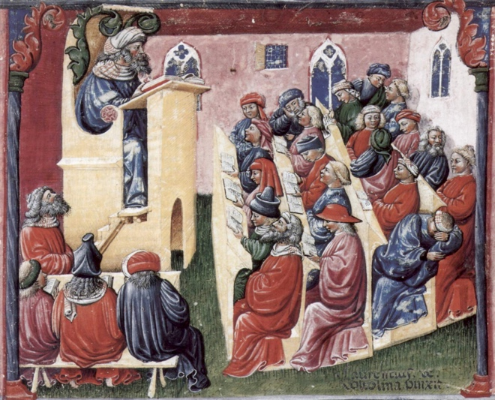
Fig. 3: Liber Ethicorum des Henricus de Alemannia

One could look back to a time before modern technology and ask what has changed? Technological advancements have undeniably developed certain things for the better; enabling wider spread access to education and the ability to share points of view and research right across the world. Pinkerton (2016) looks back to the medieval painting [Fig, 1] Liber Ethicorum des Henricus de Alemannia by Laurentius de Voltolina. The painting portrays a 14th Century Italian lecture theatre and at first glance, it may seem that not much has altered at all. Room layout and student characteristics could be likened to the modern day but this is where the similarities end. Technology is often described as having shaped, evolved and broadened the horizons of our education system. Pinkerton (2016) claims that many years ago, teaching was confined to the classroom and opinions restricted to those teaching. Today sees the ability for these theories to be shared across the world. These new methods, research and ideas are all thanks to technology and the effect it has had upon our education system.

When considering how technology has changed education, one could also consider how design has evolved since the introduction of computers. Thirty years ago, graphic design was predominantly hand produced. The Apple Mac was introduced into mainstream design studios in the nineties and from there things began to change very fast. The computer has enabled work to be completed faster and with much more ease. However, many would argue it has also limited creativity and is much more difficult to create something original than when things were done by hand. It is the designer’s choice to work solely on the computer and many designers still create things by hand, keeping in touch with their traditional roots. Designer Stephan Sagmeisters outcomes are often made possible due to the use of technology but the idea behind them and the initial craft is hand rendered which gives his work a unique quality.

When thinking about the use of an eBook within education, the devices are sometimes viewed as a tool to support reading comprehension and literacy in the learning to read process. Alison Flood (2014) found reading comprehension to be worse from a screen than from print in her article for The Guardian, she looked at the 2013 study, Reading linear texts on paper versus computer screen: Effects on reading comprehension. In this study, US Scholar Anne Mangen states that “students who read texts in print scored significantly better on the reading comprehension test than students who read the texts digitally” (Mangen, Walgermo and Bronnick, 2013). Doerr’s notion of reading a book being similar to taking a hike (Crum, 2014), is echoed when Flood claims reading a traditional book gives one a much greater sense of progress than when reading from a screen (Flood, 2014). It is suggested that there is a greater capacity to recall details when reading from a printed book because of the ability to get lost in the language and storyline more easily. Flood claims this to be true and states “readers using a Kindle were "significantly" worse than paperback readers at recalling when events occurred in a mystery story” (Flood, 2014). Author Michael Carpenter (2016), agrees with Flood, writing about his own experience of reading comprehension and claiming to achieve a better rate of retention personally when reading from a printed book.

These findings can be supported by Kozminsky and Asher-Sadon, from research conducted in 2013 using groups of 50 children at similar levels intellectually; the children used traditional books and eBooks for a variety of tests. The findings claim, “performance of the printed book group improved significantly more than the E-book group on knowledge about concepts of print, understanding of the plot, and vocabulary knowledge.” (Kozminsky and Asher-Sadon, 2013). However, these findings could be contested, as using children all at the same intellectual level could be seen as an unfair test. Digital reading could potentially benefit other readers with additional educational needs.

Flood, Kozminsky and Asher-Sadon’s theories could be opposed when considering various learning styles and also the interactive qualities of an eBook. Digital reading could be suggested to encourage explorative learning amongst some people and recollection might rank higher with some depending on an individual’s learning style or preference. It could be argued that an eBook has an advantage over a traditional book in its adaptability to each reader’s preference. Typeface, style and size can often be varied, essentially tailoring the reading experience to suit individual needs. When considering barriers to learning, such as special educational needs or dyslexia, digital could be seen as the future of reading. Tracking can be increased or decreased to help a child struggling to make out words, and typefaces can be simplified for better legibility. Two years after Flood’s article was published, Cayley Reid’s (2016) Masters research thesis referring to views from Brown and Larson, claims eBooks can help to support education and encourage literacy development, “eBooks are able to open more doors for meaning, making and comprehending for students.” (Reid, 2016 p. 60).

This is a trail of thought which has existed for quite some time. 45 years ago, Watts and Nisbet (1974) discussed how typeface size and the tracking between letters can affect the way in which a child learns to read. In Legibility in Children’s Books A Review of Research, they claim that learning from small print squeezed together or from oversized and over spaced print can hinder the learning to read process, limiting the child’s learning and causing needless complications (Watts and Nisbet, 1974, p. 7). Illustrations are often considered imperative in learning to read, children can frequently start out dependent on them, then gradually learn to rely solely on the text. Watts and Nisbet (1974, p. 77) wrote about research carried out by Vernon, Magne and Parkas, who claim illustrations have two purposes; information and motivation. Illustrations are seen as being much more effective than just a printed page of text. This notion is supported with a more modern theory from Barnett (2014) who describes his ability to enable readers to lose themselves in his storylines through the use of illustrations.

3.2

A library which has many children’s books, and which can develop new interests as well as feed the pupils’ curiosity for stimulating and authoritative materials, is a rich resource indeed. Unfortunately, such libraries are scarce in much of the world. (Staiger, 1973, p. 67)

Libraries have not always been the resourceful, inviting spaces that they are today. Byrd Pinkerton claims that in harsh contrast to today’s facilities, “Before 1500, the largest Oxford library had 400 books, and most Cambridge college libraries didn't have more than 200.” (Pinkerton, 2016). Books were extremely valuable assets which couldn’t be removed from the library and these spaces were often unpleasant and damp. It wasn’t until the 1800’s that things began to improve.


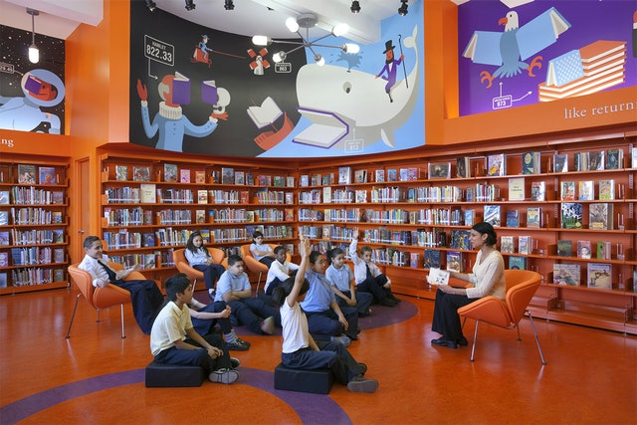
Fig. 4: New York Public School Library
Fig. 5: L!BRARY logo

Less than forty years after Staiger (1973) wrote about the lack of libraries rich in resources, in The teaching of reading. These spaces which were once sparse and in desperate need, had been filled full of rich resources and then much more quickly forgotten about with the birth of digital alternatives and the internet. Graphic Designer Michael Bierut (2017), spoke about how he revamped many of the public-school libraries across New York in 2000 with design agency Pentagram. The brief was to make these libraries desirable places to visit and his logo and branding concept L!BRARY started a snowball effect across New York. The aim was to encourage younger generations to pick up traditional books again and the result included creative outcomes from the likes of Stefan Sagmeister and Christoph Niemann (Bierut, 2017).

Random House’s Madeline Mcintosh speaks about the importance of libraries in building communities and keeping the traditional book alive. Agreeing with Bierut’s scheme, she believes libraries need to be inviting spaces which encourage the new generation to read traditional books. “the heart of what makes a library important is defined by physical books, in a physical space, connected to its community by face-to-face relationships and coming together in person over books.” (Library Journal, 2011)

When contemplating the positive impact that illustrations and interactive features can have on motivating children to learn, it is often considered crucial that the correct reading materials are used for the correct purpose. Staiger (1973, p61) claimed that the correct material for the correct outcome should always be used when possible. This supports Reid’s more recent study which portrayed eBooks to be useful when used for reading comprehension (Reid, 2016).

Chapter 4
When comparing traditional books and e-readers, a major factor to consider is the sustainability of each physical item. It could be assumed that printed books are much less environmentally friendly due to their permanent printed format and somewhat more disposable disposition compared with the non-physical aspect of a digital, downloadable story. This chapter aims to discuss whether the assumption is justified through the pros and cons of eBooks and traditional books, the longevity of each and their impact on our environment.

4.1
When considering sustainability, a book’s carbon footprint is imperative in understanding its effect on our planet. According to Michael Carpenter (2016), an e-reader’s total carbon footprint is roughly 168kg in its lifespan whereas a printed book is only 7.5kg (depending on the books size). From this study, it would seem that eBooks have a much larger negative impact. However, when the number of eBooks one reads on their e-reader in its lifetime is taken into account, these numbers could be equalled. Carpenter’s study suggests that you would need to read between twenty-two and twenty-three books on your digital device in order to lower the carbon footprint of the device to that of one single printed book (Carpenter, 2016). However, if an individual was to read this amount of stories on their device then irresponsibly dispose of it, they are technically reversing any good they had done due to the lethal chemicals released into the atmosphere (Carpenter, 2016). Most large retailers offer a recycling programme for their e-readers which ensure the device is disposed of in a sustainable and environmentally friendly manner. This isn’t widely advertised and many would suggest that it should be a better advertised factor when retailers market the devices.

Considering Carpenters (2016) research, it seems that your environmental impact depends on your reading habits. There are many factors to take into consideration, one being electricity consumption. Reading a traditional book at night requires some sort of light which uses electricity to run and most modern e-readers have a build in backlit screen which requires electricity to charge. Therefore, the time of day one chooses to read could technically have an impact on their carbon footprint. The longevity of a device also adds to this debate; the longer a device is owned for will bring down its carbon footprint as the biggest impact of an e-reader, is its production. Therefore, individuals should take into account their reading habits before deciding to go digital.

The production of eBooks has undoubtedly had a negative impact on the printing and traditional publishing industry. Over the years, publishers have had to adapt their production methods to minimise waste and enable printed books and eBooks to both exist in today’s market. However, the more eBooks being sold, usually means the less printed books being sold and if publishers are over producing, then this often results in waste and an even deeper negative impact on our environment. If large quantities of books remain unsold, the retailers can usually return the volumes to the publishers which hugely increases the publishing carbon footprint. Carpenter (2016) claims that 26% of landfills already get filled with publishing related paper and 11% of fresh water is consumed by the publishing and printing industry. However, e-readers also use their fair share of resources to produce, Carpenter states that 33lbs of minerals and 79 gallons of water are used to produce just one digital e-reader.

It seems that the best way to target these negative impacts is to decide between eBooks or printed books and stick to the decision. If one was to purchase an e-reader on a whim, barely use it and continue to purchase traditional books, they would be creating a larger negative impact on the environment. Considering this theory, traditional books being reused can reduce their carbon footprint even further. When comparing this idea to public transport; people sharing a bus are all sharing the same carbon footprint, however if all those people were driving separately, the footprint would be multiplied by the amount of people. This simplistic strategy could be applied to the use of libraries with a book’s carbon footprint. Obviously, this basic notion doesn’t take into consideration emission free cars or the amount of people on the bus, but it very simply explains how a library works when it comes to books. Each book has the ability to be read by multiple people, multiple times, each time minimising that book’s impact on our environment. This perception links in with Bierut’s (2017) rejuvenation of Public School Libraries in New York, where encouraging the younger generation to use library books instead of buying new reduces their carbon footprint.

The way in which retailers’ market books can make a big difference to which type of book the customer chooses to purchase. Large corporations don’t tend to advertise the environmental impacts of each type of reading and for someone who hasn’t looked into the sustainability of books; it might be assumed that eBooks are the most ethical option without taking into account their reading habits. Indie Publisher Melville House’s Josh Marwell talks about how big retailers tend to push the sales of eBooks over their traditional, printed alternatives as it is often a more profitable option for them (Library Journal, 2011). He claims that huge online companies send book searches to the eBook version first so it is not always the consumers who don’t want to buy traditional books but the companies who don’t want to sell them. Marwell believes this is due to “a more cost-effective way of continuing to do what they've been doing since the rise of conglomerate publishing 50 years ago.” (Library Journal, 2011).

Choosing to maximise profits through the sale of eBooks cannot be blamed entirely on the large retailers but also on the publishers themselves. HarperCollins recently introduced a loan cap on eBooks meaning the stories license would expire after 26 circulations within libraries. The cap allows the license to be used by one person at a time until all the licenses have been used (Hadro, 2011). This conflicts the notion behind sustainable library lending and its effect on the environment. HarperCollins’s Josh Marwell argues that this cap is about “selling in perpetuity and preserving a diverse marketplace for our books and authors that we think benefits all stakeholders involved” (Library Journal, 2011). He acknowledges that the cap will prove to be a test to libraries but that HarperCollins have tried to work out the best solution for all. (Library Journal, 2011).

Conclusion

In conclusion, this essay finds and presents many factors which contribute to the question of which is the better choice between an eBook and a traditional book. Both forms of reading have niche individual strengths which enable them to sit comfortably, side-by-side in today’s market. As evidence suggests, neither form of reading is superior to the other and this essay presents pros and cons for each. The findings show that the best option is often a personal choice, dependent upon ones reading behaviour and preference.

When discussing the enjoyment of reading, it is suggested that traditional books are a preferential choice due to their physical manner and appearance. Book lovers enjoy many aspects of the reading experience, from first perusing the shelves of a book shop through to displaying the book on their own bookshelf. This almost ritualistic practice involves the new book smell and the feel and weight of the tangible object. These factors overlap with the aesthetic of a traditional book. Book covers are often looked to as an art form and some suggest that this aspect of reading is completely lost to the digital reader. However, ultimately it is a personal choice and many would choose an e-reader over a printed book for their portability and flexible nature. Today’s generation is fast paced and on-the-go, e-readers can often fit in well with this lifestyle.

The way in which children learn to read is detrimental to the choice between e-readers and traditional books. The findings in this essay suggest that a traditional book enables children’s imagination to flourish. Through turning the pages and appreciating the illustrations, individuals have the ability to get lost in the storylines much more easily than through reading from a screen. Other findings show that digital reading can help with literacy in some cases; when considering special educational needs or dyslexia, the ability to adapt the reading experience for the reader is a significant factor. Considering this, many studies show literacy and recollection as being secondary when reading digitally compared with traditional books. This could be due to a number of things but distraction levels are often much higher when using a reading device; possibly because of the temptation of internet or social media apps in the background, thus never allowing the reader to become fully immersed in the story.

When an individual considers purchasing an eBook, the findings within this essay suggest that the reader’s behaviour should first be considered. The question of which form of reading is better for the environment relies entirely on the individual’s reading behaviour with the number of books read on the device deciding its overall carbon footprint. I believe this should be a wider advertised fact by the retailers who sell the e-readers. For example, I have always been a book lover and own bookshelves full of print; the scent from the spine of a brand-new book giving me great nostalgia of my childhood. However, when I started holidaying and travelling, I purchased an e-reader without a second thought. For me, it was a secondary choice to printed books but the ability to carry multiple titles in my hand luggage was revolutionary to my reading experience. Although I have no doubt read more than the suggested twenty-three titles on my e-reader, I continue to buy printed books too. However, if I had been more aware of the environmental implications, I may have adapted my reading habits to therefore reduce my own carbon footprint.

It would be interesting to carry out a sequel to this essay in the future; when the generation being born now who are growing up with digital reading and technology considered a norm, have children of their own. Currently, books are still a very popular form of reading and although there is always talk about them dying out due to digital alternatives, they remain strong in the marketplace. My generation and all of those before me grew up with traditional books and are only as adults having the digital options. Therefore, it would be interesting to see in twenty or thirty years from now, if traditional books are still as popular as they are today. Will the younger generation keep them going or will they finally become extinct; only to be found in museums behind glass as antique artefacts like the first printed books are now.

As a graphic designer, I feel that it would be a great shame if we completely lost the traditional publishing industry and their printed books. I have a great passion for print and traditional books but also feel strongly about sustainability and the impact we are having on the environment. Therefore, I think there will always be scope to improve on the way in which we produce printed books. Possibilities to discover new environmentally friendly inks and glues, use recycled paper and improve libraries to encourage recycled reading and lending. I have to embrace new technologies through my career choice but much like my work I enjoy mixing the old with the new. Designing on the computer but also drawing by hand for a more unique outcome, therefore much like design technology, I believe there is and always will be room for both forms of reading, but the future of it is entirely in the hands of the newest generations.

Bibliography

Articles:

Cocozza, P. (2017) ‘How eBooks lost their shine: 'Kindles now look clunky and unhip'’, The Guardian, 27th April. Available at: https://www.theguardian.com/books/2017/apr/27/how-ebooks-lost-their-shine-kindles-look-clunky-unhip- (Accessed: 31st July 2018)

Crum, M. (2014) ‘Authors Weigh In On Print Versus E-Books’, The Huffington Post, 6th December. Available at: https://www.huffingtonpost.co.uk/entry/print-ebooks-interviews_n_5696229?guccounter=1&guce_referrer_us=aHR0cHM6Ly93d3cuZ29vZ2xlLmNvLnVrLw&guce_referrer_cs=bUazMB9IPTUgHIepwwOZgA (Accessed: 31st July 2018).

Flood, A. (2014) ‘Readers absorb less on Kindles than on paper, study finds’, The Guardian, 19th August. Available at: https://www.theguardian.com/books/2014/aug/19/readers-absorb-less-kindles-paper-study-plot-ereader-digitisation (Accessed 21st September 2018).

Mangen, A., Walgermo, B, R. and Bronnick, K. (2013) ‘Reading linear texts on paper versus computer screen: Effects on reading comprehension’, The International Journal of Educational Research, 5th January. Available at: https://www.researchgate.net/publication/256563189_Reading_linear_texts_on_paper_versus_computer_screen_Effects_on_reading_comprehension (Accessed 25th November 2018)

Blogs:
CustomMade. (2015) ‘E-Readers Vs. Print Books’, CustomMade, [blog]. 26th January. Available at: https://www.custommade.com/blog/e-readers-vs-print-books/ (Accessed: 21st September 2018).

Books:
Feather, J. (1988) A History of British Publishing. London: Routledge.

Fox, A. and Murrell, R. (1989) Green Design. A Guide to the Environmental Impact of Building Materials. London: Longman Group.

Fuller, P. (1980) Beyond the crisis in art. London: Writers and Readers Publishing Cooperative Society Ltd.

Jury, D. (2004) Letterpress, the allure of the handmade. Switzerland: RotoVision.

Mcluhan, M. (1964) Understanding Media, the extensions of man. London: Routledge & Kegan Paul Ltd.

Mcluhan, M. and Fiore, Q. (1967) The Medium is the Massage. London: Penguin Books.

Staiger, C, R. (1973) The teaching of reading. Paris: United Nations Educational, Scientific and Cultural Organization.

Watts, L. and Nisbet, J. (1974) Legibility in Children’s Books a Review of Research. Bucks: NFER Publishing Company Ltd.

Wilson, A. (1993) The Design of Books. California: Chronicle Books.

Film:
Barnett, M. (2014) Why a good book is a secret door. [video]. Available at: https://www.ted.com/talks/mac_barnett_why_a_good_book_is_a_secret_door (Accessed: 31st July 2018)

Bierut, M. (2017) How to design a library that makes kids want to read. [video]. Available at: https://www.ted.com/talks/michael_bierut_how_to_design_a_library_that_makes_kids_want_to_read (Accessed: 31st July 2018)

Kidd, C. (2012) Designing books is no laughing matter. OK it is. [video]. Available at: https://www.ted.com/talks/chip_kidd_designing_books_is_no_laughing_matter_ok_it_is (Accessed: 31st July 2018)

Matas, M. (2011) A next-generation digital book. [video]. Available at: https://www.ted.com/talks/mike_matas (Accessed: 31st July 2018)

Internet:
Carpenter, M. (2016) Books vs ebooks: Protect the environment with this simple decision. Available at: https://theecoguide.org/books-vs-ebooks-protect-environment-simple-decision (Accessed: 21st September 2018)

Lanks, B. (2011) Chip Kidd Talks About Designing Haruki Murakami’s New Novel, “1Q84”. Available at: https://www.fastcompany.com/1665277/chip-kidd-talks-about-designing-haruki-murakamis-new-novel-1q84-video (Accessed: 29th September 2018)

Pinkerton, B. (2016) Wax Tablets, Chicken Rustling And The Medieval Roots Of The Modern University. Available at: https://www.npr.org/sections/ed/2016/04/05/472139919/wax-tablets-chicken-rustling-and-the-medieval-roots-of-the-modern-university?t=1541362153402 (Accessed: 3rd November 2018)

Purdue University (date unknown) How has technology changed education? Available at: https://online.purdue.edu/ldt/learning-design-technology/resources/how-has-technology-changed-education (Accessed: 31st July 2018)

Sustainability For All (date unknown) Carbon footprint, which is better? Ebooks or traditional books? Available at: https://www.activesustainability.com/sustainable-life/carbon-footprint-which-is-better-ebooks-or-traditional-books/ (Accessed 21st September 2018)

V&A Museum (2018) Arts and Crafts: An Introduction. Available at: https://www.vam.ac.uk/articles/arts-and-crafts-an-introduction (Accessed 29th September 2018)

V&A Museum (2018) Introducing William Morris. Available at: https://www.vam.ac.uk/articles/introducing-william-morris (Accessed 20th November 2018)

Online Journals:
Hadro, J. (2011) ‘HarperCollins Puts 26 Loan Cap on Ebook Circulations’, Liblicense, 25th Feb. Available at: http://liblicense.crl.edu/ListArchives/1103/msg00006.html (Accessed 31st October 2018)

Kozminsky, E. and Asher-Sadon, R. (2013) Media type influences preschooler’s literacy development: E-book versus printed book reading, Interdisciplinary Journal of E-Learning and Learning Objects. Available at: http://www.ijello.org/Volume9/IJELLOv9p233-247Kozminsky0865.pdf (Accessed 4th November 2018)

Library Journal. (2011) ‘Our Ebook Future’, Library Journal, vol. 136. Available at: https://search-proquest-com.ezproxy.uwtsd.ac.uk/docview/893988154/fulltext/795FA0902E6C4444PQ/1?accountid=130472 (Accessed: 31st October 2018)

Theses:
Cowan, C. (2013) Printed books versus e-Book formats: a study using Niche Gratification Theory. Unpublished MA thesis. The University of Alabama.

Reid, C. (2016) EBooks and print Books can have different affects on literacy comprehension. Unpublished MA thesis. Ralph C. Wilson, Jr. School of Education.

