
University of Wales Trinity St David
Synthesize a Solution to a Potential Real-Life Scenario
Name
Sam Logan Thomson
Student No
1701907
Email
1701907@student.uwtsd.ac.uk
Course
Computer Networks and Cybersecurity (BSc)
Module Name
Computer Forensics
Module Code
ACCB5000
Lecturer
Dr Carlene Campbell

The work of this report completed under the supervision of Dr Carlene Campbell. I declare that this report is the product of my own work and is not being submitted for any other degree etc.
Sam Logan Thomson

Table of Contents

Introduction 0
1. Tools for Computer Forensics 1
1.1 Table of Tools 1
1.2 Uses of Tools 1
1.2.1 CAINE 1
1.2.2 DEFT 1
1.2.3 X-Ways Forensics 1
1.2.4 Oxygen Forensic Suite 2
1.2.5 FTK 2
1.2.6 Autopsy 2
1.2.7 Wireshark 2
1.2.8 Magnet RAM Capture 2
1.2.9 HashMyFiles 2
1.2.10 Kali 2
1.2.11 SAFE Block 2
2. Computer Forensics Methodology 3
2.1 Introduction to Digital Forensics 3
2.2 Digital Evidence Collection 3
2.2 Crime Scene Documentation 4
2.3 Chain of Custody 5
2.4 Conducting Forensic Cloning 6
3. Case Study 7
3.1 Case Study Overview 7
3.2 Forensic Investigator or Incident Handler 7
3.3 Photographing the Crime Scene 7
3.4 Examining a Computer in Standby Mode 8
3.5 Evidence Preparation 8
3.6 Evidence Examination 9
3.7 Video File List 9
4. Practical Analysis of Evidence 10
4.1 Write Protection and Forensic Imaging 10
4.2 Analysing the Evidence 11
4.3 Invoice for Services 12
Conclusion 13
References 14

Table of Figures
Figure 1- Forensic Tool Table [1]–[5][6] 1
Figure 2- Order of Volatility [19] 4
Figure 3- Chain of Custody Template [21] 5
Figure 4- Evidence File Hashing 10
Figure 5- Forensic Image copy 11
Figure 6- Autopsy Data Analysis 12
Figure 7- Invoice for Forensic Investigation 13

Introduction
The intended purpose of this report is to accomplish multiple tasks with regards to the methodology, tools and concepts of Computer Forensics.
The first part looks at the tools for computer forensics, looking at the tools to categorise them for how they are used, what they can be used for and whether they are open source or licenced software. The aim of this is to mainly look at the tools that are frequently used in real life scenarios by Computer Forensics experts. This information is likely to be presented in the format of a table with some additional information possibly provided for select tools.
We are going to take at the methodology used in Computer forensics starting with how to deal with evidence found at a crime scene. Following up with best practices and requirements for analysing evidence. This part will be a walkthrough of the methods involved in gathering images and will be done as a precursor to the case study which will follow the best practice outlined in this section.
The last part is a case study that involves analysing a hard drive image, with documentation done on the steps taken during the investigation and a proper investigation report written. Looking at the case it needs to be decided whether an Incident Handler or a Forensics Investigator is required to analyse the evidence.
As part of the hard drive analysis care needs to be taken to find any documents, images, video and audio files that are related to the case. This all needs to be analysed with in the proper manner with chain of custody being maintained and secure storage of the evidence.
Next, we would look at the methods used to achieve the goal of locating the files, while also checking for anything that may be hidden and what tools would be used to achieve this aim.
Also, as part of the investigation we would want to do a check of the suspects contacts and whether any of them are linked to the plot.

Tools for Computer Forensics

1.1 Table of Tools
Name | Type
CAINE | Operating System
DEFT | Operating System
X-Ways Forensics | Software
Oxygen Forensic Suite | Software
FTK | Software
Autopsy | Software
Wireshark | Software
Magnet RAM Capture | Software
HashMyFiles | Software
Kali | Operating System
SAFE Block | Software
Figure 1- Forensic Tool Table [1]–[5][6]

Uses of Tools

CAINE
The first tool we go to look at is CAINE, according to the website where CAINE can be downloaded. [7]
“CAINE offers a complete forensics environment that is organised to integrate existing software tools as software modules and to provide a friendly graphical interface”
CAINE is a Linux distribution designed specifically for use with digital forensics.

DEFT
DEFT is another Linux distribution designed for digital forensics, according to the website where DEFT can be downloaded. DEFT is currently actively in use by several organisations including the military, investigators, law enforcement and IT auditors. [8]

X-Ways Forensics
X-Way forensics is a powerful piece of software. The manufacturer states [9]
“X-Ways Forensics is an advanced work environment for computer forensic examiners and our flagship product.”
This is a software-based solution however it completes several tasks including cloning and imaging disks, reading partition and file system structures, access to logical memory of running process and even data recovery techniques and file carving.

Oxygen Forensic Suite
Oxygen Forensics is a tool specifically designed for the digital forensic analysis of mobile phones. Oxygen Forensics are a large global company that provide forensics investigation software for governments, law enforcement agencies and large enterprise organisations [10].

FTK
FTK is a powerful toolkit specifically designed for digital forensic investigations. Access Data the manufacturers state it has the ability to speed up search times and the speed of forensics analysis with FTK [4].

Autopsy
Autopsy is a software kit to aid in digital forensics. Providing a graphical user interface. According to the company that own the software [11]
“It is used by law enforcement, military and corporate examiners to investigate what has happened on a computer.”

Wireshark
Wireshark is an incredibly powerful tool that is incredibly useful for real time network forensics. Wireshark provides a network analyser that allows real time traffic capture on a network. Capturing packets and allowing an in-depth analysis [12].

Magnet RAM Capture
Magnet RAM capture is a powerful tool that allows capture of evidence stored in RAM. As RAM frequently stores information not written to the hard drive this can be incredibly useful. According to Memory Forensics, numerous web apps like Gmail and incognito browsing modes only store data in memory essentially preventing the capture of evidence from the hard drive [13].

HashMyFiles
HashMyFiles is a piece of software that allows calculation of MD5 and SHA1 hashes of files [14]. This is useful as one of the first things a forensic analyst will do with a disk image is calculate a hash value of a disk image before copying and then comparing it to the hash value of the copy to ensure the two are identical.

Kali
Kali is a Linux distribution maintained by a company called Offensive Security. According to the Kali Website Offensive security is a provider of top-tier information security training and penetration testing across the globe [15].

SAFE Block
SAFE block is a software solution to write blocking. Allowing safe cloning of any evidence drive without any of the original data being overwritten or anything new being written to the disk [6]. A version of this exists for operating systems from XP right the way through to Windows 10.

Computer Forensics Methodology

2.1 Introduction to Digital Forensics
To consider how to conduct a computer forensics investigation first we need to understand what digital forensics is. According to John Sammons [16, p. 3]
“One of the major struggles in law enforcement is to change the paradigm of the police and get them to think of and seek out digital evidence. Everyday digital devices such as cell phones and gaming consoles can hold a treasure trove of evidence. Unfortunately, none of that evidence will ever see a courtroom if it’s not first recognized and collected.”
Essentially digital forensics is the gathering of digital evidence for use within a legal setting to provide proof of criminal activity and can be used when prosecuting. However currently some law enforcement struggle to realise the potential gold mine of evidence that computers and smart devices can provide for cases.

Digital Evidence Collection
The first part of the investigation to consider when looking at computer forensics is evidence collection. This needs to be conducted in a proper manner to prevent the evidence being thrown out in a courtroom. Consider the following from Infosec Institute, prior to collecting any evidence a forensic examiner needs to make sure they have legal standing, allowing them to pursue the identification, collection and preservation of any digital evidence [17].
In the UK this would start with obtaining a search warrant according to the UK Law Commision [18]
“A search warrant is a written authorisation that allows an investigator to enter premises to search for material or individuals. Search warrants are usually issued by a court application by a police officer or other investigator.”
With regards to computer forensics this means if you want any of your evidence to be admissible in court then a search warrant must be authorised prior to searching and seizing any digital evidence.
So, considering this once a search warrant is obtained the location the warrant covers then wants to be searched for all digital evidences for example computers, smart devices and removable storage media.
With regards to modern smartphones care must be taken with the collection of this evidence John Sammons recommends storing the phone in a Faraday bag or arson can and keeping it powered on to preserve evidence and prevent being locked out [16, p. 49].
The reason for the Faraday bag or arson can is to block any signals and prevent remote wiping of the phone as allowed by Apple’s “Find My Phone” app. There are multiple equivalent apps for android that allow the same goal to be achieved.
The next step of evidence collection is to consider the order of volatility. The figure below from Darril Gibson’s blog gives us an insight into what this means.
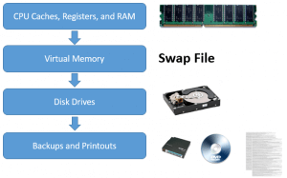
Figure 2- Order of Volatility [19]

What this means is we want to start with collecting the most volatile evidence first as it is the most likely to be lost or have nothing to recover if left for too long.
For example, RAM or Random-Access Memory contains current running information and instructions, in the event of a power down any evidence stored on RAM would be lost. Whereas the information stored on a hard drive is unlikely to be lost in the event of equipment power down of any device. We say unlikely as hard drive corruption can happen but is unlikely, whereas with a loss of power anything stored within the RAM is guaranteed.

2.2 Crime Scene Documentation
The next part of dealing with a crime scene is accurate documentation of all the evidence. According to John Sammons [16, p. 51]
“Regardless of the situation, any time evidence is collected documentation is a vitally important part of the process. There are several different types of documentation. The most common in terms of digital forensics are photographs and written notes; video is also an option for documenting evidence.”
This means taking photos of all evidence exhibits and written notes for every piece of evidence collected. You could take a video of the entire scene as well with the purpose of showing exactly how the scene was found.
According to Dick Warrington a perfect and correct record of the crime scene is an essential part of investigating any crime and important when presenting a case when it goes to court [20].
For the case of digital forensics notes could include the current power state of the device, what other devices or network infrastructure could be connected to it, essentially everything seen at the scene of the crime needs to be documented accurately for evidence logs.
This documentation can help massively when trying to reconstruct a crime scene in the lab, correct photographing and note taking can allow the crime scene to be constructed exactly how it was found in a lab setting to allow for accurate analysis.
Another thing to consider about the notes that are written is who may have access to view them John Sammons writes that these notes matter because they could end up being turned over to the opposition, so with this being kept in mind it becomes important not to draw conclusions or make speculations [16, p.53].

Chain of Custody
Next, we need to have a look at maintain the chain of custody. Consider the below template form created by Jason Sachowski.
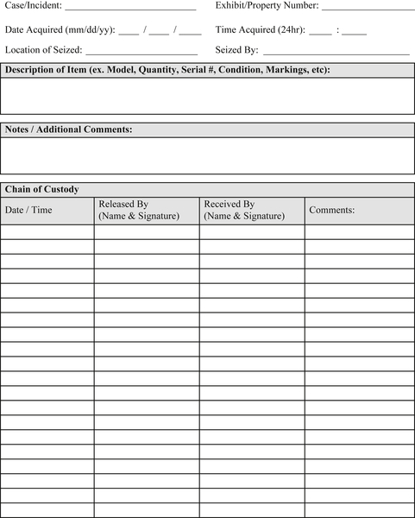
Figure 3- Chain of Custody Template [21]
As you can see the template covers everything you would expect to be covered. A space for the case or incident number, what the property or exhibit number is, the date and time the evidence was seized and who seized it and where.
A further section is provided for full details of the item including Model, Serial number, condition of device upon seizure and any markings it may have even going so far as to include a space for any additional comments on the evidence seized.
Now we need to consider the bottom part of the template. Consider the following by John Sammons [16, p. 53]
“Before a piece of evidence gets in front of a jury, it must first meet a series of strict legal requirements. One of those is a well-documented chain of custody.”
This section allows for full tracking of the evidence who has handled it, when and why. This is important as without this kind of accountability the evidence would not be deemed trustworthy and such would prevent it from being used at a trial.

Conducting Forensic Cloning
The next step in forensic analysis would be creating a copy of the data. However, this isn’t like copying and pasting data. You need an exact copy of the original to work with. This is achieved by taking a forensic clone of the drive according to John Sammons [16, p. 54]
“A forensic clone is an exact, bit-for-bit copy of a hard drive. It’s also known as a bit-stream image. In other words every bit (1 or 0) is duplicated on a forensically clean piece of media such as a hard drive.”
The expert data forensics website confirms this is done because a forensic image is an exact replica of the original data a bit like a thumb print [22]. Meaning as it is an exact copy of the original data any evidence found on it would be present in the original data.
Proving the forensic image is done using a process called hashing. According to an article on Microsoft’s website [23]
“A hash value is a numerical value of a fixed length that uniquely identifies data. Hash values represents large amounts of data as much smaller numeric values, so they are used with digital signatures.”
This is achieved by using a piece of software like HashMyFiles mentioned earlier in the report. A hash value is taken of the original hard drive image and compared with the forensic clone. If the two values match, then the clone is indeed a correct representation of the original data and can be used for investigation.
However before making this clone something else needs to be considered with regards to the original data. You need to ensure no new data is written to the evidence drive during the cloning process. This is achieved by using a write blocker. Write blockers can come in either hardware or software form and prevent the original data from being modified allowing the data to be ready only. A hardware solution for this could be the Data Copy King 2 from Salvation data [24] this device allows secure copying of the evidence drive without anything being written to it.
Other write blocking solutions exist however, ForensicSoft provide a piece of software called SafeBlock, mentioned earlier within the tools section SafeBlock provides a software-based write blocking solution that enables the speedy and safe cloning of any disk or media connected to the workstation [6].
Another reason to use a clone would be to consider the following quote from John Sammons [16, p. 56]
“Examining the clone affords us the change of a “mulligan” – a d-over as is said in golf – should something go wrong. If possible, the original drive should be preserved in a safe place and only brought out to reimage if needed.”
So, working with cloned data means the original can be kept stored away for safety, meaning it will never be in danger of accidental erasure or hard drive damage. If the clone is damaged, destroyed or overwritten then a new clone can be created from the original.
Now armed with a basic overview of the methodology of digital forensics we can go on to look at our case study. Some of the techniques mentioned here will be looked at in more detail and some techniques that have not been discussed may come up.

Case Study

3.1 Case Study Overview
With the case study we need to consider how to analyse the evidence. We have a laptop recovered from a terrorist shot and killed at Heathrow International airport. It was known to police that he had plans to bomb Mason International airport in Fiji. His identity was discovered as his face matched up with information from a terrorist watch list.
We are going to be looking at how this evidence is analysed and whether an incident handler or forensic investigator is the most appropriate person to deal with this case. John has been brought in by the police as a professional investigator.

Forensic Investigator or Incident Handler
First, we need to consider whether this case would require a Forensic Investigator or an incident handler. Now we need to consider the following quote from Doris Wells [25]
“Forensic experts can be employed by a variety of entities, such as federal, state or local laboratories or academic institutions. They may be called on to be expert witnesses or hired as consultants to contribute specialized knowledge and advice on scientific or technical issues.”

Given the nature of our case and the involvement of a dead terrorist. Evidence found on the laptop may lead to further evidence of other guilty parties. Based on this alone it would be prudent to hire someone who would be able to testify in court as an expert witness as this may lead to further convictions.
Also, one of the abilities of an expert witness in digital forensics is the ability to write a report on the evidence found in plain non-technical English. This would allow a jury in a case to understand the evidence being presented to them and even the significance of the evidence they are observing.

Photographing the Crime Scene
At the crime scene the first thing John would do is take photos. In this case John has a Canon Digital Camera. According to Jeff Smith there is a minor issue with using digital cameras, while they may provide faster results than other types of cameras, they require stringent processes in place to satisfy the prosecution, defence and judges that the images have not been altered in any way [26].
So, while John can use his digital camera to take the photos at the crime scene. Full documentation and any require policies must be followed to make these images admissible in court as a form of evidence. However, as an investigative expert you would expect John to be aware of this and to follow all precautions necessary with regards to processing these photos.

Examining a Computer in Standby Mode
With regards to the laptop found in standby mode. Care must be taken to ensure that the laptop continues to receive adequate power. Normally it would be recommended to remove the laptop battery. However, as the device is in standby consider the following from the ACPO guidelines for dealing with computer evidence [27, p. 8]
“Remove the main power source battery from laptop computers. However, prior to doing so consider if the machine is in standby mode. In such circumstances battery removal could result in avoidable data loss.”
So, in this case the continual powering of the device is to ensure no data is lost. As any lost data could be potential evidence, because before the device has been examined all data is considered evidence till shown to be otherwise.

Evidence Preparation
Prior to examination of the evidence care must be taken to make a forensic copy of the evidence. This is achieved by enabling write protection on the data to be analysed with either a hardware or software solution and making a digital forensic image again with a software or hardware solution. Verifying the copy has been done correctly is done by using a method called hashing explained earlier. It is incredibly important to make sure this is done correctly. The following four principles come from the APCO guidelines on working with computer based evidence [27, p. 4]
“Principle 1: No action taken by law enforcement agencies or their agents should change data held on a computer or storage media which may subsequnetly be relied on in court.
Principle 2: In circumstances where a person finds it necessary to access original data held on a computer or on storage media, that person must be competent to do so and be able to give evidence explaining the relevance and the implication of their actions.
Principle 3: An Audit trail or other record of all processes applied to computer-based electronic evidence should be created and preserved. An independent third party should be able to examine these processes and achieve the same result.
Principle 4: The person in charge of the investigation (the case officer) has overall responsibility for ensuring that the law and these principles are adhered to.”
The write protection enables the first principle to be upheld as it prevents the modification of any of the evidence data, allowing it to be used as evidence in a court.
Whilst the second principle advises the original evidence can be worked on where necessary. It is better to work on a forensic image of the data. As the image is an exact bit-by-bt copy of the data it is considered the same as working on the original, however were any mistakes to be made or anything to be erased during analysis of a forensic image. As the original data is stored safely and write protected another copy can be taken so the original evidence is never harmed. Were the original data to be worked on any mistakes could cost the entire investigation.
The third principle can be upheld by keeping an accurate record with a chain of custody document and also careful notation of all work done on the evidence.

Evidence Examination
For examination of the evidence many options can be used, Autopsy [28], FTK [4], CAINE [7] or even Kali Linux [15] could be used. For the purposes of this investigation Autopsy is going to be used.
Autopsy is an open source, GUI based forensic software that allows the investigation of raw image files. Also allowing keyword searches. Timeline analysis, email analysis, playback of any media files found without external viewers and even detection of file types. It can even group files by their type to assist with looking for specific file types.
Also, as we require an analysis of email, cache files and temporary internet files. Autopsy can also cater to this need with other features including web browser extraction and email analysis.
Based on these factors when the analysis is conducted in the next section Autopsy will be used, Kali Linux may also be used for part of the analysis if any of the files are encrypted as Autopsy makes no mention of decryption.

Video File List
Several video files were found, with the contents of the videos summarised below.
- The 9/11 bombings
- Terrorist camp training videos
- Executions of terrorist hostages
- Motivational speeches by terrorist leaders
- Personal videos which showed the terrorist spending time with his family
- A half hour video of two airports. Heathrow International and Mason International in Fiji.
- A video from a hotel room with 6 other suspected terrorists.
A detailed list of these videos should be made however the 5th video with the suspect spending time with his family can be discounted from this list as it is not relevant to the case. As the case is an investigation into a plot to bomb Mason International airport.
Videos 1-4 may show some of his motivations for carrying out the plot, these may not have any relevance to the case with regards to the bombing plan for Mason International. While these videos should be assessed to see whether they have anything to do to the plot based on the content it is unlikely therefore a document explaining these videos would be unnecessary.
Videos 6 and 7 however would require a document explaining the videos in brief. As these videos relate directly to Mason International airport and other suspects in the case.
So, a list should be made of all the videos minus the fifth video and a documented explanation of the two videos relating directly to the case should be prepared.

Practical Analysis of Evidence

4.1 Write Protection and Forensic Imaging
A forensic copy of the evidence image has been provided for the purposes of this analysis. The text document contained within includes the hash file to verify that it was copied exactly. The exact match of the hashing proves that the copy was made without any alteration of the original data.
The figure below shows the image was created using FTK imager and includes the hashing values done before and after the copying of the data.
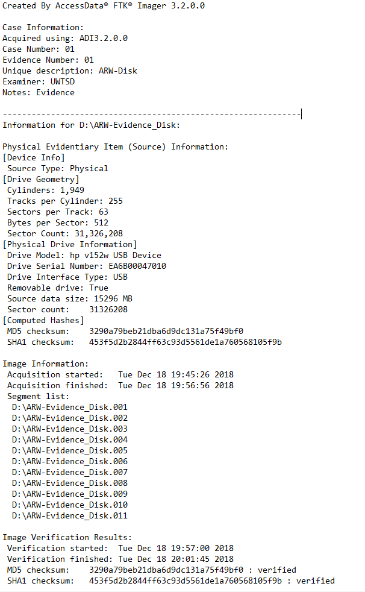
Figure 4- Evidence File Hashing
As you can see from the figure the MD5 and SHA1 checksums are verified meaning an exact bit-by-bit copy of the data was created.
A copy of this evidence file was then created using FTK imager so the copy could be worked on for the analysis of the evidence. The figure below shows that the MD5 and the SHA1 Checksum are the exact same verifying that the copied file is the exact same.
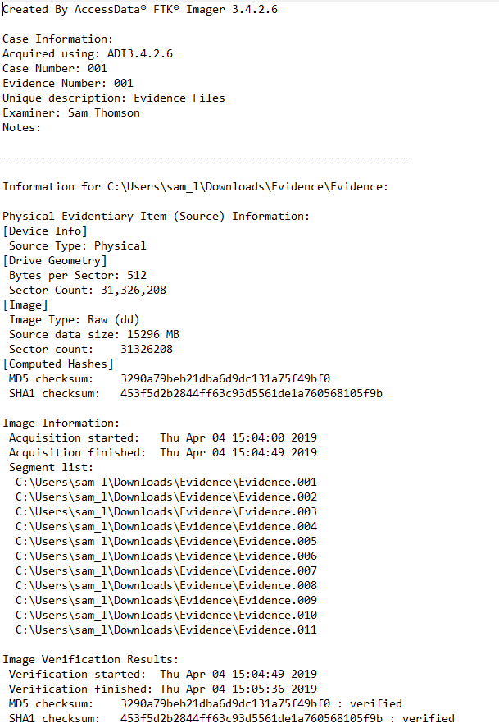
Figure 5- Forensic Image copy

Analysing the Evidence
Autopsy was used to analyse the evidence. As shown, it has recovered several files, file types and even included contact email addresses.
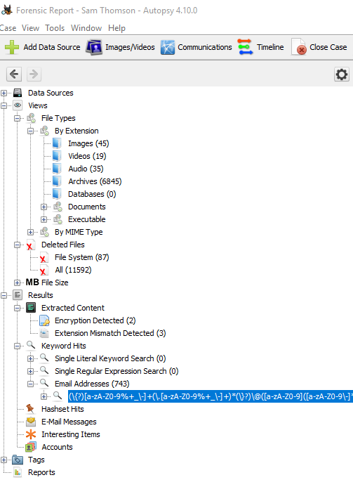
Figure 6- Autopsy Data Analysis

A report has been included with the zipped evidence file to include a summary of what was found.

Invoice for Services
Included below is the invoice for Johns services sent to Mark Wales Chief Investigator at the Heathrow Police Department. This invoice was for a digital forensic investigation of the laptop computer acquired from a Terrorist shot dead at Heathrow International Airport.
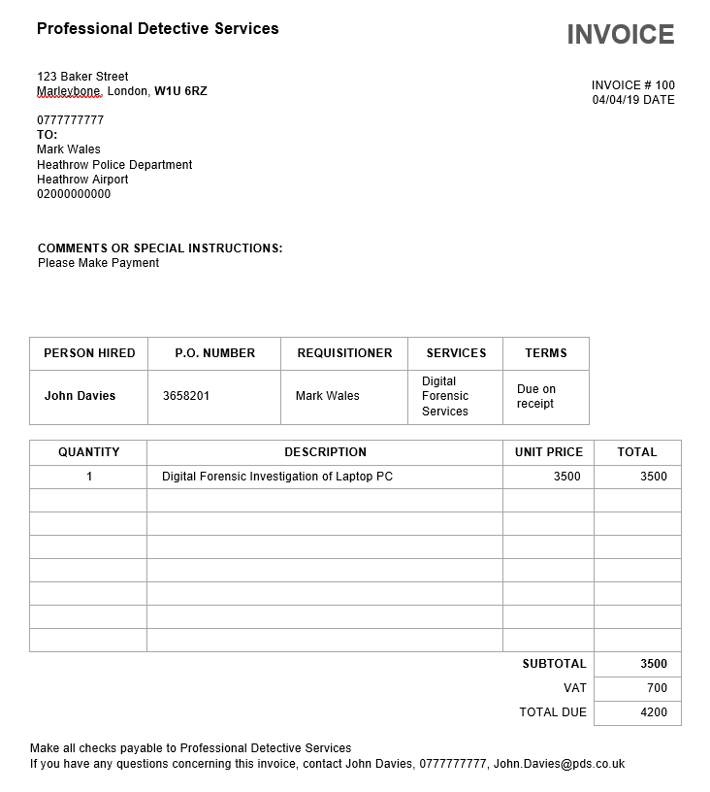
Figure 7- Invoice for Forensic Investigation

Conclusion
The tools for an investigation are numerous and vary from open source to paid software. Hashing tools exist to verify the integrity of a forensic image. Hardware and software tools exist for write protection and preventing overwriting of data due to be copied. Some tools come in the form of operating systems with a whole host of installed software for investigation. Some tools are a full suite that can do everything from forensic imaging to file carving. The tools should always be chosen for the task at hand and understanding what a tool does and how to correctly utilise it is the best way to conduct and investigation.
The methods for forensics don’t change, the crime scene needs to be correctly documented and notes and pictures taken and evidence correctly logged. Digital evidence should always be worked on from a copy unless necessary and an explanation given as to why it was necessary. Verifying the integrity of forensic images is done by getting a hash calculation of the original data and the copied data. If the two hash values are an exact match the copying process has been done correctly and you have exact matching data. Chain of custody should always be maintained as this is incredibly important and proves to a court everything that was done was done above board, it provides accountability of the analysis of evidence. Most importantly always the local laws should be followed. For example, evidence cannot be seized without a search warrant and these should always be applied for through the correct channels before any search and seizure occurs. A warrant obtained after search and seizure of the evidence would be null and void and result in the case being thrown out.
The evidence for the case study was covered in a report attached to the evidence file. Numerous types of evidence were found including document files, image files, video files and audio files. These files contained pictures of airports and airport plans amongst other things.

References

[1] “Kali Linux | Penetration Testing and Ethical Hacking Linux Distribution,” Www.Kali.Org, 2018. [Online]. Available: https://www.kali.org/. [Accessed: 29-Mar-2019].
[2] A. Tabona, “Top 20 Free Digital Forensic Investigation Tools for SysAdmins,” TechTalk, 2013. [Online]. Available: https://techtalk.gfi.com/top-20-free-digital-forensic-investigation-tools-for-sysadmins/. [Accessed: 29-Mar-2019].
[3] K. Chandan, “23 FREE Forensic Investigation Tools for IT Security Expert,” Geekflare, 2018. [Online]. Available: https://geekflare.com/forensic-investigation-tools/. [Accessed: 29-Mar-2019].
[4] “Forensic Toolkit,” AccessData, 2018. [Online]. Available: https://accessdata.com/products-services/forensic-toolkit-ftk. [Accessed: 29-Mar-2019].
[5] P. Shankdhar, “Popular Computer Forensics Top 21 Tools [Updated for 2019],” Infosec Institute, 2019. [Online]. Available: https://resources.infosecinstitute.com/computer-forensics-tools/#gref. [Accessed: 29-Mar-2019].
[6] “ForensicSoft, Inc. - Software Write Blockers and Other Forensic Tools.” [Online]. Available: https://forensicsoft.com/safeblock.php. [Accessed: 29-Mar-2019].
[7] N. Bassetti, “CAINE Live USB/DVD - computer forensics digital forensics,” 2016. [Online]. Available: http://www.caine-live.net/. [Accessed: 29-Mar-2019].
[8] “About – DEFT,” 2018. [Online]. Available: http://www.deftlinux.net/about/. [Accessed: 29-Mar-2019].
[9] X-Ways, “X-Ways Forensics: Integrated Computer Forensics Software,” Wire. [Online]. Available: http://www.x-ways.net/forensics/. [Accessed: 29-Mar-2019].
[10] “Oxygen Forensics - Mobile forensic solutions: software and hardware.” [Online]. Available: https://www.oxygen-forensic.com/en/products/oxygen-forensic-detective. [Accessed: 29-Mar-2019].
[11] “Autopsy.” [Online]. Available: https://www.sleuthkit.org/autopsy/. [Accessed: 29-Mar-2019].
[12] Wireshark, “Wireshark · Go Deep.,” 2017. [Online]. Available: https://www.wireshark.org/. [Accessed: 29-Mar-2019].
[13] “Acquiring Memory with Magnet RAM Capture | Magnet Forensics.” [Online]. Available: http://www.magnetforensics.com/acquiring-memory-with-magnet-ram-capture/. [Accessed: 29-Mar-2019].
[14] “HashMyFiles: Calculate MD5/SHA1/CRC32 hash of files.” [Online]. Available: http://www.nirsoft.net/utils/hash_my_files.html. [Accessed: 29-Mar-2019].
[15] “About Kali Linux.” [Online]. Available: https://www.kali.org/about-us/. [Accessed: 29-Mar-2019].
[16] J. Sammons, The basics of digital forensics : the primer for getting started in digital forensics. 2015.
[17] R. Fahey, “Computer Forensics: Digital Evidence.” [Online]. Available: http://resources.infosecinstitute.com/category/computerforensics/introduction/areas-of-study/legal-and-ethical-principles/digital-evidence/#gref. [Accessed: 29-Mar-2019].
[18] “Search Warrants | Law Commission,” 2018. [Online]. Available: https://www.lawcom.gov.uk/project/search-warrants/. [Accessed: 29-Mar-2019].
[19] D. Gibson, “CFR and Order of Volatility | Get Certified Get Ahead,” 2015. [Online]. Available: https://blogs.getcertifiedgetahead.com/cfr-and-order-of-volatility/. [Accessed: 29-Mar-2019].
[20] D. Warrington, “Crime Scene Documentation: Start to Finish,” Forensic Mag. [Online]. Available: https://www.forensicmag.com/article/2016/02/crime-scene-documentation-start-finish. [Accessed: 29-Mar-2019].
[21] J. Sachowski, Template C: Chain of Custody Tracking Form. 2016.
[22] “Expert Data Forensics | Las Vegas, Nevada Digital Forensics – PILB1498.” [Online]. Available: https://expertdataforensics.com/forensic-imaging-hard-drive-cloning/. [Accessed: 29-Mar-2019].
[23] Microsoft, “Ensuring Data Integrity with Hash Codes | Microsoft Docs,” 2017. [Online]. Available: https://docs.microsoft.com/en-us/dotnet/standard/security/ensuring-data-integrity-with-hash-codes. [Accessed: 29-Mar-2019].
[24] “Data Copy King - Forensic Disk Duplicator, Hard Drive Duplication/Clone/Wiping.” [Online]. Available: http://www.salvationdata.com/dck-data-copy-king.html. [Accessed: 29-Mar-2019].
[25] D. Wells, “In Brief: Law 101: Legal Guide for the Forensic Expert | National Institute of Justice,” NIJ, vol. 269, 2012.
[26] J. Smith, “INSTANT PHOTOGRAPHY for Crime Scene Investigators - ProQuest,” Law Order, vol. 51, no. 11, pp. 56–59, 2003.
[27] Association of Chief Police Officers (ACPO), “Good Practice Guide for Computer-Based Electronic Evidence,” Director, 2008. [Online]. Available: http://www.7safe.com/electronic_evidence/ACPO_guidelines_computer_evidence_v4_web.pdf. [Accessed: 04-Apr-2019].
[28] “Autopsy.” [Online]. Available: https://www.sleuthkit.org/autopsy/. [Accessed: 04-Apr-2019].

marking criteria and Student FEEDBACK

This section details the assessment criteria. The extent to which these are demonstrated by you determines your mark. The marks available for each criterion are shown. Lecturers will use the space provided to comment on the achievement of the task(s), including those areas in which you have performed well and areas that would benefit from development/improvement.

Common Assessment Criteria Applied (Assignment 1) | Marks available | Marks  awarded
1. Research-informed Literature
Extent of research and/or own reading, selection of credible sources, application of appropriate referencing conventions.
You have demonstrated your own research. However, as an academic work you need to include updated credible, peer reviewed articles. Your references were mainly website. (Grade mark: 55.00%) | 20 | 11
2. Knowledge and Understanding of Subject
Extent of knowledge and understanding of concepts and underlying principles associated with the discipline.
You have demonstrated understanding of the concepts and underlining principles. However, more depth and strength of your statements in the research section could be apply. Consult academic survey papers (IEEE, Science Direct, Elsevier, etc.) next time to help in this area. (Grade mark: 56.67%) | 15 | 8.5
3. Analysis
Analysis, evaluation and synthesis; logic, argument and judgement; analytical reflection; organisation of ideas and evidence
Very good evaluation of the case study. It would be good to maintain the numbering to match the development of the case for easier reading and marking. Otherwise, well documented and appropriate softwares/tools identified for the case scenario. Fees invoice included. In your conclusion it would be good to add recommendation or future work. (Grade mark: 86.67%) | 45 | 39
4. Practical Application and Deployment
Deployment of methods, materials, tools and techniques; application of concepts; formulation of innovative and creative solutions to solve problems.
Copy was created without modification. Process used (appropriate tools, FTK), additional files uploaded to Moodle (Grade mark: 100.00%) | 15 | 15
5. Skills for Professional Practice
Attributes in professional practice: individual and collaborative working; deployment of appropriate media; presentation and organisation.
Formatting required and there are some grammatical errors  39 (Grade mark: 60.00%) | 5 | 3

Assignment Mark (Assessment marks are subject to ratification at the Exam Board. These comments and marks are to give feedback on module work and are for guidance only until they are confirmed. ) | Late Submission Penalties (tick if appropriate) |  | 77%
 | Up to four weeks late |  | 77%
 | First Attempt? |  | 77%

