Module: LCBB6000 – Dissertation
Title: Research proposal: Exploring the role of online digital platforms in recruitment in pre and post COVID-19 in the UK

Student: Izabela Stanescu
Student ID: 2025868
Tutor: Dr. Seyed Navid Nasirpourosgoei

Table of contents

1. Background and problem statement 3
2. Research aim 3
3. Research questions 3
4. Research objectives 4
5. Research rationale 4
6. Literature review 5
7. Research methodology 6
8. Gantt Chart 9
9. References 10

Background and problem statement

The internet and digital platform has made the recruitment process to have gone global. Employers and job seekers now have better connectivity and accessibility through online digital platforms, which have made the process more effective. Such a transition was noticeable in the UK when the COVID-19 lockdown was imposed, as traditional techniques gave way to smooth-sailing online recruitment processes. Online sources such as LinkedIn, Indeed, and Glassdoor were being used pre-COVID-19 primarily as secondary recruitment sources. However, during the course of and post-COVID-19, these have been turned into principal sources for recruitment, selection, and hiring of workforce (Saunders, Lewis and Thornhill, 2023).

The problem now is to perceive how effective, inclusive, and challenging digital recruitment practices have become with this sudden shift, and the problem has been identified as the effectiveness of inclusivity and the challenge of digital recruitment practices. All these raise questions about companies’ adaptability, candidates’ experiences, and the roles of digital tools in bridging or widening accessibility gaps. This study seeks to examine how online digital platforms in UK recruiting have evolved by comparing pre-COVID-19 and post-COVID-19 practices to shed light on their long-term business reinforcement impact (Miller, 2021).

Research aim

The aim of the research is to examine the operation of online recruitment systems much sought after by HR managers, how they operate to save time in the recruitment process, and reduce the cost of hiring. This research is intended to explore emerging recruitment practices considering the influence of digital innovation (Bell, Bryman and Harley, 2022).

Research questions

- How do online digital platforms affect recruitment in the UK before and after COVID-19?
- What is the impact of COVID-19 on candidate and employer interactions through digital recruitment platforms in the UK?’

Research objectives

The dissertation research objectives are divided into two:
- To analyse the social media platforms used for recruitment evaluation in terms of attraction, engagement, and screening of would-be applicants. The most common use of platforms like LinkedIn, Facebook, and Twitter is for attracting a bigger talent pool while recruiting through direct or online modes in a more engaging kind of process on an individual level (Creswell and Creswell, 2023).
- To examine how effective these platforms are at improving recruitment outcomes. This will involve reviewing time-to-hire, the quality of candidates sourced, as well as general cost-efficiency against traditional methods, as the main performance indicators. Through an examination of these measures, the paper will expound on the benefits and possibly the drawbacks of social media recruitment so that the full picture concerning its utility can be drawn in contemporary recruitment strategies (Gray, 2022).

5. Research rationale

The COVID-19 situation changed the rules of traditional recruitment. Things became more digitalized to support remote and even flexible working conditions. Human interaction was limited, and digital platforms became more prominent in the recruitment marketing mix representing a trend that has continued even after the peak of the pandemic. This research paper explores digital recruitment platforms’ efficacy in streamlining hiring processes, increasing candidate reach, and cutting down recruitment costs under both pre- and post-COVID-19 scenarios in the United Kingdom (Silverman, 2020).
The above information clarifies how this study contributes to understanding the role of human resource information systems. The data have been increasing that digital platforms such as LinkedIn, Indeed, and Glassdoor, along with social media sites like Twitter and Facebook, are part and parcel of the modern recruitment strategy. All these platforms help a firm attract diversified global talent, data-driven insights into the fitting of candidates, and optimizing the hiring time and resources through process automation (Punch and Oancea, 2021).
This study will provide insight into digital platform potential in enhancing functionality by critically examining recruitment practice evolvement through responding to how companies can effectively harness digital tools to meet their staffing needs in the UK’s post-pandemic economy.

Literature review

Traditional Recruitment Methods refer to hiring candidates through physical, in-person processes. These methods typically include advertising job vacancies in print media, organizing career fairs, and conducting face-to-face interviews at designated locations. In traditional recruitment, candidates submit physical resumes, and the hiring process involves direct, personal interactions, such as one-on-one interviews and background checks. This emphasis is placed on personal connections, tangible assessments, and evaluating candidates through direct, in-person communication. (Malousis, Zefkilis and Daglis, 2023).
Online recruitment is the use of digital platforms such as job platforms, social media, and company websites to attract, screen, and hire candidates. The use of video interviews fastens the process and widens it with quick and broad reach. Convenience, accessibility and automation for efficiency are the three most emphasized elements in this process (Saini and Tarkar, 2024).
The very fast migration of recruitment operations to online digital platforms indeed changed the way hiring is done globally, with the COVID-19 crisis even further pushing this boundary. Such digital platforms as LinkedIn, Indeed, and Glassdoor have completely redefined how recruiters and job seekers work together, expanding boundaries in terms of reach and efficiency in hiring practices. All in all, even prior to the COVID-19 outbreak, these digital recruitment sources have been deemed quite useful in talent sourcing and employer branding and recruitment processing (Brown and Swain, 2019). Indeed, fundamental in nature was the shift by the pandemic by using digital recruitment provisioning for organizations dealing with lockdowns and remote work (Smith and Jones, 2021).
Another area of change is the increasing use of video-based and AI-enabled recruitment techniques, for example, screening resumes automatically and interviewing virtually. Such tools were extremely handy during the outbreak, not only allowing the execution of safe hiring processes but also doing this quite efficiently (Johnson, 2029). These methods are likely to continue post-COVID as a strategy followed by companies because of their cost-effectiveness and scalability although apprehension has been shown about the fairness and inclusivity of AI tools in assessing the judgment of human potential (Miller, 2021).
The pandemic altered candidate preferences and expectations. Remote and flexible work options are now a priority for many job seekers. As Evans et al. (2022) note, candidates are valuing digital recruitment platforms more and more that express company culture as well as flexibility, which is going to affect how employers use these platforms to attract talent. Features for highlighting the remote job opportunities reflect the transition of recruitment into a post-COVID world in LinkedIn (2021).
Digital platforms have widened job opportunity access for candidates, but new challenges have been created in terms of candidate engagement and authenticity. As per Walker and Phillips (2020), pre-COVID, job seekers often refrained from using online platforms alone as they found them impersonal and did not trust the interactions virtually. Post-COVID, with more digital recruitment, this has pushed most employers to invest in much stronger online engagement strategies to be believed and trusted by their potential candidates (Smith and Jones, 2021).
In other words, online the COVID-19 pandemic has forced the hand of digital recruitment platforms in becoming and transforming them into the de facto standard. Not only to reach a diverse talent pool but also to meet evolving candidate expectations and keep engagement going in a virtual setting. When and if a post-COVID world makes more use out of digital platforms, further study should be conducted to better understand the long-term impact in terms of efficiency, fairness, and authenticity (Miller, 2021).

Research methodology

This research paper has been conducted by applying secondary research with a case study approach to investigating the role of online digital platforms in UK recruitment during and post the COVID-19 outbreak. As such, this case study methodology will provide a concentrated impression regarding the evolution of digital recruitment and key transformations in recruitment patterns under the impact of external factors.
Another approach for this research is the Saunders’ Onion methodology which is a procedural set of layered steps ideal for examining UK online recruitment platforms before and after COVID-19. The guide begins from the research philosophy, proceeding to methodological choices, strategies, and data collection techniques. Hence, when adopted in this respect, the Saunders’ model will allow a systematic analysis of how things have changed concerning digital recruitment practices, letting the researcher draw the shifts in organisational adoption of user experiences as well as general implications of technology in recruitment (Saunders, Lewis and Thornhill, 2023).

Data Collection
An investigative process implies that the study makes use of secondary data sources such as industry reports, journal articles, and information that is published by the platforms themselves. In this study, data in terms of user engagement will be obtained from LinkedIn, indeed, market research firms among others. One will find journals particularly those that cover the pandemic in this case and other theories about digital recruitment strategies such as “COVID-19: Its Impact on Recruitment Selection and Organisational Performance” by Saini and Tarkar (2024), “Covid-19 and digital inclusion: Impact on employment” Jahan and Zhou (2023) and “Employment in the 21st Century: Pre- and Post-COVID-19 Changes” by Malousis, Zefkilis and Daglis (2023). As such, the study uses secondary data which is more advantageous for the study intended due to the big potential of available information on the topic designed to avoid gathering primary data. Yet it also helps save resources as well as time and cash for analysis of a mixture of data (Saunders, Lewis and Thornhill, 2023).

Data Analysis
The data gathered from the research articles will further be used for the qualitative content analysis in which various themes, and trends as well as patterns in hiring practices would be identified and presented. The focus of wine glass filled up the outline in reference to this would include the changes brought about the policy on recruitment by automation prospects across recruitment agencies, the placement of AI in the selection and recruitment of the candidates and the location of remote works. Through analysis of this kind, it is possible to gain insight into the development of recruitment technologies on the labour market as well as motives for undertaking employment in a digitalized world and prospects of work in such environments (Creswell and Creswell, 2023).

Comparative Framework
A comparative strategy will be used to direct the analysis to exploring and analysing the existing differences in employment practices over two different time horizons. That is, pre-COVID (2018 to 2019) and post-COVID (2020 up to 2022). Like how employers respond to these challenges in different situations; one can expect the expected to change in the current employment situation (Punch and Oancea, 2021).

Limitations
One of the few limitations of the secondary research method is that it is fully dependent on the availability of already documented data. It may be this is data that is general and does not approve the evolutionary processes of digital research. Besides that, some data, particularly those from market reports, could be not so reliable which mean that these reports serve the purpose of reminding the status of the telecommunication service platforms at that particular instant. In the end, this study is termed to be mainly fancy because it is entirely focused on the market demand in the UK. Other markets might not work well considering the uptake of electronic services and the practices of hiring (Miller, 2021).

Conclusion
In summary, the study covers the strategic contextual framework in which digital recruitment has evolved in the UK wherein a case study approach implementation is done and data in the ear on years obtained. It will be conducted by the study against a given baseline thus helping in understanding the shifts in the recruitment that took place before and after COVID-19 which will add insights that are useful in the contemporary recruitment that pays much attention on the use of technology.

8. Gantt Chart

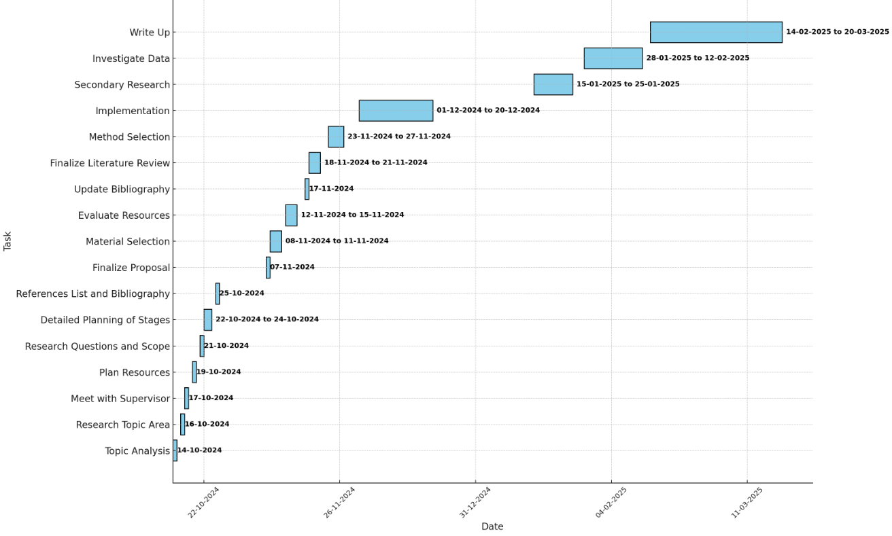

References

- Bell, E., Bryman, A., and Harley, B., (2022). Business Research Methods. 6th ed. Oxford: Oxford University Press.
- Brown, T. and Swain, J., (2019). Digital Recruitment and Employer Branding: A Comparative Study. London: Sage Publications.
- Creswell, J.W. and Creswell, J.D., (2023). Research Design: Qualitative, Quantitative, and Mixed Methods Approaches. 6th ed. Thousand Oaks, CA: Sage Publications.
- Evans, P., Rogers, L., and White, M., (2022). The New Normal of Work: Insights into Flexible Work Expectations Post-COVID. London: Kogan Page.
- Gray, D.E., (2022). Doing Research in the Real World. 5th ed. London: Sage Publications.
- Jahan, N. and Zhou, Y. (2023). Covid-19 and digital inclusion: Impact on employment. Journal of Digital Economy, (13)2, pp. 190-203
- Johnson, R., (2020). The Evolution of Digital Recruitment Practices. New York: Routledge.
- Malousis, A.T., Zefkilis, P.N. and Daglis, T. (2023). Employment in the 21st Century: Pre- and Post-COVID-19 Changes. Encyclopedia, 3(3), pp. 853-869
- Miller, S., (2021). AI in Recruitment: Balancing Efficiency with Ethical Considerations. Boston: Harvard Business Review Press.
- Punch, K.F. and Oancea, A., (2021). Introduction to Research Methods in Education. 3rd ed. London: Sage Publications.
- Saini, H. and Tarkar, P. (2024). COVID-19: Its Impact on Recruitment Selection and Organizational Performance. Institute of Business Management, 6(5), 9282-9299
- Saunders, M., Lewis, P., and Thornhill, A., (2023). Research Methods for Business Students. 9th ed. Harlow: Pearson.
- Smith, L. and Jones, K., (2021). Recruitment in the Age of COVID-19: Challenges and Opportunities. Journal of Business and Management, 43(2), pp. 134-145.
- Silverman, D., (2020). Qualitative Research. 5th ed. London: Sage Publications.
- Walker, J. and Phillips, S., (2020). Virtual Hiring: Building Trust and Engagement in Online Recruitment. Oxford: Oxford University Press.

