Exercises for Functions – 1 – passing parameters and using returns

1a. Calculate the area of a circle using a function enterfloat() to allow the user to enter a float value and then return the value back to main()

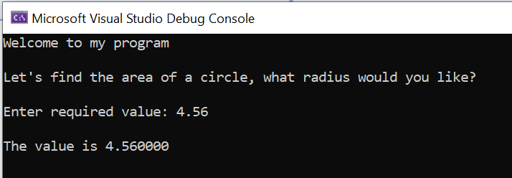
main()

enterfloat()

main()

Test this function – use a printf() in main() to double-check the returned value.

Solution:

#define _CRT_SECURE_NO_WARNINGS
#include <stdio.h>
float enterfloat(void);
void calculatecircle(float);

void main()
{
float radius, area;
printf("Welcome to my program\n\n");
printf("Let's find the area of a circle, what radius would you like?\n\n");
radius = enterfloat(); //get value from function
printf("The value is %f", radius);

}

float enterfloat()
{
float theValue;
printf("Enter required value: ");
scanf("%f", &theValue);
return theValue;
}

1b. Using another function, calculatecircle(), calculate the area of the circle and return it to main(). calculatecircle() will need to receive the radius value the user has already entered.

Sample output:

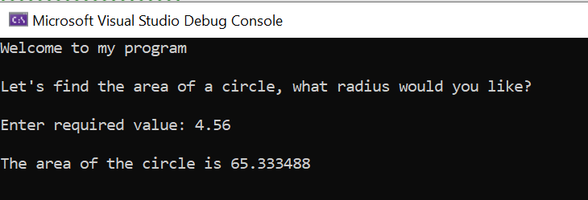
main()

enterfloat()
(return to main())

calculatecircle()
(return to main())

Solution:
#define _CRT_SECURE_NO_WARNINGS
#include <stdio.h>
float enterfloat(void);
float calculatecircle(float);

void main()
{
float radius, area;
printf("Welcome to my program\n\n");
printf("Let's find the area of a circle, what radius would you like?\n\n");
radius = enterfloat(); //get value from function
area = calculatecircle(radius); //send value to function to calculate area
printf("The area of the circle is: %f", area);

}

float enterfloat()
{
float theValue;
printf("Enter required value: ");
scanf("%f", &theValue);
return theValue;
}

float calculatecircle(float theRadius)
{
float theArea;
theArea = 3.142 * theRadius * theRadius;
return theArea;
}

1c Calculate the area of a second circle. Re-use the functions you already have.

Sample output:

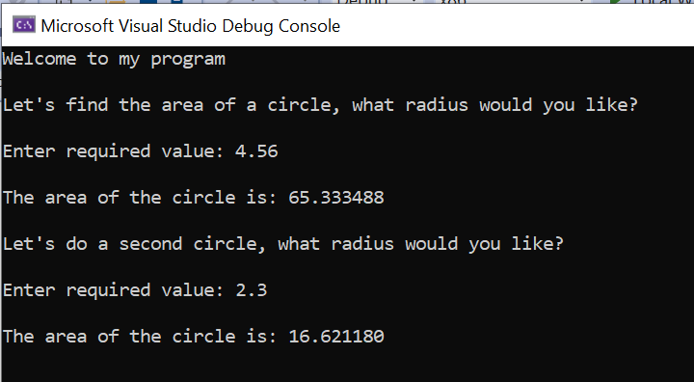

Solution:
#define _CRT_SECURE_NO_WARNINGS
#include <stdio.h>
float enterfloat(void);
float calculatecircle(float);

void main()
{
float radius, area, area2, areaRec1, areaRec2, width, length, total;
printf("Welcome to my program\n\n");

//Circle 1
printf("Let's find the area of a circle, what radius would you like?\n\n");
radius = enterfloat();
area = calculatecircle(radius);
printf("\nThe area of the circle is: %f", area);

//Circle 2
printf("\n\nLet's do a second circle, what radius would you like?\n\n");
radius = enterfloat();
area2 = calculatecircle(radius);
printf("\nThe area of the circle is: %f\n\n", area2);

}

float enterfloat()
{
float theValue;
printf("Enter required value: ");
scanf("%f", &theValue);
return theValue;
}

float calculatecircle(float theRadius)
{
float theArea;
theArea = 3.142 * theRadius * theRadius;
return theArea;
}

1d. Get the dimensions for a rectangle – width and length. We need two values (floats) for the length and width. Re-use enterfloat()

Sample output:

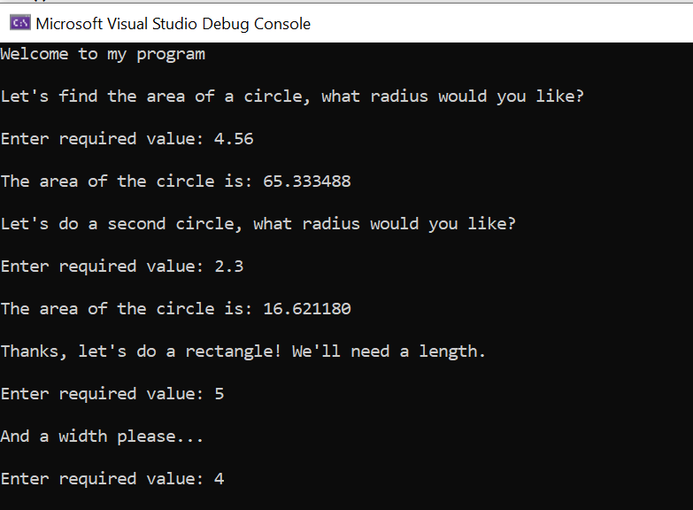
main()

enterfloat()

main()

enterfloat()

Solution:

#define _CRT_SECURE_NO_WARNINGS
#include <stdio.h>
float enterfloat(void);
float calculatecircle(float);

void main()
{
float radius, area, area2, areaRec1, areaRec2, width, length, total;
printf("Welcome to my program\n\n");

//Circle 1
printf("Let's find the area of a circle, what radius would you like?\n\n");
radius = enterfloat();
area = calculatecircle(radius);
printf("\nThe area of the circle is: %f", area);

//Circle 2
printf("\n\nLet's do a second circle, what radius would you like?\n\n");
radius = enterfloat();
area2 = calculatecircle(radius);
printf("\nThe area of the circle is: %f\n\n", area2);

//Rectangle 1
printf("Thanks, let's do a rectangle! We'll need a length.\n\n");
length = enterfloat();
printf("\nAnd a width please...\n\n");
width = enterfloat();

}

float enterfloat()
{
float theValue;
printf("Enter required value: ");
scanf("%f", &theValue);
return theValue;
}

float calculatecircle(float theRadius)
{
float theArea;
theArea = 3.142 * theRadius * theRadius;
return theArea;
}

1e Use a third function to calculate the area of the rectangle called calculaterectangle() and return the answer to main.

Sample output:

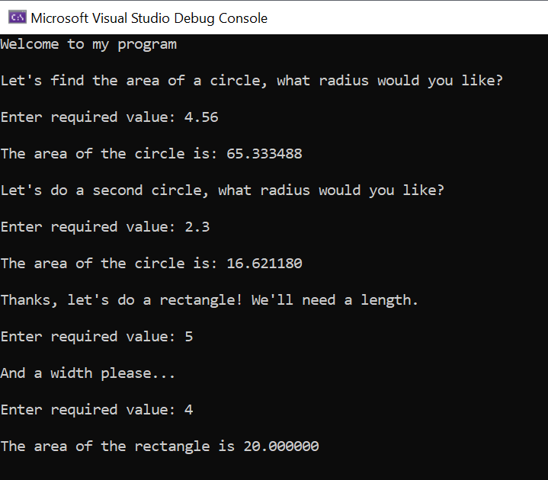
calculaterectangle() returns to main()

Solution:

#define _CRT_SECURE_NO_WARNINGS
#include <stdio.h>
float enterfloat(void);
float calculatecircle(float);
float calculaterectangle(float,float);

void main()
{
float radius, area, area2, areaRec1, areaRec2, width, length, total;
printf("Welcome to my program\n\n");

//Circle 1
printf("Let's find the area of a circle, what radius would you like?\n\n");
radius = enterfloat();
area = calculatecircle(radius);
printf("\nThe area of the circle is: %f", area);

//Circle 2
printf("\n\nLet's do a second circle, what radius would you like?\n\n");
radius = enterfloat();
area2 = calculatecircle(radius);
printf("\nThe area of the circle is: %f\n\n", area2);

//Rectangle 1
printf("Thanks, let's do a rectangle! We'll need a length.\n\n");
length = enterfloat();
printf("\nAnd a width please...\n\n");
width = enterfloat();
areaRec1 = calculaterectangle(length, width);
printf("\nThe area of the rectangle is %f\n\n", areaRec1);

}

float enterfloat()
{
float theValue;
printf("Enter required value: ");
scanf("%f", &theValue);
return theValue;
}

float calculatecircle(float theRadius)
{
float theArea;
theArea = 3.142 * theRadius * theRadius;
return theArea;
}

float calculaterectangle(float theLength, float theWidth)
{
float theArea;
theArea = theLength * theWidth;
return theArea;
}

1f. Calculate the area of the following shape. We have done most of the work already!
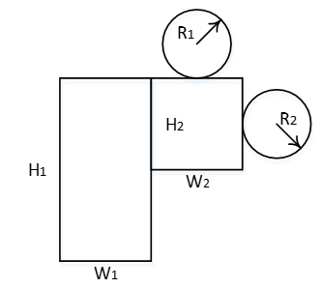

Sample output:

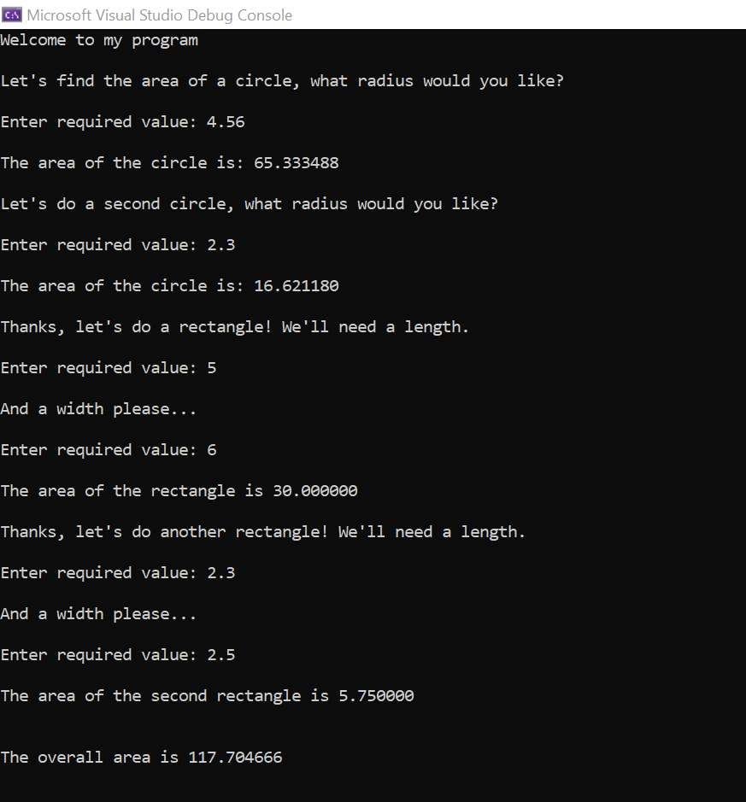

Solution:

#define _CRT_SECURE_NO_WARNINGS
#include <stdio.h>
float enterfloat(void);
float calculatecircle(float);
float calculaterectangle(float,float);

void main()
{
float radius, area, area2, areaRec1, areaRec2, width, length, total;
printf("Welcome to my program\n\n");

//Circle 1
printf("Let's find the area of a circle, what radius would you like?\n\n");
radius = enterfloat();
area = calculatecircle(radius);
printf("\nThe area of the circle is: %f", area);

//Circle 2
printf("\n\nLet's do a second circle, what radius would you like?\n\n");
radius = enterfloat();
area2 = calculatecircle(radius);
printf("\nThe area of the circle is: %f\n\n", area2);

//Rectangle 1
printf("Thanks, let's do a rectangle! We'll need a length.\n\n");
length = enterfloat();
printf("\nAnd a width please...\n\n");
width = enterfloat();
areaRec1 = calculaterectangle(length, width);
printf("\nThe area of the rectangle is %f\n\n", areaRec1);

//Rectangle 2
printf("Thanks, let's do another rectangle! We'll need a length.\n\n");
length = enterfloat();
printf("\nAnd a width please...\n\n");
width = enterfloat();
areaRec2 = calculaterectangle(length, width);
printf("\nThe area of the second rectangle is %f\n\n", areaRec2);

total = area + area2 + areaRec1 + areaRec2;

printf("\nThe overall area is %f\n\n",total);
}

float enterfloat()
{
float theValue;
printf("Enter required value: ");
scanf("%f", &theValue);
return theValue;
}

float calculatecircle(float theRadius)
{
float theArea;
theArea = 3.142 * theRadius * theRadius;
return theArea;
}

float calculaterectangle(float theLength, float theWidth)
{
float theArea;
theArea = theLength * theWidth;
return theArea;
}

