Certificate in Higher Education Business Skills for the Workplace  Enterprise and Entrepreneurship  LCLM4006 | 

Individual Written Business Plan
Student name : Ionela-Ramona Axente
Student ID :2507866
Lecturer: Ejike Udeogu

Executive Summary
Italia Wheels is a sustainable Italian food truck business that aims to provide authentic, high-quality Italian street food to customers across London. The business will offer a range of freshly prepared Italian meals, including artisan pizzas, pasta dishes, focaccia sandwiches, Italian desserts and beverages. The food truck concept responds to the growing demand for convenient, affordable and high-quality food options while also addressing increasing consumer interest in environmentally responsible businesses.
The business differentiates itself from competitors through its commitment to sustainability and community support. Italia Wheels will utilise biodegradable packaging, source ingredients from local suppliers where possible, and minimise food waste through responsible inventory management and food donation initiatives. These practices support environmental sustainability while contributing positively to the local community.
The business will operate as a sole proprietorship, allowing the owner to maintain full control over decision-making and business operations during the start-up phase. Market research, including a PESTEL analysis, indicates favourable conditions for growth due to increasing demand for street food, technological advancements in digital marketing and growing consumer awareness of sustainable business practices.
To attract customers, Italia Wheels will utilise a combination of social media marketing, a dedicated website, loyalty programmes and participation in local community events. These strategies will help increase brand awareness, customer engagement and long-term customer loyalty.
The business requires approximately £30,000 in start-up funding, which will be obtained through a combination of personal savings and a small business bank loan. The funding will be used to purchase and equip the food truck, obtain licences and permits, purchase inventory and support initial marketing activities. Overall, Italia Wheels presents a viable entrepreneurial opportunity with strong potential for growth and profitability within the UK street food industry.

TABLE OF CONTENTS
Contents | Page Number
Executive Summary | 2
1. Overview of the Business Idea | 4
2. Legal Format and Management Structure of the Startup Enterprise | 5
3. PESTEL Analysis and Competition Analysis | 7
4. Marketing Strategies and Customer Acquisition | 9
5. Funding Requirements and Start-up Expenses | 10
6. Reference List | 12

Italia Wheels: A Sustainable Italian Food Truck Business Plan

1. Overview of the Business Idea

Business Overview
Italia Wheels is a sustainable Italian food truck business that aims to provide authentic Italian street food to customers across London. The business will offer freshly prepared Italian meals, including artisan pizzas, pasta dishes, focaccia sandwiches, Italian coffee and desserts. The food truck will operate in busy commercial districts, university campuses, local markets and community events where there is a high concentration of potential customers.
The UK street food industry has experienced significant growth over recent years as consumers increasingly seek convenient, affordable and high-quality food options. According to the Department for Business and Trade (2024), the number of small businesses operating within the UK food and hospitality sector continues to grow, creating opportunities for innovative food ventures. This trend demonstrates that there is strong market demand for mobile food businesses that provide quality food while offering convenience to customers.
One important feature of Italia Wheels is its commitment to sustainability. Modern consumers are becoming increasingly concerned about environmental issues and often prefer businesses that demonstrate responsible practices. Therefore, all takeaway packaging will be biodegradable or recyclable. Furthermore, ingredients will be sourced from local suppliers wherever possible to reduce transportation emissions and support local businesses. Any surplus food will be donated to local charities and community organisations to minimise waste and contribute positively to society.
The unique selling proposition (USP) of Italia Wheels is the combination of authentic Italian cuisine, environmentally responsible operations and affordable pricing. Many food trucks focus primarily on convenience; however, Italia Wheels will differentiate itself by offering high-quality Italian recipes prepared using fresh ingredients while maintaining sustainable business practices. According to Burns (2020), businesses that successfully differentiate themselves from competitors are more likely to achieve long-term success because they provide unique value that customers cannot easily obtain elsewhere.
This business idea demonstrates strong entrepreneurial potential because it responds directly to changing consumer preferences. Customers increasingly seek convenience, authenticity and sustainability when making purchasing decisions. By addressing all three factors simultaneously, Italia Wheels can establish a competitive advantage within London's growing street food market.

2. Legal Format and Management Structure

Legal Format
Italia Wheels will operate as a sole proprietorship during its initial stages. A sole proprietorship is a business owned and managed by one individual who is responsible for all profits, losses and business decisions (Burns, 2020). This legal structure is suitable because it is relatively simple to establish, requires minimal administration and allows the owner to retain complete control over business operations.
The main advantage of operating as a sole proprietorship is flexibility. Since the business owner has full authority over decision-making, changes can be implemented quickly without consulting partners or shareholders. This is particularly beneficial during the early stages of a business when rapid responses to customer feedback and market changes may be necessary.
Although unlimited liability represents a potential disadvantage, the relatively small scale of the proposed business makes this legal structure appropriate during the start-up phase. As the business expands, the owner may consider converting the business into a limited company to provide greater legal protection and opportunities for future investment.

Management Structure
The management structure of Italia Wheels will be relatively simple. The owner will act as the Managing Director and oversee all aspects of the business, including financial management, supplier relationships, marketing activities and strategic planning.
A part-time food assistant will be employed to assist with food preparation, customer service and daily operations. During busy periods such as festivals and community events, additional temporary staff may be hired to ensure efficient service delivery.
This lean management structure enables the business to minimise labour costs while maintaining operational efficiency. According to Scarborough and Cornwall (2019), effective resource management is essential for small business success because it allows entrepreneurs to maximise productivity while controlling expenses.

3. PESTEL Analysis and Competition Analysis

PESTEL Analysis
A PESTEL analysis examines external environmental factors that may affect business performance (Johnson et al., 2020). The PESTEL analysis demonstrates that social and environmental factors create significant opportunities for Italia Wheels. Consumers increasingly seek convenient food options while also supporting businesses that adopt sustainable practices. Although economic challenges such as inflation may increase operating costs, the flexibility and lower overheads associated with food truck businesses provide a competitive advantage. Therefore, by responding to changing consumer preferences and maintaining compliance with legal requirements, Italia Wheels is well positioned to succeed within the UK street food market. (Johnson et al., 2020).

Political Factors
Political regulations play an important role in the operation of food businesses. Local councils require food vendors to obtain licences and comply with strict hygiene standards. While compliance may increase administrative costs, it also ensures food quality and consumer protection. Consequently, maintaining high standards can strengthen customer trust and business credibility.

Economic Factors
Economic conditions significantly influence consumer spending patterns. Rising inflation has increased food prices across the UK, creating challenges for hospitality businesses. However, food trucks generally have lower operating costs than traditional restaurants and can therefore offer more affordable menu options. This affordability may attract customers during periods of economic uncertainty.

Social Factors
Social trends strongly support the proposed business idea. Consumers increasingly prefer quick and convenient food options that fit busy lifestyles. Furthermore, Italian cuisine remains one of the most popular international food categories in the UK due to its familiarity and broad appeal. This social preference creates favourable conditions for business success.

Technological Factors
Technology provides several opportunities for Italia Wheels. Social media platforms such as Instagram, Facebook and TikTok allow businesses to engage directly with customers and promote products effectively. Mobile payment systems and online ordering platforms also improve customer convenience and operational efficiency.

Environmental Factors
Environmental sustainability is becoming increasingly important within the hospitality industry. Consumers are more likely to support businesses that demonstrate environmental responsibility. Therefore, the use of biodegradable packaging and local sourcing aligns with current consumer expectations and strengthens the company's market position.

Legal Factors
Food businesses must comply with numerous legal requirements, including food hygiene regulations, employment legislation and health and safety standards. Failure to comply may result in financial penalties or reputational damage. Therefore, legal compliance will remain a key operational priority.
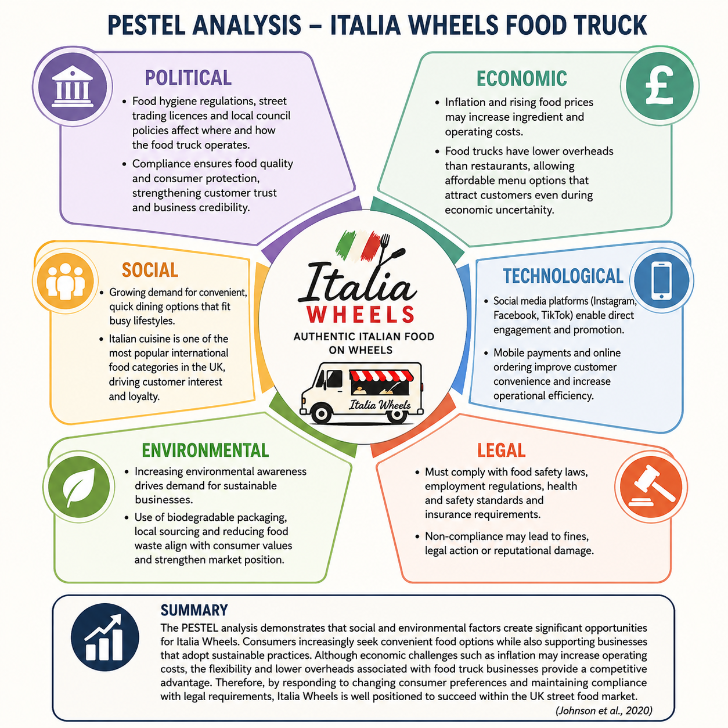

Competition Analysis
The primary competitors of Italia Wheels include local food trucks, Italian takeaway restaurants and fast-food outlets operating within London.
Italia Wheels will compete by focusing on authentic Italian recipes, sustainability initiatives and community engagement. Porter (2008) argues that differentiation is a key strategy for achieving competitive advantage. By offering a unique combination of quality, convenience and environmental responsibility, the business can attract customers who value these attributes.

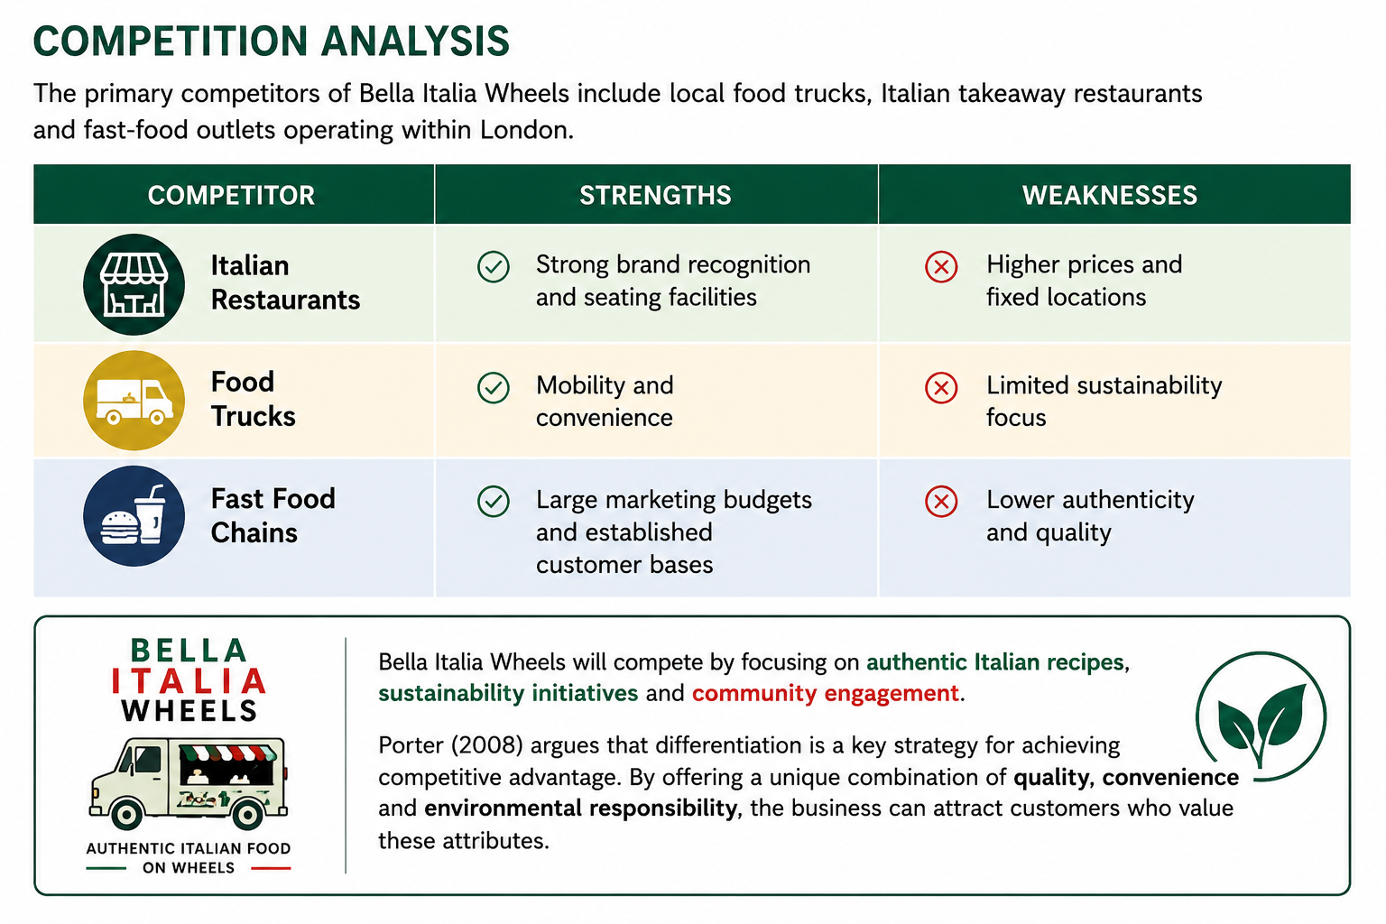
Italia Wheels
Italia Wheels

4. Marketing Strategies and Customer Acquisition

Marketing Objectives
The primary marketing objective is to establish strong brand awareness during the first year of operation while developing a loyal customer base. Marketing activities will focus on increasing visibility, attracting first-time customers and encouraging repeat purchases.

Social Media Marketing
Social media will be the primary promotional tool used by Italia Wheels. According to Chaffey and Ellis-Chadwick (2022), digital marketing enables businesses to communicate directly with consumers at relatively low cost.
The business will maintain active accounts on Instagram, Facebook and TikTok. Regular content will include menu promotions, customer reviews, behind-the-scenes videos and location updates. This strategy helps build engagement while increasing brand awareness among potential customers.

Website and Online Presence
A professional website will be developed to provide information about the menu, locations and sustainability initiatives. Customers will be able to access business information easily and stay informed about upcoming events.
Search engine optimisation (SEO) techniques will also be used to improve online visibility and attract local customers searching for street food options in London.

Location Strategy
Location selection is critical for food truck success. The business will operate in high-footfall areas including business districts, university campuses, festivals and community markets.
These locations provide access to large numbers of potential customers and increase sales opportunities. Careful analysis of customer traffic patterns will help maximise revenue generation and improve operational efficiency.

Customer Loyalty Programme
Customer retention is often more cost-effective than acquiring new customers. Therefore, Italia Wheels will introduce a loyalty card programme where customers receive a free meal after purchasing a specified number of items.
This strategy encourages repeat business and strengthens customer relationships.

Community Engagement
The business will actively participate in local community events and charitable initiatives. Food donations and partnerships with local organisations will enhance the company's reputation while demonstrating social responsibility.
Such activities support the sustainability objectives of the business and create positive brand associations among consumers.

5. Funding Requirements and Start-up Expenses

Funding Requirements
Italia Wheels requires approximately £30,000 in start-up funding to purchase equipment, secure licences and cover initial operating expenses.

Funding Sources
The primary funding source will be a combination of personal savings and a small business bank loan.Personal savings demonstrate commitment to the business and reduce reliance on external finance. However, additional funding is required to purchase the food truck and equipment necessary for operations.A bank loan is considered an appropriate funding source because it provides access to sufficient capital while allowing the owner to maintain full ownership of the business. Alternative funding options such as business angels could also be considered if future expansion opportunities arise.
According to Burns (2020), entrepreneurs often combine multiple funding sources to minimise financial risk and improve financial stability.The food truck represents the largest investment because it forms the foundation of business operations. Adequate working capital is also essential to ensure sufficient cash flow during the early stages of operation.
Cash Flow Forecast – Month 1
The cash flow forecast indicates that Italia Wheels is expected to generate a positive net cash flow of £8,600 during its first month of operation. The largest expenditure is the purchase and fitting of the food truck and kitchen equipment, which are essential for business operations. Despite significant start-up costs, the combination of personal savings, bank loan funding and projected sales revenue ensures sufficient liquidity to support the launch of the business. Maintaining positive cash flow is important because it enables the business to meet its financial obligations and support future growth opportunities (Burns, 2020).
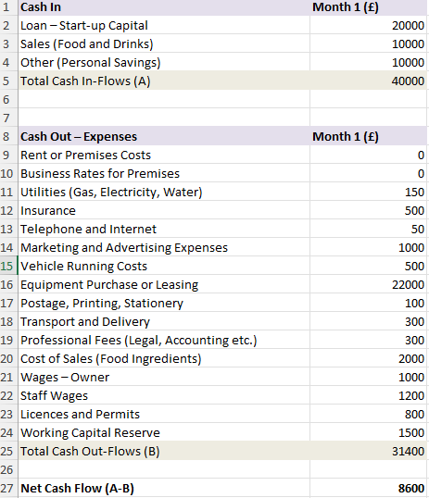

Conclusion
Italia Wheels represents a viable entrepreneurial opportunity within London's growing street food sector. The business combines authentic Italian cuisine, environmental sustainability and community engagement to create a distinctive market offering. Analysis of the external environment demonstrates favourable conditions for growth, while the proposed marketing strategy provides practical methods for attracting and retaining customers. Through effective financial planning, strong operational management and a commitment to sustainability, Italia Wheels has significant potential to achieve long-term success within the competitive food service industry.

Reference List (Harvard Style)
- Burns, P. (2020) Entrepreneurship and Small Business: Start-up, Growth and Maturity. 5th edn. London: Red Globe Press.
- Chaffey, D. and Ellis-Chadwick, F. (2022) Digital Marketing. 8th edn. Harlow: Pearson.
- Department for Business and Trade (2024) Business Population Estimates for the UK and Regions 2024. Available at: https://www.gov.uk/government/statistics/business-population-estimates-2024/business-population-estimates-for-the-uk-and-regions-2024-statistical-release (Accessed: 23 June 2026).
- Johnson, G., Scholes, K., Whittington, R. and Angwin, D. (2020) Exploring Strategy. 12th edn. Harlow: Pearson.
- Kotler, P., Armstrong, G. and Opresnik, M. (2021) Principles of Marketing. 18th edn. Harlow: Pearson.
- Office for National Statistics (2024) Consumer Trends and Household Spending in the UK. London: ONS.
- Porter, M.E. (2008) ‘The five competitive forces that shape strategy’, Harvard Business Review, 86(1), pp. 78–93.
- Scarborough, N.M. and Cornwall, J.R. (2019) Essentials of Entrepreneurship and Small Business Management. 9th edn. Harlow: Pearson.
- Statista (2024) Street Food Market and Consumer Trends in the United Kingdom. Available at: https://www.statista.com (Accessed: 23 June 2026).
- UK Hospitality (2024) Hospitality Industry Performance Report. London: UK Hospitality.

