Describing a Typical Workday: Prioritization, Delegation, Delivery, and Communication Strategies
In my role I have a range of responsibilities and projects to deliver. This essay will assess the way in which I manage my workload in order to deliver projects to a high standard within the often limited time available. A log of a typical work routine for a day is provided in Appx.1, which reflects the range of tasks I undertake and the variety of specialist and non-specialist stakeholders I communicate with to ensure successful project delivery.
Prioritisation
Every morning I list the tasks that I plan on completing that day (8.00-8.15). Numerous studies have found links between prioritisation and performance (Tripoli 1998; Gollwitzer 1999); high performers are typically those who prioritise their time across multiple demands with a focus on priorities that reflect organisational goals (Claessens et al 2009: 464). My hand-written ‘to-do list’ from the example day is provided as Fig.1. When compiling my ‘to-do list’, I make reference to a wider list of all the projects I am involved in, many of which are long-term. My list is certainly not exhaustive, omitting routine meetings and emails, and typically only including tasks of high or medium importance due to my substantial workload – low or negligible tasks are often delegated or dismissed. Compiling the prioritised list gives me the opportunity to decide what I need to delegate to deliver my projects.
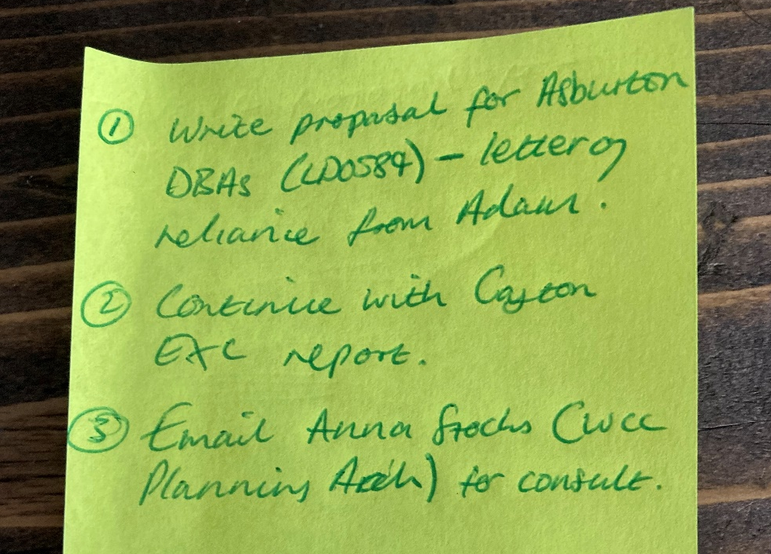
Fig.1: My hand-written to-do list
Generally, I try to prioritise tasks that have been espoused by the management team as being important, such as: tasks that secure projects, like the production of proposals and costings for new projects; tasks that are time-sensitive projects and chargeable to the client; and tasks that may cause delays to the work of other personnel or other stakeholders. Based on these espoused goals, I roughly organise my day in order of priority. For the example day, I had three high-priority tasks: a proposal and costing; email consultation about evaluation works; and the compilation of an excavation report, which would not be finished that day, but was an urgent task.
While compiling my list in the morning certainly helps me manage my time, taking time at the end of the day to plan for the next day may be more effective. In addition to providing an opportunity to reflect on my daily accomplishments (Thomack 2012: 202) and making it easier to start tasks in the morning, it may reduce stress by signalling that the workday has ended so that one can ‘switch-off’ (St James 2001).
After planning my workday, I responded to emails that needed quick responses (8.15-8.30); without sending these emails, a simple and quick task, other people’s workload would have been impacted. Once I had responded to the urgent emails, I began to work on compiling a proposal for two DBAs for an established client (8.30-10.30). This was a top-priority task as it had the potential to generate business and had an impending deadline for submission. I typically tackle the most urgent or complex tasks in the morning, in case any unforeseen problems emerge that may take time to resolve. Furthermore, although I sometimes avoid doing such, I try to tackle demanding or urgent task in the mornings, when I am often more productive; as noted by Thomack (2012: 201), workers skilled in time-management tend to tackle difficult tasks when they are most efficient.
Fortunately, I had produced the draft proposals prior to the weekly archaeology project management meeting (10.30-11.00). Although the meeting means that I can not work on ‘chargeable’ tasks, the meetings are vital to keeping informed of changing department priorities and changing responsibilities. Crucially, it is restricted to thirty-minutes, which creates a realistic schedule and ensures that the meeting does not overrun at the expense of ‘productive’ tasks (Thomack 2012; Lehman-Willenbrock et al 2017).
After the meeting, I had time to focus on the urgent PXA/UPD report (c.11.00-16.15). I planned to concentrate on the report for much of the day; in reality, I did not dedicate myself to the task for as long as I had intended. There were several low-priority tasks and non-work-related distractions that impacted my productivity – three times during the day I engaged in extraneous non-work-related conversations with colleagues. In addition to distracting me, personal conversations that are not business critical are often distracting to colleagues working in adjoining workspaces (Kjellberg and Landstrom 1994; Olson 2002; Roper and Juneja 2008). While I do not want to stifle collaboration or impact relationships, it is important to manage and reduce interruptions to limit inefficiencies. In order to deliver high-quality projects in the time available going forward it may be prudent – for example, when I need to exclusively focus on writing an excavation report – to inform colleagues that I am busy and not to be distracted.
During the example day, I also received an unscheduled call from a colleague (11.45-12.15), which likewise halted my work on the report. This call, although somewhat work-related, involved repetition of topics addressed during the abovementioned meeting (10.30-11.00) and could largely be characterised as organisational ‘gossip’. Despite the discussion of some potentially useful information that could inform my practice, the duration of the call was excessive. I sometimes struggle to ‘close’ conversations, and occasionally discussions continue beyond what is necessary. This can, accumulatively, take up time that could be used more productively. In order to improve my time-management, as suggested by Lombardo and Eichinger (2008), I should develop my skills in ‘courteously terminating’ conversations.
Following the call, like many interrupted while working on their primary task (Mark et al 2005), I did not immediately return the task I was working on. Instead, I took the opportunity to complete one of my top-priority tasks for the day – emailing a curatorial archaeologist for the cost of consultation for a quarry site extension (12.15-12.30). Despite using this period as an opportunity, such an interruption could have involved a ‘cognitive cost’ in relation to stress and would have involved a cost in terms of the time taken to reorientate back to a relatively complex task (ibid.:322).
At the end of each day – in addition to cleaning my desk which prepares one for productivity the following day (Thomack 2012) – I logged my time in the Coretime project management software used by Wardell Armstrong. This software allows me to be aware of the time I have dedicated to each task and to understand the time/budget remaining to deliver each project. Using this project management and expense/billing software means that I can take action, if necessary, to ensure project delivery; be it through delegation or a change in process. It was during this routine task I realised that I had personally not spent as much time as I have needed on writing the excavation report, a high-priority task. By doing this, at least in theory, should enable me to alter the way in which I personally plan or behave at work so that I can be more efficient and deliver high-quality projects within the time available.
Delegation
There were three occasions when I delegated throughout the day: requesting figure changes (8.15-8.30), the creation of a Letter of Reliance (8.45-9.00), and the finalisation of a proposal (13.15-13.30). Delegation is acknowledged to be a crucial aspect of effective project management (Yukl 1994; Yukl and Ping Fu 1999); it is essential if projects are to be delivered within the time available. I typically delegate tasks that could be completed quicker and to a higher standard by my colleagues, such as figure alterations using software that I am not proficient in or the creation of legal documents. The way in which projects are budgeted have implications on my decisions to delegate. An hour of administration staff time is charged to the client at £15 per hour, while my time is a comparatively expensive £95 per hour. As such, delegation is often prudent as the cost implications, and in turn timescale consequences, are significant. The delegation of tasks to others can also free up time, allowing one to focus on higher-priority tasks or tasks that require a specific skill-set.
Communication
During my workday I communicate with a variety of stakeholders. A way in which I manage communication with different audiences is by using the appropriate medium. Each medium has its own nuances and individuals have their own preferences. My choice of medium depends on a range of factors. For example, if something urgent and simple needs to be imparted and I need to be certain of comprehension, I will phone the individual; if something complex needs to be conveyed that may require a considered response, I will email the individual. Regardless of the audience or the medium, while oftentimes more jovial and friendly when communicating with specialist and non-specialist internal colleagues, I maintain professionalism through the use of respectful and courteous tone. Perhaps just as importantly, I also try to maintain a positive and constructive attitude, even in challenging or contentious situations.
On two occasions I communicated with non-specialist stakeholders – a client over the phone (14.00-14.15) and a landowner via email (8.15-8.30). The call was relatively short, focusing on the pertinent new developments within their project, and did not overrun; it is best to keep communications concise as all stakeholders are almost certainly subject to time constraints. To convey information to non-specialists I avoid technical jargon and abbreviations that may be unfamiliar. During the phone conversation with a client I conveyed the almost certain necessity of a geoarchaeological borehole survey and trial-trenching as part of a pre-determination evaluation. I tried to make it abundantly clear that it was exceedingly probable that this would be required, refraining from uncertainties and wishful thinking. I attempted to convey the ‘bad news’ clearly and explain the requirement of the bore hole survey, related to peat and gravel deposits, in simple terms without any extraneous details. Rather than explaining the methodological specifics and potential interest of palaeolithic remains or the geoarchaeological interest of peat – aspects of archaeology which are arguably not inherently interesting or conciliating to non-specialists – I focused on the practical process and implications for their development in terms of cost, planning, and timeframes. Indeed, clients often have very limited interest in archaeological findings, but understandably have significant concerns related to any impact to their development (Locock 2012 :37). Although in this instance the client understood the details I was trying to convey, it is vital to ascertain whether they have properly understood what is being communicated. In order to gain this feedback I sometimes encourage queries and questions so that the client can seek clarification or request additional explanations if something is unclear; one has to ‘actively listen’ and be prepared to explain oneself in different ways if necessary. Email correspondence (8.15-8.30) largely follows the same principals as verbal conversation with non-specialist clients and should likewise be simply conveyed, concise, specific and focused – providing the background context and the necessary information in comprehensive and ‘digestible’ chunks.
Throughout my workday I also communicated with external (12.15-12.30) and internal (8.15-8.30; 8.45-9.00; 10.15-10.30; 13.00-13.15) specialists. While similarly being concise and specific, I regularly use professionally-agreed terms and abbreviations when conversing with archaeological specialists; this makes communication more efficient as there is no need for excessive explanations. The email communication between myself and the curatorial archaeologist (12.15-12.30) is perhaps most demonstrative of how I try to communicate with specialists. I try to meticulously scrutinise my own communications to avoid any errors or ambiguities, taking care to relay relevant information accurately, as it is highly likely that the information I convey will be scrutinised, critiqued and its implications potentially resisted. To impart reliability and establish the utility of my statements, I try to acknowledge the specialist input of others and provide specific references to support my statements. Part of my efforts to effectively communicate are my attempts to avoid exaggerated statements, and conversely understated or downplayed statements; proportionality is vital, especially in the context of negotiations with a curatorial archaeologist on works that have archaeological and budgetary implications, as skewed information can have significant consequences.
Conclusion
By starting each day with a prioritised list, I ensure that critical tasks are addressed promptly in alignment with organisational goals. I prioritise tasks based on their potential for business generation, time-sensitivity, chargeability, and impact to stakeholders. In order to deliver my workload, I try to delegate tasks to strategically enhance efficiency – delegating tasks that can be completed more effectively and quicker by others. Despite planning my day, I was unable to be execute it in reality, due to unforeseen interruptions and tasks. Methods for improving my productivity and avoiding interruptions have nevertheless been proffered that could improve my ability to deliver tasks in the time available. Regardless, due to my workload, I could not, and regularly cannot, dedicate any time to professional development or business development; tasks vital to improving standards and ensuring long-term profitability.
In my role it is vital that I communicate effectively with a range of stakeholders in order to deliver successful projects. As outlined above, I try to consider the level of knowledge that the individual I am communicating with has and, significantly, what they want to achieve through each communication. Tailored communication styles, in addition to saving valuable time, can enhance mutual understanding and facilitate successful outcomes for all involved.

Bibliography
Claessens, B., van Eerde, W., Rutte, C. and Roe, R. (2009) 'Things to Do Today...:A Daily Diary Study on Task Completion at Work', Applied Psychology: An International Review, pp. 1-23. DOI: 10.1111/j.1464-0597.2009.00390.x
Gollwitzer, P. (1999) 'Implementation intentions: Strong effects of simple plans', American Psychologist, 54, pp. 493-503.
Kjelberg, A. and Landstrom, U. (1994) 'Noise in the office: Part II – the scientific basis (knowledge base) for the guide', International Journal of Industrial Ergonomics, 14.
Lehmann-Willenbrock, N., Rogelberg, S., Allen, J. and Kello, J. (2017) 'The critical importance of meetings to leader and organizational success: Evidence-based insights and implications for key stakeholders', Psychology Faculty Publications, pp. 1-13.
Locock, M. (2012) 10 Simple Steps to Better Archaeological Management: Practical Tips to Improve Your Performance. Ammanford: Carreg Ffylfan Press.
Lombardo, M. M. and Eichinger, R. W. (2008) FYI, For Your Improvement: A guide for development and coaching. Mineapolis: Lominger Limited.
Olson, J. (2002) 'Research about office workplace activities important to US businesses – and how to support them', Journal of Facilities Management, 1, pp. 31-47.
Roper, K. and Juneja, P. (2008) 'Distractions in the workplace revisited', Journal of Facilities Management, 6(2), pp. 91-109. DOI: 10.1108/14725960810872622
St James, E. (2001) Simplify your work life: Ways to change the way you work so you have more time to live. New York: Hyperion.
Thomack, B. (2012) 'Time Management for Today's Workplace Demands', Workplace Health & Safety, 60(5), pp. 201-203. DOI: 10.1177/216507991206000
Tripoli, A. (1998) 'Planning and allocating: Strategies for managing priorities in complex jobs', European Journal of Work and Organizational Psychology, 7, pp. 455-476.
Yukl, G. (1994) Leadership and Organizations. Englewood Cliffs: Prentice Hall.
Yukl, G. and Ping Fu, P. (1999) 'Determinants of delegation and consultation by managers', Journal of Organizational Behavior, 20, pp. 219-232.

Appendix 1: Time Log of Example Workday
Time Period | Task
8.00 – 8.15 | - Said hello to my colleagues.  - Compiled task list for the day.  - Uploaded photographs taken the previous day during a site and archive visit for an ancient woodland assessment
8.15 – 8.30 | - Responded to internal emails received about projects including, an email organising site access for a geophysical assessment and delegating an email requesting figure edits for a publication.
8.30 – 8.45 | - Read through a project scope provided by a client for two archaeological desk-based assessments.  - Made a Microsoft Teams call to establish availability of colleague to conduct site visits and the timescales to complete the assessments.
8.45 – 9.00 | - Compiles the combined proposal letter report for the archaeological desk-based assessments.  - Delegating the production of a Letter of Reliance from the legal/bidding team via email.
9.00 – 9.15 | - Compiled the combined proposal letter report for the archaeological desk-based assessments.  - Non-work-related chat with colleague.
9.15 – 9.30 | - Compiled the combined proposal letter report for the archaeological desk-based assessments.
9.30 – 9.45 | - Compiled the combined proposal letter report for the archaeological desk-based assessments.
9.45 – 10.00 | - Compiled the combined proposal letter report for the archaeological desk-based assessments.
10.00 – 10.15 | - Compiled the combined proposal letter report for the archaeological desk-based assessments.  - Made budget calculations and inserted them into the proposal letter report for the archaeological desk-based assessments.
10.15 – 10.30 | - Compile the Terms of Engagement (TofE) for the proposal letter report for the archaeological desk-based assessments.  - Send the TofE and the proposal letter report to the Technical Director for QA.
10.30 – 10.45 | - Made a coffee and got a glass of water.  - Heritage and archaeology weekly project management meeting.
10.45 – 11.00 | - Heritage and archaeology weekly project management meeting.
11.00 – 11.15 | • Write-up the discussion section of a research and archive report (RAR) for an excavation in Norfolk
11.15 – 11.30 | • Write-up the discussion section of a research and archive report (RAR) for an excavation in Norfolk
11.30 – 11.45 | • Write-up the discussion section of a research and archive report (RAR) for an excavation in Norfolk
11.45 – 12.00 | • Teams call with colleague – range of topics covered.
12.00 – 12.15 | • Teams call with colleague – range of topics covered.
12.15 – 12.30 | • Email curatorial archaeologist for cost for consultation on a project.
12.30 – 12.45 | • Write-up the discussion section of a research and archive report (RAR) for an excavation in Norfolk
12.45 – 13.00 | • Write-up the discussion section of a research and archive report (RAR) for an excavation in Norfolk
13.00 – 13.15 | • Write-up the discussion section of a research and archive report (RAR) for an excavation in Norfolk
13.15 – 13.30 | - Addressed tracked changes made by Technical Director during QA for the proposal letter for the archaeological desk-based assessments.  - Delegate merging and finalisation of the proposal to admin team.
13.30 – 13.45 | - Break for lunch.
13.45 – 14.00 | - Break for lunch.
14.00 – 14.15 | - Received phone call from a client with regards to potential options for mitigation to discuss in consultation with the curatorial archaeologist.
14.15 – 14.30 | • Write-up the discussion section of a research and archive report (RAR) for an excavation in Norfolk
14.30 – 14.45 | • Emailed the aforementioned proposal to the client.  • Non-work-related chat with colleague
14.45 – 15.00 | • Write-up the discussion section of a research and archive report (RAR) for an excavation in Norfolk
15.00 – 15.15 | - Catch-up phone call with a supervisor that is running a small trial-trench evaluation site.
15.15 – 15.30 | - Discussion with Technical Director about future costings for projects in London.
15.30 – 15.45 | • Write-up the discussion section of a research and archive report (RAR) for an excavation in Norfolk
15.45 – 16.00 | • Write-up the discussion section of a research and archive report (RAR) for an excavation in Norfolk
16.00 – 16.15 | - Write-up the discussion section of a research and archive report (RAR) for an excavation in Norfolk  - Non-work-related chat with colleague.
16.15 – 16.30 | - Completed Coretime log (timesheet, expense, and project management software).  - Cleared desk and organised papers prior to leaving the office.

