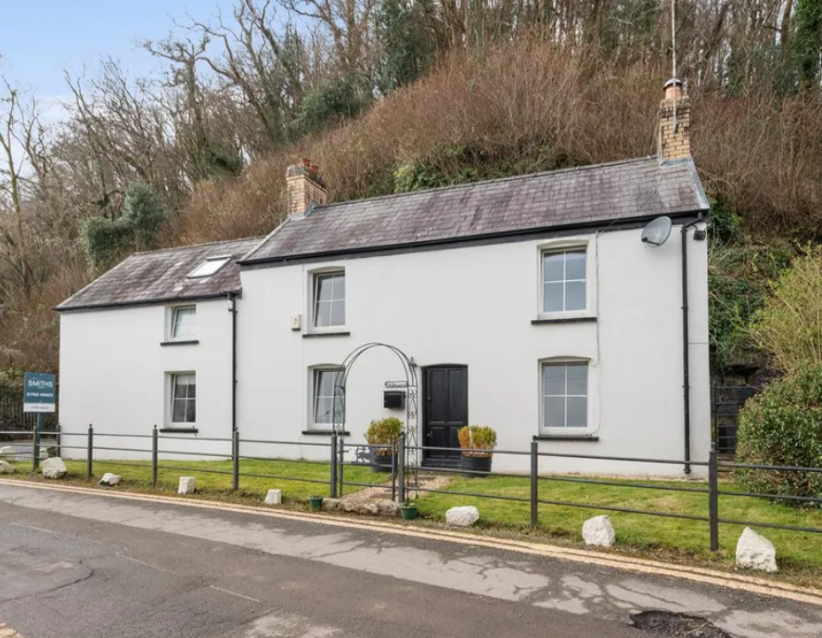
ACBA 5026 SEM 2
Underwood House Retrofit
Goodrum, Joseph (J)

Contents
Introduction 2
Existing building overview 2
Current Building performance. 3
Building performance improvements. 4
External walls. 5
Windows and doors. 7
Ventilation. 10
Floor Slab. 12
Conclusion 14
References 15
Appendix 19

Introduction

This report aims to address the need for reducing energy consumption and CO2 emissions in the building sector. As standards for new builds continue to tighten, it is equally important to improve the existing building stock. This report will explore the EnerPHit standard, which provides a Passive-oriented set of requirements for retrofits (Taylor, 2011a).
The goal is to significantly reduce the energy consumption of Underwood House while allowing for realistic flexibility in project constraints such as costs. Achieving EnerPHit means making energy-efficient renovation projects, offering the same long list of benefits as Passive House certification. This report will identify and propose changes to Underwood House to meet the EnerPHit standard, utilizing its key assessment criteria and PHPP methodology.

Existing building overview
Underwood house is a 3-bedroom, 1-bathroom, detached property, as shown in Appendix A. the original construction dates to 1874, with the addition of a single storey ground floor side extension in 1977, a further addition of a top floor to this extension in 1995, and the addition of the rear single-story extension in 2005 (SCBC, 2025).
Upon site survey it is noted that the top floor extension in 1995 was not insulated but this should have been under building control, both side extensions are not insulated.
Based upon the historical information, the scan of the property, shown in appendix B, and the site survey it is concluded that the original building is a solid wall stone construction uninsulated, the side extension is breezeblock cavity wall construction uninsulated, and the rear is breezeblock cavity wall that with 30mm insulation.
The side extension and the main roofs are cold roof pitch construction slate covered with 100mm of mineral wool insulation, and the rear extension has a lean to slate roof with 100mm of mineral wool insulation.
Underwood house is currently fitted with double glazed windows, double glazed French doors on the North aspect, and wooden doors on the East and South aspects. The ground floors are constructed of insulated screed with stone slabs. Illustration 1. Below shows that the current ventilation strategy consists of an intermittent MEV located in the Kitchen, there is also an MEV located in the bathroom although this is not shown.

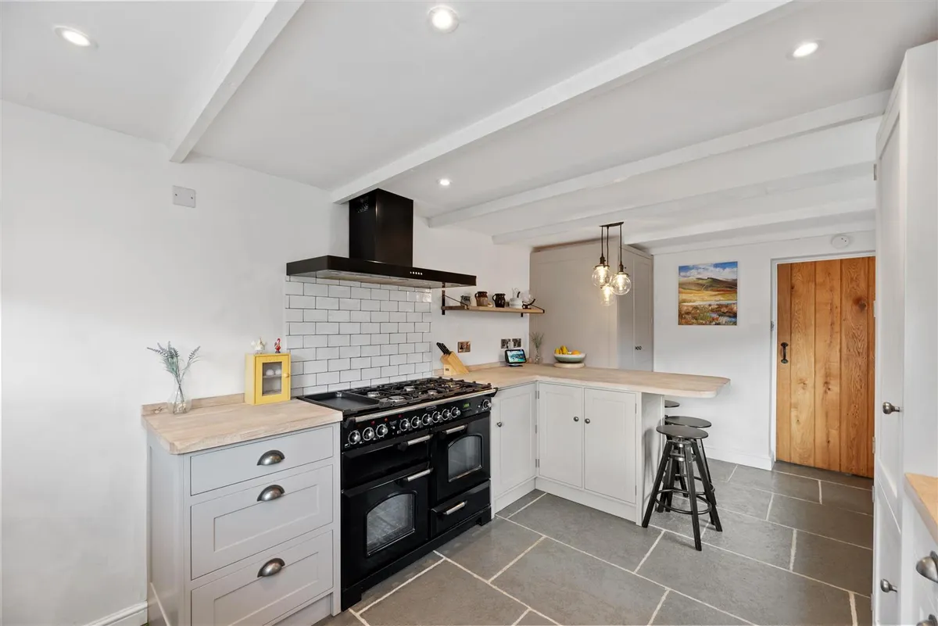
Illustration 1. Showing kitchen MEV (Zoopla, 2025a).

Current Building performance.

Underwood has been modelled using PHPP software to evaluate the current performance of the property, and to indicate the largest contributors to the heating demand of the building. Figure 1. Below shows the existing heating demand of the building, this shows that the overall losses of the building equal 395.5 kWh/(m2a). This graph indicates that the biggest losses to the building are (Microsoft Corporation, 2024a).

- 183.1 kWh/(m2a) External walls.
- 70.9 kWh/(m2a) Windows and doors.
- 60.2 kWh/(m2a) Ventilation.
- 55.1 kWh/(m2a) Floor slab.
The graph also indicates that the gains to counter the losses from the building are almost entirely made up from the heating demand of the property with minimal solar gains, this is most likely caused by the property being in a low point of the land with overshadowing behind the property.

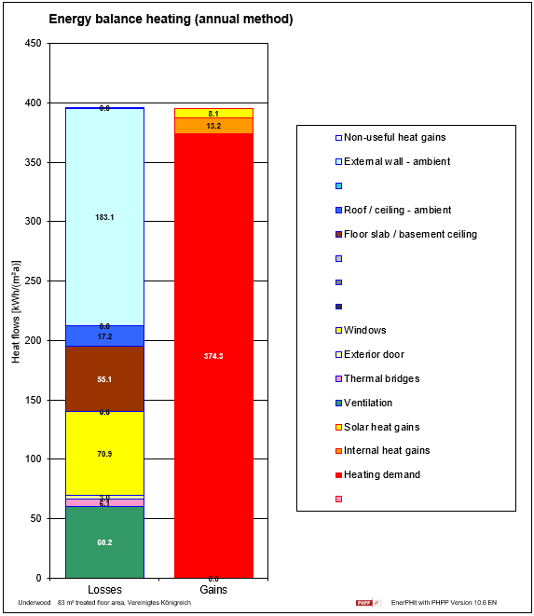
Figure 1. Current heating demand (Microsoft Corporation, 2024b).

The heating demand of 374.3 kWh/(m2a) for the property is made up using a gas combi boiler, appendix D. shows this is a Bosch Greenstar 30i LPG and was installed in 2022. Illustration 1. Below shows there is an addition of a multifuel supplementary heating device although this has not been taken into consideration in the document.

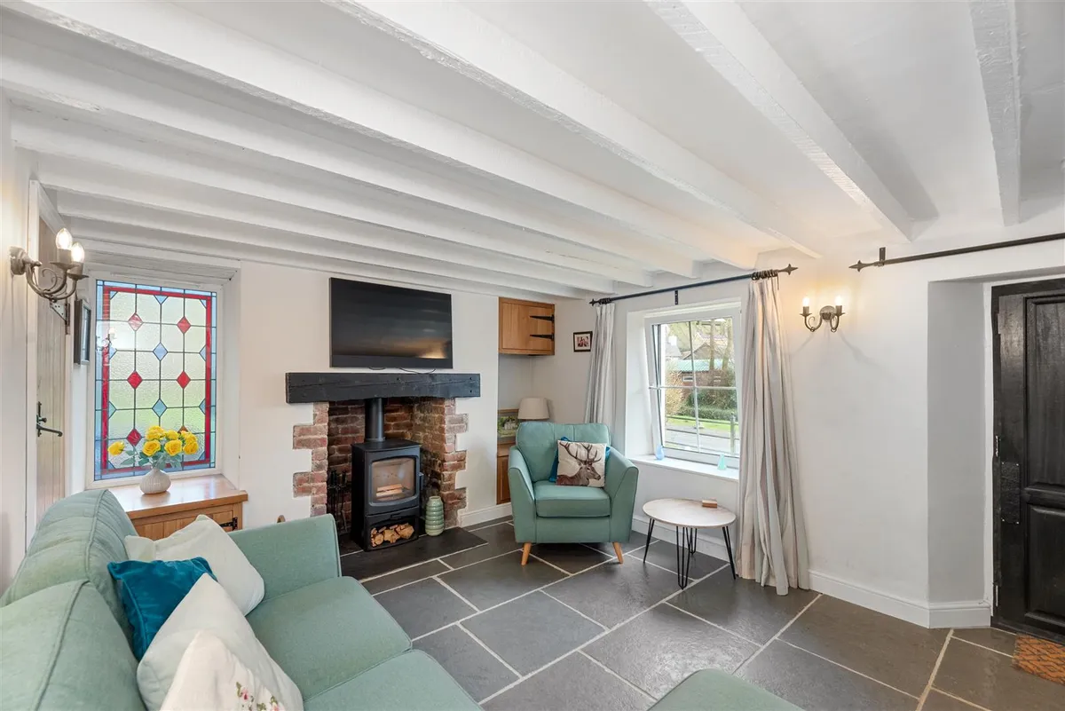
Illustration 2. Showing the supplementary heating (Zoopla, 2025b).

Appendix E shows the calculation to convert the annual gas usage and converts this into 381.61 kWh/(m2a), this figure then confirms that the building modelling in PHPP is accurate as there is a difference of only 7.31 kWh/(m2a) (Microsoft Corporation, 2024c).

Building performance improvements.
Using the information gained in figure 1. This report will evaluate and make recommendations to the buildings worst performing elements to see if the performance can be improved to meet the EnerPhit standard.

The EnerPhit standard is a certification scheme for retrofitted buildings and is the Passivhaus Institute refurbishment standard. The standard has a been created because it is difficult to improve an existing building to the point that it can gain Passivhaus certification as under the Passivhaus scheme careful consideration is required in areas such as building orientation and the fabric makeup of the building to gain certification, these elements may not be possible to change in existing buildings so the EnerPhit scheme was created and looks to improve the buildings performance in terms of thermal comfort, provide healthier living spaces, and reduce energy consumption.
Under this scheme there are two ways of obtaining certification either as a Quality-approved Passivhaus with minimum performance requirements or as a Quality-approved energy retrofit with minimum performing Passivhaus Components, Figures 2 & 3. Below show the criteria to gain certification for each of these (Taylor, 2011b) (Passivhaus, 2025).

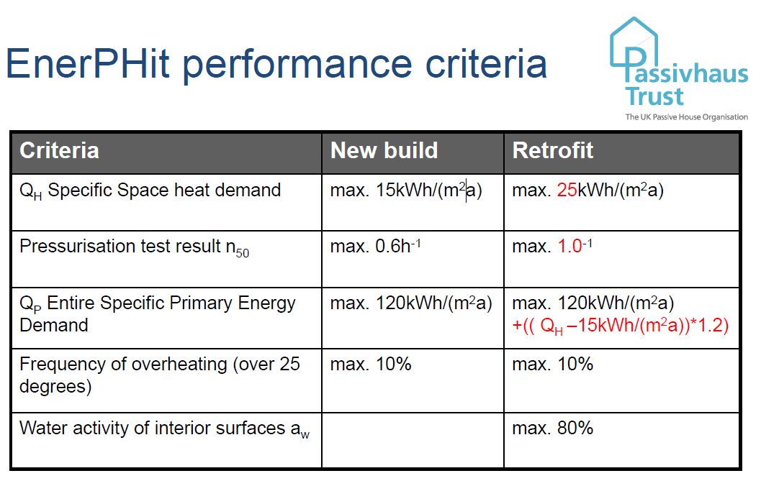
Figure 2. EnerPhit minimum performance requirements.
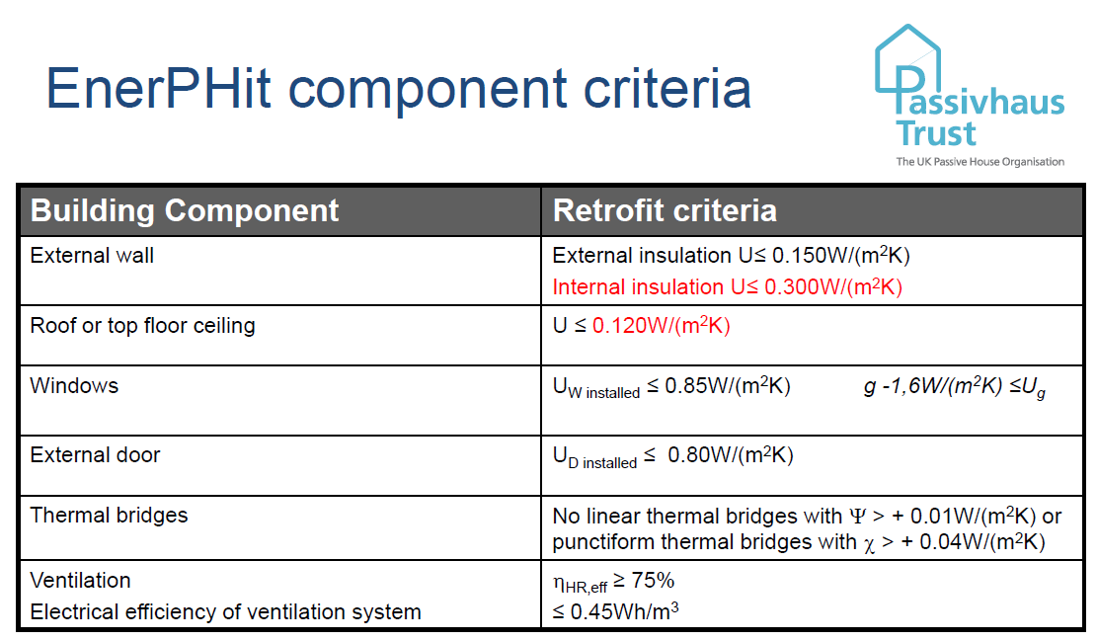
Figure 3. EnerPhit minimum component requirements.

It is noted that there are other retrofit standards that look to introduce minimum performance certification such as PAS 2035:2023 & LETI however this document will not look at these standards (Yeadon, 2023) (Passivhaus, 2024).

External walls.

The existing walls have been modelled in PHPP, and the existing performance and makeup of these elements is shown in appendix F. To improve the performance of these elements it is recommended to install mineral wool insulation to the exterior of the building and filling the cavity voids with insulation, however the unvented cavity in the rear extension it will not be possible to install insulation as the void width is less than the minimum 50mm requirement for blown insulation (pattern., 2025).
External wall insulation, EWI, has been recommended over Internal wall insulation, IWI, because this has several advantages over IWI.

- Building occupancy, currently the building is occupied fitting IWI would lead to disruption to the occupants during installation, EWI is less intrusive, although the proposed changes to the floor slab in this document could mitigate this as the occupants would need to vacate for this proposed change.
- Building floor space, adding additional insulation to the interior will reduce the total floor area of the building by making the rooms smaller, EWI will not affect the floor area.
- Building services, by installing IWI there will be additional requirements to alter the building services such as electrical sockets, EWI there will be no requirement.
However, installing EWI also has disadvantages when compared to IWI.

- Current roof overhang, at present the overhang on the roof is insufficient to apply EWI and modification to the eaves will be required to add extra thickness to the walls, along with relocation of rainwater goods.
- Insulation, the proposed eaves extension will need careful consideration on how to insulate to maintain a thermal envelope between the EWI and the current installed loft insulation.
- Windows, all the windows will need to be moved so they are in the middle of the insulation layer, this is offset by the recommendation to upgrade the windows. The Bathroom window will also need to be resized due to the increased overhang from the extended eaves.
- New render layer will be required; however, the property is currently rendered in a cement based non breathable render which we recommend changing to a breathable system (Hearne, 2018).
The use of an addition of 200mm Rockwool Mineral wool external wall HD slab insulation for the EWI and Knauf supafil-34 blown mineral wool insulation for insulating the side extension cavity. Both insulation materials are fireproof, breathable, water resistant, and the cavity fill insulation is rated for very severe climatic conditions, which is the classification for Underwood. Mineral wool is also more affordable and readily available than other insulation types, however it is not the most sustainable or best performing insulation type. Other insulation material such as sheep wool is more sustainable, better performing, but costs a lot more and is not fireproof (Rockwool, 2023) (Passivhaus trust, 09.2017) (Insulation, 2025) (Aliyev, 2024) (Sheepswoolinsulation, 2025).
Thinner amounts of insulation can be added but this would mean that the building will not meet EnerPhit standard. It is also recommend the removal of the existing cement based render system as this will be preventing moisture escaping the property, it is recommended the addition of a lime-based render system as an exterior windproof layer as this is recommended for stone buildings, and would have been the original render system when the property was constructed, we recommend the addition of Warmcote lime render, as a sustainable insulating render system (Cowland, 2023) (WarmcoteTM, no date).

Appendix G. shows the performance of the walls after the above retrofit modifications have been applied, when assessing these figures against the EnerPhit requirement shown in 3. Above the solid stone walls do not meet the minimum requirement for EnerPhit certification. For these walls to pass this requirement the insulation would need to be increased to 235mm thick or better performing insulation added, however adding this thickness would require further investigation to the feasibility of adding this much insulation. Figure 4. Below shows that the wall losses have been reduced from 183.1 kWh/(m2a) to 19.8 kWh/(m2a) (Microsoft Corporation, 2024c).

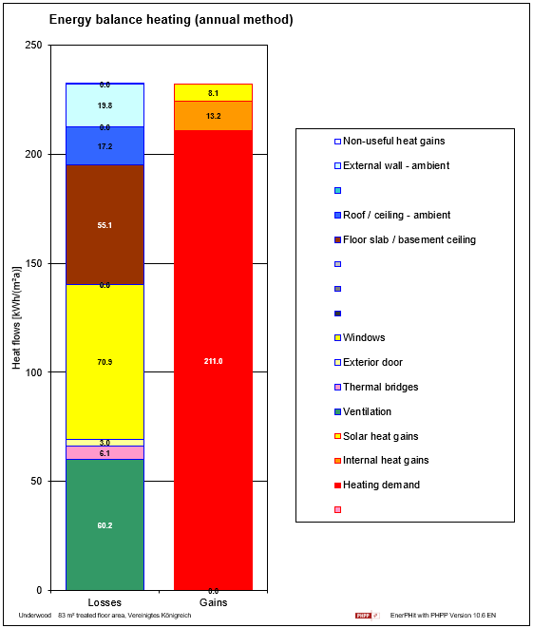
Figure 4. new walls heating demand

Windows and doors.
As listed in the building overview the windows of Underwood are currently double-glazed units, there are also double-glazed French doors and 2 wooden doors. Under the EnerPhit scheme for certification there is a requirement for these elements to not have a value greater than 0.85 W/(m²K) as shown in figure 3. The performance of the existing glazing and doors is shown in figure 5. Below, this shows that currently the windows and doors do not currently meet EnerPhit standard (Microsoft Corporation, 2024d).

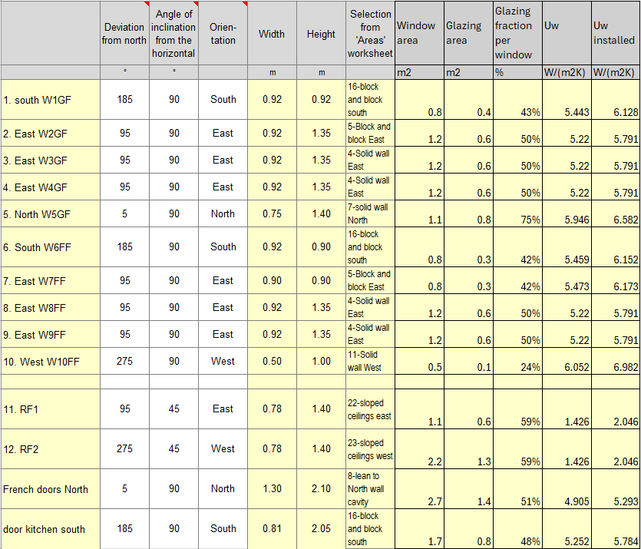
Figure 5. showing current W/(m²K)

Based upon the current performance of these elements and the proposal to install EWI we recommend upgrading the current glazing to Passivhaus certified triple glazed units and frames, it is noted that the PHPP software has not taken into consideration the previously mentioned reduced window size for the bathroom as this would need further calculations based off drawings to obtain the correct sizing to enter into PHPP. The new reduced size unit would improve the overall performance of underwood marginally.
We have specified the use of Munster Joinery PVC frames and ClimaGuard premium 2 glazing units for the windows, and ViewMax Passivhaus certified Door (Joinery, no date) (ClimaGuard® nrG, no date) (Quality windows & doors - advanced, energy-efficient solutions – viewmax, no date).
After entering these components into the PHPP Figure 6. Below shows that the shows that the W/(m²K) has reduced for each of the elements and that these are now within the range specified by EnerPhit for the building to obtain certification. Figure 7. Below shows that the losses through windows and doors for the building has reduced from 70.9 kWh/(m2a) to 10.9 kWh/(m2a) and that by installing improved performance windows and doors there is a marginal improvement in solar thermal gain of 0.5kWh/(m2a) When installing the new windows and doors good practice would be to ensure the junctions around these are taped to reduce the buildings air permeability, this will reduce further the total heating demand of the building. Moving the windows into the centre of the insulation layer as mentioned under the EWI sections will also help to reduce the thermal bridges of the building (Microsoft Corporation, 2024e) (Passivhaus trust, 06.2020).

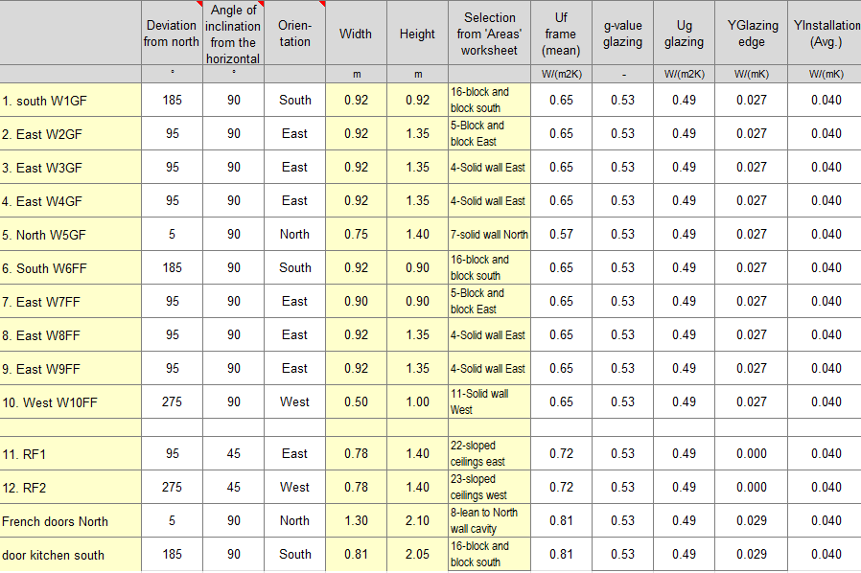
Figure 6. Showing the reduction in W/(m²K)

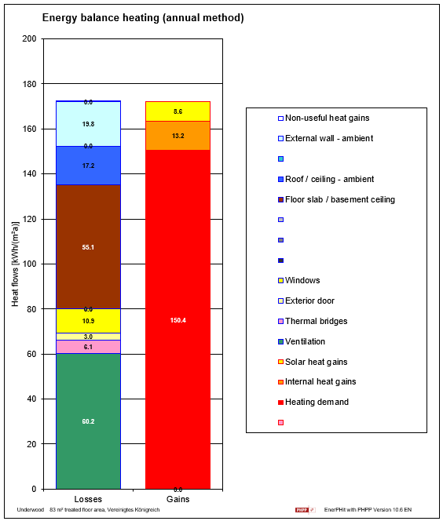
Figure 7. Passivhaus doors and windows heating demand

Ventilation.
Figure 6. below shows the different forms of ventilation strategy available, with the current ventilation strategy comprising of two intermittent MEV systems. For certification under EnerPhit components there is a requirement for the building to be fitted with a mechanical ventilation heat recovery system with a performance greater than 75% as shown in Figure 3. Installing an MVHR system is the most energy efficient form of ventilation strategy as shown in figure 8. This is because when compared to the other types of strategy available an MVHR unit will use the heated exhaust air to preheat the supply air minimising the heat loss from ventilation (Brown, 2016) (Passivhaus, 2025) (Microsoft Corporation, 2024f).

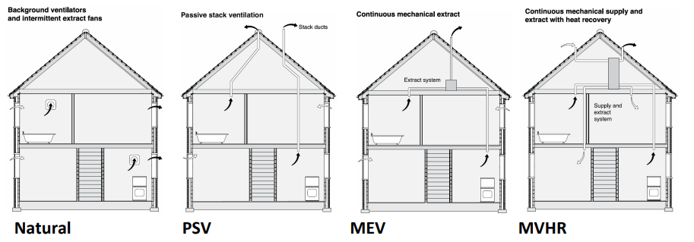
Figure 6. different forms of ventilation strategy.

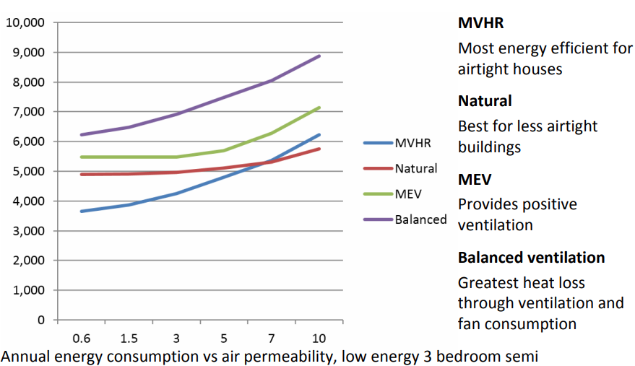
Figure 7. Graph showing energy loss by ventilation strategy.

The MVHR unit will need to be a centralised unit that provides all the extraction and supply from one system rather than a decentralised system as this will not provide the performance required to meet Enerphit standards.
We recommend the installation of a centralised Zehnder CA180 Luxe PH system as shown in appendix H. The advantages and disadvantages of installing this centralised unit are listed below.

- Maintenance and costs, having one centralised unit will lead to lower periodic maintenance and associated costs.
- Ducting, the disadvantage to having a centralised MVHR unit in a retrofit application would be obtaining the suitable routing for the supply and exhaust ducting, Underwood features disused chimneys, and these could be used for routing of ducting, a further survey would need to be conducted to ascertain the feasibility of the ductwork installation. Decentralized units do not require the same thoughtfulness to duct routes.
Once the addition of the MVHR unit was added into PHPP the ventilation loss was reduced from 60.2 kWh/(m2a) to 8.3 kWh/(m2a) shown in figure 8. Below. This was achieved by also modelling the building with a reduced air permeability to get the most benefit from the MVHR system. Figure 10. Below shows an example of how the eaves thermal bridge can be eliminated, this has been modelled in PHPP along with a reduction in air permeability (Hub, no date) (Microsoft Corporation, 2024g).

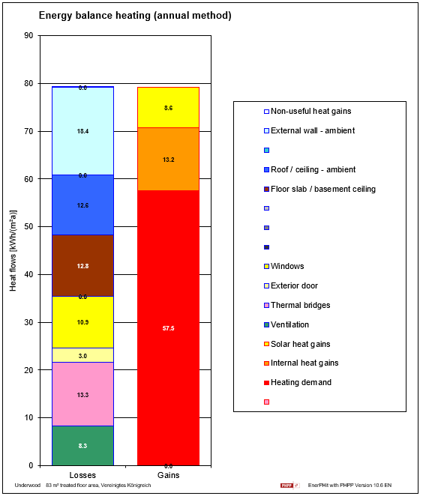
Figure 8. reduction in ventilation loss.

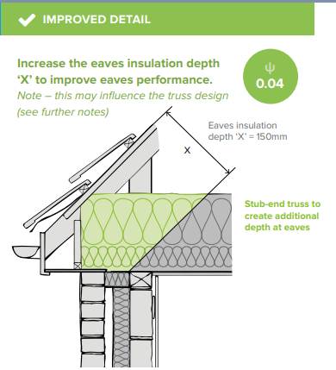
Figure 9. Showing thermal bridge mitigation.

Floor Slab.
Underwood currently has uninsulated slab flooring, as shown previously in illustration 1. Which is also modelled in PHPP and shown in figure 10. Below. The building also has thermal bridging around the floor slab which is also modelled in PHPP along with the eaves thermal bridge, as shown in figure 11. Below. As such we recommend the excavation of the current floor slab and the installation of XPS insulation into the floor slab with design considerations along the EWI junction to ensure a continuous layer of insulation and reduce the thermal bridging to ensure that the building benefits from a complete thermal envelope as recommended by Passivhaus (Price and Livingstone, 06.2022) (Cradden, 2019).
It is recommended the installation of XPS rather than EPS due to the improved load bearing and moisture performance of XPS over EPS insulation. We recommend the installation of Kingspan GreenGuard GG300 – XPS insulation, figure 12 shows this insulation modelled in PHPP, we have allowed for the installation of 90mm of insulation due to the thickness of the boards and the diminishing returns from additional layers to this. The result is that the heat loss of the building, shown in figure 13, has been reduced from 55.1 kWh/(m2a) to 12.6 kWh/(m2a) (Soprema, 2023) (Kingspan GreenGuard GG300 - (XPS), 2025) (Microsoft Corporation, 2024g).

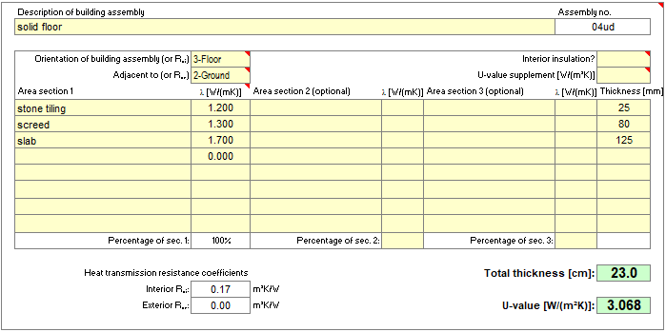
Figure 10. Showing the U value of the current slab

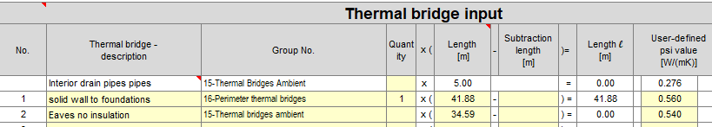
Figure 11. showing PHPP thermal bridges.

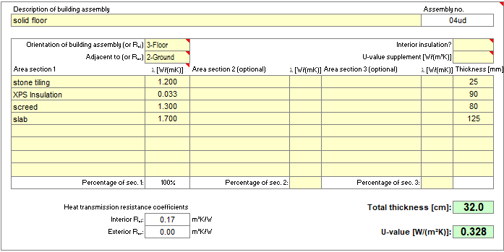
Figure 12. Showing the installation of XPS insulation.

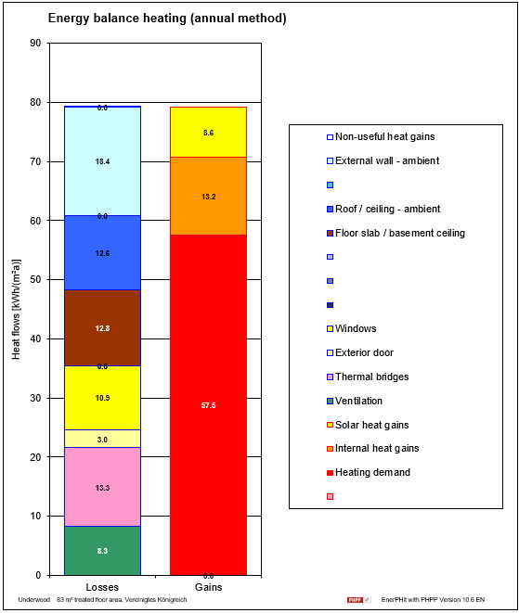
Figure 13. Showing reduction in loss through the floor slab.

Conclusion

The proposed changes to Underwood house whilst improving each elements performance and significantly reducing the energy consumption of the building as a whole fall short of being able to be certified under the EnerPhit scheme. The building is not currently able to meet the energy requirements in terms of EnerPhit performance, 25 kWh/(m2a), the proposed modification to the building the heating demand can be reduced to achieves 57.5.5 kWh/(m2a), this demand is close to the LETI retrofit standard and there may be further retrofit reductions that can be modelled in PHPP to meet the LETI requirement (Passivhaus trust, no date).
Although the building would not meet the criteria for EnerPhit certification with the proposed modifications the performance of the building has been significantly improved being reduced from 395.5 kWh/(m2a) total losses to 79.2 kWh/(m2a) this equates to a reduction of 28,467Kwh, this equates to an annual saving of £3,416.04 per annum based on a cost of 12.2p per Kwh. This means a payback period for the EWI would be approximately 8.8 years & 4.2 years for the glazing (Woody, 2024) (Checkatrade, no date a) (Checkatrade, no date b).

References
(Aliyev, 2024)
Aliyev, A. (2024) Breathable insulation for Stone Walls: Importance & types, Greenmatch.co.uk. Available at: https://www.greenmatch.co.uk/insulation/breathable/stone-walls (Accessed: May 01, 2025).

(Brown, 2016)
Brown, H. (2016) Overview of ventilation. AECB. Available at: https://aecb.net/wp-content/uploads/2024/11/Helen_Brown.pdf.

(ClimaGuard® nrG, no date)
ClimaGuard® nrG (no date) Guardianglass.com. Available at: https://www.guardianglass.com/eu/en/tools-and-resources/marking/out-of-date/coated-glass/climaguard/climaguard-nrg (Accessed: May 5, 2025).

(Cowland, 2023)
Cowland, A. (2023) Lime vs cement in architecture, Ecoright.co.uk. EcoRight. Available at: https://ecoright.co.uk/lime-vs-cement-in-architecture/ (Accessed: May 5, 2025).

(Cradden, 2019)
Cradden, J. (2019) Insulating foundations - passivehouseplus.co.uk, Passivehouseplus.co.uk. passivehouseplus.co.uk. Available at: https://passivehouseplus.co.uk/magazine/guides/the-ph-guide-to-insulating-foundations (Accessed: May 4, 2025).

(Hearne, 2018)
Hearne, J. (2018) External insulation - passivehouseplus.co.uk, Passivehouseplus.co.uk. passivehouseplus.co.uk. Available at: https://passivehouseplus.co.uk/magazine/guides/the-ph-guide-to-external-insulation (Accessed: May 6, 2025).

(Hub, no date)
Hub, Z.C. (no date) Thermal bridging guide. Available at: https://greenbuildingencyclopaedia.uk/wp-content/uploads/2016/10/ZCH-ThermalBridgingGuide-Screen_0.pdf.

(Insulation, 2025)
Insulation, K. (2025) Supafil® 34, Knauf. Available at: https://knauf.com/en-GB/p/product/supafil-r-34-23889_4206 (Accessed: May 7, 2025).

(Joinery, no date)
Joinery, M. (no date) Passiv AluClad casement window, Munster Joinery. Available at: https://www.munsterjoinery.co.uk/passiv-aluclad-casement-window (Accessed: May 5, 2025).

(Kingspan GreenGuard GG300 - (XPS), 2025)
Kingspan GreenGuard GG300 - (XPS) (2025) Insulation UK. Available at: https://www.insulationuk.co.uk/products/kingspan-greenguard-gg300-xps (Accessed: May 5, 2025).

(Microsoft Corporation, 2024a)
Microsoft Corporation (2024a) “Microsoft excel.”

(Microsoft Corporation, 2024b)
Microsoft Corporation (2024b) “Microsoft excel.”

(Microsoft Corporation, 2024c)
Microsoft Corporation (2024c) “Microsoft excel.”

(Microsoft Corporation, 2024d)
Microsoft Corporation (2024d) “Microsoft excel.”

(Microsoft Corporation, 2024e)
Microsoft Corporation (2024e) “Microsoft excel.”

(Microsoft Corporation, 2024f)
Microsoft Corporation (2024f) “Microsoft excel.”

(Microsoft Corporation, 2024g)
Microsoft Corporation (2024g) “Microsoft excel.”

(Passivhaus trust, no date)
Passivhaus trust (no date) LETI Retrofit. Available at: https://www.passivhaustrust.org.uk/UserFiles/File/Other%20Publications/LETI%20retrofit%20guide/Summary%20for%20Policymakers_V1.pdf
.

(Passivhaus, 2024)
Passivhaus (2024) LETI Retrofit standard, Passivhaus trust. Available at: https://www.passivhaustrust.org.uk/UserFiles/File/Other%20Publications/LETI%20retrofit%20guide/Summary%20for%20Policymakers_V1.pdf (Accessed: May 7, 2025).

(Passivhaus, 2025)
Passivhaus (2025) EnerPHit: The passive house standard for retrofits [passipedia EN], Passipedia.org. Available at: https://passipedia.org/certification/enerphit (Accessed: May 7, 2025).

(Passivhaus trust, 06.2020)
Passivhaus trust (06.2020) Good practice guide to airtightness. Available at: https://passivhaustrust.org.uk/UserFiles/File/Technical%20Papers/Good%20Practice%20Guide%20to%20Airtightness%20v10.4-compressed.pdf.

(Passivhaus trust, 09.2017)
Passivhaus trust (09.2017) “Good practice guide to insulation.” Available at: https://www.passivhaustrust.org.uk/UserFiles/File/Technical%20Papers/2017%20Passivhaus%20Insulation_Good%20Practice%20Guide%20Rev%200_1.pdf.

(pattern., 2025)
pattern., C. (2025) Superstructure (excluding roofs), Nhbc-standards.co.uk. Available at: https://nhbc-standards.co.uk/wp-content/blogs.dir/8/files/NHBC-Standards-2025-Chapter-6-1.pdf
(Price and Livingstone, 06.2022)
Price, S. and Livingstone, J. (06.2022) solid floor insulation guide. Gov.uk. Available at: https://assets.publishing.service.gov.uk/media/62a0683ad3bf7f036fc493ba/solid-floor-insulation-best-practice.pdf.

(Quality windows & doors - advanced, energy-efficient solutions – viewmax, no date)
Quality windows & doors - advanced, energy-efficient solutions – viewmax (no date) Viewmax.ca. Available at: https://viewmax.ca/technology/ (Accessed: May 3, 2025).

(Rockwool, 2023)
Rockwool (2023) EWI System Holders, Rockwool.com. Available at: https://www.rockwool.com/siteassets/rw-uk/downloads/datasheets/ewi-slab.pdf (Accessed: May 3, 2025).

(SCBC, 2025)
SCBC (2025) Swansea planning search, Gov.uk. Available at: https://property.swansea.gov.uk/online-applications/?lang=EN (Accessed: May 3, 2025).

(Sheepswoolinsualtion, 2025)
Sheepswoolinsualtion (2025) Sheepwoolinsulation.com. Available at: https://www.sheepwoolinsulation.com/product/premium-roll/ (Accessed: May 3, 2025).

(Soprema, 2023)
Soprema, U.K. (2023) “The difference between EPS and XPS insulation,” Soprema.co.uk. Soprema UK, 20 February. Available at: https://www.soprema.co.uk/blog/the-difference-between-eps-and-xps-insulation (Accessed: May 5, 2025).

(Taylor, 2011a)
Taylor, M. (2011a) “Enerphit the new passivhaus standard.” Available at: https://www.passivhaustrust.org.uk/UserFiles/File/Melissa%20Taylor-%20Ecobuild%20EnerPHit%20presentation.pdf.

(Taylor, 2011b)
Taylor, M. (2011b) “Enerphit the new passivhaus standard.” Available at: https://www.passivhaustrust.org.uk/UserFiles/File/Melissa%20Taylor-%20Ecobuild%20EnerPHit%20presentation.pdf.

(WarmcoteTM, no date)
WarmcoteTM (no date) Best of Lime. Available at: https://bestoflime.co.uk/product/warmcote/
(Accessed: May 7, 2025).

(Woody, 2024)
Woody, M. (2024) Battle of the gases: LPG vs Natural Gas, Ecowise Installations. Available at: https://ecowiseinstallations.co.uk/boilers/battle-of-the-gases-lpg-vs-natural-gas/
(Accessed: May 7, 2025).

(Yeadon, 2023)
Yeadon, T. (2023) The retrofit standards framework, NBS. www.theNBS.com. Available at: https://www.thenbs.com/knowledge/the-retrofit-standards-framework
(Accessed: May 7, 2025).

(Zoopla, 2025)
Zoopla (2025) “Underwood Kitchen.” Available at: https://www.zoopla.co.uk/for-sale/property/swansea/.

(no date)
(No date a) Checkatrade.com. Available at: https://www.checkatrade.com/blog/cost-guides/external-wall-insulation-cost/ (Accessed: May 7, 2025).

(no date b)
(No date b) Checkatrade.com. Available at: https://www.checkatrade.com/blog/cost-guides/triple-glazing-cost/ (Accessed: May 7, 2025).

Appendix

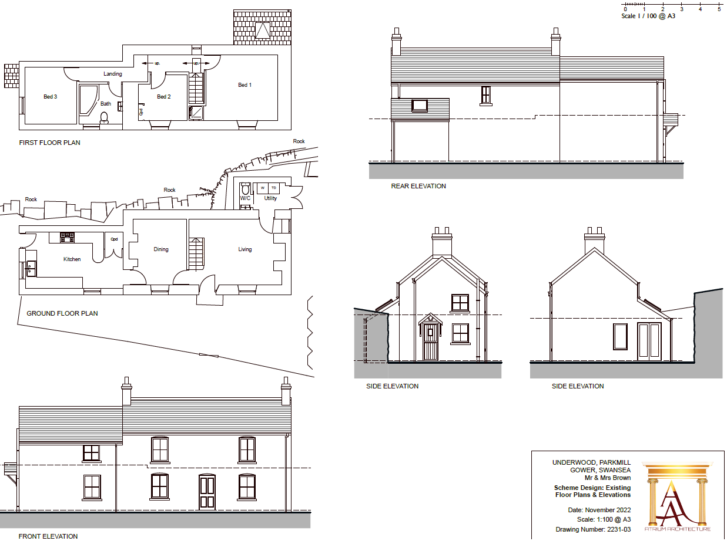
Appendix A.
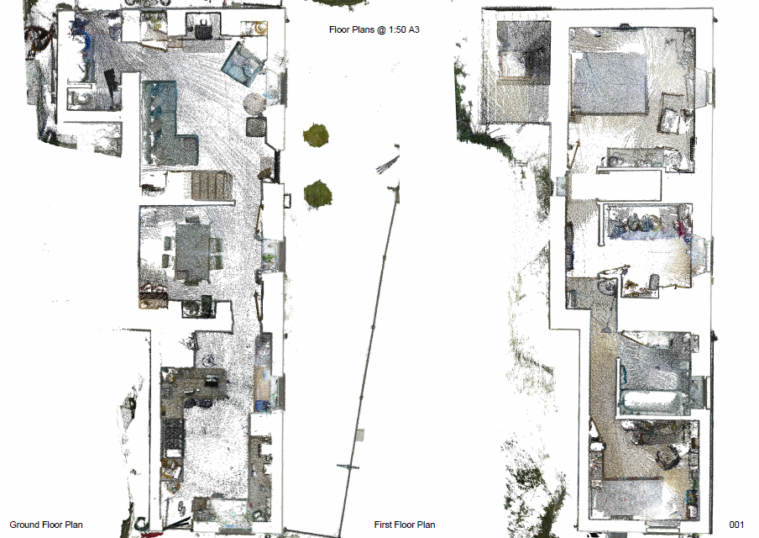

Appendix B.
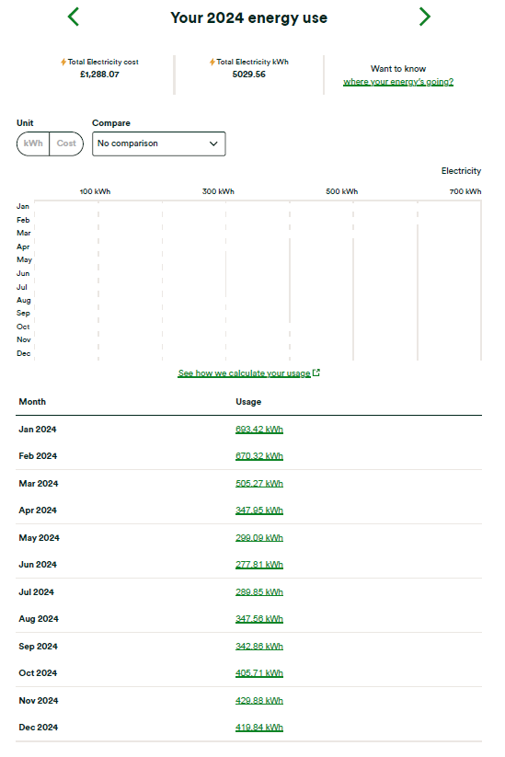
Appendix C.

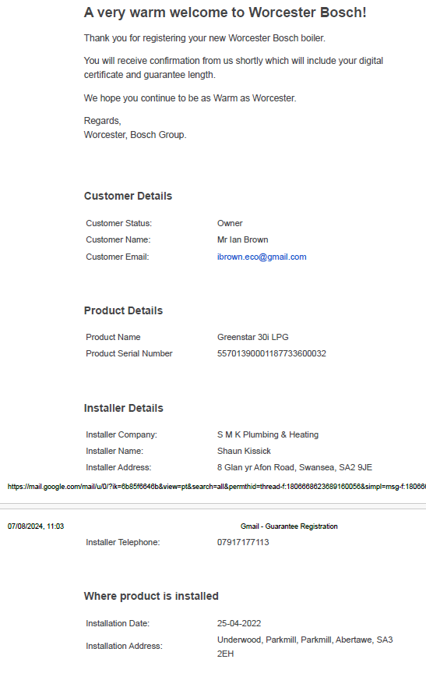
Appendix D.
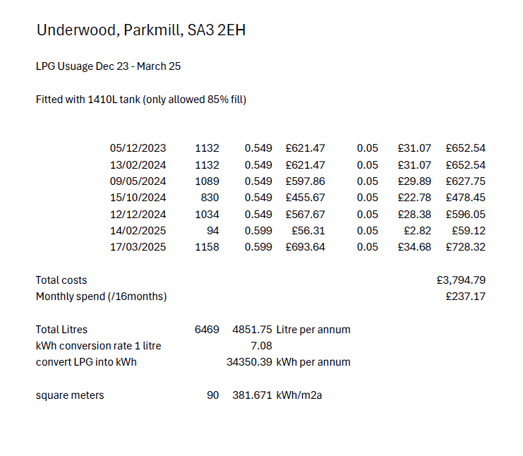
Appendix E.
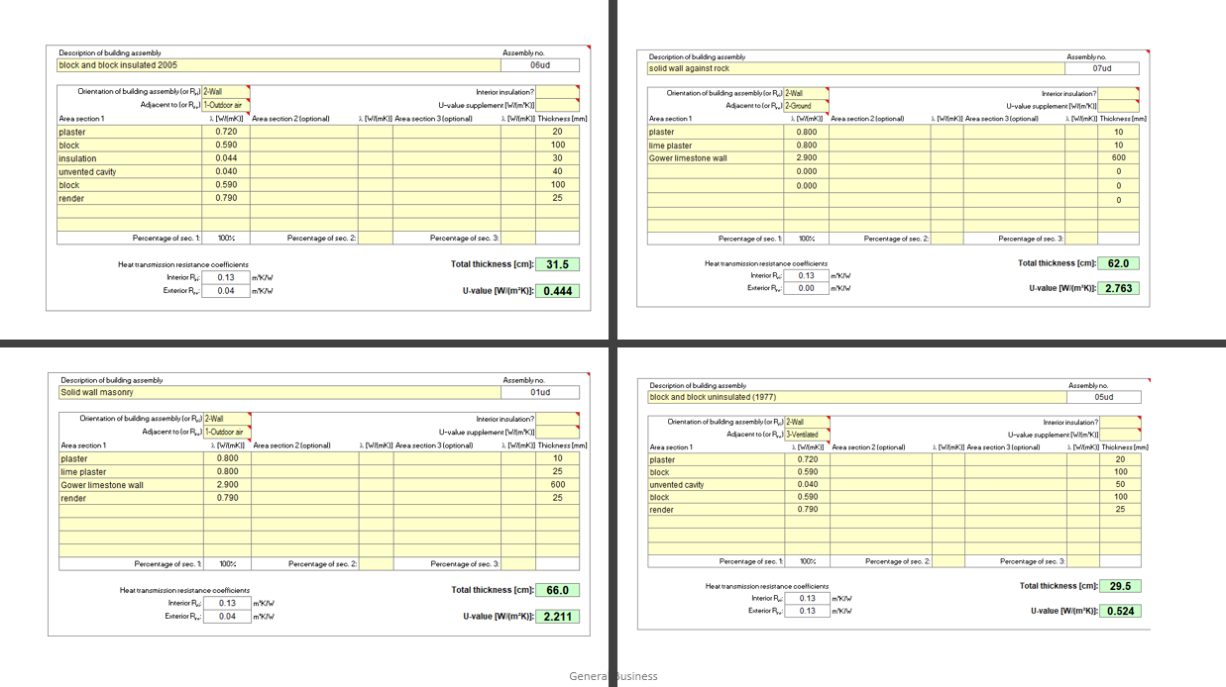
Appendix F.
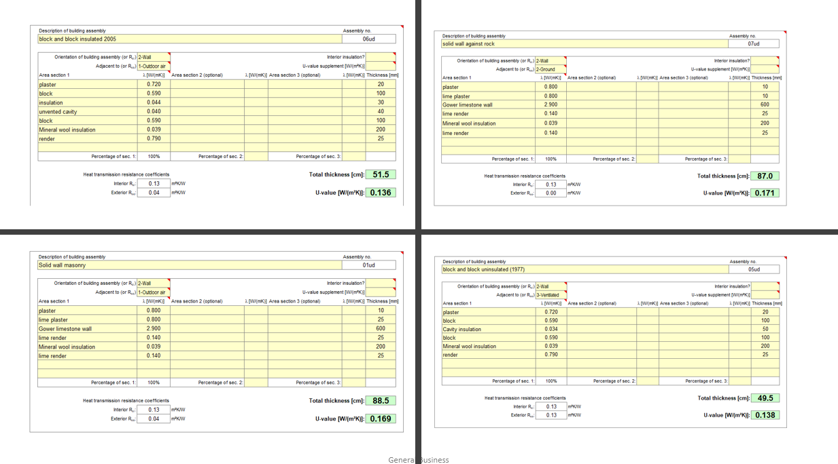
Appendix G.

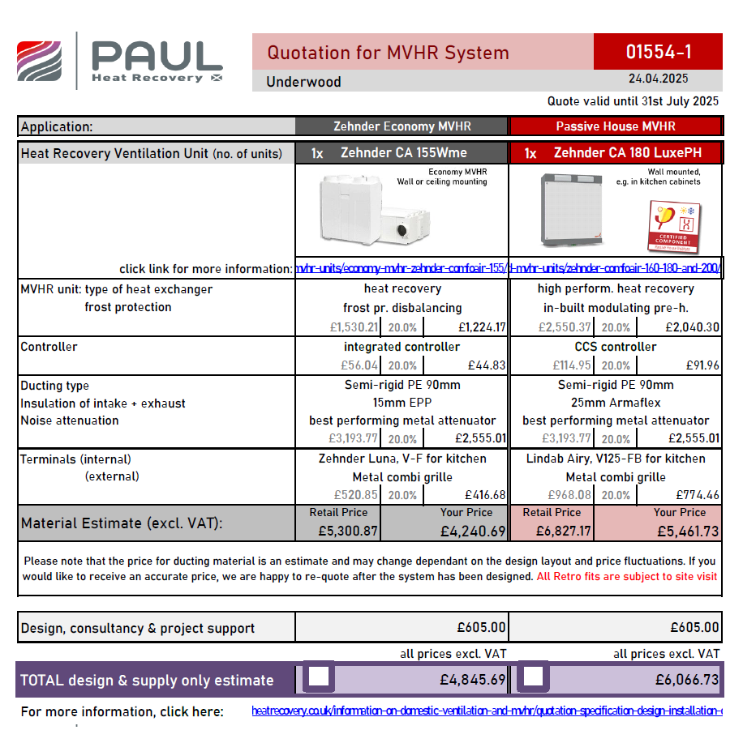
Appendix H.

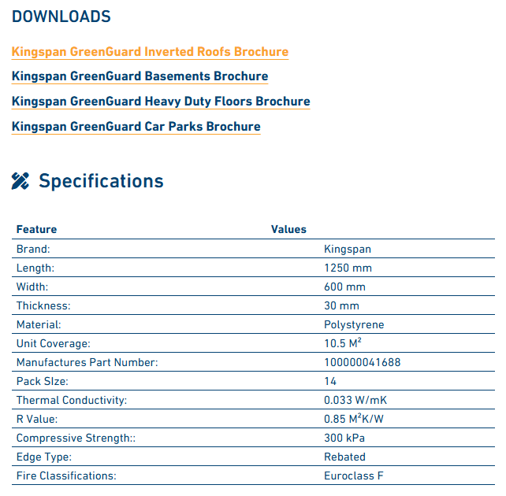
Appendix I.

