Appendices
Figure A: Own work, (2022) Personal Journal: Discussion with Teacher, University of Wales Trinity and St David.

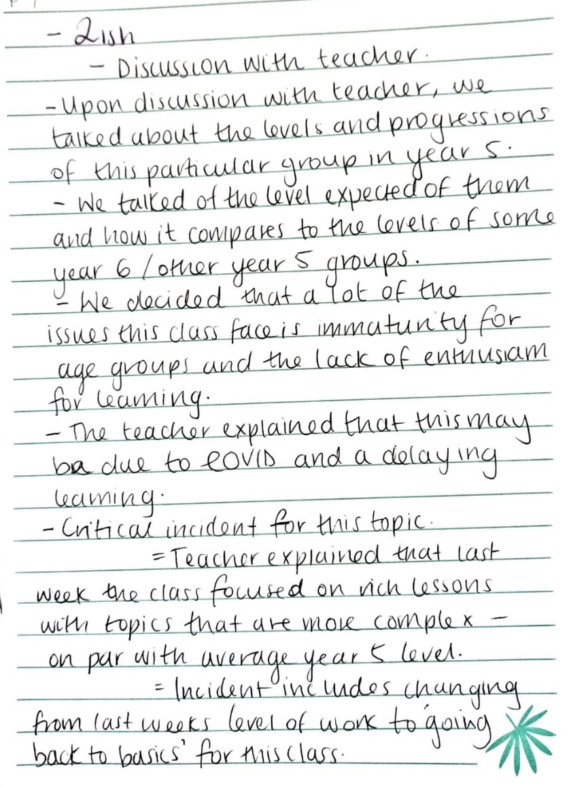

Figure B: Own work, (2022) Personal Journal: Discussion with Teacher, University of Wales Trinity and St David.

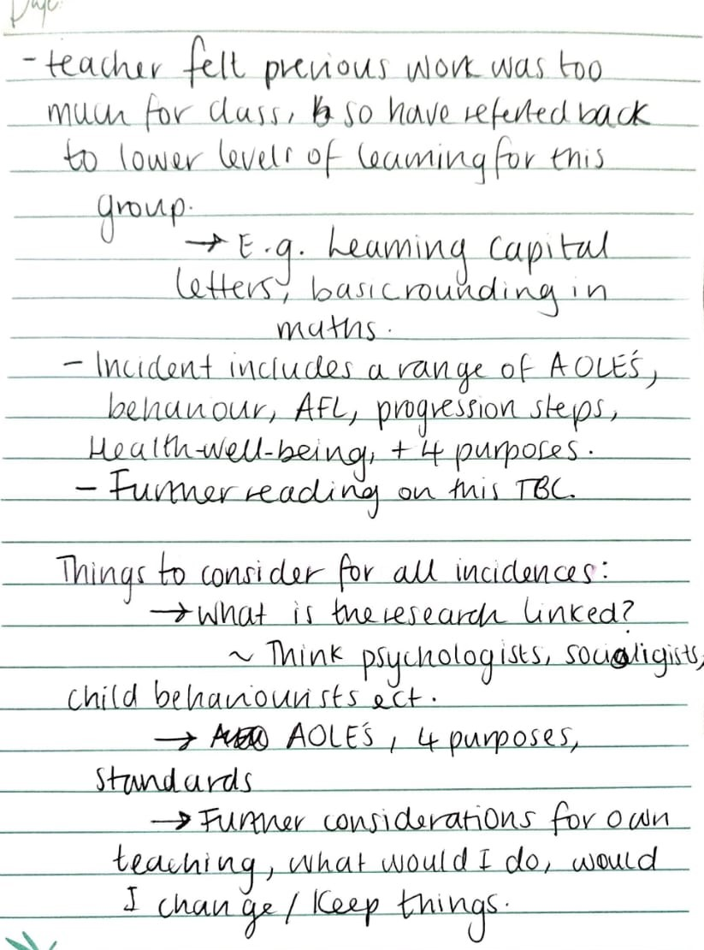

Figure C: Own work, (2022) Observation Field Notes: Record 1, University of Wales Trinity and St David. 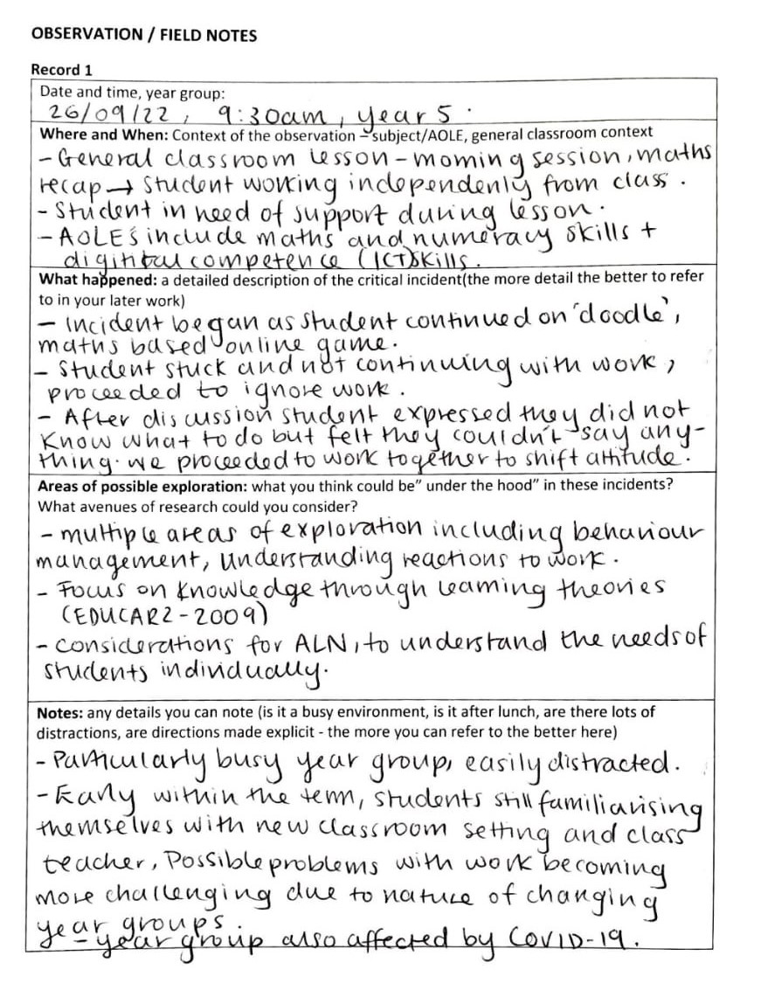

Figure D: Own work, (2022) Observation Field Notes: Record 2, University of Wales Trinity and St David.
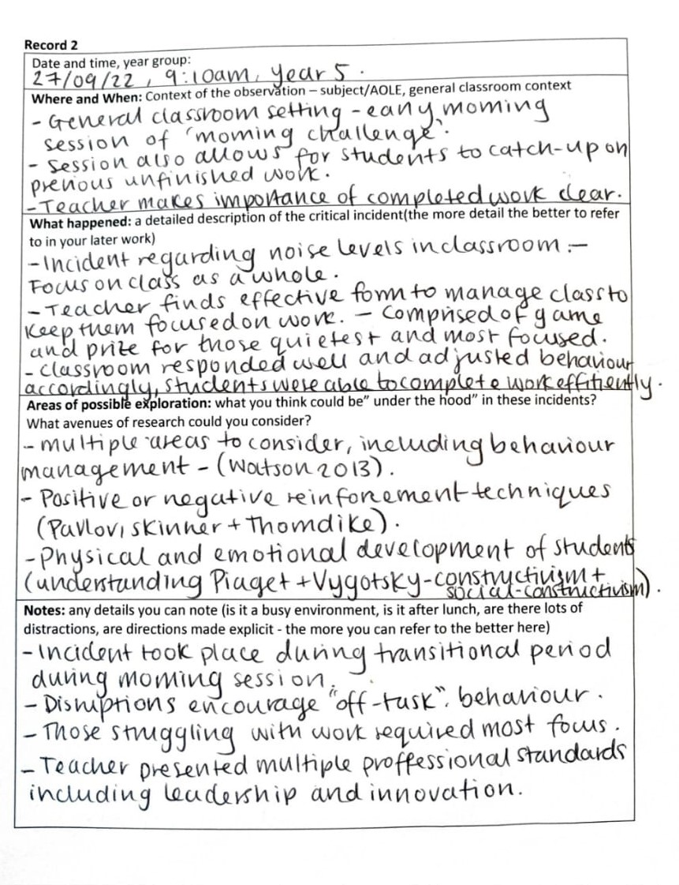

Figure E: Own work, (2022) Observation Field Notes: Record 3, University of Wales Trinity and St David.

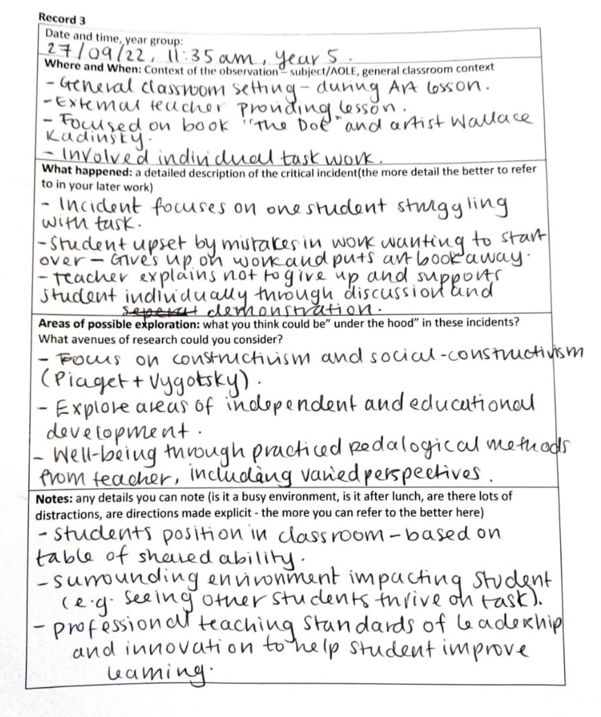

Figure F: Reynolds, P. H. (2003) The Dot [Book Illustration] Available at: https://www.thedotcentral.com/ (Accessed 3 November 2022)


Figure E: Kandinsky, W. (1913) Squares with Concentric Circles [Watercolour, Gouache and Crayon on Paper] Available at: https://www.wassilykandinsky.net/work-370.php (Accessed: 3 November 2022)

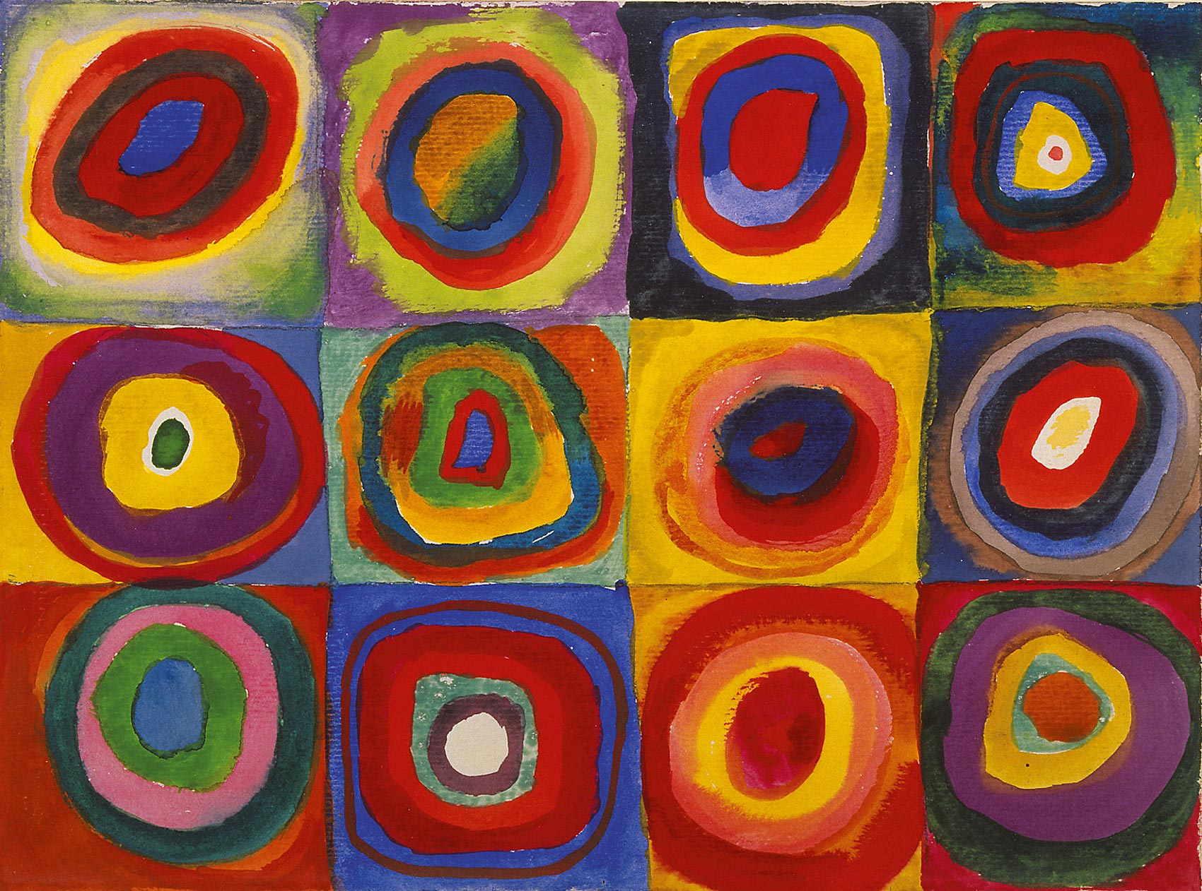

Figure G: Dr Serhat Kurt, 2020, Vygotsky’s Zone of Proximal Development and Scaffolding, Educational Technology,[Diagram] Available at: Vygotsky's Zone of Proximal Development and Scaffolding - Educational Technology (Accessed: 2 November 2022)

Inability to Learn
ZPD
(Zone of Proximal Development)
Independent Learning
The Vygotsky Scaffolding Theory

Figure H: Annie Pendrey, 2022, The Little Book of Reflective Practice: A Practical Guide to the Early Years, Routledge, p. 81

Description
Feelings
Evaluate
Analyse
Conclusion
Action Plan

Gibbs’ Reflective Cycle

Figure I: Annie Pendrey, 2022, The Little Book of Reflective Practice: A Practical Guide to the Early Years, [Table created from information] Routledge, pp. 65-66



