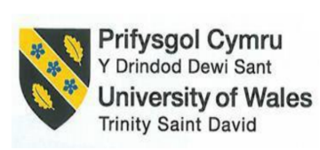

Module Title: International Meetings Management for the Hotel Industry
Module Code: BMIH6007
Assignment Title: Planning and Delivering a Croeso Creative: The Wales Arts and Design Showcase
Module Lead: Kathryn Flynn
Assessment 2
Student Name: Cristina Maria Petrache
Student ID Number: 2234360

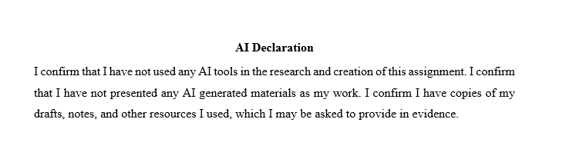

Table of Contents
1. Introduction 1
2. The Event Cycle 1
3. The Event Concept 2
4. Aim and Objectives 3
5. Event Management 4
5.1 Operational Management 4
5.2 Planning and Team Structure 4
5.3 Marketing Strategy 4
5.4 Technology and Ticketing 5
6. Event Budget 5
7. Industry Trends, Issues, and Impacts 7
7.1 Digital Transformation in Arts Events 7
7.2 Post-Brexit Logistics and Visas 7
7.3 Sustainability and Cultural Identity 7
7.4 Inclusion of Hybrid Elements 8
8. Situational and Cultural Considerations 8
9. Recommendations 9
11. References 11

Introduction
The Wales Arts and Design Showcase, organised by Croeso Creatives, is an event where people from all over meet to appreciate and promote Welsh creativity. Taking place in August 2025, the event is aligned with Visit Wales' Year of Croeso and will be held at either the SA1 Waterfront or Aberystwyth Arts Centre, both of which are accessible cultural centres. Digital art, fashion, music and innovation are on display to focus the world's eye on Wales' creative sectors. This report outlines the planning and actionable ideas for the event based on theories and practical activities to ensure its successful execution, meet stakeholder expectations, and leave a positive impact on the local economy and culture.

The Event Cycle
In Event Management, the Event Cycle consists of the planned steps that lead to organising, managing, undertaking and reviewing an event (Bowdin et al., 2023). The Event Management Body of Knowledge (EMBOK) is commonly used, covering the five essential domains of Administration, Design, Marketing, Operations and Risk (van Antwerpen, 2023). For an event to be successful, it needs planning and organisation from these aspects.
Using the EMBOK model, Croeso Creatives: The Wales Arts and Design Showcase has a valuable and organised approach. The Design Domain plays a crucial role in planning, as it is where the event's visual appeal, theme, and overall experience for guests are established (Xiang et al., 2021). At this phase, early Marketing supports the effort by making sure audience interests are satisfied and generating buzz for the event (Gutierrez-Posada et al., 2023). Professional creative design yields marketing materials that align with the event's style.
When marketing is in the design phase, activities extend beyond promotion and also assist with ticketing, stakeholder engagement, and the overall project placement. Brochures and flyers will still be used, but digital methods will also be employed (Hudson and Hudson, 2023). Utilising a website, as well as social media platforms such as Instagram, Twitter, and Facebook, will create excitement and draw more attention to the event among people in different countries (Lazzeretti et al., 2022).
Organising schedules, setting up venues and attending to technical needs are the main goals of the Operations Domain (Getz and Page, 2024). Initiatives regarding crowd control, equipment failures and potential harm to the company’s reputation will be handled in the event by the Risk Domain with the help of contingency plans. After the event, the Administration Domain ensures that evaluation, stakeholder reporting, and financial reconciliation proceed smoothly (Lewis, 2025). With the help of the EMBOK model, Croeso Creatives can be sure its plan follows industry best practices and stays together for a successful and resilient approach.

The Event Concept
Croeso Creatives: The Wales Arts and Design Showcase will be a lively three-day event highlighting Welsh creativity, culture, and fresh ideas at Swansea's SA1 Waterfront or Aberystwyth Arts Centre in August 2025. Many artists, creative experts, students and enthusiasts come together at the event to enjoy the wealth of innovative events in Wales.
Day 1 – Welsh Identity and Traditional Arts
The event begins by showcasing Welsh traditions through crafts and cultural performances, creating a powerful narrative about local heritage and art. There will be exhibits of textiles, live performances by folk musicians and markets featuring artists, as well as key lectures from leaders in the cultural world.
Day 2 – Digital Futures and Innovation
On the second day, the topic is innovation and new developments in creative industries. Digital experiences, AR runway presentations, and creative workshops focusing on AI and immersive art are planned for visitors to try. Setting up expert panels, organising a hackathon and hosting student shows help unite art and technology.
Day 3 – Fashion, Collaboration and Culture
Sustainable fashion, model runways and time for brands to connect all around the week at the Clay Memorial Day. The highlights of the event include the Croeso Awards Gala, which honours top achievements in Welsh creativity and fosters partnerships with countries from around the world.
Since the industry comprises more than 3,000 entities and 30,000 employees, the event offers financial opportunities, awareness, and cultural exchange. The company's focus on all types of art activities has made Wales well-known in the global creative scene.
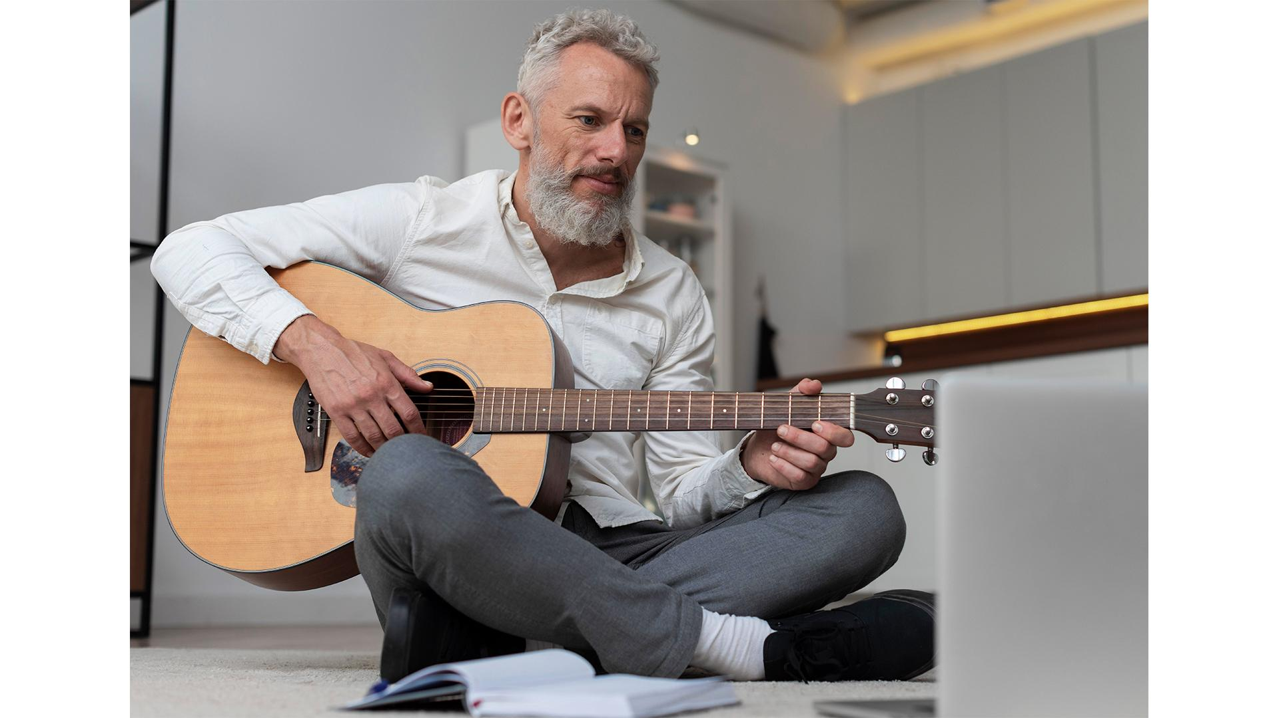
Source: (Author)

Aim and Objectives
Aim
The purpose of Croeso Creatives: The Wales Arts and Design Showcase is to honour Welsh creative industries by creating an exciting way to share culture, team up with other creatives, and connect with the world, ensuring that during the "Year of Croeso," Wales is recognised for its creativity and strong history.
SMART Objectives
Objective | Specific | Measurable | Achievable | Relevant | Time-bound
1. Increase Attendance | Attract local and international visitors to the event | 1,200+ attendees, incl. 200 from abroad | Yes, with strong marketing and partnerships | Supports cultural tourism and event visibility | By the end of the event (August 2025)
2. Secure Partnerships | Collaborate with industry and public sector stakeholders | At least 10 sponsors/partners | Achievable through outreach and creative value | Enhances credibility and resource support | By July 2025
3. Ensure Financial Viability and Impact | Generate profit and ensure attendee satisfaction | £3,000+ profit, 90% satisfaction score | Realistic through sales, funding, and planning | Aligns with event sustainability and long-term strategic goals | Within one month after the event ends

Event Management
The event will be delivered successfully if event management is handled effectively. Handling every aspect of the event smoothly requires a well-designed plan, specialised staff, focused marketing and technology integration.

Operational Management
In operational management, the main tasks include organising logistics, handling the venue, and ensuring staff assistance during the event (Dowson et al., 2022). Due to the broad range of programs, including exhibitions, performances, workshops, and panel sessions, an operations plan for an event will outline venue constraints, health and safety procedures, crowd management strategies, and accessible routes available (Mallen, 2024). There will be a catering team, staff organising the event's hospitality, personnel keeping the event secure, and personnel running the lighting and sound equipment. To maintain quality and professionalism, people will work together with local service providers and individuals from nearby institutions (i.e., universities and colleges) (Bladen et al., 2022).

Planning and Team Structure
The event team will operate under the direction of an Event Director and a well-defined organisational structure. A Creative Programme Manager, Marketing Manager, Sponsorship Coordinator, Technical Director and Volunteer Coordinator are part of the supporting team (Leigh et al., 2021). Regular meetings will happen in preparation for the event, assisted by charts and analysis tools provided by project management. Dowson et al. (2022) claim that for some critical roles, such as exhibition organisation and stage production, external experts and artists will be involved.

Marketing Strategy
Marketing strategies will cover the needs of people in both the company’s home country and abroad (Kotabe and Helsen, 2022). Advertising channels, such as print, TV, and the internet, will be employed. Instagram, Facebook, X, and Twitter will feature teaser clips, spotlights on artists, and special countdowns (Khaleque and Krasteva, 2021). Creative Wales, Visit Wales, and well-known arts influencers will help the project reach a wider audience. Copies of the flyers and brochures will be distributed at the most popular tourist and cultural spots in Wales. Ensuring that campaign messages are available in Welsh and English makes the campaign more open to everyone, and connecting with local communities helps it to be recognised in those areas.


Technology and Ticketing
Event planning will rely heavily on technology for execution (Dumas et al., 2023). A dedicated website will have ticketing, schedule updates and artist backgrounds. Using QR-coded tickets will enable people to enter easily and avoid long queues. Augmented reality (AR) technology will enhance the engagement of exhibits, guiding guests through digital displays and notifications on their phones (Lee et al., 2024). After the event, people will gather feedback online to assess how satisfied participants are and how well the event was conducted.

Event Budget
Income Breakdown
Factors | Estimation (£)
Rent of the Venue | 1000
Staffing and Workforce | 1500
Entertainment Activities | 800
Use of the Equipment | 650
Decoration | 400
Cleaning Services | 300
Foods and Beverages | 1500
Catering Services | 1850
Promotional Activities | 450
Advertisements | 350
Photographers | 150
Miscellaneous Charges | 600
Total | £9550

Funding Resources
Income Resources | Estimation
Sale of the Tickets | 2000
Sponsorships | 3000
Sales of Merchandising | 800
Workshops and Seminars | 1000
Funding | 1200

Delivering Croeso Creatives is estimated to cost approximately £9,550, which is evenly allocated to vital areas of the operation. Reserving the venue and staff costs (£1,000 and £1,500 respectively) help guarantee there is enough space and skilled help during the event. Attendees enjoy catering and other hospitality services totaling £3,350, making them very valued by the event. The money set aside for equipment and decoration (£1,050) helps create a nice setting and entertainment (£800) helps the event stay fun. Getting the word out about the company with promotional activities (£450) and advertising (£350) is needed to draw attention and make it visible. It is clear from the amount for cleaning (£300), photography (£150) and miscellaneous costs (£600) that the business was carefully managed and planned.
Leading income for the concert will come from sponsorships (£3,000) and ticket sales (£2,000) which together provide £5,000 in total revenue. Material provided by workshops and seminars (£1,000) is valuable and sources like buying in and running activities (£800 and £1,200) ensure there is enough income to cover expenses. Overall, the budget demonstrates a sound strategy for managing financial costs and earnings, which helps ensure the event is sustainable and utilises resources effectively.

Industry Trends, Issues, and Impacts

Digital Transformation in Arts Events
Due to the increased use of digital technology at arts events, audiences are connecting with culture in different ways (Koleva and Berbenkova, 2021). Thanks to augmented reality, virtual tour apps, and AI in art, many people can now participate in and interact with exhibitions. Incorporating features like AR in galleries and live streams by Croeso Creatives attracts viewers from all over the world (Lee et al., 2024). It also boosts new ideas in programming and greater earnings from selling tickets online and hosting virtual events. Even so, events now require a robust IT infrastructure, effective cybersecurity, and well-trained staff and attendees, which must be considered during the planning stage (Armstrong, 2025).

Post-Brexit Logistics and Visas
There are no additional challenges for UK-based cultural events due to Brexit, particularly regarding the movement of EU artists and materials in and out of the country (Faucher, 2023). Dealing with visas, customs checkpoints, and moving artwork and equipment now requires more effort, time, and expense (Toszek, 2024). When recruiting artists from other countries, especially in the EU, Croeso Creatives must address these difficulties. Establishing early contact with logistics companies and lawyers can help prevent many risks. Mallen (2024) claims that losing access to some critical EU arts grants could harm arts organisations' long-term strategies, necessitating the exploration of UK-based or self-funded options.

Sustainability and Cultural Identity
Now, making events sustainable is key, and organisers are expected to try to mitigate the environmental impact through improved transportation, reusable items, and environmentally conscious catering (Kovaitė et al., 2022). Following the trend, Croeso Creatives facilitates buying from nearby businesses, online booking and using less plastic. The festival, featuring both traditional and contemporary Welsh art forms, reminds the public of their national identity and supports sustainable tourism (Gutierrez-Posada et al., 2023).

Inclusion of Hybrid Elements
Since the COVID-19 pandemic, blending physical and digital components in events has become a common practice (Estanyol, 2022). They make it possible for participants from far away and those with disabilities to attend online. Croeso Creatives achieves this by organising virtual panels, allowing people to explore their galleries online, and facilitating online Q&A sessions. Offering hybrid delivery can benefit more people, but it comes with higher technical and monetary requirements (Koleva and Berbenkova, 2021).

Situational and Cultural Considerations
To be successful, the understanding of wider social and cultural factors is necessary for Croeso Creatives: The Wales Arts and Design Showcase. By conducting a SWOT analysis, an organisation can assess both its advantages and disadvantages, as well as the areas of opportunity and challenge from outside, to gain a clear strategic overview of how the event stands in Wales' culture and economy.
Strengths
The event ties into Visit Wales' "Year of Croeso," lending it strong cultural significance and national brand support. Wales' history of art and the rise of its creative economy, backed by more than 3,000 businesses, form an appealing foundation (Lewis, J2025). Because the event combines fashion, digital art, and music and is presented in two languages, it attracts and includes people from all over the world.
Weaknesses
The budget allocated for the event (£9,550) is smaller than that for significant international events, so the scale of marketing may be limited. It is not always sure that organisations can rely on securing the necessary sponsorships from external sources (Xiang et al., 2021). The use of two locations means it may encounter challenges in moving equipment and consistently delivering training.
Opportunities
Cultural tourism and digital engagement are on the rise globally, allowing the event to benefit from them. The use of new hybrid methods and technologies, for example, AR, offers new ways for interaction (Ammirato et al., 2022). Alliances with universities, local councils and creative businesses could bring more resources and emphasising Wales’ local identity after Brexit could help it become better recognised abroad.
Threats
A major external challenge can be sudden changes in the economy, such as inflation or cuts to public budgets, which may result in fewer attendees or reduced support from partners (Kotabe and Helsen, 2022). Less participation by musicians from other countries may be the result of post-Brexit visa difficulties (Toszek, 2024). Additionally, competing with similar festivals based in the UK or Europe can limit the event's visibility, especially when digital marketing is not executed effectively.

Recommendations
- Strengthen Strategic Partnerships: Collaborate with Creative Wales, local councils, and universities to secure funding, venue support, and volunteer engagement, ensuring operational success and cultural authenticity (van Antwerpen, 2023).
- Enhance Digital Integration: Incorporate digital features such as AR exhibits, online purchasing, and digital exhibits to attract more people online and from other countries (Lee et al., 2024).
- Actively practice environmental sustainability by using eco-friendly equipment, encouraging attendees to use public transport, and collaborating with green caterers to better align with today's trends and audience values (Xiang et al., 2021).
- Design a strong marketing strategy: Promote your event in both languages (Welsh and English) on social networks, in local media, and with well-known influencers to attract more people and improve ticket sales (Lewis, 2025).
- Conclusion
In conclusion, due to the Wales Arts and Design Showcase, run by Croeso Creatives, creativity from Wales receives global attention. Planning, ensuring the project aligns with the Event Management Body of Knowledge, and highlighting innovation, sustainability, and culture make the event successful. When digital technologies, inclusive programs, and teamwork among stakeholders are involved, both audience participation and community benefits will increase. A SWOT analysis gives the event an organised way to handle and plan for different kinds of difficulties. Wales Tourism hopes people will see Wales as somewhere filled with creativity, warm people and many things to do.

References
Ammirato, S., Felicetti, A. M., Linzalone, R., and Carlucci, D. (2022). Digital business models in cultural tourism. International Journal of Entrepreneurial Behavior & Research, 28(8), 1940-1961.
Armstrong, S. (2025). From Planning to Execution: The Multifaceted Role of an Executive Protection Specialist. Super Gringo Books.
Bladen, C., Kennell, J., Abson, E., and Wilde, N. (2022). Events management: An introduction. Routledge.
Bowdin, G. A., Allen, J., Harris, R., Jago, L., O'toole, W., and McDonnell, I. (2023). Events management. Routledge.
Dowson, R., Albert, B., and Lomax, D. (2022). Event planning and management: Principles, planning and practice. Kogan Page Publishers.
Dumas, M., Fournier, F., Limonad, L., Marrella, A., Montali, M., Rehse, J. R., and Weber, I. (2023). AI-augmented business process management systems: a research manifesto. ACM Transactions on Management Information Systems, 14(1), 1-19.
Estanyol, E. (2022). Traditional festivals and COVID-19: Event management and digitalisation in times of physical distancing. Event Management, 26(3), 647-659.
Faucher, C. (2023). Resilience and adaptation of the UK’s arts sector during the process of the UK’s withdrawal from the EU. International Journal of Cultural Policy, 29(2), 231-246.
Getz, D., and Page, S. J. (2024). Event studies: Theory and management for planned events. Taylor & Francis.
Gutierrez-Posada, D., Kitsos, T., Nathan, M., and Nuccio, M. (2023). Creative clusters and creative multipliers: Evidence from UK cities. Economic Geography, 99(1), 1-24.
Hudson, S., and Hudson, L. (2023). Marketing for tourism, hospitality & events: a global & digital approach. Sage Publications Limited.
Khaleque, N., and Krasteva, G. (2021). Experience Technology. How the Creative Industries Help Increase the Audience Engagement at Virtual and Hybrid Events.
Koleva, P., and Berbenkova, M. (2021). Reconnect: Cultural Content and Audiences in the Digital Environment. Culture. Society. Economy. Politics (Culture-SEP), 1(2).
Kotabe, M. M., and Helsen, K. (2022). Global marketing management. John Wiley & Sons.
Kovaitė, K., Šūmakaris, P., and Korsakienė, R. (2022). Sustainability in creative and cultural industries: a bibliometric analysis. Creativity Studies, 15(1), 278-298.
Lazzeretti, L., Oliva, S., Innocenti, N., and Capone, F. (2022). Rethinking culture and creativity in the digital transformation. European Planning Studies, 1-9.
Lee, C. I., Pan, Y. H., and Chen, B. (2024). Participatory Exhibition-Viewing Using Augmented Reality and Analysis of Visitor Behavior. Applied Sciences, 14(9), 3579.
Leigh, J., Cairncross, G., and Lamont, M. (2021). Training for event volunteers: factors influencing event managers' resource allocation decision-making. International Journal of Event and Festival Management, 12(1), 16-35.
Lewis, J. (2025). The cultural, economic and social value of the creative industries. In Research, Development and Innovation in the Creative Industries (pp. 1-24). Routledge.
Mallen, C. (2024). The event operational planning phase of the event planning model. In Event Management in Sport, Recreation, and Tourism (pp. 67-114). Routledge.
Toszek, B. (2024). The Creative Sector’s Position in the post-Brexit and post-pandemic Welsh Economy. Scientific Journal of Bielsko-Biala School of Finance and Law, 28(1), 18-23.
van Antwerpen, S. (2023). A proposed integration of the event and project management body of knowledge. International Journal of Applied Sciences in Tourism and Events, 7(2), 107-119.
Xiang, Z., Stienmetz, J., and Fesenmaier, D. R. (2021). Smart Tourism Design: Launching the annals of tourism research curated collection on designing tourism places. Annals of Tourism Research, 86, 103154.

