BMPF 7003: Working and Learning: An Introduction to Work-Based Higher Education

1. Assessment Component One – a written assignment Critically evaluate a range of concepts theories and models that you have recently studied, explaining their relevance to your workplace practice and procedures, and develop a strategy for applying what you have learned to improve your practice and performance.

Tonal Placement Sensations: How can we achieve resonance more effectively?

This independent study will examine the literature on the use of tonal “placement” of the voice to achieve resonance and examine whether such language can be useful in today’s pedagogy. I will consider how I can apply this to my practice.
Terms such as “singing into the mask”, “sense the voice at the end of one’s nose” or “use your chest/head voice” (Titze, 1981; Stark, 1981), were used (and still are) by teachers to help their students feel vocal resonance. I will aim to ascertain whether there is a use for these terms or whether they have become redundant.
Resonance is created by boosting various harmonics in the vocal tract - otherwise called as Formants (Titze, 1981; Howard and Angus, 2006). This study will aim to understand whether it is more objective for teachers to understand how to utilise formants and harmonics to achieve resonance rather than just relying on tonal “placement” or imagery.

A deep understanding of formants and harmonics is crucial to this study.
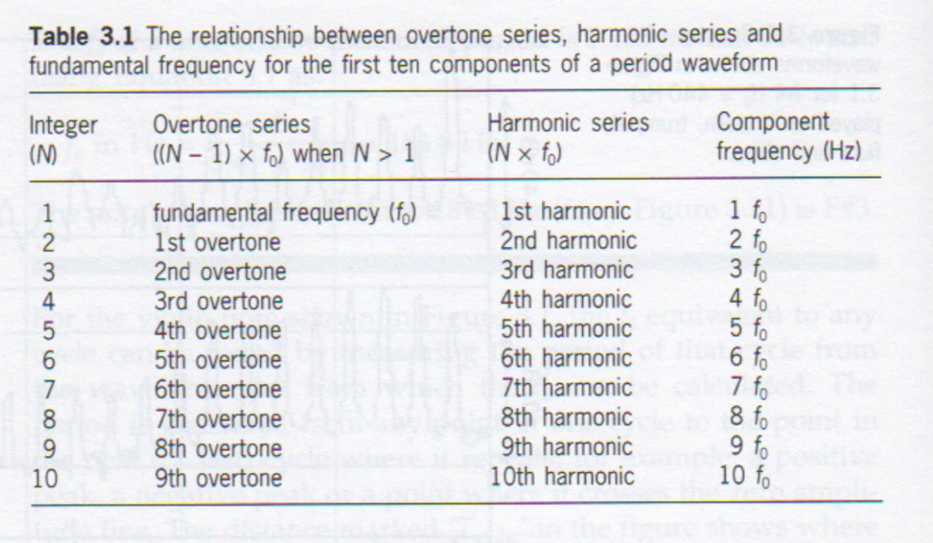
The vocal tract is a container of air that starts from the top of the vocal folds and extends all of the way to the edge of the lips (Sundberg, 1987). The vocal tract consists of the lips, the tongue, the velum (soft palate) and the larynx (Sundberg, 1987). Each of these parts move, changing the shape of the vocal tract to produce different sounds (Howard and Angus, 2006). As we exhale, the breath reaches the vocal folds which vibrate to create a tone. These tones are made of multiple frequencies that follow a periodic sequence – these are called the harmonics (Howard and Angus, 2006). See Figure One below to understand the periodic sequence (Bozeman, 2013).

Formants are the natural acoustic resonances of the various harmonics produced from the wave forms within the vocal tract (Sundberg, 1977; Howard, D and Angus, J, 2006). Since the vocal tract is shape-able - by moving the lips, the tongue, the soft palate, the larynx, the pharynx and the jaw - the resonances are tuneable. This is unlike the resonances produced by a brass instrument, for example (Bozeman, 2013). There are only around three to five formants that are low enough in pitch and strong enough in intensity to be heard (Howard and Angus, 2006). The longer the vocal tract, and thus the lower the pitch, the more audible formants will be present in the sound. The first two formants are the most receptive to changes in the shape of the vocal tract and are therefore tuneable to define vowels – they are known as “vowel formants” (Bozeman, 2013). They can be tuned by adjusting the shape of the vocal tract (Wolfe, J, Garnier, M and Smith, J, 2009). For example, a narrowing near the lips causes a lower first formant and a higher second formant whilst a narrowing near the back of the vocal tract causes a higher first formant and a lower second formant (Bozeman, 2013). Tuning a formant to a harmonic (or a harmonic moving into a formant peak) is often called “acoustic coupling”. For example, tuning the first formant to the first harmonic, is called F1/H1 acoustic coupling (Bozeman, 2013). This specific example means tuning the fundamental frequency (Harmonic 1 or H1) to the first formant. Each formant/harmonic coupling will produce a different timbre (Bozeman, 2013). Understanding what each coupling sounds like can and how to create it, can be of great assistance to us as teachers when asking our students to achieve a certain sound (Titze, 1981). A mastery of formant/harmonic coupling outweighs the vague description of “tonal placement” (Miller, 2008).

Use of tonal “placement” played a large part in traditional vocal pedagogies and is still used by some teachers today (Stark, 1999). “Schools of singing” such as Bel Canto (Stark, 1999) used resonance imagery ﻿in which sensations of localized vibration were used to indicate good tone. “Singing into the mask” and “sing from your chest” are all terms that teachers have used to help students utilise resonance (Titze, 1981). However, Kenneth Bozeman defends that as placement of tone is an illusion, teachers cannot solely rely on it to help their students achieve optimal resonance as it is completely kinaesthetic (Bozeman, 2013). ﻿In her book, The Functional Unity of the Singing Voice, author Barbara Doscher urges teachers and singers to understand the anatomy and physiology involved in singing. She mentions that kinaesthesia is often considered to be a faculty of perception beyond our five senses. Kinaesthesia does involve the sense of touch, which is recognized by the body’s sensory nerve endings, but it may involve much more than that (Bauer, 2016). Use of “tonal placement” pairs kinaesthetic senses with the ambiguous subject of imagery. Dr Karen Tillotson Bauer notes that whilst use of imagery may work for some students, its metaphorical nature may make not make sense to others (Bauer, 2016). Use of resonance imagery is intangible for some and so it is unreasonable to expect students to take an intangible image and turn it into a specific application (Bauer, 2016).

I have frequently used “tonal placement” in my practice as some terms were passed down to me from my teachers. Challenging these historic terms with up to date voice science is far less ambiguous than tonal “placement” sensations. There is some use for it in my practice – for example, a student that has a high kinaesthetic awareness may feel the sympathetic vibrations created by the voice. In this case, a student could perceive “tonal placement” as an indication that they are achieving a certain tone.

‘Singing Into the Mask’

Many historical pedagogues use the term “singing into the mask” to help their students utilise resonance (Stark, 1999). This vague instruction is supposed to allow the singer to feel the sensations of resonant vibrations in the nose and forehead (Taylor, 2013). In Anthony Frizzells book “The Tenor Voice, A Personal Guide to Acquiring a Superior Singing Technique”, he defines “the mask” as “a vocal term that attempts to describe the “triangular” area of the face formed by the eyes, nose and mouth” (Frizell, 2007, Page 19). This direction may be useful to a student who has a high kinaesthetic awareness and feels strong vibrations that they could then replicate time again, to achieve optimum resonance (Bauer, 2016). Though, this could lead the singer to believe that the tone is created in “the mask” area – which is impossible as these resonant cavities cannot produce the vibrations created by vocal folds (Frizzell, 2007). Bozeman’s states that small cavities such as the skull bone and sinuses do vibrate sympathetically with higher frequencies so a tone that is resonating one of the higher harmonics, may be felt in the “the mask” (Bozeman, 2013).
Sundberg’s research (1974) into the Singers Formant Cluster (SFC) could explain some of the strong vibrations that students feel when singing into “the mask”. The SFC is the clustering of the third, fourth and/or fifth resonances of the tract (the number of formants will depend on the fundamental frequency (H1)). When a strong SFC is tuned to the higher harmonics, there is a considerable boost in the frequency range 2-4kHz (Wolfe, J, Garnier, M and Smith, J, 2009) ﻿a range in which human hearing is very sharp. Because there is a strong boost in the higher frequencies when using the SFC, the singer may feel resonance in the small cavities such as the skull bone and sinuses (Bozeman, 2013). In Richard Miller’s book “Securing Baritone, Bass – Baritone and Bass Voices”, he states that “the mask” area is an excellent conductor of sympathetic vibration. The mask may feel like a resonator, but it is not. The response from sympathetic vibrations may vary significantly from singer to singer. (Miller, 2008, Page 120). The use of the SFC is sometimes called “ring” (Miller, 2008).
Bozeman (2012) states that a strong SFC can be formed by putting the voice under certain conditions. By using a low larynx, an open throat and a narrow epilaryngeal tube, complete with strong glottal closure will help achieve a strong SFC.
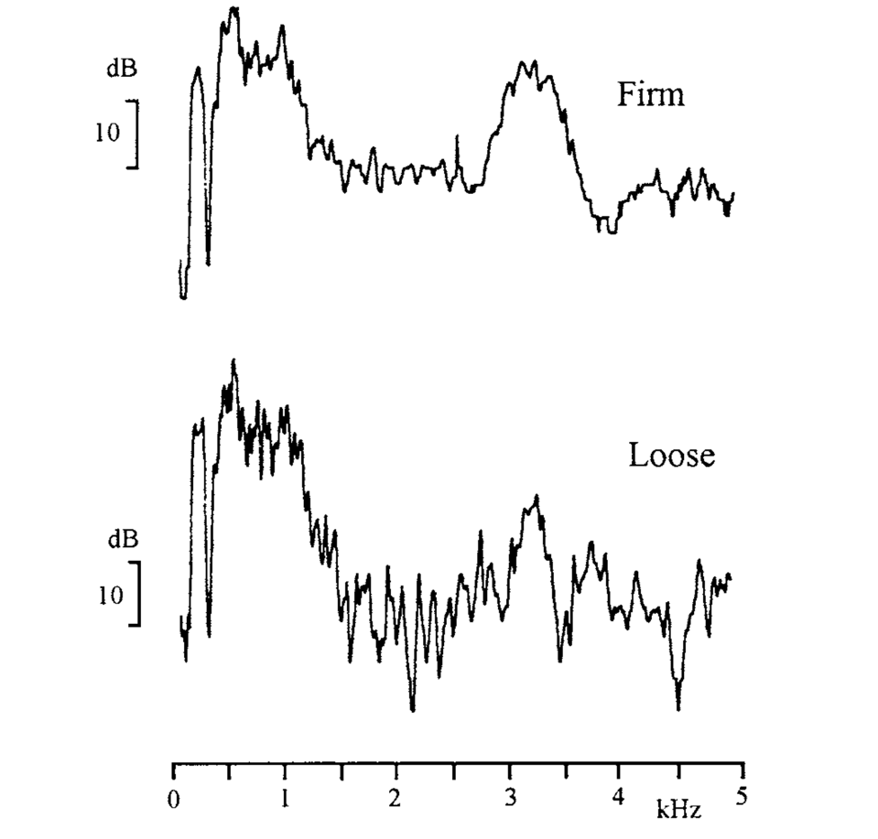
Figure 2 (left) from James Stark’s book “Bel Canto: A History of Vocal Pedagogy” (Page 241). Here is a ﻿long-time-average-spectra: paired tones using loose (weaker glottal closure) and firm phonation (stronger glottal closure), sung on a chromatic scale, G3–D4, using the vowel (a).
﻿

Whilst the first two formants (vowel formants) are virtually the same for both, the “loose” phonation lacks a lot of energy in the upper partials (Stark, 1999). We lose the compactness of the singer’s formant cluster in the “loose” phonation.
As a teacher, I have never used the term “sing into the mask” as it does not make much sense to me. I cannot personally direct a tone to “the mask area” so cannot expect my students to do the same. I can however appreciate that sympathetic vibrations may be felt in “the mask” area when utilising the SFC. Ensuring my students have a stronger glottal closure may assist them in utilising the singer’s formant cluster. Also, through use of low larynx exercises and narrowing the epilaryngeal tube through use of twang, the singer may be able to achieve a strong SFC. Aiming to achieve these conditions within the voice will be a far less ambiguous direction to give my student than “singing into the mask”. I exclusively teach CCM so the use of the SFC isn’t needed as much as in Classical singing - though the use of “ring” is often a favoured aesthetic.
“Chest Voice/Head Voice”
Two tonal “placement” sensation that I need to challenge my own preconceptions of are the use of “Chest voice” and “Head voice”. These are two very common terms have been used throughout the history of Voice Pedagogy. This use of resonance imagery is supposed to allow the singer to feel resonance in their chest for their lower range (a heavier voice) and resonance in their “head” for their higher range (lighter voice) (Stark, 1999). Stark adds that this is stating where the tone is felt and not where it is formed (Stark, 1999).
The literature on registers contains many different names to classify “head voice” and “chest voice”. The Bel Canto School of Singing used the terms “head voice and “chest voice” before Manuel Garcia characterized registers based on a mechanical principle of a laryngeal event (Stark, 1999; Henrich, 2006). Differently, Sundberg (1987) names three registers for women – chest, middle and head registers; and two registers for men – modal and falsetto (Sundberg, 1987). Vennard describes two mechanisms – heavy mechanism (chest) and light mechanism (head) (Vennard, 1967). Henrich (2006) classifies four mechanisms: M0 (vocal fry); M1 (“chest” higher closed quotient, low and medium pitches); M2 (“head or falsetto” lower closed quotient, higher pitches) and M3 (whistle) (Henrich, 2006). I have tried out all of the terms as stated above with students and the one that seems to cause least confusion are heavy and light mechanism. After conducting this study, I have decided to eradicate the terms “chest voice” and “head voice” from my practice as they seemed to cause a lot of confusion and a lot of tension for students.
Bozeman (2013) describes uses the terms “yell timbre” to describe “chest voice” and “whoop timbre” to describe “head voice”. “Yell” is described as shouting “Hey” at your friend from afar whilst “whoop” is described as waving your hand vigorously at a friend as you call to them with a loud "You-hooooo!” (Bozeman, 2010). As teachers, we can instruct our students to create both of these sounds to allow them to feel the difference in the two mechanisms. I have used both of these in my practice and have found them to be useful – especially the yell timbre. Students find it easy to recreate the “Hey” but the “whoop” is a little more ambiguous at times. To find the “head voice” sound, I find the just using the “oo” vowel is easiest.
Bozeman has focused heavily on breaking down the timbres for the various acoustic couplings. Each formant/harmonic coupling will produce a different timbre (Bozeman, 2013). Understanding what each coupling sounds like can and how to create it can be of great assistance to us as teachers when asking our students to achieve a certain sound (Titze, 1981). Miller adds that a mastery of formant/harmonic coupling outweighs the vague description of “tonal placement” (Miller, 2008).
“Yell” is achieved by a F1/H2 coupling (Bozeman, 2013). Raising the larynx will raise the first formant, which will allow F1 to track H2. If the singer combines the raised larynx with a narrow pharynx and a wide mouth, they will create the yell timbre. Coupling F1 with H2 will create an energy boost in the sound creating sympathetic vibrations that can be felt in the chest area. Bone, like wood, is a significant transmitter of sympathetic vibrations (Miller, 2004). An M1/yell dominant sound can also potentially be felt in the front of the face, similarly to “singing into the mask”. If F1 is boosting H2 (a higher harmonic), then the vibrations will be felt in the front of the face (Bozeman, 2010). The vowel /a/ (“ah”) is useful for a yell timbre due to its high F1 location (Bozeman, 2010). Here I have used the spectrogram to track the first formant to the second harmonic through a phrase. Understanding that and M1 dominant sound is created by the coupling of F1/H2, we can instruct our students not to look out for sympathetic waves felt in the chest but to instead help them to choose a vowel that allows F1 to track H2.
The “whoop” timbre can be achieved by an F1/H1 coupling (Bozeman, 2010). The boost in the fundamental frequency/lower frequencies is most likely to be felt in the pharyngeal column (see figure four for the location of the pharyngeal column). After taking a look at the location of the pharyngeal column, it is unsurprising that the “whoop”/M2 dominant sound, is often called “head voice”. The vowel /u/ (“oo”) is useful for a whoop timbre due to its low F1 location (Bozeman, 2010). Understanding that and M2 dominant sound is created by the coupling of F1/H1, we can instruct our students not to look out for sympathetic waves felt in the head/pharyngeal column, but to instead choose a vowel that allows F1 to track H1.

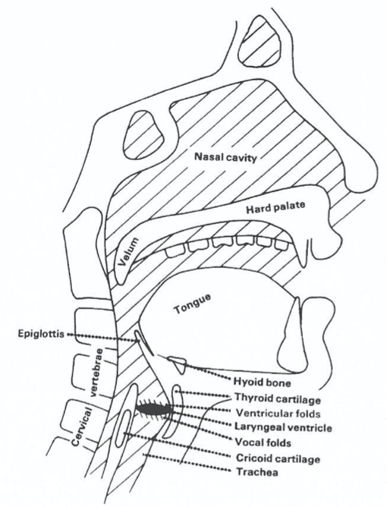
Figure 3 – A look at the parts of the vocal tract. Pharyngeal column highlighted in red. (Dimon, 2018)

Strategies to Apply To My Practice
I have learnt a lot from this study that I can input into my teaching.
Gaining a good understanding of acoustic couplings has assisted my preconceptions surrounding placement sensations such as head and chest voice. I have been able to slowly remove these terms and instead replaced them with “light voice” and “heavy voice”.
For my more advanced students, I have been able to use the Voce Vista in lessons to aid their sound without speaking of placement. The VoceVista is a spectrogram analyser with the ability to give clear readings of where each formant lies for a particular sound. I am to continue to use the VoceVista in lessons to aid my teaching, gaining a deeper understanding of formants and harmonics.
As a CCM teacher, lot of my students favour a M1 dominant unlike their classically trained counterparts (Stark, 1999). It often uses a heavier, louder timbre up to and beyond the passagio. Tracking F1 to H2 is a useful tool in my practice and is something that I have begun to use.
In this example, my student was singing “Chandelier” by Sia. The first line of the chorus starts with an “I” (I’m gonna swing from the chandelier, from the chandelier). The “I” is on a Bb4 which has a value of 466Hz. This song uses a heavier, excited sound navigating through the passagio in the female voice. To achieve a “yell/M1” sound, I tracked the first formant to the second harmonic. See figure 6 to see the first time she sung the word “I” using the vowel /aɪ/ (like the word “eye”).

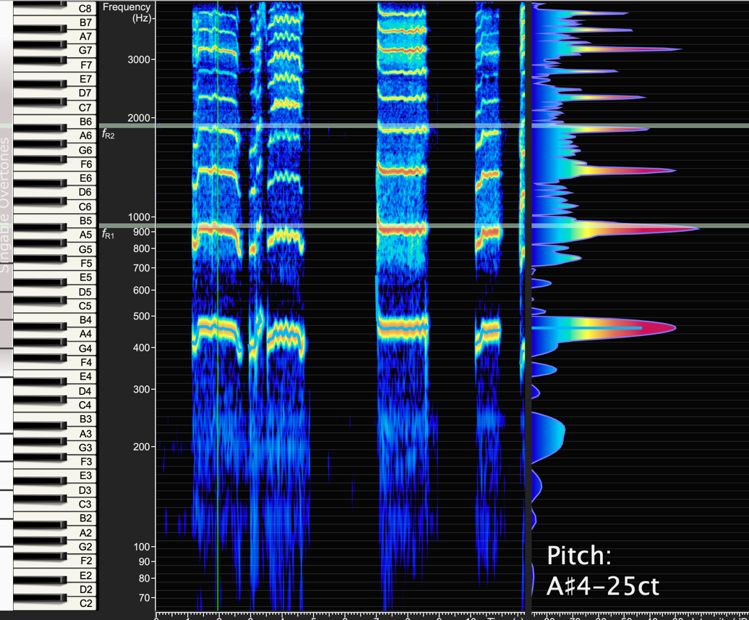
Figure 4 shows a boost in the second harmonic indication a coupling of F1/H2 though it as not as strong as figure 7 below. There isn’t a lot of energy in the upper harmonics either.

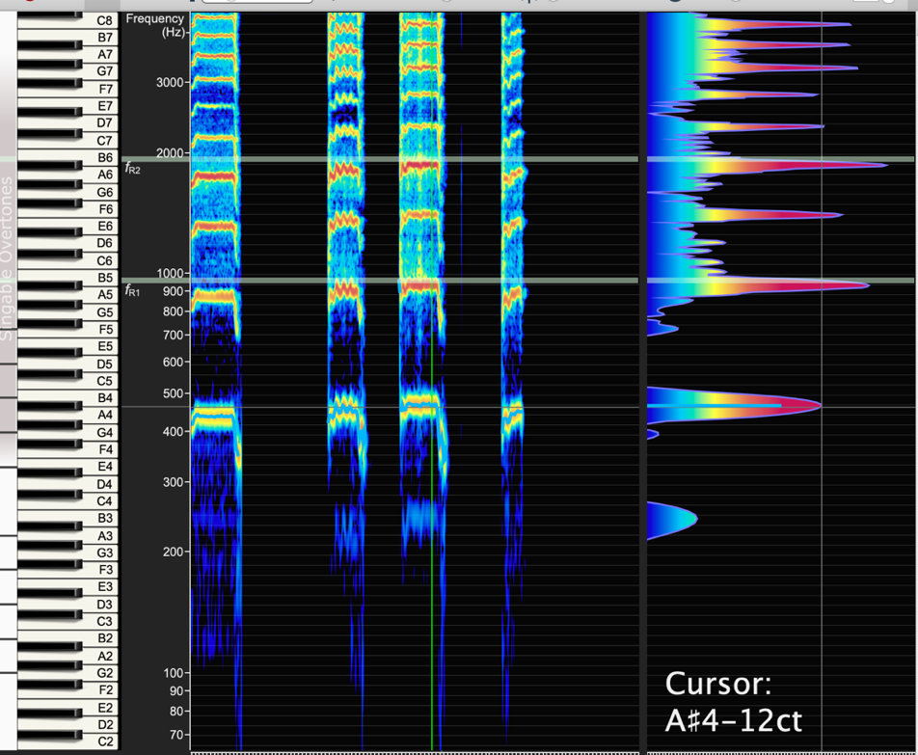
To find a more suitable vowel, I explored the vowel chart on the VoceVista to find a vowel that had a first formant value of the second harmonic of Bb4. The second harmonic of Bb4 is Bb5 which has a value of 932Hz. I chose the vowel /a/ as in “father”. As you can see in Figure 7 to the left, this vowel has a stronger F1/H2 coupling. There is also a strong fourth harmonic because the second formant lies in close proximity to the fourth harmonic – around 1800Hz. This vowel change has allowed for a much bigger, excited sound. This was all done without any mention of placement or imagery.

Moreover, I understand that placement sensations do exist however they are sympathetic vibrations that can be different for each student. If a student has a high kinaesthetic awareness, these sensations might be useful. However, it is far more objective to utilise the formants and harmonic couplings which I will endeavour to use far more frequently than any tonal “placement” sensations.

A Reflective Review Comprising of Two Parts:
a) Reflect on your recent learning experience, and the value of learning you acquired. Assess your current competencies and identify future development needs in the context of the work situation.

b) Devise a detailed personal development plan which incorporates development objectives, activities to be undertaken, methods, resources review periods and timescales

Using reflective theory was essential to completing this study. The concepts outlined by Schon (1983), “Reflection in Action” and “Reflection on Action”, were two that most resonated with my practice. As I exclusively teach on a one-to-one basis, my lessons are tailored to each students’ individual needs and voice type. I have learnt a lot just by “thinking on my feet” in attempt to allow students to achieve resonance in their voices – “Reflection in Action” (Ghaye on Schon, 1998, Page 6). I also take from Ghaye’s definition of “Reflection on Action” which coincides with my desire to understand how to allow students to create a resonant sound through shaping the vocal tract and without talking of placement imagery. After the “surprise, puzzlement or confusion” of “Reflection in Action”, taking the time to reflect and learn from my actions has been very useful. This reflective model was very helpful to start digesting what I was learning and how I could rationalise it and implement it in my practice.

After researching various different methodologies for reflective theory, I favoured Borton’s (1970) model which intends to answer three questions “What?”, “So What?” and “Now What?”. This methodology seemed the easiest way to assess my learning journey throughout this study in order to “challenge assumptions, ideological illusions… and question personal behaviours” (Bolton, 2010, Page 68). This reflective model has allowed me to reach definitive conclusions from my study.

It was important for me to undertake thorough research on the formants and harmonics of the vocal tract in order to allow my students to achieve resonance in their voices without discussing tonal “placement” sensations. I have learnt from personal experience that the area of “placement” was bewildering and illusive. My first singing teacher continuously subjected me to “placement” language such as “chest voice”, “head voice” “split the resonance”. This led to my own misconceptions on the matter which this study has allowed me to challenge.

It is my responsibility to ensure that my students understand that a tone cannot be “placed” in a specific area and an attempt to do so could potentially damage their vocal health which I am liable for. My objective was to understand how to allow my students to feel resonance without the mention of “placement”. I believe that many of my students over analyse where the tone is felt and then attempt corelate that with a certain timbre. An example of this is the use of “chest voice” – students will often feel for vibrations in their chest to indicate “chest voice” or a “heavier voice” is being used. My goal was to allow my students to move away from searching for these sensations and to find new more objective ways to achieve optimal resonance.

“What?”

I started by attempting to gather suitable resources regarding tonal “placement” sensations in attempt to understand how these terms arose. It was important that I understood what each “placement” sensation was trying to describe so that I could later analyse what was going on from the point of view of voice science. On the outset, I had a good understanding of terms such as “head and chest voice” as I had personally used them before. However, I felt that I lacked an understanding of some terms such as “sing into the mask” as this is a term often used in Classical styles of singing; as a CCM singer and teacher, I had never used this term.

Once I had a better grasp of various tonal “placement” sensations, I endeavoured to gain a deeper understanding of formants and harmonics. I examined texts by Professor Kenneth Bozeman and Professor Johan Sundberg to understand how we create different timbres through boosting the various harmonics. Reading these texts was somewhat confusing so I purchased the spectrogram program, the VoceVista. I spent many hours analysing the VoceVista spectrogram looking at my own voice as well as some colleagues and students. This primary research was incredibly valuable in allowing me to gain a deeper understand of the timbres created from the various formant and harmonic couplings. I then experimented by shaping my vocal tract in various ways to see how that effected the spectrogram. I looked into formant values for each vowel to gain a deeper understanding of where the first and second formants lie for each vowel. This allowed me to understand better pair each formant and harmonic coupling.
It was after this that I began to consider both the formants and harmonics and tonal “placement” sensations concurrently. This was where it started to become confusing. The literature surrounding this topic is somewhat contradicting and incomplete; it is undoubtably an area that needs some more research. I discovered that the more literature I read, the more opinions I discovered. Relating everything back to the VoceVista analysis helped me to form my own opinions on the matter.

“So What?”

After conducting my research, I was incredibly fascinated by what I had discovered. It felt truly empowering to understand how to utilise resonance and I was incredibly excited to implement what I had learnt into my regular practice.

Though, I did find it incredibly difficult to let go of my own prejudices of tonal “placement” sensations. I had used some of these terms such as “head voice” and “chest voice” for many years and letting go of them was a slow process. I began to replace language in my practice opting for terms such as “heavy voice/heavy mechanism” in place of “chest voice” and “light voice/light mechanism” in place of “head voice”. This shift in language allowed me to “sort through uncertainties and unclarities” (Bolton, 2010, Page 4).

I did begin to feel overwhelmed in attempting to include all of this new information into my practice and so began to introduce it slowly and where necessary. After learning all of this exciting information, it was difficult not to overuse it as this would have resulted in confusing students. I had to find ways to convert scientific terminology into something more accessible. I used vowel tuning as a way to access the different formant and harmonic couplings in place of discussion of tonal “placement”.

I was relieved to know that a lot of what I had already been practicing was correct and useful – I just needed to irradicate any discussion of tonal “placement”. I had always used a lot of vowel tuning within my practice however this was done on a basic level – it felt far more objective to understand where the first and second formants lie for each vowel.
Bozeman’s (2013) use of “Yell” timbre has been incredibly useful when attempting to teach a student how to “Belt”. Understanding how to track the first formant to the second harmonic has been essential to this. Combining a raised larynx with a narrow pharynx and a wide mouth, students have been able to achieve a “Belt”. This has been advantageous in my practice as “Belt” is a well desired sound amongst my students; giving them the tools to practice this safely is very important.
I have never really used the term “Singing into the mask” so did not need to remove that from my practice. However, I have had students that have used the term in the past and it is a relief to know that I can now understand what it means to “sing into the mask” and allow those students to utilise resonance without the need for discussion of tonal “placement”. I now aim to gradually change their views on terms such as “singing into the mask” in a positive and non-condescending way. I aim to do this by giving them exercises that allow for a stronger glottal closure paired with a vocal tract shaped to give a strong Singers Formant Cluster (Also, through use of low larynx exercises and narrowing the epilaryngeal tube through use of twang). I need to undertake more research to understand “twang” alongside this.
I do appreciate that I have only exposed a few tonal “placement” sensations and that there are many more that I will endeavour to understand with further research. Tonal “placement” sensation terms such as “feel the split of resonance”, “sense the voice at the end of one’s nose” or to “get the tone up and over” are some that I intend to gain a deeper understanding of.
“Now What?”
I feel that there is further research to be done on the area of resonance. I plan to gain a deeper understanding of “ring” within CCM and its link to the Singers Formant Cluster. I want to understand what it means to develop a strong SFC or “ring” through VoceVista analysis of various Classical and CCM singers. I do not feel like I fully understand the use of the SFC as I come from a CCM background. I want to understand how all of the moveable parts of the vocal tract change the position of the formants.
Following on from this, I would also like to understand how sounds such as “twang”, “cry” and “sob” are formed and what each of those do to the various formant values. As well as examine the literature, I will use the VoceVista to analyse various colleagues and students. I am hoping to find new ways to help my students achieve sounds such as “twag”, “cry” and “sob” as I feel that these terms can be quite subjective. Some students cannot directly imitate “sob” for example, so I wish to gain a deeper understanding of what it means to create sob through shaping the vocal tract relating it to the VoceVista analysis to understand what is happening on the spectrogram.

Personal Development and Learning Plan
Why am I doing this course? | I want to streamline my language as a teacher removing as much subjective content as possible. I want to ability clear and concise direction to my students in order for them to achieve their best possible sound, with their vocal health being at the top of the priority list.  I aim to broaden my general knowledge as a teacher in order to best serve a variety of students.
What is the direct benefit to me? | This course will give me the opportunity to continuously development of my teaching. Its unbiased nature means that I can explore various avenues without being restricted by pedagogy from a single “model” of teaching.  I would eventually like to use the information acquired from this MA to help professional vocalists/vocal teachers.  I am also interested in growing my network of voice professionals through this course. I flourish around like-minded people so having the opportunity to have regular contact with others on my course is incredibly exciting.
Developmental area  - Gain a deeper understanding of the formant and harmonic couplings focusing on the upper harmonics | Action  Revisit the literature reviewed focusing on works by Professor Kenneth Bozeman.  Use the VoceVista to analyse various singers including CCM and Classically trained singers to gain a better understanding of what is happening with the upper harmonics when creating various tones  Deadline – To be completed by the end of the next project
- Better understand the use of “sob”, “cry” and “twang | Discover literature based on “sob”, “cry” and “twang” more specifically looking at the Estill model  Establish what is happening within the vocal tract to create these sounds through watching some videos of singers using the stroboscopy when making these sounds.  Use the VoceVista to analyse various singers including CCM and Classically trained singers when making these sounds.  Deadline – To be completed by the end of the next project
- Look into other tonal “placement” sensations | Revisit the literature found for this study focusing on other tonal “placement” sensations.  Speak to singers and teachers who use tonal “placement” sensations in attempt to understand how they fit it into their pedagogy.  Deadline – To be completed by the end of the next project

References

Bolton, G (2010) Reflective Practice: Writing and Professional Development, SAGE Publications Ltd; Third Edition
Borton, T. (1970) Reach Touch and Teach, McGraw-Hill Inc.,US
Bozeman, K (2013) Practical Voice Acoustics, Pedagogical Applications for Teachers and Singers, Pendragon Press, Hillside, NY
Dimon, Theodore (2018) Anatomy of the Voice: An Illustrated Guide for Singers, Vocal Coaches and Speech Therapists, North Atlantic Books, Berkeley, CA
Doscher, B (1988) The Functional Unity of the Singing Voice
Frizzell, Anthony (2007) “The Tenor Voice, A Personal Guide to Acquiring a Superior Singing Technique”, Branden Books; 2nd Edition (24 Jun. 2014)
Hock, M (2014) A Dictionary For The Modern Singer, Rowman & Littlefield, New York
Howard, D and Angus, J (2006) Acoustics and Psychoacoustics
Manuel Garcia (1894) Hints on Singing, Ascherberg, Hopwood and Crew, Ltd, London
Maternach, B (2018) Journal of Singing
Miller, Donald (2000) Registers in Singing. Empirical and Systematic Studies in the Theory of the Singing Voice, Rijksuniversiteit Groningen,
Miller, R (2004) Solutions for Singers – Tools for Every Performer and Teacher, Oxford University Press
Richard Miller (2008) Securing Baritone, Bass-Baritone, and Bass Voices, Illustrated Edition, OUP USA;
Stark, H (1981) Journal of Singing, Volume 37
Stark, J, (1999) Bel Canto: A History of Vocal Pedagogy, University of Toronto Press, Toronto
Sundberg, J (1987) The Science of the Singing Voice, Northern Illinois University Press, Northern Illinois
Sundberg, J (1987) The Science of the Singing Voice, Northern Illinois University Press, Dekalb, IL

Sundberg, J (2003) Research on Singing in the Retrospect, KTH Computer Science and Communication

Taylor, David (2018) The Psychology of Singing A Rational Method of Voice Culture based on a Scientific Analysis of all Systems, Ancient and Modern, Franklin Classics Trade Press
Tillotson Bauer, Karen (2016) The Role of Kinesthesia in a Pedagogy for Singing, Journal of Singing - The Official Journal of the National Association of Teachers of Singing; Jacksonville, Fla. Vol. 73
Titze, I (1981) Journal of Singing, Volume 37
Tony Ghaye (1998) Teaching and Learning through Reflective Practice: A Practical Guide for Positive Action, Routledge (7 Dec. 2010)
Vennard, W (1967) Singing, the Mechanism and the Technique, Carl Fischer Inc, New York
Vos, R; Murphy, D; Howard, D; Daffern, H (2018) Determining the Relevant Criteria for Three-dimensional Vocal Tract Characterization, Journal of Voice
Wolfe, J, Garnier, M and Smith, J (2009) UNSW; Vocal Acoustics: An Introduction (updated 2013)

