
Programme: MSc Public Health and Social Care in Practice
Module: Community Care and Management of Longer-term Conditions
Module Code: LCHS7003
Component: Information Booklet of Long-term Condition Management
Lecturer Name: Dr. Raheela shaikh
Topic: Living with Osteoarthritis in the UK
A Whole-Person Approach to Long-Term Condition Management
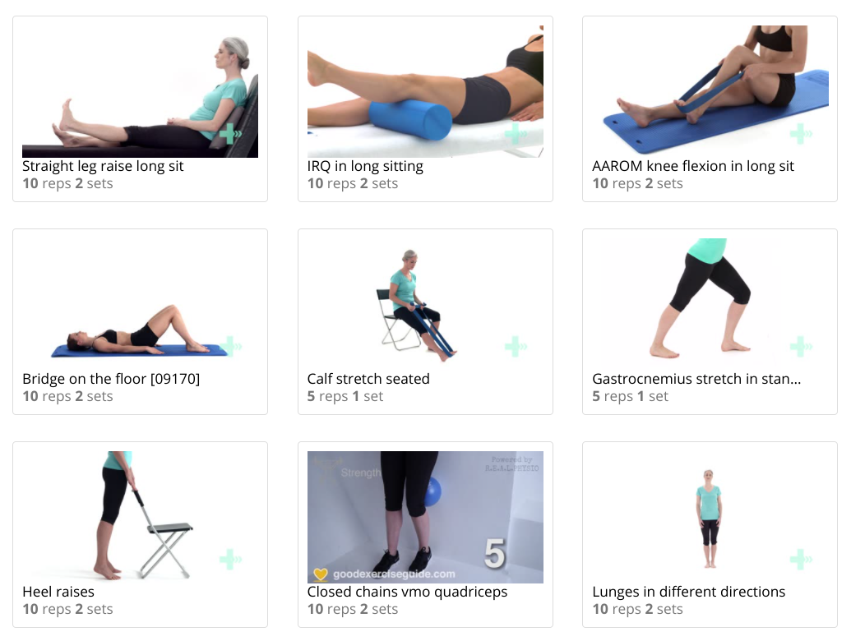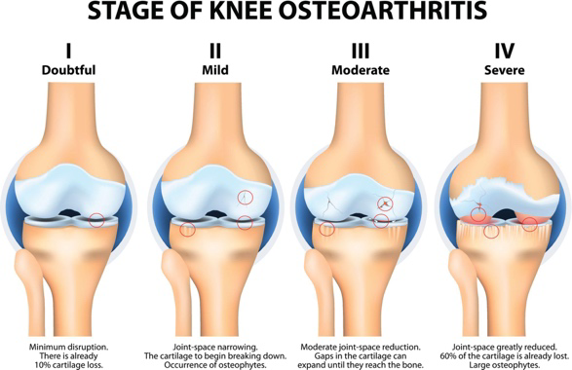
Prepared by: KRUPALI HASMUKHBHAI RAMANI
Student ID number: 2520812 Date: 26th FEBRUARY 2026
Table of Contents
1. Introduction 3
2. Understanding Osteoarthritis 5
2.1 Definition and Pathophysiology 5
2.2 Burden and Prevalence 5
2.3 Risk Factors and Aetiology 7
3. Impact of Osteoarthritis: Physical, Psychological & Social Dimensions 8
3.1 Physical Impact 8
3.2 Psychological Impact 8
3.3 Social Impact 9
3.4 Impact on Families and Informal Carers 9
4. Evidence-Based Management in the UK 10
4.1 NICE Guidelines 10
4.2 Non-Pharmacological Approaches 11
4.3 Pharmacological and Surgical Interventions 13
5. Theoretical Models & Frameworks 14
5.1 UK Model: The NHS Long Term Plan / House of Care Model 14
5.2 International Model: Wagner’s Chronic Care Model 15
6. Political, Health and Social Care Agendas 17
7. Recommendations for Improving Person-Centred Care 17
8. Conclusion 18
Reference List 19

1. Introduction
Osteoarthritis (OA) stands as a chronic degenerative joint disease that is categorised by cartilage breakdown which happens in a progressive manner along with joint pain, stiffness, and functional impairment, which usually occurs in the knees, hips, and hands (Andraskar, 2024). It also acts as the prevalent type of arthritis all over the world and is a serious long-term disease as it is chronic and affects the day-to-day living. As per WHO (2023) osteoarthritis is estimated to affect 528 million individuals in the global landscape, with only about 73% of the affected individuals aged 55 years and above, and women constituting the majority of the cases relative to men.
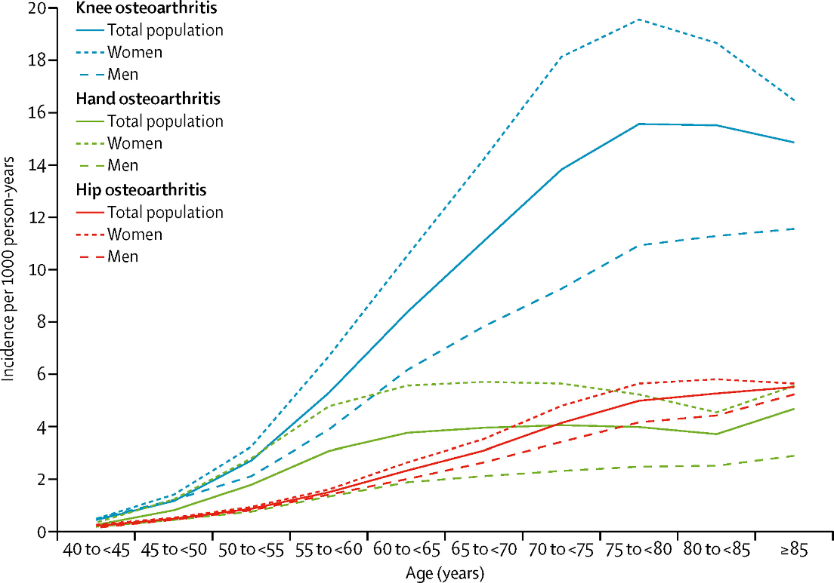
Figure 1: Osteoarthritis in Men and Women
(Source: Hunter and Bierma-Zeinstra, 2019)
In the UK, approximately 1 out of 10 adults is clinically diagnosed with osteoarthritis, and prevalence rates sharply increase with age; the number is also set to rise as the population ages and multimorbidity rises (Swain et al., 2020). OA is a significant health concern worldwide and a challenge to the UK population due to the ageing demographic profile as well as its increasing prevalence rates of obesity and other risk factors (Hawker and King, 2022). Osteoarthritis is thus a chronic condition in the definitions of health and social care policies and needs integrated and holistic care management in care settings.
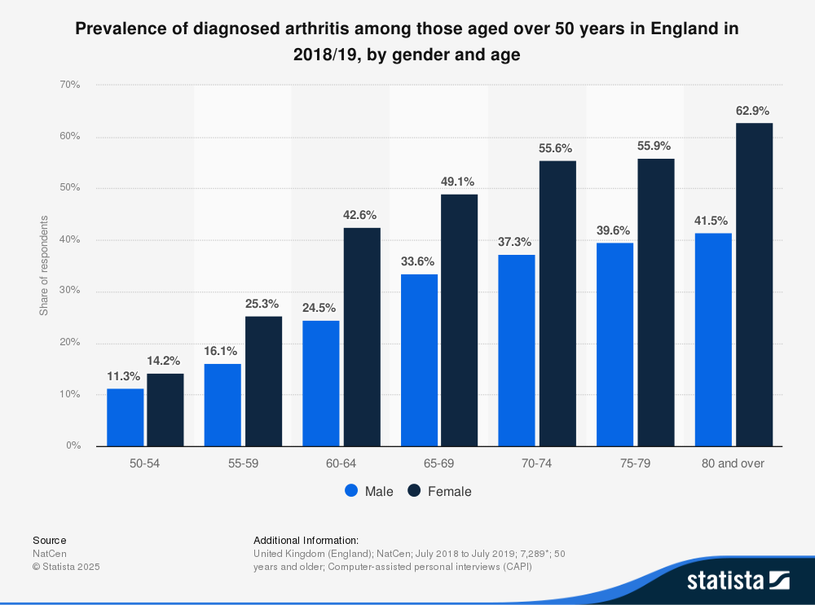
Figure 2: Age group of Osteoarthritis
(Source: Statista and Institute for Fiscal Studies, 2025)
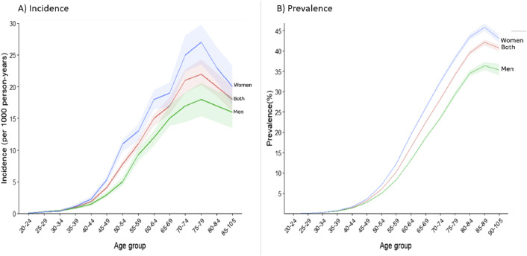
Figure 3: Incidence and Prevalence of Osteoarthritis
(Source: Swain et al., 2020)
The primary aim of this booklet is to review the concept of osteoarthritis and its management in the UK health and social care systems in a critical manner based on empirical evidence and policy framework to guide whole-person care.

2. Understanding Osteoarthritis

2.1 Definition and Pathophysiology
As already mentioned, OA stands as a progressive degenerative joint disease that is chronic and is characterised by structural and functional failure of a synovial joint (Andraskar, 2024). It particularly entails continuing cartilage erosion of the articular cartilage as well as subchondral bone remodelling, osteophyte formation and different extents of synovial inflammation. In contrast to the classical perspective of OA as a mere wear and tear, modern evidence by authors such as Girish and Subhadra (2025) identifies it as a multifactorial condition which comprises of mechanical stress, low-grade inflammation, and biochemical alterations in the joint.

2.2 Burden and Prevalence
- OA stands as a common health issue afflicting the world health sector, with an estimated 595 million cases worldwide in 2020, which considerably accounts for roughly 7.6% of the global population, thus act as a significant rise in the aggregate number of cases since 1990 (Wang et al., 2025).
- It is one of the most common causes of disability, especially in adults aged above 70 years, and with high rates of these years lived with disability or YLDs worldwide (Healthdata.org, 2026).
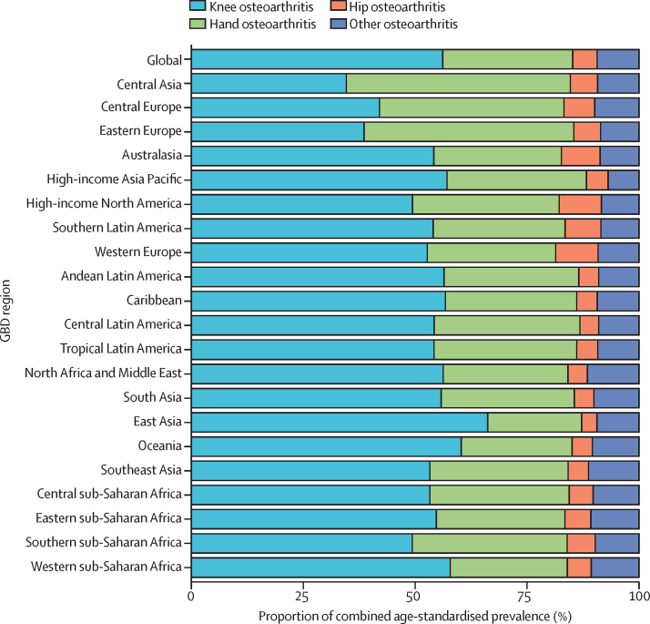
Figure 4: Global Prevalence of Osteoarthritis
(Source: Wang et al., 2025)
- Symptomatic osteoarthritis is prevalent among adults in the United Kingdom with a prevalence of about 10% at a certain age and the prevalence of the condition increases significantly with age.
- At the same time, the incidence rates indicate 6.8 new cases per 1 000 person-years, as well as where knee OA is the most typical clinical manifestation (Coates et al., 2023).
- The costs of NHS services and social care to the economy are high as the consultations and hospital care related to osteoarthritis occupy a significant amount of healthcare resources.
- The morbidity and healthcare burden of OA is likely to continue to rise as the UK population continues to grow older (Wang et al., 2025).
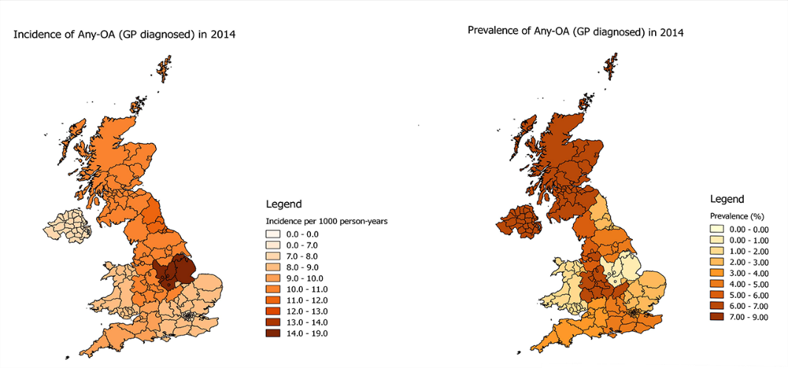
Figure 5: Osteoarthritis Burden In UK
(Source: Swain et al., 2020)

2.3 Risk Factors
Risk Factor | Mechanism of Contribution | Evidence-Based Explanation
Age | Biological joint degeneration | Ageing leads to reduced cartilage repair capacity, subchondral bone remodelling, and cellular senescence, increasing vulnerability to joint damage (Healthdata.org, 2026).
Obesity | Mechanical overload and metabolic inflammation | Excess weight increases biomechanical stress on weight-bearing joints (knees, hips) while adipose tissue also releases pro-inflammatory cytokines such as leptin, contributing to low-grade systemic inflammation (Shumnalieva, Kotov and Monov, 2023).
Genetics | Inherited susceptibility | Genetic variants affecting cartilage integrity, bone density, and inflammatory pathways increase OA risk (Coates et al., 2023). Family history is a recognised predictor, particularly in hand and hip OA.
Previous Joint Injury | Post-traumatic structural damage | Ligament tears, fractures, or meniscal injury alter joint biomechanics, accelerating cartilage breakdown and leading to post-traumatic osteoarthritis.
Occupational Risks | Repetitive joint stress | Jobs involving kneeling, squatting, heavy lifting or prolonged standing also increases risk due to cumulative mechanical strain (Nygaard et al., 2022).

3. Impact of Osteoarthritis: Physical, Psychological & Social Dimensions

3.1 Physical Impact
- Osteoarthritis is associated with chronic joint pain and stiffness and progressive functional loss, which is usually accompanied by mobility and independence (Wang et al., 2025).
- Continuous pain has been associated with fatigue and sleep disturbance that subsequently increase the severity of symptoms and lower the quality of life.
- Such an aspect of disability is complicated and thus compounded by multimorbidity affecting many people, especially cardiovascular disease and obesity (Wang et al., 2025).
- The perception of pain differs too much among people that depends on psychosocial and neurological variables, which complicates the purely biomedical models (Nygaard et al., 2022). Delayed diagnosis can increase the deterioration and disability of the joints.
- Also, polypharmacy that can include analgesics and anti-inflammatory drugs increases the risk of gastrointestinal, renal and cardiovascular complications, especially in elderly individuals (Shareef et al., 2025).

3.2 Psychological Impact
- Osteoarthritis chronic pain is closely correlated with depression and anxiety, proving that both have a bidirectional relationship in which psychological distress exacerbates pain perception (Hawker and King, 2022).
- The loss of mobility can pose a danger to identity, independence and self-worth especially to people who were formerly active (Hawker and King, 2022). Distress can also be increased by fear of being attached to the family members or services.
- Disability and healthcare utilisation may be increased by pain catastrophising, in which people expect the illness to become worse. It has been evidenced by Alwhaibi and Alhawassi (2025) that the common mental health disorders are highly likely to be triggered by the long-term pain conditions.
- Moreover, osteoarthritis tends to stand as an invisible disability and absence of manifestation may lead to stigma, confusion, and undermined social approval.

3.3 Social Impact
- Osteoarthritis is a serious problem with regard to social functioning and the consideration of socioeconomic stability. In this case, decreased mobility can impair the work ability, which causes absentees, retirement, or poor performance (Wang et al., 2025).
- Lost income, transportation expenses and modifications in the home may lead to financial strain. Social involvement tends to reduce since pain limits leisure and community activities, making people more isolated (Hawker and King, 2022).
- Gender disparities can be also identified as females are of more prevalence and oftentimes have more expectations of caregiving coupled with their health issues.
- Occupational exposure and deprivation are also social determinants, which affect the burden of disease, and this fact demonstrates that osteoarthritis is not only a clinical complication but also a socially patterned health problem (Marks, 2024).

3.4 Impact on Families and Informal Carers
Impact Domain | Families | Informal Carers
Carer Burden | Families often experience role redistribution when a member develops osteoarthritis, particularly in advanced stages (Alemu et al., 2025). Household responsibilities may shift, affecting family dynamics and routines. | Informal carers (often spouses or adult children) provide direct physical assistance with activities of daily living such as dressing, bathing, and mobility (Sun et al., 2025).
Emotional Stress | Families may experience anxiety regarding disease progression, loss of independence, and future care needs. Witnessing chronic pain can contribute to emotional distress and feelings of helplessness. | Informal carers frequently report psychological strain, including stress, burnout, depression, and social isolation (Turner et al., 2024).
Financial Implications | Reduced household income may occur if the affected individual decreases work hours or retires early (Turner et al., 2024). Additional costs include home adaptations and transport. | Carers may reduce employment or leave work entirely, resulting in lost income and pension contributions. Financial strain may increase dependency on social support systems.
Intergenerational Strain | Multigenerational households may face tension as caregiving responsibilities impact childcare, employment, and family relationships (Sun et al., 2025). | Adult children providing care may experience conflict in balancing parental care with their own family and career obligations, which can increase role strain.

4. Evidence-Based Management in the UK

4.1 NICE Guidelines
Guideline NG226 by National Institute of Health and Care Excellence or NICE helps to offer the evidence-based guidelines to diagnose and treat osteoarthritis in individuals aged 16 years and above in the UK. It focuses on the holistic practice that emphasizes the self-management and non-pharmacological therapies as the foundation of care. In this case, therapeutic exercise, weight management (where relevant) and information and support are core treatments of all individuals with osteoarthritis and are customized to meet the needs of the individual aimed at improving their functional and quality of life (NICE, 2025).
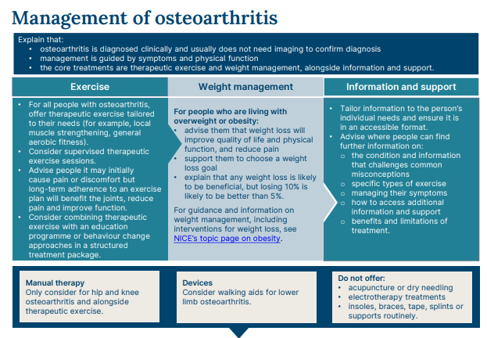
Figure 6: Guidelines for Managing Osteoarthritis
(Source: NICE, 2025)
Analgesia is used with non-drug treatments while patients receive topical non-steroidal anti-inflammatory drugs or NSAIDs as their first treatment option and doctors prescribe systemic medications at their minimum effective dosage for the least amount of time (NICE, 2022). The importance of shared decision-making in the choice of pain relief is emphasized. Only in the event that symptomatic effects have a major effect on quality of life, and non-surgical treatment proved ineffective, joint replacement surgery is advised (NICE, 2025). This recommendation supports self-management, patient education and personalised care planning as the key mechanisms in long-term management of osteoarthritis.

4.2 Non-Pharmacological Approaches
Physiotherapy:
- In the UK, physiotherapy and therapeutic exercise is first-line treatment of osteoarthritis. It has been demonstrated that almost half of individuals with osteoarthritis visit physiotherapy and attendance has been linked to more positive beliefs regarding exercise and a more positive response to rehabilitation programmes (Toomey et al., 2024).
- Physiotherapists also are becoming increasingly viewed as useful primary examiners in knee osteoarthritis with some studies indicating that they can offer equivalent care to physician-led examination and may even be better cost-effective in primary care (Ho-Henriksson et al., 2022).
- The musculoskeletal physiotherapy is gaining demand; more than 323,000 individuals were waiting to receive MSK rehabilitation services in England, which points to the high service burden that is linked to the management of osteoarthritis (The Guardian, 2024).
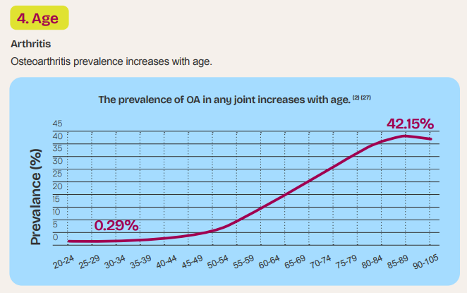
Figure 7: Osteoarthritis Growing with Age
(Source: Arthritis UK, 2024)
Occupational therapy: This therapy aids in the protection of joints, activity adaptation and autonomy. Considering that osteoarthritis occurs in about 10% of adults in the UK and causes chronic pain in more than one-third of patients, functional limitations that need this treatment are prevalent (Lohan et al., 2023).
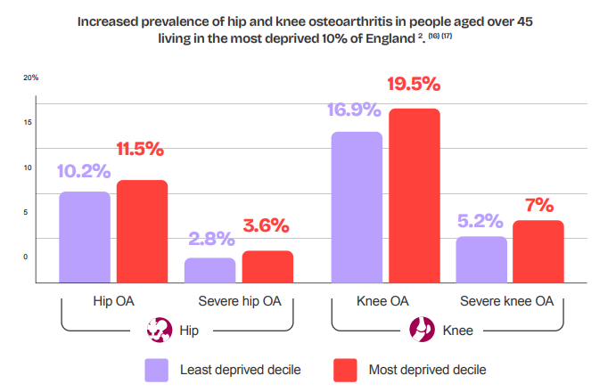
Figure 8: Increased Rate of Osteoarthritis in Aged People
(Source: Arthritis UK, 2024)
Social prescribing and community exercise:
- This are encouraged in order to alleviate isolation and enhance physical functioning.
- It is estimated that osteoarthritis affects 344 million individuals worldwide, and rehabilitation would help them, which explains the need to implement community-based interventions (World Health Organization, 2023).
- Osteoarthritis has been a leading cause of disability in the UK where an estimated 10 million Arthritis patients of above 65 years old experience the disease and where community exercise programmes are needed to preserve mobility and independence (Arthritis UK, 2024).
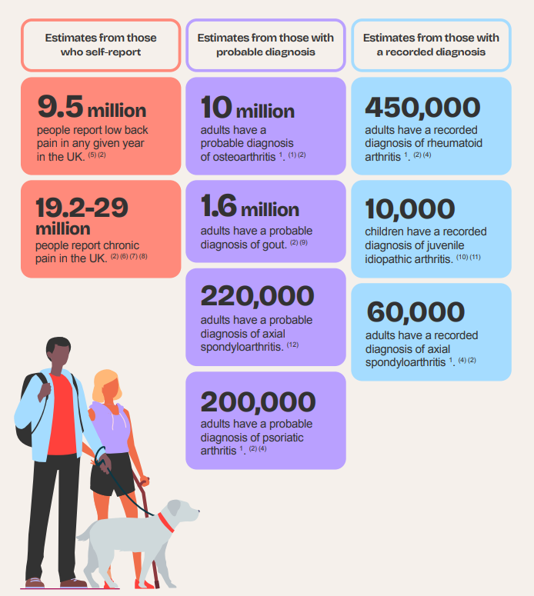
Figure 9: Probable Diagnosis of Osteoarthritis
(Source: Arthritis UK, 2024)

4.3 Pharmacological and Surgical Interventions
- NSAIDs: Non-steroidal anti-inflammatory drugs are commonly prescribed to treat the pain of osteoarthritis, especially because more than one-third of patients report chronic pain of more than three months of duration, which causes the use of NSAIDs in the primary care setting (Lohan et al., 2023). The levels of healthcare utilisation are enormous, and almost 10% of individuals visiting UK primary care have osteoarthritis, which indicates the current need to continue using pharmacological pain management (Swain et al., 2023).
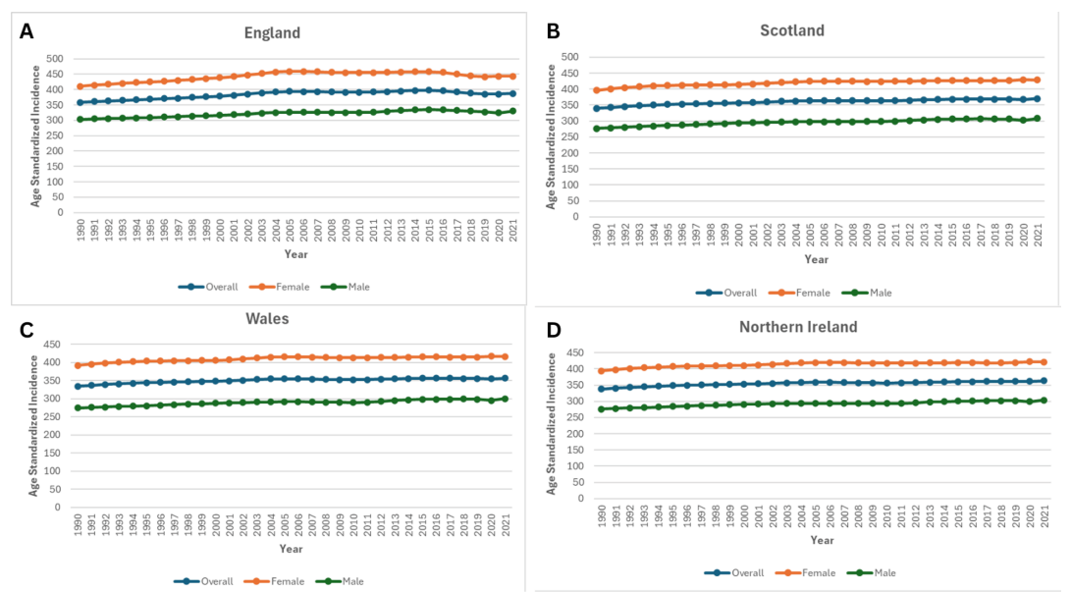
Figure 10: Trends in Age-Standardised of Knee Osteoarthritis in the UK
(Source: Tayyab et al., 2025)
- Corticosteroid injections: Intra-articular corticosteroid injections are widely applied to address short-term pain relief, especially during the moderate and severe disease. Growing incidence of knee osteoarthritis which reached 4.51 million cases in England by 2021 have led to more people using injection therapies to postpone surgical treatment (Tayyab et al., 2025).
- Joint replacement surgery: Joint replacement is a definitive remedy to severe osteoarthritis. According to the UK registry data, the UK carried out around 99,000 hip replacements and 98,000 knee replacements in 2022, which means that osteoarthritis has become a significant burden of surgery (The Guardian, 2024). Joint replacement is more common in older age, with a rate over 600 per 100,000 women aged 75-79 years, which testifies to the connection between ageing and progressive illness based on the need to undergo surgery (The Guardian, 2024).

5. Theoretical Models & Frameworks

5.1 UK Model: The NHS Long Term Plan / House of Care Model
House of Care model as part of the NHS Long Term Plan advocates person-centred collaborative care to persons living with long-term illnesses like osteoarthritis. The model is premised on collaborative care planning, in which patients and professionals jointly decide and make decisions through the use of personalised goal setting and multidisciplinary coordinated input (Peat et al., 2023). The given approach portrays the current NHS ideology with its focus on empowerment, prevention, and integration between primary, secondary and community services (Verity et al., 2022). Education, social prescribing and community-based rehabilitation prioritise the provision of self-management support and thus are especially appropriate where lifestyle change impacts the outcome in the case of osteoarthritis.
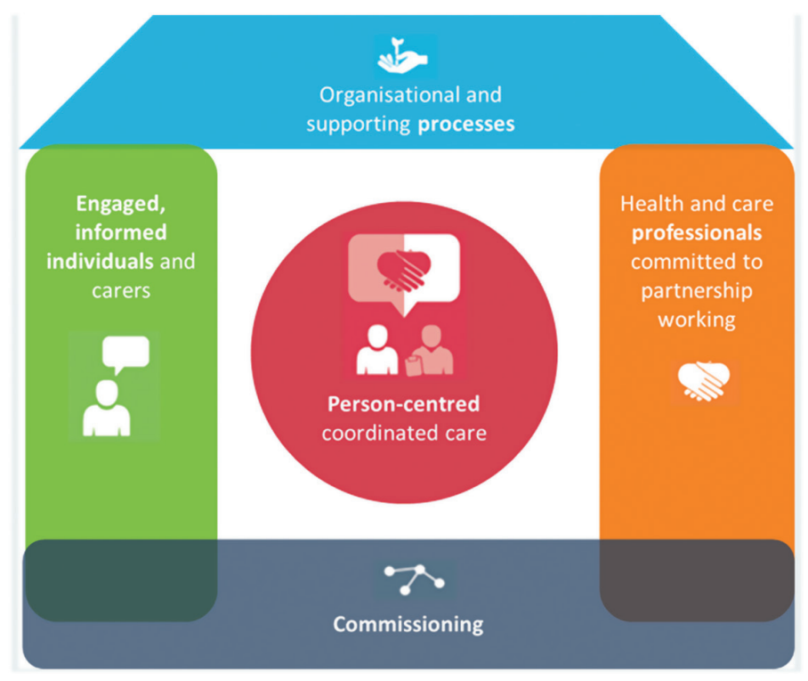
Figure 11: House of Care Model
(Source: Peat et al., 2023)
The enforcement is however uneven and consistent. Multidisciplinary integration is restricted by the shortage of workforce, the lack of communication between health and social care, and the existence of inequalities on a regional level (Senyapar, 2025). Moreover, time constraints in the primary care may limit meaningful shared decision making and turn the model into a procedural exercise instead of actual co-production.

5.2 International Model: Wagner’s Chronic Care Model
- CCM offers a globally accepted model that is dedicated to effective relationships between informed patients and proactive healthcare teams (Bokhari et al., 2024).
- The model focuses on redesign of health system, decision support, self-management education and mobilisation of community resource to enhance outcome with chronic diseases.
- This framework promotes the access to early intervention, rehabilitation, and coordinated monitoring over the long-term, which strengthens preventative and community-based management in osteoarthritis treatment (Toomey et al., 2024).
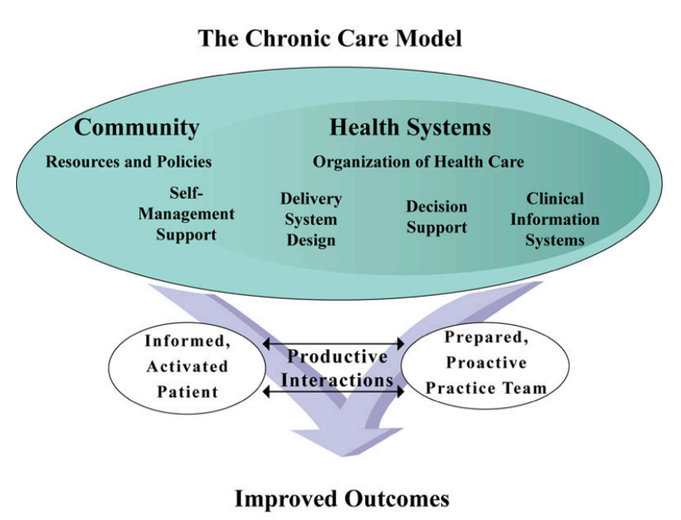
Figure 12: Wagner’s Chronic Care Model
(Source: Zuccaro, 2015)
CCM has high conceptual clarity and flexibility in other healthcare systems, which are more sustainable and applicable globally as compared with the UK House of Care model. Its systematic interest in system redesign can provide more organisational predictability compared to the NHS policy, which is susceptible to policy and funding changes (Senyapar, 2025). Nevertheless, CCM can be accused of the lack of focus on the integration of social care and broader socio-economic determinants, which are better identified in the UK policy discussion (Toomey et al., 2024).

6. Political, Health and Social Care Agendas
- The UK policy agendas have a strong impact on the management of osteoarthritis in the prevention, integration, and personalised care priorities. The NHS Long Term Plan, which is spearheaded by the NHS England, focuses on prevention, early intervention and community-based service expansion to avoid hospital addiction (Nationalarchives.gov.uk, 2025).
- This is in line with osteoarthritis management where weight management and rehabilitation with promotion of physical activity may postpone the development of the disease. Integrated Care Systems are designed to enhance the coordination of primary, secondary and social care, facilitating multidisciplinary pathways and social prescribing programs (van der Feltz-Cornelis et al., 2023).
- There is also a preventative role of the public health strategies. The roles that were once performed by Public Health England, and now in the UK Health Security Agency, and national policies on obesity and physical activity emphasize the role of lifestyle change in the prevention of osteoarthritis and disability.
- The Care Act 2014 supports the personalisation agenda by encouraging independence, wellbeing and carer involvement in the long-term condition management (Barnes et al., 2017).
Policy still lacks effective implementation even though there is a good policy alignment. There is a lack of integration between services because of divided commissioning arrangements within ICSs, and workforce shortages restrict access to physiotherapy and community rehabilitation. Continued pressure on funding limits preventative efforts whereby in most cases emphasis is placed on the acute care demand rather than long-term management.

7. Recommendations for Improving Person-Centred Care
Recommendation Area | Person-centred improvement strategy
Co-production approaches | Actively involve individuals with osteoarthritis in care planning, goal setting and service design to enhance empowerment, treatment adherence and satisfaction while ensuring services reflect lived experience.
Digital self-management tools | Expand access to NHS-approved digital platforms, remote physiotherapy and symptom-tracking apps to support education, exercise adherence and early symptom monitoring, particularly for individuals with mobility barriers.
Early intervention | Strengthen primary care screening, rapid referral to physiotherapy and weight-management services to delay functional decline and reduce future surgical demand.
Community partnerships | Increase collaboration with voluntary organisations, exercise groups and social prescribing networks to address isolation and promote sustained physical activity.
Carer inclusion | Recognise carers as partners in care through education, emotional support and involvement in decision-making to reduce caregiver burden and improve continuity of care.
Multidisciplinary integration | Improve coordination between GPs, physiotherapists, occupational therapists and social care to deliver holistic and continuous support across disease stages.
Health inequality reduction | Target deprived populations through culturally appropriate education, accessible community services and transport support to minimise disparities in outcomes.
End-of-life considerations | In severe frailty and advanced multimorbidity, prioritise pain control, functional comfort and shared advance care planning to maintain dignity and quality of life.

8. Conclusion
- In summary, osteoarthritis is already a major and increasing health concern to a population in the UK as a result of ageing population, increasing levels of obesity and the increasing need of rehabilitation and joint replacement services.
- In addition to pain and loss of mobility, the disease causes severe psychological distress, social isolation and burden of care to the caregiver, which support the requirement of a whole-person approach to the management process.
- It has been shown that multidisciplinary and community-based care, combined with the integrated one, can enhance functional outcomes, self-management and fewer healthcare visits.
- Nevertheless, endemic policy-practice gaps, labour pressures and health disparities ensure the necessity of sustainable reform.
- Prevention strategies, individualised care preparation and joint service provision deserve increased strength to enhance the quality of life of osteoarthritis patients and their families in line with the module focus on holistic care, policy awareness, and long-term condition management

Reference List
Alemu, N.L., Das, N., Watts, J.J., Robinson, S., Chen, G. and Gao, L., (2025). The Burden of Informal Caregiving for Adults with Musculoskeletal Conditions: A Systematic Review: NL Alemu et al. PharmacoEconomics, 43(10), pp.1179-1204. https://link.springer.com/content/pdf/10.1007/s40273-025-01523-x.pdf
Alwhaibi, M. and Alhawassi, T.M., (2025). Mental health and health-related quality of life among adults with osteoarthritis: A national population-based study. PLoS One, 20(6), p.e0325780. https://journals.plos.org/plosone/article/file?id=10.1371/journal.pone.0325780&type=printable
Andraskar, K., (2024). Recent advances in the understanding and management of osteoarthritis: a comprehensive review. Journal of Internal Medicine and Pharmacology (JIMP), 1(01), pp.53-62. https://sennosbiotech.com/JIMP/1/article/download/20/33 (Accessed: 23 February 2026).
Arthritis UK. (2024). The State of Musculoskeletal Health. Available at: https://www.arthritis-uk.org/policy-and-data/health-intelligence/the-state-of-musculoskeletal-health/ (Accessed: 24 February 2026).
Barnes D, Boland B, Linhart K, and Wilson K., (2017). Personalisation and social care assessment - the Care Act 2014. BJPsych Bull. 2017 Jun;41(3):176-180. https://pmc.ncbi.nlm.nih.gov/articles/PMC5451654/
Bokhari, N.S., Saleh, S.F., Alhazmi, Z.E., Alhazmi, M.H., Filfilan, O.R., Alsharif, A.S., Alsulaimani, B.M. and Alhujuri, M.Y., (2024). Interprofessional Collaboration Between Medical And Nursing Teams To Enhance Quality Of Care For Patients With Chronic Diseases. The Review of Diabetic Studies, pp.104-124. https://www.diabeticstudies.org/index.php/RDS/article/view/720/598
Girish, L. and Subhadra, K.T., (2025). Understanding Knee Osteoarthritis: A Comprehensive Review. Indian Journal of Integrative Medicine, 5(2), pp.78-88. https://mansapublishers.com/ijim/article/download/4908/4221
GOV.UK (2022). Physical activity: Applying All Our Health. GOV.UK. Available at: https://www.gov.uk/government/publications/physical-activity-applying-all-our-health/physical-activity-applying-all-our-health (Accessed: 26 February 2026).
Hawker, G.A. and King, L.K., (2022). The burden of osteoarthritis in older adults. Clinics in geriatric medicine, 38(2), pp.181-192. https://www.binasss.sa.cr/bibliotecas/bhm/may/5.pdf
Healthdata.org (2026). Global, regional, and National Burden of osteoarthritis, 1990–2020 and Projections to 2050 | the Institute for Health Metrics and Evaluation. [online] Available at: https://www.healthdata.org/research-analysis/library/global-regional-and-national-burden-osteoarthritis-1990-2020-and. (Accessed: 24 February 2026).
Ho-Henriksson, C.M., Svensson, M., Thorstensson, C.A. and Nordeman, L., (2022). Physiotherapist or physician as primary assessor for patients with suspected knee osteoarthritis in primary care–a cost-effectiveness analysis of a pragmatic trial. BMC musculoskeletal disorders, 23(1), p.260. https://link.springer.com/content/pdf/10.1186/s12891-022-05201-3.pdf
Hunter, D.J. and Bierma-Zeinstra, S. (2019). Osteoarthritis. The Lancet, 393(10182), pp.1745–1759. https://www.thelancet.com/journals/lancet/article/PIIS0140-6736(19)30417-9/abstract
Lohan, C., Coates, G., Clewes, P., Stevenson, H., Wood, R., Tritton, T., Massey, L., Knaggs, R., Dickson, A.J. and Walsh, D., (2023). Estimating the cost and epidemiology of mild to severe chronic pain associated with osteoarthritis in England: a retrospective analysis of linked primary and secondary care data. BMJ open, 13(11), p.e073096. https://bmjopen.bmj.com/content/bmjopen/13/11/e073096.full.pdf
Marks, R., (2024). Osteoarthritis and social disadvantage interactions: retrospective overview and emergent findings and health implications. Int. Phys. Med. Rehab. J, 9(1), p.39. https://www.researchgate.net/profile/Ray-Marks/publication/379236093_Osteoarthritis_and_Social_Disadvantage/links/660049fdf3b56b5b2d25e3be/Osteoarthritis-and-Social-Disadvantage.pdf
Nationalarchives.gov.uk. (2025). NHS Long Term Plan. Available at: https://webarchive.nationalarchives.gov.uk/ukgwa/20250707103655/https://www.longtermplan.nhs.uk/ (Accessed: 26 February 2026)
NICE (2022). Recommendations | Osteoarthritis in over 16s: Diagnosis and Management | Guidance | NICE. [online] www.nice.org.uk. Available at: https://www.nice.org.uk/guidance/ng226/chapter/Recommendations. (Accessed: 23 February 2026).
NICE (2025). Management of Osteoarthritis - Visual Summary. [online] Nice.org.uk. Available at: https://www.nice.org.uk/guidance/ng226/resources/visual-summary-on-the-management-of-osteoarthritis-pdf-11251842157.
Nygaard, N.P.B., Thomsen, G.F., Rasmussen, J., Skadhauge, L.R. and Gram, B., (2022). Ergonomic and individual risk factors for musculoskeletal pain in the ageing workforce. BMC Public Health, 22(1), p.1975. https://link.springer.com/content/pdf/10.1186/s12889-022-14386-0.pdf
Peat, G., Fylan, B., Breen, L., Raynor, D.K., Olaniyan, J. and Alldred, D.P., (2023). Person-centred deprescribing for patients living with frailty: a qualitative interview study and proposal of a collaborative model. International Journal of Pharmacy Practice, 31(3), pp.282-289. https://academic.oup.com/ijpp/article-pdf/31/3/282/51002257/riad016.pdf
Senyapar, H.N.D., (2025). Interdisciplinary Collaboration in Social Work Management: Models, Barriers, and Strategies for Integrated Sustainable Service Delivery. Technium Soc. Sci. J., 76, p.186. https://www.researchgate.net/profile/H-Nurguel-Durmus-Senyapar/publication/396215556_Interdisciplinary_Collaboration_in_Social_Work_Management_Models_Barriers_and_Strategies_for_Integrated_Sustainable_Service_Delivery/links/68e400dbd221a404b2a5c077/Interdisciplinary-Collaboration-in-Social-Work-Management-Models-Barriers-and-Strategies-for-Integrated-Sustainable-Service-Delivery.pdf
Shareef, J., Sridhar, S.B., Saeed, Z.M. and Alsereidi, A.M.R., (2025). Evaluation of Potential Drug–Drug Interactions, Polypharmacy, and Prescribing Patterns of NSAIDs Among the Older Adults in a Secondary Care Setting. Clinical Interventions in Aging, pp.1875-1894. https://www.tandfonline.com/doi/pdf/10.2147/CIA.S545906
Shumnalieva, R., Kotov, G. and Monov, S., (2023). Obesity-related knee osteoarthritis—current concepts. Life, 13(8), p.1650. https://www.mdpi.com/2075-1729/13/8/1650
Statista and Institute for Fiscal Studies, (2025). Prevalence of diagnosed arthritis among those aged over 50 years in England in 2018/19, by gender and age. Available at: https://www.statista.com/statistics/983315/england-arthritis-among-older-people/ (Accessed: 27 February 2026)
Sun, J., Li, X., Cheng, Y., Liu, H., Tian, X., Liang, P. and Wang, H., (2025). Empowering informal caregivers of patients with musculoskeletal disorders: a randomized controlled trial of a structured home-based exercise intervention in a resource-limited Chinese community. BMC nursing, 24(1), p.1207. https://link.springer.com/content/pdf/10.1186/s12912-025-03881-5.pdf
Swain, S., Coupland, C., Sarmanova, A., Fu-Kuo, C., Mallen, C.D., Doherty, M. and Zhang, W., (2023). Healthcare utilisation and mortality in people with osteoarthritis in the UK-findings from a national primary care database. British Journal of General Practice. https://bjgp.org/content/bjgp/early/2023/05/05/BJGP.2022.0419.full.pdf
Swain, S., Sarmanova, A., Mallen, C., Kuo, C.F., Coupland, C., Doherty, M. and Zhang, W., (2020). Trends in incidence and prevalence of osteoarthritis in the United Kingdom: findings from the Clinical Practice Research Datalink (CPRD). Osteoarthritis and cartilage, 28(6), pp.792-801. https://www.sciencedirect.com/science/article/pii/S1063458420309183
Swain, S., Sarmanova, A., Mallen, C., Kuo, C.F., Coupland, C., Doherty, M. and Zhang, W., (2020). Trends in incidence and prevalence of osteoarthritis in the United Kingdom: findings from the Clinical Practice Research Datalink (CPRD). Osteoarthritis and cartilage, 28(6), pp.792-801. https://www.sciencedirect.com/science/article/pii/S1063458420309183
Tayyab, M., Ahmad, Z., Tanveer, M., Ahmad, M., Shah, S., Syed, R., Khan, A.A., Shabir, M., Ali, M. and Idrees, M., (2025). Temporal Trends and Regional Disparities in Knee Osteoarthritis Across the United Kingdom: Insights From the Global Burden of Disease Study 1990–2021. Cureus, 17(9). https://www.cureus.com/articles/407693-temporal-trends-and-regional-disparities-in-knee-osteoarthritis-across-the-united-kingdom-insights-from-the-global-burden-of-disease-study-1990-2021.pdf
The Guardian (2024). Power tools at the ready! The life-changing science behind hip and knee replacements. the Guardian. Available at: https://www.theguardian.com/lifeandstyle/2024/feb/11/power-tools-at-the-ready-the-life-changing-science-behind-hip-and-knee-replacements (Accessed: 24 February 2026).
The Guardian (2024). Shortage of NHS physio roles leave patients in pain as waiting lists soar. The Guardian. Available at: https://www.theguardian.com/society/article/2024/may/26/shortage-of-nhs-physio-roles-leaves-patients-in-pain-as-waiting-lists-soar (Accessed: 24 February 2026).
Toomey, C.M., Bhardwaj, A., Browne, J., Dowling, I., Grealis, S., Hayes, P., Higgins, N., Maguire, D., O’Hora, J., Rector, J. and Wood-Thornsbury, A., (2024). Guideline-based exercise management for hip and knee osteoarthritis: a cross-sectional comparison of healthcare professional and patient beliefs in Ireland. BMJ open, 14(7), p.e080646. https://bmjopen.bmj.com/content/bmjopen/14/7/e080646.full.pdf
Turner, S.G., Robinson, J.R., Pillemer, K.A. and Reid, M.C., (2024). Prevalence estimates of arthritis and activity-limiting pain among family caregivers to older adults. The Gerontologist, 64(5), p.gnad124. https://pmc.ncbi.nlm.nih.gov/articles/PMC11020308/
van der Feltz-Cornelis C, Attree E, Heightman M, Gabbay M, and Allsopp G., (2023). Integrated care pathways: a new approach for integrated care systems. Br J Gen Pract. 2023 Aug 31;73(734):422. https://pmc.ncbi.nlm.nih.gov/articles/PMC10471334/
Verity, F., Richards, J., Read, S. and Wallace, S., (2022). Towards a contemporary social care ‘prevention narrative’of principled complexity: An integrative literature review. Health & Social Care in the Community, 30(1), pp.e51-e66. https://onlinelibrary.wiley.com/doi/pdf/10.1111/hsc.13429
Wang, Y., Tang, X., Peng, J.R., Deng, Y., Lan, S., Yen, Y. and Tang, Y., (2025). Global, regional, and national burden of osteoarthritis among middle-aged and older adults: estimates from the global burden of disease study 2021 and projections to 2050. Frontiers in Medicine, 12, p.1696929. https://www.frontiersin.org/journals/medicine/articles/10.3389/fmed.2025.1696929/pdf
WHO (2023). Osteoarthritis. [online] www.who.int. Available at: https://www.who.int/news-room/fact-sheets/detail/osteoarthritis. (Accessed: 24 February 2026).
World Health Organization (2023). Osteoarthritis. www.who.int. Available at: https://www.who.int/news-room/fact-sheets/detail/osteoarthritis (Accessed: 24 February 2026).
Zuccaro, L., (2015). Improving chronic kidney disease management using Wagner’s model for chronic care. University of Ottawa Journal of Medicine, 5(1), pp.17-20. https://uottawa.scholarsportal.info/ottawa/index.php/uojm-jmuo/article/download/1213/1265/

