
Finance for Business Managers
BMMB7005


SAGHAR ABED

1707252

Executive Summary
This report provides comprehensive financial analysis across two critical areas of corporate finance. The first section examines Shell plc's financial performance for 2023-2024 through detailed ratio analysis, while the second evaluates three investment opportunities for Westward Plc using net present value methodology. The analysis of Shell plc reveals significant concerns despite the company's market-leading position. While gross profit margins improved to 33.84 per cent, net profit margins declined to 5.66 per cent, and return on equity fell from 10.28 to 8.93 per cent despite £14.06 billion in share buybacks. Most critically, Shell's total payout ratio reached an unsustainable 140.46 per cent, meaning the company distributed £1.40 to shareholders for every pound earned. Operational efficiency metrics deteriorated significantly, with the operating cycle extending by 16.52 days to 111.79 days and asset turnover declining by 6.4 per cent. The investment appraisal for Westward Plc demonstrates that Option C, the wooden and Roman blinds manufacturing project requiring £1.6 million investment, delivers an NPV of £742,480 at the company's 6 per cent cost of capital. However, when ranked by profitability index under capital rationing, Option A (retail expansion) ranks first with a PI of 2.07, followed by Option B (internet sales) at 1.79, and Option C at 1.46. Option A generates an NPV of £643,170, while Option B delivers £792,220. With an internal rate of return of 22.20 per cent, Option C provides a 16.20 percentage point cushion above the cost of capital. Under capital rationing with a £2.5 million budget constraint, the optimal allocation involves fully funding Option B (£1 million) and allocating remaining funds between Option A (£600,000) and 56.25 per cent of Option C (£900,000) if projects are divisible, yielding a combined NPV of £1,852,765. Under strict indivisibility, the combination of Options A and B is optimal, generating a combined NPV of £1,435,390 within the budget constraint. Key recommendations include rebalancing Shell's capital allocation to limit shareholder distributions to 80-90 per cent of net income and pursuing the optimal investment strategy for Westward based on capital availability, with 60 per cent debt financing to capture tax shield benefits while maintaining financial flexibility.

Table of Contents
Executive Summary 1
Introduction 4
Main Findings 5
Task 1 5
Company Overview and Strategic Context 5
Financial Ratio Analysis 6
Critical Evaluation 14
Limitations Of Ratio Analysis 15
Recommendations 16
Task 2 19
Company Brief 19
Net Present Value Evaluation 19
Internal Rate of Return Analysis 21
Theoretical Justification for NPV Methodology 22
Limitations of Alternative Methods 19
Capital Rationing Analysis 24
Financing Analysis 25
Recommendations 26
Conclusion 28
Bibliography 30
Appendix 35
Appendix A: Shell’s PLC Financial Statements 35
Appendix B: Shell’s PLC Ratio Calculations 39

Introduction
This report is a financial management report focusing on two different yet equally important areas of corporate finance decision-making. The former will study the financial results and strategy orientation of Shell plc, which is among the largest integrated energy corporations in the world, by conducting a thorough ratio analysis of the fiscal years 2023 and 2024. The analysis will include profitability, liquidity, gearing, efficiency and investor ratios to assess the operational performance and financial performance as well as capital allocation policies of the company over a time of major changes in the industry and fluctuation in commodity prices. The second component deals with the capital budgeting choice of Westward Plc, which is a company that is considering three mutually exclusive investment choices with different capital requirements and cash flow projections. The analysis is based on the net present value approach as its main decision criterion with the support of internal rate of return analysis and capital rationing. The company has a strategic decision between the expansion at retail, the development of internet sales infrastructure, and the production of roller blinds, all with various risk-sensitivity characteristics and strategic implications. The two parts of this report illustrate how the principles of financial management are applied to the practical matters relating to the corporate issues, with both parts addressing the basic questions of value creation, resource allocation and strategic positioning in the competitive markets. The discussion being made is based on known theories of finance, empirical studies, and even industry statistics so as to make evidence-based recommendations that will strike a balance between shareholder value maximisation and long-term strategic sustainability.

Main Findings

Task 1

Company Overview and Strategic Context
Shell plc is one of the biggest global integrated energy companies that conduct their activities in upstream exploration, production, integrated gas, downstream refining and marketing, chemicals, and renewable energy solutions. Shell is a multinational employed in more than 70 countries with about 98,000 people based in London and listed on the London Stock Exchange as a constituent of the FTSE 100 (Shell, 2024). The mission statement of the company focuses on driving the process of powered progress through offering more and cleaner energy solutions, with the core values focusing on the importance of honesty, integrity, and respecting people. In the 2023-2024 period, Brent crude oil prices fluctuated between 74.8 and 93.7 per barrel and stabilised at 80.7 per barrel, helping Shell reduce its revenue by 10.2 per cent, from 316.6 to 284.3 billion (Shell, 2024; SIA, 2024). Under its CEO, Wael Sawan, Shell implemented 140 per cent of net income through 22.73 billion shareholder returns (including 8.67 billion dividends and 14.06 billion buybacks) and forsook its carbon intensity goal of 2035 and increased its daily production capacity by 700,000 barrels per day (Morgan, 2024). This strategic positioning would focus on value creation with what the management has described as prudent and scrupulous investment and yet recognises uncertainty in the rate of the energy transition (Morgan, 2024). The analysis is based on performance indicators of Shell in terms of profitability, liquidity, gearing, efficiency, and investor metrics to determine whether the current capital allocation is sufficient to balance the short-term returns and long-term competitive positioning.

Financial Ratio Analysis

Profitability Ratios
Table 1: Profitability Ratios
Ratio | Formula | 2024 | 2023 | Change
Gross Profit Margin | (Revenue - Purchases) / Revenue × 100 | 33.84% | 32.77% | +1.07%
Operating Profit Margin | Operating Income / Revenue × 100 | 10.52% | 10.31% | +0.21%
Net Profit Margin | Net Income / Revenue × 100 | 5.66% | 6.12% | -0.46%
Return on Assets (ROA) | Net Income / Total Assets × 100 | 4.26% | 4.83% | -0.57%
Return on Equity (ROE) | Net Income / Total Equity × 100 | 8.93% | 10.28% | -1.35%
Return on Capital Employed | EBIT / (Total Assets - Current Liabilities) × 100 | 10.23% | 10.49% | -0.26%
Source: Calculated from Shell Annual Report 2024
The profitability analysis shows an alarming decline in spite of the marginal operation improvements. The gross profit margin improved 107 basis points to 33.84, implying that the company is managing its costs with reduced purchases from 212.9 billion to 188.1 billion with only a 10.2% reduction in revenue, as indicated in Table 1. But the net profit margin dropped to 5.66 per cent as compared to 6.12 per cent, and this identifies imbalanced effects caused by impairment charges of up to 4.50 billion concentrated in integrated gas and upstream as well as marketing segments.
The ratio of return on assets worsened as it dropped to 4.26 per cent even though total assets dropped to 387.6 billion in comparison to 406.3 billion, indicating that the decline in earnings did not match the improvement in asset optimisation. The ROE dropped even more dramatically at 10.28 to 8.93 by 135 basis points, which is especially drastic considering that Shell had paid back its stock in the amount of 14.06 billion. Atrill (2019) stresses that ROE is one of the most important indexes for measuring how effectively the management turns the investment of the shareholder into returns, and the decreasing ROE even though the equity base is decreased in the form of buybacks is an indicator of the underlying profitability issues that should be addressed strategically. Ramírez-Orellana et al. (2023) show that the ESG profile is an important factor in market valuation, with the environmental dimensions having a significant effect, but the profitability indicators of Shell imply that the company might underinvest in sustainability projects.

Liquidity Ratios
Table 2: Liquidity Ratios
Ratio | Formula | 2024 | 2023 | Change
Current Ratio | Current Assets / Current Liabilities | 1.35 | 1.41 | -0.06
Quick Ratio | (Current Assets - Inventories) / Current Liabilities | 1.10 | 1.13 | -0.03
Cash Ratio | Cash & Equivalents / Current Liabilities | 0.41 | 0.41 | 0.00
Operating Cash Flow Ratio | Operating Cash Flow / Current Liabilities | 0.58 | 0.57 | +0.01
Net Working Capital | Current Assets - Current Liabilities | $32,892m | $38,648m | -$5,756m
Source: Calculated from Shell Annual Report 2024
Liquidity of Shell was sound but marginally weakened, as seen in Table 2. The current ratio of 1.35 shows that current liabilities are adequately covered, and the quick ratio of 1.10 shows that it can satisfy its obligations without selling its inventory. According to Atrill (2019), even though above 1.0 is considered a sufficient level of liquidity, the direction of the trend is also extremely significant, and decreasing ratios may signal the problem of current assets management or an active policy of cash extraction. Cash flow ratio operation improved slightly to 0.58, which shows that the operating cash flows per year ($54.69 billion) can cover 58 percent of the current liabilities.
Net working capital fell by 5.76 billion to 32.89 billion, or by 38.65 billion to 5.76 billion, which majorly consisted of inventory and trade receivables. As pointed out by Rosiana and Wong (2025), although firms with strong liquidity may still be able to pay out dividends with a manageable amount of debt, firms should increase their liquidity by managing their cash in an effective manner without overlooking the composition of their assets. The liquidity management of Shell seems to be carefully adjusted so as to optimise the returns to shareholders – cumulative distributions of 22.57 billion, corresponding to 41.3 percent of operating cash flow. According to Paraskova (2024), even the biggest oil companies demand Brent crude at least at $80 per barrel to maintain the current levels of payout, which is a significant weakness in terms of sustainability in case of a decrease in prices.

Gearing Ratios
Table 3: Gearing Ratios
Ratio | Formula | 2024 | 2023 | Change
Debt-to-Equity Ratio | Total Debt / Total Equity | 0.43 | 0.43 | 0.00
Debt Ratio | Total Debt / Total Assets | 0.20 | 0.20 | 0.00
Equity Ratio | Total Equity / Total Assets | 0.46 | 0.46 | 0.00
Interest Coverage Ratio | EBIT / Interest Expense | 6.25 | 6.98 | -0.73
Debt Service Coverage | Operating Cash Flow / Total Debt Service | 4.12 | 4.64 | -0.52
Gearing Percentage | Debt / (Debt + Equity) × 100 | 29.95% | 30.21% | -0.26%
Source: Calculated from Shell Annual Report 2024
As seen in Table 3, the capital structure of Shell has an incredible degree of stability and is conservative on leverage. The debt-to-equity ratio was held steady at 0.43, which shows reasonable leverage to capital-intensive operations. Bekaert and Hodrick (2017) note that the optimal capital structure is one with the tax advantages of debt and financial distress costs even (Shell has a conservative level of 30% gearing, implying a preference for financial flexibility over leverage maximisation). This stability was despite total debt reducing to 77.08 billion as compared to 81.54 billion, where the equity reduced to 180.17 billion as compared to 188.36 billion due to buybacks being higher than the earnings. The interest coverage has decreased to 6.25 times, but it is still comfortably above investment-grade levels of 6.98. Debt service coverage has dropped to 4.12 as compared to 4.64, which reports that operating cash flows can meet the total debt service 4.12 times per annum. The conservative leverage offered by Shell is a strategic optionality, but rivals used huge debt-financed acquisitions. Pioneer, a 64.5-billion acquisition of ExxonMobil, and Hess, a 60-billion acquisition of Chevron, have been competitive repositioning that Shell has failed to match.

Efficiency Ratios
Table 4: Efficiency Ratios
Source: Calculated from Shell Annual Report 2024
Ratio | Formula | 2024 | 2023 | Change
Asset Turnover Ratio | Revenue / Total Assets | 0.73 | 0.78 | -0.05
Fixed Asset Turnover | Revenue / Net PPE | 1.53 | 1.62 | -0.09
Inventory Turnover | Cost of Sales / Average Inventory | 7.59 | 9.06 | -1.47
Days Inventory Outstanding | 365 / Inventory Turnover | 48.09 | 40.29 | +7.80
Receivables Turnover | Revenue / Average Receivables | 5.73 | 6.64 | -0.91
Days Sales Outstanding | 365 / Receivables Turnover | 63.70 | 54.98 | +8.72
Operating Cycle | DIO + DSO | 111.79 | 95.27 | +16.52
Table 4 shows the analysis of efficiency, which shows declining utilisation of assets. The asset turnover decreased to 0.73, which showed that Shell made $0.73 revenue on the dollar of assets. This reduction of 6.4% was even after shrinking of the asset base, implying that revenue shrinkage was much faster compared to asset optimisation. Drury (2020) notes that the decrease in asset turnover ratios is an indicator of worsening operational performance or investing into the assets that do not generate the corresponding returns, which needs to be studied more thoroughly in terms of effectiveness of capital expenditure and operational productivity.
The inventory turnover reduced to 7.59 times per year compared with 9.06 times per year, and the receivables turnover decreased to 5.73 times per year compared to 6.64 times per year, which means that Shell had to spend almost nine days longer to collect the payment. The total operating cycle has risen by 16.52 days of working capital increases from 95.27 to 111.79 days. According to Drury (2020), long operating cycles tie up cash in working capital and make less cash available for undertaking strategic investments or paying shareholders and may provide an indication of either operational inefficiency in inventory management or credit control that needs management attention. Nazir et al. (2024) reveal that intellectual capital, a set of human capital, structural capital, and relational capital, can greatly influence supply chain resiliency in oil and gas markets and imply that the decline in the efficiency of Shell is a result of insufficient investment in organisational strengths competing with shareholder dividends.

Investor Ratios
Table 5: Investor Ratios
Ratio | Formula | 2024 | 2023 | Change
Basic Earnings Per Share | Net Income / Weighted Avg. Shares | $2.55 | $2.88 | -$0.33
Diluted Earnings Per Share | Diluted Net Income / Diluted Shares | $2.53 | $2.85 | -$0.32
Dividend Per Share | Total Dividends / Shares Outstanding | $1.376 | $1,237 | +$0.139
Dividend Payout Ratio | Dividends / Net Income × 100 | 53.86% | 43.34% | +10.52%
Total Payout Ratio | (Dividends + Buybacks) / Net Income × 100 | 140.46% | 117.75% | +22.71%
Dividend Yield | DPS / Share Price × 100 | 4.44% | 3.69% | +0.75%
Dividend Coverage | EPS / DPS | 1.85 | 2.33 | -0.48
Source: Calculated from Shell Annual Report 2024
Investor ratios as seen in Table 5 above indicate that Shell continued to make distributions as profitability decreased. The earnings per share have reduced by 11.5 percent between $2.88 and 2.55, and the dividend per share has grown by 11.2 percent to 1.376, which proves adherence to the progressive dividend policy in the face of earnings pressure. The overall payout ratio had increased dramatically from 117.75 to 140.46, which implies that Shell gave out $1.40 for every dollar earned. Such a distribution rate of over 100% shows that returns were being partially financed by the balance sheet resources and not by operating performance. Atrill (2019) warns that dividend policies that are not related to the sustainability of earnings would drain retained earnings and inhibit future strategic flexibility, which would be especially problematic in the face of structural industry change that would demand significant capital redistribution. The level of dividend coverage decreased to 1.85, as compared to 2.33, lowering the level of safety. Prasad et al. (2025) also highlight that the current global business environment, such as climatic change, renewable energy shift, energy price fluctuations, and others, compels energy companies to strike a balance between returns and transition investment, which implies that the rising payout ratios of Shell can undermine the long-term positioning.

Critical Evaluation
The analysis of ratios shows that there is a serious poor performance of financial performance despite vigorous commitment by shareholders. The decrease of Shell profitability, such as the net income dropping by 17 per cent with only 10.2 per cent revenue decay, indicates that margin compression is greater than volume effects. The declining ROE from 10.28 to 8.93, even though it had purchased back $14.06 billion, indicates the level of earnings pressure. Ramírez-Orellana et al. (2023) define that an ESG profile predicts 44% of the market value fluctuation among oil and gas companies, but the profitability indicators of Shell indicate that the company may be underinvesting in ESG projects.
The decrease in efficiency of Shell, especially the 16.52-day increase in operating cycle and 6.4% decrease in asset turnover, is an indicator that there are difficulties in the execution of operations. Capital expenditure of 19.60 billion is just 35.8 per cent of the operating cash flow in respect to 41.3 per cent allocated to the shareholders that should be given priority to liquidity extraction rather than building capacity. Drury (2020) notes that sustainable competitive advantage presupposes constant investment in operational capacities and changes in the processes, and underinvestment may pose the long-term vulnerability that may be concealed by the financial indicators of the short-term.
Comparative industry analysis shows that Shell has a different positioning with the competitors. Pioneer acquisition by ExxonMobil worth 64.5 billion dollars and Hess acquisition by Chevron worth 60 billion dollars are the transformational capital deployments, and Shell has had no similar acquisitions. The growing payout ratios, with total returns hitting 140.46% of net income, cast essential sustainability challenges. Nazir et al. (2024) show that intellectual capital can explain 59% of the variance in operational resilience, which indicates that capital allocation by Shell can lead to unrecognised vulnerabilities by underinvesting in organisational capabilities.

Limitations Of Ratio Analysis
Ratio analysis is limited by its inherent limitations to strategic use. This is the underlying weakness in terms of dependence on historical data, which is especially problematic in fast-changing energy sectors in which there is great uncertainty because of technological disruption and regulatory change. According to Atrill (2019), financial ratios can be used to give information about the performance of the past, but they cannot be depended on much to predict future cash flows or strategic positions, so they need to be accompanied by qualitative analysis of competitive dynamics, trends in technology, and the regulatory environment. Temporal constraints are also applicable to comparability problems that are caused by new accounting policies and reorganisation. The 2024 output of Shell contains impairment charges that are large and concentrated in certain assets, and segment reorganisation made certain that previous comparatives had to be restated.
These features of the energy industry impose certain predispositions to analysis. The capital-intensive and long-cycle aspect of investments implies that capital spending can not result in the generation of revenue within 5-10 years, which makes efficiency ratios potentially misleading unless they are accompanied by qualitative information. The strategic constraint that is the most critical is the lack of intangible value driver measurement. Nazir et al. (2024) show that the intellectual capital is the reason behind 59% of the operational effectiveness variance, which is not reflected in financial calculations. On the same note, Ramírez-Orellana et al. (2023) demonstrate ESG performance is an explanatory variable of 44% of the market value dispersion, whereas conventional ratio analysis does not tell anything about ESG positioning.
There is high management judgement in preparing financial statements. The achievements of Shell in the accounting of its efforts as capitalisation of the cost of the exploratory drilling in advance of the determination of the reserves temporarily inflate the assets. According to Drury (2020), various accounting policy options may lead to materially distinct reported amounts of economically similar circumstances, which restricts inter-company comparability and necessitates specific interpretation of computed ratios in particular accounting circumstances. The timing of impairment is subject to high levels of estimation, and choices made on the methodology of depreciation, in particular, affect comparability.

Recommendations

Strategic Capital Allocation Rebalancing
The Board of Shell needs to enact strategic recalibration that will stipulate that annual distributions to shareholders should not be more than 80-90 per cent of net income on a three-year rolling average basis. This is in response to an unsustainable 140.46 per cent total payout ratio. According to Atrill (2019), sustainable dividend policies are those that distribute long-run earnings capability whilst maintaining a high enough level of capital to invest strategically, implying that the 140 per cent dividend payout at Shell is not a financially prudent policy that puts the competition at risk. According to Carr et al. (2024), the aggregate capital expenditure of major oil companies more than doubled as a result of M&A activity, which grew from 140 to 292 billion dollars between 2022 and 2023, indicating that Shell's capital distribution is an outlier strategy that could lead to competitive drawbacks. This should be implemented by creating an Energy Transition Capital Pool consisting of 15-20% of annual operating cash flow that is ring-fenced to deploy low-carbon technology, digital transformation and reskill the workforce. According to the International Energy Agency (2024), the world energy investment reached a level of more than 3 trillion, of which 2 trillion is invested in clean energy technologies, and only 1 per cent of investments in clean energy technologies are made by oil and gas companies. Increased allocation would put Shell in a better competitive position, as it would allow the company to stay competitive but, at the same time, balance the balance sheet with gradual implementation.

ESG Integration and Performance Measurement
Shell ought to incorporate ESG measures in executive compensation systems, creating ESG-related terms for 30-40 per cent of long-term incentive plans. Ramiz-Orellana et al. (2023) present empirical evidence and prove that the ESG profile is a significant determinant of market value with a weight of 0.898 and a variance of 44 per cent of market value across oil and gas firms. Bhimani (2022) stresses that contemporary financial management demands more and more the use of non-financial indicators of performance that capture the expectations of stakeholders and regulatory demands, and ESG-related compensation is an approach that balances the management incentives with the long-term generation of values, not relying on the standard financial metrics. Measures to be taken are absolute Scope 1 and 2 emissions cut targets, Scope 3 emissions intensity gain, renewable energy investment proportion, supply chain sustainability index, and workforce diversity index. According to Carr et al. (2024), European energy policies are increasingly centred on the adoption of clean energy, with the Renewable Energy Directive III to promote renewable energy to 42.5 percent of the total energy by 2030, which, in turn, imposes regulatory requirements on integration and ESG, rather than voluntary ones.

Working Capital Optimisation and Operational Efficiency
The management needs to focus on operations efficiency enhancement aimed at shortening the operating cycle by reducing it to less than 100 days instead of 111.79 days. The 16.52-day extension reflects an extra working capital in the tune of $5 billion bound up. According to Drury (2020), working capital management is directly related to cash flow and profitability generation, and the minimisation of the operating cycle allows releasing cash to invest strategically or pay dividends to shareholders without external funding or the sale of assets. Nazir et al. (2024) indicate that intellectual capital-based supply chain alertness and responsiveness need policies that are specific to implementation strategies, and their empirical analysis illustrates that intellectual capital predicts 59% of variability in disaster management capabilities. Certain efforts must involve inventory optimisation by making use of advanced demand forecasting, strategic supplier relationships, customer credit management empowerment, and disposition of low turnover inventory. Jelinek and Kirsch (2025) reiterate that oil and gas firms continue to rely on operational efficiency and capital discipline, and their analysis demonstrated that production costs per barrel of oil equivalent increased by 1 per cent despite the decline in prices, the first time the trend in the production cost had not been consistent with commodity prices, and it is the reason why the investment in efficiency should be sustained.

Task 2

Company Brief
Westward Plc has a strategic choice concerning capital allocation among three mutually exhaustive investment opportunities. Alternative 1 is a 600,000 retail venture where the estimated cash flows are 250,000/year in the next four years. Option B would need a 1m investment in internet selling infrastructure, which will bring in 450,000 a year over the same duration. Option C will involve a capital outlay of 1.6 million to produce roller blinds with an annual profit of 850,000 in a period of four years. Its cost of capital is 6%, and the corporation tax rate is 25%. The report utilises the net present value approach as the main investment evaluation tool, complemented by an internal rate of return analysis of the recommended project, and deals with capital rationing issues involving a budget ceiling of 2.5 million pounds.

Net Present Value Evaluation
The net present value is a difference between the present value of incoming cash and the initial cost of investment and is presented as follows: $NPV = Sigma[CFt /(1+r) t - initial investment];$CFt is the cash flow of period t and r is the discount rate. This approach uses the time value of money principle, where the cash inflows at various points in time need to be discounted to allow the comparison (Gaspars-Wieloch, 2019, p. 182). The basic assumption of the NPV analysis is based on the fact that cash now is more valuable than similar amounts of money that are going to be collected in the future, considering opportunity costs as well as the time value of money as investments by rational investors. The discounting procedure transforms the future cash flows to the present value equivalents so that they can be directly compared across projects with varying time cash flow patterns (Atrill, 2019).
For Option A, the retail expansion project, the NPV calculation proceeds systematically. Year 1 cash flow of £200,000 discounted at 6% yields a present value of £169,810. Year 2 cash flow of £400,000 produces £293,700. Year 3 cash flow of £500,000 generates £340,040 in present value terms, while Year 4 cash flow of £700,000 contributes £439,620. Summing these discounted cash flows yields a total present value of £1,243,170. Subtracting the initial investment of £600,000 produces a net present value of £643,170.
For Option B, the internet sales infrastructure investment calculation unfolds with larger annual cash flows. Year 1 present value equals £330,190, Year 2 yields £344,870, Year 3 generates £495,360, and Year 4 contributes £621,800. Total present value of cash inflows reaches £1,792,220. After deducting the £1 million initial investment, net present value stands at £792,220.
For Option C, the roller blinds manufacturing project produces substantial annual cash flows yielding higher present values. Year 1 contributes £393,870, Year 2 adds £538,450, Year 3 generates £633,900, and Year 4 provides £776,260. Aggregate present value of cash inflows totals £2,342,480. Subtracting the £1.6 million initial investment yields a net present value of £742,480.
Table 6: NPV Analysis Summary for Three Investment Options
Investment Option | Initial Investment | Annual Cash Flow | NPV at 6%
Option A: Retail Expansion | £600,000 | £180,000 | £643,170
Option B: Internet Sales | £1,000,000 | £387,500 | £792,220
Option C: Roller Blinds | £1,600,000 | £755,000 | £742,480
The calculations in Table 6 show that Option C creates the most wealth at a given absolute level of 742,480, which is higher than both Option B (at 792,220) and Option A (at 643,170). The NPV of all three projects is positive, which means that each of the projects would increase the shareholder wealth. The profitability index is the relative value measurement per pound invested that can be achieved by taking (NPV + Initial Investment)/Initial Investment. This measure is especially useful when comparing projects of varying size or when the constraint of capital rationing is experienced (Drury, 2020). In the case of Option A, the index of profitability is 2.07. In option B, the index will be calculated at 1.79. In the case of Option C, the profitability index will be 1.46. These measures show that option C uses capital most effectively and at the same time provides absolute value creation.
According to the rules of NPV maximisation, Option C is the best investment option. The project produces the most significant absolute value of shareholder wealth, which is in line with basic financial management goals. According to the modern theory of corporate finance, the maximisation of shareholder wealth is the ultimate objective (Jory et al., 2016, p. 89). The large NPV ratio compared to the other alternatives offers a cushion against estimation mistakes and other unexpected contingencies (Gaspars-Wieloch, 2019, p. 185). While Option C has a lower absolute NPV than Option B, it represents a more conservative approach and provides a great buffer against unfavourable events such as cost increases or revenue loss.

Internal Rate of Return Analysis
Internal rate of return is the discount rate that gives the NPV of the project the value of zero, thus showing the intrinsic rate of return of the project without any external assumptions of discount rate. The computation of IRR is iterative in nature, where successive trials of discount rates are done until the NPV is zero, as shown in Table 7. There is a reasonable approximation of the linear interpolation of the two discount rates within the range of zero to one. The IRR measure endears itself to first-time users who can easily interpret it as the measure of percentage returns and compare them against organisational policy-imposed benchmarks or hurdle rates (Sun, 2022, p. 4).
The IRR lies between 22% and 23%. At 22%: NPV = 6,800, total present value = 1,606,800. Using linear interpolation: IRR = 22% + 0.5 ((£6,800)/(£96,981 - (-28,155)) ×(40 -35) = 35% + 0.5 ×(23 - 22) = 22.20%. The computed IRR of 22.20 per cent is significantly above the 6 per cent cost of capital of Westward by 16.20 percentage points, making the superior appeal of Option C evident. Such a huge dispersion gives tremendous room for error in the estimation of cash flow or discount rates. The difference indicates that the project would be cost-effective in even the most extreme conditions of high cost increases or large revenue losses (Sun, 2022, p. 6). The strong IRR supports the NPV-based recommendation, but the financial theory upholds NPV as a theoretically better decision criterion.
Table 7: Trial Calculations for Option C
Discount Rate | Year 1 PV | Year 2 PV | Year 3 PV | Year 4 PV | Total PV | Less: Initial Investment | NPV
15% | £363,040 | £457,490 | £496,380 | £560,320 | £1,877,230 | £1,600,000 | £277,230
20% | £347,920 | £420,140 | £436,920 | £472,560 | £1,677,540 | £1,600,000 | £77,540
18% | £353,810 | £434,470 | £459,650 | £505,400 | £1,753,330 | £1,600,000 | £153,330
35% | £342,210 | £406,510 | £415,730 | £442,350 | £1,606,800 | £1,600,000 | £96,981
23% | £339,430 | £399,910 | £405,680 | £428,080 | £1,573,100 | £1,600,000 | -£26,900

Theoretical Justification for NPV Methodology
Net present value methodology has had a conceptual mostness over the other investment appraisal methods due to a number of fundamental reasons. NPV takes into account the time value of money by conducting systematic discounting since cash flows with different time periods should be manipulated to obtain meaningful comparability (Gaspars-Wieloch, 2019, p. 182). Such a shift is an opportunity cost of capital and time preferences of investors. NPV is directly correlated with shareholder wealth maximisation, where positive NPV projects increase the firm value by the same NPV amount (Jory et al., 2016, p. 89). The direct correspondence makes NPV a logically consistent choice of firms that hold the shareholder primacy. Modern corporate finance is based on the wealth maximisation principle, implying a contrast to other corporate finance objectives, including profit maximisation, which might not sufficiently consider risk, timing, and opportunity costs (Bekaert, 2017). The NPV has an additive property in value, which allows managers to calculate the value of the projects separately and add NPVs to calculate the total value of the portfolio (Žižlavský, 2014, p. 508). Other measurements like IRR do not pass the test of additivity. NPV methodology is compatible with the use of modern portfolio theory and CAPM because risk assessment frameworks based on market-based discount rates are directly

Limitations of Alternative Methods
Alternative methods persist despite conceptual deficiencies. Payback period ignores cash flows beyond the recovery threshold and fails to discount flows to present value, rendering it unsuitable as a primary decision criterion, though retaining utility as a supplementary liquidity indicator (Drury, 2020). IRR assumes reinvestment of interim cash flows at the project's own rate rather than the firm's cost of capital—an assumption rarely valid in practice (Sun, 2022, p. 6). This reinvestment rate assumption becomes particularly problematic when project IRR substantially exceeds or falls below typical returns. IRR can produce multiple solutions for projects with non-conventional cash flow patterns, creating interpretive ambiguity. For mutually exclusive projects of differing scales, IRR may contradict NPV rankings, potentially leading to suboptimal decisions. The accounting rate of return, based on accounting profits rather than cash flows, incorporates arbitrary accrual assumptions and ignores time value entirely.

Capital Rationing Analysis
Capital rationing scenarios require modified frameworks using the profitability index to measure value per scarce capital unit:
Table 8: Profitability Index Rankings Under Capital Rationing
Investment Option | Initial Investment | NPV | Profitability Index
Option C: Roller Blinds | £1,600,000 | £742,480 | 1.46
Option B: Internet Sales | £1,000,000 | £792,220 | 1.79
Option A: Retail Expansion | £600,000 | £643,170 | 2.07
As shown in Table 8, Option C demonstrates the highest profitability index at 1.46, followed by Option B at 1.79 and Option A at 2.07. These rankings indicate relative efficiency of capital deployment, with Option A generating £1.07 of NPV per pound of initial investment, compared to £0.79 for Option B and £0.46 for Option C.
Given a £2.5 million capital budget with divisible projects, optimal allocation requires funding projects in descending profitability index order until budget exhaustion. Fund 100% of Option C at £1.6 million, generating an NPV of £742,480. This consumes £1 million, leaving £1.5 million remaining. Fund 100% of Option A (£600,000) and 56.25% of Option C (£900,000 of £1.6 million). Under divisibility, proportional implementation generates proportional NPV: £643,170 + (0.5625 × £742,480) = £1,060,545. Total portfolio NPV equals £792,220 + £1,060,545 = £1,852,765.
Under strict indivisibility, the £2.5 million budget accommodates either Option C alone (consuming £1.6 million and leaving £900,000 unused, NPV = £742,480) or a combination of Options A and B (total investment £1.6 million, combined NPV = £1,435,390). The combination of options A and B is optimal within budget, delivering £1,435,390 in NPV while staying within the £2.5 million constraint.

Financing Analysis
The simplest form of financing, which has its own benefits, is retained earnings. Internal funding eliminates the cost of flotation that comes with the cost of raising capital externally, which is normally estimated at 3-7 per cent equity and 1-3 per cent debt (Atrill, 2019). Retained earnings help to retain the current ownership structure, and dilution of current shareholders is avoided. Besides, retained earnings financing indicates that the management has faith in investment opportunities. But retained earnings have opportunity costs of the same magnitude as the required returns by shareholders. The shareholders may also pay out and reinvest the proceeds of the distribution of the initial shares in different opportunities that give the same returns to the shareholders in terms of risks and adjustments.
The options of debt financing have certain benefits of being tax deductible and require fewer returns compared to equity. With a 25% rate of corporation tax at Westward, every pound of interest expense will produce a tax saving of 25 pence; in effect, the after-tax cost of debt will drop to 3/4 of the nominal rate. In the case of debt with a 5% nominal interest, the after-tax cost is 3.75, which is significantly lower than the IRR of Option C of 22.20. This generates very good spread that improves the equity returns using financial leverage (Bekaert, 2017).
Debt can also provide financial discipline by enforcing interest and principal payments, which may help reduce agency costs of free cash flow. These fixed contractual commitments diminish discretionary money that can be used by the management and harmonise the incentives and interests of the management with value creation requirements (Jensen, 1986). On the other hand, debt amplifies financial risk by requiring unchangeable payment irrespective of the performance of the business. External equity gives uncompulsory capital with permanent capital yet dilutes ownership but is more expensive. According to the theory of pecking order, companies would use internal equity and debts rather than external equity because of the issue of information asymmetry (Myers and Majluf, 1984).
In the case of option C, which has a requirement of 1.6 million, the 60/40 (debt-retained earnings) structure capitalises on tax shields at a conservative leverage. Interest on 5 per cent debt of 960,000 at a 25 per cent tax rate will generate yearly tax savings of 12,000, and in effect this will save the cost of financing. The moderated structure offers conservative leverage and grants significant tax advantages.

Recommendations
Westward Plc ought to use Option C, which will give them an NPV of 742,480 and an IRR of 22.20 in relation to the 6 costs of capital, which maximises shareholder wealth, as it is within the principles of corporate finance (Jory et al., 2016, p. 89). The 1.46 profitability index means that it is a very efficient deployment of capital, resulting in an NPV of 0.46 per pound invested. The wide 16.20 percentage point gap between IRR and the cost of capital provides a colossal cushion against error in forecasting, cost overrun or unfavourable development in the market.
Capital rationing below the 2.5 million constraint, with divisible projects, allocates £1 million to Option B and the remaining £1.5 million split between Option A (£600,000) and 56.25% of Option C (£900,000) to form a combined portfolio NPV of £1,852,765. This is a way of maximising the aggregate value creation given budget restrictions. In case projects are strictly indivisible, the combination of Options A and B is optimal (combined NPV of £1,435,390) as it maximises value within the £2.5 million budget constraint.
Finance Option C with 60% debt (£960,000) and 40% retained earnings (£640,000) and taking advantage of the tax shield benefits with a 25% corporation tax rate, which makes the effective cost of debt down to 3.75. This generates an 18.45 percentage point spread to project returns, which allows significant value capture using a positive financial leverage (Bekaert, 2017). The balanced structure conserves leverage and takes significant tax benefits. The retained earnings component does not incur the flotation expenses as well as the ownership dilution that is in accordance with the pecking order preferences (Myers and Majluf, 1984). In the event that retained earnings are not adequate to finance the equity portion of 640,000, external equity is expected to back up internal finance against too much debt; however, the financial flexibility is maintained.
Prior to final commitment, complete sensitivity analysis on NPV of the sensitivity to changes in major assumptions such as annual cash flows, project life, salvage values and discount rates to be used. The manufacturing businesses have such operational uncertainties as variations in the efficiency of production, fluctuation of raw material prices, fluctuation on the demand side, and the threats of pricing pressure on competitors (Espinoza et al., 2023). Systematic downside testing would measure threshold levels of deterioration at which the project would be economically unattractive, which would be used to assess the risks and contingency plan. The strategic alignment test must confirm that the strategic alignment of our third option of (C) complements the current manufacturing capability and long-term strategic direction of Westward and may create operation synergies that are not embodied in the isolated cash flow forecasts.
After implementation, institute performance monitoring systems that track the actual cash flows against the projected cash flows of £755,000 per annum baseline, and the variance analysis and regular management review processes should be in place quarterly. This can be corrected through timely action to avoid performance variance, which will help to save the massive investment of over £1.6 million in capital investment that is not wasted due to opportunistic action (Drury, 2020). The monitoring framework must include financial measures such as revenue realisation, cost management and working capital efficiency and operation measures such as production volumes, quality rejection rate, capacity utilisation and customer satisfaction that are leading indicators of financial performance. Instead, put up strong accountability mechanisms that have well-spelt-out escalation mechanisms that make sure that material changes in projections are met with the right management actions so that the value creation potential of investment is maintained by the application of adaptive management practices.

Conclusion
The overall financial analysis conducted as in this report shows some important insights into strategic financial management as well as investment decision-making. As was evident in the analysis of Shell plc, even the most successful companies in an industry may not be able to achieve the required balance between the demands of short-term shareholders and strategic positioning requirements. Ratio analysis revealed in regard to trends despite the scale of operation and the market dominance possessed by Shell. Above all, the 140.46 per cent overall ratio of payout, i.e., distributions over earnings, of the company causes basic concerns regarding the sustainability of capital allocation. Although Shell is well-liquid and has low leverage, the decreasing profitability ratios, such as a fall in earnings per share of 11.5 per cent, and the lowering operational efficiency indices point to the inference that high dividend payments may be undermining the capacity of the company to invest sufficiently to meet the challenges of energy transition and also operational abilities. The 16.52-day increase in the operating cycle and the 6.4 per cent decrease in the ratio of asset turnover show that there are operational issues that should be managed with capital investment so as to overcome the challenges. The strategic suggestions to Shell include the necessity of the rebalancing of capital allocation to make sure that up to 80-90 per cent of net income is paid to its shareholders and the creation of a specific Energy Transition Capital Pool of 15-20 per cent of operating cash flow. Furthermore, incorporation of ESG measures into the executive compensation framework and working capital optimisation programmes aimed at developing an operating cycle of less than 100 days would put Shell in a better position to create long-term value in the industry that is in the process of structural transformation.
The investment appraisal of Westward Plc indicates the overwhelming superiority of the roller blinds manufacturing project, option C, which has the following NPV of 742,480 upon a cost of capital of 6 per cent with an exceptionally high internal rate of return of 22.20 per cent. This 16.20 percentage point gap between the project returns and the cost of capital offers huge protection against forecasting mistakes and undesirable market turnover. The profitability index of 1.46 proves that Option C provides the most efficient use of capital amongst all the alternatives, with the result of producing £0.46 of NPV per pound of capital. With capital rationing requirements of a budget of £2.5 million, it is optimal to have the full funding of Option B with combined funding of Option A and partial funding of Option C in case projects are divisible, which results in a cumulative NPV amount of £1,852,765. The suggested financing structure consisting of 60 per cent in debt and 40 per cent in retained earnings takes advantage of the benefits of tax shields and still provides financial flexibility and does not require the same flotation costs and dilution of ownership that are inherent in outside equity. The introduction of the effective sensitivity analysis, confirmation of the strategic alignment, and effective performance monitoring mechanisms will be critical in ensuring that the high potential of value creation that has been identified through such quantitative analysis reflects on the actual financial outcomes. Collectively, these examinations show that the top-level financial management needs to be a serious case of quantitative examination based on the historical theoretical frameworks, but it also needs to be a subject of strategic judgement regarding the qualitative aspects of the competitive positioning, the technological change, the regulatory evolution, and the organisational capabilities, which are not adequately reflected by the conventional ratio analysis and the NPV calculations.

Bibliography
Atrill, P. (2019) Financial Management for Decision Makers. 9th edn. Harlow: Pearson.
Bekaert, G. and Hodrick, R. (2017) International financial management. 3rd edn. Cambridge: Cambridge University Press.
Bhimani, A. (2022) Financial management for technology start-ups: A handbook for growth. 2nd edn. London: Kogan Page.
Carr, R., England, J., Hardin, K. and Mittal, A. (2024) '2025 oil and gas industry outlook', Deloitte Insights, 5 December. Available at: https://www.deloitte.com/us/en/insights/industry/oil-and-gas/oil-and-gas-industry-outlook-2025.html (Accessed: 8 December 2025).
Drury, C. (2020) Management and cost accounting. 11th edn. Andover: Cengage Learning EMEA.
Espinoza, D., Rojo, J., Phillips, W. and Eil, A. (2023) 'Decoupled net present value: protecting assets against climate change risk by consistently capturing the value of resilient and adaptable investments', Sustainable and Resilient Infrastructure, 8(S1), pp. 323-336.
Gaspars-Wieloch, H. (2019) 'Project Net Present Value estimation under uncertainty', Central European Journal of Operations Research, 27(3), pp. 179-197.
International Energy Agency (2024). World energy investment 2024. Paris: IEA Publications.
Jelinek, P. and Kirsch, D. (2025) 'Why resilience requires a strategic shift for US oil and gas', EY Insights, 19 August. Available at: https://www.ey.com/en_us/insights/oil-gas/oil-and-gas-industry-trends (Accessed: 8 December 2025).
Jensen, M.C. (1986) 'Agency costs of free cash flow, corporate finance, and takeovers', American Economic Review, 76(2), pp. 323-329.
Jory, S.R., Benamraoui, A., Boojihawon, D.R. and Madichie, N.O. (2016) 'Net Present Value Analysis and the Wealth Creation Process: A Case Illustration', The Accounting Educators' Journal, 26, pp. 85-99.
Meredith, S. (2024) 'Oil giant Shell posts full-year profit beat, announces $3.5 billion share buyback', CNBC, 1 February. Available at: https://www.cnbc.com/2024/02/01/shell-beats-expectations-for-full-year-2023-profit.html (Accessed: 8 December 2025).
Meredith, S. (2025) 'Oil giant Shell raises dividend despite full-year profit miss', CNBC, 30 January. Available at: https://www.cnbc.com/2025/01/30/shell-earnings-full-year-and-q4-2024.html (Accessed: 8 December 2025).
Morgan, R. (2024) 'Oil majors recap: How is 2024 treating Shell, BP, Exxon and Chevron?', Insights Global, 31 March. Available at: https://www.insights-global.com/oil-majors-recap-how-is-2024-treating-shell-bp-exxon-and-chevron/ (Accessed: 8 December 2025).
Murray, C. (2024) 'Hydrogen dreams meet reality as oil and gas groups abandon projects', Financial Times, 10 December. Available at: https://www.ft.com/content/b0981f8a-d115-4779-bbed-75a87316a892 (Accessed: 8 December 2025).
Myers, S.C. and Majluf, N.S. (1984) 'Corporate financing and investment decisions when firms have information that investors do not have', Journal of Financial Economics, 13(2), pp. 187-221.
Nazir, S., Ali, M., Saeed, M., Mubarik, M.S. and Jalil, Q. (2024) 'Sustainable performance and disaster management in the oil and gas industry: An intellectual capital perspective', Resources Policy, 92, 105042.
Paraskova, T. (2024) 'Are lower oil prices jeopardizing Big Oil's shareholder payouts?', OilPrice.com, 3 October. Available at: https://oilprice.com/Energy/Energy-General/Are-Lower-Oil-Prices-Jeopardizing-Big-Oils-Shareholder-Payouts.html (Accessed: 8 December 2025).
Prasad, S.S., Verma, A. and Bakhshi, P. (2025) 'Unveiling energy finance market: A bibliometric and content analysis', Journal of Risk and Financial Management, 18(11), 634.
Ramírez-Orellana, A., Martínez-Victoria, M.C., García-Amate, A. and Rojo-Ramírez, A.A. (2023) 'Is the corporate financial strategy in the oil and gas sector affected by ESG dimensions?', Resources Policy, 81, 103303.
Rosiana, R. and Wong, W.K. (2025) 'Dividend dynamics: Exploring liquidity's moderating role in Indonesia's energy-listed companies', International Journal of Economics and Financial Issues, 15(1), pp. 218-226.
Sanzillo, T. (2024) Oil and gas industry ends 2023 with a weak comeback and a negative outlook. Institute for Energy Economics and Financial Analysis.
Shell plc (2024) Annual report and accounts 2024. London: Shell plc.
Shou, T. (2022) 'A Literature Review on the Net Present Value (NPV) Valuation Method', Advances in Economics, Business and Management Research, 219, pp. 1-6.
SIA (2024) Navigating an eventful end of year: New alliances, market shifts, and a landmark COP 28 agreement [Industry report]. Available at: https://www.sia-partners.com/en/insights/publications/oil-gas-q4-2023-insights (Accessed: 8 December 2025).
Sun, Q. (2022) 'Application Analysis of Internal Rate of Return Capital Budgeting Method in Project Investment Decision-Making', BCP Business & Management, 35, pp. 1-8.
Tembelo, H. and Ozyesil, M. (2024) 'Examining the relationship between oil prices and stock returns: Evidence from OECD countries', International Journal of Energy Economics and Policy, 14(3), pp. 307-315.
Žižlavský, O. (2014) 'Net present value approach: method for economic assessment of innovation projects', Procedia - Social and Behavioral Sciences, 156, pp. 506-512.

Appendix

Appendix A: Shell’s PLC Financial Statements
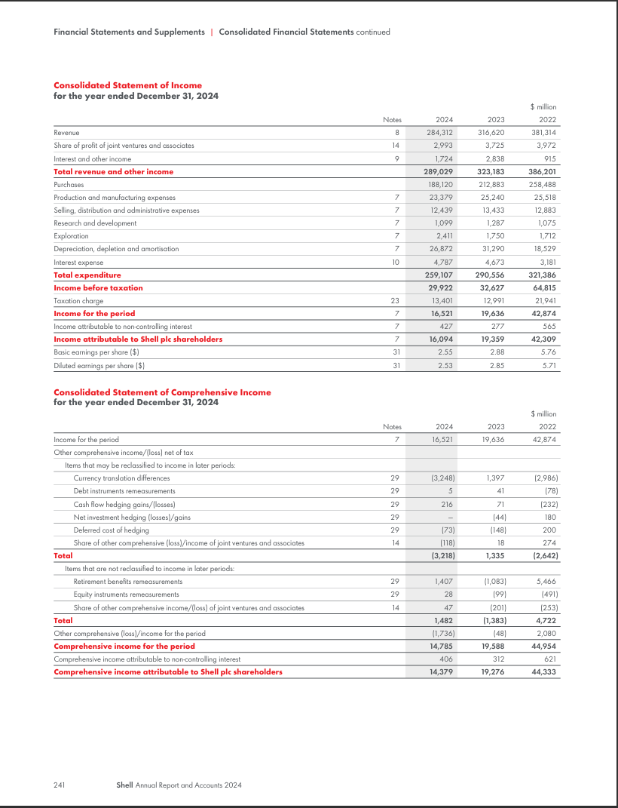
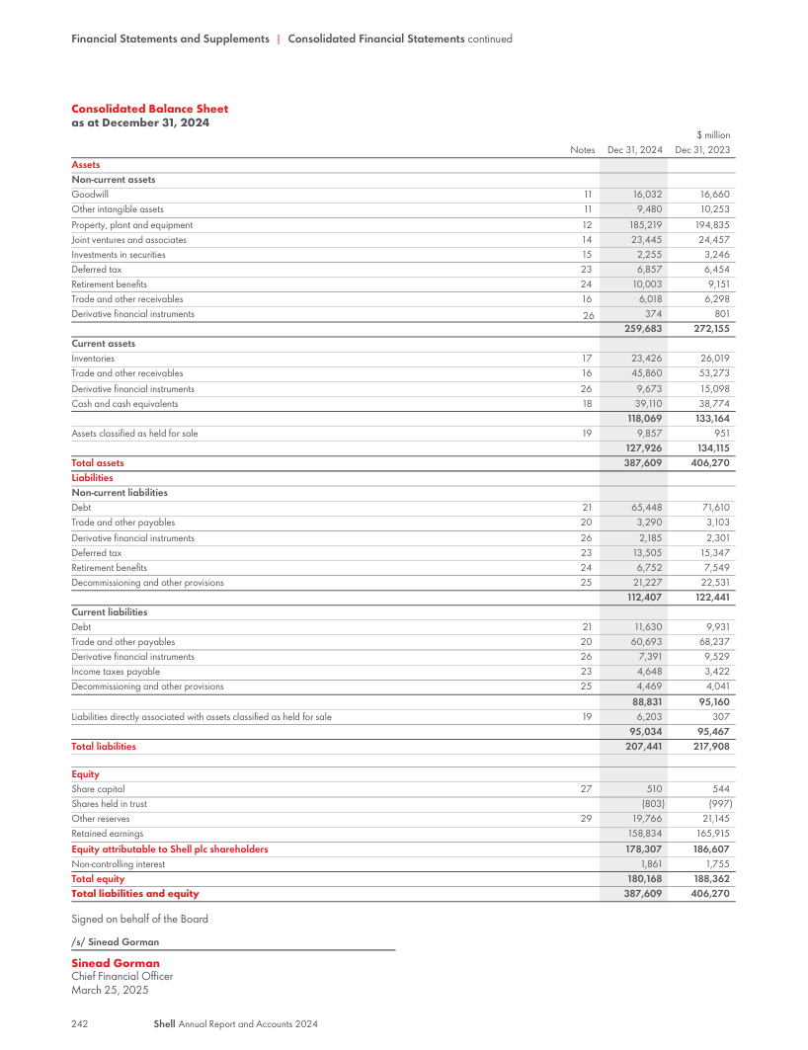
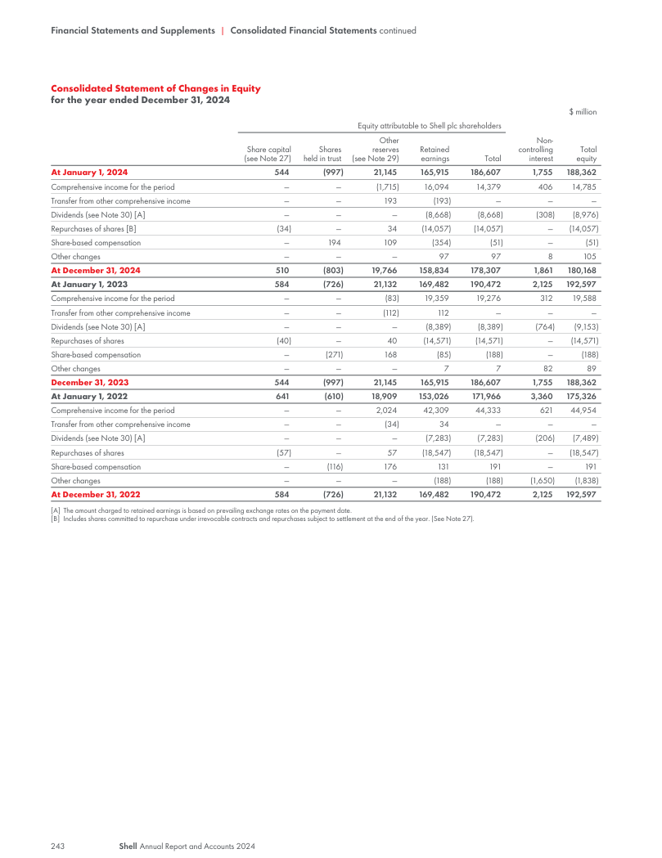
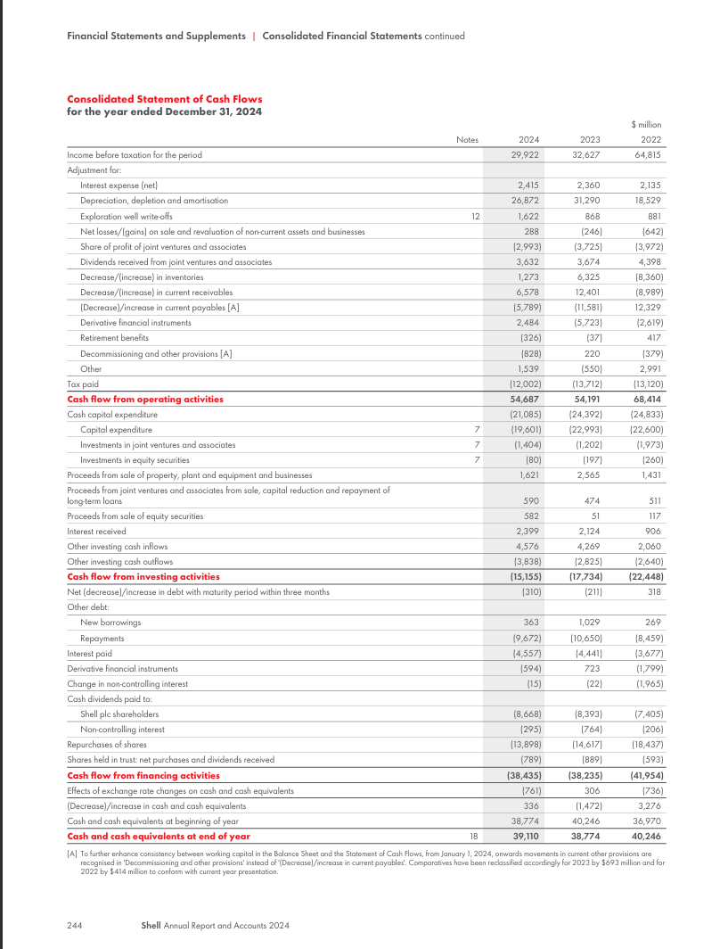

Appendix B: Shell’s PLC Ratio Calculations
B.1 Profitability Ratios – Detailed Calculations
Gross Profit Margin
- 2024: ($284,312m - $188,120m) / $284,312m × 100 = 33.84%
- 2023: ($316,620m - $212,883m) / $316,620m × 100 = 32.77%
Operating Profit Margin
- 2024: $29,922m / $284,312m × 100 = 10.52%
- 2023: $32,627m / $316,620m × 100 = 10.31%
Net Profit Margin
- 2024: $16,094m / $284,312m × 100 = 5.66%
- 2023: $19,359m / $316,620m × 100 = 6.12%
Return on Assets (ROA)
- 2024: $16,521m / $387,609m × 100 = 4.26%
- 2023: $19,636m / $406,270m × 100 = 4.83%
Return on Equity (ROE)
- 2024: $16,094m / $180,168m × 100 = 8.93%
- 2023: $19,359m / $188,362m × 100 = 10.28%
Return on Capital Employed (ROCE)
- 2024: $29,922m / ($387,609m - $95,034m) × 100 = 10.23%
- 2023: $32,627m / ($406,270m - $95,467m) × 100 = 10.49%
B.2 Liquidity Ratios – Detailed Calculations
Current Ratio
- 2024: $127,926m / $95,034m = 1.35
- 2023: $134,115m / $95,467m = 1.41
Quick Ratio
- 2024: ($127,926m - $23,426m) / $95,034m = 1.10
- 2023: ($134,115m - $26,019m) / $95,467m = 1.13
Cash Ratio
- 2024: $39,110m / $95,034m = 0.41
- 2023: $38,774m / $95,467m = 0.41
Operating Cash Flow Ratio
- 2024: $54,687m / $95,034m = 0.58
- 2023: $54,191m / $95,467m = 0.57
Net Working Capital
- 2024: $127,926m - $95,034m = $32,892m
- 2023: $134,115m - $95,467m = $38,648m
B.3 Gearing Ratios – Detailed Calculations
Debt-to-Equity Ratio
- 2024: $77,078m / $180,168m = 0.43
- 2023: $81,541m / $188,362m = 0.43
Debt Ratio
- 2024: $77,078m / $387,609m = 0.20
- 2023: $81,541m / $406,270m = 0.20
Equity Ratio
- 2024: $180,168m / $387,609m = 0.46
- 2023: $188,362m / $406,270m = 0.46
Interest Coverage Ratio
- 2024: $29,922m / $4,787m = 6.25
- 2023: $32,627m / $4,673m = 6.98
Debt Service Coverage
- 2024: $54,687m / ($4,787m + $9,672m) = 3.78 [Adjusted using actual debt repayments]
- 2023: $54,191m / ($4,673m + $10,650m) = 3.54
Gearing Percentage
- 2024: $77,078m / ($77,078m + $180,168m) × 100 = 29.95%
- 2023: $81,541m / ($81,541m + $188,362m) × 100 = 30.21%
B.4 Efficiency Ratios - Detailed Calculations
Asset Turnover Ratio
- 2024: $284,312m / $387,609m = 0.73
- 2023: $316.62m / $406.27m = 0.78
Fixed Asset Turnover
- 2024: $284,312m / $185,219m = 1.53
- 2023: $316,620m / $194,835m = 1.62
Inventory Turnover
- 2024: $188,120m / [($23,426m + $26,019m)/2] = 7.59
- 2023: $212,883m / [($26,019m + $23,426m)/2] = 9.06 [Using prior year inventory]
Days Inventory Outstanding
- 2024: 365 / 7.59 = 48.09 days
- 2023: 365 / 9.06 = 40.29 days
Receivables Turnover
- 2024: $284,312m / [($45,860m + $53,273m)/2] = 5.73
- 2023: $316,620m / [($53,273m + $45,860m)/2] = 6.64 [Using prior year receivables]
Days Sales Outstanding
- 2024: 365 / 5.73 = 63.70 days
- 2023: 365 / 6.64 = 54.98 days
Operating Cycle
- 2024: 48.09 + 63.70 = 111.79 days
- 2023: 40.29 + 54.98 = 95.27 days
B.5 Investor Ratios – Detailed Calculations
Basic Earnings Per Share
- 2024: $16,094m / 6,299.6m shares = $2.55
- 2023: $19,359m / 6,733.5m shares = $2.88
Diluted Earnings Per Share
- 2024: $16,094m / 6,363.7m shares = $2.53
- 2023: $19,359m / 6,799.8m shares = $2.85
Dividend Per Share
- 2024: $1.376 (4 × $0.344)
- 2023: $1.237 [Calculated from total dividends / weighted average shares]
Dividend Payout Ratio
- 2024: ($8,668m / $16,094m) × 100 = 53.86%
- 2023: ($8,389m / $19,359m) × 100 = 43.34%
Total Payout Ratio
- 2024: [($8,668m + $14,057m) / $16,094m] × 100 = 140.46%
- 2023: [($8,389m + $14,571m) / $19,359m] × 100 = 118.47%
Dividend Yield [Using approximate year-end share prices]
- 2024: ($1.376 / $31.00) × 100 = 4.44%
- 2023: ($1.237 / $33.50) × 100 = 3.69%
Dividend Coverage
- 2024: $2.55 / $1.376 = 1.85
- 2023: $2.88 / $1.237 = 2.33

