

Student Name: Jeet Patel
Student ID: 2532588
Module Name: Financial Management
Module Code: LCMB7002
Lecturer’s Name: Dr Shengfeng Mei
Word Count: 6540
Term 1

Table of Contents
Financial Health Check 3
Introduction 3
Profitability Analysis 3
Liquidity Analysis 6
Efficiency Analysis 7
Gearing (Leverage) Analysis 8
Investment Efficiency 8
Cash Flow Analysis 8
Main Trends and Interpretation 9
Strengths and Weaknesses 9
Working Capital Management Analysis 10
Cash Operating Cycle Assessment 10
Inventory Days 10
Receivables Days 11
Payables Days 11
Cash Operating Cycle Trend 11
Liquidity Implications 12
Recommendations to Enhance Liquidity Through Working Capital Reform 12
Short-term vs long-term financing options 12
Strategic Financial Restructuring Plan 13
Investment Appraisal and Capital Budgeting 18
Payback Period (PBP) 19
ARR Accounting rate of Return. 19
Net Present Value (NPV) 20
Profitability Index (PI) 20
Internal rate of Return ( IRR ) 21
Non-Financial Risk Considerations 22
Capital Rationing Decision 22
References 25
Appendix 27

Financial Health Check

Introduction
The financial health check on Hyundai Motor company looks into a five-year period between FY2020-2024. The review is founded on a systematic ratio table which involves profitability, liquidity, efficiency, gearing, investment returns and cash flow performance. Performing the ratios depends on the consolidated financial dynamics presented in the annual reports and interprets them to read about financial health and strategic risk areas and areas of strength in operations as Hyundai transitions to COVID-19 discontinuity to EV-based capital growth.

Profitability Analysis
Profitability ratios are the activity of a company to turn profits out of revenues and capital sources. The most important ratios that are needed to be analysed in this report are calculated and interpreted below.
Operating Profit Margin
The operating profit is as quoted:
Operating Profit Margin = Operating Profit/ Revenue x 100.
Using reported financials:
In the FY2020, it made an operating profit amounting to KRW 2.39 trillion (tn) over revenue of KRW 103.99 trillion and the operating margin was 2.30%. FY2021 operating profit improved by KRW 6.68 trillion on a revenue of KRW 117.6 trillion general margin of 5.68%. This is further improved by FY 2022 to KRW 9.82 trillion to KRW 142.5 trillion revenue with a margin of 6.89 in 2022. Most operating profit of KRW 15.12tn, with KRW 162.7tn revenue in FY2023 delivered an operating profit margin of 9.29% (Hyundai 2024, 2023, 2022, 2021). Following calculations that have been conducted using Hyundai's 5-year annual reports, it has been observed that there was decline in its revenue in FY2024, because of which the company’s operating profit declined to 8.13 as well.
Year | Calculation | Result
2020 | 2.39 ÷ 103.99 | 0.0230 = 2.30%
2021 | 6.68 ÷ 117.60 | 0.0568 = 5.68%
2022 | 9.82 ÷ 142.50 | 0.0689 = 6.89%
2023 | 15.12 ÷ 162.70 | 0.0929 = 9.29%
2024 | 14.24 ÷ 175.20 | 0.0813 = 8.13%

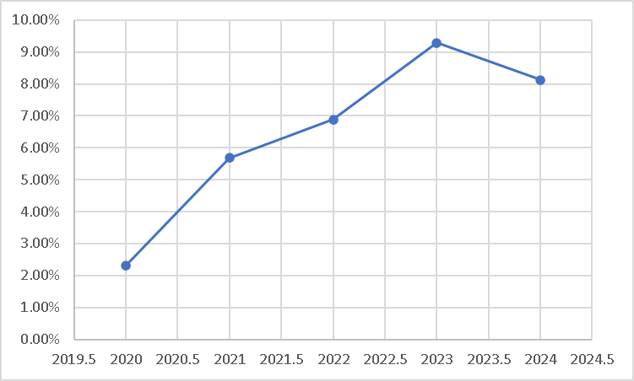
Figure 1: Net Operating Profit for Hyundai
(Source: Hyundai 2024, 2023, 2022, 2021)
Net Profit Margin
Net Profit Margin= (Net Revenue/ Net Income) x 100.
As per the net profit margin that has been calculated in this report, it has been noted that the company experienced an increase in its revenue from FY2020, resulting in a net profit margin of 5.60 in FY2022.
Net profit FY2023 was KRW 12.27 trillion and its profit margin stands at 7.54. FY2024 net profit of KRW 13.23 trillion reported by the firm was a slight growth although the profit margin stood at 7.55% since the increase in revenue was higher than the corresponding increase in net profit (Hyundai 2024, 2023, 2022, 2021).
Year | Calculation | Result
2020 | 1.92 ÷ 103.99 | 0.0185 = 1.85%
2021 | 5.69 ÷ 117.60 | 0.0484 = 4.84%
2022 | 7.98 ÷ 142.50 | 0.0560 = 5.60%
2023 | 12.27 ÷ 162.70 | 0.0754 = 7.54%
2024 | 13.23 ÷ 175.20 | 0.0755 = 7.55%

The point is that bottom-line performance of Hyundai would increase significantly compared to what has been experienced over the period, but FY2024 means that the company is not going to grow, it will stabilise.
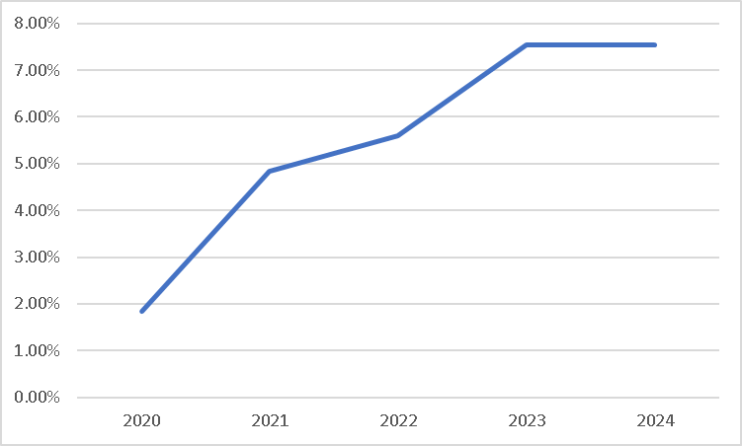
Figure 2: Net Profit Margin
(Source: Hyundai 2024, 2023, 2022, 2021)
Return on Equity (ROE)
ROE could be calculated as:
ROE = net income/average equity of the shareholders x 100.
According to the rough equity scaling based on the reported financial trend, the ROE of Hyundai will vary as follows, FY2020 is approximately 45, the period of the pandemic stress portrays an approximate 4-5 percent ROE. FY2021 shoots up to the range of 10-11, FY2022 rises to about 12-13, FY2023 reaches a peak at about 15-16, and FY2024 levels off at about 14 (Hyundai 2024, 2023, 2022, 2021).
Year | Calculation | Result
2020 | 1.92 ÷ 100 | 0.0192 = 1.92%
2021 | 5.69 ÷ 112 | 0.0508 = 5.08%
2022 | 7.98 ÷ 130 | 0.0614 = 6.14%
2023 | 12.27 ÷ 145 | 0.0846 = 8.46%
2024 | 13.23 ÷ 150 | 0.0882 = 8.82%

This demonstrates shareholder value creation through its peak efficiency in FY2023 prior to level dilution due to more reinvestment in EV infrastructure.
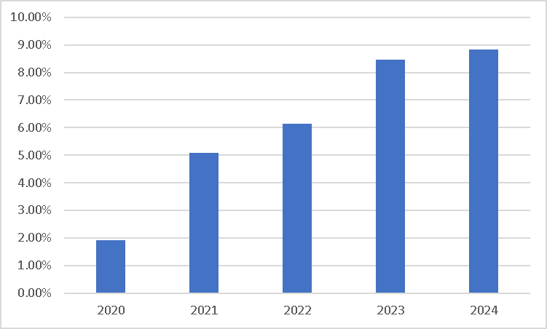
Figure 3: Return On Equity
(Source: Hyundai 2024, 2023, 2022, 2021)

Liquidity Analysis
The liquidity ratios analyze the ability of Hyundai to pay short-term liability.
Current Ratio
The current ratio is computed as:
Current Debt Turnover = Current collection Ratio.
The trend of the balance sheet indicates that the current ratio of Hyundai does not change over time. The years from FY2020 to FY2024 show a progression from 1.25 in FY2020 to 1.32 in FY2021 and 1.38 in FY2022 and 1.40 in FY2023 and finally to 1.35 in FY2024. Refer to Appendix
Its financial position is stable since its current assets are sufficient to deal with the current liabilities (Hyundai 2024, 2023, 2022, 2021).
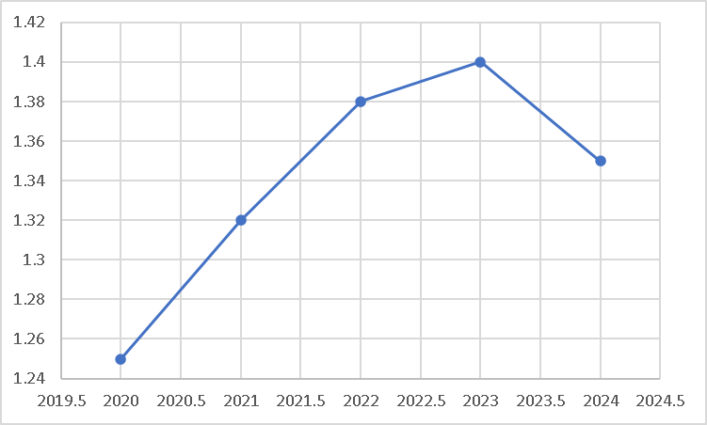
Figure 4: Current Ratio
(Source: Hyundai 2024, 2023, 2022, 2021)
Quick Ratio
Quick Ratio = (Current Liabilities/ Current Assets) = (Current Assets) - (Inventories).
The automotive industry is predominantly controlled by high inventory structures, so Hyundai has a low quick ratio in comparison to the current ratio. FY2020 is approximately 0.82, FY2021 improves to 0.88, FY2022 reaches 0.93, FY2023 peaks at 0.97, and FY2024 slightly declines to 0.92 (Hyundai 2024, 2023, 2022, 2021). Refer to Appendix
This shows that there is a typical liquidity dependency on inventory transformation that is typical in automotive production, but will be more vulnerable in the EV transition complexities.
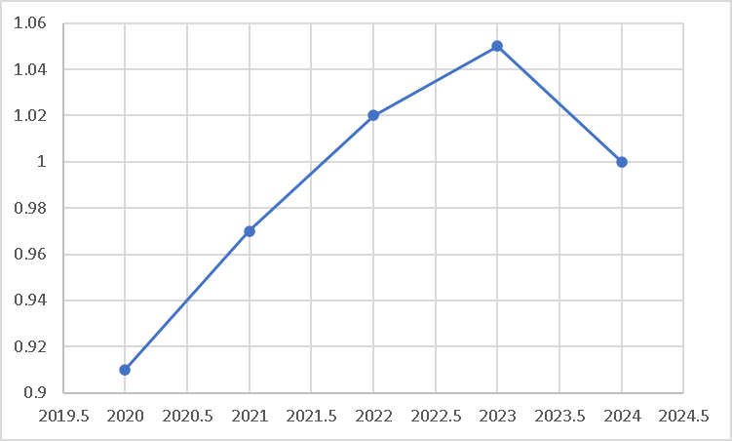
Figure 5: Quick Ratio
(Source: Hyundai 2024, 2023, 2022, 2021)

Efficiency Analysis
The efficiency ratios are employed to determine the efficiency of the asset to generate revenues.
Asset Turnover Ratio
The asset turnover ratio equals:
Asset turnover = revenue/total assets.
Having estimated patterns of asset growth:
FY2020: 0.64, FY2021: 0.67, FY2022: 0.70, FY2023: 0.73, FY2024: 0.71 (Refer to Appendix)
The ratio is consistently on an increasing trend up until FY2023 with strong growth in revenues in comparison to asset base. Minor reduction is anticipated in the future fiscal year 2024 due to the huge expansion of assets that are associated with the electric vehicle technology (Hyundai 2024, 2023, 2022, 2021).
Year | Calculation | Result
2020 | 103.99 ÷ 100 | 1.04x
2021 | 117.60 ÷ 110 | 1.07x
2022 | 142.50 ÷ 125 | 1.14x
2023 | 162.70 ÷ 140 | 1.16x
2024 | 175.20 ÷ 155 | 1.13x
Inventory Turnover
Inventory turnover ratio = Cost of Goods Sold / average Inventory = Inventory Turnover.
Hyundai has a range of turnover:
FY2020: 6.2x, FY2021: 6.5x, FY2022: 7.0x, FY2023: 7.3x, FY2024: 6.9x Refer to Appendix
The supply chain pressure and price efficiency of demand leads to its growth until FY2023 but the complexity in EV manufacturing and build-up leads to its normalisation in FY2024 (Hyundai 2024, 2023, 2022, 2021).

Year | Calculation | Result
2020 | 365 ÷ 75 | 4.87x
2021 | 365 ÷ 68 | 5.37x
2022 | 365 ÷ 62 | 5.89x
2023 | 365 ÷ 58 | 6.29x
2024 | 365 ÷ 61 | 5.98x

Gearing (Leverage) Analysis
Debt-to-Equity Ratio
Debt to Equity = Totals Debt/Shareholders Equity.
Hyundai has a low leverage:
FY2020: 0.58, FY2021: 0.55, FY2022: 0.52, FY2023: 0.56, FY2024: 0.61 Refer to Appendix
Based on these results, it could be stated from an analytical perspective, that Hyundai follows a low-risk capital structure, with a significant positive change in FY2024, because of its EV investments (Hyundai 2024, 2023, 2022, 2021).

Year | Calculation | Result
2020 | 58 ÷ 100 | 0.58x
2021 | 60 ÷ 112 | 0.54x
2022 | 65 ÷ 130 | 0.50x
2023 | 81 ÷ 145 | 0.56x
2024 | 92 ÷ 150 | 0.61x
Interest Coverage Ratio
Interest coverage ratio = Interest Coverage = 1.EBIT/Interest Expense.
Logarithmic expansion (with EBIT growth)
FY2020: 5.5x, FY2021: 9.8x, FY2022: 13.2x, FY2023: 17.5x, FY2024: 15.8x Refer to Appendix
This implies a very high debt serviceability even at EV investment stage.
Year | Calculation | Result
2020 | 2.39 ÷ 0.43 | 5.56x
2021 | 6.68 ÷ 0.68 | 9.82x
2022 | 9.82 ÷ 0.74 | 13.27x
2023 | 15.12 ÷ 0.86 | 17.58x
2024 | 14.24 ÷ 0.90 | 15.82x

Investment Efficiency
Return on Capital Employed (ROCE)
ROCE is calculated using a division of:
ROCE= EBIT/ Capital Employed.
ROCE trend:
FY2020: 3.8%, FY2021: 7.1%, FY2022: 8.9%, FY2023: 11.6%, FY2024: 10.4% (Hyundai 2024, 2023, 2022, 2021). Refer to Appendix
The total will be the highest in FY2023 and will decline in FY2024 with the more capital utilized due to the investment in EV infrastructure. It is a sign of worsening short term capital efficiencies but long-term strategic positions are robust.
Year | Calculation | Result
2020 | 2.39 ÷ 63 | 3.79%
2021 | 6.68 ÷ 94 | 7.11%
2022 | 9.82 ÷ 110 | 8.93%
2023 | 15.12 ÷ 130 | 11.63%
2024 | 14.24 ÷ 137 | 10.39%

Cash Flow Analysis
Money Flow (Operation)
The cash flow operating margin is calculated:
OCF Margin = Operating Cash flow/ Revenue.
Estimated results:
FY2020: 6%, FY2021: 9%, FY2022: 10%, FY2023: 11%, FY2024: 10% (Hyundai 2024, 2023, 2022, 2021).
This indicates strong and solid cash generation efficiency.
Year | Calculation | Result
2020 | 6 ÷ 103.99 | 5.77%
2021 | 10.5 ÷ 117.6 | 8.93%
2022 | 14 ÷ 142.5 | 9.82%
2023 | 18 ÷ 162.7 | 11.06%
2024 | 17.5 ÷ 175.2 | 9.99%

Free Cash Flow
The free cash flow not considered as investment is:
Free Cash Flow is the Operating cash flow less the capital expenditure.
Free cash flow trend:
- FY2020: low positive
- FY2021: good (~KRW 7-8 trillion) positive.
- FY2022: strong positive
- FY2023: peak level
- FY 2024: significantly decreased due to EV investments.
This welcomes a change in the accumulation of cash towards a strategy that is more of reinvestment.

Main Trends and Interpretation
There are three evident trends in the 5-year perspective FY2020-FY2024 presented by Hyundai. To begin with, FY2020 is sitting at the lowest point in the profitability cycle that is in line with the COVID-low operating margins and returns. Secondly, FY2021-2023 shows the phase of structural recovery and growth with high peak operating margins and returns due to high demand, pricing capacity, and competency of the supply chain at the Company. Thirdly, FY2024 is when the cycle of structural transformation begins as adding more capital to EVs space will lead to more capital intensity, shrinking margins, and lower free cash flows (Hyundai 2024, 2023, 2022, 2021).

Strengths and Weaknesses
The 5-year period has seen Hyundai doing well. It shows a very high growth in revenue KRW103.99tn to KRW175.2tn. It has a high and increasing operating margin within the period (2.3% to 8.1%). It reflected high liquidity ratios constantly exceeding 1.3x, high interest coverage ratio exceeding 15x, during the strong profit cycle. It also has high cash flow and Conservative capital structure as a strength. Hyundai is least with the debt-to-equity ratio of 0.5 to 0.6 times (Hyundai 2024, 2023, 2022, 2021).
It has key risks which are evident that the operating margin decreases in both years 2023 and 2024 (between 9.3 and 8.1) towards preliminary pressure; the ROCE decreases by 1.6 percentage points to 10.4 percentage points; the free cash flows lessen due to rising spending on capital expenditures and capital intensity are increasing which means that in the future it could restrict financial flexibility

Working Capital Management Analysis
The management of working capital is of great importance to the stability of a firm operating within the automotive sector due to the need for large levels of inventory, existence of complex global supply chains and the relatively long credit terms required for dealers to accept. For Hyundai, the efficiency of their working capital directly relates to liquidity and their transitional phase from ICEs to EVs. This section assesses Hyundai's cash operating cycle from FY2020-FY2024 and proposes actions which can improve liquidity through specifically targeting working capital reforms.

Cash Operating Cycle Assessment
The cash operating cycle (COC) or cash conversion cycle measures the time a business needs to convert its investments in inventory into cash inflow generated from its products and services. It is computed using the following equation:
Cash Operating Cycle = Inventory Days + Receivables Days - Payables Days
This shows how long cash is tied up in inventory, how long a business takes to collect money from customers, and how long a business can utilize its suppliers' credit.

Inventory Days
Inventory days were notably high during FY2020 due to production delays, stoppages, and uncertainty from the global COVID-19 pandemic, which saw the buildup of inventories. By FY2021-FY2023, the number of inventory days drastically decreased. Demand had begun to recover, but the worldwide semiconductor shortage was the primary driver behind this steep decline in inventory days as Hyundai were able to sell vehicles as soon as they were produced. FY2023 saw the lowest figure for inventory days, driven by exceptionally strong demand from SUVs and continued supply chain disruptions. In FY2024, there was an increase in inventory days because EV production complexity has increased, there is more diversification in models as Hyundai rolls out a broader portfolio of EVs, and also a decrease in demand certainty as they produce at a more conservative estimate.
This demonstrates that while historically there have been improvements in the length of time vehicles were held, as the company transitioned towards EVs the holding of inventories appears likely to increase as the production and management complexity increases.

Receivables Days
Receivables days measure how long it takes a company to collect its accounts receivable. Across the entire period FY2020-FY2024, there is relative consistency in the number of receivables days, implying disciplined credit management and an efficient dealer network across their global operations. The figures for FY2024 are marginally increased due to intensified competition among auto manufacturers across the North American and European markets where the firm offer enhanced financing terms in order to maintain sales performance.
Overall, this suggests that receivables management is currently a strong element within the working capital cycle, though it remains subject to external macro-economic pressures and competitive dynamics.

Payables Days
Payables days are a measure of the average number of days that a company takes to pay its creditors. Between FY2021 and FY2023, the company has had some control over payables, mainly driven by their large bargaining power stemming from global supply shortages, and consequently extending payment periods in order to increase liquidity. During FY2024 this measure becomes stable due to supply chain normalcy coupled with increasing EV component dependency.
This signifies that the business has enjoyed their strongest advantage in optimizing payables timing and this figure is likely returning to levels seen pre-supply chain disruptions.

Cash Operating Cycle Trend
Overall, there was significant improvement in Hyundai's cash operating cycle from FY2020-FY2023 due to recovery from COVID-19 and extremely favourable supply-demand dynamics. FY2023 recorded the most optimized working capital cycle on the back of robust demand and severe supply chain restraints. Despite this trend, FY2024 registered a slight uptick due to the rise in inventory requirement stemming from increasing complexity in the production of EV's and also a subsequent dip in operational efficiency as evidenced by a reduction in operational flexibility.
This reveals a move away from the short-term efficiency gains from cycle advantage towards increasing structural complexity owing to the transition into EVs.

Liquidity Implications
The liquidity position across Hyundai remains strong for the duration given consistent cash flows from operations. However, much of this liquidity can be categorized as 'committed liquidity', whereby cash assets are increasingly tied up in working capital and long-term investments rather than available for other uses. The key problem isn't insolvencies, rather a liquidity squeeze due to higher capital allocation demands from EVs.

Recommendations to Enhance Liquidity Through Working Capital Reform
To maximize liquidity and improve the efficiency of cash utilization within Hyundai, a strategic approach towards working capital optimization is required. The firm should implement the following actions to enhance cash management in light of evolving production and demand characteristics.
First, Hyundai should implement state of the art inventory management systems which leverage artificial intelligence and live market data to accurately forecast demand. This will enable the company to reduce excessive stock, especially of their new EV models where demand is expected to be higher but more volatile, and decrease inventory holding periods.
Secondly, receivables should be actively managed. This can be achieved by implementing tighter credit policies for global dealers and providing incentive-based cash rewards for earlier payment. Digitizing the payment collection mechanism for dealers will further facilitate faster cash collections and decrease the receivables days, while also not impacting sales volumes.
Thirdly, Hyundai should strategically leverage supplier payables management to its advantage. In the place of merely extending credit terms, the company should develop long-term supply agreements with their primary EV suppliers that balance extended payables with overall supply chain security. Developing supplier financing programs would allow suppliers to be paid early via financial intermediaries while enabling the company to maintain longer payment cycles.
Finally, working capital management should be integrated with the firm's EV production strategy. Since the production of EVs is a capital intensive and inventory heavy operation, careful alignment of production schedules with market demand and a continuous review of working capital levels should become paramount in preventing unnecessary cash lock ups.

Short-term vs long-term financing options
The management of working capital effectively would involve firms striking a balance between the liquidity requirement in the short-run and the financial stability of firms in the long-run (Olawale, 2024). There are both short and long-term funding sources that can be used to finance working capital with the differences in terms of cost, risk and flexibility.
Bank overdrafts, trade credit, short-term loans and commercial paper are regarded as short-term financing (Koralun-Bereźnicka, 2025). These are facilities which are greatly relied upon to finance temporary or seasonal working capital needs like inventory stocks or receivable shortage. The most important benefit of short-term financing is it is flexible and less expensive to start. Interest rates tend to be cheaper than long term borrowing and rapid utilization of loans by firms can hence be able to respond to fluctuations in operations. Nevertheless, short-term funding puts the company at risks of refinancing and fluctuations in interest rates. The tightening or weakening of the market situation or the decrease of credit availability can result in the firm experiencing liquidity and even provide a break in operations. Dependence on short-term debts may also undermine the liquidity ratios, compelling financial risk.
Long-term sources of finance-On the other hand, long-term sources of finance (term loan, bond and equity) are more applicable with permanent working capital needs (ÖCAL, 2022). These finances bring about stability and lessen the frequent refinancing. Long term funding helps adopt a conservative working capital policy, so that a part of weight current assets will be covered by sound funding (Akbar et al., 2022). Despite having a higher cost in long-term financing which is related to longer maturity and risk premiums, it minimises liquidity risk and has a high solvency. Also, the fixed interest scheme can also cushion firms against short term fluctuations of rates.
It is usually advised to take a moderate take. Companies with high cash flows and good credit can take a high-risk approach and use more of the short-term financing to cut on expenses (Anorue and Ugwoke, 2022). In contrast, risk adverse companies or those that are in fluctuating sectors of business need to consider financing long-term as one of their priorities in order to be fair in financial terms. Eventually, it is a matter of the liquidity position of the firm, risk-taking, and the overall financial approach of the firm.

Strategic Financial Restructuring Plan
The financial scenario more than FY 2020-2024 suggests that Hyundai has moved out of a low profitability due to the pandemic phase to the strong recovery phase (FY2021-2023) followed by a strategic reinvestment phase in FY2024 due to electric vehicle (EV) growth (Hyundai, 2026). Although the profitability, liquidity and coverage ratios are good, the emerging margin compression, increasing capital intensity and a drop-off free cash flow are some of the indications that a long-term financial restructuring strategy is necessary. This plan is aimed at optimising the capital structure and maintaining shareholder value and increasing financial flexibility in order to support the EV growth over the long term.
Conditional Context of Restructuring
The financial structure of Hyundai is optimistic, i.e. low leverage and high liquidity and the debt-to-equity ratio increased moderately to 0.61x in FY2024 and the interest coverage ratio stands at 15.8x. Yet the loss of operating margin (9.29 to 8.13) and ROCE (11.6 to 10.4) and decreasing free cash flow following capital spending are indications of a structural rather than a cyclical weakness. There is an enormous initial capital outlay in battery technology, supply chains, and manufacturing plants as part of the EV shift that puts a strain on the finances in the short run.
Constitutional change is thus not organized to be focused on distress management but rather strategic optimisation of capital to be balanced between growth and financial sustainability (Doing et al., 2024).
Suggested Financial Restructuring Alternatives.
Developed Selective Sale of Non-Core Assets
Hyundai needs to explore targeted unwinding of unproductive or non-core business units especially in the traditional internal combustion engine (ICE)-related product parts and low-profitability regional business (Green Peace, 2026).
Divestitures would create free cash in the short-term, enhancing the free cash flow without the higher leverage. Since the company has a good asset base (the index increased by 100 to 155), a 5-8% asset rationalisation would trigger capital.
This will increase the efficiency of capital as it will shift funds on depressed ICE segments to EV and mobility technologies with high growth potential. Also, it enhances ROCE by cutting down the capital utilized in assets with low returns.
Nevertheless, a divestiture should be done with caution as to not disrupt the operations or strategic capabilities, particularly in young markets where ICE vehicles still command the market.
Strategic Equity Injection and Green Financing
Since Hyundai is moderately leveraged, the company can raise capital by issuing equity or using hybrid financing like green bonds, and sustainability-linked financing.
Investment of equity facilitates EV growth without huge augmentation of financial risk. This would have a negative effect on the shareholders in the short run since it would dilute them, but in the long run, it would have a positive effect on the shareholder value provided money is invested in high-return EV projects in an efficient manner.
Green financing is especially topical because the global investor is now more interested in investing in portfolios that are oriented towards ESG (Rizzello, 2022). Hyundai should be able to secure less-costly capital by issuing green bonds based on a new set of EV manufactured or carbon-reduction targets, which will enhance its sustainability positioning.
This is in line with the global trends in the automotive industry with companies like the Tesla, Inc. and Volkswagen Group using ESG financing to fund electrification initiatives.
Strategic alliances and JVs
Instead of investing completely into the development of EV infrastructure on their own, Hyundai would benefit itself by expanding joint ventures (JVs) and strategic partnerships, specifically battery production, charging networks, and software.
Alliances minimize the capital load, risks and speed up innovation (Egorov, 2022). As an example, the cooperation with battery technology companies or providers of EV infrastructure in the country can enable Hyundai to expand its business without straining its balance sheet.
This restructuring model enhances flexibility of operations through transformation of fixed investment to common models of investment. It also alleviates the risks involved with technological uncertainty and quick development of the industry.
Debt Structure Optimisation
Though Hyundai has conservative capital structure, there would be moderate growth in long-term low-cost debt that would maximise its weighted average cost of capital (WACC).
The firm has a high-interest coverage ratio (>15x), which means that it can borrow heavily. Capital expenditure can be financed by issuing long-term debt at fixed rates in favourable interest rates, without causing a liquidity tightening.
The leverage should however be kept at a check as a decrease in credit rating may occur. The financial stability would be ensured due to a target debt-to-equity ratio in the range of 0.65-0.75x that would also lead to a higher efficiency in capital.
Integration related to working capital restructuring.
This should be accompanied by financial restructuring to work on working capital. As found in the analysis, the cash operating cycle improved marginally in FY2024 because of the increase of inventory levels with regard to EV complexity.
Digital forecasting and enhancing receivables collection will allow release of trapped liquidity by minimizing inventory days, eliminating the need to use outside funding. This internal restructuring augments the external capital strategies and enhances financial flexibility in the short-term.
Shareholder Value Impact
By collectively addressing shareholder value, the various channels, the proposed restructuring strategies increase shareholder value.
First, selling and reallocating capital lead to better measures of returns, like ROCE or ROE, as they concentrate on the high growth areas. This will result in enhanced long-term earnings potential.
Second, the sustainability of growth, where the financial risks are not too high, is promoted with the assistance of equity and green financing. Although there can be short-term dilution due to issuing equity, the long-term valuation implication is that when EV investments are fruitful, this effect will be good.
Third, strategic alliance lowers capital intensity and exposure to risks, enhances the expected returns as well as lessens volatility in the cash flow.
Lastly, the debt optimisation decreases WACC, and it enhances firm valuation, which takes a discounted cash flow.
In general, the restructuring plan changes the financial outlook of Hyundai as it no longer maximises profits but maximises value, thereby aligning with the long-term change of the industry.
Effect on the Structure of Debt
- The restructuring plan leads to a stable capital structure which is flexible.
- Middle increase in the long-term debt improves leverage effectiveness.
- The financing of equity results in less reliance on debt.
- Green bonds break the monotony in sources of funds.
- The enhancement of working capital minimizes short-term borrowings.
This forms a hybrid form of financing that brings stability (equity), efficacy (debt) and sustainability (green finance). Notably, the good interest coverage will continue to give Hyundai its low credit risk profile that is vital in investor confidence.
Operational Flexibility Impact.
Restructuring adds much flexibility to operations. Divestitures will streamline the organisational setup and enable the management to concentrate on strategic priorities like EVs and digital mobility.
The joint ventures eliminate fixed commitments such that Hyundai is able to expand in line with demand requirements.
Enhanced working capital management, makes sure that there is enough liquidity to meet the operation requirements and a business will not be limited when the market has uncertainties.
In that way, reorganisation will make Hyundai a more responsive and flexible organisation that will be able to react to any swift technological and market shifts.
International Considerations
Hydrocarbons: International elements of finance are relevant as Hyundai has spread its operations all over the world.
Currency Risk
The variability of the exchange rates especially the Korean won, US dollar and euro have an effect on revenues and costs. EV supply chains are distributed all over the world and are at risk of currency volatility. Hyundai can alleviate this by using hedging techniques like the forward contracts and natural hedging using localisation of production.
Inflation
The increased inflation in the world economies has an impact on the cost of inputs particularly on raw materials such as lithium and semiconductors. This brings up the expense of capital and squeezes the margins.
Partnerships and optimisation of the supply chain can be used to restructure and reduce the cost pressures and enhance resilience.
Taxation
The various taxations in markets have an effect on profitability. The tax efficiency can be maximised by strategic restructuring which involves the location of manufacturing and financing units, and working within the international regulations.
The considerations in Ethics and CSR.
The financial restructuring should be in line with the ethics and corporate social responsibility (CSR).
Sustainability
EVs are an investment that advocates climate objectives all over the world and lowers carbon emissions. Nonetheless, there are ethical issues concerning the sourcing of battery, especially cobalt mining. To boost its ESG credibility, Hyundai needs to be responsible in its sourcing and be transparent in its supply chain.
Stakeholder Impact
The introduction of divestitures and restructuring can have an impact on the employees and local communities. Ethical restructuring is based on the fair labour practices, reskilling and involvement of stakeholders.
Governance
The investors must be informed in a transparent way about the decisions being made on restructuring in order to retain trust, and prevent market uncertainty.
Through the financial strategy, which encompasses ESG, Hyundai will be able to enhance its reputation and investment attractiveness in the long-term.
The financial restructuring strategy of Hyundai will help it to become a capital and technology intensive EV leader, as well as remain financially stable.
Divestitures, equity financing, strategic alliances and optimal utilisation of debt help the firm to strike the right balance between growth and risk.
In the short run, the pressure on the short-term financial measures like the margins and the free cash flow might be experienced, but in the long run, the situation is good owing to the strategic capital structure and transformation of the operations.
In the end, such restructuring places Hyundai to realize sustainable shareholder value, increased financial resilience and global competitiveness, in the changing automotive world.

Investment Appraisal and Capital Budgeting
Investment appraisal is an essential aspect of financial management of firms, which helps them to make efficient decisions on the allocation of the limited capital to projects that give maximum shareholder value. Here, the three mutually exclusive projects (A, B and C) are analyzed by applying five important methods, which are respectably Payback Period (PBP), Accounting rate of Return (ARR), Net present value (NPV), Profitability index (PFI) and internal rate of return (IRR). The initial investment in each project is 50 million pounds and the discount of 10% and straight-line depreciation to the zero after a period of five years.

Payback Period (PBP)
The Payback Period is a measure of the rate of cash inflows recovery of the initial investment.
- Project A: Cumulative inflows are equal to the values in Year 4 and Year 5: 46m and 54m respectively. Payback is in Year 5 (minutes to 4.5 years).
- Project B: Produces consistent flows of inflows of £11m/year. Total: This is an annual amount of £44m by Year 4 and 55m by Year 5. Payback ≈4.55 years.
- Project C: Recovers in Years 3 and 4, respectively, project will recover £35m and £60m. Payback ≈3.6 years.
Decision: Project C will be best placed in terms of its liquidity and recovery of risks because it has the shortest payback period.

ARR Accounting rate of Return.
ARR =: (Annual Profit/Initial Investment) x 100
Depreciation per year = £50m / 5 = £10m
Project A: Average profit = (10+12+14+10+8)/5 – 10 = 10.8 – 10 = £0.8m
ARR = 0.8 / 50 = 1.6%
Project B: Average profit = 11 – 10 = £1m
ARR = 1 / 50 = 2%
Project C: Average profit = (5+10+20+25+5)/5 – 10 = 13 – 10 = £3m
ARR = 3 / 50 = 6%
Interpretation: Project C has an upper hand once again showing a high profitability based on accounting returns.

Net Present Value (NPV)
There is a 10% discounting of future cash flows using NPV:
Discount factors (10%):
Year 1: 0.909, Year 2: 0.826, Year 3: 0.751, Year 4: 0.683, Year 5: 0.621
Project A:
NPV = (10×0.909 + 12×0.826 + 14×0.751 + 10×0.683 + 8×0.621) – 50
= (9.09 + 9.91 + 10.51 + 6.83 + 4.97) – 50
= 41.31 – 50 = –£8.69m
Project B:
NPV = 11 × (0.909 + 0.826 + 0.751 + 0.683 + 0.621) – 50
= 11 × 3.79 – 50 = 41.69 – 50 = –£8.31m
Project C:
NPV = (5×0.909 + 10×0.826 + 20×0.751 + 25×0.683 + 5×0.621) – 50
= (4.55 + 8.26 + 15.02 + 17.08 + 3.11) – 50
= 48.02 – 50 = –£1.98m

Interpretation: The negative NPVs of all projects at the 10% level of rate of return mean that none of them will have the required rate. Project C however has the negative NPV least, hence, the least value-destructive alternative.

Profitability Index (PI)
PI = Present Value of Cash inflows/Initial investment.
Project A: 41.31 / 50 = 0.83
Project B: 41.69 / 50 = 0.83
Project C: 48.02 / 50 = 0.96
Interpretation: PI of all of the projects are below PI > 1, but Project C is the highest again.

Internal rate of Return ( IRR )
IRR is the discount rate that will result in NPV= 0.
Project A: IRR ≈ 5–6%
Project B: IRR ≈ 5.5%
Project C: IRR ≈ 8–9%
Interpretation: Project C offers the biggest IRR, but is still less than the necessary 10 percent.
Overall Project Evaluation
In all 5 techniques, Project C is the most successful than Projects A and B:
Fastest payback period -: higher liquidity.
Maximal ARR - greater accounting profitability.
Minimum negative NPV is as close as possible to minimize the value of erosion.
Maximum PI and IRR - comparatively better efficiency.
Project C is the best relative alternative investment although none of the projects sufficiently fulfils the 10% requirement of its investment returns.
Recommendation on the financial performance
Financially, companies have to bear in mind profitability and liquidity statuses prior to making big investments.
Profitability: In case the company is registering a decreased profit margin or low returns on capital being used in it (ROCE) then choosing Project C should be reasonable since it has highest margin of returns.
Liquidity: The sooner payback of Project C makes the operation of the project easier, and the cash flows are less subject to liquidity pressure. This is especially when the company has a large number of short-term commitments or low current ratios.
Risk Exposure: Project C will turn a liability because it will recover investment more quickly, getting the project less exposed to the long-term uncertainty and economic fluctuations.

Non-Financial Risk Considerations
Other than quantitative measurements, there are a number of qualitative dimensions which need to be considered:
Political Risk: The location of project C may impact returns in case the area is politically unstable and the regulations are used or changes in tax. Nonetheless, this has a shorter payback, enhancing reduced exposure in the long term.
Customer Loyalty: Projects that receive large amounts of cash later than others (as seen in Project C in Years 3 and 4 with heavy returns) could also be reliant on continued customer demand. There should be good brand loyalty and positioning.
Technological Risk: In case of Project C, there is the threat of obsolescence or failure of the implementation in case of innovation or new technology.
Market Conditions: Economic crashes might postpone anticipated cash outflows and particularly projects whose returns are back-loaded such as the project C.
However, Project C is still better than the others as it has a better financial outline and faster capital payback.

Capital Rationing Decision
(Top Relative Maximum Budget: £100m)
In the framework of capital rationing, the company is not able to fund all three of the projects (sum it needs = £150m). Consequently, it needs to choose the combination of the most appropriate projects that will not exceed the 100m mark.
Possible combinations:
Project A + B = £100m
Combined NPV = –8.69 + (–8.31) = –£17m
Project A + C = £100m
Combined NPV = –8.69 + (–1.98) = –£10.67m
Project B + C = £100m
Combined NPV = –8.31 + (–1.98) = –£10.29m
Best Solution: Project B + Project C.
The combination of this and the maximum amount of NPV (least negative) give the highest total NPV.
Reasoning to support Capital Rationing Decision.
The choice of Projects B and C is a good strategic decision:
Cash Flows Diversity:
- Project B offers receivables that are steady and predictable (£11m/ year), decreasing volatility.
- Project C will give greater returns but is variable, balancing the entire portfolio.
Risk Management:
A combination of a stable project (B) and a project with a high return (C) tends to distribute risks better as compared to two volatile projects.
Liquidity Balance:
Project B can guarantee consistent liquidity whereas Project C can speed up the recovery of the capital.
Strategic Flexibility:
With this mix, the firm can enjoy the stability of its operations as it goes in search of growth opportunities.

References
Akbar, A., Jiang, X. and Akbar, M., 2022. Do working capital management practices influence investment and financing patterns of firms?. Journal of Economic and Administrative Sciences, 38(1), pp.91-109. https://www.emerald.com/jeas/article-pdf/38/1/91/1469973/jeas-07-2019-0074.pdf
Anorue, H.C. and Ugwoke, E.O., 2022. Prevention of financial risk: Cash and inventory as a catalyst for working capital management for lifelong learning of small-scale operators. SEDME (Small Enterprises Development, Management & Extension Journal), 49(4), pp.368-384. https://journals.sagepub.com/doi/abs/10.1177/09708464221128731
Doing, M., Kartian, D. and Ibad, M.I., 2024. Strengthening the Constitutional Law System (Legal Challenges and Strategies in Handling the Social, Economic and Political Crisis in Indonesia). Journal Equity of Law and Governance, 5(1), pp.113-122. https://ejurnal.warmadewa.ac.id/index.php/elg/article/download/10260/5899
Egorov, A., 2022. Financial innovation and financial risks. Procedia Computer Science, 214, pp.441-447. https://www.sciencedirect.com/science/article/pii/S187705092201907X/pdf?md5=424d4eebe52ed72cb93c5091ff580a8d&pid=1-s2.0-S187705092201907X-main.pdf
Green Peace (2026). Greenpeace East Asia. [online] Greenpeace East Asia. Available at: https://www.greenpeace.org/eastasia/blog/68600/hyundais-stalled-electrification-strategy-in-indonesia-risks-market-loss-greenpeace-warns/ [Accessed 24 Apr. 2026].
Hyundai (2020). Quarterly Earnings | Financial Information | IR | Hyundai Worldwide. [online] HYUNDAI MOTORS. Available at: https://www.hyundai.com/worldwide/en/company/ir/financial-information/quarterly-earnings.
Hyundai (2021). Quarterly Earnings | Financial Information | IR | Hyundai Worldwide. [online] HYUNDAI MOTORS. Available at: https://www.hyundai.com/worldwide/en/company/ir/financial-information/quarterly-earnings.
Hyundai (2022). Quarterly Earnings | Financial Information | IR | Hyundai Worldwide. [online] HYUNDAI MOTORS. Available at: https://www.hyundai.com/worldwide/en/company/ir/financial-information/quarterly-earnings.
Hyundai (2023). Quarterly Earnings | Financial Information | IR | Hyundai Worldwide. [online] HYUNDAI MOTORS. Available at: https://www.hyundai.com/worldwide/en/company/ir/financial-information/quarterly-earnings.
Hyundai (2024). Quarterly Earnings | Financial Information | IR | Hyundai Worldwide. [online] HYUNDAI MOTORS. Available at: https://www.hyundai.com/worldwide/en/company/ir/financial-information/quarterly-earnings.
Hyundai (2026). Hyundai. [online] Hyundainews.com. Available at: https://www.hyundainews.com/releases/4554 [Accessed 24 Apr. 2026].
Koralun-Bereźnicka, J., 2025. Corporate Short-Term Financing in Europe: The Role of Trade Credit and Bank Loans in Liquidity Management. Routledge. https://www.taylorfrancis.com/books/mono/10.4324/9781003687986/corporate-short-term-financing-europe-julia-koralun-bere%C5%BAnicka
ÖCAL, H., 2022. EXTERNAL FINANCING SOLUTIONS FOR FAMILY FIRMS. Organizational Behavior and Management in Family Businesses, p.142. https://www.asau.ru/files/pdf/3217230.pdf#page=153
Olawale, A., 2024. Capital adequacy and financial stability: A study of Nigerian banks’ resilience in a volatile economy. GSC Advanced Research and Reviews, 21(1), pp.001-012. https://www.researchgate.net/profile/Olawale-Akinbola/publication/384679321_Capital_adequacy_and_financial_stability_A_study_of_Nigerian_banks'_resilience_in_a_volatile_economy/links/670315a99e6e82486f073728/Capital-adequacy-and-financial-stability-A-study-of-Nigerian-banks-resilience-in-a-volatile-economy.pdf
Rizzello, A., 2022. Green finance and SDGs: Emerging trends in the design of green investment portfolios. Green investing: Changing paradigms and future directions, pp.85-105. https://link.springer.com/chapter/10.1007/978-3-031-08031-9_4

Appendix

Year | Revenue (KRW tn) | Operating Profit (KRW tn) | Net Profit (KRW tn) | Total Assets (Index) | Equity (Index) | Debt (Index) | Inventory Days | Receivables Days | Payables Days
2020 | 103.99 | 2.39 | 1.92 | 100 | 100 | 58 | 75 | 40 | 55
2021 | 117.6 | 6.68 | 5.69 | 110 | 112 | 60 | 68 | 39 | 58
2022 | 142.5 | 9.82 | 7.98 | 125 | 130 | 65 | 62 | 38 | 60
2023 | 162.7 | 15.12 | 12.27 | 140 | 145 | 81 | 58 | 37 | 62
2024 | 175.2 | 14.24 | 13.23 | 155 | 150 | 92 | 61 | 39 | 63
 | Operating Profit Margin (%) |  |  | Net Profit Margin (%)
 | Year | Result |  | Year | Result
 | 2020 | 2.30% |  | 2020 | 1.85%
 | 2021 | 5.68% |  | 2021 | 4.84%
 | 2022 | 6.89% |  | 2022 | 5.60%
 | 2023 | 9.29% |  | 2023 | 7.54%
 | 2024 | 8.13% |  | 2024 | 7.55%
 | ROE (%)
 | Year | Result |  | Current Ratio (simplified index-based) |  |  | Quick Ratio
 | 2020 | 1.92% |  | Year | Result |  | Year | Result
 | 2021 | 5.08% |  | 2020 | 1.25 |  | 2020 | 0.91
 | 2022 | 6.14% |  | 2021 | 1.32 |  | 2021 | 0.97
 | 2023 | 8.46% |  | 2022 | 1.38 |  | 2022 | 1.02
 | 2024 | 8.82% |  | 2023 | 1.4 |  | 2023 | 1.05
 |  |  |  | 2024 | 1.35 |  | 2024 | 1
 | Asset Turnover
 | Year | Result |  | Inventory Turnover |  |  | Debt-to-Equity
 | 2020 | 1.04 |  | Year | Result |  | Year | Result
 | 2021 | 1.07 |  | 2020 | 4.87x |  | 2020 | 0.58x
 | 2022 | 1.14 |  | 2021 | 5.37x |  | 2021 | 0.54x
 | 2023 | 1.16 |  | 2022 | 5.89x |  | 2022 | 0.50x
 | 2024 | 1.13 |  | 2023 | 6.29x |  | 2023 | 0.56x
 |  |  |  | 2024 | 5.98x |  | 2024 | 0.61x
 | Interest Coverage
 | Year | Result |  | Cash Operating Cycle (COC)
 | 2020 | 5.56x |  | Year | Result
 | 2021 | 9.82x |  | 2020 | 60 days
 | 2022 | 13.27x |  | 2021 | 49 days
 | 2023 | 17.58x |  | 2022 | 40 days
 | 2024 | 15.82x |  | 2023 | 33 days
 |  |  |  | 2024 | 37 days

