International Business Communication

Tongxin Tang 2107042
International Business Communication BMBM6021

Contents
Introduction 3
Situations that demand effective communications in international business 3
Communications failures, causes, and effects on business relationships 5
Strategies to overcome communication challenges between the UK and UAE 8
Conclusion and recommendations 11
References 12

Introduction
Global business communication has become commonplace in the recent past with more companies operating beyond their home countries (Hurn, 2013). However, international businesses face the challenge of communication due to the differences between the national cultures (Sifianou, 2013). For instance, a company from country A that has a high context culture (based on Hall’s cultural context) may face communication challenges when it operates in country B with a low context culture (DeVito, 2018). The essay presents a reflection of communication challenges between a UK Company that operates in the United Arabs Emirates (UAE). The reflection is based on Boud’s Triangle Representation (figure 1) (Misra and Misra, 2021)). Based on the model, the essay describes the event (the challenge of communication between a UK company and the UAE and precisely focussing on the effects of international cultures on business communication), reflects on the challenges of communication (how differences in national cultures cause communication challenges), and presents what has been learnt in the form of recommendations for businesses that operate outside their home countries. The essay has five sections; introduction, reflection on situations in businesses where effective communication is needed, communication failures, strategies to overcome communication challenges, and finally conclusions and recommendations.
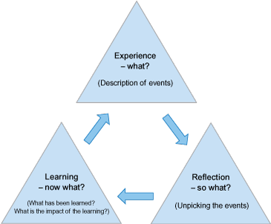
Figure 1: Boud’s Triangle Representation
Source: Misra and Misra (2021)
Situations that demand effective communications in international business
International business communications, unlike local businesses face the challenges of dealing with differences in national cultures (Neuliep, 2016). These communications challenges are exhibited in certain business situations. From the module international business communication and experience working for an international organisation, the first situation that demands effective communication in international business is relationship building. This also involves the process of developing trust between business partners. According to Boersma, Buckley, and Ghauri (2003), relationship building involves developing trust that refers to the expectation that each party to a negotiation will honor the agreement, completely perform their roles, and behave honorably even in cases where no exploit promises are made. However, the process of developing trust and relationships depends on the cultures of the parties involved in international businesses. For instance, high individualistic countries (mostly Western countries) perceive relationships as transactional and are based on business needs. On the other hand, collectivist countries prefer developing personalised relationship and trust ahead of business deals (Saunders, 2023). Developing relationships, which is the first step in business associations therefore not only demand a good knowledge of partners’ cultures but also good communications skills.
Secondly, effective communications is needed in business negotiations and bargaining. Communications in international business negotiations are the means through which negotiators may achieve the set goals, build relationships, and resolve any forms of disputes. However, communications become more complex in situations of negotiations and bargaining in international businesses since the negotiators encounter different laws, governments, and ideologies that are usually absent in negotiator’s home countries. One important aspect that complicate communication in international business negotiation is differences in the national cultures (Ting-Toomey and Dorjee, 2018). Differences in cultures may create communication problems (Saunders, 2023). For instance, a negotiator coming from a culture that avoid confrontation may remark, “That is difficult” to mean an end of a negotiation while another part feels there is still room for negotiation. Similarly, culture influences the form and substance of the deal. Finally, cultural barriers makes it difficult to understand one another’s behavior (Ting-Toomey and Dorjee, 2018). For instance, a an insistence of a negotiator from collectivist culture to employ relatives may be perceived as securing loyal, trustworthy, and long-term employees while the same may imply nepotism to the Americans.
Furthermore, decision making and time keeping situations in international businesses demand effective communication. For instance, most Western cultures measure time by the clock. However, most Eastern cultures measure time based on personalities. For instance, they do not let time to interfere with their judgement. The role of time on international communications (chronemics) determines whether an individual is either polychronic (people-oriented) or monochronic (task oriented) that impacts the possibility of arriving late in meetings (Luthans and Doh, 2018). For instance, an individual from the Middle East may arrive in meetings late due to personal or family commitments. Such situations demands intercultural skills when managing international businesses. Furthermore, in regards to decision making, international business managers need to be aware of power distance and ‘who makes the final decision’ in a team (Hu et al., 2018). For example, while it may be commonplace for any team member from an American team to make decisions, most decisions in an Eastern team will be made by the top management due to their high power distance. Instances of decision making therefore calls for knowledge of international cultures.
Communications failures, causes, and effects on business relationships
National cultures affect the structure of organisations. Businesses may adopt a hierarchical structure that are more top-down with most of the decisions made at the top. Flat organisational structure, on the other hand, refers to a more decentralised organisation where decision making are distributed across the organisation (Islam, Jasimuddin, and Hasan, 2015). Organisational structures therefore vary between regions and countries. De Waal and Frijns (2016) interviewed 36 Emirati and Western managers in order to determine the effects of national cultures on management practice amongst the UAE businesses. The researchers conclude that most businesses in UAE have a hierarchical structure. This conforms to the UAE’s high power distance (74) as noted in the Hofstede’s cultural model, figure 2) (Hofstede Insights, 2024). In support of this, Ali (2005) argues that most Arab organisations are organised based on the principle of sheikocray where the managers view the organisations are their personal fiefdom. However, their autocratic leadership of the hierarchical structure is controlled by religious laws, paternistic orientation, and concern on what the society feels towards them, and Islamic instructions that limit oppression (Ali, 2005). Similarly, Gamble (2003) investigated the challenge of transferring HRM practices between the UK and China and noted that UK organisations commonly adopt flat organisational structures. The flat structures conform to the UK’s low power distance (35) of the UK, figure 2 (Hofstede Insights, 2024). According to Ali (2005) and Gamble (2003), differences in organisation structure causes a challenge in communication and precisely negotiation and decision making. For instance, the flat organisational structure in the UK implies that all team members are allowed to negotiate and make decisions. Similarly, both junior and senior members of the organisation can engage in direct communication (Gamble, 2003). However, for hierarchical structure in UAE, communication is mostly top-down with only top managers allowed to make ley decisions (Ali, 2005). This difference may present a challenge for UK businesses in the UAE.
In addition to organisational structure, differences in national cultures may also present the challenge of cultural business customs. International business customs are communication rules that people follow in other countries (Ali, 2005). For instance, Turner and Trompenaar’s mode, suggests that individuals from the United Kingdom are Universalists while those from the UAE are particularist (Trompeenars-Hampden-Turner-tconsulting.com, 2024). When doing business with those from the UAE, UK business partners are more likely to encounter those who are relationship oriented and prefer unwritten rules. Unlike in the UK, legal contracts are less likely to be fully negotiated and adhered to since personal relationships play a major role in business communications. Business partners from the UAE are more likely to change business contracts based on the relationships that they build over time. However, while relationship building is important in the UAE, relationships with women is restricted since socialisation across genders is prohibited (Ali, 2005). This may directly impact how to develop business relationships between the UK and UAE firms. Furthermore, procedures are less likely to be strict. Similarly, from the Turner and Trompenaar’s model (figure 2) and Hofstede’s model of national cultures (figure 3), the UK is individualist unlike the collectivist UAE (Hofstede Insights, 2024; Trompeenars-Hampden-Turner-tconsulting.com, 2024). Negotiators from the UK are therefore more likely to focus on quick business decisions as opposed to building relationships. Furthermore, individuals from the UAE are loyal to self and family. They value being polite and harmonious in communications. The individuals are also controlled by the Muslim religion. For example, buying on credit, using alcohol, and raising interests may be prohibited (Ali, 2005). From Turner and Trompenaar’s model, people from the UAE have a greater orientation towards the past as compared to the average Brit (Trompeenars-Hampden-Turner-tconsulting.com, 2024). Therefore, the effects of long-term traditions and religion is eminent in business communications.
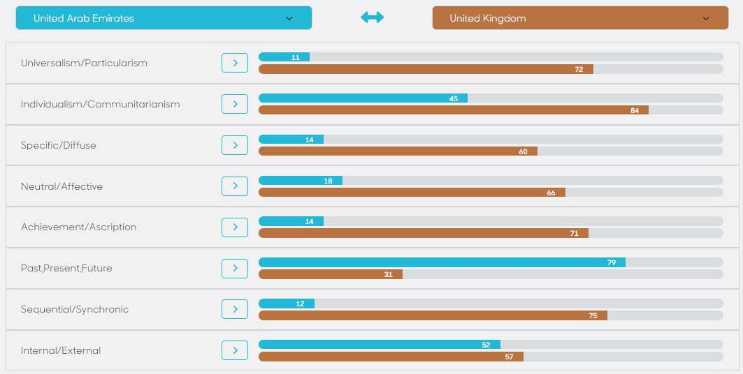
Figure 2: Turner and Trompenaar’s cultural model (the UK vs United Arabs Emirates)
Source: Trompeenars-Hampden-Turner-tconsulting.com (2024)
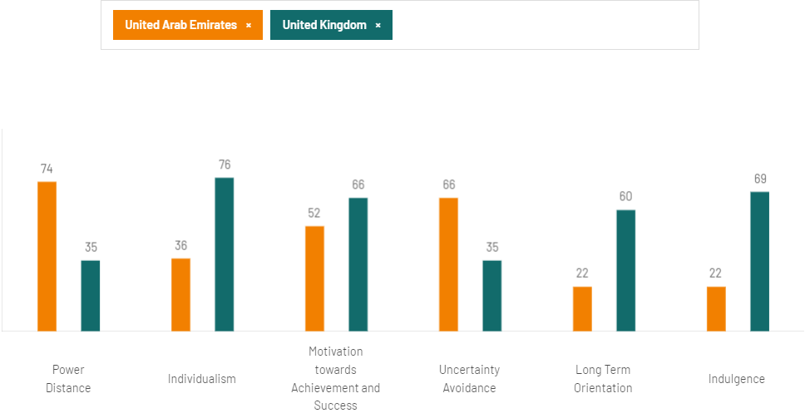
Figure 3: Hofstede’s model of national cultures (the UK vs United Arabs Emirates)
Source: Hofstede Insights (2024)
Finally, from figure 4, the UK is low context while the UAE is high context culture. This directly impacts international business communication between the UK and the UAE. For instance, the UAE has a situational and relational knowledge, communication is less verbally explicit, and decisions are face to face (Hall, 2023). However, the UK ha a rule-based relationship, knowledge is transferable, communication is more explicit and verbal, and decisions can be made by any member of the team (Nelson, Treichler, and Grossberg, 2013). The use of non-verbal cues in communications situations such as negotiations, bargaining, and decision making may create challenges between the UK and UAE when UK partners fail to effectively interpret the partners’ body language. Furthermore, in business interactions, UAE values non-verbal communications cues, direct verbal messages, and personalised disagreements. However, in the UK, words are critical since messages are carried in words unlike in non-verbal communications. Furthermore, disagreements in business dealings in the UAE are depersonalised (Hall, 2023). These differences may cause communication challenges for international businesses that operate in the UAE and the UK.
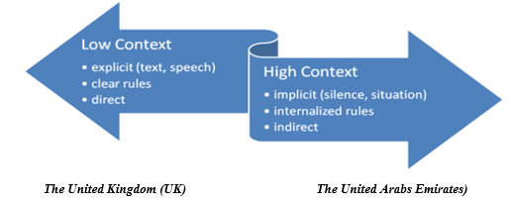
Figure 4: Hall’s model of national cultures (the UK vs United Arabs Emirates)
Source: Hall (2023)
Strategies to overcome communication challenges between the UK and UAE
The final stage of Boud’s Triangle representation presents the key lessons from an incident and what to do to overcome the issues from the incident (Misra and Misra, 2021). From the discussions on the intercultural communication between the UK and the UAE, business partners between the two countries need to adopt the 3R approach (recognise, respect, and reconcile) to address the communication challenges.
The first strategy is towards an effective intercultural communication is to recognise the differences in national cultures. The business partners should target by increasing their awareness on the cultural differences (Martin et al., 2013). For instance, there is need to recognise differences such as power distance, cultural context, universalism vs particularism, and religious differences and how these differences affect business communications. Recognition of the cultural differences will enhance a partner’s awareness of the need to adapt their communication strategy to the international context. Precisely, international business partner may increase their awareness of cultural differences through culture specific training within the organisation and benchmarking sessions to compare cultures (Holmes, 2014). Secondly, international business partners should also respect the differences in national cultures. When one notices a different style of communication, for instance, they should learn to embrace the person’s point of view. Furthermore, international business partners need to reconcile the differences in national cultures by being empathetic towards the other culture (Martin et al., 2013).
In addition to the 3R model, communicators between the UK and UAE should both address all the barriers to effective communication and develop skills for effective communication in international contexts. From figure 5, this includes addressing the challenge of language differences (by using a common language), avoiding noise and distractions, developing interests in communication between the parties involved in communication. In addition, the communicators should either avoid larger distances or use technologies that limit the adverse effects of large physical distances in international communication. Furthermore, the parties should pay attention to the aspect of time. This involves determining whether the communicating partners are either polychronic (people-oriented) or monochronic (task oriented) (Luthans and Doh, 2018) and how this directly affect the extent to which they pay attention to time keeping. Developing approaches to reduce these
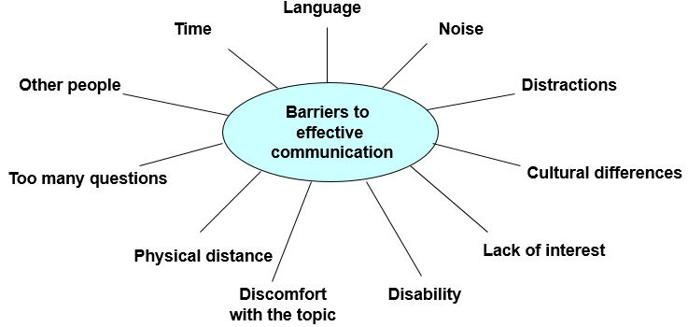
Figure 5: Barriers to effective communications in international business
Source: Adapted from Cavusgil et al. (2014); Czinkota et al. (2021)
From figure 6, business partners from UAE and the UK need to effectively use both non-verbal communication cues (body language, silence, eye contact and visible mouth, smiling face) and verbal communication cues (checking for understanding, encouragement to continue, and summarising what has been said during situations in international business communications such as decision making, bargaining and negotiation, and relationship building (Ahmed, 2016). However, the use of these strategies of effective communication should also conform to the national cultures of the business partners (Ahmed, 2016).
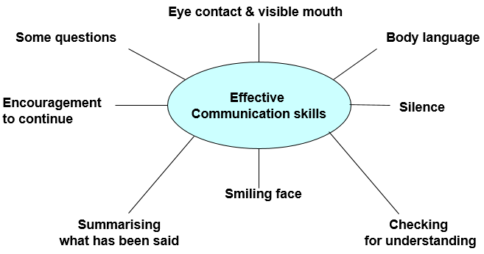
Figure 6: Effective communication skills for international business
Source: Adapted from Ahmed (2016)
Conclusion and recommendations
In summary, this reflection demonstrates that there are cultural differences between the UK and UAE as shown in the Turner and Trompenaars model, Hofstede’s model of national cultures, and Hall’s cultural contexts. The essay further shows that these differences in national cultures affect communications during specific international business communication situations such as negotiation and bargaining, relationship building, and decision making. For instance, while UAE focuses on relationship and trust building, the UK is least focused on building personal relationships in business. In addition, communication in UAE in top-down as opposed to the horizontal approach in the UK. The essay therefore demonstrates that international business communicators need to develop specific strategies to overcome these communications challenges.
As an action plan, I firstly plan and recommend that every international business communicators needs to bridge the cultural gap between countries for effective communications. A research by Litvinova, Andriutsa, and Movchun (2021) shows that this can be practically accomplished through online cultural training, offered on platforms such as https://www.futurelearn.com/ and https://www.udemy.com/. An online cultural training increases the awareness and recognition of differences in national cultures and allows international business communicators to be cognisant of cultural differences when they communicate. Similarly, as an international business communications expert, I plan to undertake a training on effective communication skills for international business persons. As demonstrated in figure 6, these skills include effective use of both verbal and non-verbal cues (Cavusgil et al., 2014). However, while communications skills are needed for international business communicators, an effective use of the strategies depends on one’s awareness of the others’ cultures (Kourova and Modianos, 2013). For instance, an effective use of a body language, as a non-verbal communication cue depends on the communicator’s awareness of the other’s cultural context as defined in Hall’s model (Samovar et al., 2015). For instance, an awareness that UAE would prefer non-verbal communication cues as opposed to a more direct communication preferred in the UK will enable an international business person to adopt the best body language during communication situation between the two countries. Evidently, the most important strategy to overcoming challenges of international communication in business is enhancing one’s awareness of the differences in national cultures between countries through training and benchmarking approaches.

References
Ahmed, S. (2016) ‘An evaluation of effective communication skills coursebook’, Advances in Language and Literary Studies, 7(3), pp.57-70.
Ali, A.J. (2005) Islamic Perspectives on Management and Organization. Cheltenham: Edward Elgar Publishing Limited.
Boersma, M.F., Buckley, P.J. and Ghauri, P.N. (2003) ‘Trust in international joint venture relationships’, Journal of business research, 56(12), pp.1031-1042.
Cavusgil, S.T., Knight, G., Riesenberger, J.R., Rammal, H.G. and Rose, E.L. (2014) International business. Melbourne: Pearson Australia.
Czinkota, M.R., Ronkainen, I.A. and Gupta, S. (2021) International business. Cambridge: Cambridge University Press.
De Waal, A. and Frijns, M. (2016) ‘The influence of the UAE context on management practice in UAE business’, International Journal of Islamic and Middle Eastern Finance and Management, 9(2), pp.236-253.
DeVito, J.A. (2018) Human communication: The basic course. London: Pearson.
Gamble, J. (2003) ‘Transferring human resource practices from the United Kingdom to China: the limits and potential for convergence’, International Journal of Human Resource Management, 14(3), pp.369-387.
Hall, J.K. (2013) Teaching and researching: Language and culture. London: Routledge.
Hofstede Insights (2024) Country comparison. Available at: https://www.hofstede-insights.com/country-comparison-tool?countries=united+arab+emirates%2Cunited+kingdom (Accessed January 08, 2024).
Holmes, P. (2014) Intercultural dialogue: challenges to theory, practice and research. Language and Intercultural Communication, 14(1), pp.1-6.
Hu, J., Erdogan, B., Jiang, K., Bauer, T.N. and Liu, S. (2018) ‘Leader humility and team creativity: The role of team information sharing, psychological safety, and power distance’, Journal of Applied Psychology, 103(3), pp.313-323.
Hurn, J. B. (2013) ‘Response of managers to the challenges of globalisation’, Industrial and Commercial Training, 45(6), pp.336-342.
Islam, M.Z., Jasimuddin, S.M. and Hasan, I. (2015) ‘Organizational culture, structure, technology infrastructure and knowledge sharing: Empirical evidence from MNCs based in Malaysia’, Vine, 45(1), pp.67-88.
Kourova, A. and Modianos, D. (2013) ‘Inter-cultural awareness and its role in enriching students’ communicative competence’, The International HETL Review, Special Issue, pp.60-70.
Litvinova, T., Andriutsa, N. and Movchun, V. (2021) ‘Developing students’ intercultural communicative competence through online learning’, International Journal of Emerging Technologies in Learning (Online), 16(8), pp.162-174.
Luthans, F. and Doh, J.P. (2018) International management: Culture, strategy, and behavior. London: McGraw-Hill.
Martin, J., Nakayama, T., van Oudtshoorn, G.V.R. and Schutte, P. (2013) EBOOK: Experiencing Intercultural Communication: An Introduction. London: McGraw Hill.
Misra, P.K. and Misra, P.K. (2021) ‘Competencies for Teaching’, Learning and Teaching for Teachers, pp.163-179.
Nelson, C., Treichler, P.A. and Grossberg, L. (2013) ‘Cultural studies: An introduction’, In Cultural studies (pp. 1-22). London: Routledge.
Neuliep, J.W. (2016) Intercultural communication: A contextual approach. London: Sage Publications.
Samovar, L.A., Porter, R.E., McDaniel, E.R. and Roy, C.S. (2015) Intercultural communication: A reader. London: Cengage learning.
Saunders, F. (2023) ‘The role of trust in international business relationships’, Journal of Research and International Business Management, 10, pp. 30-31.
Sifianou, M. (2013) ‘The impact of globalisation on politeness and impoliteness’, Journal of Pragmatics, 55, pp.86-102.
Ting-Toomey, S. and Dorjee, T. (2018) Communicating across cultures. New York: Guilford Publications.
Trompeenars-Hampden-Turner-tconsulting.com (2024) Explore what binds and divides for reconciliation. Available at: https://www.thtconsulting.com/culture-factory/culture-explore/compare-countries/ (Accessed January 03, 2024).

