Cover Letter
MODULE NAME: EFFECTIVE TEAM WORKING & COMMUNICATION
MODULE Code : BMSW4002

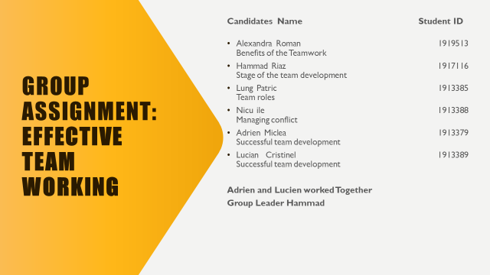
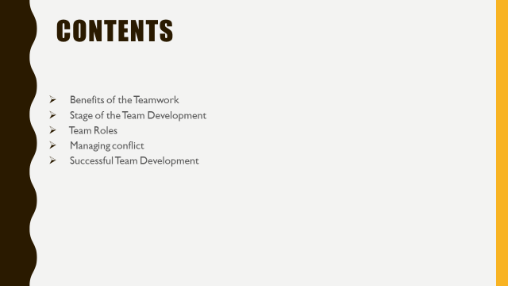
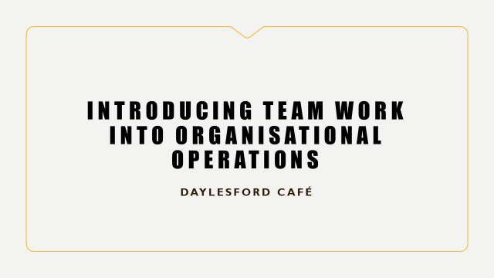
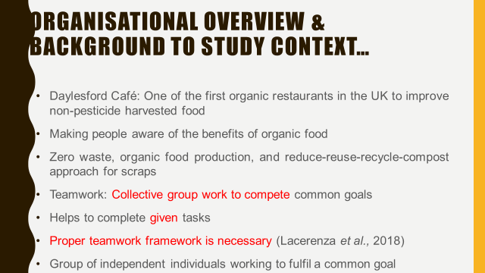
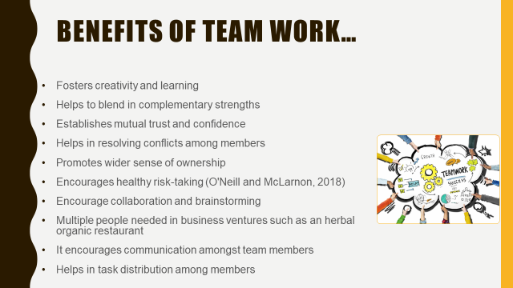
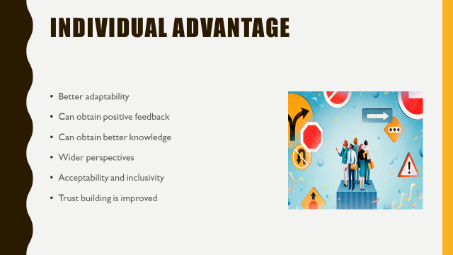
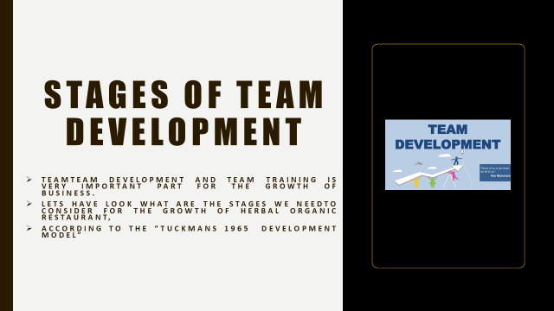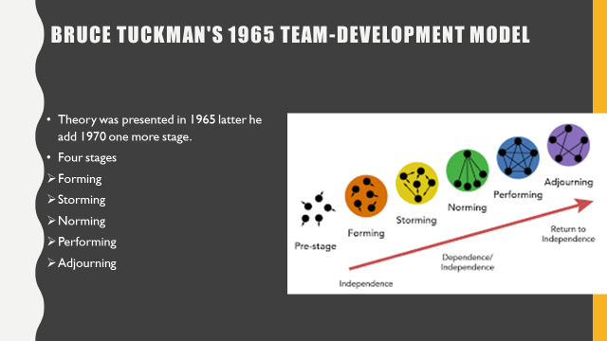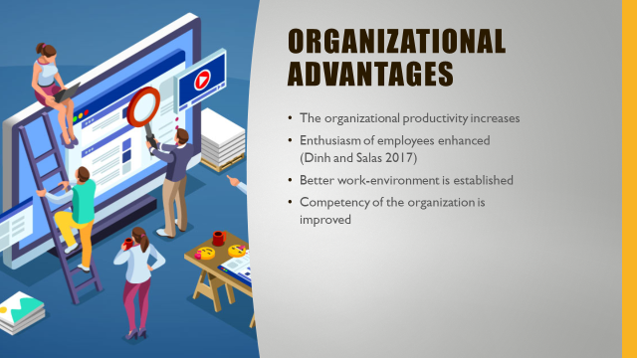
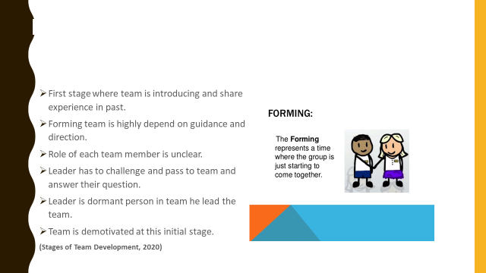
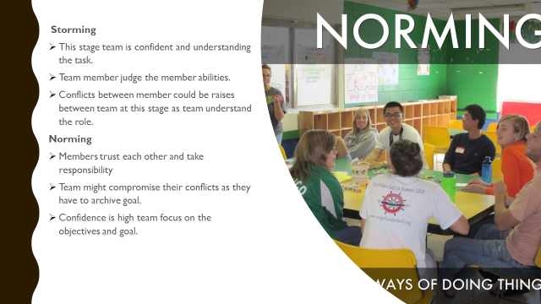
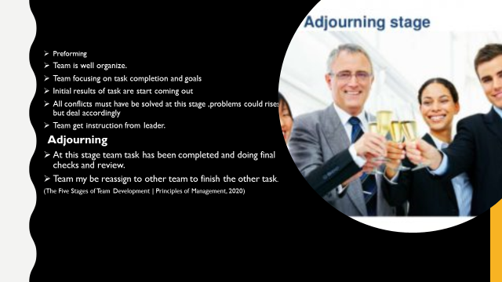
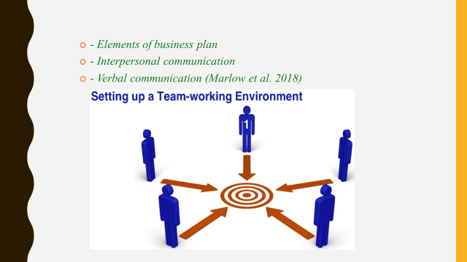
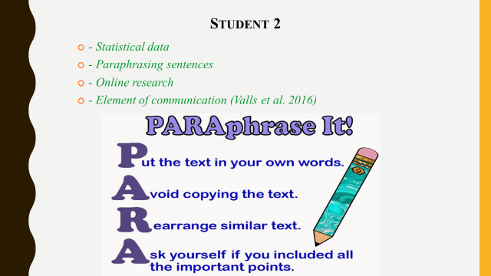
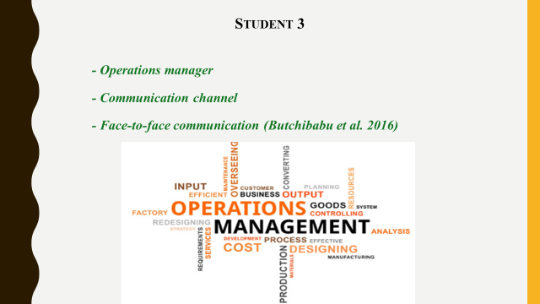
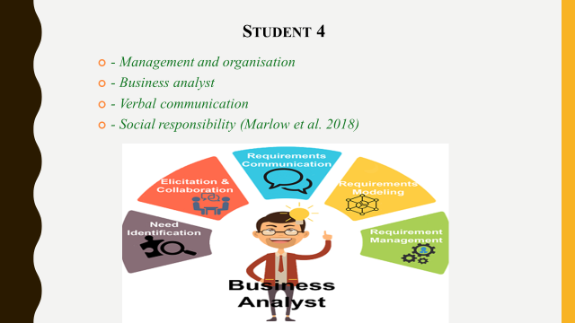
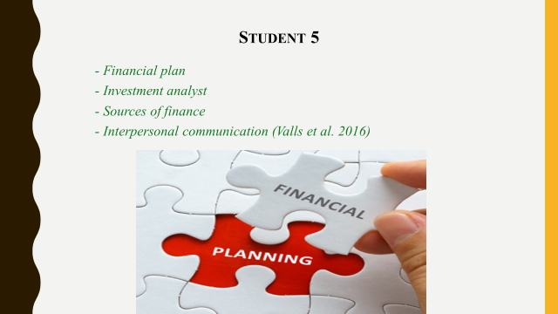
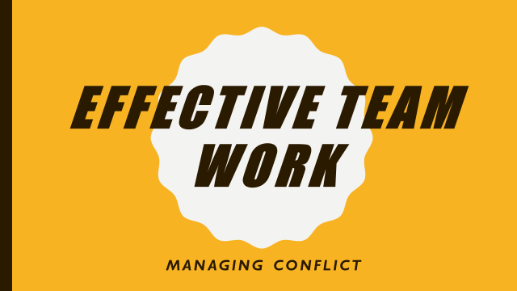
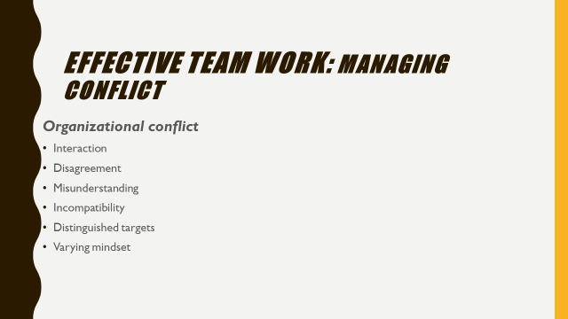

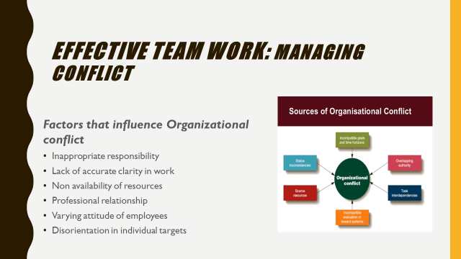
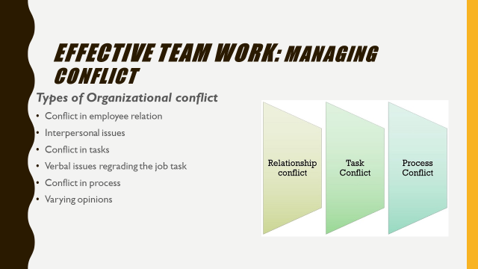
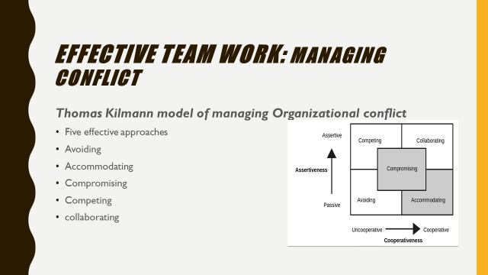
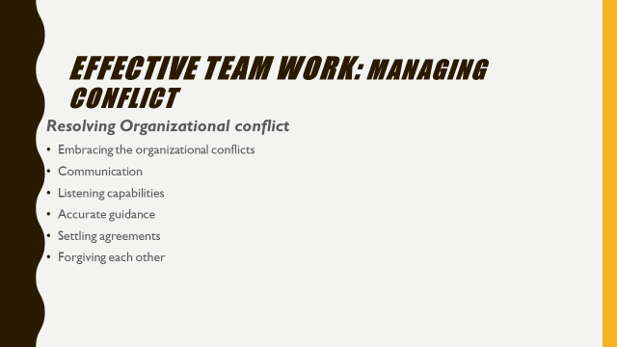
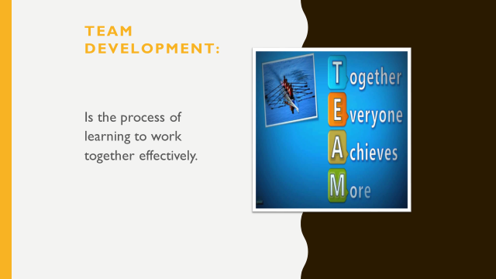
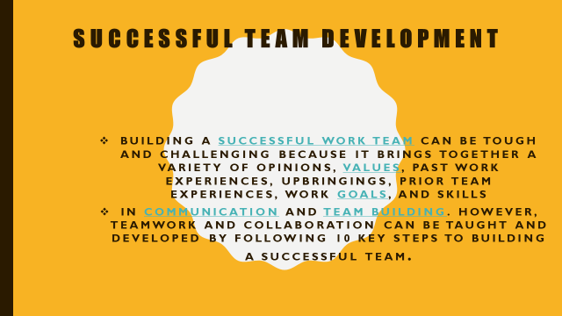
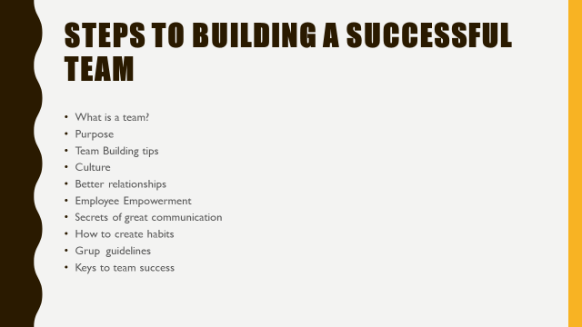

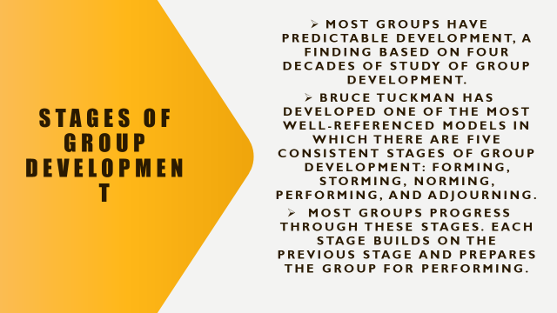
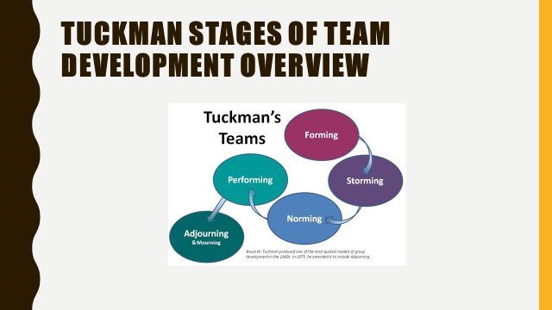
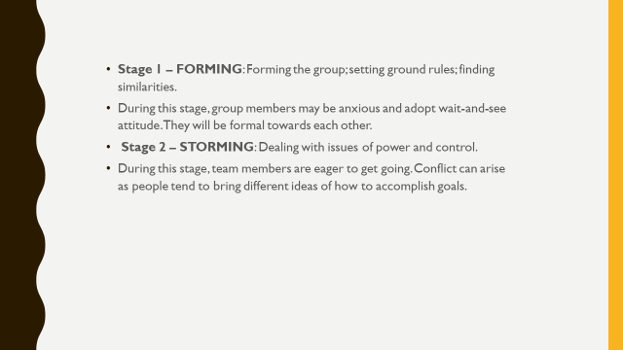
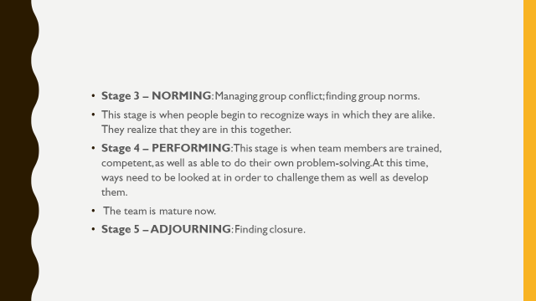
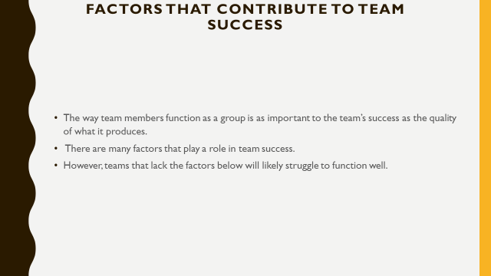
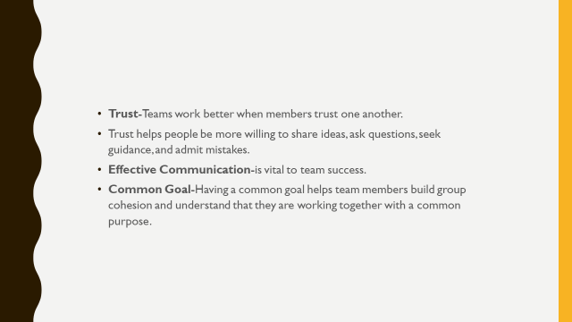
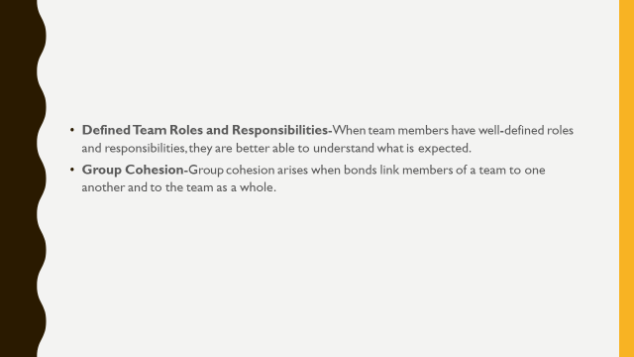
References
Student name Alekszandra Roman
- Lacerenza, C.N., Marlow, S.L., Tannenbaum, S.I. and Salas, E., 2018. Team development interventions: Evidence-based approaches for improving teamwork. American Psychologist, 73(4), p.517.
- O'Neill, T.A. and McLarnon, M.J., 2018. Optimizing team conflict dynamics for high performance teamwork. Human Resource Management Review, 28(4), pp.378-394.
- Dinh, J.V. and Salas, E., 2017. Factors that influence teamwork. The Wiley Blackwell handbook of the psychology of team working and collaborative processes, pp.13-41.
- Slideshare.net. 2020. Stages Of Team Development. [online]Availableat:<https://www.slideshare.net/AbdulAhad144/stages-of-team-development-76908863> [Accessed 9 August 2020].
Student Lucian 1913389 And Adrian 1913379 ,
- The Happy Manager. 2020. Team Goal Setting | Defining Meaningful Results. [online] Available at: <http://the-happy-manager.com/tips/team-goal-setting/> [Accessed 19 July 2020].
- The Happy Manager. 2020. Why Is Teamwork Important? | 8 Good Reasons Why Teamwork Is So Important!. [online] Available at: <http://the-happy-manager.com/articles/why-is-teamwork-important/> [Accessed 02 August 2020].

Student Nicu ile 1913388
- The Happy Manager. 2020. Team Goal Setting | Defining Meaningful Results. [online] Available at: <http://the-happy-manager.com/tips/team-goal-setting/> [Accessed 19 July 2020].
- The Happy Manager. 2020. Why Is Teamwork Important? | 8 Good Reasons Why Teamwork Is So Important!. [online] Available at: <http://the-happy-manager.com/articles/why-is-teamwork-important/> [Accessed 02 August 2020].

Student Hamamd Riaz 1917116

- Slideshare.net. 2020. Stages Of Team Development. [online] Available at: [Accessed 9 August 2020]. •

- Courses.lumenlearning.com. 2020. The Five Stages Of Team Development | Principles Of Management. [online] Available at: [Accessed 9 August 2020]

Student Lung Patric 1913385
Butchibabu, A., Sparano-Huiban, C., Sonenberg, L. and Shah, J.,
2016. Implicit coordination strategies for effective team
communication./Human factors,/58(4), pp.595-610.
′
- Marlow, S.L., Lacerenza, C.N., Paoletti, J., Burke, C.S. and Salas,
E., 2018. Does team communication represent a one-size-fits-all
approach?: A meta-analysis of team communication and
performance./Organizational Behavior and Human Decision
Processes,/144, pp.145-170.
′
- Valls, V., González‐Romá, V. and Tomás, I., 2016. Linking
educational diversity and team performance: Team communication
quality and innovation team climate matter./Journal of
Occupational and Organizational Psychology,/89(4), pp.751-771
Butchibabu, A., Sparano-Huiban, C., Sonenberg, L. and Shah, J.,
2016. Implicit coordination strategies for effective team
communication./Human factors,/58(4), pp.595-610.
′
- Marlow, S.L., Lacerenza, C.N., Paoletti, J., Burke, C.S. and Salas,
E., 2018. Does team communication represent a one-size-fits-all
approach?: A meta-analysis of team communication and
performance./Organizational Behavior and Human Decision
Processes,/144, pp.145-170.
′
- Valls, V., González‐Romá, V. and Tomás, I., 2016. Linking
educational diversity and team performance: Team communication
quality and innovation team climate matter./Journal of
Occupational and Organizational Psychology,/89(4), pp.751-771

- Butchibabu, A., Sparano-Huiban, C., Sonenberg, L. and Shah, J.,2016. Implicit coordination strategies for effective teamcommunication./Human factors,/58(4), pp.595-610.

- Marlow, S.L., Lacerenza, C.N., Paoletti, J., Burke, C.S. and Salas, E., 2018. Does team communication represent a one-size-fits-all approach?: A meta-analysis of team communication and performance./Organizational Behavior and Human Decision Processes,/144, pp.145-170.

- Valls, V., González‐Romá, V. and Tomás, I., 2016. Linking educational diversity and team performance: Team communication quality and innovation team climate matter./Journal of Occupational and Organizational Psychology,/89(4), pp.751-771

