Introduction to physiology
Name: Karon Mcqueen
Student number:1809080
Tutor: Mumtaz Goolam
BMHP 5003

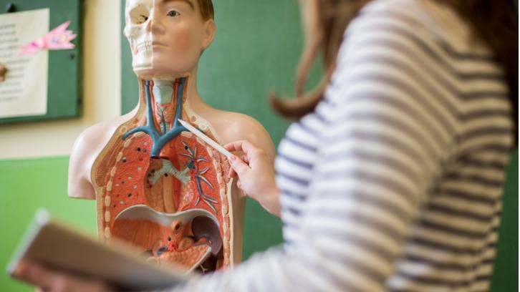

Cardiovascular System

The Cardio-vascular system consist of three parts, its role is to supply oxygen around the body and to transport materials to the cells to help get rid of carbon Dioxide; (1) The heart is two pumps that pushes the blood around the body each pump works separately, it is a closed system of vessel called arteries, veins and capillaries, (2) The blood transferences oxygen and other resources to the compartments, (3) The blood vessel is a tube and it carries the blood to different segmentts of the body. (Taylor, 2020)

Heart

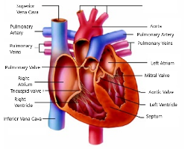 (Clip Art Library, 2020)
The heart, is about the range of a grown-up fist, it is like a twin pump. both side of the heart operates independently. The left side push blood from the heart to the lungs and the right-side pushes blood from the heart to the remainder of the body. The different margin of the heart are isolated by the septum. The vital purpose of the heart is to distribute the tissues with oxygen and nutrients continuously and to remove the metabolic waste products. The heart is comprised of cardiovascular muscle, a specific sort of muscle tissue. Since the heart pumps all through life, it should be comprised of tissue that can keep up its effectiveness all during a person lifetime. This tissue is provided with blood by the coronary vessels. The heart is comprised by four-compartments- individually the heart carries a higher chamber and lower ventricle. The left ventricle carries the heaviest solid divider within the chamber which pushes the blood from the heart to the remainder of the body. There are valves amongst the chamber and the ventricle which are on two borders. For the heart to keep on thumping at a standard level, the circumstance of the heartbeat is constrained by a little territory within the head of the chamber called peace maker. From here the electrical motivations are led to the remainder of the heart. (SEER Training, 2020)

Blood circulation

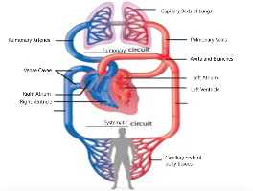 (Pin on Study, 2020)

The circulation framework has twofold course of the body which imply how the blood flows within the heart two times throughout a dissemination of the body. Deoxygenated blood flows within the correct chamber from the vena cava, which is the largest vein within the body. The chamber engages, pushing blood into the correct ventricle. The ventricle at the point agreements and drives blood into the aspiratory corridor. From here, The blood streams into the lungs where fume trade happens. Carbon dioxide departs in the blood and travel in the lungs for ousted, then oxygen depart from the lungs and transport within the blood then transfer to the body cells, The blood is currently oxygenated then goes to one side chamber onto the pneumonic veins. The left chamber seals then powers blood into the left ventricle. The ventricle at that point agreements and powers blood into the aorta, the fundamental corridor, which at that point branches into different supply routes then returns blood to different parts within the body, vessels fume trades happens, afterwards oxygen is conveyed in the cells then carbon dioxide is gathered from the cells and reclaimed in the heart for the entire cycle to begin once more. (NCBI, 2020)

Blood & Plasma

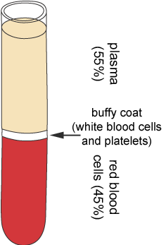 (Paxton, Knibbs and Peckham, 2020)
A normal grown-up has 5-6 litres of blood. The blood is comprised of 55% plasma and 45% platelets. Plasma, the fluid aspect, is a straw-shaded liquid which is comprised of 90% liquid. The saying 10% comprises of broken up nutriment, squander, and minerals (e.g. potassium sodium and chloride, blood clotting variables, hormones and antibodies). Different kinds of platelets are suspended in the plasma. (Paxton, Knibbs and Peckham, 2020)
Red blood cell White blood cell
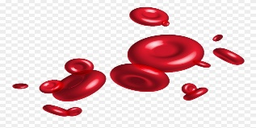 (PinClipart, 2020) 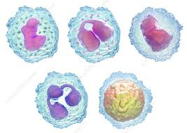 (De Angelis, 2020)
(1) Red blood cells are bi-inward circles which when explored don’t have a core, they cover haemoglobin a protein that conveys oxygen which creates the cells red. (2) White blood cells-are cells that support and battle disease, there are diverse types:
- Monocytes and neutrophils are phagocytes-they overwhelm unfamiliar issue in the blood
- Lymphocytes-B lymphocytes that produce antibodies and T Lymphocytes that wreck contaminated cells.
- Platelets of thrombocytes are fragments of blood cells that creates enzymes and assist with blood clotting.
Blood circulates around the body continually. It takes around a moment for the blood cells to go throughout the body when it is very still. At the point when the blood is practicing pace of course will be much faster. (Hoffman, 2020)

Blood Vessels
Blood is circulated to different area of the body, so it needs a proficient vehicle framework where to do so, similar to road framework with enormous, medium and little vessel, much like Motorways, A-roads and B-roads there are three unique sorts of vessel:
- Arteries - transport away blood from the heart
- Veins -bring blood back to the heart
- Capillaries connects the arteries and the vein
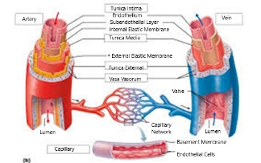 (Structure Of Blood Vessels, 2020)

These are little blood vessels with teeny walls containing of only a coating of cells with very small opening which allows the blood to flow through such as oxygen, chemical substances, and other waste products from cells. (Waugh, Grant and Chambers, 2014)

Disorder of blood vessel
An individual can have problem with their blood vessel which can cause by a stroke; it is a clot in an artery or vessel that cuts off blood flow to the brain. The blood vessels can get blocked or they rupture and bleed. When a blood vessel is blocked, it produces a haemorrhage in the brain. This can trigger less blood flow to the brain cells. The blood nourishes the brain cells with oxygen, glucose, and nutrients. When a blood vessel in the brain becomes clogged or burst that part of the brain beyond the affected vessel cannot obtain oxygen then dies. An individual will experience failure of movement in their limbs and have problem speaking depending on where in the brain this occurs (NHS, 2020), this can cause by being over-weight or obese, smoking, drinking, use of drugs and diabetes.
An individual should seek medical help to determine what type of stroke so that they can get the right medication (Mayo Clinic, 2020) such as thrombolytic that may dissolve the clot. A stroke can cause death and it depends on how quickly the damage of the brain can be restored which will need assessment such as stabilizing the airway, breathing and circulation, then a rapid, concise exam and history as the patient get IV access telemetry and lab test drawn, CT and perfusion image. (Pysio-Pedia, 2020)

References:
Clipart-library.com. 2020. High School Circulatory System Worksheet - Clip Art Library. [online] Available at: <http://clipart-library.com/clipart/8izKLz7eT.htm> [Accessed 12 October 2020]
De Angelis, M., 2020. White Blood Cells, Illustration - Stock Image - C047/5459. [online] Science Photo Library. Available at: <https://www.sciencephoto.com/media/1062423/view/white-blood-cells-illustration> [Accessed 12 October 2020].
Hoffman, M., 2020. Human Anatomy: Blood - Red And White Cells, Plasma, Circulation, And More. [online] WebMD. Available at: <https://www.webmd.com/heart/anatomy-picture-of-blood#1> [Accessed 12 October 2020].
Mayo Clinic. 2020. Stroke - Symptoms And Causes. [online] Available at: <https://www.mayoclinic.org/diseases-conditions/stroke/symptoms-causes/syc-20350113> [Accessed 23 October 2020].
Ncbi.nlm.nih.gov. 2020. How Does The Blood Circulatory System Work?. [online] Available at: <https://www.ncbi.nlm.nih.gov/books/NBK279250/> [Accessed 23 October 2020].
nhs.uk. 2020. Stroke. [online] Available at: <https://www.nhs.uk/conditions/stroke/> [Accessed 23 October 2020].
Paxton, S., Knibbs, A. and Peckham, M., 2020. The Leeds Histology Guide. [online] Histology.leeds.ac.uk. Available at: <https://www.histology.leeds.ac.uk/blood/blood_content.php> [Accessed 12 October 2020].
Physiopedia. 2020. Stroke: Assessment. [online] Available at: <https://www.physio-pedia.com/Stroke:_Assessment> [Accessed 23 October 2020].
PinClipart.com. 2020. Redbloodcell Sticker - Red Blood Cells Png Clipart - Full Size Clipart (#4083660) - Pinclipart. [online] Available at: <https://www.pinclipart.com/maxpin/ihxoiRT/> [Accessed 12 October 2020].
Pinterest. 2020. Pin On Study: Anatomy & Physiology. [online] Available at: <https://www.pinterest.co.uk/pin/208221182752795813/> [Accessed 12 October 2020].
quizlet.com. 2020. Structure Of Blood Vessels. [online] Available at: <https://quizlet.com/373657432/structure-of-blood-vessels-diagram/> [Accessed 11 October 2020].
Taylor, T., 2020. Cardiovascular System - Human Veins, Arteries, Heart. [online] Innerbody. Available at: <https://www.innerbody.com/image/cardov.html> [Accessed 12 October 2020].
Training.seer.cancer.gov. 2020. Structure Of The Heart | SEER Training. [online] Available at: <https://training.seer.cancer.gov/anatomy/cardiovascular/heart/structure.html> [Accessed 12 October 2020].
Waugh, A., Grant, A. and Chambers, G., 2014. Ross And Wilson Anatomy & Physiology In Health & Illness. 12th ed. Elsevier Science Health Science, p.9.

