PROBLEM SOLVING AND DECISION MAKING
CLASS: BMSW4004
Report

Student name: Marinela Camelia Craciunel
Student number: 1818825
Lecturer: Afzal Munna

Table of Contents
Introduction 4
Part 1: Problem at workplace 5
1.1 Choose problem 5
1.2 Reasons of the problem 5
13. Advantages/ disadvantages of the selected problem 5
1.4 How to resolve the problem 5
1.5 My experience of the problem at the workplace 5
1.6 Seven steps to problem solving 6
Part 2: Decision Making 7
2.1 Types of Decision 7
2.2 Factors affecting decision making 7
2.3 Ingredients of good decision making 7
2.4 Fishbone Analysis 8
2.5 SWOT Analysis 9
2.6 PESTLE Analysis 10
2.7 Porter’s Five Force Model 11
Part 3: Solution 12
3.1 Proposed solution 1 - I will be analysing this solution as this is the viable solution for the problem which the casino is facing 12
3.2 Proposed solution 2 13
3.3 Evaluation of the proposed solution 1 as this is the viable solution for the problem which the casino is facing 13
Source: (Self-Created) 13
Part 4: Implementation 14
4.1 Implementation plan for the proposed solution 14
4.2 Monitor and review of implementation plan 14
Conclusion 15
References 16
Appendices 18

Introduction
The report will discuss about the Grosvenor Casino Leo also popular as Leo Casino in Liverpool which is operated under the name of Grosvenor Casino Ltd. that operates both in England and Wales (Casino Liverpool | Grosvenor Casino Leo, 2020). The main purpose of this report is to discuss about the customer dissatisfaction issue that leads to management issue. This report will focus on the decision making process and find out solutions for the resolving issue and will also evaluate the strength and weakness of the proposed solutions and implement the selected solution.

Part 1: Problem at workplace

1.1 Choose problem
Gambling industry is facing a dangerous time currently where the customers are sort of at a situation where they are starting to rebel against the nickel and diming at Leo casino in UK. It has been analysed by Collins, et al., (2019) that currently high pricing strategy of casino leads to aggressive customer behaviour on the management.

1.2 Reasons of the problem
The casino is taking huge restaurant fees and also made paid parking and the customers are feeling nothing else than gouging being attempted by the casino. Moreover, shrinking comps and games are giving less return to the customers. Several casinos are squeezing the customers enormously that the game is not making any more fun at present.

13. Advantages/ disadvantages of the selected problem
There is only one opportunity for the casino in this situation is to make new types of value or walk against the flow of cost sneak which not provide any big profit as they will lose more customers from their hand (Prentice, Wongand Lam, 2017). Furthermore, apart from executive offices, maximum people are non-executive they play for their own enjoyment if they get disappointed for the above mentioned reasons then they will no longer going to visit here and will switch to other firm. Thus, it will also lose several loyal customers.

1.4 How to resolve the problem
To resolve the major issue that is current high pricing strategy, the management of the casino should pay attention on their strategy. In order to better analyse of the current major issue of the company, different analytical tools such Fishbone analysis, SWOT and PESTLE analysis that will be implemented in the next section (Serrat, 2017).

1.5 My experience of the problem at the workplace
While I was working in the casino as a ground staff in the last week, I heard one customer is shouting in an aggressive mood on one of our casino employees who is catering food. I noticed the whole situation and went there to handle the heat situation and came to understood that particular customer often comes to our casino but now left with poor remark by stating that our casino is stealing money by increasing several charges on food, also at bar, parking and by changing the rule of the game (Kayand Skarlicki, 2020). Operations manager has come down at the floor and trying to cool down the customer however unable to convince him rather it has increases the flames of fire without dampening and it is just because of current high pricing strategy which makes the customer angry and such situation is also proving that the management of the company is not efficient in making a strategy. According to my perception, playing such game increases the excitement and hence they often cannot hold on the temper and burst out in anger and based on all aspects the company should make proper strategy.

1.6 Seven steps to problem solving
Setting forth the conflict management processes within the companies like casinos is prime challenge as it has to deal with public emotions and if they maintain it such processes support to decrease conflict among between employees and customers as well.
Seven steps that can help in problem solving are given below:
- The manager or the employee should permit aggressive customer to express and speak about their feelings unless they are not releasing their aggravation and cool down (Van Akenand Berends, 2018).
- The employee or the manager should utilise empathy statements in correct tone to reveal that they understand their customer’s frustrations and feelings.
- They should proffer opinion or agree/ disagree with their customers and should work on to resolve the issue effectually.
- They should react on the customer’s aggressive rather allow them to speak out what is their issue(Hao,et al., 2017).
- The employee and the manager should use verbal softeners to make the customer calm down.
- Assess something through listening and find out to agree with the customer and that may lead to collaboration and negotiation.
- The manager and the employee should set limits and utilise timeouts and let the customer think about the alternative and if they do not agree upon, they should set the limits and end the conversation.

Part 2: Decision Making

2.1 Types of Decision
There are several kinds of decisions in a company however the following are the kinds of decisions that are essential and they are-
- Tactical as well as strategic decisions
- Programmed as well as non-programmed decisions
- Basic as well as routine decisions (Gati, Levinand Landman-Tal, 2019)
- Policy and operating decisions

2.2 Factors affecting decision making
Some of the factors affecting in the process of managerial decision making:
- Certainty
- Risk (Zardo, 2018)
- Uncertainty

2.3 Ingredients of good decision making
To make well decision, the manager of the organisation should consider the following things that have been depicted in the below figure.
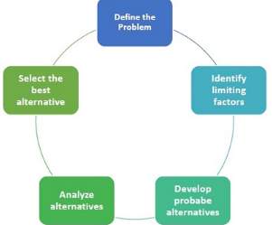
Figure shows process of decision making
(Source-Adair, 2019)

2.4 Fishbone Analysis
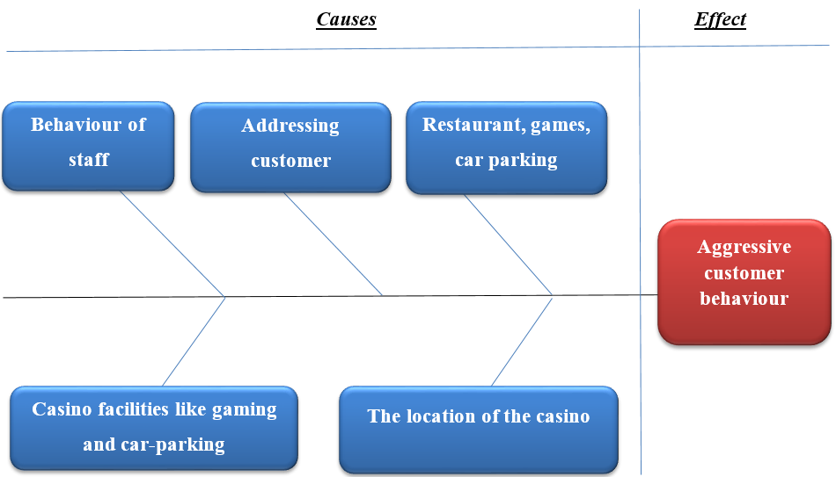

Figure shows Fishbone analysis model
(Made by: Author)
According to Milani (2019), a fishbone diagram is often called cause and effect diagram is a visualisation tool to categorise the potential reasons of an issue for recognising its main causes.
The Fishbone diagram provided above highlights the main elements of people, methods, materials and equipment and environment which help explain the identified problem. The problem has been identified as aggressive customer behaviour at Leo Casino. The causes that lead to it have been identified as the high fees at the restaurant, car-parking fees and gaming fees. Moreover, the behaviour of the managers has not been empathetic and responsive, worsening the problem. The problem and causes have been analysed using the proposed analytical tool which has been illustrated in the diagram. The root causes of this major issue have been given in section 1.2.

2.5 SWOT Analysis

(Source: Güreland Tat, 2017)

2.6 PESTLE Analysis

(Source: Self-Created)

2.7 Porter’s Five Force Model

(Source: Self-Created)

Part 3: Solution

3.1 Proposed solution 1 - I will be analysing this solution as this is the viable solution for the problem which the casino is facing
For better casino experience, it is important for Leo Casino in tracking the behaviour of the players for offering them the satisfaction that they generally wish for- both on and off- the floor. This engages the behaviour of players at the table (like size of bet or the play length) alongside other things such as gift store alongside food purchases (healthy options) besides requests for room service. The casino would do well in collecting this information via exercising a loyalty card and in lieu of that loyalty; players will be tendered incentives in keeping playing, like upgradation in meals, better hotel accommodations and coupons. It is important the casinos try and dish out something new at least once a week so that players come back again and again to play at the casino (Ferrazzi,et al., 2019).
Fishbone Analysis:
Cause 1: Unsatisfied guests
Effect: When it is about guest services, it generally takes a strategy of formidable sort in being successful within the gaming sector. As seen in this report satisfying guests who are not that happy or satisfied about dropping £400 at the craps table within 15 minutes and then not getting a free drink or a meal at lower price which is bare minimum in such situations can prove to be challenging.
Cause 2: Poor technology:
Technology plays a major part in everything these days, same for the gaming industry too. Technology helps the gaming company in personalizing the experiences of the customers by studying their behaviour like how can the players be kept on the floor for longer period of time and the areas in the casino which have most foot traffic. Such data can be evaluated and exercised in developing the casino related experience for customers across the board.
Cause 3: Untrained professionals:
It is not always the case that the staffs within a casino are properly trained though they should be as they require handling different types of people with different set of emotions. Sometimes their poor man management leads to a situation where the guests turn hostile as not everyone can manage an individual who has just lost out on his pennies.
Cause 4: Ofering same old things
Casino is a place where people tend to try their luck out, play games in order to earn some extra money, have a drink or two and have fun, though more often than not they lose out on their money, does not get new offerings that would keep the guests or players hooked to the casino.

3.2 Proposed solution 2
Membership card can be another strategy that can help the company to give different offers to the customer for certain time limit. This strategy can also help to gain competitive edge over its competitors in the market.

3.3 Evaluation of the proposed solution 1 as this is the viable solution for the problem which the casino is facing
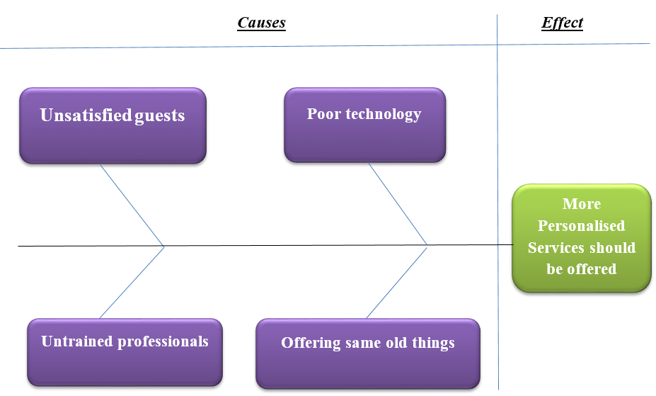

Source: (Self-Created)
It is essential to evaluate the potentialities of the two selected options for identifying which can work well. Spending in other areas can help to give more returns to the customers and also help them to get a meal and in some other facilities like vouchers for shopping in a well-known mall. However, buying low rate meal can also create an impact on health of the customers if the food is not healthy and hence they should introduce some healthy and delicious meals for the customers. This will be one of the unique and innovative strategies for Leo Casino as no other competitors in the market have yet started.
The first option seems more viable in case of Leo Casino as the only way they can trim down the rate of unsatisfied gamers is by tracking and studying their behaviour, their emotions their desires and other aspects what would keep them hooked to the game table. Emotions tend to run high in casinos and therefore Leo Casino would do well to personalize its offerings in order to cater to the needs of every gamer. It is largely about compensating them to a certain extent on days they might have incurred heavy losses. A free drink, a healthy meal at the lowest possible price and a room service of quality sort on request can be some that Leo Casino can bring in to have more satisfied customers.

Part 4: Implementation

4.1 Implementation plan for the proposed solution
Goal | Activity | In charge | Duration
Retaining customers and attracting new customers | Offering healthy food at low price by doing marketing such as promoting in social media and also place hoarding (Rowell, 2018) | Ground staff and manager at operations | 1 month

4.2 Monitor and review of implementation plan
The above mentioned implementation plan can be monitored by monitoring the number of new customers are responding against the promotional activity and also by reviewing the social media users (Kumar, Vijayakumarand Jain, 2018).

Conclusion
It can be concluded from the above discussion that proper strategy is important for the casino to retain their customer base and hence the management need to take care of the existing and new strategy whether they are properly executing or not and reaching the goals of the company.

References
Adair, J. (2019). Decision Making and Problem Solving: Break Through Barriers and Banish Uncertainty at Work. Kogan Page Publishers.
Collins, P., Shaffer, H.J., Ladouceur, R., Blaszszynski, A. and Fong, D. (2019). Gambling Research and Industry Funding. Journal of gambling studies, pp.1-9.
Ferrazzi, G., Ventura, V., Balzaretti, C.M. and Castrica, M. (2019) Exploring the Landscape of Innovative “from Food to Feed” Strategies: A Review. Dynamics International Journal on Food System, 10(3), pp.287-297.
Gati, I., Levin, N. and Landman-Tal, S. (2019). Decision-making models and career guidance. In International handbook of career guidance (pp. 115-145). Springer, Cham.
Grosvenorcasinos.com. (2020) Casino Liverpool | Grosvenor Casino Leo. Available at: https://www.grosvenorcasinos.com/local-casinos/liverpool/ (Accessed 18th of April 2020).
Gürel, E. and Tat, M. (2017). SWOT analysis: a theoretical review. Journal of International Social Research, 10(51).
Hao, J., Liu, L., von Davier, A.A. and Kyllonen, P.C. (2017) Initial steps towards a standardized assessment for collaborative problem solving (CPS): practical challenges and strategies. In Innovative assessment of collaboration (pp. 135-156). Springer, Cham.
Huang, Y. (2019) December. Strategic Environment Analysis of Logistics Enterprise based on SWOT-PEST-Michael Porter's Five Forces Model--Taking SF Express as an Example. In 2nd International Symposium on Social Science and Management Innovation (SSMI 2019). Atlantis Press.
Kay, A.A. and Skarlicki, D.P. (2020) Cultivating a conflict-positive workplace: How mindfulness facilitates constructive conflict management. Organizational Behavior and Human Decision Processes.
Kumar, M., Vijayakumar, P. and Jain, P.K. (2018) Unit-4 Monitoring and Evaluation. IGNOU.
Lewis, R. (2017). Porter's Five Forces of competitive advantage.
Milani, F. (2019). Problem Analysis. In Digital Business Analysis (pp. 223-236). Springer, Cham.
Morgan, P. (2017). Business Student's Guide to Study and Employability. 1st ed. London: Sage.
Onlinecasinomaxi, (2020). Onlinecasinomaxi.co.uk. Available at: https://onlinecasinomaxi.co.uk/blog/gambling-as-a-means-of-environment-protection/ (Accessed 18th of April 2020).
Perera, R. (2017). The PESTLE analysis. Nerdynaut.
Prentice, C., Wong, I.A. and Lam, D. (2017). Uncovering the service profit chain in the casino industry. International Journal of Contemporary Hospitality Management.
Rastogi, N.I.T.A.N.K. and Trivedi, M.K. (2016). PESTLE technique–a tool to identify external risks in construction projects. International Research Journal of Engineering and Technology (IRJET), 3(1), pp.384-388.
Rowell, J. ( 2018). Do organisations have a mission for mapping processes?. Business Process Management Journal.
Serrat, O. (2017). The critical incident technique. In Knowledge Solutions (pp. 1077-1083). Springer, Singapore.
Zardo, P. (2018). Access, engagement, then impact: factors affecting decision-makers' use of research. Impact of Social Sciences Blog.
Zhang, C., Leng, M. and Zhou, L. (2020). DEVELOPING STRATEGIES OF SOCIAL ENTERPRISES EXPLAINED USING PORTER'S FIVE FORCES ANALYSIS MODEL: TAKING MENTAL CHALLENGED CAR WASH AS AN EXAMPLE. International Journal of Organizational Innovation, 12(3).

Appendices



