Undergraduate Sports Student’s Perceptions of Physical Literacy

‘Dissertation submitted to the University of Wales Trinity Saint David in fulfilment of the degree of Master of Arts in Physical Literacy, Sport and Physical Education’

2023

Nathan Price

Abstract
Background: Within today’s society, there are concerns surrounding sedentary behaviour. Physical Literacy is a concept which focuses on an individual being physically active for their life course, with individuals being confident, competent and motivated to move.
Previous studies have highlighted that there wasn’t a clear understanding of physical literacy. These studies have focused on pre-service teachers and teachers. This is the first time undergraduate sports students have been asked about their perceptions of physical literacy.
Objective: Review undergraduate sports students’ perceptions of physical literacy within a single university department. For students to highlight methods they would use to develop confidence, competence and motivation in future careers.
Method: Eighty undergraduate sports students completed an online questionnaire, with 7 of the sample completing individual interviews.
Results: A thematic analysis of participant responses was completed. 67.1% of responses highlighted never hearing of the concept of physical literacy. Within the interviews, participants from responses had experienced physical literacy but were unaware they had. Questionnaire responses highlighted the importance of physical activity, plus the need for confidence and competence to be developed.
Conclusion: The study highlighted that a clear understanding of physical literacy wasn’t consistent across the participants. Areas of concern focused on participants not having a clear understanding about developing motivation, confidence and competence in their future careers. The participants highlighted a desire to have known more with regard to physical literacy in their undergraduate programme.

Acknowledgements
I want to thank my parents and my daughter for their support throughout my project.

I would also like to thank my research supervisor Nalda Wainwright for their support and encouragement and for providing light when all around was dark. I will be forever grateful for your help.

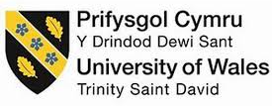
DECLARATION FORM

Master’s Degrees by Examination and Dissertation Declaration Form

- This work has not previously been accepted in substance for any degree and is not being concurrently submitted in candidature for any degree.
Signed:

Date: 02/11/2023

- This dissertation is being submitted in partial fulfilment of the requirements for the degree of MA in Physical Education, Sport and Physical Literacy
Signed:

Date: 02/11/2023

- This dissertation is the result of my own independent work / investigation, except where otherwise stated.

Other sources are acknowledged by explicit references. A bibliography is appended.
Signed (candidate):

Date: 02/11/2023

- I hereby give consent for my dissertation, if accepted, to be available for photocopying, inter-library loan, and for deposit in the University’s digital repository.

Signed (Candidate):

Date: 02/11/2023

Supervisor’s Declaration.

I am satisfied that this work is the result of the student’s own efforts.

Signed: ………………………………………

Dated: ………………………………………….

Contents Page
Page Number

- - Introduction 1
  - – Aims 2
  - - Objectives 2
- – Review of Literature 3
  - - Physical Literacy and Physical Activity 5
  - - Research into Perceptions of physical literacy 6
- – Methodology 13
  - – Procedure 14
  - - Participants 15
  - - Ethics 16
  - - Analysis 16
  - - Research Trustworthiness and Reliability 17
- – Results 18
  - – Questionnaire Analysis 18
  - - Theme 1. Understanding Physical Literacy 32
  - - Theme 2. Motivation, competence and confidence 33
  - - Theme 3. Future careers 35
- – Discussion 37
  - - Understanding of Physical Literacy 37
  - - Motivation, Competence, and Confidence 41
  - - Future Careers 45
- – Conclusion 49
  - – Limitations 49
  - - Recommendations 51

Page Number
7.0 – References 54
8.0 – Appendices 62
8.1 – Participant Informed Consent Form 62
8.2 – Copy of the Questionnaire 64
8.3 – Copy of the Interview Structure 68
8.4 – Example of a Transcribed Interview – Participant 1 72

List of Figures and Tables
Page Number
Figure 1 - Students response to the term ‘physical literacy’ 18
Figure 2 - A breakdown of the different courses of
study for the participants 19
Figure 3 - Overview of the participant’s opinions of
the need for a positive physical activity experience. 19
Figure 4 - Overview of the participant’s opinions of
how important lifelong participation in physical activity. 20
Figure 5 - Overview of the participant’s opinions
on the importance of confidence concerning different movements. 20
Figure 6 – Overview of the participant’s opinions
on the importance of an individual being physically component. 21
Figure 7 – Overview of the participant’s opinions
on the importance of motivation, linked to moving 21
Figure 8 – An overview of the intended future
careers for the participants within the study 22
Figure 9 – An overview of participants opinions
surrounding a philosophy linked towards physical literacy. 23

Page Number

Table 1 - Analysis of the Questionnaire responses,
and creation of key themes 24

1.0 – Introduction
Current issues surrounding health and wellness, such as a lack of physical activity, contribute to rising healthcare costs (Quennerstedt, McCuaig and Mardh, 2021), with Uljas et al. (2022) highlighting global concerns with regard to inactivity and a decline in physical activity. Duncombe and Preedy (2020) also highlighted low levels of physical development in early childhood following authors’ discussions and observations with teachers and colleagues. They highlighted that previous research had identified that 9% of boys and 10% of girls (2-4) met the recommended daily physical activity levels. Teachers highlighted that children are now starting school less physically ready – with most teachers highlighting a decline over a 6-year period. Clark et al. (2022) suggest that children who achieve the recommended guidelines for physical activity every day are likely to have positive psychosocial indicators and less likely to have chronic diseases. However, worldwide, there is only a small proportion meeting this recommendation. Gavigan et al. (2023) suggest that the high percentage of children not participating in regular physical activity could be due to them lacking the necessary key physical skills.
Due to concerns about the lack of physical activities being undertaken, graduates from university programs will need to understand how to engage individuals. One concept that is gaining attention to address this is Physical Literacy. The International Physical Literacy Association (2017) states, “Physical literacy can be described as the motivation, confidence, physical competence, knowledge and understanding to value and take responsibility for engagement in physical activities for life.” Whitehead (2019) comments that physical literacy should challenge professionals to consider how they can engage others in a wide range of physical activities to gain potential benefits from this. Stoddart and Selanders (2022) suggest that within a world with ever-increasing sedentary behaviour, physical literacy provides the tools to break this lifestyle. Stoddart and Humbert (2017) highlight that physical literacy has been identified as an approach to help children become physically active and reduce sedentary behaviour. Physical Literacy is a method the full school environment uses to promote physical activity (Harvey and Pill, 2019). Roetert, Ellenbecker and Kriellaars (2018) argue that physical literacy contributes to the development of a healthy life for the duration of the lifespan and is possible across many fields, including sport, recreation, injury prevention and education (Kriellars, 2013).
Physical Literacy is an area of interest for the researcher with application to their profession of a university lecturer. There is a desire to ensure graduating sports students are fully prepared for future careers, and physical literacy knowledge would enhance their future practice. Therefore, this study explores students understanding of this concept.
1.1 - Aim:
To develop an understanding of undergraduate sports students perceptions of physical literacy at a West Midlands University.
1.2 – Objectives:
- Assess students perceptions of physical literacy
- Explore graduate’s opinions of the inclusion of physical literacy within sports-based undergraduate programs
- Review how motivation, confidence and competence will be developed by students on completion of their studies

The next chapter will consider the development of physical literacy in the literature, highlighting existing research and students in particular focused on perceptions of Physical Literacy. The next section will provide an overview of the methodology used to conduct the study and the data collection methods used. The following section will present the findings from the review of the responses provided from interviews and questionnaires, with the creation of key themes from the responses received. The penultimate section will discuss the findings in relation to the perceptions of the participants and make comparisons with previous research surrounding physical literacy perceptions. The final section will provide limitations to the current study, which will be linked to recommendations for future studies. With an overall conclusion provided.

2.0 - Review of Literature
This chapter outlines the literature and existing research in relation to the research problem, as outlined in the previous chapter. Firstly it discusses the concept of physical literacy, secondly, the links to physical activity and finally, existing research into understanding of the concept.
The earliest term of physical literacy began in the late 1880s with Maguire and the United States Army Corps of Engineers. They referred to physical literacy as movement competency while in a social setting. The term ‘physical literacy’ in the 1930s was highlighted as an educational requirement that was seen as just as important as ‘mental literacy’ among high school graduates (Nebraska state educational association, 1931; National Education Association of the United States. Dept. of secondary teachers, 1935; British Institute of Adult Education and National Institute of adult education, 1937). Canadian Association for Health (1958) highlighted that greater motor skill competency or developing physical literacy was a compulsory requirement to develop physical activities beyond basic movements such as walking. Within Kelly and Strafford (1965), they highlighted that physical literacy continued to be identified as movement competence or proficiency in motor skills. Which they felt were important for both physical activity and fitness.
In the late 1960s, George Morrison proposed that ‘to be physically literate, one must be imaginative, creative, and clear in expressive movement and efficient in utilitarian movement and inventive, versatile and skilful in object movement (Wall, 1994).
During the 1960s and 1970s, physical literacy continued to be an important requirement for fitness and physical activity, which was linked to health benefits. Although there are early origins of physical literacy, according to Whitehead (2010), there hasn’t been much debate on the concept until recently. Indeed Dr Margaret Whitehead created a new interest in physical literacy, as she felt this area needed reviving, alongside the association with a healthy lifestyle and physical activity (Whitehead, 2001). According to the International Physical Literacy Association (2017), Whitehead is seen as the modern champion of the physical literacy world and is the co-founder alongside the Canadian Sport for Life organisation of the Internal Physical Literacy Association. Whitehead (2010) states that physical literacy is a universal concept for anyone regardless of where they live, gender, age and culture. In addition, Whitehead (2001) proposed that physical literacy focuses on the whole person, is unique to every individual and helps improve the quality of life.
Having a philosophical background, Whitehead created a more diverse definition of physical literacy ‘Physical Literacy is described as the motivation, confidence, physical competence, knowledge and understanding to value and take responsibilities for maintaining physical activity and pursuits throughout the life course’ (Whitehead, 2013; International physical literacy association, 2015). During the development of the definition, Whitehead considered that physical literacy was more than fundamental movement skills, prompting the inclusion of psychological components within the definition. A variety of organisations have developed various definitions of physical literacy. Physical and Health Education Canada (2014) focused more on an educational definition of physical literacy ‘Individuals who are physically literate, move with competence in a wide variety of physical activities while in multiple environments which benefit the health and development of a whole person.’ In contrast, Canadian Sport for Life (CS4L) defined a physically literate individual as ‘Physical literacy is the cornerstone of both participation and excellence in physical activity and sport’ and also defined physical literacy as ‘mastering of fundamental sport skills and fundamental movement skills that permit a child to read their environment and make appropriate decisions, allowing them to move more confidently and control within a wide range of physical activity situations’. Also, in Canada, physical literacy is a foundation for lifelong participation in physical activity (CS4L,2014). This is due to physical literacy developing the whole person, with body and mind seen as one. Edwards et al. (2013) and ParticipACTION (2015) comment that psychomotor learning is seen as a recognised element of physical literacy, with other domains (cognitive and affective), plus there is considered an association with a variety of variables, including behavioural, physical and psychological. Gately (2010) highlights that physical literacy is more than just about physical competency. As it is proposed it can influence important outcomes, including motor skills, strength, obesity, and cardiovascular fitness. In addition, Alagul (2012) and Macdonald et al. (2014) believe physical literacy could help improve academic performance. Whitehead (2010) has suggested that physical literacy has the opportunity to generate health benefits. In addition, there is the potential to reduce cardiovascular diseases, including diabetes and cancer, in children and adults (Warburton, Nicol, and Bredin 2006; Gately, 2010); Almond, 2013; Reiner et al, 2013). Durden-Myers, Meloche, and Dhillon (2020) suggest that physical literacy aims to develop human potential through positive interactions with the world and central to this concept is the lived experience. Physical literacy is a concept that aims to promote lifelong participation in physical activity. Reflection this PartipACTION (2015) have identified that Canada’s physical literacy statement has four elements. Which should be considered within in any context when considering physical literacy: (1) Motivation and confidence, (2) Physical competence, (3) Knowledge and understanding, (4) Engagement in physical activities for life.
2.1 - Physical Literacy and Physical Activity
Several sources have highlighted that a physically literate individual can complete a variety of fundamental motor skills, which allows the individual to participate confidently in different physical and sporting activities. Plus, interact in different environments confidently (CS4L, 2014; Higgs, Balyi and Way, 2008; Mandigo et al., 2009; Whitehead, 2001). Regarding environments, CS4L (2014) states that if an individual can have a range of skills, this will increase the focus of being physically active for life in environments such as water, on-air, snow and land. In addition, Jefferies et al. (2019) state that physical literacy includes movement vocabulary, movement fluency and physical proficiency. Researchers have highlighted that although physical literacy can be developed at any point, that childhood is the optimal time to develop (Higgs, Balyi and Way, 2008; Mandigo et al, 2009: Whitehead, 2010). Delaney et al. (2008) suggest that physical literacy development should be considered in line with a child’s development of numeracy and literacy. Cairney et al. (2016) suggest physical literacy can provide a powerful framework for viewing movement in relation to fundamental movement, the environment created and the positive affective elements that help create a positive psychological mind-set. If an individual can have the opportunity to develop physical competence in such areas as running, jumping, catching and throwing for example, then there is an opportunity to participate in a variety of physical activities, but as Higgs et al. (2008) comment, if competence isn’t developed then it will result in dropping out of physical activities. Teachers alone do not influence children’s behaviour. Parents, teachers, and coaches can collaborate to ensure that a child is active for life (Decobby et al., 2005; PHE Canada, 2013). Durden-Myers, Meloche, and Dhillon (2020) state that physical activity for lifelong requires a physical literacy practice to provide meaningful opportunities to experience the lived experience and lifeworld interactions—the richer and more varied the experiences, the more opportunity for humans to realise their full potential.

Keegan et al. (2013) comment that many research groups, governments, policymakers and organisations have advocated using physical literacy interventions to assess the impact on an individual’s development. However, Giblin, Collins and Button (2014) highlight that due to the nature of physical literacy, it is challenging to measure the impact or attributes. In addition, Giblin, Collins and Button (2014) mention that a tool to measure needs to be more than focused on skill attainment. According to Giblin, Collins and Button (2014), there is a limitation to the assessment tools available as these do not consider the way an individual interacts with the environment to complete the skilled movement. However, Robinson and Randel (2017), are of the belief that physical literacy doesn’t need to be measured. In addition, they commented that by measuring, you are moving away from the value of the concept.

Although there are limitations to measuring physical literacy, there are three Canadian tools, but these are restricted to land only. Kriellaars (2013) developed the first test, Physical Literacy Assessment for Youth (PLAY), which is focused on a holistic measurement of a child’s physical literacy level. These measurements involved six tools: (a) PLAY Coach; (b) PLAY Parent; (c) PLAY Self; (d) PLAY Fun; (e) PLAY Basic; (f) PLAY Inventory. The test involves 18 different tasks and provides a total score. The test provides information on the confidence and competence of the individual. The 2nd test is the Canadian Assessment of physical literacy (CAPL) tool, developed by HALO (Healthy Active Living and Obesity Research Institute). The tools focus on, according to Tremblay and Lloyd (2010) and Longmuir et al. (2015), Fundamental skills throughout obstacle course, Physical activity behaviour, Physical fitness and a Questionnaire assessing awareness, knowledge and understanding. The assessment uses jumping, catching, throwing, hopping, and kicking. The third assessment is Passport for Life, a tool designed by PHE Canada that supports the advancement and development of students’ physical literacy (PHE Canada, 2013). According to PHE Canada (2013), the tool focuses on four areas, which are active participation, movement skills, fitness skills and living skills. The tool focuses on self-report questionnaires and objective testing.
2.2 - Research into perceptions of physical literacy
Although there have been numerous studies focused on physical literacy, there have been concerns that the concept has been misinterpreted or misunderstood. Jurbala (2015) questioned the concept of physical literacy. Numerous definitions have been provided, which support a number of positions that supports the user in a designated area. This would suggest that the definition has been adapted when required. Young et al. (2021) suggest confusion with the subject matter means that the concept of physical literacy is being misused or misunderstood. Young, O’Connor and Alfrey (2020) Highlighted the misuse of physical literacy within Long Term Athlete Development models, where this is more motor learning and development than the physical literacy concept. They highlight that the concept doesn’t need a single definition or set in stone. Links with fundamental movement skills and physical competence cause confusion with regard to physical literacy and its concept. Shearer et al. (2018), within their review, noted that the use of different definitions in different countries confused at times, which resulted in the concept being implemented inconsistently. There are a number of inconsistencies surrounding physical literacy (Edwards et al., 2016). Dudley et al. (2017) suggest that further empirical evidence is needed before physical literacy can be considered best practice.

There aren’t any studies focused on undergraduate students’ perceptions of physical literacy, with the existing focus placed on teachers’ perceptions of physical literacy and that of pre-service teachers. This has been done by both Physical Education and general-subject teachers.
Harvey and Pill (2019) completed a study focused on Physical Education teachers’ interpretation of physical literacy. The justification for the Harvey and Pill (2019) study was that physical literacy is not universally understood or accepted, with some criticism of how institutions have approached it. The study method data collection was via social media —specifically Twitter, with hashtags used for the researchers to collect opinions. Within the study, 79 participants engaged in a 1-hour discussion. The following points were raised and reported from the discussion by Harvey and Pill (2009). Participants in the study discussed the idea of physical literacy being a potential ‘touchstone’ and ‘organises our understanding of the learning’. In addition, physical literacy provides an educational focus. However, there is confusion about how an understanding of physical literacy is provided to Physical Education practitioners. The sample also highlighted the confusion concerning physical literacy and fundamental movement skills. As the concept has previously been linked to motor skills, it has been confused by participants in the existing research. Harvey and Pill (2019) suggested that Physical Education teachers would be motivated to use physical literacy to raise the creditability of the subject area. It was noted that the physical literacy philosophies could enhance the subject area and also help increase children’s movement and competence. Physical literacy was seen as the solution to children's lack of physical activity for the responses received. Physical literacy could be the change to help develop the curriculum of PE. However Harvey and Pill’s work highlights a lack of structured understanding of physical literacy and its concept, which has caused confusion.
There were limitations to Harvey and Pill’s (2019) study, which focused on the use of Twitter to collect responses—limited to those who have access to social media platforms. Also, there is limited opportunity to expand on the ideas as limited to a set number of characters. Plus, if participants didn’t use the correct #, their responses wouldn’t have been recorded. Finally, the influence of others agreeing with others instead of exploring their full opinions on the subject matter.

The Robinson, Randall, and Barrett (2018) study reported similar findings to Harvey and Pill (2019), with confusion surrounding physical literacy. Within their research, Robinson, Randall and Barrett (2018) state that Physical Education teachers appear to rely on policymakers’ decisions/interpretations of physical literacy instead of having a clear understanding of it. This can compound the differing interpretations of different Physical Education teachers. In addition, generalist teachers are also confused and misguided concerning physical literacy and its concepts and its impact on children. The 22 participants were Physical Education teachers within Robinson, Randall, and Barrett’s (2018) study and were based in a single province in Canada. The study’s findings highlighted general confusion concerning the relationship between Physical Education and physical literacy. Physical literacy is being used as an outcome for Physical Education and in areas as a justification. Robinson, Randall, and Barrett (2018) believe that if Physical Education teachers can’t see a difference between Physical Education and physical literacy then this is concerning. Whitehead has presented papers which have attempted to clarify the differences between the two areas (physical literacy and Physical Education). Physical literacy is focused on humans reaching their full potential via movement, and each individual is unique. Physical literacy differs from Physical Education and offers no threat to the subject area. Robinson, Randall, and Barrett’s work suggest teachers believed that physical literacy is about providing children with more opportunities to move and also experience different ways to move with early research focused on the need for various movements across various environments. The idea of physical literacy being part of other lessons was highlighted, with an example of balancing on a beam and completing reading or maths activities simultaneously. Physical literacy has been used to support other areas, which has added to the misunderstanding or interpreting of the concept. Robinson, Randall, and Barrett (2018) discussed that developing fundamental motor skills will promote or lead to physical literacy is a misconception as no evidence has been provided to support this. This was highlighted by the participant’s feedback in the study. As they focused on fundamental motor skills, believing this is physical literacy, but in fact, fundamental motor skills have been part of the Physical Education focus for many years. However, it could be conceded that movement competency is an important aspect of physical literacy. However, movement competency alone doesn’t constitute physical literacy (Whitehead, 2010).
Robinson, Randall, and Barrett (2018) highlighted the following findings from their study suggesting that it was alarming to the researchers that some participants had completely incorrect and incompatible understandings of physical literacy, confusing physical literacy and fundamental motor skills. They suggest that an incomplete understanding of the concept of physical literacy is troublesome as the participants are leaders in Physical Education and that all prospective teachers and practising Physical Education teachers ought to have an understanding of the philosophical foundations that physical literacy is built upon. Physical literacy has the potential to offer something new and greater. It involves Physical Education teachers looking at their work further and making a difference.
Foulkes et al. (2020) completed a study with teaching staff views and opinions via semi-structured interviews and focus groups focused on physical literacy development in the preschool years. It was highlighted that within a preschool setting, staff would support children on their physical literacy journey. Foulkes et al. (2020) highlighted that staff in preschool settings were in need of additional training to gain further support for the delivery of physical literacy. The results highlighted the participants, confusion surrounding the physical literacy definition and participants raised concerns with regard to ideas to support physical literacy, as there was a consensus that the strategies focused on physical activity, with limited information presented on the other areas of physical literacy (Foulkes et al. (2020). This would highlight that more consideration is given to how physical literacy concepts are delivered to practitioners/potential practitioners and supports the focus of this study to explore undergraduate perceptions of physical literacy.

Similar to the previous studies mentioned Stoddart and Humbert (2017) completed a mixed-methods study, with 106 teachers responding to the questionnaire. As with previous studies mentioned, Stoddart and Humbert, highlighted that Physical Education educators did not fully understand the role or purpose of physical literacy. They also suggest that as specialists and generalist teachers are involved in developing physical literacy, an understanding of the concept is needed. Teachers play a key role in developing and fostering physical literacy, so it is important to understand what teachers know about physical literacy (Stoddart and Humbert, 2017). An interesting finding from Stoddart and Humbert’s study was no real differences between specialists and generalists in their understanding of physical literacy. This would suggest knowledge of the teachers regarding physical literacy needs enhancement. Most of the teachers in their study did not understand the concept of physical literacy, which may result in confusion over definitions. Teachers highlighted the lack of time to develop the subject of Physical Education, which they felt impacted the opportunity to develop physical literacy. A recommendation of the Stoddart and Humbert study was for future work on how teachers are gaining their physical literacy knowledge is needed.

Following on from their previous study, Stoddart and Humbert (2022) completed interviews with six teachers. As the previous Stoddart and Humbert (2017) study, Physical Education teachers had a partial understanding of physical literacy. Many in the sample were uncertain about developing physical literacy within their teaching. They highlighted that Physical Education is a method to promote physical literacy. All participants, apart from the Physical Education specialist, demonstrated that they were unaware of a connection between Physical Education and physical literacy. However, participants couldn’t provide awareness of links between subjects could be possible Stoddart and Humbert (2022). Links between Physical Education and physical literacy also could be impacted as the non-Physical Education teachers mentioned a lack of planning for Physical Education lessons.
Stoddart and Humbert’s (2022) recent research study highlights several key aspects, the complexity of physical literacy as a concept, teacher’s need to understand to help pupils become physically literate, physical literacy is more than learning movement concepts being focused on the development of the whole person. The purpose of Physical Education and physical literacy needs to be understood by teachers to help ensure that lifelong participation in physical activity is achieved. Teachers play a key role in developing and fostering physical literacy.
The conclusion from Stoddart and Selander’s (2022) research is to strengthen pre-service teachers’ understanding and use of the four essential and interconnected elements of physical literacy. Plus, the philosophical foundation of physical literacy and the development of inclusive practices to help prepare teachers to support every student on their physical literacy journey. However, their study was conducted after the PETE program, so it’s unclear of their physical literacy knowledge following their undergraduate program.
Edwards et al. (2019) investigated the continual professional development of primary school teachers to deliver physical literacy. Within the study, two primary schools were chosen with separate demographic. The programme used had a three-phase approach. Edwards et al. (2019) highlighted that practitioners need to be aware of the philosophical underpinnings of physical literacy. To understand the concept and use it within a teaching or coaching environment. In addition, Physical Education is seen as the main opportunity to help children to develop their physical literacy. This means those involved in this delivery have a prior understanding of physical literacy. Physical Education for most children is their first experience. It must be of high quality to encourage involvement in physical activity but also for the person leading to have knowledge and experience of physical literacy. The findings of Edwards et al. (2019) highlighted that there was potential for individuals to gain an understanding of the impact of physical literacy with the whole person mentioned and the idea of enjoying physical literacy when they leave school. To enhance the research, it would have been improved to know the participant’s thoughts on physical literacy before undertaking the training, as this would allow us to assess the impact of continual professional development.
Limited research surrounding the perceptions of physical literacy is the reason for this study to be conducted. The previous studies focused on school teachers. Previous studies (Harvey and Pill , 2019; Robinson, Randall and Barrett, 2018; Stoddart and Humbert (2017); Stoddart and Humbert, 2021; Foulkes et al., 2020). They have highlighted general confusion about physical literacy and Physical Education. With the majority of the participants needed clarification on what physical literacy is and how they would deliver it within their teaching practice. Edwards et al. (2019) reviewed the impact of CPD training, which enhanced the participants’ knowledge within their study, but previous physical literacy training wasn’t recorded. The Stoddart and Selanders (2022) study highlighted that integrating physical literacy within a teacher-education programme could prepare teachers to support students on a physical literacy journey. However, this study didn’t review physical literacy knowledge before their PETE program. With the previous studies focused on teachers, this study will focus on undergraduate sports students to investigate if there are misconceptions about physical literacy at this stage of their learning.

The following chapter will provide the methodical approach used to collect responses focused on perceptions of physical literacy, with the background to the data collection methods and participants within the study.

3.0 - Method
This chapter outlines the rationale for the research design and methodological process in the study to address the research question of undergraduate sports students’ perceptions of physical literacy within a West Midlands University. Firstly the chapter outlines the research position and design aligned to this, next the methods for data generation are outlined, participants and ethical considerations. Finally, the data analysis and approaches to ensure the trustworthiness for the study are discussed.
A small-scale mixed methods study with an interpretive paradigm has been developed using questionnaires and interviews. Flick (2006) considers qualitative research relevant to the study of social relations as it demonstrates a variety of perspectives which within this study were based on the participant's opinions to address the research question. This approach considers that viewpoints and practices in the field differ because of the various subjective perspectives and social backgrounds (Jones, Brown and Holloway, 2013).
Cohen, Manion and Morrison (2011) suggest that the interpretive approach centres on the individual and their thoughts and opinions on the subject matter, with Blaxter et al. (2006) highlighting that the interpretivism paradigm is focused on the individual's opinion and is widely used in the field of social research. Weber (1995, cited in Blaxter et al., 2006) suggested that the social sciences are concerned with understanding a selected area. As such, this research approach was used to develop an understanding of the student’s knowledge of physical literacy.
Lynch (2010) suggests that questionnaires are a flexible data collection method to gather many responses and can be used for any sample size. In addition, Lynch (2010) highlights that questionnaires can allow for information to be collected on the same questions for the responses to be analysed, comparisons to be made, and patterns and themes found. As Cohen, Manion and Morrison (2011) highlight, interviews are a method that allows for the further exploration of participants' opinions.
Before conducting the research with the identified participants, the researcher completed a pilot in order to remove problems not considered during the data collection development (Bajpai , 2011). Piloting is needed when developing a good questionnaire or any process of collecting data and is necessary to ensure the questionnaire developed allows for the analysis to answer the research questionnaires developed (Bell, 2005). The pilot was conducted with a small sample of two sports lecturers to ensure that the selected target group understood the questions during the entire research project and that the method developed was appropriate. In addition, consideration was given to how the technique was delivered to the participants and to diagnose any problems with the aid of an independent individual.
To ensure the questionnaire is ethical, the researcher has followed guidelines provided by Cohen, Manion and Morrison. (2011), who state that to achieve an ethical questionnaire, it should not invade privacy or ask for sensitive information. In addition, all the participants were volunteers for the study and were able to remove their completed questionnaire if they so wished. The questionnaire introduction provided this information to participants. The questionnaire used both open and closed questions. The combination of open and closed questions provided data on specific issues for comparison, allowing the researcher to analyse the views in a visual format and for the participants to provide their opinions with open questions. These two questioning methods allowed for the collecting both quantitative and qualitative data to increase the validity and reliability of the responses provided to answer the research questions.

Cohen, Manion and Morrison (2011) suggest that questionnaires can be administered without the researcher being present and can be straightforward to analyse. Denscombe (2007) highlights questionnaires’ limitations, including incomplete or poorly completed responses to questions and limited opportunities to provide detailed answers. However, combining the questionnaire with follow-up interviews ensured the opportunity to follow up on the topics to explore participants’ opinions.

3.1 - Procedure
An announcement was placed on course programme pages on the university virtual learning environment area. The announcement requested the completion of a questionnaire for a research study. However, it highlighted that this was optional. The announcement was posted on the 14th of February 2022, the academic year's first teaching day of semester 2. Only a single announcement was published, and no further announcements were made. Verbal encouragement was provided by the researcher, which was a reminder of the questionnaire and whether could it be completed where possible. The questionnaire was closed on the 8th of July, 2022. The questionnaire was completed via Google Forms. An overview of the study was provided before the participants completed the questionnaire (appendix 8.2).

Interviews were conducted between 4th July 2022 and 12th July 2022. The interview participants volunteered via both email and verbal confirmation. All interviews were recorded via Microsoft Teams and the transcription function. The interviews were conducted at a time suitable to the participants, and a Microsoft Teams link was sent via email to the participants before the scheduled interview. Each participant had to give verbal consent, answering the participant consent form (appendix 8.1). The participants were given a number for them to be able to be withdrawn from the study at any point. Upon completion of the interview, a transcribing process was completed. The interview recording was re-watched, and the transcription was reviewed and corrected. A copy of the transcribed interview was sent to each participant for respondent validation, which is a member checking process (Birt et al., 2016)(appendix 8.4). An interview guide was used for all interviews (appendix 8.3).

3.2 - Participants
All participants were students studying a sports-based degree programme at a West Midlands university (n=80). The participants were from a range of levels of study. No personal details were required from the participants other than identifying the course and year of study.
Follow-up interviews were conducted (n=7) with both male (n=5) and female (n=2) students aged between 22 and 40 years old. All these participants had completed their final year of study and were awaiting their classification. The participants selected were not due to complete a postgraduate qualification within the university. The participants were from the following programmes of study: BA Sport and Fitness Studies (n= 2), BSc Strength, Conditioning and Nutrition (n= 2), and BSc Sports Therapy (n= 3). During the interview, participants provided their age, degree study programme, and future career choice which they intended to pursue at that time.

3.3. - Ethics
Before completing the study, an ethical consideration process was completed by the researcher. As part of the study, an ethical procedure for the University of Wales Trinity Saint David was completed and approved before contacting potential participants. The researcher, in addition, contacted the head of the department for the identified participants before beginning the study in line with the university's policies for completing research.
Each participant for the interview completed an informed consent form before starting the study (appendix 8.1) and had the opportunity to withdraw at any point. As highlighted by Cohen, Manion and Morrison (2011), informed consent is a process in which participants volunteer to be part of a selected study. In addition, informed consent was important for establishing the research relationship (Cohen, Manion and Morrison, 2011).
The current relationship between the researcher and the participants has to be highlighted, as that of a lecturer and student. As Etherington (2007) highlights, the researcher's current relationship is a power imbalance. Therefore, it was made clear to the participants that their participation in the study did not impact their programme of study or any future assessments or degree classification. The statement before completing the questionnaire highlighted that the process was voluntary. For the interviews, final 3rd-year students who finished their studies in the summer of 2022 were used to ensure that the power imbalance for interviews was removed.
Flick (2006) believes that beyond everything, researchers need to guarantee participants complete confidentially. The researcher for this study ensured that no personal details were recorded through either questionnaire or the interview process. For data protection, all interview recordings were deleted once transcribing had been completed.
3.4 - Analysis
A descriptive analysis was completed concerning the questionnaire responses. Further analysis was required of qualitative data from open questions. Thematic analysis of the questionnaires and interviews was completed via Nivo version 11. Braun and Clarke (2013) state that thematic analysis is a process of identifying themes across the dataset, and following Braun and Clarke’s (2013) steps, several clusters were created from the responses provided. Further analysis of clusters identified themes.

3.5 - Research Trustworthiness and Reliability
To ensure that the study completed was trustworthy, the researcher piloted the questionnaire and interview, ensuring that the questions allowed participants to give their opinions and address the research question Thomas and Nelson (2015). The piloting process used independent sources to ensure the questionnaire and interview structure was suitable for the research study to be completed.
The use of interviews and questionnaire provides the study with triangulation, as stated by Cohen, Manion and Morrison (2011), which is the use of two or more methods to collect data which allows for the study to provide further opinions and not become biased by the use of one data collection method.
An interview guide was used to ensure that interviews were conducted in the same manner to provide opinions on the research questions included (Thomas and Nelson, 2015) (appendix 8.3)
Cohen et al. (2011) believe that getting the right sample is vital and can affect the reliability of the study. The sample size can depend on the purpose of the study and the nature of the participants to be used. Combining questionnaires with interviews, this study was able to collect data from a larger number of participants whilst still being able to explore the opinions in depth in line with the interprevtivst paradigm.

The chapter has detailed the methodological approach used to answer the research question. Following the method chapter, the next chapter will be the results section, which will review the data collected from the participants.

4.0 - Results
The chapter presents the mixed methods result used to address the research question of undergraduate students’ perceptions of physical literacy.
The results have been split into different processes for the separate data collection methods. The questionnaire’s open and closed questions have been reviewed in a descriptive analysis format. In contrast, a thematic analysis has been completed on the interview responses and the open-question responses from the questionnaire. First, the descriptive analysis of the questionnaire will be presented, followed by the themes that were identified from the analysis of the combined qualitative data. Qualitative data were analysed thematically to align to the concept of physical literacy.

4.1 - Questionnaire Analysis

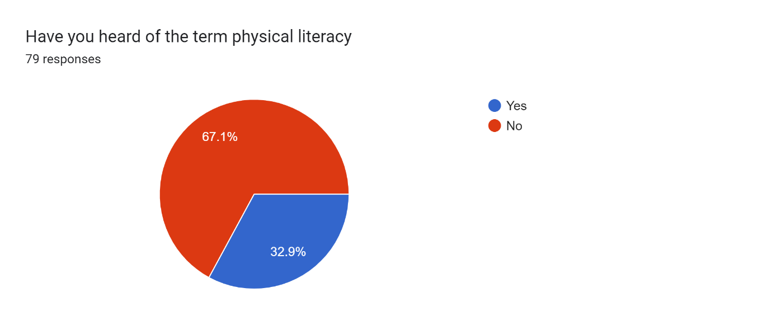
Figure (1) – Students response to the term ‘physical literacy’
Within the sample of the students questioned, the large amount hadn’t heard of the term physical literacy. However due to the response rate from the different programmes (Figure?), with 51.3% coming from programmes (sport and fitness, and sport, coaching and fitness) having being taught physical literacy within a module of study.
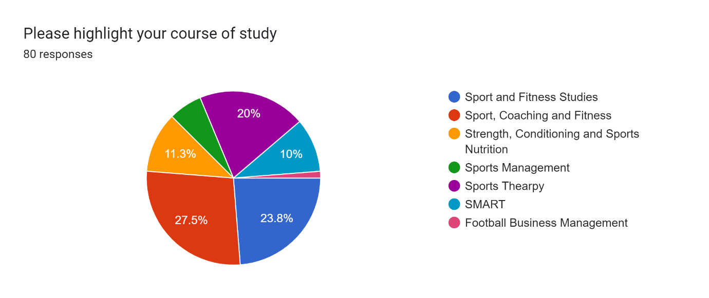
Figure (2) – A breakdown of the different courses of study for the participants.

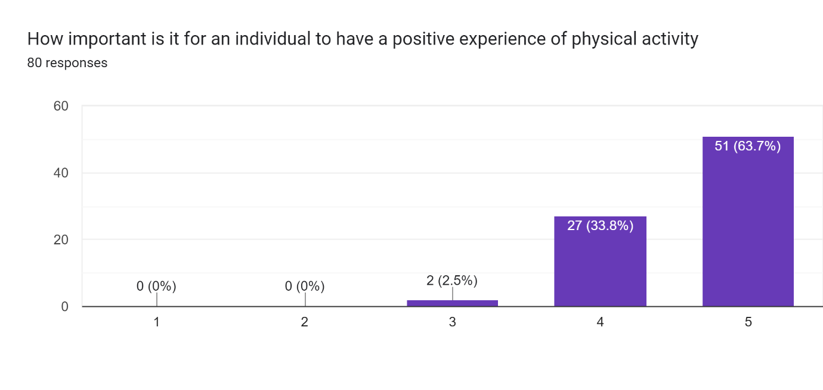
Figure (3) - Overview of the participant’s opinions of the need for a positive physical activity experience.
From the sample, 97.5% highlighted that having a positive physical activity experience was important to very important.
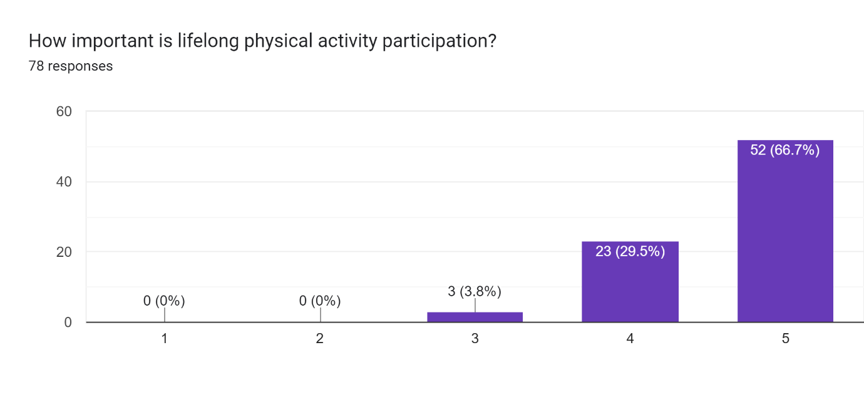
Figure (4) - Overview of the participant’s opinions of how important lifelong participation in physical activity.
From the sample, 96.2% highlighted that having a positive physical activity experience was important to very important.
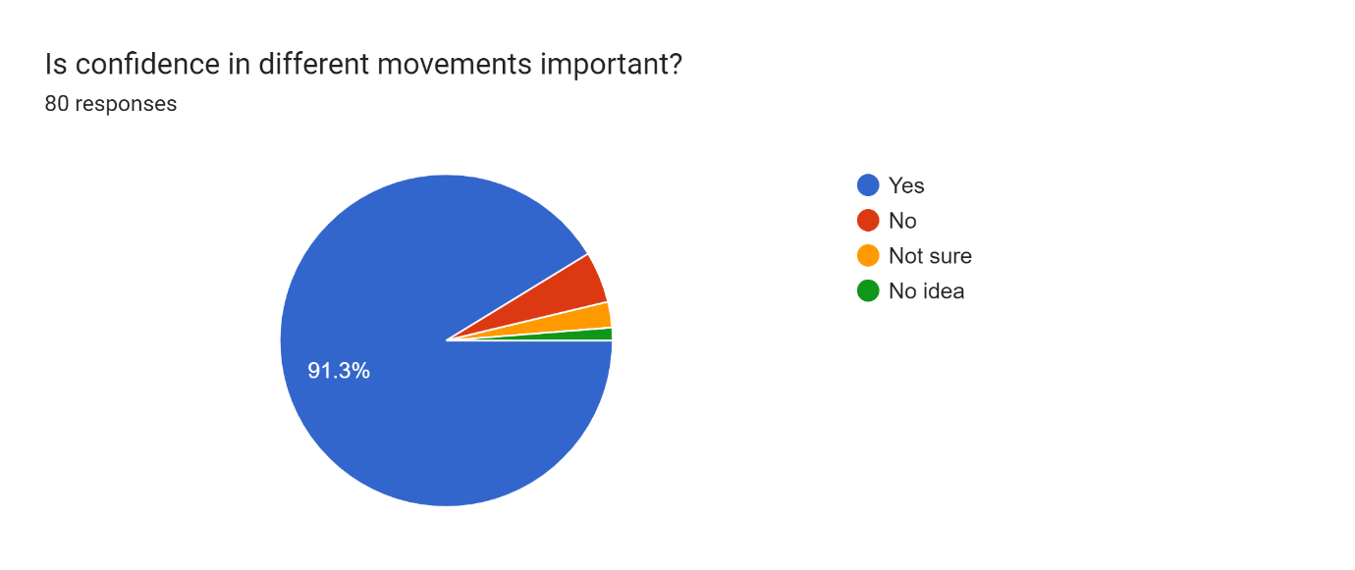
Figure (5) – Overview of the participant’s opinions on the importance of confidence concerning different movements.
From the sample, 91.3% have highlighted that having confidence in different movements is essential. However, the question wasn’t linked to sporting movements.

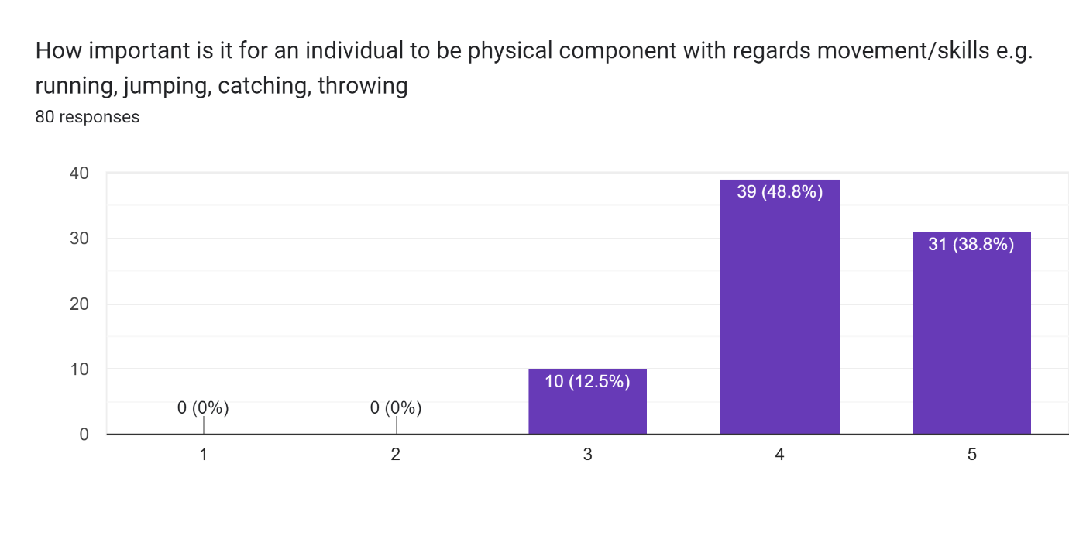
Figure (6) – Overview of the participant’s opinions on the importance of an individual being physically component.
From the sample, 87.6% highlighted that being physically component was important to very important. The physical componence is linked to physical movements and skills with locomotive and object-based, highlighted in the question.

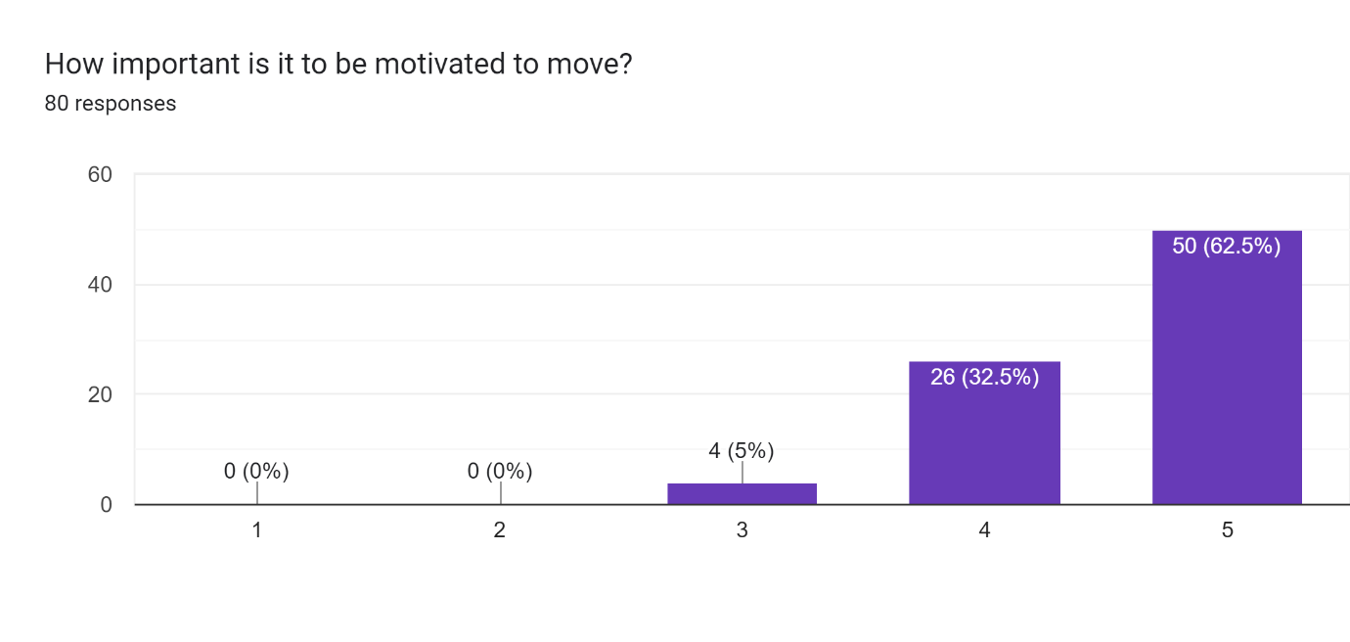
Figure (7) Overview of the participant’s opinions on the importance of motivation, linked to moving.
From the sample, 95% highlighted that being motivated was important to very important with regards to motivation and moving. From the question responses, participants highlighted the importance of motivation, but ideas on how this could be achieved were limited.
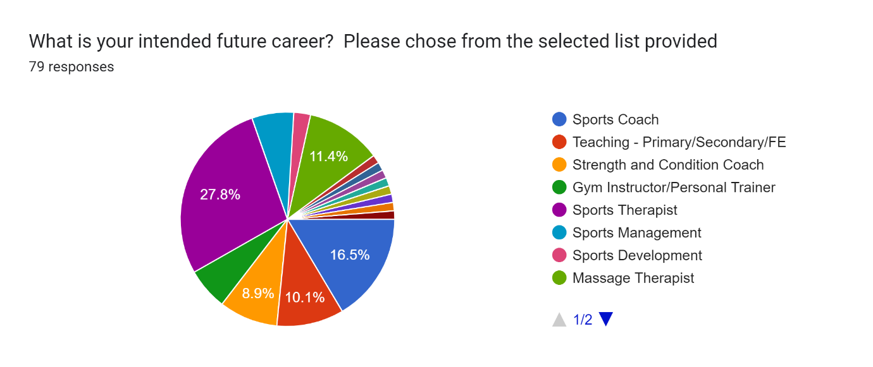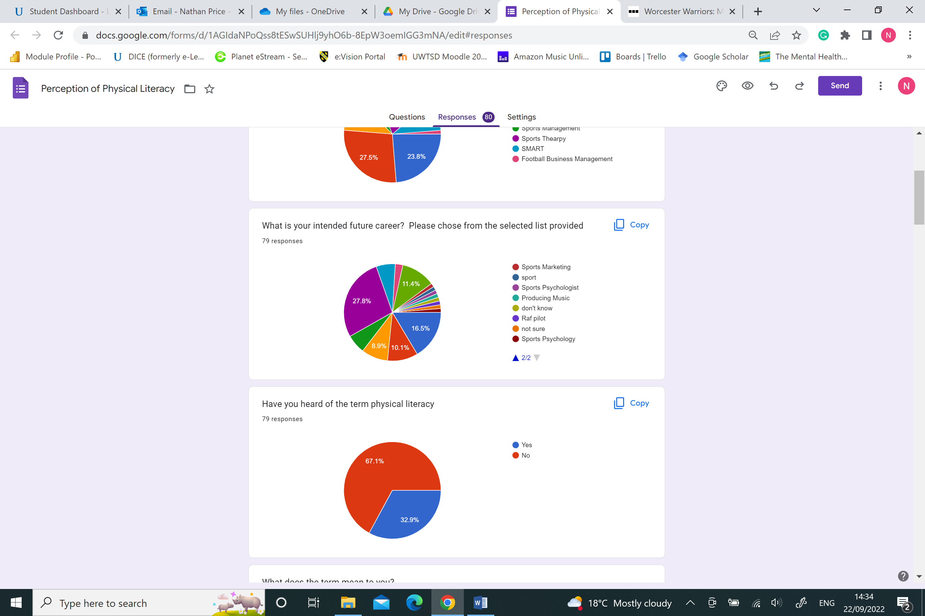

Figure (8) An overview of the intended future careers for the participants within the study.
The future careers highlighted included Sports Therapist (27.8%), Sports Coach (16.5%), Massage Therapist (11.4%), Teaching (10.1%), and Strength and Condition Coach (8.9%). It was anticipated that therapist (39.2%) careers would be the most chosen future career. As this programme of study has the most students enrolled.

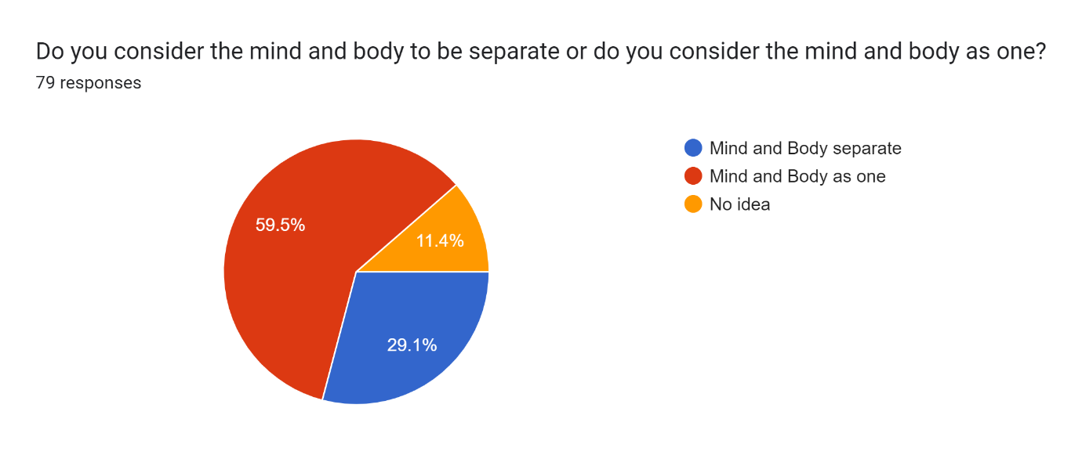
Figure (9) An overview of participants opinions surrounding a philosophy linked towards physical literacy.
From the sample, 59.5% of the participants believed that the mind and body were one, and 29.1% believed that the mind and body were separate. The remaining 11.4% had no idea about the question surrounding body and mind.

This section will focus on a thematic analysis of the interviews and open-question responses in the questionnaire. The responses received were coded in relation to the concept of physical literacy and refined into three overarching themes with subthemes.

Table (1) – Analysis of the Questionnaire responses, and creation of key themes
Theme | Relationship to Physical Literacy | Sub-Theme | Examples
Understanding Physical Literacy | What is Physical Literacy | The perception of the concept | Concerning the responses to their understanding of physical literacy was. There was a range of differing responses. This would be expected due to the participants in the study. However, the range of responses is from an understanding to a misconception.  A sample of responses linked to an understanding is below:  “Physical literacy means to have confidence and competence to perform fundamental skills. Such as developing running/ jumping/ hopping/ catching/ throwing etc from a young age in order to feel confident to participate in sport”  “Developing fundamental movements in order to be confident in participating sport and physical activity”  Other participants had some idea of the concept, below are a sample of responses:  “I think its to do with children and sporting movements but I can't really remember. It was discussed in a sports coaching lecture”  “Its something to do with young children and playing sport. I know motivation is included”  “Exploring of physical movements, and developing confidence in these”  “Its linked to lifelong participation in activities -really important within young children”  “The ability to value and take responsibility for engagement in physical actions for life”  “Having confidence in your self and your physical being.”  The misconceptions included, the following:  “Something to do with movements and writing”  “running while reading”.  “No idea - literacy is writing but don't get how linked to physical part”
 | Links to Philosophy and the perspective of Whitehead | Opportunity to explore and learn movements | Participants were asked for how their knowledge and understanding of movements has been developed. A range of different responses were provided, however an education environment was mentioned in a significant number of responses. This included, school Physical Education lessons, college and university lectures. Linked to this idea of education, other responses mentioned coaches or being taught by someone but not specific on who. One participant highlighted the use of videos via you-tube.  Below are a sample of responses received:  “by being taught by someone who understood movement”  “Learning, experience, time”  “Friendship groups and peers who had similar interests participating in games, PE and social activity”  “Learnt lots at university, but early experiences would be within primary school”  “school, college and university”  “PE lessons at school, and given more understanding at university”  “not sure, guess in primary school pe lessons”
Motivation, competence and confidence. | Key components of Physical Literacy. | Motivation | A sample of responses below, highlighted brief ideas but without any real indication of how motivating an individual could be achieved:  “Make it interesting”  “told they are doing something well”  “They experience the benefits”  “someone telling them to move”  “Introducing games, tasks or activities that will require physical movement”  “Physical shape, health and wellbeing, improved life expectancy”  Other responses began to add more indication of how an individual maybe motived to move:  “Encouragement and goals specific to them”  “give them encouragement and set goals to achieve”  “Positive feedback, and rewards”  “Highlight the benefits of movement, and create opportunities for them to do so”  “Having small goals that are achievable and rewarding themselves for achieving those goals”  In contrast two participants, highlighted more structured ideas towards motivation of individual(s) moving:  “Someone could be motivated to move by playing with friends/ find a fitness buddy/ going to a fitness class they enjoy/ make friendly competition with friends or family such as ‘ who can do the most steps ‘ /”  “Feel they are competent to engage/complete exercise; feel they have support from others and are able to be social; and that they have freedom/choice in what they are doing.”
Motivation, competence and confidence. | Key components of Physical Literacy. | Competence | Concerning developing componence, participants were asked to give ideas on how they would help create competence in different movements.  There was a range of responses, with some limited ideas with regards how confidence could be developed in movements:  “by doing it lots of times”  “Lots of coaching feedback, and correction of movements”  “Get them to watch you-tube at home of videos or in coaching sessions”  “i would encourage them by supporting them through verbal chats”  “teach them correctly”  “good coaching”  Some participants, gave a little more detail to the process they would use:  “by introducing then to the environment and movements slowly”  “Start at a beginner level. When learn some skills then okay a mini game where those skills would be used. For example in football, learning to control the ball.. ball possession and then play a mini match and continue to work on skills and improvements”  “allow the individual to explore, and create different opportunities”  “Teaching/coaching --> Practice --> Teaching/coaching --> Experience”  One participant, tried to explore the idea of developing competence in further detail:  “Start from the beginning. For example even if someone is an adult and struggles to perform specific movement.. teaching them from a reception level is best and can work up from there. To teach throwing and catching could be start catching a ball by hugging the ball into the chest and progress by catching with hands such as the 3 c’s ( cup, catch and chest). In regards to different things environments.. I’m not too sure but I will say to not just okay sport in one environment such as a hall.. maybe some days take it to an out door area to experience different weathers and other things around you.”  What was noted is that participants provided the same response for developing competence and confidence with individuals.
Motivation, competence and confidence. | Key components of Physical Literacy. | Confidence | The participants provided a variety of ideas concerning developing confidence for individuals. The responses varied in detail. The limited responses included:  “Positive experiences”  “by doing it lots of times”  “Practice”  “Teach them correctly”  “by encouraging them”  “Showing progression”  Additional responses provided further detail on possible ideas to help develop confidence:  “Learn from the basics or that movement. For example YouTube is great to visually see how different movements and skills can be executed. Learning simply how to throw and catch can give you confidence in not just one sport but different spots. Take up classes/ ask a friend to help you:”  “Learning at a beginner level such as throwing catching which can be used in various sports/ jumping/ running/ hopping. Learning and practicing skills can make an individual confident when put in a situation where they would need to show these skills. Getting praise can also encourage individuals to be confident and praising when they execute a skill well.”  “by giving children the opportunity to try and develop their own skills. let them take charge of the coaching environment and to encourage them”  What was noted is that participants provided the same response for developing competence and confidence with individuals.
Future Careers | Developing or enhancing physical literacy within career choice | Developing physical activity | Participants were asked to provide ideas, with examples on how they would help an individual to become physically active in their future career. There was a range of responses provided. The ideas presented in areas was limited in detail and examples.  One participant highlighted:  “I'm looking at coaching with children, so not sure how I can impact on this”  Other participants highlighted limited responses, on how they would achieve this:  “By them having fun”  “by educating them”  “by trying to do different activities to stay active”  “Explain the benefits to individuals”  Other participants, gave more detail to the process they would use:  “discuss with each patient the importance of a healthy lifestyle with includes regular physical activities like walking”  “Find out their hobbies: what sport do they enjoy. If they don’t enjoy sport.. what activity that requires being active and then look out for activities outside of education that they could attend”  “Going to create training programmes with lots of different opportunities and tell them the benefits of being healthy”  Finally some participants added further detail to some strategies they would use:  “See where there interests lie. Teach them skills as opposed to a specific sport unless they show interest in a certain sport. Encourage individuals to join extra curricular to make friends and learn new things and may even meet those who have similar interests.”  “Allow them to set goals short term and long term goals to help them see improvements and stay motivated. Also do variety of exercises allowing them to stay motivated and do sport specific exercises”  “Firstly, have them achieve small goals such as walking every day whether that being walking with a friend or the dog. Then slowly increase the intensity of this activity mostly through distance until the person is able or wants to start jogging/ running. Once this has happened have them start performing set runs e.g. 2.5k or 5k and timing them so they have a goal to improve their time. Then maybe introduce them into the gym based on what their goals are and work on developing their skills in the gym and their experience.”

4.2 - Theme 1. Understanding Physical Literacy
Understanding Physical Literacy is the first theme of focus. With consideration given towards their experiences of physical literacy. Plus their understanding of the philosophies of physical literacy developed by Margret Whitehead. Participant 7 was confident in their understanding of physical literacy from the interviews completed. However, this is due to them completing their final year research project on physical literacy. The remaining responses gave vague descriptions of their interpretations of physical literacy. Within the participants interviewed, a limited understanding of physical literacy was provided. In response, participants 1, and 2 mentioned ‘movements’, ‘fundamentals’, and ‘the ability to understand your own kind of movements’. Participant 4 hadn’t heard of the term but was able to gauge a link with physical activity, and Participant 6 created confusion by linking sport and physical activity. Again the questionnaire responses created a mixed response concerning understanding the concept of physical literacy. Several respondents highlighted the links to physical movements, and other responses mentioned functional movements and lifelong physical activity participation. As with the interviews, one respondent in the questionnaire sample detailed further, including confidence and competence with performing fundamental skills. As outlined in the methodology, the definition of the international physical literacy association was shared with the interview participants, following the participants providing their own thoughts on the definition. Participant 3 was surprised by the amount contained within the definition. The definition being shared allowed the participants to gain clarification of the area of focus for the study and for their perceptions to be provided further.
Linked to the understanding was the participants’ experience in terms of physical literacy. As before, the responses weren’t clear on whether they had experienced physical literacy. Participant 6 may have indicated difficulties in knowing if they had experienced physical literacy. As they said, what they experienced wasn’t branded as physical literacy, but from reviewing the information in the interview, they experienced it indirectly. Participant 1 offered a similar experience, “I’ve probably encompassed a lot of those things without realising”. Other participants offered a different perspective on their experience. Participant 3 said they “don’t know about the take responsibility, especially at a young age”. However, participant 5 highlighted “having the experience of learning new things that kind of brought joy”. This highlights that the participants have had varied experiences.
The philosophies of physical literacy were shared, as the participants interviewed did not know of these. However, once the different philosophies were shared, the participants were more interested in the concepts. The participants agreed with the concept that the mind and body are seen as one (monism). Participant 1 highlighted the idea of having a healthy body and mind. The exception was participant 7, who thought the mind and body were separate. For the second (existentialism) and final (phenomenology) philosophies, participants focused more on these areas. The participants mentioned the learning environment and different journeys of everyone. Participant 1 idea that “everyone’s journey with many things in life is very different”, and Participant 2 felt that you “kind of adapt to your surroundings”. Participant 3 went further with “a product of their environment”, and finally, participant 4 “kind of developed from life experiences”. These responses were a theme for all the interviewed participants. Participant 7 focused on phenomenology by stating, “Everyone will have a different thought of physical literacy.”
Overall the understanding of physical literacy was limited, with some experiences without realising. The exception was participant 7, who had previous experience with physical literacy with their research project. However, this knowledge didn’t include the philosophies of physical literacy. The definition provided gave an insight into the area, and participants started understanding the concept more.
4.3 - Theme 2. Motivation, competence and confidence.
The next theme focuses on motivation, competence and confidence. These are key elements of physical literacy. It became evident that there was confusion surrounding these areas and how participants would develop these in future careers. The first area of focus is motivation. All the participants had a basic understanding of motivation, with the responses focused on doing an activity for enjoyment, being an internal or external factor and having goals to achieve. However, there was a basic understanding of the concept of motivation. How to develop motivation, there was less understanding and vague ideas across interviews and questionnaire responses. The participants focused on creating enjoyable sessions or doing activities which you enjoy. Then a number mentioned the need for goals and achieving these. With positive praise, highlighting the benefit of physical activity and feedback mentioned. However, there was no consideration of how this would be achieved. It identified generic ideas without a single participant being specific about what that involved. The only exception was participant 5, who highlighted that individuals would be motivated differently and find methods to motivate someone. Again it didn’t give specific ideas or examples of how this would be achieved. This highlighted a lack of awareness and understanding about the application of motivation.
As with motivation, there was a basic understanding concerning competence. There were numerous participants, 1, 2, and 3, who looked at the concept of repetition of activity as a method for deciding if competence was achieved. Participant 6 highlighted the ability to complete many physical activities and rarely experienced an activity they couldn’t do. Participant 7 took a different approach and mentioned focusing on fundamentals instead of sport-specific ideas. What became apparent across the interviews and questionnaires was that there wasn’t a real understanding of what is considered competence in physical activities. The responses were vague. When asked how competence could be developed, as with motivation, different strategies were mentioned. However, for the majority of responses, it was limited. The generic responses focused on watching others perform and repeating a specific movement. A questionnaire response highlighted “Teaching/coaching --> Practice --> Teaching/coaching --> Experience” as a method to develop competence. Disappointingly the response didn’t explore this process further. Several responses focused on the coach's role in developing the performer's competence, but again, other than structured coaching points, and feedback, little more was provided. The final element of consideration was playing sports or completing physical activities with performers of a higher ability/standard. This was to act as an aspiration or to observe them perform the movements, which would allow for understanding and copying. The issue with the responses provided is the limitation of what is considered competence.
The final element is confidence. As with motivation and competence, the response was limited. There were links between confidence and motivation provided, plus confidence and competence. However, it was clear that strategies to develop confidence were not explored fully in the responses provided. Several participants (1, 4, 5 and 7) linked the idea of confidence and continuing to participate in physical activities. Within the questionnaire responses, ideas included positive encouragement and allowing support to be given to developing movements. Some responses considered the environment, but this was more the environment of the activity, e.g. clubs and schools, as opposed to the different environments to complete activities, e.g. indoors and outdoors. The development of confidence was linked to the individual leading the session, e.g. coach/teacher. The need for feedback and instructions was highlighted by participants 2 and 7 in their responses. Within the questionnaire responses, the same response for competence was provided for confidence “Teaching/coaching --> Practice --> Teaching/coaching --> Experience”, but again further exploring would have highlighted how. The idea of being out of the comfort zone was mentioned, but again, it didn’t explore how this could be linked to confidence and the purpose of this approach. As with the previous areas of competence and motivation, the limited responses haven’t allowed for a complete understanding from the participants.
Overall, the areas of motivation, competence, and confidence have, in general, demonstrated a need for more understanding from the participants regarding how they could develop and what each involves.
4.4 - Theme 3. Future careers
The final theme is focused on the future careers of the participants, with consideration to studying physical literacy as part of their undergraduate degree programme. All the participants interviewed are focused on a career working with people. Each career involved helping individuals complete physical movements. All the participants mentioned links to at least one of the following areas competence, confidence and motivation as an element linked to their future careers. Participate 3 highlighted a desire to work with children and to help them not lose motivation in physical activity. Similar was Participant 7, who wanted to use their knowledge from the undergraduate programme as a sports coach to create fun and engaging sessions. At the other end of the scale was Participant 6, who was focused on a career with elite performers. Participants 2, 4 and 5 focused on the patient’s rehabilitation within their chosen careers. They highlighted the idea of increasing engagement in physical activities as a critical element in helping their patients. Within the questionnaire, most responses focused on a career linked to supporting individuals to complete movements, either a fitness professional, coach/teacher or injury rehabilitation. Numerous responses highlighted the idea of highlighting the importance of physical activity on health. With positive experience mentioned, and the development of skills to feel confident. There was also the idea of varied training programmes linked to health and exposing them to different movements. A questionnaire response, which would have been interesting to explore further, was the response, “teach them skills, not sports”.
All the participants interviewed stated that they felt more understanding of physical literacy would be an element for inclusion in their degree programme by highlighting that from what they have heard in their interviews, further knowledge would have been beneficial. Participant 3 highlighted that it would be good background knowledge and help understand the journey of individuals they have worked with or could potentially work with more. Participant 6 wanted the inclusion of physical literacy before their degree programme and for the importance of the concept to be made clear when discussing physical activity. Participant 7, who completed a sports project around physical literacy, felt more was needed on the concept. Although it is discussed in the coaching aspect of the programme, more is needed to link with fitness-based modules.
Overall the participants in the study would have liked the degree programme to give more information on physical literacy as part of their undergraduate degree. The majority of careers are based on physical activity or developing another movement. Therefore this knowledge would prove beneficial.

The next section of the study will discuss the results of this study, with previous research focused on perceptions of physical literacy. Both questionnaire and interview responses will be used to highlight any common themes across this research study and previous studies.

5.0 - Discussion
This chapter critically discusses the results and findings presented in the previous chapter. The discussion focuses on an in-depth critical analysis of the three themes which emerged from the data analysis in relation to existing research and literature.
5.1 - Understanding of Physical Literacy
Whilst it could be expected that many participants would have yet to hear of the term physical literacy. What was surprising was that 50% of the participants were from a programme of study which included lectures based on physical literacy.
The findings of this study are similar to Harvey and Pill (2019), which highlighted that there was a lack of a structured understanding with regard to physical literacy in the participants in their research. In addition, Robinson, Randall and Barrett (2018) study discovered that some participants in their study had a completely incorrect and incompatible understanding of physical literacy. The researchers also commented that participants had an incomplete understanding of the concept of physical literacy. A study conducted by Stoddart and Humbert (2017) found that most participants did not understand the concept of Physical Literacy. The authors suggest that the term literacy could have caused confusion among participants as they might be thinking of a writing and reading concept. A further Stoddart and Humbert (2021) study found that all participants, except one, did not understand the concept of physical literacy. Finally, Foulkes et al. (2020) reported that the definition of physical literacy was a term misunderstood and caused confusion among 70% of the participants in the study. These studies highlight a similar outcome to the current study. Where there was a limited understanding of physical literacy. It appears there is a constant theme surrounding where the message of physical literacy isn’t being shared, not being listened to, or miscommunication of what the concept involves. In the case of this study, it is a mixture of two elements, with some courses of study not including the concept of physical literacy. In the course that does, the participants haven’t been able to recall the information.

In the case of the current study, physical literacy isn’t being made clear enough in the undergraduate programme it’s included within. This is a theme which aligns to other studies with Foulkes et al. (2020) highlighting a lack of clarity regarding physical literacy. In addition, Harvey and Pill (2019) highlighted confusion about how the concept of physical literacy provided to Physical Education practitioners. Robinson, Randall and Barrett (2018) suggested that their participants believed physical literacy was the rebranding of Physical Education. There needs to be further integration into the undergraduate curriculum of physical literacy. Foulkes et al. (2020) highlight that more consideration must be given to how physical literacy concepts are delivered to potential practitioners which is supported by Young, O’Connor and Alfrey (2020), who highlight the inconsistencies in the physical literacy definition and how it has been used within sports and public health. Within the current study, participants in the interviews discussed their previous experiences regarding physical activities. Participant 3 discussed their opportunities to participate in several activities. Interestingly they “fell out of love” with Physical Education and physical activities. The participant highlighted that whilst being a teenager was not motivated. The researcher asked about the school not highlighting the importance of physical activity. In response, the participant mentioned that Physical Education was just part of the timetable, but there was no inclusion of the long-term benefits of physical activity.
Participant 5 offered a similar opinion that the benefits of life-long physical activity were not an outcome of Physical Education within the school. They experienced different activities, but it was about keeping children active. The lessons were a mandatory part of the school and felt like a box-ticking exercise. All the participants mentioned they had the opportunity to take part in serval physical activities across both primary and secondary schools and those interviewed continued onto sport-based degree programmes, it would appear that they all are interested in sports or physical activities. It is therefore possible to suggest that Physical Education gave all interviewees an interest in physical activities. However, the message of the importance of lifelong participation hasn’t been made clear within the subject area. From the interviews it was clear that even though, the concept of physical literacy had been experienced, the participants weren’t aware of this, or the teachers weren’t aware they were developing physical literacy within their lessons. This is another theme of the research studies, including Harvey and Pill (2019), who highlighted confusion surrounding physical literacy and Physical Education. In addition, the participants mentioned that there was limited information provided to teachers on how to develop physical literacy. In addition, Robinson, Randall and Barrett (2018) highlighted that Physical Education teachers appear to rely on policymakers’ interpretations of physical literacy instead of having their own clear understanding. Stoddart and Humbert (2021) highlighted that teachers play a key role in developing physical literacy, so it needs to be understood by them so that lifelong participation in physical activity can be achieved. This is a follow on from a previous study by Stoddart and Humbert (2017), which highlighted the limited understanding of teachers with regard to physical literacy. As, teachers play a key role in developing and fostering physical literacy and the concepts of physical literacy are being misunderstood due to policymaker’s interpretations, there needs a rethink of how it is shared and communicated.
The current study, the participants have been based on sports undergraduate programmes, which is different to the other studies, Robinson, Randall and Barrett (2018), had 22 PE background teachers, Stoddart and Humbert (2021), six teachers with 1 being a PE specialist, Stoddart and Humbert (2017) 106 teachers a mix of generalist and specialist, Harvey and Pill (2019) study focused upon 79 PE teachers, and Foulkes et al. (2020) 9 teachers early years. Which highlights the challenge of sharing the physical literacy message. As where does it become integrated to ensure a constant message?
As it’s a concept linked to lifelong participation in physical activities, then it could be a continual reinforcement, but it needs to be integrated throughout the school curriculum and also post-compulsory education programmes which are linked to areas such as sport, early years, and health and social care, for example. Until the concept is shared throughout the different areas, it could be considered that physical literacy will continue to be misunderstood. The issue remains the same: integrating physical literacy within education and then into society so that it is understood by teachers, coaches, policymakers and those participating.

Sport England, from their Active Lives Children and Young People Survey (2022), refers to positive attitudes toward physical activities, and a link has been developed with physical literacy, with the definition from the international physical literacy association being highlighted in the report. In addition, Sport England (2023) is developing a new physical literacy consensus statement for England in partnership with several universities. This highlights the increased use of physical literacy in England and further emphasises the need for sports graduates to develop an understanding of this concept.
Whilst it is promising that Sport England is developing a statement linked to physical literacy, and this approach will help increase the message, caution is needed, as the previous studies have been completed in countries, for example, Canada and Wales, where physical literacy has been used more within their school curriculum. Stoddart and Humbert (2017), based in Canada, suggest there still needs to be clarity on what physical literacy involves. Sport England needs to ensure that physical literacy becomes an important element of their work with consistent messaging. Research into the concept needs to be given time so that the integration into schools and society can be measured in the future via questionnaires, focus groups and interviews.
The inconsistent level of knowledge about physical literacy in this study suggests there is still a need for suitable training. Edwards et al. (2019) focused on the continual professional development of primary school teachers to deliver physical literacy and suggest that an increased understanding of physical literacy can be achieved with the correct training.

A challenging aspect of understanding physical literacy is the three philosophies of physical literacy that Whitehead (2010) suggests underpin the concept. Previous studies have not investigated these as part of the perceptions of physical literacy. Quennerstedt, McCuaig and Mardh (2021), within their review, believe that if the philosophical principles of physical literacy are not appreciated, then this limits the potential of the concept. In addition, Harvey and Pill (2019) consider using the physical literacy philosophies in a Physical Education teaching context whilst helping participants move and improve competence. Robinson, Randall and Barrett (2018) also highlighted the importance of consideration of the three philosophies suggested by Whitehead (2010) to develop an understanding of physical literacy discussed the consideration of the three philosophies of Whitehead to develop Physical Education.
Within this study, the questionnaires focused on participants thoughts about the whole person reflecting Stoddart and Humbert’s (2021) views that physical literacy is focused on the development of the whole person. Interestingly within the questionnaire responses, 59.5% identified the mind and body as one and this element was explored further in the interviews.

Following an overview of monism, existentialism, and phenology was provided for the interview, each interviewee was asked about their thoughts on each one. Whilst participants were intrigued by the different philosophies linked to physical literacy, their views were different about the philosophies and appeared limited, making it difficult to draw, conclusions from the responses and highlighting the need for future research to consider the philosophies when researching physical literacy.
5.2 - Motivation, Competence, and Confidence
The next section will focus on the physical literacy attributes of motivation, competence, and confidence (Whitehead, 2010). From the participant's responses, it was noted that participants had little understanding of how to develop competency, confidence and motivation with individuals. For each area within the questionnaire, responses did not provide structured ideas. The questionnaire responses all highlighted the importance of motivation regarding movement. However, the responses to achieving this were basic and without clear strategies.
At times, the same response was provided. For motivation, it focused on limited responses focused around making it interesting, links to the benefits of health/well-being and feedback. These ideas could help with motivation, but the limited responses could be due to a lack of knowledge or not wanting to fully explore for the purpose of the research study. Ntoumanis and Standage (2009) suggest providing meaningful justification for completing the activity, including health benefits. The participants in the study have highlighted this but have not explored the processes they would use to convey the message to the individuals they would be working with.

Kremer et al. (2012) suggest that motivation focuses on a determination or a willingness to participate in sports or physical activity over time. Although participants would need some element of motivation to participate, there needs to be an element of professionals giving support to achieve this and as such, highlights the need for professional development to support understanding of physical literacy (Edwards et al., 2019).

Some more detailed questionnaire responses mentioned the idea that the individual has a choice. Niemiec and Ryan (2009) discuss the need for autonomy for individuals as a critical element within motivation, as individuals can have responsibility for their physical activity choices, and Self Determination theory identifies this a key element of motivation Deci and Ryan's (2000). Autonomy has been considered by the participants in a haphazard manner, with questionnaire responses including mention of “Positive experience, “Giving the opportunity to take control of the environment”, and “that they have freedom/choice in what they are doing”. Participant 1 highlighted that “The individual themselves need to understand they are accountable”, and Participate 6 commented “So motivation to do physical activity could just be that they enjoy if for themselves” and Participant 7 stating “allow them to give ideas for the different activities that take place in after school clubs for example”.

Another participant mentioned using goals, stating, “So just setting goals. So at the end of this goal, you will be able to do this, and then that will motivate that athlete then to” (participate 4), with a questionnaire response “Having small goals that are achievable and rewarding themselves for achieving those goals”. “Goal theory assumes that goals are cognitive representations of what individuals are trying to accomplish and their purposes or reasons for doing the task” Pintrich (2000, p96). However, the responses lacked detail on how the goal could be constructed and the impact this could have on the individual, indicating the need for more in-depth study of these attributes of physical literacy.

The interviews allowed participants to explore their ideas further, with several highlighting the importance of motivation. Participant 1 highlighted that motivation is “key for long-term participation”, and Participant 7 mentioned that there needs to be motivation to attend a fitness class. As before, not all participants were able to explain their strategies fully. Within the interviews, participants highlighted the use of goals again, but this was vague, as no specific examples were provided. There was consideration for the use of motivation linked to an individual returning from injury, and Participant 2 highlighted that “injured patients would need their own self-motivation” and Participant 5 highlighted the use of programs to “show progression when returning to play”, but again this was a brief consideration without highlighting their own role in developing motivation.

The exception to the previous responses was the concept of “developing habits and routines with the idea of ingraining self-motivation included in the response” (participant 3). In addition, participant 3 highlighted the importance of reinforcing the benefits of being physically active.

The idea of developing competence was similar to motivation. With both the questionnaire and interview responses highlighting the idea of an individual being competent to complete movements. However some researchers have highlighted the negativity towards competence. Roetert, Ellenbecker and Krillaars (2018) state that there is too much focus on the competence component of being physically active. Indeed, Quennersault, McCuaig and Mardh (2021) highlighted that physical literacy, from some researcher's perspectives, is a process and can’t be measured. This would make it challenging to develop an individual to demonstrate competence. In contrast, Corbin (2016) discusses physical literacy is part of the long-term athlete development plan for both elite sports and healthy nations. Li et al. (2019) research highlights that physical literacy gives the capability to pursue a healthy and active lifestyle. They expanded further to highlight the need to generate confidence and competence within the coaching environment. Stodden et al. (2008) proposed a model that demonstrates the link between obesity and motor competence resulting in much research focused on early years children (Robinson et al., 2015; Wainwright et al. 2018, 2019; Duncombe and Preedy (2020).

This research highlights that early childhood is a key time for children to develop control and coordination with both large and small movements and supports the notion that competence forms a core element of physical literacy.

It is, therefore, important for those involved in physical activity to understand how they can support the development of physical competence.

However, the responses for how to achieve competence focused on vague ideas with observations of you-tube clips and other participants highlighted. Some highlighted the need for ensuring that coaching is provided to provide feedback and support to improve. “Lots of coaching feedback, and correction of movements” none of the responses highlighted how they would determine an individual’s competence.

One of the participants highlighted the need for parents and nurseries to be the focus for developing competent movements stating that “mothers are expected to do tummy time with babies….The responsibility to develop that would whoever is in that role. So if that’s a nursery setting, then it would be everyone who’s caring for children” (Participant 6), but they were not able to give details of how this should be developed. The lack of knowledge in this area again highlights the need for participants focused on this career choice to develop a more structured approach to how they will achieve competence with the individuals they will work with. Robinson, Randall and Barrett (2018) highlight that all prospective and practising PE teachers should understand physical literacy. Foulkes et al. (2020) Pre-school settings and staff support physical activity. However, these individuals need to understand physical literacy. Indeed they further added practitioners to receive additional training and workshops, plus increased funds to support.
The final element is confidence. As with motivation and competence, limited ideas have been presented on how to support the development of confidence. It was noticed that participants provided the same responses to competence and confidence within the questionnaire responses. These responses included “Positive experiences” “by doing it lots of times” “Practice”. Roetert, Ellenbecker and Kriellars (2018) highlight that more focus is needed on teaching people confidence with regards physical activity. In addition, Jurbala (2015) highlighted that a physically literate individual moves confidently and competently in a range of physical activities. The participants interviewed highlighted that having confidence was important, but how to develop confidence provided vague responses. Participant 5 stated “kind of showing them how the progressing through different stages” and Participant 7 highlighting the need to “praise what they can already do and every time they make progress”.

Some of the interviews did link motivation and confidence together tentatively. Participant 1 mentioned that “a lack of confidence would be very demotivational”. Participant 4 noted “Meeting their goals, and hopefully will increase their confidence”. Participant 2 stated “I think overcoming that initial self-doubt is going to kind of increase their confidence and then hopefully obviously increase their engagement in physical activity” and, Participant 1 highlighted the need to create “a welcoming environment with a community feel”. There were ideas of informing participants they were doing well, which was linked to motivational feedback, “ Getting praise can also encourage individuals to be confident and praising when they execute a skill well.” but again the limited information highlighted a lack of structured ideas.

Participant 3 mentioned the idea of working with an experienced individual to learn and observe. With a questionnaire response providing a similar idea “Learn from the basics or that movement. For example YouTube is great to visually see how different movements and skills can be executed. Learning simply how to throw and catch can give you confidence in not just one sport but different spots. Take up classes/ ask a friend to help you:”. This aligns to to the research of Gray et al. (2009), and the development of a mastery environment. However, this raises the question of how the mastery environment is created and who controls it. Again, the limited response meant it did not provide detailed ideas. Participant 6 mentioned “self-efficacy”. As stated by Gallucci (2014), the self-efficacy theory was developed by Albert Bandara, with the belief that an individual can execute necessary actions to attain selected goals or actions needed. With the focus on an individual developing this approach, but again they weren’t clear how this approach would be achieved or managed.

Each area of motivation, competence, and confidence was highlighted as being important elements however, how this can be achieved provided limited details. These elements are key ideas for being physically active for the life course. It is concerning that participants who are sports undergraduates are not clear on how they will achieve these three areas of physical literacy.

5.3 - Future Careers
The concluding section focuses on the theme of future careers of the participants within this study and their thoughts on being exposed to physical literacy during their undergraduate programme of study.
All the participants interviewed highlighted a desire to have known more about physical literacy and wanting the concept included within programmes of study. The participants who were interviewed are focused on careers based on movements, and an understanding of physical literacy would be of benefit to them. Harvey and Pill (2019) highlighted how their participants also expressed a desire to know more about the concept, as they felt limited information was provided. For physical literacy to grow, more exposure to the concept is needed. Robinson, Randall, and Barrett (2018) reinforce this need for more information as they highlight that the different interpretations of physical literacy which they suggest is due to a lack of understanding.
With 39% of the respondents in the questionnaire highlighting a career as a therapist. Roetert, Ellenbecker and Kriellaars (2018) suggestion that sports medicine and health-related professions should embrace and implement physical literacy is pertinent for this study. There could be more of a structured approach to include physical literacy within programmes of study like sports therapy. This would allow for a greater understanding of a patient's movement experience as a development concept, but also, as Roetert, Ellenbecker and Kriellaars (2018) highlight, healthcare professionals can play a significant role in the development of physical activity for the life course.
The participants were asked about ideas to help an individual to become more physically active. For the chosen profession of coaching, there is a need to help an individual to be competent in their movements. To avoid the health implications suggested by Stodden et al. (2008) from poor competence and perceived low motor competence and the links with obesity. There needs to consideration of the individual needs as outlined by Hulteen et al. (2018) with their lifelong physical activity model. This would help coaches to understand how to help develop fundamental movements before sport-specific movements to help individuals become physically active for the life course. From this participant’s response, more is needed to ensure that the concept of physical literacy is shared and integrated into the programme of study. This study reinforces the need for physical literacy concepts to be more integrated in a more structured manner to develop sports students understanding and awareness.

Of the interview participants, all but one are focused on a career in helping individuals be physically active. The other career is focused on further education teaching (participant 2). Participant 7 was focused on a career in sports coaching and had a different perspective to the questionnaire response. As they wanted “to help children became confident in physical movements”, they felt this impacted them in not enjoying Physical Education lessons in school (Participant 7). Cale and Harris (2018) highlight the need for a skilled teacher or coach is important to create the right learning opportunities and the pedagogical approach. Robinson, Randall and Barrett (2018) state that there is a need to develop various movements across various environments. However, participant 7 didn’t highlight different environments to develop the children they coach. In addition, Participant 7 wanted to “focus on fundamentals as opposed to sport-specific movements. Clark & Metcalfe (2003) suggest the idea of building a base layer allowing individuals to create their own mountains for each sport. However, participant 7 didn’t mention the idea of helping individuals be physically active for the life course, which is a key element of physical literacy.
Cairney et al. (2016) suggest physical literacy can provide a powerful framework from which to view movement in relation to fundamental movement, the environment created and the positive affective elements that help create a positive psychological mind-set. The concept of creating a positive mind-set could have been something Participant 7 considered in an ad-hoc manner, with them wanting to help develop children’s confidence.
Participant 3 highlighted “helping young children stay motivated to keep being physically active”. Which was something they struggled with. Quennerstedt, McCuaig and Mardh (2021) Physical Literacy has the potential for lifelong movement, positively affecting self-esteem, motivation and physically active. How Participant 3 was going to help children stay motivated wasn’t explored further with any specific strategies.
Participant 1 wanted to create opportunities to enjoy physical activity as a sports development or healthy lifestyle officer. Cale and Harris (2018) state that Physical Literacy would allow for a sound understanding of a healthy and active lifestyle. Durden-Myers, Meloche, and Dhillon (2020) suggest physical literacy is a concept that aims to promote lifelong participation in physical activity and reflecting this participant 1 mentioned they’d “like the idea of everyone doing physical activities”. Corbin (2016) discusses Canada’s Long Term Athlete Development Plan, which provides a framework to implement physical literacy by creating physical activity programmes for individuals across the lifespan. Canada uses Physical Literacy for both elite sports and a healthy nation. All these participants (1, 3 and 7) would have benefited from learning more about physical literacy, as the concept is linked to their ideas for future career choices.

The remaining participants (4, 5 and 6) were focused on helping individuals returning from sports injuries or working as strength and conditioning coaches. There was some consideration for movements and the need to be physically active, but this was not the focus of the career choice. Cale and Harris (2018) highlight the need to be more considerate of the health knowledge young people develop on their physical literacy journey. Movement and health are highlighted as key focus areas when fostering a physical literacy approach. The delivery of health knowledge is an area of development which requires more consideration of how professionals present the ideas. As sports therapists could be linked to lifelong participation, there is a need to understand physical literacy and how they share this information. Castelli, Barcelona and Bryant (2015) suggest physical literacy is a notion that means everyone will maximise their potential, and no set standard exists. Everyone will have their own physical literacy journey, focusing on their lived experiences. The journey for Participant 6’s clients would impact how they coach and develop them. Understanding this would help Participant 6 to become a skilled professional linked to Cale and Harris (2018) previously mentioned idea of creating the right environment.
From the interviews, all participants highlighted a desire to have learnt about physical literacy, following a review of the definition and philosophies within the interview. As the participants of this study will be focused on careers linked to physical activity, this knowledge and understanding will enhance their careers further.

The next concluding chapter will review the limitations of the current study, make suggestions for future studies and provide an overall conclusion.

6.0 Conclusion
The study focused on the perception of physical literacy among undergraduate sports students. The response is that students need more knowledge of physical literacy. Within the sample, there was some experience of the concept, but they weren’t aware until discussed during interviews. All those interviewed highlighted a desire to learn more about physical literacy within their undergraduate program. A number of future careers highlighted would benefit from physical literacy knowledge.
What was concerning with the sample was the lack of understanding of how the subjects would develop an individual’s motivation, competence and confidence. Without these elements being developed, there is a danger that the individuals they support become sedentary.
The concept of physical literacy continues to grow, but what it lacks is that those who are involved in physical activities know about the concept. This research has impacted the researcher who will further develop physical literacy teaching within their practice. More time will be spent reviewing the philosophical underpinnings of physical literacy, with also a focus on how students can help individuals develop confidence, competence and motivation with whom they work.
Physical literacy has the potential to ensure that individuals are physically active for their life course, but this is only possible if the message of the concept is shared and understood. The confusion surrounding physical literacy impacts its growth. More must be done to share the message, and ensuring sports students in undergraduate program’s knowledge would be a step in the right direction.

6.1 - Limitations
Within the study, numerous limitations have been identified. The first limitation of the study was the actual objectives. Although the study was focused on student’s perceptions of physical literacy. However, what is the purpose and impact of knowing this information? The researcher believes that physical literacy is a component that needs to be included within sports degree programmes which involve sports coaching, health and well-being and fitness-based module, for example. Understanding people’s physical literacy journeys would allow students to understand further the impact of confidence, competence and motivation on lifelong physical activity. In addition, those considering a career in coaching need an understanding of physical literacy to support their performers in developing their confidence and competence with various object-based and loco-motive skills. This knowledge of physical literacy and the philosophy linked to the area allows the students to understand another concept which impacts their future careers. However, as this is the researchers perspective the research has sought to address issue bias in the data generation, but acknowledges that this may be a limitation of the study.
The study is focused on a single university within the West Midlands area. Which means the study has limited impact. The researcher has integrated physical literacy concepts within a programme of study, but this is one of the smaller programmes. However, this isn’t a uniformed approach within the department. Alongside knowing the student’s perceptions, then there needs to be evidence to support the need for physical literacy concepts within the other study programmes. Stoddart and Selanders (2022) suggest PETE programs must address physical literacy and provide enough time to explore and be informed practitioners fully. No matter where the PETE programme is located in the world. Physical Education teachers need to learn about physical literacy. To support children's physical literacy development and journey. Uljas et al. (2022) suggest that training in Physical Education for classroom teachers is insufficient to develop physical literacy and student awareness of the concept. The researcher agrees with Stoddart and Selanders. However, further studies are needed to support this, as this is based on a specific program for teaching. However, all students, sports, and health need this knowledge.
For the study to have an impact, there has been an understanding of the concepts of physical literacy and how it would enhance students’ knowledge and help with future career choices. Due to this, the study design would need to be enhanced further. It would involve an intervention approach. Selected subjects would be given theoretical and practical knowledge of physical literacy. The selected subjects must be involved with delivery sessions or working with individuals in a movement/coaching/teaching environment. This would allow us to investigate the impact of physical literacy in working environments and provide further justification for the need for physical literacy to be included in study programmes. There is still an opportunity to consider students’ perceptions of physical literacy, but this could be completed once subjects had completed training/teaching.
Within the study, the collection tools have the potential to be developed further. The questionnaire provided did allow for the collection of perceptions. However, the limitation of questionnaires could have impacted the quality of the responses. The mixture of open and closed questions allows for the opportunity to analyse the results, but the development of the questionnaire could be explored further. The language within the questionnaires wasn’t always clear, which could have impacted the responses received. This links with the interview questions developed, which again were unclear. The researcher noted this during the interview process. As there was, at times, confusion with questions, with subjects requesting the questions repeated or the answers received not linked to the question’s focus. There is a need for the researcher to develop the data collection processes. This may include observations or focus groups. The subjects’ perceptions in the study may not be a fair reflection of their knowledge and understanding.
6.2 - Recommendations
It would be recommended that future studies continue to investigate perceptions of physical literacy, with those individuals working with children, teachers, physical activity, sports and health, for example. With Sports England developing physical literacy consensus statement with several universities, there needs to be research to establish that the message is being shared and, more importantly, understood. There is an opportunity for a longitude study to review physical literacy knowledge before an undergraduate program, post-study and within a future career three years after graduating. This would allow for further research to review the impact of physical literacy knowledge and how it benefits future generations.
The study’s sample population needs further consideration, as apart from Stoddart and Humbert (2017), no other study has more than 100 participants. Therefore future studies could consider a larger sample size. However, this would mean the data collection process would need further development, or a larger research team would be needed to gain participants’ responses.
Using the Edwards et al. (2019) study would be interesting if participants were asked about their perceptions of physical literacy before the CPD training. The collection of their perception of physical literacy six weeks post-training. This would allow the review of the impact of the CPD training and what impact physical literacy training has had on their professional practice.
The data collection method of questionnaires could be developed as a standardised approach. For future studies, the questionnaire used by Stoddart and Selanders (2022) could form the basis, with the adaptions made to suit the target audience, for example, those employed as coaches, teachers, and sports therapists. This would allow for a more targeted approach and understanding of how physical literacy would help support their chosen profession.
Any future studies would need to consider the philosophy of Whitehead. Quennerstedt, McCuaig and Mardh (2021) state that if the philosophical principles of physical literacy aren’t appreciated, this will limit the concept. Therefore any future studies need to consider gaining perspective on these.

7.0 - Reference List

Alagul, O. (2012) ‘Dance unit with physical literacy’, Social Behaviour Science, 47(4), pp.1135–1140.
Almond, L. (2013) ‘The role of movement skill competency in the pursuit of physical literacy: Are fundamental movement skills the only pathway’, Journal of Science and Medicine in Sport, 20, pp.77.
Bajpai, N. (2011) Business Research Methods. India: Dorling Kindersley PVT Limited.
Bell, J. (2005) Doing Your Research Project. 4th Edition. Buckingham: Open University.
Birt, L., Scott, S., Cavers, D., Campbell, C. and Walter, F. (2016) ‘Member Checking: A Tool to Enhance Trustworthiness or Merely a Nod to Validation?’, Qual Health Res, 26(13), pp. 1802-1811.
Blaxter, L. Hughes, C. and Tight, M. (2010) How to Research. 4th Edition. Buckingham: Open University.
Braun, V. and Clarke, V. (2013) Successful Qualitative Research: A practical guide for beginners. London: Sage.
British Institute of Adult Education and National Institute of Adult Education. (1937) Adult Education, National Institute of Adult Education.
Cale, L. and Harris, J. (2018)’The Role of Knowledge and Understanding in Fostering Physical Literacy’, Journal of Teaching in Physical Education. 37, pp. 280-287.
Cairney, J., Debard, C., Dudley, D. and Kriellaars, D. (2016) ‘Towards a Physical Literacy Framework to Guide the Design, Implementation and Evaluation of Early Childhood Movement - Based Interventions Targeting Cognitive Development’, Ann Sports Med Res, 3 (4), pp. 1073.
Canadian Association for Health, P. E., and Recreation (1958) Journal of the Canadian Association for Health, Physical Education and Recreation, Canadian Association for Health, Physical Education and Recreation.
Canadian Sport for Life. (2014) Physical Literacy Assessment for Youth. Available at; http://www.physicalliteracy.ca/play (Accessed 22nd January 2022).
Castelli, D., Barcelona, J. and Bryant, L. (2015) ‘Contextualizing physical literacy in the school environment: The challenges’, Journal of Sport and Health Science. 4, pp. 156-163.

Clark, H., Dudley, D., Barratt, J. and Cairney, J. (2002) ‘Physical literacy predicts the physical activity and sedentary behaviours of youth’, Journal of Science and Medicine in Sport. 25, pp. 750-754.
Clark, J. and Metcalfe, J. (2002) ‘The Mountain of Motor Development: A Metaphor’, In J. E. Clark, & J. Humphrey (Eds.) ‘Motor Development: Research and Reviews Reston’ VA: NASPE Publications.
Cohen, L., Manion, L. and Morrison, K. (2011) Research Methods in Education. 7th Edition. London: Croom Helm.
Corbin, C. (2016) ‘Implications of Physical Literacy for Research and Practice: A Commentary.’ Research Quarterly for Exercise and Sport. 87(1), pp. 14-27.
Deci, E. and Ryan, R. (2000). The "What" and "Why" of Goal Pursuits: Human Needs and the Self-Determination Behavior. Psychological Inquiry. 11 (4), pp. 227 – 268.
Decorby, K., Halas, J., Dixon, S., Wintrup, L. and Janzen, H., (2005). Classroom Teachers and the Challenges of Delivering Quality Physical Education. The Journal of Educational Research, 98(4), pp.208-221.
Delaney, B., Donnelly, P., News, J. and Haughey, T. J. (2008) Improving physical literacy. Belfast: Sport Northern Ireland.
Denscombe, M. (2007) The good research guide: for small-scale social research projects. 3rd Edition. Buckingham: Open University.
Dudley, D., Cairney, J., Wainwright, N., Kriellars, D. and Mitchell, D. (2017)’Critical Considerations for Physical Literacy Policy in Public Health, Recreation, Sport and Education Agencies’, Quest, 69(4), pp. 436-452.
Durden-Myers, E., Meloche, E. and Dhillon, K. (2020) ‘The Embodied Nature of Physical Literacy: Interconnectedness of Lived Experience and Meaning’ , Journal of Physical Education, Recreation and Dance. 91(3), pp. 8-16.
Duncombe, R. and Preedy, P. (2020) ‘Physical development in the early years: exploring its importance and the adequacy of current provision in the United Kingdom’, Education 3-13 International Journal of Primary, Elementary and Early Years Education. DOI: 10.1080/03004279.2020.1817963
Edwards, L., Bryant, A., Morgan, K., Cooper, SM., Jones, A. and Keegan, R. (2019) ‘A Professional Development Program to Enhance Primary School Teachers’ Knowledge and Operationalization of Physical Literacy’, Journal of Teaching in Physical Education. 38, pp. 126-135.
Edwards, L., Bryant, A., Keegan, R., Morgan, K. and Jones, A. (2016) ‘Definitions, foundations and associations of physical literacy: a systematic review’, Sports Medicine. 47(3), pp.113–126.
Etherington, K. (2007) ‘Ethical Research in Reflexive Relationships’, Qualitative Inquiry, 13(5), pp. 599-616.
Flick, U. (2006) An introduction to qualitative research. 3rd edition. London: Sage Publications.
Gallucci, N. (2012) Sport Psychology (2nd Edition). New York: Psychology Press.
Gately, P. (2010) ‘Physical literacy and obesity’, in Whitehead M. (ed.) Physical literacy: throughout the lifecourse. Oxon: Routledge.
Gavigan, N., Belton, SJ., Meegan, S. and Issartel, J. (2023) ‘Moving Well-Being Well: a process evaluation of physical literacy-based intervention in Irish Primary schools’, Physical Education and Sport Pedagogy. 28(2), pp.196-211.
Giblin, S., Collins, D. and Button, C., (2014)’Physical Literacy: Importance, Assessment and Future Directions’, Sports Medicine. 44(9), pp.1177-1184.
Gray, S., Sproule, J. and Morgan, K. (2009) ‘Teaching team invasion games and motivational climate’, European Physical Education Review. 15 (1), pp. 65-89.
Foulkes, J., Foweather, L., Fairclough, S. and Knowles, Z. (2020) ‘ “I Wasn’t Sure What it Meant to Be Honest” - Formative Research Towards a Physical Literacy Intervention for Preschoolers’, Children. 7(76), pp. 1-26.
Harvey, S. and Pill, S. (2019) ‘Exploring Physical Education teachers everyday understandings of physical literacy’, Sport, Education and Society, 24(8), pp. 841-854.
Higgs, C., Balyi, I., Way, R., Cardinal, C., Norris, S. and Bluechardt, M. (2008) Developing physical literacy: A guide for parents of children aged 0 to 12. Vancouver, BC: Canadian Sports Centres.
Hulteen, R., Morgan, P., Barnett, L., Stodden, D. and Lubans, D. (2018) ‘Development of Foundational Movement Skills: A Conceptual Model for Physical Activity across Lifespan’, Sports Medicine. 48(7), pp. 1533-1540.
International Physical Literacy Association. (2015). "Canada's Physical Literacy Consensus Statement." Retrieved November 2021, from http://www.physicalliteracy.ca/sites/default/files/Consensus-HandoutEN-WEB_1.pdf
Jefferies P, Ungar M, Aubertin P and Kriellaars D (2019) ‘Physical Literacy and Resilience in Children and Youth’, Front Public Health 7, 346.
Jones, I., Brown, L. and Holloway. (2013) Qualitative Research in Sport and Physical Activity. London: Sage
Jurbala, P. (2015) ‘What is Physical Literacy, Really?’, Quest. 67(4), pp. 367-383.
Li,M-H., Sum, R., Wallhead, T., Ha, A., Sit, C. and Li, R. (2019) ‘Influence of Perceived Physical Literacy on Coaching Efficacy and Leadership Behaviour: A Cross-Sectional Study’, Journal of Sports Science and Medicine. 18, pp. 82-90.
Longmuir, P., Alpous, A., Borghese, M., Callender, L., Fournier, A. and Boyer, C. (2015) ‘Assessing the Accuracy of Physical Literacy Screening Tasks with the Canadian Assessment of Physical Literacy (CAPL)’, Paediatrics and Child. 20(5), pp. 83.
Lynch, C. (2010) Doing your Research Project in Sport. London: Sage.
Keegan, R., Keegan, S., Daley, S., Ordway, C. and Edwards, A. (2013) Getting Australia moving: Establishing a physically literate and active nation (game plan). CEPLAY. National Institute of Sport Studies.
Kelly, E. D. and G. T. Stafford (1965). Adapted and corrective Physical Education. USA:Ronald Press Co.
Kriellaars, D. (2013)’ Physical literacy: From research to practice workbook’, Canadian Sport for Life. 1, pp. 1–32.
Kremer, J., Moran, A., Walker, G. and Craig, C. (2012) Key Concepts in Sports Psychology. London: Sage.
Macdonald D, Abbott R. and Hunter L, (2014) ‘Physical activity—academic achievement: student and teacher perspectives on the ‘new’ nexus.’, Physical Education Sport. 19(4) pp.436–449.
Mandigo, J., Francis, N., Lodewyk, K., & Lopez, R. (2009) ‘Physical literacy for educators’, Physical and Health Education. 75(3), pp.27-30.
National Education Association of the United States. (1935) Dept. of Secondary Teachers Secondary Education.
Nebraska State Education Association (1931) Nebraska Educational Journal, Nebraska State Teachers Association.
Niemiec, C. P., and Ryan, R. M. (2009)’ Autonomy, competence, and relatedness in the classroom: Applying self-determination theory to educational practice’, Theory and Research in Education. 7, pp.133–144.
Ntoumanis, N. and Standage, M. (2009)’Motivation in Physical Education classes: A self-determination theory perspective’, Theory and Research in Education. 7(2), pp. 194–202.
ParticipACTION. (2015). The Biggest Risk is Keeping Kids Indoors. The 2015 ParticipACTION Report Card on Physical Activity for Children and Youth. Toronto: ParticipACTION.
Physical Literacy Association (2017) https://www.physical-literacy.org.uk/ (Accessed 21st January 2022).
Physical and Health Education Canada. (2014). "What is Physical Literacy?" http://www.phecanada.ca/programs/physical-literacy/what-physical-literacy (Accessed 21st January 2022).
Physical and Health Education Canada. (2013). "What is Physical Literacy?" Physical Literacy, from http://www.phecanada.ca/programs/physical-literacy/what-physical-literacy. (Accessed 21st January 2022).
Pintrich, P. (2000) ‘An Achievement Goal Theory Perspective on Issues in Motivation Terminology, Theory and Research’, Contemporary Educational Psychology. 25, pp. 92-104.
Quennerstedt, M., McCuaig, L. and Mardh, A. (2021) ‘The fantasmatic logics of physical literacy’, Sport, Education and Society. 26(8), pp. 846-861.
Reiner M, Niermann C, Jekauc D, Woll A. (2013) ‘Long-term health benefits of physical activity--a systematic review of longitudinal studies’, BMC Public Health. 8(13)
Robinson, D., Randall, L. and Barrett, J. (2018) ‘Physical Literacy (Mis)understandings: What do Physical Education Teachers know about Physical Literacy?’, Journal of Teaching in Physical Education. 37, pp. 288-299.
Robinson, L. E. Stodden, D., Barnett, L., Lopes,V., Logan, S., Rodrigues, L. and D’Hondt, E. (2015)’Motor Competence and its Effect on Positive Developmental Trajectories of Health’, Sports Medicine. 45 (9), pp. 1273–1284.
Robinson, D. and Randall, L., (2016) ‘Marking Physical Literacy or Missing the Mark on Physical Literacy? A Conceptual Critique of Canada’s Physical Literacy Assessment Instruments’, Measurement in Physical Education and Exercise Science. 21(1), pp.40-55.
Roetert, E., Ellenbecker, T. and Kriellaars, D. (2018) ‘Physical literacy: Why should we embrace this construct?’, British Journal of Sports Medicine. 52(20), pp. 1291-1292.
Shearer, C., Goss, H., Edwards, L., Keegan, R., Knowles, Z., Boddy, L., Durden-Myers, E. and Foweather, L. (2018) ‘How Is Physical Literacy Defined? A Contemporary Update’, Journal of Teaching in Physical Education. 37, pp. 237-245.
Sport England (2023) Physical literacy consensus for England: evidence review.
Sport England (2022) Active Lives Children and Young People Survey – Academic year 2021-22 – Published December 2022.
Stoddart, A. and Humbert, L. (2017) ‘Physical literacy is...? What teachers really know’, PHEnex Journal. 8(3), pp. 1-18.
Stoddart, A. and Humbert, M. (2021) ‘Room to grow: Teachers’ knowledge and understanding of Physical Education and physical literacy’,The Curriculum Journal. 00, pp. 1-17.
Stoddart, A. and Selanders, K. (2022) ‘Preparing for physical literacy: Exploring pre-service teachers’ training and understanding’, Teaching and Teacher Education. 120, pp. 1-13.
Stodden, D., Goodway, J., Langendorfer, S., Roberton, M., Rudisill., Garcia, C. and Garcia, L. (2008) ‘A Development Perspective on the Role of Motor Skill Competence in Physical Activity: An Emergent Relationship’, Quest. 60(2), pp. 290-306.
Tremblay, M. & Llyod, M. (2010) ‘Physical Literacy Measurement The Missing Piece’, Physical & Health Education Journal. 76 (1), pp. 26-30.
Thomas, J.R., and Nelson, J.K. (2015) Research Methods in Physical Activity. 7th edition. Champaign:Human Kinetics.
Uljas, L., Valtonen, J., Autio, O. and Ruismaki, H. (2022) ‘Supporting physical literacy: a case study of preservice classroom teachers’ perceptions’, Journal of Physical Education and Sport. 22 (9), pp. 2069-2075.
Wainwright, N., Goodway, J., John, A., Thomas, K., Piper, K., Williams, K. and Gardener, D. (2019) ‘ Developing children’s motor skills in the Foundation Phase in Wales to support physical literacy’, Education. pp. 3-13.
Wainwright, N., Goodway, J., Whitehead, M., Williams, A. and Kirk, D. (2019) ‘Playful pedagogy for deeper learning: exploring the implementation of the play-based foundation phase in Wales’, Early Child Development and Care.
Wall, J. M., N. (1994) Children and movement: Physical Education in the elementary school. Dubuque, Iowa: Wm C Brown Co. Publishers.
Warburton D, Nicol C, Bredin S. (2006) ‘Health beneﬁts of physical activity’, CMJA. 174(6), pp. 9-80.
Whitehead, M. (2001) ‘The Concept of Physical Literacy’ European Journal of Physical Education. 6(2), pp. 127-138.
Whitehead M. (2010) ‘The concept of physical literacy’ in Whitehead, M. (ed.) Physical Literacy – Throughout the life course. London: Routledge.
Whitehead, M. (2013). What is physical literacy and how does it impact on Physical Education? In S. Capel, & M. Whitehead (eds.) Debates in Physical Education Abingdon. Oxford: Routledge.
Whitehead M. (2019) ‘Overview and Recent Developments Physical Literacy’ in Whitehead, M. (ed.) Physical Literacy Across the World. London: Routledge.
Young, L., O’Connor, J. and Alfrey, L. (2020) ‘Physical literacy: a concept analysis’, Sport, Education and Society. 25(8), pp. 946-959.
Young, L., O’Connor, J., Alfrey, L. and Penney, D. (2021) ‘Assessing physical literacy in health and Physical Education’, Curriculum in Health and Physical Education. 12 (2), pp. 156-179.

8.0 – Appendices
8.1 – Copy of participant informed consent form
Title of project/study:
Undergraduate sport student’s perception of Physical Literacy.
Brief overview of project and activities involved:
The study is focused around your own opinions of physical literacy. The study will involve an anonymous questionnaire plus an individual interview. The Individual’s interviews will be based around the following areas:
1. Previous experience of physical activities
2. Understanding of physical literacy
3. Philosophy to surrounding physical literacy
4. Physical Literacy, and future career
The meetings will be recorded via Mircosoft teams, and then deleted once transcribed. Throughout the study results, you will remain anonymous. You will be requested to check the transcript to ensure you feel it’s a fair reflection of your ideas and opinions.
You will be able to request a copy of the transcribed interview. A copy of the assessment linked to the research, will be available on request.
Name of Researcher: Nathan Price

Please confirm the statements below:
1. My involvement in the study and its purpose has been fully explained to me.
2. Confirm that I have had the opportunity to ask the lead researcher any questions.
3. I understand that my participation is voluntary, and that I am free to withdraw from participating in the study at any time, without giving any reason and without my rights being affected.
4. I understand that my academic programme will not be impacted by my withdrawal from , and my involvement is voluntary and will not impact my module results
5. I have read the above information. I understand the nature, demands, risks and benefits of the project and I agree to participate in this research.
6. I understand that at any time I may contact the module lecturer n.wainwright@uwstd.ac.uk with any questions or concerns I may have with my involvement in this research.
7. I agree to participate in the above study.
Name of participant: Date: Signature:
Name of researcher: Date: Signature:

8.2 – Copy of Questionnaire
Perception of Physical Literacy
Hello - Thank you for your interest in this study. Here's all the info
Introduction
You are being invited to take part in a study. Before you decide whether to do so, it is important that you understand why the study is being undertaken and what your involvement will include. Please take the time to read the following information. Do not hesitate to ask me if there is anything that is not clear or for any further information you would like to help you make your decision.
What is the purpose of this study?
The study focuses on your understanding of the term ‘physical literacy’. The questions focus on your opinions on the topic. There are no right or wrong answers, and all responses are anonymous. This type of study has been completed previously with teachers but never before with undergraduate sports students.
Do I have to take part?
It is completely up to you whether or not you decide to take part in this study. The study involvement is voluntary and not linked to your study programme. You are free to withdraw at any stage without giving a reason (by emailing me using the address below). A decision to withdraw at any time, or a decision not to take part at all, will have no implications for you whatsoever or impact on your future grades.
How long will the study last and what does it involve?
The minimum involvement is to complete the questionnaire, which should take between 5-10 minutes to complete. If you would like more involvement there is an opportunity to complete an individual interview with the researcher to discuss your ideas and opinions further. If you would like to be involved in the interview process then please inform the researcher using the email address below.
How will my taking part in this study be kept confidential? Will my information be shared?
All of your data will be collected using an online survey through google documents, and no personal information will be collected as part of the questionnaire process.
Who has reviewed this study?
Ethical approval for the study has been granted by University of Wales Trinity Saint David.
Who can I contact if I have any questions?
If you would like further information or would like to discuss any details personally, please get in touch with Nathan Price by email: 1903339@student.uwtsd.ac.uk

Please highlight your course of study:
Sport and Fitness Studies
Sport, Coaching and Fitness
Strength, Conditioning and Sports Nutrition
Sports Management
Sports Thearpy
SMART
Football Business Management

What is your intended future career? Please chose from the selected list provided
Sports Coach
Teaching - Primary/Secondary/FE
Strength and Condition Coach
Gym Instructor/Personal Trainer
Sports Therapist
Sports Management
Sports Development
Massage Therapist
Sports Marketing
Other

Have you heard of the term physical literacy?
Yes
No
What does the term mean to you?

How important is it for an individual to have a positive experience of physical activity
1 – Not very Important to 5 Very Important

How important is lifelong physical activity participation?
1 – Not very Important to 5 Very Important
How important is it to be motivated to move?
1 – Not very Important to 5 Very Important

Provide ideas on how someone could be motivated to move?

Is confidence in different movements important?
Yes
No
How could confidence in different movements be created?

How important is it for an individual to be physical component with regards movement/skills e.g. running, jumping, catching, throwing
1 – Not very Important to 5 Very Important

How would you help someone become competent in different movements and environments?

How was your knowledge and understanding of movements developed?

Do you consider the mind and body to be separate or do you consider the mind and body as one?
Mind and Body Separate
Mind and Body as one
No idea

For your future career, how are you going to develop an individual to become physical active for their life course – provide examples

8.3 – Copy of Interview Structure

Interview Questions:

Welcome – Thank you for agreeing to compete this research interview. If you could review the consent form on the screen, which you have been provided with. I have sent you. Just want to remind you this process is voluntary, and you can withdraw at any time. In addition, your name will not appear at any time within the study, or transcribing. This meeting is going to be recorded, and then will be deleted once transcribed.
Have you any questions?

Background Information:
- Confirmation of study programme:
- Personal Details – Gender/Age/Nationality

- What is your physical activity history? (Any sports, fitness, school experiences – including PE lessons at each school attended).
- Prompt about the early school PE experiences - did you feel it encouraged life-long physical activity? - (Reminder: Ensure that the participant explores the ideas fully, and ensure that the school sports activities are really explored by them)

- Tell me about your study programme – what was the key learning elements for yourself on the degree you completed?

- What is your future career focus? Why have you chosen to follow that specific career path?

Knowledge:
- Have you heard the term physical literacy? - What is your understanding of the term? (Ensure that the participants, give an idea of what they think it is, even if not heard of)

Competence

- Would you consider yourself to be physically competent? How have you reached that decision with regards to your level of competence? - Explain (Focus on different skills as opposed to sports – researcher to ask about the locomotive and object-based skills)

- How did you develop your physical competence? - Get them to explore these ideas

- Is physical competence an important an element within your future career) - explain why (does not matter if it is a no response)

- Who do you think should help an individual to become physically competent?

Motivation
- What's your understanding of motivation? (Ensure that they explore in detail)

- Is motivation a key element with regards to physical activity? (Why)

- How within your future career would you motivate an individual - provide examples?

- With regards to continual engagement within physical activities – what part does motivation play?

Confidence
- What impact does confidence have on continual participation within physical activity?

- How can an individual's confidence be developed with regards physical activity? - ask for examples

- How has your confidence been impacted or developed with regards physical activity?

- For your future career how are you, going to develop confidence in physical activity

Definition to be provided:

“Physical literacy can be described as the motivation, confidence, physical competence, knowledge and understanding to value and take responsibility for engagement in physical activities for life.”
(IPLA, 2017)

- What are your thoughts on the definition of PL (Physical Literacy)?
- Thinking of your previous experiences – have your experienced physical literacy?
- Is a concept which you believe could be included within your study programme – Explain why?

PL – There are 3 different philosophies that have been developed:
Your opinion of each individual philosophy is wanted – remember it's your personal perspective. I will also ask whether these could have enhanced your physical activity journey, and if they could have been included within your study programme:

Monism – the mind and body are seen as one.
- Do you agree or disagree with this approach? - Why?
- Is this something you would like to consider in your future career?

Existentialism – individuals create themselves as they live and interact with the world
- Do you agree or disagree with this approach? - Why?
- Is this something you would like to consider in your future career?

Phenomenology is that each individual will have a unique perspective of the environment and the situation.

- Do you agree or disagree with this approach? - Why?
- Is this something you would like to consider in your future career?

Is there a certain philosophy, that you prefer? -Why?

With the brief information of PL, is this an area with regards your studies, that you would like to have explored?
Would it help with your future career – choice?

Have you any questions you would like to ask?
Thank you for your participation in the interview – a copy of the transcript will be provided, for you to check and agree you feel it is a fair representation of your responses.

8.4 – Copy of a Transcribed Interview – Participant 1

Nathan Price
OK, welcome and thank you agreed to complete this research interview. I'm just gonna put the consent form.
On the screen for you just to go through what you are consenting to.
So hopefully you can see the consent form.
Participant 1
Yes.

Nathan Price
OK. So it's a sports students perception of physical literacy. So it's based upon your own opinions and you already done the anonymous questionnaire. So this is the individual tutorial or interview that we're going to do now.

Nathan Price
So it's gonna be based on these four areas. Your previous experience of physical activities, physical literacy, philosophy to surrounding physical literacy and then physical literacy in your future career.

Nathan Price
So I'm gonna be recording.
By teams, and then it'll be deleted once it's been transcribed and you'll remain anonymous. You will be known as participant one.
So you'll have the opportunity to see your answers from the study if you wish to.
And it's you will also be requested to check the transcript.
Before it's put into the study to show you to fair reflection of your ideas and opinion.
and you can have a copy of this assessment once it's done.
So you're happy.
Participant 1
Yes.

Nathan Price
OK. So number one, are you happy that you're aware of your involvement in the study and it's purpose?
Participant 1
Yes.
Nathan Price
You've had the opportunity to ask the lead researcher any questions. Is there any questions you need to ask?
Participant 1
Nope.

Nathan Price
OK, that you will participate is voluntary and you're free to withdraw at any time without any reason, without any rights being affected.
Participant 1
Yes.

Nathan Price
And you understand that you're academic program not being impacted by your withdrawal from. And any involvement is voluntary and not impacts my module results.
Participant 1
Mm-hmm. Yep.

Nathan Price
I've read the above information, understand the nature, demands and risk and benefits this project, and I agree to participate.
Participant 1
Yes.

Nathan Price
And then I understand that anytime my contact the module lecturer with any questions concerns I might have with regards your involvement in this research.
Participant 1
Yes.

Nathan Price
And then the final question for this part, I agree to participate in the above study.
Participant 1
I do.

Nathan Price
Fantastic. So. Let's just get stopped the sharing. So.
Can you just confirm the name of the program that you were on?
Participant 1
Sport and Fitness Studies.

Nathan Price
Perfect. And then can you just confirm your gender, age and your nationality?
Participant 1
Male 40 and British.

Nathan Price
Perfect. So I'm just going to ask you a question now and just want you to go through it. Also, what is your physical activity history? So any sports, any fitness, you're school experiences, your PE, anything to do with it, just go through from what you can remember as a small child right up until today.
Participant 1
So through school participated in rugby and cricket. Uhm, been playing golf since my mid-teens. And then gym, work for approximately 12 years.

Nathan Price
OK. So can we go back to your school experience with regards cricket and rugby and so tell me a bit about them. What happened in those sort of lessons or school sports?
Participant 1
So they were additional to standard sort of PE sessions. Uh, and determined by time of year.
So we would have at least one session per week for each sport being coached by one of the one of the teaching staff who had experience in in those fields.
We just had the one team for both. We weren't particularly successful.
UM. But it was basic coaching and then generally sort of practice games.
With the cricket some work and then that's. A little bit of work on throwing, bowling, catching.

Nathan Price
OK. What about you? Do you remember anything about your PE lessons? What did you do in your PE lessons?
Participant 1
Uh, I think the PE lessons they were, they were generally multi sports. So we were probably go through a few weeks.
Uh. Of doing different sports at a time. So we might have sort of three or four weeks of of football and three or four weeks of rounder’s three or four weeks of cricket, then rugby and.
Uh. Bit of a cross country running exposed was in there.

Nathan Price
OK. And did your PE lessons, did they encourage you to keep participating outside of school? Did you see them as that vehicle?
Participant 1
Oh they were maybe a driver to play in some of the sports delivered by the school.
But then it was in those sessions. That sort of drove to play externally, so I played cricket outside of school.

Nathan Price
OK, so the after school clubs helped you get into community sort of coaching and team programs.
Participant 1
Yeah, they did. Yeah. More so than the PE shows, the PE filtered into the after school once, and then they after school once filtered into. Enter sort of a different club.

Nathan Price
OK, I've got you. So thank you for that. Can you now tell me about your study program, So what some of the key things that you did on your degree and what was the key areas of interest for you?
So we looked a lot at leadership styles.
Participant 1
We're looked at reletionships between coaches and athletes.
Uhm. So basic movement fundamentals, I suppose we're in there as well.
Umm. Yeah, that's sort of thing

Nathan Price
Is that about what you can remember?
Participant 1
That's about what I can remember at the moment.

Nathan Price

Is there anything like a key learning that you took from it? What's with the key things that you could remember?
Participant 1
I think the key points were with the relationship parts of the sporting relationships, maybe with coaching and athletes.
Uh. So maybe part of that psychology aspect of it as well. That was more of the area that's sort of stuck with me a bit.

Nathan Price
OK. And So what is your future career focus?
Participant 1
Uh, I want to work with sport teams. And help develop.
And sort of encourage more physical activity, especially from a younger age.
So a lot of drop off going to sport of through teen and late teens wanna try and encourage people to stay in, stay in sport and physical activity going into that age range.

Nathan Price
OK. And why have you sort of chosen that specific career path?
Participant 1
I think. As I’ve seen a lot of people that drop away.
From any form of physical activity, even just walking around, there's a high dependence on Uber's even for short journeys. So it's a combination of trying to keep people physically active, there's the benefits on people's mental health, but then there's also the sort of the kick that.
Supporting, you know, with, with, with climate change, the less reliance we have on vehicles, they just encourage people to walk around can support the planet as well. So it's sort of a bit of a kick on from all of those really.

Nathan Price
OK. Thank you. So just gonna ask you some questions now about some different areas. So have you ever heard the term physical literacy?
Participant 1
I have heard the term, yeah.
Nathan Price
So have you got an understanding of what it is?
Participant 1
Uh, I I believe it's the basic. It's so the underpinning fundamentals. Uh, between sort of teaching and action and learning and action. Uhm.
So it's understanding how movement works, why it would work.
And how to get that information from A to B and the end user being able to do that?

Nathan Price
OK, that's fine. So I'm just gonna ask you some different questions around different areas now. So would you consider yourself to be physically competent?
Participant 1
I believe so, yeah.

Nathan Price
OK, so how have you reached that decision with regards being level of competency?
Participant 1
Umm. I mean in, in broad terms, I think it's practice repetition.
Uh, it's listening to those with more expertise. It's reading on subjects, you know, even things like You Tube channels in in areas that I have interest so.
With the golf it's repeating particular movements that have been taught to me key triggers.
To practice on, work on to create one motion and understanding why outcomes occur if the certain process.
Hasn't been followed, and the same with the sort of time in the gym as well. It's understanding and movement pattern.
Just for the sake delivery of a movement, to be honest.

Nathan Price
OK, that's brilliant. You've answered quite a few questions there for me.
And so is physical competency an important element within your future career, do you think?
Participant 1
I think so because if someone is more competent at a particular movement or set of movements.
That I think that increases motivation, enjoyment and then you've got more chance of someone continuing within whichever area there they're interested, whether it's a sport or whether it's just general activity.
And the more motivated someone is, the more likely they are to try and get someone else involved. Friends. Peers.
And just for general enjoy myself, I think being having a basic competency.
It certainly helps.
In the number of a number of sports activities, yeah.

Nathan Price
OK, brilliant. And who do you think should help an individual to become physically competent? You can just go through a range of different people. If you think there's more than one.
Participant 1
Yeah. I think the thing that's probably there's multiple, I think I think parents have family members have an important role, especially in the early development.
It just based the things you know, just playing catch for example helping riding the bike.
Just going out walking things like that, I think that's quite important at a younger age.
Then friendship groups and teachers at school.
Again, it's encouraging movement, especially in in systolic physical activity, in after school clubs and things like that and developing skills so, so people can enjoy whatever activities they're putting together, whether it's one activity over a number of weeks or it's a range of activities and it changes regularly.
Uhm.
Again, growing older. I think you've got an important role and then if you are fortunate enough to go into Uh Into a team or an environment where there is a coach?
Then they have a they have a key point in. It's trying to sort.
Use the basic physical literacy skills that you've got, uh, and then standing that, you know, the basic levels of competency that you have and developing those sort of fine tuning them really, but keeping getting an enjoyable manner.

Nathan Price
OK, brilliant.
And let's go on to the next part now. So what do you understand of? I know everybody mentioned this, So what do you understand of motivation?
Participant 1
Different things motivate different people, so there's not a one size fits all.
Umm. I think a key factor for motivation is enjoyment.

If you don't enjoy something, it's very difficult to be motivated, uh, to enjoy do that activity or that particular you know the single movement.
Uhm.
It its offering encouragement, guidance it could be and I'm around the motivation
The individual themselves need to understand that they're accountable. It's not a reliance on someone else then needs to be sort of the two pronged approach really.
Uh, so yeah, it's not one size fit, it's all really.

Nathan Price
OK. Yeah, good. so is motivation a real key aspect you think within regards physical activity?
Participant 1
In the long term, yeah, I think it is. I mean, when you're younger.
It's expected, especially at school, that you participate in.
In sort of PE sessions and uh.
Whether you like it or not, you have to do it.
But I certainly think.
As you get older, yeah, it's a it's a key factor to for the long term participation.
If yeah, if you get to a stage where something is not enjoyable, you can't be motivated by it. You're not gonna be. You're not gonna do it. You're gonna find something else. That that's easier that you enjoy more.

Nathan Price
OK. And have you thought about how you're gonna motivate individuals in your future career with regards participation in physical activities?
Participant 1
Uh, yeah, I think it's giving a range of options. It's ensuring that we communicate with people.
It's ensuring the facilities, equipment is good. It's building relationships with key groups.
It's understanding their needs and wants. What they're expectancy is. Uh, it will change year on year and although you can have sort of a main structured plan. It needs to adapt to different people.
So yeah, it's it. It certainly, I think building relationships and and ensuring communication is good. That gives you the main. Uh. The main points that you can build on to try and try and motivate.
Youngsters and young adults UM to continue in. As you say, sort of a single activity as single sport multisport, just to keep people moving to be honest.

Nathan Price
OK. Thank you. And then I think you've also mentioned this one earlier. So we have a look at your area. So what impact does confidence have on continual participation within physical activity?
Participant 1
Excuse me? It is important if someone is not confident in either their surroundings or.
In the activity they're participating in. Uh, that they're gonna have really, really low enjoyment levels that they're gonna become very demotivated.
And just not want to continue it doesn't mean that everyone has to become an elite athlete or.
Uh. Excel in that particular field they just need to be able to enjoy it. So allowing people to participate with those with similar skill sets. Uh. So you know, with cricket, you, you don't want to be playing someone that has basic skills in cricket playing with someone that county level because it although you can learn by watching. Those that are a bit better or much better if.
If you're having to face them all the time and you're, you know, constantly.
You, like wicket, is being taken all the time. You're not getting many opportunities.
Uh, it just saps the so the strength from the will from you. So it's making sure that you've got.
The ability to offer something for each level. Uhm. So someone's not confident with where they are in in, in this area of skill, that's gonna be very demotivating. But equally if they're not comfortable within their surroundings, if it's someone that's that's new to sport and then not comfortable with the people they're around unless you build a good community welcoming environment, they're not gonna enjoy it. They'll go once or twice and then be I don't fit in with these people.
Which is something that I never wanna hear. So it it's again being very welcoming. It's trying to introduce to as many people as possible. Just make them furthest comfortable as you could possibly wear them.
Nathan Price
Fantastic. You've answered all the questions I had around confidence there and that one. So that's thank you for that.
Umm. So I'm gonna now give you the definition from the IPL. So that's the Institute for Physical Literacy Association. So they defined physical literacy can be described as the motivation, confidence, physical competence, knowledge and understanding to value and take responsibility for engagement in physical activities for life.
Participant 1
Umm.

Nathan Price
I want to what your thoughts on that definition of physical literacy?
Participant 1
Uh, yeah, It's very broad, it covers, it, covers a lot.
And. I think it's. I've probably encompassed a lot of those things without realizing that maybe have encompassed all of those things. Uhm. Yeah, it certainly a very broad term.

Nathan Price
Yeah. So you've obviously mentioned there, you think you've experienced it at some point. So do you think it's something on your study program that you would have liked to explore further?
Participant 1
Yeah, I think probably would have liked to have looked into it a bit more. I think it's probably of covered those just through generate experience and understanding how and why would have been would have been quite interesting and I think. Raising people's awareness of that.
Uh would be would be really good. Now again sort of here in the term and having a bit of a bit of an idea of what they means is one thing. But if more people Understood. What it covered - And how you can achieve these things Uh, I think we we would be in a lot better place. In a very quickly, actually.

Nathan Price
Yeah. OK.
Thank you. So now I'm gonna go through some different philosophies that have been developed by Margaret Whitehead with the regards physical literacy.
So each of them just gonna ask what you think of these philosophies against your personal opinion and then ask whether you think it could enhance someone's physical activity journey. And again, if it's something you would have liked to have looked into further. So the first one is monism, which is the mind and body are seen as one. So what do you think of that philosophy?

Participant 1
Uh, yeah, certainly think there's a direct link with mind and body.
Whether that be the the knowledge. Of something to have the most efficient movement and the safe is movement that you possibly can or. Uh, with the best movement you possibly can, but equally, yeah, they're linked. The physical health is directly linked with mental health, so again it's probably a slightly different route into it. But yeah, you know, healthy body, healthy mind.
Uh, so yeah, I certainly agree that that's that's. That's correct.

Nathan Price
OK. The next one, this is gonna where my pronunciation is not gonna be the best is existentialism. And that's where an individual create themselves as they live and interact with the world.
Participant 1
Umm. Uh, to an extent I think uh AM.

Nathan Price
Do you ever think you had the opportunity to explore environments? I'm thinking back to your PE lessons in different. Areas as opposed to being like an A sports hall.
Participant 1
I think you learn by experience. You learn by seeing you learn by listening, and you need to be put into an environment where you where you can learn. I don't think that's always possible.
Not everyone has access to facilities to try everything.
Uh to see everything. And again, that's it depends who you're seeing and listening to depends on what you can learn. Uh, and how they communicate with you?
So. Sort of learned behaviours, isn't it? It's. I think maybe agree with that point

Nathan Price
Yeah.
Participant 1
I think it's very that's it sounds very sort of definitive and it's not.
Again, I think it's a bit more complex than that.

Nathan Price
OK, so this one, the next one builds on into this one, which is phenomenology. So it's the, it's each individual having new perspective of the environments and their situation.
So it's talking about the idea that everyone's got their own individual unique journey to on the physical literacy.
Participant 1
Yeah, I think I think everyone will. Everyone's journey with a lot of things in life is very different. You know, again, there's not one size fits all. Uh, it. But again, that I think it's very dependent on previous experience.
You can only know how much the you know, so if someone's.
And they bought up with one sport. Uh. Compared to someone that's been that's been brought up with multi sports, their experiences is gonna be different and they're understanding is gonna be different. Different economic backgrounds. Again, it's access to different things, different activities, you know, different peers. So yeah, that there certainly would be there certainly would be differences. However, I think if you're going into specific. A lot of goals are generally the same, but it's how you get there. It's the route that you take.

Nathan Price
OK. Is there any of those three philosophies that sort of stand out to you the most?
Participant 1
I think I think the first one the link between mind and body.
I'm I'm definitely an advocate of that. Uh.
I think it's a very interesting topic.
Uh. There's a lot more awareness of links with physical and mental health now.
So general physical and mental wellbeing. But again, the that can be used towards sort of the mind and body linkage to it's to competency of a movement rather than that the Wellness side of things. So you've got it's quite broad. But there are aspects of that they're quite poignant for most people that undertake physical activity in general. And I think if more people understood that. Activity X will support Y. Whether that be just to, you know, feel you’re a typical person that wants to lose a few pounds or They want to look and hope it better when they go on holiday and things like that, or increase exactly the same if someone is in a stressful environment.
And understanding that they can, you know, the other end of the spectrum, they can go out and do something, something they enjoy to do, which will help sort of distress and clear the mind and give a bit of time for reflection. Really. So yeah, I think that's quite that's quite an interesting one.

Nathan Price
OK. So is that something? Again, as we mentioned earlier, you would like to learn a bit more about physical literacy on your study program. Would you have liked to explore the philosophy a bit more?
Participant 1
Uh, yeah, I think so. Even. So being guided towards. So you could sort of be researched yourself.

Rather than having it some dedicated points in sessions for it, it could be you know these are these are areas to look into it. It may have been covered but I may have missed it, but it's one that I think it's. It would be nice to have it, you know, just a little bit of a nudging in the direction, you know, someone say, you know, this is a, this is where you can get a breed, some bits and go and learn that it'll be more.

Nathan Price
OK. So do you think more knowledge and understanding of physical literacy would have will help with your future career, so you would have liked to have that underpinning?
Participant 1
Yeah, definitely. Definitely think it's with anything you need to have sort of sound foundations and something like that would certainly.
Offer some clarity in in other areas, so I think if you got more of an understanding of that base layer, you can certainly build on that. And give yourself. It gives yourself the knowledge that you to work in different ways as well. So yeah, definitely, uh. Different.

Nathan Price
OK, brilliant. Have you got any questions that you'd like to ask?
Participant 1
Ah, no, no, that's absolutely great.
Nathan Price
OK. So thank you for your participation in the interview. You'll have a copy of the transcript will be provided to you and if you could just check over and feel it's a fair representation of your responses and your opinions, and then it will be included in the study. Remember, you can withdraw any points if you want. You are participant number one.
Participant 1
OK. Thank you very much, Mr. Price.

Nathan Price
Thank you very much for your time.
Participant 1
Cheers. Bye bye.

Nathan Price
Bye bye.

Interview time 34 mins

