A theoretically informed analysis of the Uruk Vase
The Uruk, Vase is an approximately one metre tall vase, found in modern day El-Warka in Iraq by German Assyriologists during their 1933/1934 winter excavation campaign (Wartke 2003). It was found in a deposit of cult items and made from alabaster (van de Mieroop 2007: 25). As seen in Figure 1, the vase has multiple levels of imagery showing wheat on the bottom, with sheep and goats above that, followed by naked men carrying receptacles of the produce. The top layer of the scene is of an ornately dressed human ruler supplicating to a female figure. The female figure at the top is the deity Inanna, identified via the two reed posts behind her (van de Mieroop 2007: 25). Inanna, also known as Ishtar in Akkadian, was the goddess of love and war, and, along with the sky god Anu, was the patron deity of Uruk (Crawford 2004: 28). The vase is from the Uruk III period, during the last century of the fourth millennia BCE, making it around five thousand years old (van de Mieroop 2007: 19, 25). The whole of the fourth millennia BCE was an important period of time for the development of civilisations, with changes taking place that amounted in similarity to the Industrial Revolution of the nineteenth century CE, with Uruk being the type site for settlements during this time (van de Mieroop 2007: 19-20). In addition, the relationship between art and society evolved into something new (van de Mieroop 2007: 20). This change will be explored below using the Uruk Vase as a case study.
Art historians, anthropologists, and archaeologists can never say with certainty the utility of all material culture they find. Alabaster is a soft mineral and easy to carve, but also easy to damage. It is quite heavy yet lighter than marble. Taking this into account and the height and content of the carvings, it would be reasonable to suggest that the vase's utility was for ornamental display, presumably in association with the other cult items it was discovered with. The actual purpose of the artwork on it is harder to decipher. It appears to be a narrative relief showcasing how the farmed fauna and flora is taken by the workers to the human ruler, who then presents it to the goddess of the city. It appears that Inanna has an abundance of votive offerings in her temple, including a miniature of herself, and possibly one of high-ranking male temple official (van de Mieroop 2007: 25). The anthropologist Susan Pollock argues that during the Uruk period in Mesopotamia, the cosmology was based upon an identification of both the social and the natural world (1999: 189). In essence, events occurred, and the social order existed because they were a given in nature – and the human social order was inseparable from within this nature. “The realm of the gods and goddesses were not... radically distinct from the realm of nature...” (Pollock 1999: 187). It could be argued that the depiction of the goddess on the vase as a human figure is an illustration of this related human and divine world. The vase also showcases the hierarchy of the city – where the grain and the animals are at the bottom, with the human ruler at the top with the goddess. It shows how every aspect of the city has its place for the greater good or keeping the patron deity contented. Pollock explains how the ideological messages changed over time in Mesopotamia, and that during the Uruk period, inequalities in the social order were shown as natural, unlike the previous Ubaid period where they were masked – Pollock uses the Uruk Vase as evidence (1999: 195). As she explains, for the people in power, the political and economic power along with all other social inequalities, needed to be portrayed as the “natural order of things” that continued the rhythmic pattern of nature (Pollock 1999: 189). So, the Uruk Vase's depiction of this hierarchy could have been an attempt by the ruler of the time to show how naturalised the inequalities between the highest and the lowest ranks of society were. But what makes the vase an example of art according to anthropologists?
How art is designated as such is also contended by scholars, however Morphy seems to have the best argument that art is art if it was intended as art (1994: 652). He claims that there are three ways to analyse art, namely their iconographic, aesthetic, and functional perspectives (Morphy 1994: 655). He creates a further paradigm for what constitutes art as objects having semantic and/or aesthetic properties (1994: 655). However, this definition seems to leave out the iconographical perspective from his three criteria; the perspective that the Uruk Vase can be analysed under. The iconographical approach to analysing art is denoting objects that “encode meaning, or represent something, or create a particular meaning” (Morphy 1994: 655). If we agree with Pollock's conclusions about the vase, then Morphy's iconographical perspective is also reasonable. The vase clearly shows the differing hierarchy in ancient Mesopotamia, and in this situation explicitly in Uruk. Whilst alabaster would have been easy to carve, the fact it is also easy to damage means the was probably a lot of technical skill put into carving this relief on the vase. It must have been important and probably displayed or used in some sort of cult context due to where it was found. In addition, it has imagery on it of votive offerings, so it is reasonable to assume those situations took place when the vase was created. Within the art, the naturalisation of the inequalities in the city would have been encoded as a message for the people to see. It would have represented the hierarchy of the human ruler being the closest to the deity yet present the lower status individuals such as farmers as integral to the running of society. Considering the changes that were happening during the fourth century BCE with the advent of city states and bigger civilisations, with improved and more sophisticated administration of the settlements (Crawford 2004: 16-17), having both a hierarchy with different statuses for different levels of society, and somehow having the elite justify that to the lowest rungs of the society would have been integral to the running of the society. The Uruk Vase definitely presents the hierarchy as harmonious and for the betterment of the civilisation.
This theory of art having communicative properties where the artist is the agent of the encoded message is rejected by Gell (1998). He argues that the art object does not include its own intrinsic nature, instead being dependent on the relational context (Gell 1998: 7). His theory that art is the system which intends to change the world rather than possessing an encoded message which speaks for itself (1998: 6), can be applied weakly to the Uruk Vase. It is true that for a modern viewer it no longer holds the same connotations as it maybe did when it was first created, because the civilisation it represents no longer exists. However, Gell also says that he does not think art has its own visual language, and it cannot be analysed semantically (1998: 6). This means any semantic interpretation of the vase would be impossible, however I believe Gell is too restrictive with his theory. Many visual objects do not have actual written language on them but can be analysed as art objects using Morphy's theory in the way Pollock interprets the vase. For example, a flag is merely colours, but they have not only aesthetic properties, but semantic and functional ones as well. The Black Country flag includes a glass cone, synonymous with the industrial history of the area – additionally nowhere on the flag does it explicitly note the region's motto of “black by day, red by night”, yet the red and black colours on the flag represent this instead (see Figure 2). People feel affinities to flags from the semantic connotations of them, although they are not always intended to change the world in the way Gell tries to theorise art analysis. The imagery on the vase is much like this. People from Uruk would have presumably felt an affinity to the goddess Inanna, and maybe felt pride at being an aspect of her care during supplication. The hierarchy that kept the cogs of the new civilisation running smoothly being represented on the vase would have solidified the message that the rulers would have wanted to present to their people.
Nevertheless, Gell makes a convincing argument in support of analysing art due to their function and not their aesthetic with an analogy of a warrior on a battlefield seeing an enemy's shield (1998: 5-6). In relation to the Uruk Vase, its function would be to present the social order of the city as a natural way of life, however it definitely does this via its aesthetic design. Its size probably made it quite imposing on anyone who looked at it, and its function was probably to communicate the ideology of the people and consolidate those ideals in the society. Religious beliefs and practices were reflected in artwork to portray communal, and unpaid, labour projects as necessary services from the people to their gods (Pollock 1999: 194). The Uruk Vase falls into this category, where the presence of Inanna receiving goods off the human ruler who himself has relied upon the labour of his people reflects this.
Gell's theories are probably too strict to apply to every ancient artwork, and Morphy's are good criteria to base an analysis off. Pollock's arguments are the most reasonable to apply to the Uruk Vase. Despite the five thousand year gap since the vase was first carved to its discovery, and the eradication of the civilisation it hails from, the vase clearly depicts a deity being associated with the natural order of the world, stretching to representing the social order as natural for all the citizens from the lowliest peasants up to the temple officials and the king, all working communally with their purposes to keep the world running smoothly. The artwork perpetrates the ideology that the king is second only to the divine figures. It may have been made with the intention to change the world – naturalising the inequalities of civilisations in the Uruk period, and it cannot be denied that the intricate design carved into the easily damaged alabaster prerequisites a craftsman having the skill and time to create the art. It was probably displayed in or near a temple to remind the people of their place in the world, and to prevent anyone questioning the way of the world with its inequalities and the division of labour. It may have even been used to create a feeling of a harmonious community for the people of Uruk, insomuch as everyone had a place in the city and they all must play their part to keep the patron deity happy. Art should not need actual language inscribed on it in any way to deliver a message, encoded or otherwise, and the visual nature of the art should be seen as a language in itself. The vase, whilst being intricate and aesthetic, clearly has hidden connotations to create a justification for the social inequalities and representing the Mesopotamian cosmology as it was understood by the layman in the Uruk period.

Figures

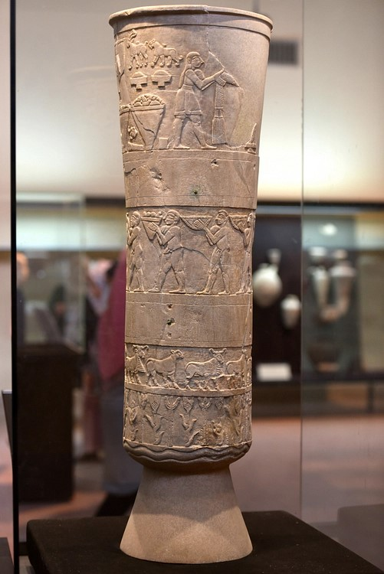
Figure 1: Uruk Vase (after Amin)

Figure 2: Black Country Flag (after Hogweard)
Bibliography
Crawford, H. 2004. Sumer and the Sumerians. 2nd Edition. Cambridge University Press. Cambridge.
Gell, A. 1998. Art and Agency, An Anthropological Theory. Clarendon Press. Oxford.
Morphy, H. 1994. The Anthropology of Art in Ingold, T. (ed.) Companion Encyclopaedia of Anthropology, Humanity, Culture, and Social Life. Routledge. London and New York. pp. 648-685
Pollock, S. 1999. Ancient Mesopotamia, The Eden that Never Was. Cambridge University Press. Cambridge.
van de Mieroop, M. 2007. A History of the Ancient Near East ca. 3000 – 323 BC. 2nd Edition. Blackwell. Oxford.
Wartke, R. B. 2003. Frankfurter Allgemeine Zeitung. 26th April, p.39 [newspaper] available at https://web.archive.org/web/20070928181330/http://www.d-a-g.de/warka.html [accessed 9th March 2022]

